

Report

Managing Marketing Change Nike Case Study

4,125 words
Submitted on 08/01/2024
Module BMMB7026

Table of Contents

Introduction 1
1.0 Main Findings 2
2.0 Nike Case Study 4
2.1 7P’s Marketing Mix 4
2.2 Customer Journey Map 5
2.3 McKinsey Loyalty Loop 5
2.4 Porter’s Five Forces 6
2.5 PESTLE Analysis 7
2.6 SWOT Analysis 9
2.7 Lewin’s Force Field Analysis 10
3.0 Conclusions 12
4.0 Recommendations 13
References 14
Appendices 23
Appendix A 23
Appendix B 24
Appendix C 25
Appendix D 26
Appendix E 27
Appendix F 28
Appendix G 29
Appendix H 30

Executive summary
The success of any organisation is a complex subject where many variables directly or indirectly influence its reputation and profitability. Marketing principles and practices have been helping organisations stay relevant in meeting customers’ needs, evolving from traditional concepts to a more dynamic approach incorporating competition, digitalisation, and a focus on creating customer value through its products and services. This evolution is crucial for businesses to adapt to market fluctuations and maintain competitiveness.
However, while marketing drives demand and consumption, it faces criticism for promoting consumerism and sometimes neglecting ethical and environmental considerations.
This report provides a comprehensive analysis of the evolving landscape of marketing strategies, with a specific focus on Nike, Inc. It delves into various aspects of Nike marketing, the critical role of environmental and sociocultural factors, and their impact on the company's marketing strategy.
Additionally, it examines Nike's journey from a distributor of athletic shoes to a leading global brand in sports apparel and equipment, including its marketing mix, customer segmentation, digital presence, and brand value growth, emphasising its strategic responses to market trends and consumer behaviour.
Moreover, using strategic tools like the 7P’s Marketing Mix, McKinsey Loyalty Loop, Porter’s Five Forces, PESTLE Analysis, SWOT Analysis, and Lewin’s Force Field Analysis provides insights into Nike's market position and strategy.
The report concludes that Nike has effectively navigated the changing marketing landscape by focusing on customer-centric strategies, digitalisation, and sustainability. The company has managed to maintain its market leadership and brand value through innovative marketing strategies and adaptability to changing market dynamics and consumer preferences.
Ultimately, Nike's approach to marketing, characterised by a blend of innovation, sustainability, and adaptability, serves as a model for others in the industry. The company's ability to align its strategies with evolving market and consumer needs is a critical success factor.
Based on the conducted research and after the evaluation of Nike’s marketing strategies and practices, it was recommended to strengthen commitment to sustainable practices and materials, invest in digital channels for improved customer engagement, address ethical concerns in manufacturing and business practices, adapt marketing strategies to cater to diverse consumer needs and market dynamics, continue to innovate and differentiate products from competitors and reduce dependency on retail partners by enhancing direct-to-consumer sales.

Introduction
This report has been created as a part of the Managing Marketing Change (BMMB7026) module assignment to demonstrate the knowledge and skills obtained from the learned material.
This academic report will be submitted on the deliberated date and time via Turnitin on 08/01/2024 to meet the assignment requirements and stipulated deadlines.
Nike has been chosen to analyse its marketing strategies and their effectiveness in meeting global challenges that might impact its relevance and profitability. Moreover, a range of strategic management and marketing tools, such as PESTLE, 7P’s Marketing Mix, Porter’s Five Forces, SWOT, McKinsey Loyalty Loop, Customer Journey Map, TOWS and Force Field Analysis, have been deployed to scrutinise Nike’s strategic development vector.
To ensure the credibility of the findings, conclusions and recommendations, the report's author has used various sources of information, including but not limited to textbooks, scientific journals, articles, magazines, reviews, videos, legal policies, and governmental and public websites.

1.0 Main Findings
Marketing is an integral part of any business (Cameron and Green, 2015). Moreover, as a concept of achieving business objectives through customer value, marketing continually evolves, ensuring organisational adaptivity mechanisms to mitigate market trend fluctuations, harness available profitable opportunities, and gain competitiveness (Fahy and Jobber, 2022). Therefore, stepping away from traditional marketing concepts, today, contemporary marketing strategies consider competition - another crucial aspect of the trading process (Blythe and Martin, 2019).
However, despite glaringly apparent benefits, marketing often receives criticism for creating a “religion of consumerism”, overemphasising short-termism and material possessions over society’s long-term interests and ethical values (Harhut, 2022).
Indeed, this criticism is not unfounded and is grounded in compelling evidence of unethical practices in organisations' pursuit of maximal profit (Godfrey, 2022). Moreover, as demand creates supply, consumption is driven by marketers' desire to satisfy customers' wants, sometimes conflicting with environmental and ethical aspects neglected by organisations (White, Hardisty and Habib, 2019).
Hence, today's commercial advantage could be gained if the company understands the causality between its business activities and the framework of interdependent variables that impact customers' lives and will take a severe approach towards sustainability by using corporate social responsibility (CSR) and consider factors beyond financial reward (Deloitte, 2023).
Guliyev and Huseynova (2021) declare that the Fourth Industrial Revolution has launched vast globalisation and industrialisation, opening new foreign markets for Multinational Enterprises (MNEs), expanding their sphere of interests, increasing interconnectedness, and spreading knowledge and technologies across borders. Moreover, expanding markets and growing competition profoundly impacted companies' marketing planning activities, where the company's competitive advantage in implementing marketing strategies relies on the integrated effort of all organisational departments to meet and exceed customer satisfaction (Palmer, 2021). Therefore, the marketing department within every organisation must drive and coordinate all necessary add-value activities to align corporate goals with customer satisfaction to create better value than its competitors. Additionally, cross-market differences and cultural diversity create complexity for a market strategy where various aspects must be considered for effective targeting and touch points identification to offer a unique selling proposition that will outperform existing competitors’ offers (Hollensen and Opresnik, 2018).
It is worth noticing that today, companies utilise technological advancements to improve products and services, making them more efficient and cost-effective (Whitehouse, 2023). Similarly, Tordjman and Bertini (2023) confirm that digitalisation streamlines information exchange channels and facilitates customers' touchpoint extension.
Additionally, from the marketing perspective, digitalisation opens a new perspective of customer engagement, allowing companies to monitor customer data and market trends to develop deliberate strategies and address unforeseen events when implementing change through relevant emergent strategies (Fox, 2023). Moreover, sophisticated data analysis provides a comprehensive picture of latent market opportunities and helps to identify the stimulus of customers' repeated purchasing behaviour (Kingsnorth, 2019).
Furthermore, Biesenbach (2018) stipulates that the customer is the main focal point of any marketing activity. Hence, marketers need to understand the marketplace and customers' needs, as they have to diversify data inputs to recognise customers' behaviour shifts.
In contrast, misinterpretations of customers' needs and the inability to operate and analyse collected data can lead to strategic myopia and financial and reputation loss (Grigsby, 2018).
Thus, change is an imminent and continuous process that supports organisational resilience to internal and external contexts that disrupt usual business ways, pushing them to change to remain relevant and profitable (Cameron and Green, 2019).
According to Hahn (2021), digitalisation and globalisation have created a fast-paced business environment where a reactive approach to market adaptation could be fatal to any company of any scale. Therefore, change management is crucial in shaping and delivering marketing strategies that satisfy organisational and customer needs (Franklin, 2021).
Ghelber (2022) states that change management supports marketers' adaptation to fluctuations in consumer behaviour and provides an agile approach when dealing with contingencies and market shifts. Moreover, effective change management will support stakeholders' inclusiveness and streamline the decision-making process through systematic communication between diverse teams within the organisation (George, 2023).
Therefore, new marketing strategies can be efficiently implemented with minimal change resistance within the organisation, as all involved parties will understand the necessity of change and how their efforts contribute to the new marketing objectives, especially if these new strategies involve technological or manufacturing process improvements (Sirkin, Keenan and Jackson, 2005).
Bavent (2022) confirms that, as an MNE that achieved a significant economy of scale, Nike is not an exception when taking necessary actions to adjust its business strategies to maintain its leading market position and provide value for its customers depending on current environmental and sociocultural trends as the primary change drivers in the sporting goods industry.

2.0 Nike Case Study
Nike, a prominent American multinational company, has significantly impacted the athletic apparel and footwear industry since its establishment on January 25, 1964, by Bill Bowerman and Phil Knight (Knight, 2016). Moreover, the company was initially named Blue Ribbon Sports and acted as a distributor for Onitsuka Tiger (ASICS). However, it rebranded to Nike in 1971 with the famous "Swoosh" logo, named after the Greek goddess of victory, and became Nike, Inc. in 1978 (Sichol, 2019).
According to Abloh et al. (2021), the brand's market growth was based on innovative marketing and product development at that time, and its partnership with Michael Jordan in 1984 led to the Air Jordan brand, a pivotal moment in the company’s history and sports marketing.
Woody (2021) stipulates that Nike’s iconic "Just Do It" slogan was also significant in rising brand popularity in 1988, supported by authentic promotion and advertisement campaigns, allowing the company to expand its market into sports equipment and apparel, becoming an athletic and cultural icon.
Today, with a brand value of $33.18 billion, Nike continues to lead the global sports apparel market (Nike, 2023). Additionally, the company has demonstrated exponential revenue growth since 2012, with only one revenue drawdown in 2021 due to the COVID-19 pandemic. However, after the pandemic upheaval, Nike recovered and, in 2023, reported 51.217 billion U.S. dollars of global revenue (Tighe, 2023).

2.1 7P’s Marketing Mix
Allen (2020) confirms that the 7P’s Marketing Mix is a useful concept that can create an effective marketing strategy to help the company adapt to market dynamics fluctuations. Therefore, the organisation can comprehensively understand its business offering and how it is presented and perceived in the market.
The 7Ps Marketing Mix analysis showed that Nike employs a mixed pricing strategy, combining value and premium-based pricing. Moreover, this allows Nike to charge higher prices than competitors due to its substantial brand equity (see Appendix B). Hence, this strategy aids in increasing profits and covering research and development expenses (Team, 2020). Moreover, Nike's core product was initially running shoes designed specifically for athletes, filling a gap in the market (Johnston, 2021). However, the company expanded its product line to encompass a broader range of sports, including apparel and equipment (Tighe, 2023a).
Mohammed-Ali (2022) states that Nike targets younger consumers through social media and events at educational institutions and sports organisations. Additionally, Nike has successfully ventured into online sales, utilising technology that ensures a streamlined purchasing process, accurate shoe and apparel sizing, and an improved feedback mechanism (Digiday, 2019).
Ultimately, the analysis confirmed that Nike employs a detailed and comprehensive approach to dividing its broad customer base into smaller subsets of consumers with common needs and interests to target them more effectively with its products and marketing efforts.
Thus, Nike uses thorough customer segmentation, including demographic, geographic, behavioural, and psychographic attributes, and continuously monitors consumer behaviour influences, values, beliefs and attitudes through various touch points as a part of its Marketing strategy change management (Gregory, 2023b).
For instance, demographic segmentation includes a wide range of customers from 15 to 45 years old, where the company targets mainly middle-aged customers with disposable income capacity and establishes a relationship with a younger audience to ensure the future growth of brand enthusiasts as a long-term marketing strategy (Edrawmind, 2022).
Regarding the physical evidence, Nike’s stores and website have a sporty and authentic design aligned with the brand image (Sudan, 2020). Hence, a strong authenticity is what makes Nike recognisable and stand out from its rivals.

2.2 Customer Journey Map
Nike’s customer journey map revealed an omnichannel approach when creating customer experience. Moreover, the company uses various touchpoints for target marketing, product line promotion and differentiation from its competitors (see Appendix G). In contrast, Nike’s customer journey map analysis also identified certain gaps and inconsistencies in social media activity, mainly emphasising public content rather than product line promotion. However, recent social media marketing strategy changes demonstrate evolving product promotion prioritisation in most social media platforms’ content (Nagpal, 2021).
According to Dussart (2011), the commoditization of customer relationships can be fulfilled by effective Customer Relationship Management (CRM) and implementation of relationship marketing, where technological solutions will allow the collection of credible data about all the touchpoints during the customer–company interaction. However, Buttle and Maklan (2019) state that it is impossible to please every customer, and the company must concentrate on creating high-value experiences that make meaningful journeys for target customers. Therefore, organisations can manage cross-channel touchpoints and use their CRM framework efficiently.

2.3 McKinsey Loyalty Loop
Lok (2018) confirms that understanding customer behaviour is vital for improving their experience, developing relevant marketing strategies and increasing customer retention.
According to Hanlon (2022), the McKinsey Loyalty Loop is a framework that serves as a mapping tool for customers' buying journey to improve their decision-making process and loyalty.
Siebert et al. (2020) state that this model has apparent advantages, as it shifts from a linear model to a more circular one, representing a dynamic process that focuses on customer experiences and interactions with a brand to influence their loyalty and subsequent purchasing decisions.
Nike’s McKinsey Loyalty Loop analysis (depicted in Appendix F) confirmed that its investments in marketing campaigns and successful branding created a strong image that attracts customers when they are looking for new sportswear.
For instance, Nike increased its advertising and promotion expenditures by 17.7%, from 3.85 billion in 2022 to 4.6 billion in 2023 (Statista, 2023a).
On the other hand, its direct competitor, Adidas, spent only 2.8 billion on advertising for the same period, 48.6% less than Nike (Parker, 2023).
Additionally, research confirmed that a significant improvement had been made in product distribution channels and the ease of purchase practices, as Nike invested in key technologies and inculcated digitalisation in its processes, thriving on both online and offline sales, reaching a significant 38% of the direct to consumer (D2C) sales in 2023 (Statista, 2023b).
Therefore, Nike improved customers’ post-purchase experience and increased the repurchase process, as satisfied customers might skip the initial consideration and active evaluation stages entirely.

2.4 Porter’s Five Forces
Pride et al. (2022) declare that organisations must be able to navigate through market fluctuation, identifying and utilising emerged profitable opportunities to gain a superior advantage position in the market.
Indeed, Porter's Five Forces Analysis is a valuable tool for examining the competitive forces within the global sports apparel market that Nike considers when planning changes in its marketing strategy (see Appendix C).
For example, the analysis revealed that the sportswear market is highly saturated with brands like Nike, which creates significant competition tensity and pressure for Nike's product positioning strategy and product and service substitution risks.
However, according to WallStreetZen (2022), despite this fierce competition, Nike is an undisputed market leader with 43.7% of the global sports shoe market, where 23.7% belongs to its primary competitor Adidas and 7.6% to Puma.
This market share disposition confirms a moderate force of substitution, as consumers have alternatives in sports shoes, non-athletic and casual footwear. Moreover, research affirmed a moderate price-performance ratio of Nike's competitors, which indicates customers' satisfaction with competitors' shoe quality and performance. Therefore, customers can easily switch from Nike's products to substitute alternatives if they provide more value for the money.
Additionally, to address the threat of substitution, Nike makes a marketing effort to showcase its focus on developing and integrating the latest technologies and advanced materials in its products (Snowden, 2020). Moreover, Nike uses a Closed-Loop Business Model to recycle and reuse materials to reduce production waste (Kumar, 2020). This model allows unique recycling, donation, refurbishing and re-creation services that distinguish the company from its competitors and provide a unique selling point (Nike, Inc., 2023).
Nonetheless, Nike has the first-mover advantage in implementing sustainable practices and materials in its products and services, as the company’s innovation pipeline is supported by financial capital and available technologies (Ferguson, 2023).
Consequently, this advantage is a critical success factor that differentiates Nike from its rivals, provides a superior market proposition and value for its customers, and mitigates the risk posed by alternative offerings.
Additionally, the research confirms that Nike mitigates the risks of Bargaining Power with its strong brand presence and high customer loyalty, differentiating with its wide range of products, including innovative and unique product lines (Beldad, 2023).
Moreover, regarding the Bargaining Power of Suppliers, Nike has significant negotiating power due to its large scale and high volume of orders, diversifying its supplier chain to reduce dependence on individual suppliers (CIPS, 2023).
Therefore, by maintaining a dominant market position, strategic relationships with suppliers and high brand loyalty, Nike managed to diminish the bargaining power of buyers and suppliers.

2.5 PESTLE Analysis
According to CIPD (2023), PESTLE analysis serves as a strategic framework that guides the decision-making process by identifying and evaluating external factors and macro-environmental influences that affect the organisation during its business activities.
A deep dive into the main driving forces of the change in marketing strategies (see Appendix A) confirms that the environmental factor is the primary driver that tangibly influences Nike’s business strategy, current marketing decisions, and overall organisational development vector (Becker et al., 2022).
According to the Massachusetts Institute of Technology (2023), the linear take-make-waste model of the footwear industry is profoundly unsustainable from a social, economic, and environmental perspective.
However, the sociocultural factor is also crucial for Nike, as changes in consumers' lifestyles and beliefs dictate how they respond to marketing stimuli and define the pattern of their choices (Solomon, 2020).
Stacey and Mowles (2016) claim that environmental and sociocultural factors necessitate organisational strategic adaptations to align with evolving consumer preferences and regulatory requirements.
Similarly, MacArthur (2021) ascertained that a shift in people's relationship with the physical environment significantly changed customer consciousness regarding environmental consumption costs and Nike's impact on climate change, its control measures in terms of pollution, energy efficiency, and use of environmentally friendly processes and recyclable materials.
As a result, Nike tangibly increased investments in product distribution channels and marketing to fulfil customers' expectations and address buyer behaviour change (Tighe, 2023b).
Moreover, in response to increasing concerns about climate change and environmental sustainability, Nike has introduced environmentally sustainable products, exemplified by the "Space Hippie" sneakers (The Index Project, 2021). These innovative products are meticulously crafted from recycled and sustainably-minded materials prominently featured in Nike's marketing campaigns to resonate with environmentally conscious consumers (Nike, 2020).
Furthermore, stringent environmental regulations and waste management standards in Europe and North America have prompted Nike to ensure that its manufacturing processes and materials comply with these requirements (Delmas, 2002).
Ellis (2021) declares that Nike’s commitment to carbon emission reduction is underscored in the company’s marketing activities, aiming to enhance consumer trust in the company's eco-friendly practices. Moreover, as consumer awareness of environmental issues grows, Nike's marketing campaigns emphasise circular design initiatives to align its efforts with consumer values and signify support for environmental causes (Nike, 2019).
For instance, Nike's marketing strategies focus on its initiatives to recycle old sneakers, effectively transforming them into new products (Playtop Licensing Ltd., 2021). Therefore, this approach reduces waste and champions the principles of a circular economy, aligning with current environmental trends to ensure product life cycle longevity (Thomas, 2023).
As a result, the company’s environmental impact-mitigating actions resonate with environmentally conscious consumers while addressing industry-specific challenges associated with environmental responsibility, confirming a direct correlation between climate change and buyer behaviour.
For example, Becker et al. (2023) state that the athletic footwear and apparel industry has grown exponentially during the past two years due to the increasing awareness of health, fitness, and sports in the post-COVID period, especially among younger generations. Similarly, Latham (2021) confirms that 60% of consumers have been making more environmentally friendly, sustainable, or ethical purchases since the start of the pandemic, and these trends continue even in post-pandemic times.
Additionally, Kotler and Armstrong (2023) distinguish the current five major buying behaviour shifts of consumers that impact organisations like Nike, such as an increase in single-person households, consumers' demand for convenience, change in preference for immediate access to goods and services, connectivity technologies and handheld devices, increased social conscience and awareness of ethical and sustainable practices.
Gregory (2023a) states that, as a market-driven company, Nike identified and addressed these elements in its current marketing strategy by integrating the Marketing Mix with Market Segmentation. Moreover, Nike has designed a customer-centric and optimised approach for market performance and competitiveness to keep brand relevance and product value creation following current trends of sociocultural factors.
The rise of social trends acts as a push factor that Nike uses to adjust its marketing activities and invest significantly in its women's line, focusing on leggings, sports bras, athleisure and activewear (Salpini, 2022). Moreover, the importance of the brand's social impact makes internal and external customers scrutinise its work ethics and manufacturing practices, material sources and CSR initiatives, which adds the needed amount of pressure on Nike to launch strategic changes (Gupta, 2023).
For instance, Kolk (2023) states that the company is renowned for pioneering hot topics like gender and disabilities within its marketing strategy, thriving on equity, diversity, and inclusion, and creating effective advertising and promotional campaigns to create an authentic brand identity.
Similarly, Mwenda (2022) states that Nike has mastered influencer marketing and has set up endorsements with celebrities and high-profile athletes like Michel Jordan, Cristiano Ronaldo, and Tiger Woods to improve brand recognition. Additionally, Hoos (2019) confirms that the company uses impactful slogans and visual lines with inspirational and storytelling narrative elements with an intense emotional and rational appeal to capture the audience's attention and resonate with their values and beliefs, building brand loyalty through affiliation and emotional connection.
Moreover, there is credible evidence that Nike takes a stance on social and environmental issues, aligning its marketing promotional mix strategy with social trends to expand its target audience by creating relationships through various channels and promotion tactics, often capitalising on controversy (Kelner, 2019).
However, it should be noted that despite Nike’s tremendous effort in branding strategy, the company has also faced backlash over unethical labour practices, leading to increased public attention to its manufacturing and sustainable practices (Birch, 2012).

2.6 SWOT Analysis
As illustrated in Appendix D, the SWOT analysis was used to identify micro-environmental factors, such as Nike's strengths and weaknesses, that impact the company's marketing strategy and must be considered during the strategic adjustment when implementing change.
The SWOT analysis results infer that brand fame and innovative marketing strategies provide a solid ground for brand recognition. Moreover, the brand's digital presence and changes in its digital marketing strategies, which occurred even before the recent global pandemic, provided a robust online presence on various social media platforms, its website, and mobile applications, allowing an efficient circumvention and substitution of its offline product distribution channels and effective recovery from the drastic economic effect of the pandemic (Safdar, 2020).
Indeed, digitalisation impacts interpersonal communication velocity between people on all levels, leading to a closer connection between social media and commerce, changing people's lifestyles and expanding their horizons of socialisation and sphere of interests (Li et al., 2022). Therefore, Nike’s focus on ameliorating the digital customer experience is essential.
The analysis also confirmed that Nike has certain weaknesses, such as over-dependency on retail partners (Miller and Bain, 2023). However, the compelling evidence shows that the company is trying to mitigate related risks with counteractions and additional efforts to direct-to-customers retail strategy, ensuring better control over marketing and branding (Guyot, 2022).

2.7 Lewin’s Force Field Analysis
Lewin’s Force Field analysis was used as a change management tool to understand the driving and restraining forces that initiate or defer Nike’s organisational change to more sustainable practices related to its Move to zero strategic commitment as a remedial action to address the Environmental and Sociocultural factors.
Due to the simplicity of the visual representation of the forces, this decision-making tool encourages the identification and thorough analysis of the negative and positive options that influence the company's ability to move from the current state to a desired future state. However, in contrast, the tool’s simplicity could also be deemed a limitation factor, as the subjective nature of the assessment might not capture the complexity of the change dynamics.
As displayed in Appendix H, Lewin’s Force Field Analysis of Nike shows the apparent prepotency of the driving forces, as the brand’s competitive advantage and goodwill depend on the effective use of innovative opportunities by creating new sustainable materials, processes and manufacturing technologies. In return, these sustainable initiatives will lead to innovative products, reputation improvement and competitive advantage. Additionally, compliance with environmental legal regulations will ensure the company’s unity with the law, eliminating legal and reputation implications and financial losses.
In contrast, the change implementation requires initial cost consideration, as the new sustainable technologies are more expensive to develop and implement. Moreover, due to the large scale of Nike’s business and the complexity of its supply chain, it might be challenging to ensure a unified approach and standardisation across the entire supply chain.
Additionally, before the change implementation, Nike must reevaluate its business priorities, such as digital transformation or market expansion, as those activities can compete with the Move to Zero implementation milestones and targets for financial resources and attention.
However, Nike’s innovation pipeline, supported by financial capital and already available technologies, can help the company overcome the aforementioned potential barriers and maintain the first-mover advantage in implementing sustainable materials and practices while delighting its customers by fulfilling their expectations.
Therefore, this change is a critical success factor that will differentiate Nike from its rivals, provide a superior market proposition and value for its customers, and mitigate the risk its competitors pose.

3.0 Conclusions
To recapitulate. Based on the research findings and TOWS analysis (see Appendix E), it is reasonable to conclude that Nike achieved the leading market position unequivocally due to its highly adaptable marketing strategy and innovative branding, product promotion and advertising ideas.
Moreover, the comprehensive analysis of Nike's marketing strategies and practices illustrates the company's successful navigation through the complex landscape of contemporary marketing, thriving on physical and digital product distribution channels.
Furthermore, it was confirmed that Nike's marketing approach is characterised by its adaptation to environmental and sociocultural trends, digitalisation, globalisation, and commitment to sustainability, providing superior value propositions than competitors for its customers, underscoring its position as a market leader in the athletic apparel and footwear industry.
Additionally, an assessment of the effectiveness of Nike’s marketing campaigns, supported by the key measurement metrics, leaves no doubt about their efficacy, and despite adverse COVID-19 effects on global businesses and implemented control measures, the company has recovered and increased its profitability in succession years.
However, although the company demonstrates agility when dealing with market trend fluctuations and contingencies, the research also pointed out challenges such as ethical concerns and the need for a more sustainable business model that must be addressed to maintain the first-mover advantage and market-leading position.

4.0 Recommendations
The research findings show that Nike should continue prioritising and expanding its sustainable practices and ethical manufacturing, prioritising innovation in product development and integration of new technologies in manufacturing processes, as this aligns with environmental and sociocultural trends and strengthens brand loyalty among increasingly environmentally-conscious consumers.
Additionally, given the effectiveness of digital channels, Nike should further integrate digital marketing strategies to enhance customer engagement and experience. Moreover, to mitigate the weakness of over-dependency on retail partners, Nike should continue to develop its direct-to-consumer retail strategies, ensuring better control over marketing, branding, and customer relationships.
In light of past criticisms over labour practices, Nike should proactively address these concerns in its marketing and operational strategies to maintain and improve its brand reputation.
As a result, implementing these recommendations will help Nike sustain its current market leadership and adapt to evolving market demands and consumer expectations, ensuring long-term success and brand resilience.

References
Abloh, V. et al. (2021) Virgil Abloh : Nike ICONS. Köln: Taschen.
Allen, A. (2020) The 7Ps of the Marketing Mix, Oxford College of Marketing. Oxford College of Marketing. Available at: https://blog.oxfordcollegeofmarketing.com/2020/10/08/understanding-the-7ps-of-the-marketing-mix/ (Accessed: 28 December 2023).
Bavent, A. (2022) Nike: Running Directly Towards the Future of Apparel, www.kantar.com. Available at: https://www.kantar.com/north-america/inspiration/brands/nike-running-directly-towards-the-future-of-apparel (Accessed: 28 December 2023).
Becker, S. et al. (2022) Sporting Goods 2022: the New Normal Is Here | McKinsey, www.mckinsey.com. Available at: https://www.mckinsey.com/industries/retail/our-insights/sporting-goods-2022-the-new-normal-is-here (Accessed: 22 December 2023).
Becker, S. et al. (2023) Sporting Goods 2023: The Need for Resilience in a World in Disarray | McKinsey, www.mckinsey.com. Available at: https://www.mckinsey.com/industries/retail/our-insights/sporting-goods-2023-the-need-for-resilience-in-a-world-in-disarray (Accessed: 31 October 2023).
Beldad, A. (2023) 10 Reasons Why Nike Has Been so Successful, AdvanceTec - Tech News, Crypto, Business, Gaming, Reviews, and More. Available at: https://advancetec.co.uk/10-reasons-why-nike-has-been-so-successful/ (Accessed: 29 December 2023).
Biesenbach, R. (2018) Unleash the Power of Storytelling : Win hearts, Change minds, Get Results. Evanston, Il: Eastlawn Media.
Birch, S. (2012) How Activism Forced Nike to Change Its Ethical Game | Simon Birch, The Guardian. The Guardian. Available at: https://www.theguardian.com/environment/green-living-blog/2012/jul/06/activism-nike (Accessed: 30 December 2023).
Blythe, J. and Martin, J. (2019) Essentials of Marketing. 7th edn. Harlow, United Kingdom ; New York: Pearson Education.
Buttle, F. and Maklan, S. (2019) Customer Relationship Management : Concepts and Technologies. 4th edn. London Routledge.
Cameron, E. and Green, M. (2015) Making Sense of Change Management : a Complete Guide to the models, Tools and Techniques of Organizational Change. 4th edn. London ; Philadelphia, Pa: Kogan Page.
Cameron, E. and Green, M. (2019) Making Sense of Change Management : a Complete Guide to the models, Tools and Techniques of ... Organizational change. Kogan Page Stylus.
CIPD (2023) PESTLE Analysis, CIPD. Available at: https://www.cipd.org/uk/knowledge/factsheets/pestle-analysis-factsheet/ (Accessed: 22 December 2023).
CIPS (2023) How Nike Transformed Supply Chains to Survive Covid, Cips.org. Available at: https://www.cips.org/knowledge-and-insight/how-nike-transformed-supply-chains-to-survive-covid (Accessed: 29 December 2023).
Delmas, M.A. (2002) ‘The Diffusion of Environmental Management Standards in Europe and in the United States: an Institutional Perspective’, Policy Sciences, 35(1), pp. 91–119. Available at: https://doi.org/10.1023/a:1016108804453.
Deloitte (2023) The Sustainable Consumer 2023, Deloitte. Deloitte. Available at: https://www2.deloitte.com/uk/en/pages/consumer-business/articles/sustainable-consumer.html (Accessed: 28 December 2023).
Digiday (2019) In Effort to Grow Direct sales, Nike Integrated Its App Strategy into Its Stores, Digiday. Available at: https://digiday.com/marketing/nike-integrated-app-strategy-stores/ (Accessed: 29 December 2023).
Dussart, C. (2011) Creative Cost-Benefits Reinvention. Palgrave Macmillan.
Edrawmind (2022) Nike Market Segmentation, Targeting, and Positioning, Edrawsoft. Available at: https://www.edrawmind.com/article/nike-market-segmentation-targeting-and-positioning.html (Accessed: 29 December 2023).
Ellis, D. (2021) Nike’s Net-Zero Ambition: They ‘Just Did It’ | Sustainability, Supply Chain Digital. Available at: https://supplychaindigital.com/sustainability/nikes-net-zero-ambition-they-just-did-it (Accessed: 29 December 2023).

Fahy, J. and Jobber, D. (2022) Foundations of Marketing. 7th edn. London: McGraw-Hill UK Higher Ed.
Ferguson, E. (2023) Nike Inc. Operations Management: 10 Decisions, Productivity, Panmore Institute. Available at: https://panmore.com/nike-inc-operations-management-10-decisions-areas-productivity (Accessed: 5 November 2023).
Fox, J. (2023) Digital Marketing for Business 2023 3 Books in 1. Jake Fox.
Franklin, M. (2021) Agile Change Management a Practical Framework for Successful Change Planning and Implementation. London: Kogan Page, Limited.
George, S. (2023) CIPD | Change Management, CIPD. Available at: https://www.cipd.org/uk/knowledge/factsheets/change-management-factsheet/ (Accessed: 28 December 2023).
Ghelber, A. (2022) Council Post: How to Use Change Management to Execute a New Marketing Vision, Forbes. Available at: https://www.forbes.com/sites/forbescommunicationscouncil/2022/06/21/how-to-use-change-management-to-execute-a-new-marketing-vision/?sh=1a0e47f05184 (Accessed: 6 November 2023).
Godfrey, O. (2022) Top 20 Unethical Companies in the World (Allegedly) - ClimateRealTalk, Climate Real Talk. Available at: https://climaterealtalk.org/unethical-companies-in-the-world/ (Accessed: 28 December 2023).
Gregory, L. (2023a) Nike Inc.’s Marketing Mix (4Ps/Product, Place, Promotion, Price) - an Analysis, Panmore Institute. Available at: https://panmore.com/nike-inc-marketing-mix-4ps-product-place-promotion-price-analysis (Accessed: 31 October 2023).
Gregory, L. (2023b) Nike’s Promotional Mix (Marketing Communications Mix), Panmore Institute. Available at: https://panmore.com/nike-marketing-communications-mix (Accessed: 1 November 2023).
Grigsby, M. (2018) Marketing Analytics. Kogan Page Publishers.

Guliyev, M. and Huseynova, K. (2021) ‘Transformative Impacts of Globalization on the Economy of South Caucasus and Central Asia1’, SHS Web of Conferences. Edited by T. Kliestik, 92(2261-2424), pp. 7–22. Available at: https://doi.org/10.1051/shsconf/20219207022.
Gupta, R. (2023) Is Nike an Ethical Company?, Market Realist. Available at: https://marketrealist.com/p/is-nike-an-ethical-company/ (Accessed: 29 December 2023).
Guyot, O. (2022) Nike Reduces Its Number of Retailers, Fashion Network. Available at: https://uk.fashionnetwork.com/news/Nike-reduces-its-number-of-retailers,1456122.html (Accessed: 30 December 2023).
Hahn, K. (2021) Social Digitalisation. Palgrave Macmillan.
Hanlon, A. (2022) McKinsey’s Consumer Decision Journey | Smart Insights, Smart Insights. Available at: https://www.smartinsights.com/marketing-planning/marketing-models/mckinseys-consumer-decision-journey/ (Accessed: 29 December 2023).
Harhut, N. (2022) Using Behavioral Science in Marketing. Kogan Page.
Hollensen, S. and Opresnik, M.O. (2018) Marketing : Principles and Practices : a management-oriented Approach. S.L.: Opresnik Management Consulting.
Hoos, B. (2019) Council Post: Four Things We Can Learn about Influencer Marketing from Nike and Apple, Forbes. Available at: https://www.forbes.com/sites/forbesagencycouncil/2019/06/14/four-things-we-can-learn-about-influencer-marketing-from-nike-and-apple/?sh=50e1f04a3628 (Accessed: 7 November 2023).
Johnston, M. (2021) How Nike Makes Money: Sports Equipment and Apparel Rise, Investopedia. Available at: https://www.investopedia.com/articles/markets/080415/how-nike-nke-makes-its-money.asp (Accessed: 28 December 2023).
Kelner, M. (2019) Nike’s Controversial Colin Kaepernick Ad Campaign Its Most Divisive yet, The Guardian. The Guardian. Available at: https://www.theguardian.com/sport/2018/sep/04/nike-controversial-colin-kaepernick-campaign-divisive (Accessed: 4 November 2023).
Kingsnorth, S. (2019) Digital Marketing Strategy : an Integrated Approach to Online Marketing. 2nd edn. Kogan Page Inc.
Knight, P.H. (2016) Shoe dog: a Memoir by the Creator of Nike. London: Simon & Schuster.
Kolk, A. (2023) Nike Marketing Strategy and Campaigns, EpiProdux Blog. Available at: https://epiprodux.com/blog/nike-marketing-strategy-and-campaigns/ (Accessed: 5 November 2023).
Kotler, P. and Armstrong, G. (2023) Principles of Marketing. 19th edition. Harlow: Pearson Education Limited.
Kumar, E. (2020) Nike Operations Management, www.skillsire.com. Available at: https://www.skillsire.com/read-blog/240_nike-operations-management.html (Accessed: 5 November 2023).
Latham, K. (2021) ‘Has Coronavirus Made Us More Ethical consumers?’, BBC News, 14 January. Available at: https://www.bbc.co.uk/news/business-55630144 (Accessed: 7 November 2023).
Li, C. et al. (2022) ‘Does the Internet Bring People Closer Together or Further Apart? the Impact of Internet Usage on Interpersonal Communications’, Behavioral Sciences, 12(11), p. 425. Available at: https://doi.org/10.3390/bs12110425.
Lok, J. (2018) Why Needs to Predict Consumer Behavior. Independently Published.
MacArthur, E. (2021) Circular Design for fashion. Cowes: Ellen Macarthur Foundation Publishing.
Massachusetts Institute of Technology (2023) 3 Questions: a Roadmap toward Circularity in the Footwear Industry, MIT News | Massachusetts Institute of Technology. Available at: https://news.mit.edu/2023/3-questions-roadmap-toward-footwear-circularity-1027 (Accessed: 1 November 2023).
Miller, D. and Bain, M. (2023) Nike’s Complex Relationship with Wholesale, Explained, The Business of Fashion. Available at: https://www.businessoffashion.com/articles/retail/nikes-complex-relationship-with-wholesale-explained/ (Accessed: 30 December 2023).
Mohammed-Ali, A. (2022) Exploring Nike’s Pioneering Athlete Partnerships Shining Light on the next Generation of Sport, Hypebeast. Available at: https://hypebeast.com/2022/12/nike-athlete-partnership-future-of-sport-campaign (Accessed: 29 December 2023).
Mwenda, K. (2022) Nike athletes: a List of the Most Influential Athletes Sponsored by Nike, SportsBrief - Sport news. Available at: https://sportsbrief.com/athletics/29319-nike-athletes-a-list-influential-athletes-sponsored-by-nike/ (Accessed: 7 November 2023).
Nagpal, B. (2021) How Nike Uses Social Media and Is winning?, www.linkedin.com. Available at: https://www.linkedin.com/pulse/how-nike-uses-social-media-winning-bhavay-nagpal (Accessed: 16 December 2023).
Nike (2019) ‘Circularity: Guiding the Future of Design | Nike’, YouTube. Available at: https://www.youtube.com/watch?v=ma3setT67pM (Accessed: 29 December 2023).
Nike (2020) ‘Space Hippie: These Nike Sneakers Are Trash | Nike’, YouTube. Available at: https://www.youtube.com/watch?v=Sm9r_Zs2z6s (Accessed: 29 December 2023).
Nike (2023) NIKE, Inc. Reports Fiscal 2023 Fourth Quarter and Full Year Results, investors.nike.com. Available at: https://investors.nike.com/investors/news-events-and-reports/investor-news/investor-news-details/2023/NIKE-Inc.-Reports-Fiscal-2023-Fourth-Quarter-and-Full-Year-Results/default.aspx (Accessed: 28 December 2023).
Nike, Inc. (2023) Circular Solutions. Move to Zero., Nike.com. Available at: https://www.nike.com/gb/sustainability/services (Accessed: 1 November 2023).
Palmer, M. (2021) What Your Customer Wants and can’t Tell You : Unlocking Consumer Brains with the Science of Behavioral Economics. Coral Gables: Mango Publishing.
Parker, J. (2023) How Much Does Adidas Spend on advertising?, www.zippia.com. Available at: https://www.zippia.com/answers/how-much-does-adidas-spend-on-advertising/ (Accessed: 16 December 2023).
Playtop Licensing Ltd. (2021) The History of Nike Grind, www.youtube.com. Available at: https://www.youtube.com/watch?v=xGA5d5hCXsE (Accessed: 29 December 2023).

Pride, W. et al. (2022) Marketing Concepts and Strategies. 9th Edition. Cengage Learning EMEA.
Safdar, K. (2020) ‘Nike’s Sales Bounce Back from Coronavirus Slide’, Wall Street Journal, 22 September. Available at: https://www.wsj.com/articles/nikes-sales-bounce-back-from-coronavirus-slide-11600809973 (Accessed: 30 December 2023).
Salpini, C. (2022) 50 Years in: Nike’s Game Plan for Winning with Women, Retail Dive. Available at: https://www.retaildive.com/news/50-years-in-nikes-gameplan-for-winning-with-women/624302/ (Accessed: 31 October 2023).
Sichol, L.B. (2019) From an Idea to Nike. HMH Books for Young Readers.
Siebert, A. et al. (2020) ‘Customer Experience Journeys: Loyalty Loops versus Involvement Spirals’, Journal of Marketing, 84(4), pp. 45–66. Available at: https://doi.org/10.1177/0022242920920262.
Sirkin, H., Keenan, P. and Jackson, A. (2005) The Hard Side of Change Management, Harvard Business Review. Available at: https://hbr.org/2005/10/the-hard-side-of-change-management (Accessed: 28 December 2023).
Snowden, S. (2020) Green Gear: Nike Space Hippie Sneakers Made from Leftover Bits Found on Factory Floors, Forbes. Available at: https://www.forbes.com/sites/scottsnowden/2020/08/24/green-gear-nike-space-hippie/?sh=5df5b7a772f0 (Accessed: 5 November 2023).
Solomon, M.R. (2020) Consumer Behavior : buying, having, and Being. 13th edn. Harlow, Essex: Pearson.
Stacey, R. and Mowles, C. (2016) Strategic Management and Organisational Dynamics the Challenge of Complexity to Ways of Thinking about Organisations. Harlow, United Kingdom Pearson Education.
Statista (2023a) Nike Ad Spend Worldwide 2014-2019 | Statista, Statista. Statista. Available at: https://www.statista.com/statistics/685734/nike-ad-spend/ (Accessed: 16 December 2023).

Statista (2023b) NIKE Direct Revenue Share Worldwide 2022, Statista. Available at: https://www.statista.com/statistics/1278371/nike-direct-to-consumer-revenue-share-worldwide/ (Accessed: 17 December 2023).
Sudan, L. (2020) Nike’s Marketing Mix, Medium. Available at: https://medium.com/@lianasudan/nikes-marketing-mix-cd5c2aac1a50 (Accessed: 29 December 2023).
Team, T. (2020) Pricing Strategies of Nike, The Strategy Watch. Available at: https://www.thestrategywatch.com/pricing-strategies-of-nike/ (Accessed: 28 December 2023).
The Index Project (2021) Space Hippie, theindexproject.org. Available at: https://theindexproject.org/post/space-hippie (Accessed: 29 December 2023).
Thomas, D.S. (2023) ‘Cost-Effective Environmental Sustainability’:, NIST Advanced Manufacturing Series [Preprint]. Available at: https://doi.org/10.6028/nist.ams.100-48-upd1.
Tighe , D. (2023) Nike’s Revenue Worldwide from the Fiscal Years of 2005 to 2022, Statista. Statista. Available at: https://www.statista.com/statistics/241683/nikes-sales-worldwide-since-2004/ (Accessed: 16 December 2023).
Tighe, D. (2023a) Nike - Statistics & Facts, Statista. Available at: https://www.statista.com/topics/1243/nike/#topicOverview (Accessed: 31 October 2023).
Tighe, D. (2023b) Nike Ad Spend Worldwide 2014-2019 | Statista, Statista. Statista. Available at: https://www.statista.com/statistics/685734/nike-ad-spend/ (Accessed: 3 November 2023).
Tordjman, K.L. and Bertini, M. (2023) High-Tech Touchpoints Are Changing Customer Experience, Harvard Business Review. Available at: https://hbr.org/2023/03/high-tech-touchpoints-are-changing-customer-experience (Accessed: 28 December 2023).
WallStreetZen (2022) NIKE Statistics - NIKE Facts, Stats, Trends & Data (2021) | WallStreetZen, www.wallstreetzen.com. Available at: https://www.wallstreetzen.com/stocks/us/nyse/nke/statistics (Accessed: 4 November 2023).

White, K., Hardisty, D. and Habib, R. (2019) The Elusive Green Consumer, Harvard Business Review. Available at: https://hbr.org/2019/07/the-elusive-green-consumer (Accessed: 28 December 2023).
Whitehouse, S. (2023) Using Technology to Improve Business Processes and Boost Profits, www.winman.com. Available at: https://www.winman.com/blog/using-technology-to-improve-business-processes-and-profits (Accessed: 28 December 2023).
Woody, S. (2021) Soled out : the Golden Age of Sneaker Advertising. London: Phaidon Press Ltd.

Appendices

Appendix A
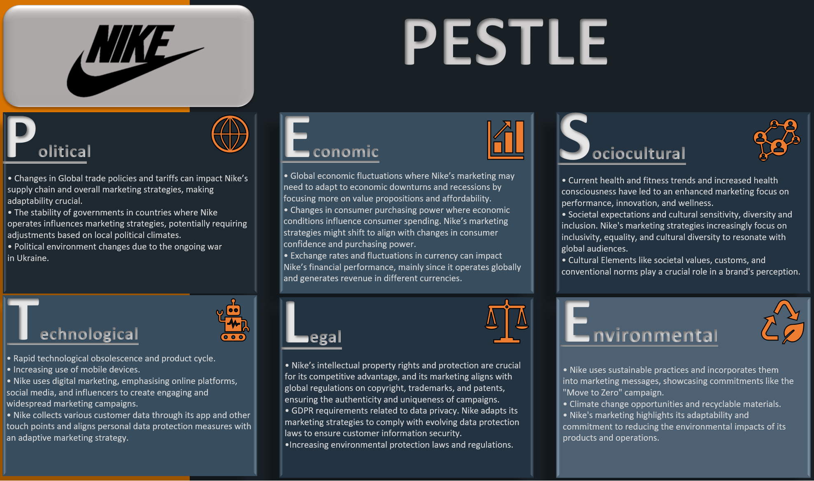

Appendix B
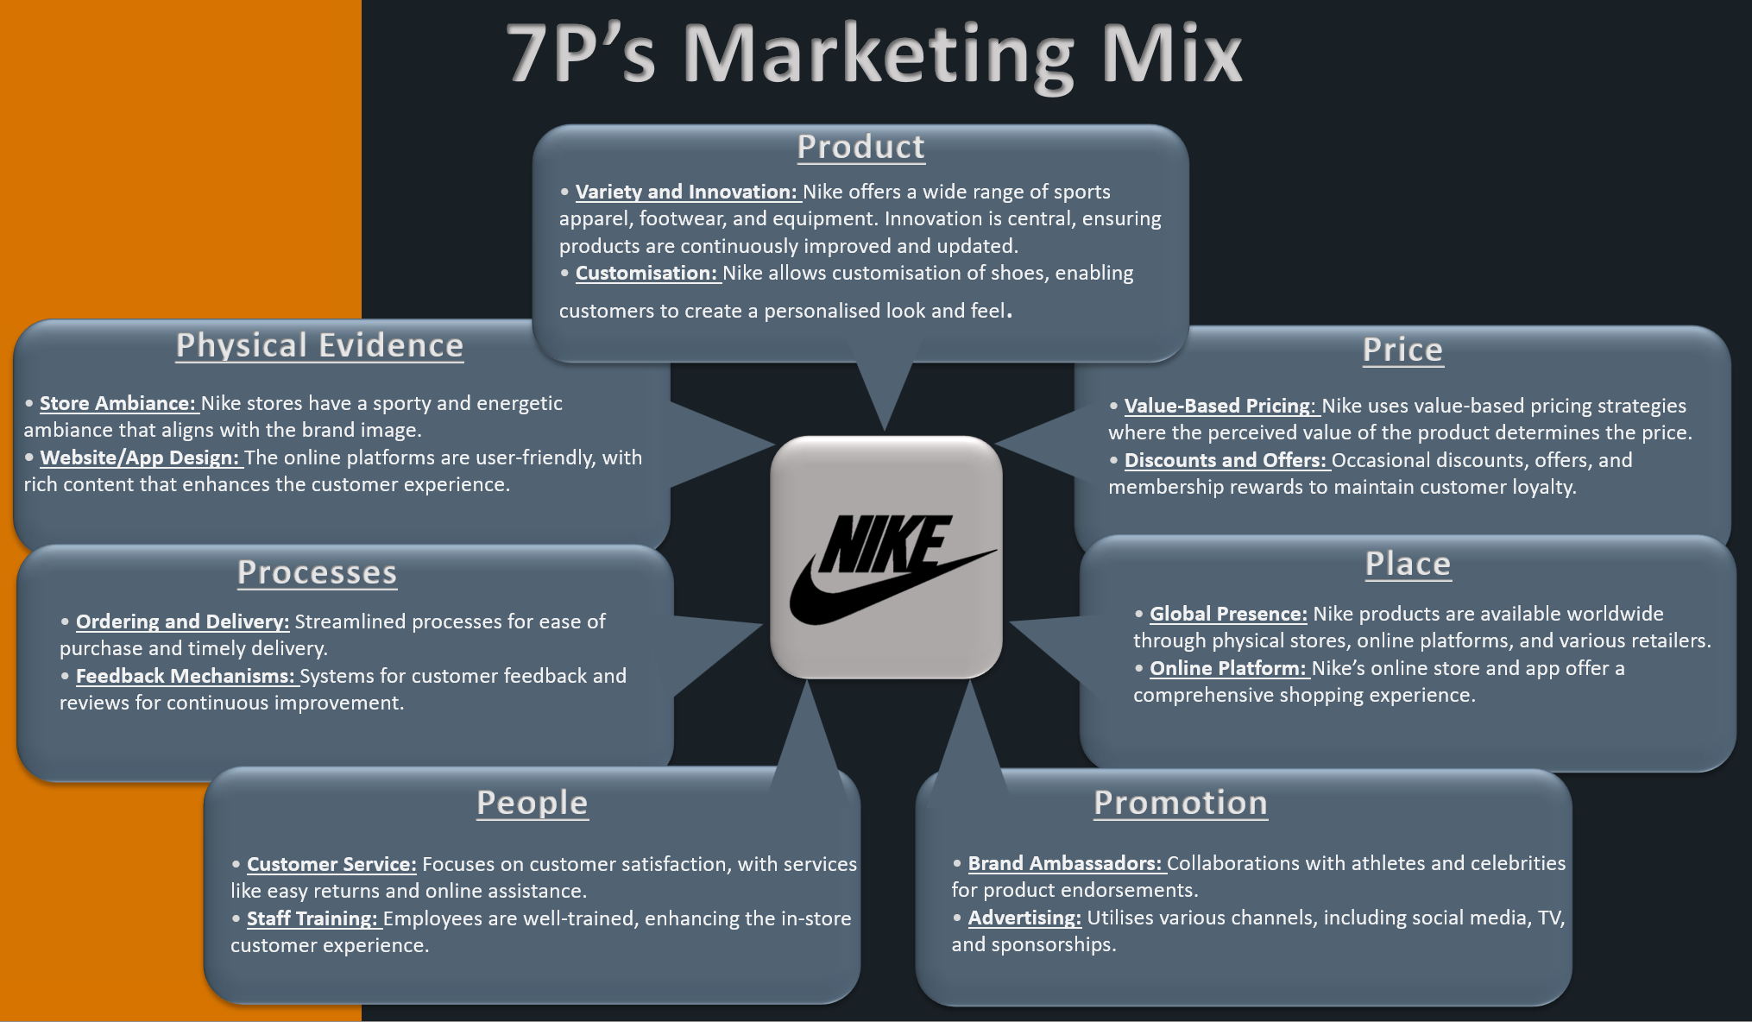

Appendix C
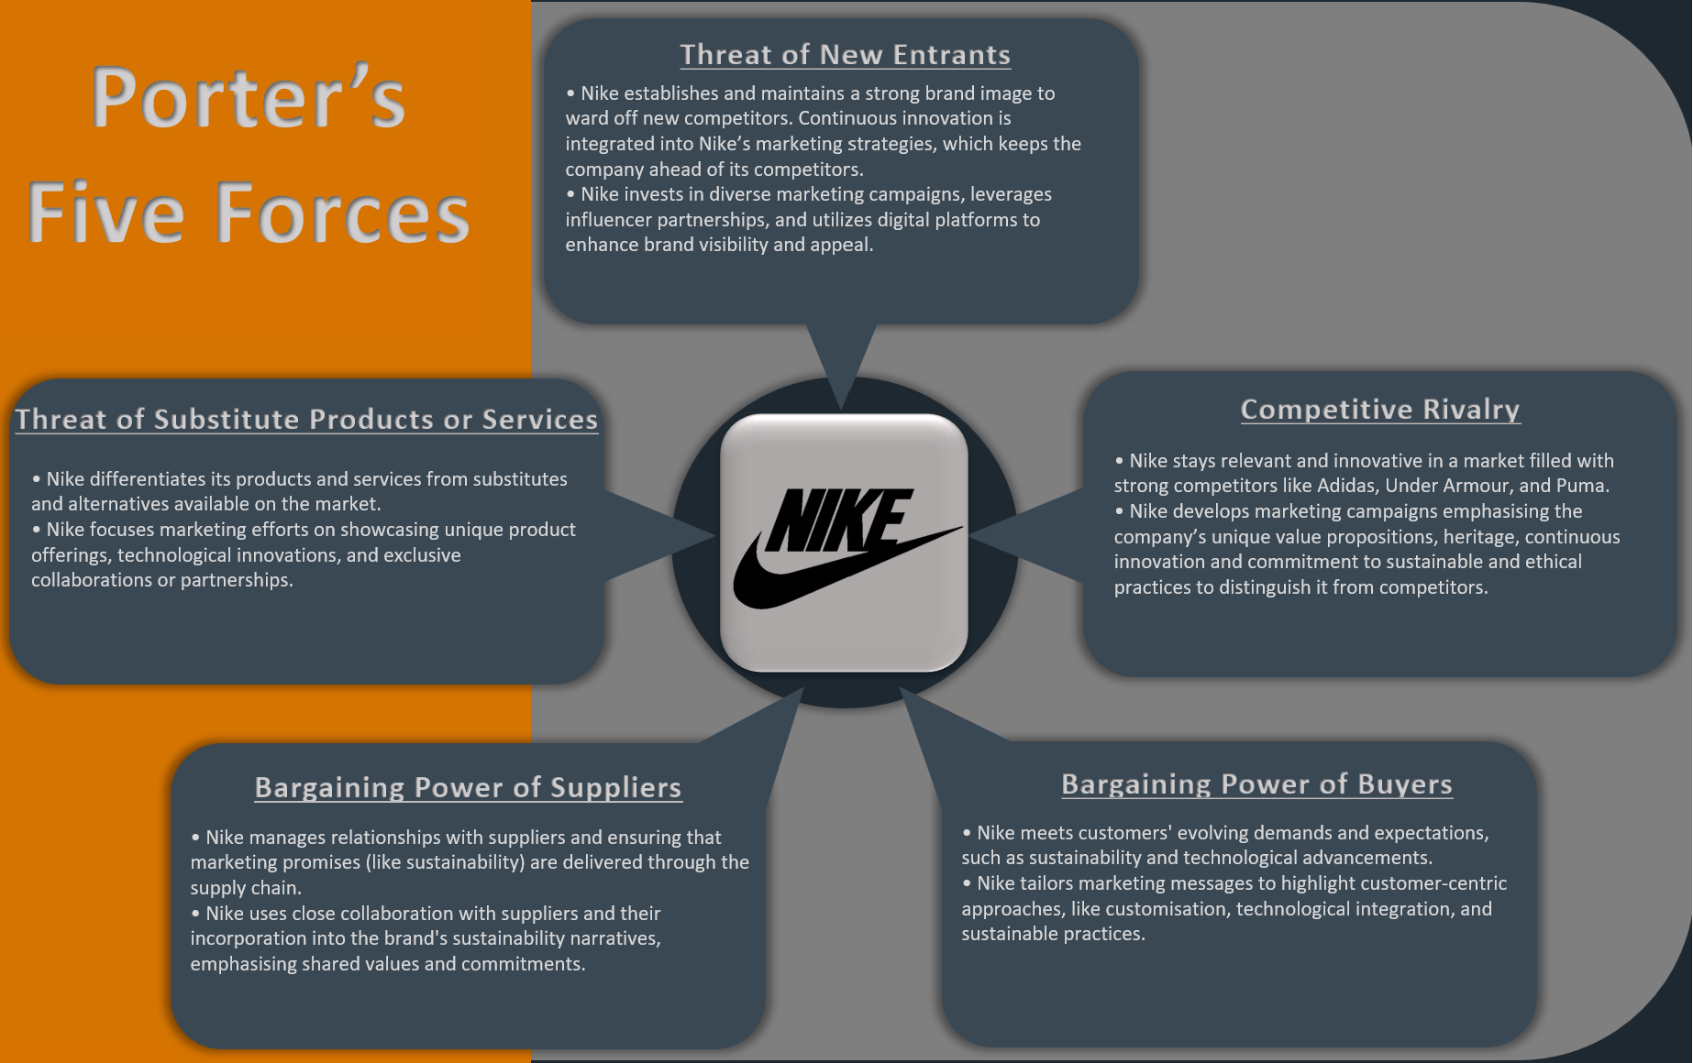

Appendix D
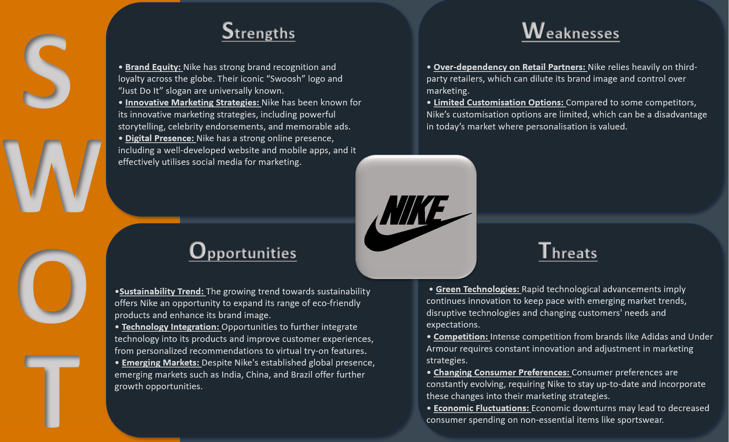

Appendix E
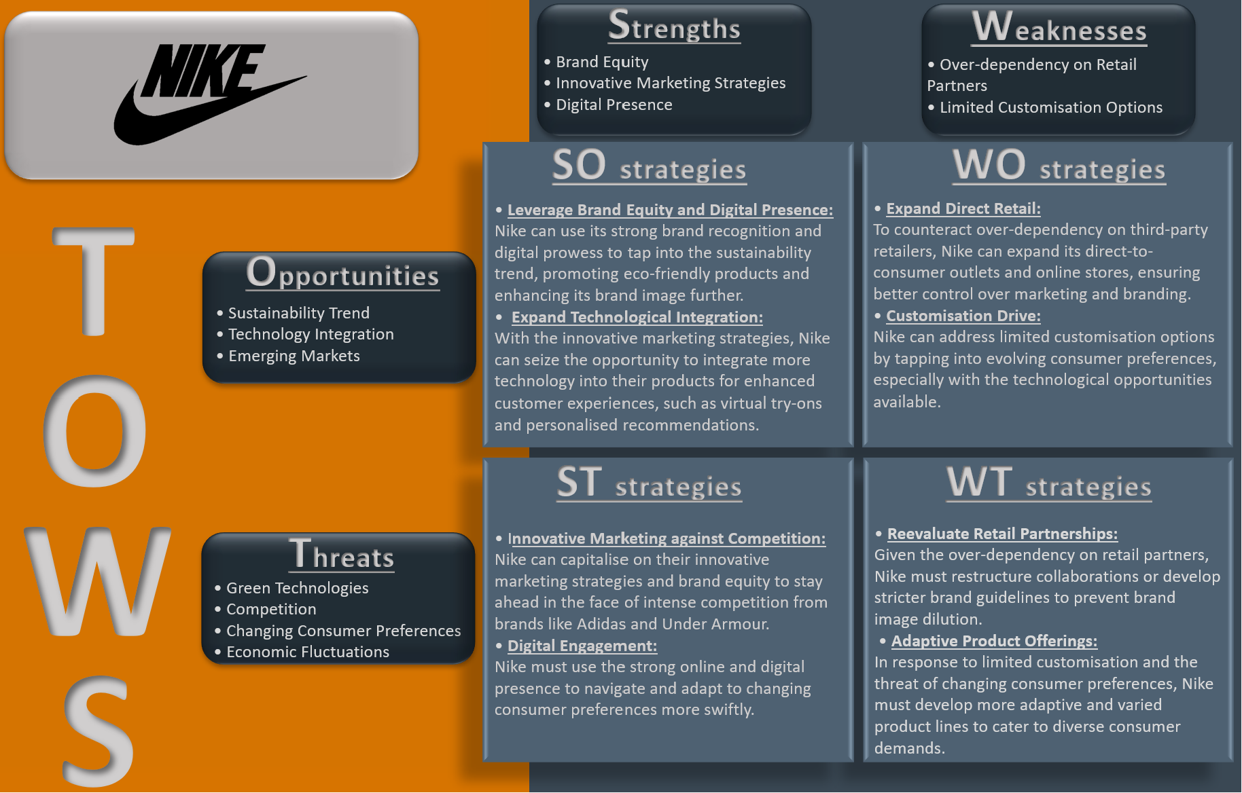

Appendix F
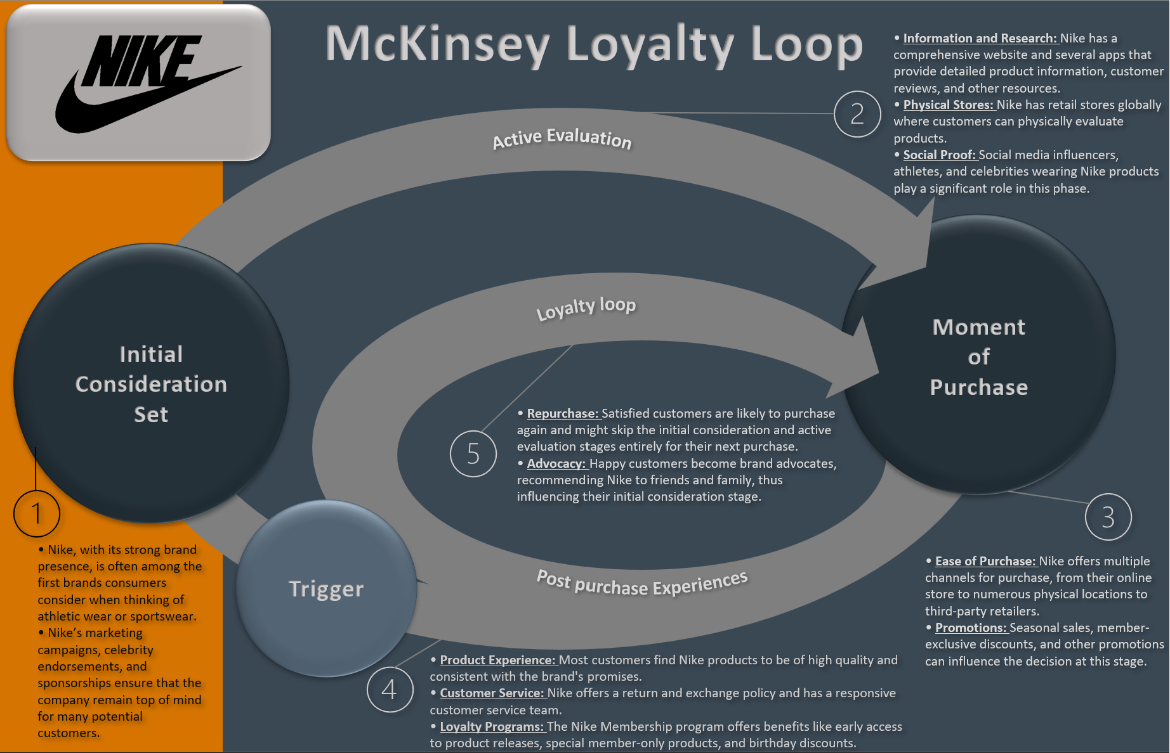

Appendix G
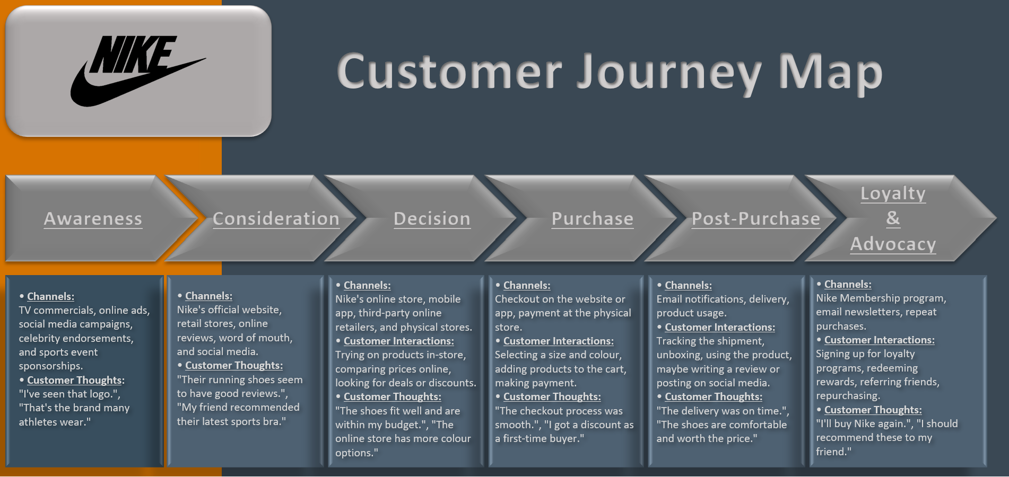

Appendix H


