Reflection
Reflection is a way of assessing yourself and help you develop your skills and review their effectiveness, it is about questioning yourself in a positive way, what you do and why do you do it and then deciding whether there is a better or more efficient way of doing it.
(The open university & unison in partnership, 2020)
Beliefs and values – beliefs are basically assumptions that we make and they grow from what we hear, see or experience, from those we develop an opinion that we hold to be true at that time our values stem from our beliefs and they are things that are important to us like equality, trust, loyalty, honesty and many more, knowing the difference between your values and beliefs can be a little confusing people use both to guide their actions and to form their attitudes towards different things but they are essentially different. (difference between net, 2020)

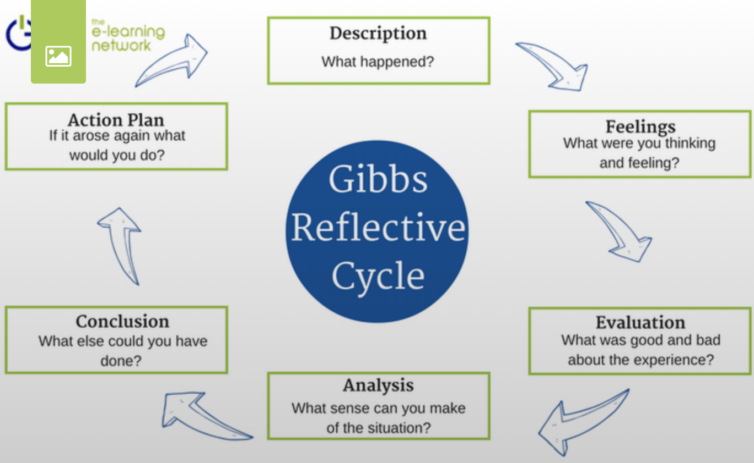

The Gibbs reflective cycle encourages people to think systematically about the experiences they had during a specific situation, event or activity, reflection on those experiences can be structured in phases. (Toolshero, 2020)
Description. What happened?
Feelings. What were you feeling before and after situation?
Evaluation. What was good and bad about the experience?
Analysis. What went well and what didn’t go well?
Conclusions. What I learnt from it? What else could I have done?
Action plan. How can I make sure that I can act differently next time?

Description – Myself, Laura and Lisa worked as a group and we decided to do our presentation on the phoenix centre as we currently or have previously worked there and are familiar with their values, we each chose a value of our choice and then we met with the manager of the phoenix centre and she went into more detail with us about their values so then we went and did more research so we could get ready and prepare for our presentation.
Feelings – I felt with being an employee at the phoenix centre I struggled to find any negatives as I personally think they are dedicated in what they offer to the community and felt that maybe we should have chosen another company where we could have critically analysed our findings, with that said I think the presentation went as well as it could have my nerves got the better of me on the day and felt with only one slide it was hard not to just read off my paper, I think we should have practised more as group which we will be doing in the future.
Evaluation – Even though its easy to talk about something we share the same values in made it hard to find any negatives, I think we work well in our group but only having the one slide made it difficult to actually present the presentation as I felt I was just reading my notes instead of engaging with the people watching our presentation.
Analysis – I think we got our points across of the values of the phoenix centre, when we met with the manager we went through the centres business plan to give us more information but we didn’t actually critically analyse it, during the presentation itself I found I was very nervous and I spoke very fast which is something I have to work on.
Conclusion – I have learnt that doing presentations have built up my confidence I just need to try and control my nerves on the day, I also enjoy working as a team I could have practised more in the house so I didn’t have to rely on reading from my paper, I enjoyed doing it on the phoenix centre as I could relate to it with it being my workplace and my findings were backed up by the centres manager.
Action plan – To meet more with my group to practise more next time and to try and speak more slowly and engage more with the people that are watching.
Barrett’s personal values – After doing the Barrett’s values and awareness test it is clear that having close relationships and connections with others is important to me, I need to feel a sense of love and belonging, if these needs are threatened or not met I will experience anxiety about not being excepted.
My values show:
. having meaningful close relationships and time to spend with the people I care about are important in my life.
. Kindness, empathy and consideration are shown in my interactions with others.
. demonstrating consideration in my relationships helps to build confidence so that people feel I can be relied upon.
. I demonstrate dedication in all that I do.
. I appreciate the freedom of autonomy and not being reliant on others.
. I enjoy working with others and like to cooperate and share experiences.
The type of values I selected indicates that the connections I build with others are most important to me, understanding our values helps us better understand ourselves and why we act or react in the way that we do, if you make a decision which goes against your own values it will make you feel uneasy as you are not being true to yourself.
Alone we can do so little, together we can do so much
'The Phoenix' in Townhill, Swansea is the flagship community enterprise centre of the Hill Community Development Trust Ltd. Owned and managed by a voluntary board of directors, the centre has a great track record of success and stands as the lasting legacy of the only Urban I Community Initiative in Wales which ran between the mid-1990s and the last day of 2001. (phoenix on the hill, 2020)

I believe that these are my core values and I apply these in my job daily as being a part of the phoenix centre team you must have compassion and kindness which I think all the staff show and it brings the community together in times of need, And I will try and work on the values I scored low on for the future.

Open.ac.uk. (2020). Self reflection | The Open University & Unison in Partnership. [online] Available at: http://www.open.ac.uk/choose/unison/develop/my-skills/self-reflection [Accessed 3 Mar. 2020].
toolshero. (2020). Gibbs Reflective Cycle: learning through personal reflection | toolshero. [online] Available at: https://www.toolshero.com/management/gibbs-reflective-cycle-graham-gibbs/ [Accessed 3 Mar. 2020].
Differencebetween.net. (2020). Difference Between Values and Beliefs | Difference Between. [online] Available at: http://www.differencebetween.net/language/difference-between-values-and-beliefs/ [Accessed 3 Mar. 2020].
The Phoenix on the Hill. (2020). The Phoenix on the Hill. [online] Available at: https://thephoenixonthehill.com/ [Accessed 3 Mar. 2020].

