Creating a strategic direction for school improvement

Amy Smith

Section A

This report will outline research on the new Curriculum for Wales and show a strategic direction for the new Area of Learning and Experience (AoLE) – Science and technology including a clear vision as the leader of this AoLE.

During this assignment, the name of the school that the strategic plan has been developed for will not be disclosed for anonymity purposes. Any data used or reference to school documents will also be anonymised following the guidelines in the BERA (2018) document.

Education is the engine of our economy, it is the foundation of our culture, and it’s an essential preparation for adult life. (Gibb, 2015)

Education is a vital part of all our lives and will influence our choices throughout life, therefore, it is extremely important that as educators we ensure that pupils have access to the best education possible. Some pupils will thrive in their education settings with nurturing backgrounds in and out of the school setting. However, a large percentage of pupils in my setting will only experience learning within the school setting. Therefore, the new curriculum in Wales needs to be introduced to classrooms and pupils with enthusiasm and careful and precise planning so the pupils have the best start that we can provide for them.

The pupils that attend my school are living in one of the most socially deprived areas in Swansea. Every year our baseline at two years old is decreasing with pupils’ speech and language skills very poor. Following the current curriculum in Wales, our Foundation Phase Indicator (FPI) has shown a downward trend over the past five years as shown in Figure 1.

Foundation Phase Indicator (O4+) Figure 1
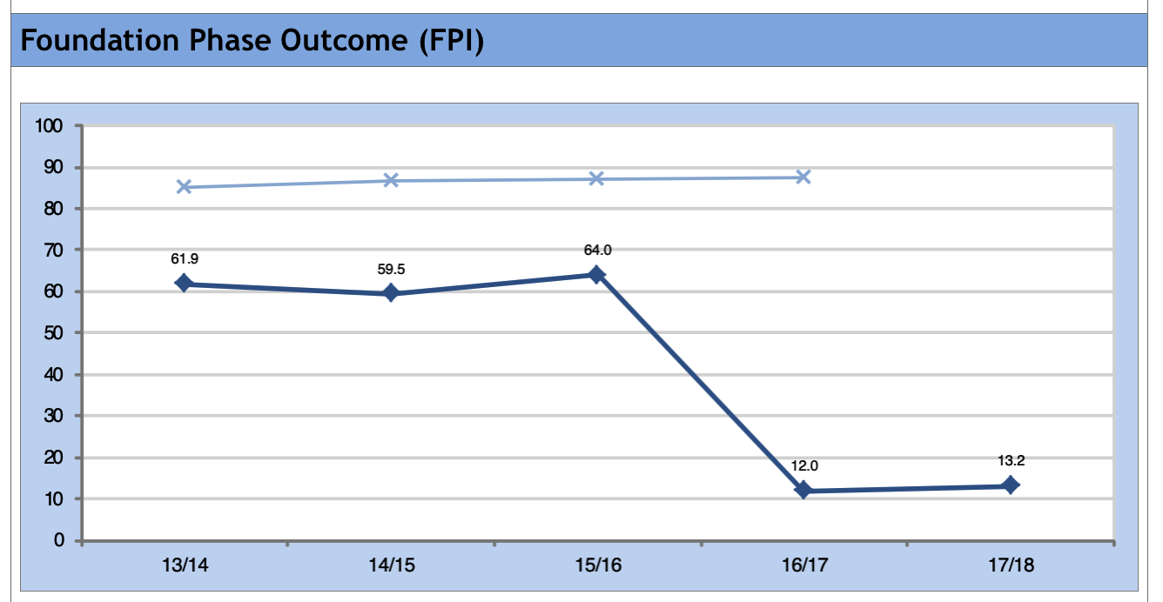
As a school we have discussed the reasons and concluded that many factors can affect the schools FPI data including class cohorts, pupils baselines on entry to school, social factors, and we have questioned whether current government expectations on pupil results at the end of foundation phase puts pressure on teachers and school to take the more formal approach of teaching, which many pupils in our school aren’t ready for.

Key Stage Two CSI results- Figure 2
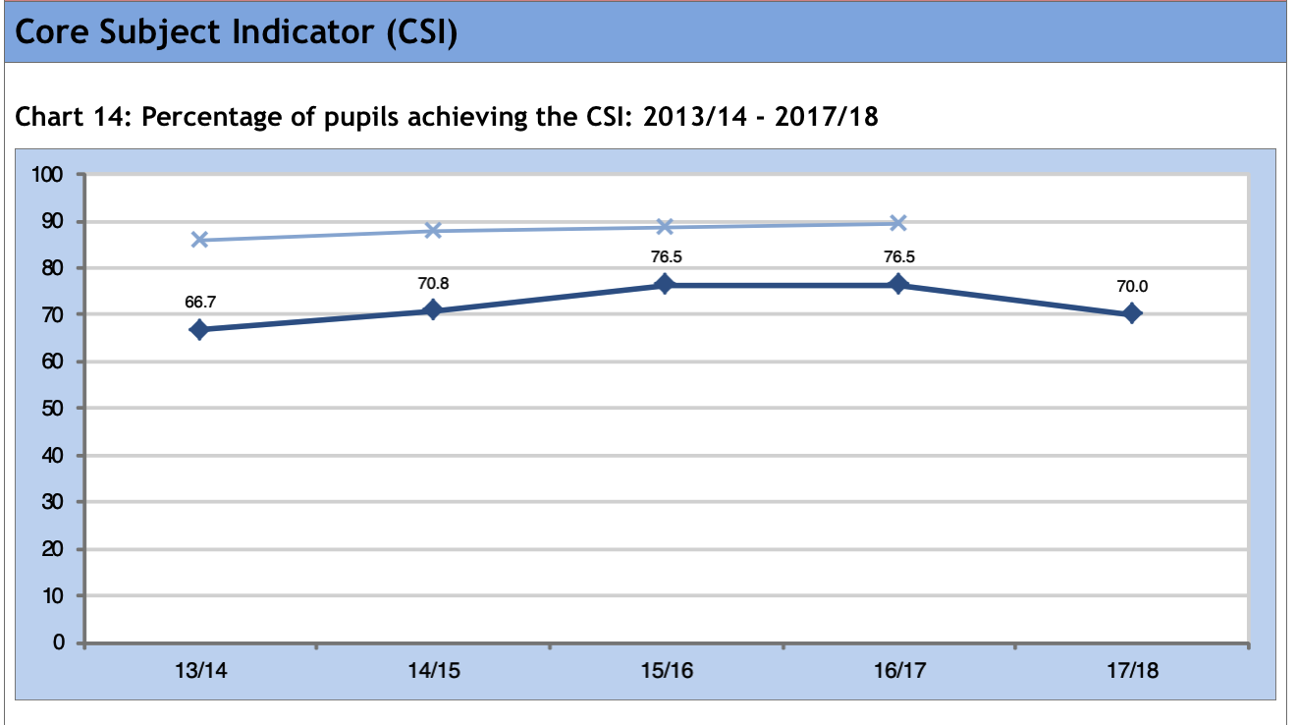
Within key stage two our Core Subject Indicator (CSI) has fluctuated over the past five years and as with the foundation phase, many factors can contribute to the end of year results. Again, a pressure for teachers to meet expected targets for pupils achieving the ‘expected’ level 4 or above in the CSI, even though, educators know that not all pupils will achieve in all subjects throughout the curriculum.

Education in Wales
Our current education system is very data driven; comparing schools to other schools in the same areas. I believe that this can distract educators from their passion of teaching and puts pressure on getting results. This culture is making schools compete against schools to ensure they are not at the lower end of the ranking system. This can often mean pupils are having uninspiring experiences in school and therefore become detached from learning. In Wales, with our current education, I feel that we aren’t allowing pupils to thrive in areas that they can achieve in because we are expecting all pupils to have the same end outcome and ability in the core subjects.

In 2014, the OCED stated that “Wales’ performance in the 2009 PISA has served as a catalyst for reform. It showed student performance to be significantly below the OECD average and that PISA 2009, has decreased significantly in mathematics and science since 2006” (OCED, 2014 pg 21)

Therefore, over the past five years, the curriculum has been reviewed and reports have been published outlining areas with shortcomings. When asked to review the curriculum, Donaldson (2015) produced the Successful Futures document which stated:

The curriculum, then, has become overloaded, complicated and, in parts, outdated. Assessment arrangements are not making the contribution they should to improving learning.’ (Donaldson, 2015, p11)

Donaldson (2015) has identified the need for change with the curriculum and assessments, which supports my views and thoughts on assessments being constructed to achieve targets, rather than to support pupils learning and helping them progress at their own pace. In the review, Donaldson (2015) also suggested ways forward to change the curriculum and school experience for all pupils, focusing on ensuring pupils become life-long learners with the introduction of the four purposes. Therefore, the new curriculum is less focused on frameworks to follow.

“It is not a set of instructions to be implemented, as was the explicit intention of the previous National Curriculum, but instead it is a set of resources and ideas to be enacted into practice” (Donaldson, 2015 pg14)

Donaldson’s (2015) areas of learning are giving the pupils and teachers an opportunity to take more control of the learning within their classroom and will hopefully bring enthusiasm back into the curriculum. All schools will be going through huge changes over the next few years, raising many questions about how to start and move forward. One question that all school leaders will be asking themselves and their staff is how do schools move forward successfully?

As a member of the Senior Leadership Team, I have been involved in many discussions this past year in relation to the new curriculum and the best way to introduce the changes and move forward within our school. My responsibility within the school is to lead the new Digital Competence framework (DCF) ensuring that this is embedded within all areas of learning. As a result of leading DCF, I have also been assigned the lead of Science and Technology.

Science and Technology education is becoming more essential in today’s society; therefore, I believe is a vital part of a young person's life to help them in the wider world and will open them to further opportunities in future life choices. The draft curriculum for Wales 2022 – Science and Technology (2019) emphasis how important this area of the curriculum is in todays’ society stating:

‘Developments in both Science and Technology have always been drivers of change in society, underpinning innovation and impacting on everyone’s lives, materially, economically and culturally.’ (p3)

This demonstrates that the new area of learning isn’t introducing something new or unrelated but incorporating the skills that have driven change and will continue even more to drive change in the future. Young people are seeing new innovations and experiencing new technologies as part of their daily life and it is inevitable that technologies will become increasingly more in demand as generations develop, as well as new discoveries in the natural world which will require adults with specific skills and scientific knowledge.

Moving forward – creating a strategic direction to implement Science and Technology

Introducing new concepts and ideas into any school environment will face challenges both from staff and pupils. As my role as a leader, I feel it is essential that everyone’s opinions are considered when making changes within a school. Within my setting we have a range of teachers at different stages of their career, some have been teaching for over thirty years and have seen many changes happen in education over those years, others are Newly Qualified Teacher’s (NQT) starting their teaching journey and finally there are teachers that have been teaching for a few years and are continuing their learning journey. This can be very difficult to manage with staff all having different views on change, and confidence levels to implement the suggested changes.

It is crucial that all members of staff have a clear vision for teaching and learning. My vision for teaching and learning is a positive environment for both staff and pupils. Pupils and staff to be valued for their own talents and abilities and for them to be comfortable enough to discuss openly their feelings, share ideas or concerns without being judged and to continue to learn from others.
Pupils to have the experiences to learn at their own pace and reach their own potential and succeeded in their personal education journey and not to be judged on meeting unachievable data. Finally, for the pupils to feel safe and cared for and have opportunities and experiences that they may not access outside of school.

Therefore, to be able to lead this area of learning I need to share my vision, understand other visions and work collaboratively with all members of staff to develop a team, who feel valued and listened to. I strongly believe that to be able to achieve this we need to have a shared vision with input from all the staff within the school. This supports research carried out by Harris et al (2013) where they argue that “effective leaders in schools will be those who are able to build collaborative cultures through generating positive relationships” (p12)

In my current role as a leader, I feel that I already have positive relationships with the staff and through previous coordinator roles, where I have implemented smaller changes within the school, I have listened to colleagues opinions, positive and negative and have been able to have an open and professional dialogue. As part of my role, it is important to build relationships with my team based on trust and to be able to identify when team members may need some further support, as well as recognising that during change there will be challenges to overcome.

Fullan (2007) research identifies that all schools going through change will experience implementation dips, which leaders need to be aware of. This is when members of staff may experience a “psychological fear of change, and the lack of technical know-how or skills to make the change work” (Fullan 2007, pg 41) Through having open professional dialogues and trust, teams will be able to overcome these challenges and make positive changes with the new AoLE.

When developing a strategic plan for the AoLE it is important that we have an articulated plan or plans to implement steadily through the school. Everyone within the team needs to have a clear understanding of why the change is being implemented and the benefits of the change. I strongly believe that without a purpose and an invested and motivated staff, any changes that are tried to be implemented would fail. As part of the plan, there need to be clear actions, which are regularly discussed and reviewed. If something hasn’t worked as well as planned then make changes, an action plan should be a working document for all parties, and not seen as a list that must be achieved perfectly.

The Science and Technology area of learning and experience has been created in the new curriculum, with influence from research that Professor Donaldson took into consideration when reviewing the national curriculum.

“Computing should be integrated into the curriculum as the fourth science, served by a mandatory Programme of Study, and receive the same status as the other three sciences” (Arthur, Crick and Haywood, 2013, p15)

This quote from Arthur, Crick and Haywood (2013) was based on their research and beliefs that computing should be a quintessential Science, Technology, Engineering and Mathematics. As ultimately technology is the driving force for the future. Therefore, there it makes sense that computer science is now a prominent part of the new curriculum for Wales.

A five-year strategic plan for Science and Technology
Step one | Step two | Step three | Step four | Step five
2017/18 | 2018/19 | 2019/20 | 2020/21 | 2021/22
All staff to engage with successful futures document (2015)
Staff to be given directed time to read document | Develop working teams for each AoLE  Roles established within each team and assigned to a team member
Staff meetings planned to give feedback and suggestion on successful futures. | To review current practices in AoLE  Feedback meetings to be timetabled for professional dialogue
Read, familiarise and analyse the draft curriculum for Wales (2019)
In AoLE teams
Create an action plan with specific targets for planning/implementing and assessment needs.
Action plans created for areas within the AoLE
Audit current resources including staff strengths and weaknesses

Training to be identified and budgeted into school plans.

Teachers to begin planning with the draft curriculum – using any CPD within their classrooms.

Planning to be shared and discussed – teachers to support teachers.
Book looks to share good practise among staff.

 |  |  | Review training and any further training needed to be identified and budgeted into school plans.
 |  |  | The new curriculum being at the front of our school planning – beginning to be implemented further across all year groups.
New curriculum and assessments to be in place.
Clear views agreed by all members of staff

Step one - Successful futures has been an important document in all schools preparing for change over the last four years and schools have engaged with Professor Donaldson’s findings. The draft curriculum has been waited for with anticipation by educators throughout Wales. As a staff, we have read and had professional discussions on Donaldsons’ (2015) report and findings agreeing that the four purpose approach is needed to help our pupils to become lifelong learners and to prepare them for a future, which is far more advanced than what the current national curriculum (2008) can prepare them for.

Step two – Each area of learning has been assigned a lead teacher, this was discussed as a staff and decided upon mutually, which has already established trust between members of staff. The open dialogue has allowed everyone to feel comfortable within the new AoLE and many of the national curriculum (2008) subject coordinators have naturally fitted into the new area of learning, with some staff changing to follow an interest and strength.

Feedback meetings have been timetabled and implemented for all staff to share their reviews on the schools current practices and initial ideas of change in line with the new AoLE’s.

Step three – Every member of staff will have to familiarise themselves with the draft curriculum (2019) - in teams the specific AoLE will be analysed, identifying skills already in our curriculum and also focusing on new skills that have been introduced especially with regards to coding and programming in Science and Technology, body image, social influences and media within the Health and Well-being.
This would lead onto the school having action plans for each of the seven areas. As a school, priorities would be identified to feed into the schools’ yearly school improvement plan.

Regarding Science and Technology, in my team, we have taken an aspect that is our strength to lead the action plan. For example, one member has taken responsibility for Science (with aspects of the design technology included) and other taken Information technology and computer science elements. Although, each action plan targets will be discussed as a team and reviewed regularly with all staff.

Step four – Training will be vital to drive the curriculum forward within school. Training needs will be identified and accommodated within school (teachers supporting teachers) or by attending ERW run training days if available for Continued Professional Development (CPD). Budget will also need to be addressed and planned for across the seven areas, therefore, this will need to be prioritised along with resource costs.

Step 5 – Over the five year plan there will be regular review sessions within teams and as a whole staff to ensure that the curriculum is being implemented and staff are comfortable planning, delivering and assessing. At the end of the five-year plan, it is hoped that the new curriculum final draft will be being used correctly and will become embedded into daily practice along with the assessment and progression steps.

Section B

Within the Science and Technology AoLE there are many different areas that teachers will need to critically evaluate their own skills. Therefore, we need as a school to plan effectively and not overload staff with too many actions to complete. It is vital that areas are proritised. Therefore, within our team, we have looked at the draft curriculum for 2022 and identified the need to focus on the new elements of computer science as we feel that many of the staff at our school will need further continued professional development and training in this area. This also links to our school improvement plan (SIP) for the next academic year, which states ”To analyse and plan for the new currciulum” and “To develop computer science within the curriculum alongside ICT”. When the DCF was first announced, I asked staff to complete a short questionnaire on where they felt they were on the skills matrix. As shown in Appendix 1, many staff felt less confident with the more technical aspects of the digital curriculum and this will likely be the case with the coding and computer science aspects of the new AoLE.

In 2012, the Welsh Education Minister, Leighton Andrews, arranged for an ICT steering group to carry out research and report on ICT within Primary and Secondary schools with recommendations on how to improve. Arthur, S et al (2013) reported on the ICT curriculum suggesting that the current curriculum was not progressive enough and not future proof because the curriculum focuses on how to use IT and not the creation of software and digital content. Furthermore, Arthur, S et al states that ‘a career in IT typically involves some degree of logic, creativity, communication and collaboration, managing uncertainty, and problem solving.’ (Arthur, S et al, 2013 p13)

The recommendations from the ICT steering group, 2013, report to create a new subject which incorporated computer Science and IT was recognised by Professor Donaldson in his Successful futures review (2015). This resulted in the Digital Competence Framework document being introduced alongside Literacy and Numeracy as a cross curricular responsibility and the incorporation of computer science within the new Science and Technology AoLE.

As an educator and leader within the school, I understand that the introduction of computer science will be a daunting experience for many teachers. With computer Science becoming a new part of the curriculum, many current Primary educators will not have had experience themselves of these skills and therefore this could have a negative impact on pupils’ development and experience if not addressed.

Moller and Crick (2018) identified that many teachers in primary struggle or feel less confident with the current ICT curriculum, which isn’t as advanced as the new proposed curriculum. Their findings showed that:

“this lack of teacher competence has a direct impact on school children: applications to study computer science at university slumped in the early part of the millennium—especially amongst females—and many of those who started a university computer science degree course found themselves dropping out during the first year, surprised at what computer science is and what studying it entails” (p419)

I agree that we need to be looking at the future and helping to provide the next generation of adults with the best opportunities to succeed and become lifelong learners.

Action plan for Computer Science / ICT within the AoLE Science and Technology (Step 3 from 5 year plan)
Planning | Late Summer 2019 / Autumn 2019 | SMT, teachers & Chair of Governors.
Reviewing | Half Termly | As above

Links:
Priority 1 – Standards, outcomes, and progress:
- To discuss and review new AoLE - Computer science elements of Science and Technology
- To develop teacher skills and understanding
- To review current practices within school
- To identify strengths and weaknesses and create a CPD timetable.
Actions / Milestones/  Success Criteria |  |  | Who?  (named) | When?  (actual dates) |  | Intended outcomes |  | Type of monitoring & reporting mechanism | Who?  (named) |  | When?  (actual dates) | Costs |  | Progress updates
 |  |  |  |  |  |  |  |  |  |  |  |  |  | Aut. | Spr. | Su.
A) To discuss and review the computer science and ICT elements of the new curriculum (identified within the Science and Technology AoLE draft curriculum) |  |  | Science and technology team | Summer term ’19 and Autumn term ’19  Inset days |  | For staff to have a clear understanding of the new elements of the curriculum. |  | Inset day meeting time - followed by staff meeting to feedback findings. | All teachers, SLT, Science and Technology Lead |  | Inset day July 2019  Inset day September 2019 | N/A
B) To develop teacher confidence and understanding of computer science within the curriculum.  Discussion meetings and questionnaire to be completed by all staff to identify strengths and weaknesses. |  |  | All teachers  Questionnaire compiled and analysed by Lead teacher  SLT | Throughout the year. Specific INSET days and ADDs sessions on calendar. |  | To promote and raise confidence in delivering computer science and ICT skills across the curriculum to ensure pupils will have the opportunities to develop their computer science and ICT skills. |  | Staff discussions.  Staff questionnaire to be completed to identify strengths and weaknesses.  Planning discussions. | All teachers, SLT,  Science and Technology team |  | July 2019 - questionnaire  September inset day 2019  Autumn term 2019 | N/A
C) Review of current ICT and Computer science strands (DCF overlap) being planned and delivered within the current curriculum. |  |  | Lead teacher  Class teachers  SMT | Scheduled ADDs sessions throughout the year to share examples of work with staff. |  | To identify strands that need to be developed further for CPD. |  | Learning walks, planning discussions and book looks (as a staff) - examples of pupils work stored in central areas for access on HWB. | All teachers  Lead teacher  SMT |  | Autumn term - learning walk  Autumn term / spring term- Scheduled ADDs sessions for work / planning sharing. | N/A
D) CPD Training to be arranged for identified staff. In house or accessed through ERW support menu. |  |  | SMT.  Lead Teacher | Release time for staff to attend CPD training days. |  | To ensure that CPD is arranged to ensure that the teachers re able to deliver the skills to the pupils. |  | CPD timetable - evaluations from teachers after attending the training.  Planning and book looks to monitor new skills from CPD being used within the classroom inline with the new curriculum. | Science and Technology team / Lead teacher  SLT |  | Release time for CPD - Autumn - Summer 2019-20 depending on the CPD course timetables and availability. | Supply cover (£90 a day - Apollo) to attend CPD  specific costs to be added when training has been booked.
Resources |  |  |  |  |  | Costs |  | CPD required |  |  |  |  |  | Costs
- Cover for staff/teachers to attend the CPD training. INSET days and ADDs sessions to be planned for time to review the curriculum, feedback findings etc, |  |  |  |  |  | Supply costs (approx £90 a day Apollo) |  | - Computer science / ICT skills especially Analyse strand as identified in previous year. |  |  |  |  |  | Supply costs (approx £90 a day Apollo)  CPD course costs iff applicable.

The action plan above focusses on Step three of the strategic plan. Within this action plan I have identified the need for training for staff to be able to implement the new Science and technology AoLE. I believe one of the challenges my team will have with leading the Science and Technology AoLE is staff competence in delivering the computer science aspect.

When adults and children feel self-conscious and worried about something, they often put up barriers and can become defensive. Many of the AoLE’s I believe primary educators will feel comfortable with because they are adapting the way they deliver the curriculum rather than having to deliver a whole new subject which has been incorporated into the curriculum. As a leader, I will want to ensure that my members of staff do not feel intimated by the new curriculum and can see that they have a supportive team around them. I am very passionate that teachers need to continue to have opportunities to learn and not to be left without support or criticised for not understanding. It is important that we continue to learn together and feel comfortable to share our weaknesses’ as well as strengths. If we as educators do not understand the subject, then we can’t expect our pupils to be able to learn from our guidance. Bransford et al. (2004) concluded

“Outstanding teaching requires teachers to have a deep understanding of the subject matter and its structure, as well as an equally thorough understanding of the kinds of teaching activities that help students understand the subject matter in order to be capable of asking probing questions” (p.188).

Another barrier or challenge that will arise is being able to fund the CPD training as well as then being able to purchase new equipment needed e.g for coding, algorithms etc. Every year, schools' budgets are being cut by the Government, this causes my setting difficulties year on year. As the lead teacher for this AoLE, I will look at teacher support through sharing members of staffs' strengths, as well as accessing as many ERW funded training days as possible, where supply costs are covered. Also explore the use of Swansea University Technocamps, who offer a range of CPD for teachers and teaching assistants but also will demonstrate skills through workshops and example lessons within the school for free.

In addition to training, I would arrange learning walks, which in the past, have been a positive experience for all members of staff. Learning walks would be agreed with all staff, including a focus for the walk and at a convenient time for the class teacher and the pupils. Following on from any findings within the learning walk, peer observations through traids would be used to share staff skills. Bell’s (2005) research found that ‘peer observation partnerships can help teachers improve their teaching practice, transform their educational perspectives and develop collegiality’ (p3)

In my opinion, developing trust and co-operation between staff will benefit all within the school setting. A clear and agreed objective before observations and learning walks establishes trust and will ensure success for both the observers and the teacher being observed.

In order to achieve the desired outcomes of the five year plan. The action plan for this academic year, will be reviewed with all staff and the AoLE team half termly. Everyone’s contribution is valued and considered when adapting and making changes.

Evaluation

Through creating a strategic plan for the Science and technology AoLE, I have met the following professional leadership standards:

Pedagodgy

- Effective formal leadership descriptor: Leadership ensures that the ongoing curriculum development and ambition in Wales are underpinning and driving the agenda for the quality of teaching in the school (Welsh Government, 2018, Professional standards for teaching and leadership)
- Sustained highly-effective formal leadership descriptor: Building enthusiasm in all staff for the fascination with learning is a key leadership endeavor to encourage all to better themselves to the benefit of learners. (Welsh Government, 2018, Professional standards for teaching and leadership)
- The strategy is shared, challenged and communicated at all levels to align infrastructure arrangements with purpose and outcome (Welsh Government, 2018, Professional standards for teaching and leadership)

Through working in teams under the new seven areas of the curriculum and leading my AoLE – I will be ensuring that I build enthusiasm for staff, ensuring that I am approachable and supportive and ensuring that we have a good quality teaching within the school. A shared vision within the teams and schools.

Leadership

- Effective formal leadership descriptor: Empowering others - Leadership takes account of the experience of other colleagues, the challenges they face and encourages them to flourish (Welsh Government, 2018, Professional standards for teaching and leadership)

As part of the questionnaire (in action plan) and open professional dialogues, I will encourage staff to share their experiences and continue to develop their skills.

Professional Learning

- Supporting growth in others: Leadership enables all staff to become the best they can be, recognising and realising potential in all learning contexts. (Welsh Government, 2018, Professional standards for teaching and leadership)

As a leader, I will do my best to support others, arrange triads and CPD to help all staff to progress.

Innovation
- Effective formal leadership descriptor: Leadership ensures that the expertise and experience are continually developed and shared within and across the school and beyond” (Welsh Government, 2018, Professional standards for teaching and leadership)

Collaboration

- Partner schools, departments and individuals within schools benefit mutually from an imaginative range of sustained high quality and flexible support to develop professional practice (Welsh Government, 2018, Professional standards for teaching and leadership)

I will encourage learning from each other, sharing good practice. As the action plan progresses and we as a school are familiar with the new AoLE, I will explore working with our cluster schools, and the possibility of creating triads across the cluster to share good practice.

Appendix 1

The graph above shows teachers' responses to a self-assessment on their confidence levels to deliver the ICT skills for their current year group and confidence levels for some of the new strands introduced through the Digital Competence Framework.

The graph shows that the find and analyse strand and the data and computational thinking (Computer science elements) are the areas where staff feel less confident with their understanding and competence to teach the skill.

References
Arthur, S., Crick, T. and Hayward, J., 2013. The ICT steering group’s report to the Welsh government. Cardiff: Welsh Government.

Bell, M. (2005). Peer observation partnerships in higher education. NSW, Australia: Higher Education Research and Development Society of Australasia Inc.

British Educational Research Association [BERA] (2018) Ethical Guidelines for Educational Research, fourth edition, London. Available at: https://www.bera.ac.uk/researchers-resources/publications/ethical-guidelines-for-educational-research-2018 Accessed: 27th August 2019

Bransford, J., Brown, A., & Cocking, R. (Eds.). (2004). How people learn: Brain, mind, experience and school. Washington DC: National Academy Press.

Donaldson, Graham, Welsh Government, corp creator. (2015) Successful futures : independent review of curriculum and assessment arrangements in Wales : February 2015.

Fullan, M. (2007) Leading in a culture of change (2nd ed.). San Francisco, California: Jossey-Bass.

Gibb, N. (2015) Schools Minister Nick Gibb addresses the Education Reform Summit. Available at https://www.gov.uk/government/speeches/the-purpose-of-education Accessed: 29th August 2019

Harris, A., Day, C., Hopkins, D., Hadfield, M., Hargreaves, A. and Chapman, C., 2013. Effective leadership for school improvement. Routledge.

Moller, F. and Crick, T., 2018. A university-based model for supporting computer science curriculum reform. Springer

Oecd, A., 2014 Improving Schools in Wales: An OECD Perspective

Welsh Government, 2019, DRAFT STATUTORY GUIDANCE A guide to Curriculum for Wales 2022 Cardiff: Welsh Government.

Welsh Government, 2019, Draft statutory guidance, area of learning and experience, Science and technology Cardiff: Welsh Government

Welsh Government, 2018, Professional standards for teaching and leadership” Excerpt From: “190621 WEG149 Interactive PDF - TEACHING & LEADERSHIP 2019 ENG”.

20042004

