

TASK 2: Report

Student name: | Mohammed Ansari | Student ID number: | 2024571
Programme: | BSc/HND Computing (All Streams)
Module: | L4 - Introduction to Web and Database Concepts
Module code: | ACCA4023
Lecturer: | Gareth Jones
Assignment Title: | HTML & CSS Web Development
Submission deadline: | Mon 26th April @3pm

TASK 2: Report

Table of Contents:
Introduction
Requirements
Implementation
Evaluation
References
Appendices

Introduction section:
MilasITsolution is being designed to establish the connection between company and its clients to create awareness regarding user friendly solutions company can offer to its clientele. All the pages are with full of information smoothly usable without any eyestrain and uploading easily. Colour scheme is sober. Website pages have all required components such as Summary, Introduction, Services, Specialisation and Contact details for further possibility of tailored enhancement as per customer’s requirement and queries / request.

Requirements
This website is designed for the purpose of IT Services which is targeting the customers (site visitors).

Implementation
Website screenshots are attached in implement section.

Evaluation
Website usability, accessibility, and search engine optimisation are all very important for website quality analysation. Important points for websites evaluation are Purpose, Relevance, Accuracy and Authority

References
References details are mentioned in reference section were very useful while building website.

Appendices
Text listings of all HTML and CSS kept in zipped folder along with webpages.

Requirements section:
MilasITsolution is being designed to establish the connection between company and its clients to create awareness regarding user friendly solutions company can offer to its clientele. All the pages are with full of information smoothly usable without any eyestrain and uploading easily. Colour scheme is sober. Website pages have all required components such as Summary, Introduction, Services, Specialisation and Contact details for further possibility of tailored enhancement as per customer’s requirement and queries / request.
The key points have covered the following elements;
- Availability and Accessibility
- Clarity
- Learnability
- Credibility
- Relevancy
The main purpose of this website is to provide IT Services as per customer’s requirement.
This website commences the subjective services as per below mentioned details;
IT Services | : | Cloud Services, Cyber Security, Business Telephone and Backup & Business Continuity
Software Services | : | Digital Marketing, Website Design & Development, Managed Hosting and eCommerce
Professional IT Services | : | Microsoft Office 365, Public Cloud (AWS, Azure, Google Cloud) and GSuite by GoogleCloud
The website is targeting the audience of different sectors i.e. Industries, Offices, retail business and Individuals who don’t have Internal IT Team.

Implementation section:

Home (index)
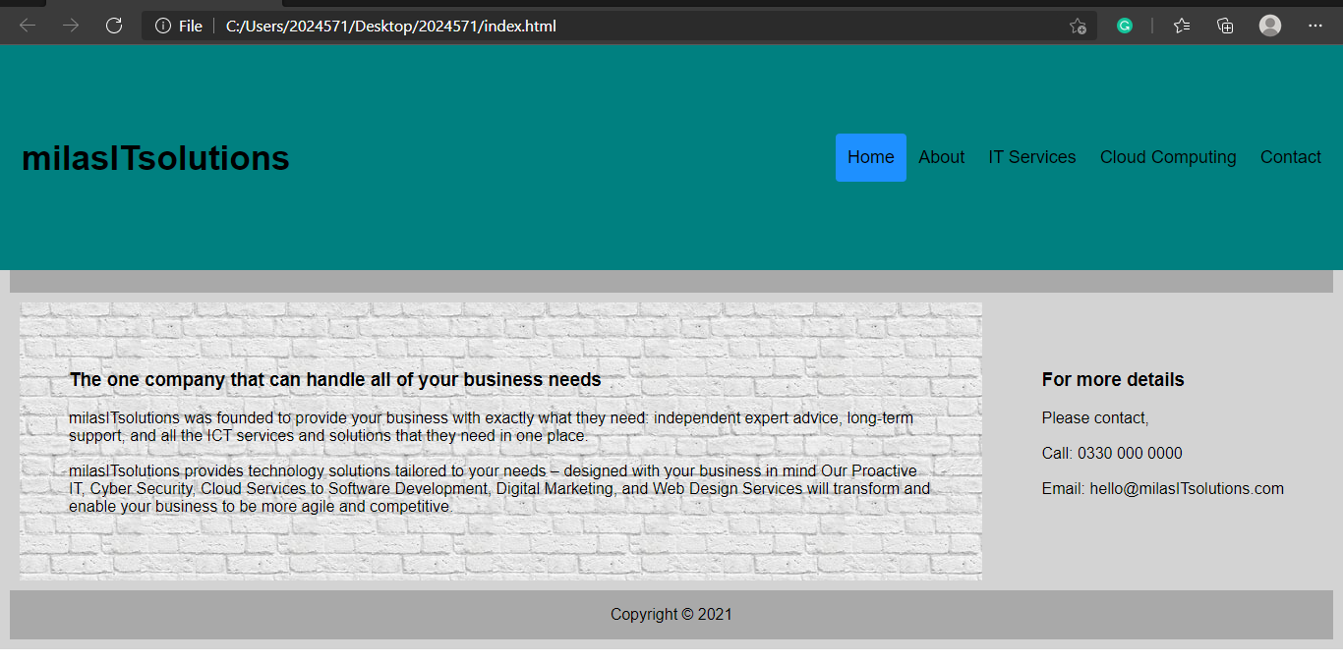
About
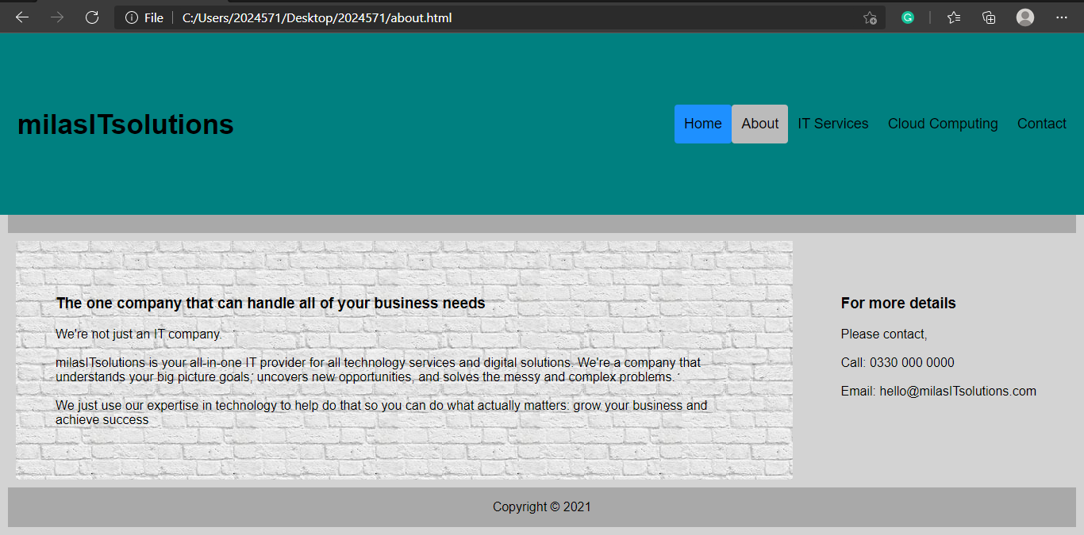

IT Services
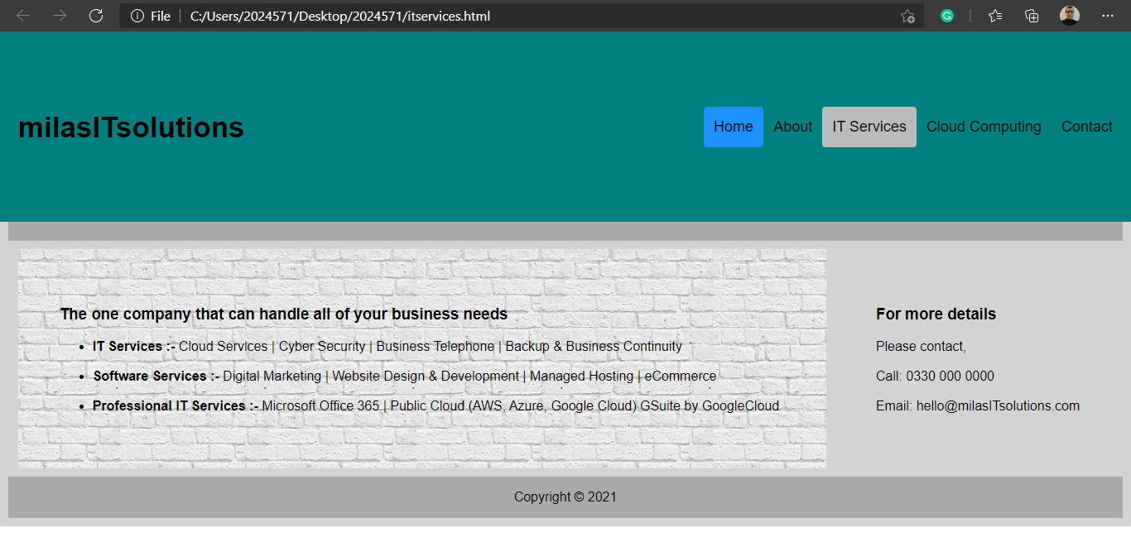

Cloud Computing
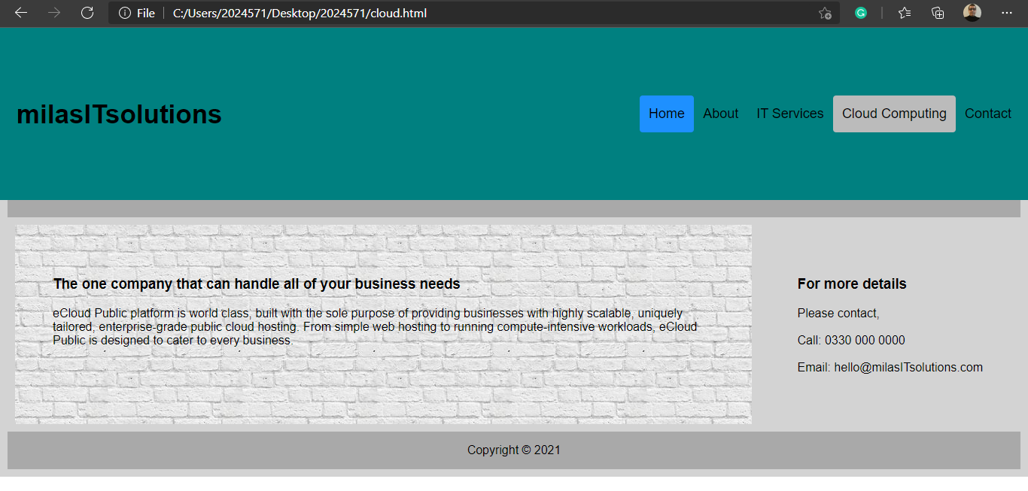
Contact
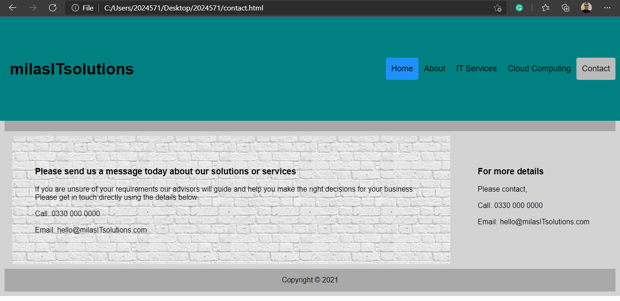

Evaluation section:
- Website usability, accessibility, and search engine optimisation are all very important when analysing the quality of a website.

Key principles points for Website usability / accessibility are

- Availability and Accessibility
The availability and accessibility of website is very important. If people try to access your website and it doesn’t work - for whatever reason - your website becomes worthless.
Example: Amazon.com .
- Clarity,
The core of usability is clarity. If website visitor is distracted or confused, they will either need more time to find what they came for, or they might forget their initial goal all together. Either way, they will not experience your website as user-friendly or chances are that they leave dissatisfied and with no intention of coming back.
Example: Apple.com
- Learnability
Learnability is another important aspect of usability. Goal to design intuitive interfaces - interfaces that don’t require instructions, or even a long process of trial and error to figure them out. Key to intuitive design is to make use of what people already know, or create something new that is easy to learn
Example: Microsoft.com
- Credibility
Credibility is a crucial aspect of any website. Even if people find the content they are looking for, if they don’t trust you, that content is worthless. Your website could cause site visitors to be sceptical about your business in any number of ways including whether or not you really exist, your reputation, or the quality of your content.
Example: L’ORÉAL.com
- Relevancy
Relevancy contributes to good website usability. It is not enough that your website is clear, your content must also be relevant. Again, it is essential that you know your users and why they visit your site.
Example: Nike.com

Reference: www.crazyegg.com

- SEO / Search Engine Optimization the process of improving website to increase its visibility for relevant searches. The better visibility of webpages have in search results, the more likely you are to garner attention and attract prospective and existing customers to your business.

Search engines such as Google and Bing use bots to crawl pages on the web, going from site to site, collecting information about those pages and putting them in an index. Next, algorithms analyse pages in the index, taking into account hundreds of ranking factors or signals, to determine the order pages should appear in the search results for a given query.

Reference: searchengineland.com

- Usefulness (usability and utility):

MilasITsolution is being designed to establish the connection between company and its clients to create awareness regarding user friendly solutions company can offer to its clientele. All the pages are with full of information smoothly usable without any eyestrain and uploading easily. Colour scheme is sober. Website pages have all required components such as Summary, Introduction, Services, Specialisation and Contact details for further possibility of tailored enhancement as per customer’s requirement and queries / request.

- Search Engine Optimisation (SEO):
On-page SEO is the process of optimizing the content of a webpage for search engines. The ultimate goal of on-page SEO is to speak the ‘search engines’ language’ and help search engine crawlers understand the meaning and context of webpages.
Summary on-page SEO techniques:
- Publish high-quality content.
- Optimize page titles and Meta descriptions.
- Optimize page content.
- Headings and content formatting.
- SEO Images and other multimedia elements.
- URL optimization.
- Internal links.
- External links.

In milasITsolutions website pages optimized with page titles and Meta descriptions, page contents, Heading & content formatting, URL (IT Services page / main para last section - Professional IT Services) Internal (webpages) and external links (email).

  - Accessibility:

MilasITsolution is being designed user friendly solutions company can offer to its clientele. All the pages are with full of information smoothly usable without any eyestrain and uploading easily. Colour scheme is sober. Website pages have all required components such as Summary, Introduction, Services, Specialisation and Contact details for further possibility of tailored enhancement as per customer’s requirement and queries / request.
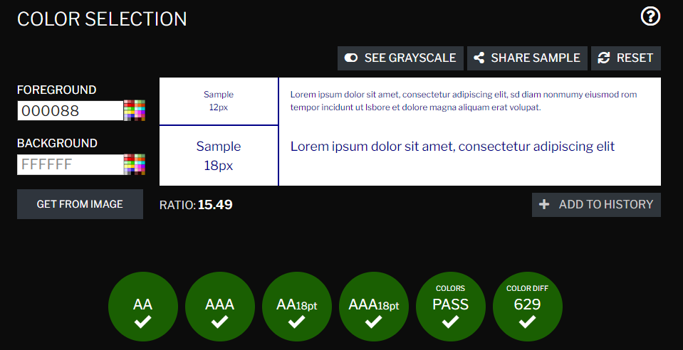

References:
- Search Engines: Google, Bing
- www.w3schools.com
- www.javatpoint.com
- www.siteimprove.com
- www.wordpress.com
- www.crazyegg.com/blog
- www.vividblock.com
- www.ukfast.co.uk
- www.vecteezy.com
- www.flaticon.com
- www.freeimages.com
- https://htmlcolorcodes.com/
- www.html.com

Appendices
Text listings of all HTML and CSS kept in zipped folder along with webpages.

Validation
- HTML
Error: Quote “in attribute name. Probable cause: Matching quote missing somewhere earlier.

At line 135, column 30

-align: center;">IT Services</

Corrected as per suggestion

  - CSS
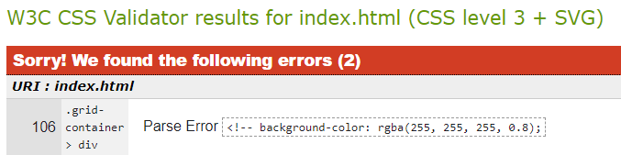

Corrected as per suggestion

