

International Market Entry Strategy and Marketing Mix of IKEA in Germany and India
Programme | Master of Business Administration
Module | International Marketing: Principles and Practices
Module code | LCMB7026
Lecturer | Dian Mayasari
Student name | Asif Mahmud Emon
Student ID | 2439438
Word count | 5623
Submission date | 20 March 2026

Table of Contents
1. Introduction 3
2. Comparative market analysis: PESTEL 4
3. Comparative STP analysis 9
4. Comparative international marketing mix (7Ps) 10
4.1 Product 10
4.5 People, Process and Physical evidence 13
5. Directional development strategy in India 14
6. Ethical issues in the marketing mix 15
7. Recommendations 16
8. Conclusion 17
Section 2: Reflective account using Gibbs’ reflective cycle 18
9. Reflection 18
References 21

1. Introduction
In this report, the international market entry strategy and marketing mix of IKEA in Germany and India are evaluated. The two have been chosen due to the contrast being strategically appropriate and materially diversifying compared to a mere developed/ developing country comparison. Germany is a highly developed, high-income, digitally developed European economy with high concentration in the furniture and home-improvement sector in which IKEA competes. India is a growing and low-income and very heterogeneous market with a growing home furnishing demand, although infrastructure, housing types, service needs and affordability pressures are much different. It is the contrast that enables a better evaluation of the extent to which a global retailer can standardise its proposition and the areas that it has to customise.
The brief has task requirements that are used to structure the report. It then contrasts the macro-environment in Germany and India based on PESTEL with specific consideration on consumer behaviour and culture. It then assesses the segmentation, targeting and positioning of IKEA, and then compares the 7Ps, particularly the product, price, place and promotion. The next evaluation of the report measures the directional development strategy of IKEA in India, evaluates ethical concerns associated with the marketing mix, and offers recommendations. Section 2 puts the reflective cycle of Gibbs to the research and writing process.
The main thesis is that IKEA defends a greatly standardised brand core in both markets, which revolves around democratic design, self-service retail logic, flat-pack efficiency and coordinated omnichannel experience, but it is far more profoundly adapting the commercial system in India than in Germany. Germany Adaptation is comparatively small since the market already qualifies IKEA in terms of scale, assortment logic and culture of home-improvement. In India, IKEA has been forced to moderate the expectations of the conventional big-box model by scaling the geographic expansion, stretching the service provision, small customer meeting spaces, and moderating cost and local living standards. This indicates that the international strategy of the company can not be seen as mere standardisation or adaption but rather as selective modular adaption in a highly controlled global format.

2. Comparative market analysis: PESTEL
The most strategically relevant PESTEL contrasts are summarised in table 1. This is not to enumerate all the macro factors, but to determine the factors that significantly influence the path of market, consumer experience and resource allocation of IKEA between the two countries.
Factor | Germany | India | Strategic implication for IKEA
Political / regulatory | Stable policy environment; predictable consumer regulation; advanced competition and product-safety rules. | Stable democratic setting but more layered regulation, infrastructure approvals and state-level complexity; foreign retail expansion remains operationally more demanding. | Germany supports scale efficiency; India requires phased expansion, careful compliance and longer planning cycles.
Economic | High GDP per capita, mature demand, slower market growth, stronger labour costs. | Lower GDP per capita but stronger medium-term growth and a rising urban middle class. | Germany rewards efficiency and brand consistency; India requires sharper affordability architecture and gradual market development.
Social / cultural | High acceptance of functional self-service retail; smaller households and urban apartments support storage solutions and convenience. | Family-centric households, multi-generational living, aspirational consumption and stronger need for service reassurance. | The same IKEA proposition must be framed differently: convenience and style in Germany, accessible aspiration and guided solutions in India.
Technological | Very high internet penetration and stable omnichannel habits. | Large digital audience but uneven physical access and significant regional variation. | Germany can assume frictionless omnichannel usage; India must use digital as a scaling tool while recognising uneven fulfilment reach.
Environmental | High expectations around circularity, energy efficiency and responsible consumption. | Environmental concern is rising, but affordability and access remain immediate priorities for many buyers. | Sustainability messaging is important in both markets, but the balance between affordability and environmental claims must be managed carefully.
Legal | Well-established standards for delivery, returns, data protection and consumer rights. | Growing consumer protection and e-commerce regulation, but execution conditions differ by location and logistics capability. | Germany allows standardised policy communication; India requires clearer service communication and operational flexibility.
The most apparent structural divergence is the economic one between Germany and India. World Bank statistics reveal that the GDP per capita of Germany is about US $56,103.7 in 2024 as compared to that of India of 2,694.9. This gap is important as IKEA is competing based on an affordability promise, which is never absolute, but relative. A sofa or modular Kitchen that would seem to be attainable in Germany, may become aspirational in India when the question of delivery, assembly and room-size is put into consideration. Thus, the price architecture used in one market cannot just be replicated in another one.
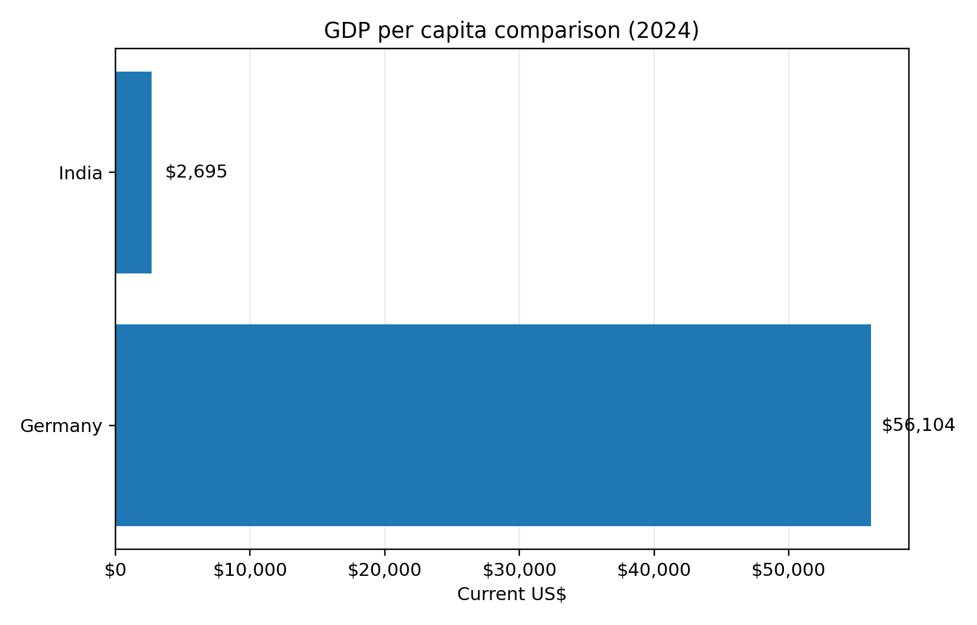
Figure 1. GDP per capita comparison between Germany and India, 2024. Source: author-created chart based on World Bank country data.
Figure 1 supports the reason why the value proposition of IKEA needs to be viewed differently across the two nations. In Germany, the concept of affordable design is functioning within a developed consumer economy whereby discretionary income and housing infrastructure is fairly stable. In India, the same idea has to deal with stronger price sensitivity, larger range of variations in the housing size and more urgency to focus on more entry-level and space-saving solutions. This leads to the second strategic implication, which is that affordability in India cannot be substantially based on nominally low prices only, but need to be reinforced by assortment discipline, access point that is of smaller sizes, and the design of selective service.
The social and cultural aspect is even of more significance than the macroeconomic gap since this brief requires a greater comparison of consumer behaviour and culture. Germany is less distant to the assumptions of the traditional IKEA model: a high culture of home improvement planned, comparatively large acceptability of self-service retail and a consumer population accustomed to researching products online and then going to the stores or placing an order to pick up and deliver. The self-selection logic, the flat-pack transport and modular furnishing consequently become behaviourally congruent with the market. The Click and Collect service by IKEA in Germany represents a mature omnichannel rationale since pickup can be made in stores or pickup points and a collection-based pricing incentive is offered on the basis of a membership.
India is not just different in terms of income. The household setup is more varied, the intergenerational co-residence is more widespread, the choices of the housewife are more frequently negotiated within the family, and the purchases of home furnishing might be placed between the necessity, the desire and social mobility. This is not to say that IKEA global proposition is not appropriate, but only that the company needs to minimise decision friction. India thus needs more support, planning, room inspiring and trust forming as compared to Germany. The increase of online delivery by IKEA India in North India and the first Bengaluru Plan and Order Point demonstrate that the company has realised that planning and approach to customers must be brought closer to the customers instead of depending on destination megastores.
Both the countries are digitally important technologically, although the trend is different. According to DataReportal, in 2025 the internet penetration in Germany (93.5) and India (55.3) is 93.5% and 55.3% respectively. The omnichannel customer experience in Germany is low-friction and stable due to the digital environment. India, in its turn, is an amalgamation of huge digital coverage and imbalanced physical servicing. IKEA has reacted to this by leveraging online growth as a market-entry mechanism, but with clearly limited delivery areas and pin code serviceable zones. The implication is important: in India digital is not only a marketing channel, but it is also a tool of disciplined market geographical development.
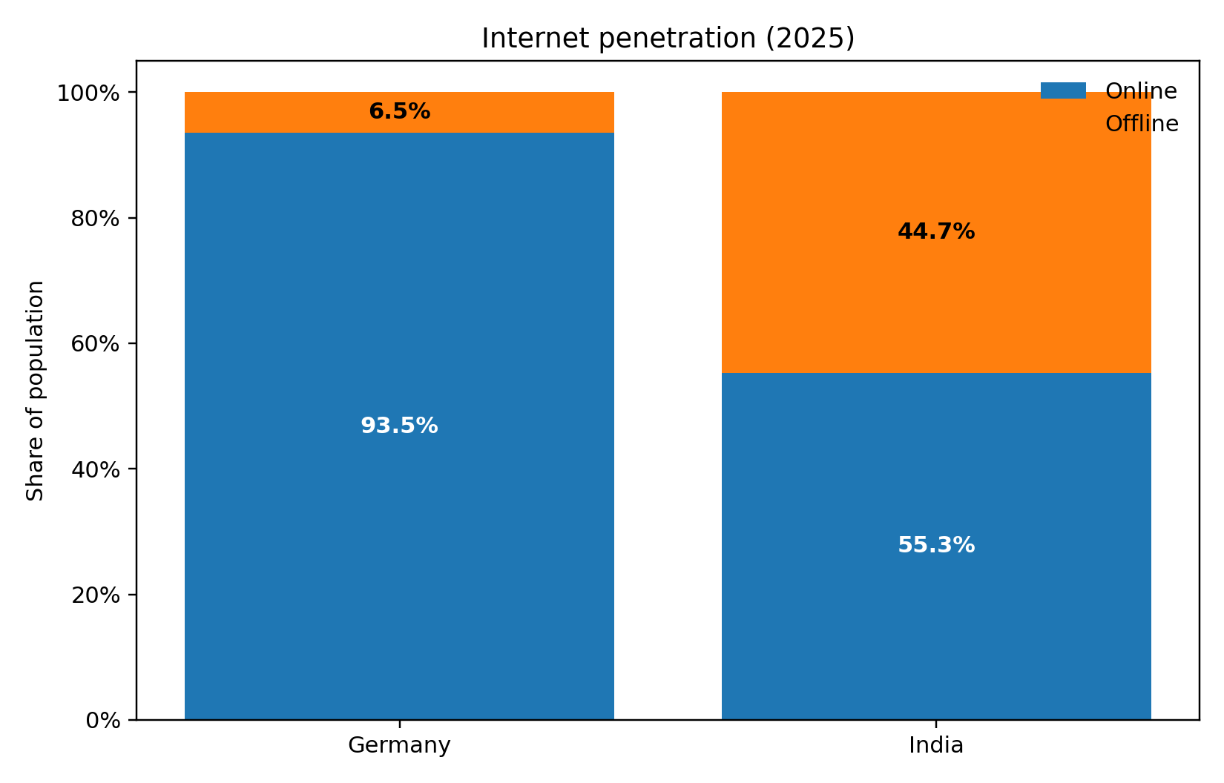
Figure 2. Internet penetration in Germany and India, 2025. Source: author-created chart based on DataReportal country reports.
The reason why omnichannel cannot be considered the same capability in the two countries is illustrated in Figure 2. Online research, pick up and parcel or truck delivery can be integrated into a developed retail system in Germany. In India, the level of digital penetration is high in absolute terms, but omnichannel remains more reliant on the areas where IKEA can provide, assemble and support the customer experience. Thus, the technology strategy adopted by the company in India is not merely a marketing communication strategy; it is a strategy of reaching more people without straining the fixed assets.
Both nations exert significant, yet varying, pressure in the environment and the law. The German consumers and regulators work in an environment where sustainability, product durability, energy efficiency and circularity are high expectations. Environmental agenda of India is also growing at a high rate, but many customers still focus on affordability, durability and accessibility of the services. The strategic dilemma IKEA is thus presented with is the classical one: it has to maintain its sustainability credibility, and at the same time, it should not allow the expense of sustainability efforts to alienate the brand to cost-conscious families. This is its tension at the core of its international marketing challenge.

3. Comparative STP analysis
The segmentation of IKEA in the two markets is multi-layered and not demographic. The best segmentation logic would be a mix of life stage, home formation, home-space restriction, budget sensitivity, and desire to take part in the IKEA shopping model. In Germany, IKEA will be able to address a comparatively wide range of urban and suburban customers, such as young adults who furnish first apartments, families who need functional value, and design-sensitive customers who want cheap fancies. In India, the market that can be effectively addressed is smaller due to physical access, delivery coverage, size of the home, and purchasing power of those who can practically purchase the brand.
Focusing on targeting is therefore different. In Germany, IKEA can retain a broad-market approach because the category is mature and the shopping model is already familiar. In India, the immediately addressable market is narrower and is concentrated in urban middle-income and upper-middle-income households in large metropolitan areas that are digitally reachable and open to organised home retail. This is why IKEA India has expanded through Delhi-NCR online delivery, city stores and the Bengaluru Plan and Order Point rather than through immediate nationwide rollout (IKEA, 2025b; IKEA, 2025c; IKEA, 2025d). The targeting logic is selective rather than nationwide, because physical access, fulfilment reach and household purchasing power still shape who can be served efficiently.
The global brand coherence of IKEA is the strongest in positioning. In both markets, the brand is offering high quality, functional, and affordable home furnishing solutions. But, it is the positioning in each market that is different. In Germany, IKEA can afford to pay more attention to convenience, design efficiency, family membership benefits and self-directed shopping. The positioning requires another level of instructed access in India. IKEA continues to sell democratic design, yet it needs to lessen the path along that design as something less fearful by inspiring rooms, planning services, simplified delivery communications and more localised digital entry-points.
Another interpretation that would be useful is that IKEA standardises meaning of the brand but customise the access path to the brand. This difference is important as a lot of discussions over adaptation and standardisation prove to be too dichotomous. Germany and India demonstrate that a company can maintain a consistent position statement and still localise the commercial and service system that will render such a positioning statement plausible in practise.
STP element | Germany | India | Critical evaluation
Segmentation | Broad life-stage and household segmentation in a mature category. | Urban, digitally reachable, middle-income and aspirational family households. | India uses narrower effective segmentation because geography and service access materially shape demand.
Targeting | Mass-premium value targeting across a wide addressable market. | Selective urban market development focused on metros and adjacent high-potential cities. | India’s targeting is more disciplined and operationally constrained, not merely marketing-led.
Positioning | Affordable, functional design with convenient omnichannel fulfilment. | Affordable aspiration with more support, planning and trust-building. | The brand promise stays global, but the path to conversion is adapted locally.

4. Comparative international marketing mix (7Ps)

4.1 Product
The product strategy of IKEA is internationally identifiable through Scandinavian design cues, modularity, flat-pack engineering and room-based merchandising. In product terms, IKEA standardises the core product idea of affordable, functional home furnishing, while adapting the actual and augmented product by market. In Germany, the global range can operate with relatively limited modification because consumers are already familiar with self-assembly, storage-led solutions and the service routines around the brand. In India, product localisation is more closely related to assortment localisation: reduced space-to-live, various family set-ups, climate and higher intensity of use is met by increased requirements of tight curation, stronger entry-price hierarchy and more evident room-solution framing.
This implies that adaptation in India will not primarily consist in creating an entirely new collection, but in local relevance in terms of range curation and enhanced-product support. The Plan and Order Point format of IKEA India in Bengaluru is a positive indicator of this change since it shifts the offer towards design planning and solution selling as opposed to the display of the physical only (IKEA, 2025d). The India entry into Delhi is also indicative of format logic premised on access, planning and directed purchase support as opposed to mere copying of the developed German store model (IKEA, 2025c). Assortment adaptation and augmented product are more useful in explaining product strategy in India than is the case with physical product redesign.
4.2 Price
Price is the most evident explanation why standardisation on an international level has limits. The global price policy of IKEA is established on the principles of democratic design and low costs, yet the feeling of affordability is not the same in Germany and India. In Germany, IKEA is able to compete as a cheaper-but-stylish mass-premium furnishing as the level of income is higher. In India, sticker price is not the only problem, but overall cost of acquisition, including delivery, access to services as well as affordability of intended, multi-item purchases. IKEA itself, in its messages about still reducing prices, confirms the argument that price is a strategic core of the brand (IKEA, 2024a).
Another indication is that the two markets do not have the same service pricing and fulfilment economics. The utilisation of membership-related and Click & Collect benefits in Germany is more developed, whereas the official service pages offer several organised delivery and collection opportunities in a mature market environment (IKEA, 2025f; IKEA, 2025g). In India, the communication of deliveries is more selective and visible in connexion with the conditions and availability of the service (IKEA, 2025h). The strategic point is that a global low-price storey can only succeed when the overall buying experience, not only the shelf price, is cheap and operationally feasible.
4.3 Place
The most evident area of divergent differentiation between the two markets lies in place strategy. The distribution characteristics of Germany are characterised by the high channel intensity and the presence of the mature system of omnichannel: large-format stores, Click and Collect, pickup points, parcel delivery and truck delivery are all combined into a single dense service net (IKEA, 2025f; IKEA, 2025g). The channel is also quite short since IKEA maintains strong control of the route to market due to its own retail and service infrastructure. This renders place in Germany dependable, habitual and very convenient to the consumers who travel between online shopping, shopping in the store and picking up their orders.
India has a more selective market-coverage policy. IKEA has introduced distribution by online delivery in the Delhi-NCR area, city-format access point and the Bengaluru Plan and Order Point in addition to large-format shops instead of directly copying the full format used in Germany (IKEA, 2025b; IKEA, 2025c; IKEA, 2025d). This would be in place theory terms, lower channel intensity and phased spatial coverage, which is to minimise capital risk and maximise reach. This is a critical point since place adaptation in this case is not only concerned with the location of stores but also with the selection of the channel length, retail format and service footprint that will suit the infrastructural and behavioural realities of the market.
4.4 Promotion
The promotional approaches in the two countries are constructed on the international IKEA storey of improved everyday life, democratic design and room inspiration, but the facts reveal dissimilar focuses. In Germany, advertising can be based more on the familiarity of categories and on self-directed transition between the online and the store worlds. Promotion in India also needs to minimise uncertainty by clarifying access channels, organising support and official service channels. This can be seen in the launch messages of online delivery by IKEA India, its expansion to Delhi and Bengaluru Plan and Order Point that all contain brand message and advice on how the customer can actually shop and plan purchases (IKEA, 2025b; IKEA, 2025c; IKEA, 2025d).
Indian promotion hence plays an educative and a persuasive role. The warning to customers about counterfeit IKEA sites and social media platforms also suggests that trust-building and clarifying the channels are also included in the communications mission in a new omnichannel market (IKEA, 2025i). Conversely, in Germany, promotion could be more product-focused, offer and inspiration-based since the architecture of the service is already known. This distinction helps to advance the broader thesis that promotion is closely intertwined with place and process instead of being an independent communications tool.

4.5 People, Process and Physical evidence
The other three Ps serve to make the contrast even stronger. The people are more significant in India because the direction, strategizing and encouragement could be more decisive in conversion. The process is also different because the cheque out, delivery and installation expectation are more variable. Physical evidence remains the centre of the IKEA experiential model in both countries, though smaller, edited formats are becoming more popular as an extension of destination stores in India. This implies that the delivery system can be highly localised even in the event of standardisation of core experiential DNA.
7P | Germany | India | Judgement
Product | Global range with limited adaptation; strong fit with self-service culture. | Curated range, compact-living relevance and stronger planning support. | Moderate adaptation in India improves relevance without eroding brand identity.
Price | Affordable mainstream positioning; service incentives via membership. | Higher sensitivity to total cost, delivery and assembly charges. | Affordability in India must be managed systemically, not just through ticket price.
Place | Mature omnichannel ecosystem with stores, pickup and delivery options. | Phased network using big-box stores, online delivery, city stores and planning points. | Place is the most strategically adapted element in India.
Promotion | Brand and offer-led communication. | Brand plus education, reassurance and service explanation. | Promotional content in India carries more informational labour.
People | Lower dependency on intensive support. | Higher value of co-worker guidance and planning support. | Human support is more commercially significant in India.
Process | Standardised and low-friction. | More carefully managed due to delivery scope and service variability. | Process adaptation protects conversion in India.
Physical evidence | Large-format experiential retail remains effective. | Mix of destination and smaller-format meeting points. | India shows more format innovation within the global IKEA system.

5. Directional development strategy in India
The matrix created by Ansoff can be applied, in this case, since the current direction of IKEA in India can be best described as market development with selective format innovation. The company does not entirely alter the product-market logic of IKEA; it is just expanding the same logic to new geographies, points of entry and demand clusters of customers and serviceable within India. It is supported by the North India online rollout, the first Delhi city store, the Bengaluru Plan and Order Point. Such actions increase market penetration without the company having to imitate the entire big-box approach everywhere simultaneously.
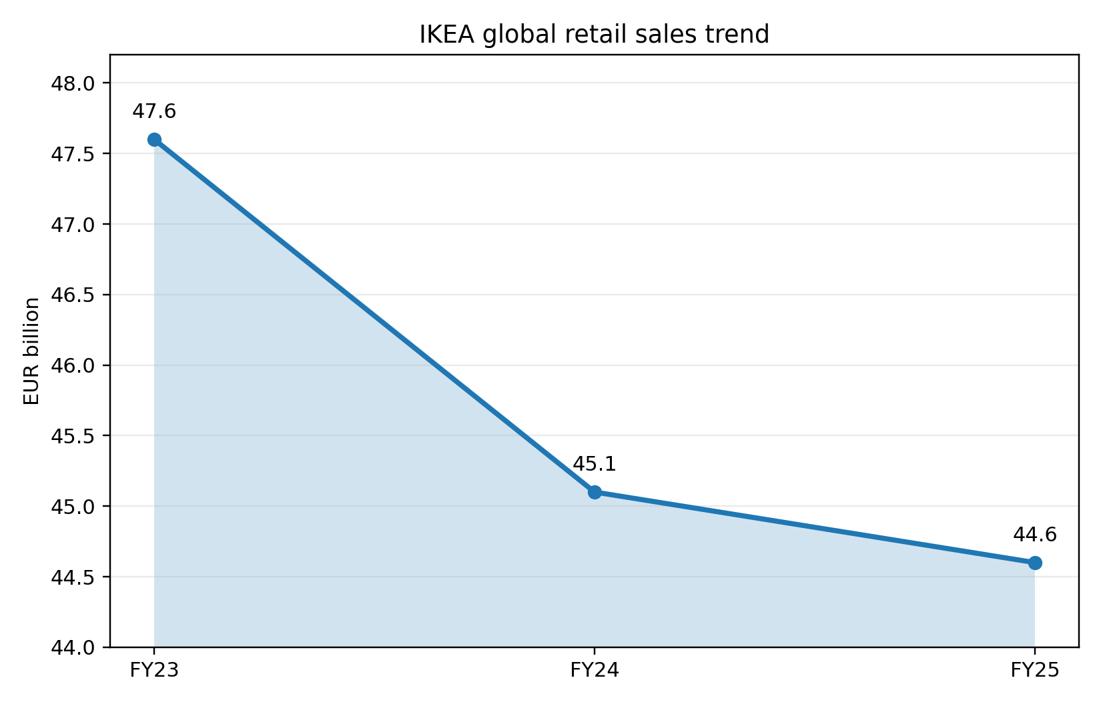
Figure 3. IKEA global retail sales trend, FY23 to FY25. Source: author-created chart based on IKEA year-in-review disclosures.
This strategic assessment can be well put in context by figure 3. International sales have also been consistent but moderately reduced in the past three financial years since IKEA has been focusing on low prices and wider accessibility. The above situation makes it more significant to have restrained growth decisions in markets like India. Instead of pursuing the scale by prematurely rolling out into physical locations, IKEA seems to be developing a more capital-aware omnichannel presence. This is a strategically good move since it fits in the uneven geography in India, price sensitivity and urban concentration.
There are four reasons why the strategy is attractive. First, it minimizes the capital risk due to the increased access on digital and smaller formats. Second, it enhances learning, which enables IKEA to monitor response by city and service area prior to higher commitments. Third, it defends the brand in that the delivery, planning and customer care remain as it expands. Fourth, it establishes a channel between awareness and trial to increased household expenditure. The market development in India is thus not merely opening more stores but sequencing access in such a manner that it maintains the brand promise to be believable.
Nonetheless, there exist limits too. A gradual approach can reduce market share uptake in case local or digital-native rivals are more aggressive. It can also make the brand appear urban-elite in case the expansion continues to be concentrated in more high-income metros. The dilemma to IKEA is thus to keep expanding without jeopardising service quality and making the business model overly complex.

6. Ethical issues in the marketing mix
Ethical evaluation should not treat one controversy in isolation; it should assess whether the marketing mix is consistent with responsible and sustainable marketing. The first tension concerns affordability and sustainability. IKEA publicly presents climate action, circularity and lower emissions as part of its value proposition, and the FY24 sustainability and climate reports show progress, including a 5% reduction in overall climate footprint and continuing decarbonisation efforts (IKEA, 2025j). However, the ethical question remains whether a model built on affordability and high-volume home consumption can encourage repeated replacement cycles while simultaneously claiming sustainability leadership. The question is whether economic accessibility, environmental responsibility and social credibility are promoted simultaneously and not selectively through a triple-bottom-line prism.
The second problem is the service fairness and transparency. Stakeholder and service-ethics wise, customers should never be coaxed into making expectations that the delivery system is unable to meet. The processes of buying in Germany are more transparent due to its well-developed logistics and more definite criteria of service, and in India, the delivery areas, the possibility to get the services, and the availability of goods are more evidently based on pin code and access to the store. The customer-information pages of IKEA India indicate that the company is trying to establish the areas of serviceability, official channels and terms of delivery in a more explicit manner (IKEA, 2025h; IKEA, 2025i). This is important in the business sense but it will also be an ethical issue since unspecified promises of fulfilment would shift the risk of operations to the first-time customers.
The third challenge is related to environmental footprint of growth logistics. The fact that IKEA released heavy-duty electric trucks in India is an encouraging operational move, however, it also illustrates a larger sustainability issue: growth in emerging markets continues to rely on the movement of large-sized goods, which will continue to emit logistics unless distribution infrastructure is redesigned on a material scale (IKEA, 2025e). Environmental communication can only be seen as credible in terms of sustainability-marketing, when it is supported by operation change rather than symbolism. The ethical reputation of IKEA would then be based on whether affordability, growth of circularity and delivery are in practise and not just a corporate story.

7. Recommendations
- Recommendation 1: IKEA needs to reinforce its India product policy with additional local-solution merchandising and planning assistance, as brand identity is not the primary product issue but assortment relevance. This is already reflected in the Bengaluru Plan and Order Point, where the solution selling will help to lower the purchase risk and empower the augmented product in India (IKEA, 2025d). An extension of this reasoning would make the adaptation of products more apparent without undermining the global uniformity.
- Recommendation 2: IKEA needs to inform about total acquisition cost in India better, and deliver conditions, service limits and price-related fulfilment terms should be more transparent at earlier stages of customer experience. This is based on the direct comparison between the mature service architecture in Germany and the more selective nature of the delivery environment in India (IKEA, 2025f; IKEA, 2025g; IKEA, 2025h). It is not only a matter of commercial efficiency, but also the fairness and trust in the services.
- Recommendation 3: IKEA needs to operationalise sustainability communication and make it more market-specific by connecting the claims more visibly to logistics, transport and access decision-making in India. The launch of heavy-duty electric trucks is a productive beginning, although the ethical credibility will be more effective when the promotional sustainability claims are anchored in the delivery and circularity metrics that can be observed instead of the general brand-level messages (IKEA, 2025e; IKEA, 2025j).

8. Conclusion
The example of IKEA operation in Germany and India demonstrates that there is no necessity to choose between full standardisation and total adaptation in case of successful international marketing. Instead, the company protects a tightly-knit global centre and localises the route by purchasing, service system and roll out sequence to the local market realities. Germany is among the markets, in which the classical IKEA model can be managed without relatively much alteration. India should be more commercialised especially in place, process, price structure and directed entry. This does not undermine the brand. Quite on the contrary, it demonstrates that the best global strategy is a strategy that homogenises the meaning of the brand but localises the mechanisms through which customers can realistically experience it.

Section 2: Reflective account using Gibbs’ reflective cycle

9. Reflection
Description. My research process started with a clearer definition of the problem of analysis than the brief itself. Rather than viewing the task as a mere comparison between two country reports, I redefined it as an inquiry on how a global retailer could strike a balance between standardisation and adaptation in situations whereby the two markets are not just different in terms of wealth, but also in terms of infrastructure, household structure and service expectations. This ruling formed the whole report. The first step I took was to collect company and country data, and then I picked academic literature that would assist me in interpreting data instead of describing it. I applied this evidence in organising the report according to macro-environment, STP, 7ps, directional strategy, ethics and recommendations.
Feelings. Initially, I feared that IKEA would be a brand that is too well-known and hence tough to critically analyse. Brands known can also lure writers into description since the brand storey seems self-evident. Another danger that I foresaw was overgeneralizing cultural difference in a naive manner. As I proceeded with the research process, I felt more confident when I realised that there were even stronger differences that were not necessarily cultural, but operational as well. The delivery geography, city-store development and planning-point approach of India allowed a more detailed analysis than general statements of East versus West or developed versus emerging market.
Evaluation. One of my greatest strengths in the process was the integration of existing official information and fundamental academic theory. The official sources also assisted me in avoiding outdated claims, particularly in the case of the recent market expansion of India and the existing omnichannel formats. The scholarly materials came in handy in another manner; they offered conceptual aids to assessing when standardisation can still be possible and when adaptation is commercially needed. One of the weaknesses of my process was that some useful market data, particularly category-level data on home-furnishing, was more difficult to obtain out of entirely open sources than macroeconomic data. Due to this, I was forced to depend more on the disclosures of the company and country indicators than on the sector-specific syndicated reports.
Analysis. The model by Gibbs promotes a more in-depth explanation of the reasons the process was undertaken in the way it was. The greatest lesson to me was the fact that present day corporate information should be critically used. Authoritative sources are useful as they are up-to-date and narrow, but not apolitical. They are meant in part to project the company positively. This implied that I could not copy the language of the company blindly, particularly sustainability and accessibility. I thus applied academic theory as a test of the assertions. Citing an example, when they said that affordable to a large number, I did not simply assume the words but I questioned them on whether the affordability was still viable when delivery, access to the service and housing conditions in India were factored into it. This enhanced the quality of decision in the report.
The second analytical lesson was a lesson on methodology. The short demands comparison, which is all too readily turned into the juxtaposition of two distinct descriptions. To prevent that, I employed a comparative logic in the process. All the sections were composed on contrast, implication and judgement. This has compelled me to enquire not only what IKEA is doing in Germany and India, but why the difference is strategically important. That helped to enhance the coherence and make the recommendations more convincing since they were based on cross-market analysis, not on individual observations.
Conclusion. Generally, the process enhanced my knowledge of how the strategy of international marketing must be assessed at post graduate level. I was made to understand that good analysis goes beyond mechanic application of frameworks. PESTEL, STP and 7Ps are practical but they can only be good when applied to create argument. I also came to the conclusion that the most persuasive piece of work in such an assignment hinge on the ability to choose sources wisely, compare them thoroughly, and be ready to analyse tension and contradiction, particularly when the company narratives seem to be too polished.
Action plan. There are three ways in which I would enhance the process and transfer the learning beyond this assignment. First, I would create a source matrix earlier, dividing theoretical, macro, company and ethical evidence so that future academic and professional reports are more balanced from the outset. Second, I would bring independent industry evidence into the process earlier so that I can challenge company narratives more confidently in future research and in workplace market analysis. Third, I would continue applying the lesson that recommendations should emerge from completed analysis rather than intuition. This is useful not only for future assignments, but also for managerial decision-making, project evaluation and everyday judgement about how credible business claims really are.

References
Ansoff, H.I. (1957) ‘Strategies for diversification’, Harvard Business Review, 35(5), pp. 113-124.
DataReportal (2025a) Digital 2025: Germany. Available at: https://datareportal.com/reports/digital-2025-germany (Accessed: 10 March 2026).
DataReportal (2025b) Digital 2025: India. Available at: https://datareportal.com/reports/digital-2025-india (Accessed: 10 March 2026).
De Mooij, M. and Hofstede, G. (2010) ‘The Hofstede model: Applications to global branding and advertising strategy and research’, International Journal of Advertising, 29(1), pp. 85-110.
Douglas, S.P. and Wind, Y. (1987) ‘The myth of globalization’, Columbia Journal of World Business, 22(4), pp. 19-29.
Gibbs, G. (1988) Learning by Doing: A Guide to Teaching and Learning Methods. Oxford: Oxford Polytechnic.
Hollensen, S. (2020) Global Marketing. 8th edn. Harlow: Pearson.
IKEA (2024a) IKEA continues to lower prices for customers. Available at: https://www.ikea.com/global/en/newsroom/corporate/ikea-retail-sales-fy24-241010/ (Accessed: 10 March 2026).
IKEA (2025a) The year in review FY25. Available at: https://www.ikea.com/global/en/our-business/how-we-work/year-in-review-fy25/ (Accessed: 10 March 2026).
IKEA (2025b) IKEA answers the call to ‘When is IKEA coming to North India’ with the launch of online deliveries. Available at: https://www.ikea.com/in/en/newsroom/corporate-news/ikea-answers-the-call-to-when-is-ikea-coming-to-north-india-with-the-launch-of-online-deliveries-pub889756b0/ (Accessed: 10 March 2026).
IKEA (2025c) IKEA moves in to a new home in Delhi. Available at: https://www.ikea.com/in/en/newsroom/corporate-news/ikea-moves-in-to-a-new-home-in-delhi-pub38418e20/ (Accessed: 10 March 2026).
IKEA (2025d) IKEA India taps into the need for home design planning with its very first ‘Plan and Order Point’ in Bengaluru. Available at: https://www.ikea.com/in/en/newsroom/corporate-news/ikea-india-taps-into-the-need-for-home-design-planning-with-its-very-first-plan-and-order-point-in-bengaluru-pube8fe1460/ (Accessed: 10 March 2026).
IKEA (2025e) IKEA deploys first heavy-duty electric truck in India. Available at: https://www.ikea.com/in/en/newsroom/corporate-news/ikea-deploys-first-heavy-duty-electric-truck-in-india-pub419a9980/ (Accessed: 10 March 2026).
IKEA (2025f) Click & Collect: Order online and collect later. Available at: https://www.ikea.com/de/en/customer-service/services/click-collect/ (Accessed: 10 March 2026).
IKEA (2025g) Delivery service: options and prices. Available at: https://www.ikea.com/de/en/customer-service/services/delivery/ (Accessed: 10 March 2026).
IKEA (2025h) Delivery service. Available at: https://www.ikea.com/in/en/customer-service/delivery-service-pubd5889e60 (Accessed: 10 March 2026).
IKEA (2025i) Caution against fake IKEA website and social media channels. Available at: https://www.ikea.com/in/en/customer-service/knowledge/articles/2b7504dc-f069-40f1-97e1-gfd1f67f3760.html (Accessed: 10 March 2026).
IKEA (2025j) IKEA Sustainability and Climate Reports FY24: making progress towards climate goals and investing in the future. Available at: https://www.ikea.com/global/en/newsroom/sustainability/ikea-sustainability-and-climate-reports-fy24-250130/ (Accessed: 10 March 2026).
Jain, S.C. (1989) ‘Standardization of international marketing strategy: Some research hypotheses’, Journal of Marketing, 53(1), pp. 70-79.
Kotler, P. and Keller, K.L. (2016) Marketing Management. 15th edn. Harlow: Pearson.
Levitt, T. (1983) ‘The globalization of markets’, Harvard Business Review, 61(3), pp. 92-102.
Vrontis, D. and Thrassou, A. (2007) ‘Adaptation vs. standardization in international marketing: the country-of-origin effect’, Innovative Marketing, 3(4), pp. 7-21.
World Bank (2025a) Germany. Available at: https://data.worldbank.org/country/DE (Accessed: 10 March 2026).
World Bank (2025b) India. Available at: https://data.worldbank.org/country/india (Accessed: 10 March 2026).
World Bank (2025c) Data for Germany and India. Available at: https://data.worldbank.org/?locations=DE-IN (Accessed: 10 March 2026).

