Callum Bailey (2307997)

Computer Networking and Cyber Security (Bsc)
introduction to Web and database concepts
HTML & CSS Web Development

Contents
Abstract 2
Introduction/Context 2
Implementation 2
Validation 4
Evaluation A 5
Usability 5
Search Engine Optimisation 5
Accessibility 5
Evaluation B 5
Usefulness 6
SEO 6
Accessibility. 6
References 7
Appendices 7

Abstract
The following report will contain my answer to the assignment HTML and CSS Web Development, it will include screenshots and explanations to each question.

Introduction/Context
The website I decided to create was related to a video game that I play called the World of Warcraft, the purpose of the website is to provide fans of the game with news and a place to shop for merchandise.

Implementation
Below are screenshots of my 5 webpages developed.
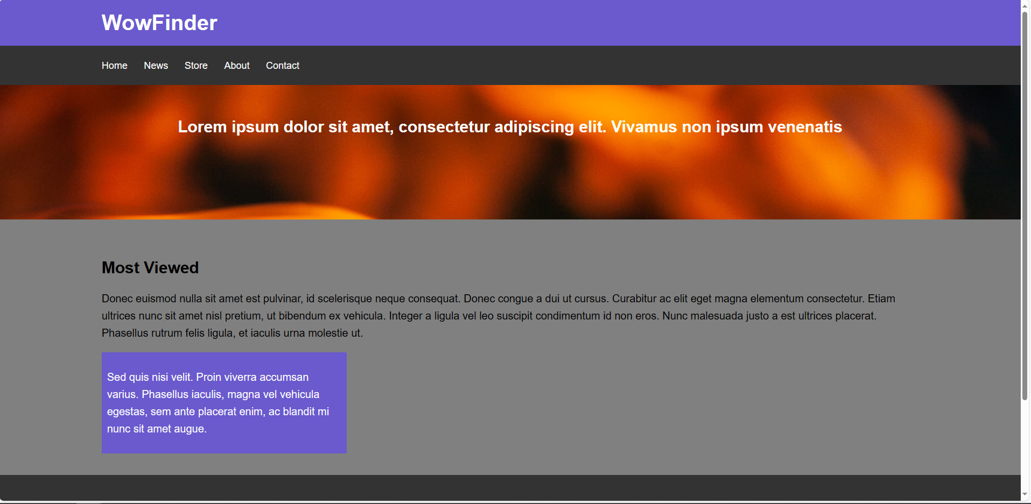
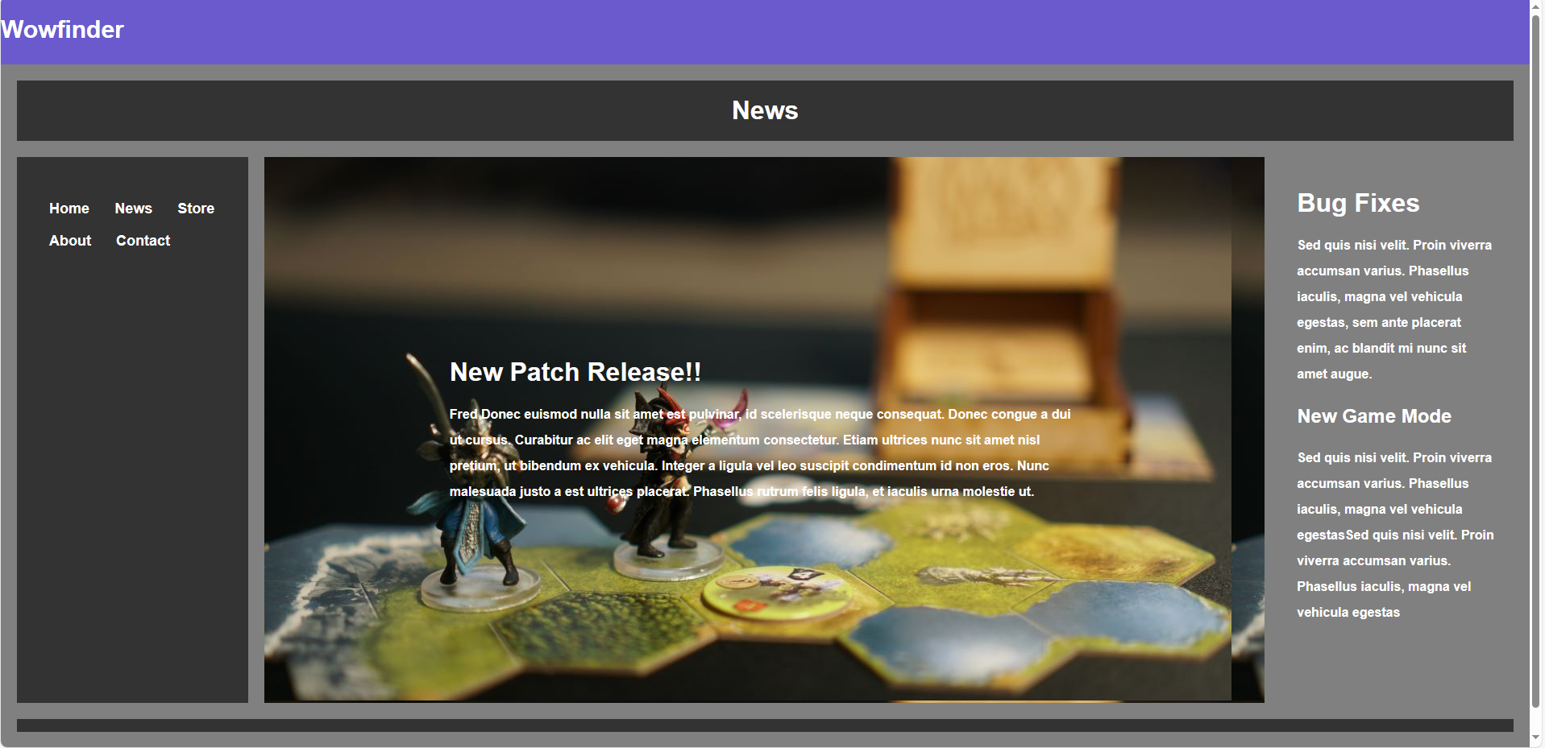
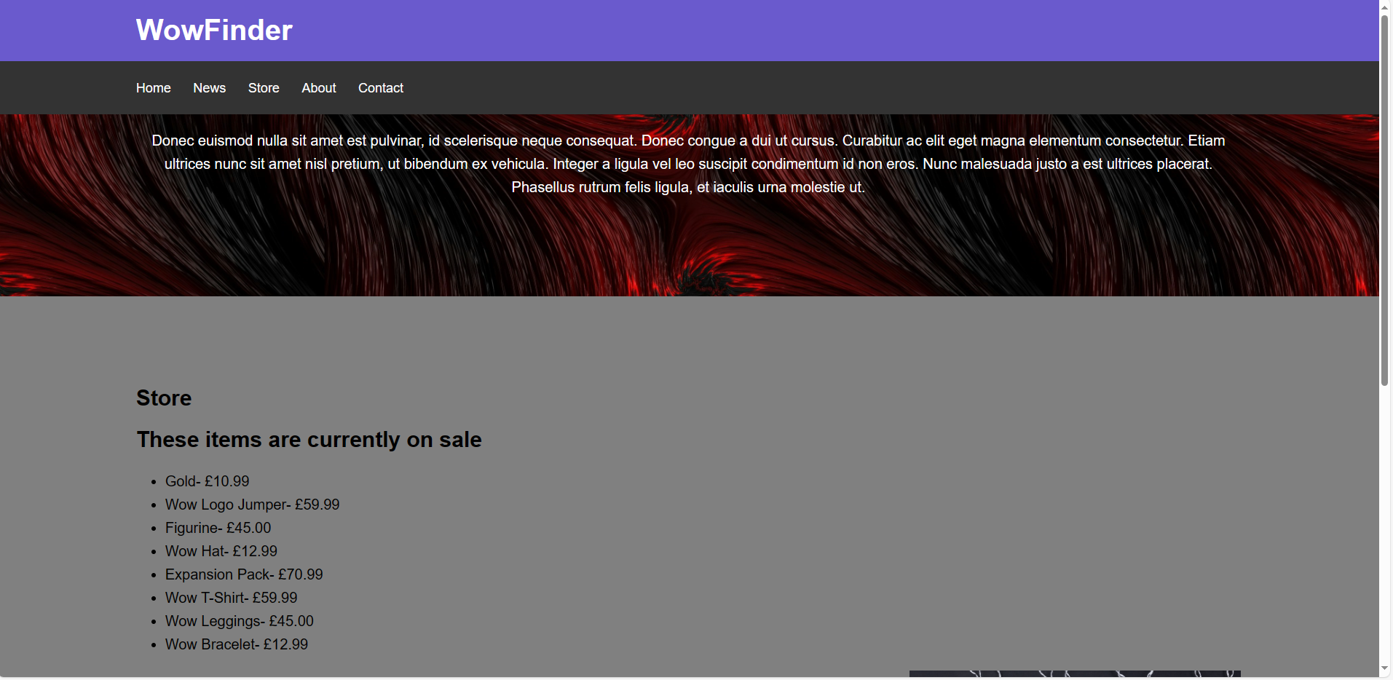
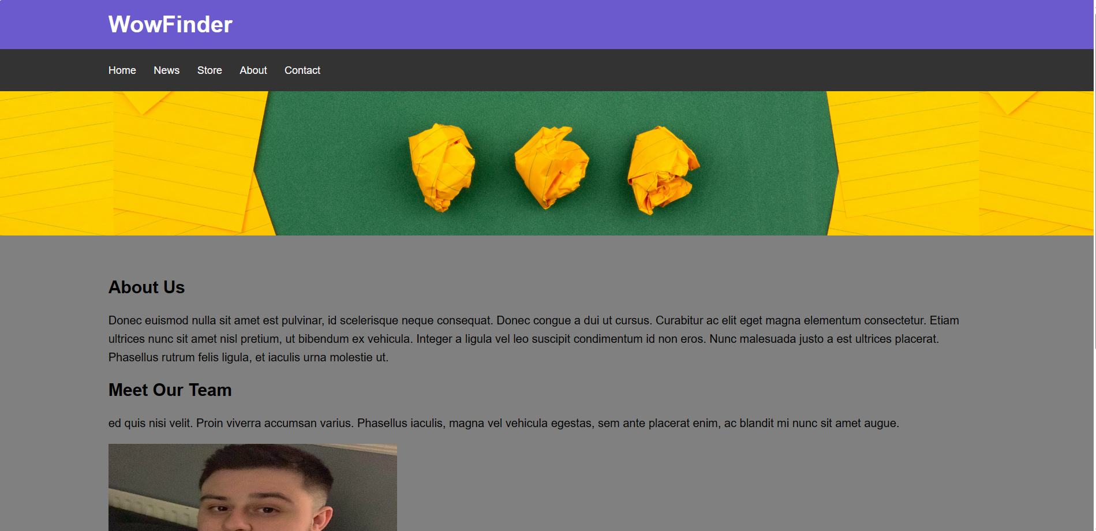
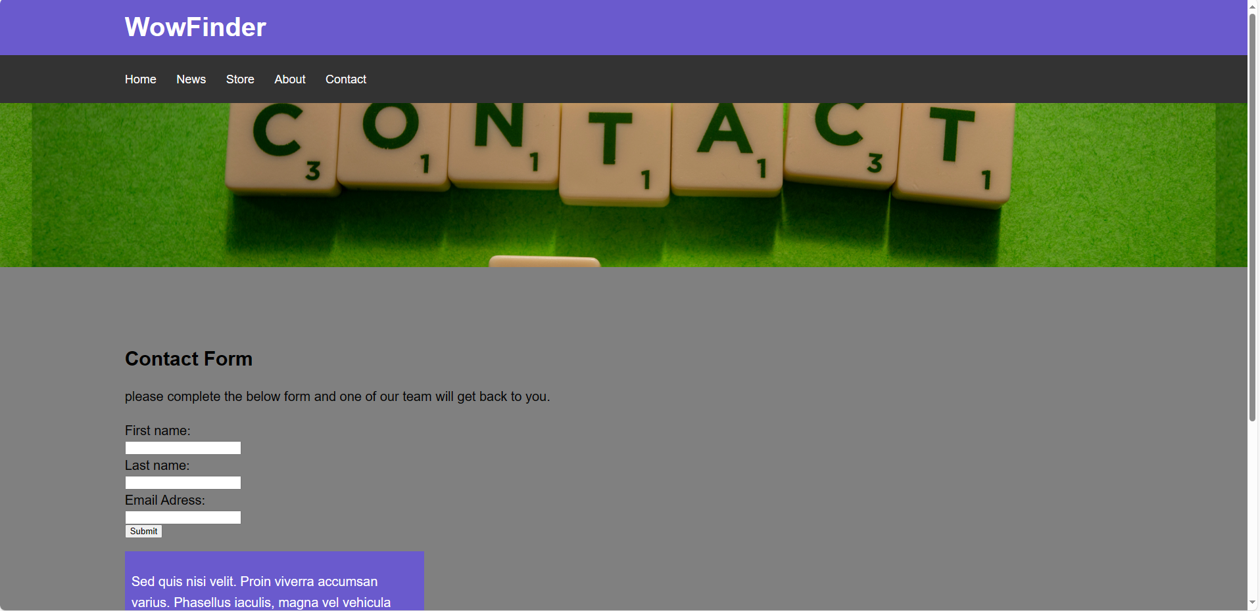

Validation
When using the HTML validator provided a few errors were highlighted, the first was regarding adding a language tag to the document, I was unsure of how to do this or where it should be placed in my HTML document so on this occasion, I chose not to fix the issue as it did not affect the usage of my webpage. The other warnings were regarding my usage of the h1 element, I decided to use this throughout my code, but the validator suggested that I shouldn’t use this, again as it did not affect the usage of my web page, so I decided to overlook this.
For the CSS validation, the only error that arose was a parse error, I was unsure how to fix this issue and could not see the effect on my page so I also decided to look past this.
Below are screenshots from my validation tests.

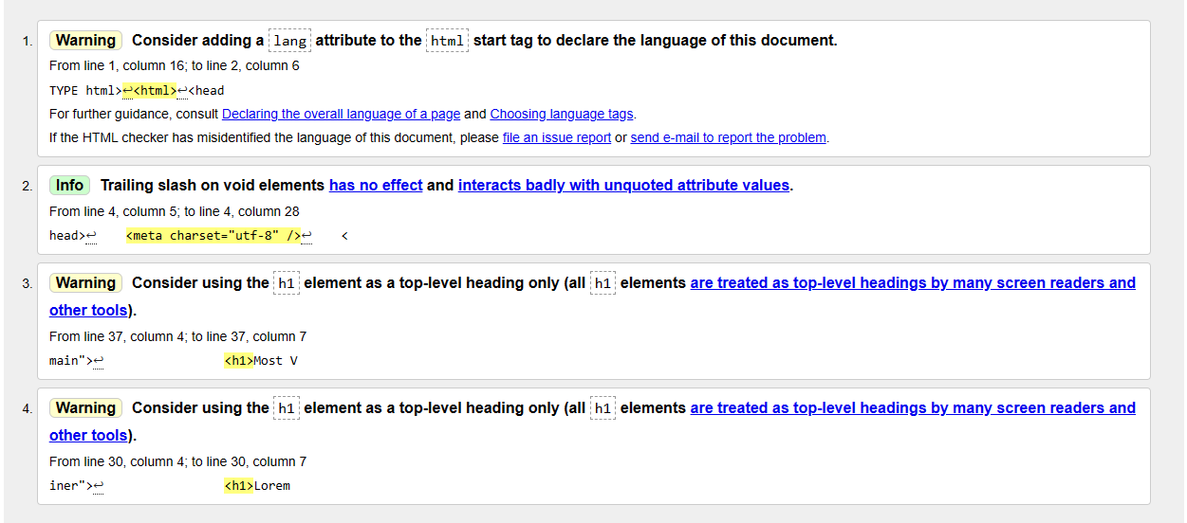

Evaluation A

Usability
As part of my research into the useability of websites it was made clear that it is essential for successful websites to focus on useability this is down to a few main reasons, the first being how more people are now using mobile phones to surf the web. Therefore, it is desirable that your website can be viewed on almost any device. To do this it may be a good idea to focus on easy navigation, fitting font sizes, and the overall user interface. [1] Some of my interpretations of usability include the speed of the webpage, and how text-heavy the page is.

Search Engine Optimisation
Search Engine Optimisation or SEO specifically on-page is “On-page SEO is the practice of optimizing elements on your website, like page speed and keyword density, versus factors off your website, like external backlinks, to improve a site’s ranking and visibility in search engines.”[2]
From this definition, I learned that on-page SEO is exactly as it sounds it’s a way of optimising your page or website but including elements directly on your page. I also discovered that it is best to focus on elements such as the title tag, headings, keywords, and images, all of these will boost your SEO and in turn your rankings on the search engine hopefully leading to higher viewer readings. [2]

Accessibility
Accessibility is the acknowledgment of how disabilities can affect how someone uses a website and implementing tools or removing barriers so that everyone can access the content. W3 directly talks about 6 main disability areas and states that we should focus on these areas to improve the accessibility of our sites, these include auditory, cognitive, neurological, physical, speech, and visual disabilities. It was also noted that web accessibility also helps improve the user experience for everyone with benefits to people with temporary disabilities, slow internet connectivity, and the age of the individual. [3] Overall it is clear that access to the information provided on a webpage is essential.

Evaluation B

Usefulness
I tried to complete my website with simplification in mind, I didn’t want my web page to be long and I wanted to limit the information provided on each page. I also wanted to allow the pages to have easy navigation and therefore wanted a coherent theme throughout.
I believe that I achieved some of the goals I set out, my 5 pages share a common structure and colour theme, and all text stands out from the background and is easy to read, I also included a working navigation bar that allows users to flip between pages easily, this, in turn, has made a big impact on my usefulness. An area that I didn’t focus on when completing my webpage was how it might appear on a mobile device, I wasn’t sure how to test this and therefore have no insight on how the finished product will appear on a mobile device, if I was to improve anything specifically this would be my first task. Another improvement I would like to create would be more interactive features on the website such as links to other websites with information, or images that changed over the duration of being on the website as I believe this would also increase the usability and usefulness of the webpage.

SEO
SEO wasn’t something that I was concerned about when creating my website, I was aware of SEO techniques but when completing the assignment my focus was mainly on the UX design of the website and not on the content therefore going into this evaluation I know there are many improvements that I could make. Some SEO elements that I did include in my design are keywords and headings, I tried to ensure that each block of text had a heading, and examples of this are on my news page where Included the titles of “new patch” and “bug fixes” and “new game mode”. As mentioned above there was not a lot of SEO used on my page so if I were to improve anything I would improve my keyword density in the paragraphs of information, and mention the game I was creating the website more throughout my website.

Accessibility.
Areas of my website that I feel improved the accessibility include the text size and contrast. All the information provided on my webpage is clear and available in a large font. Information is spread out effectively so that it can be read clearly, and images are used throughout. Additionally, a navigation is present on each page allowing for easy use of the website and each page shares a theme to improve user familiarity.
An area of my website that I would like to improve my website is including text-to-speech options and image descriptions as currently there are no accessibility features for auditory disabilities. Overall, I believe that the accessibility of my webpage is okay, but does have a lot of room for improvement, mainly in areas related to auditory disabilities, I would also like to include features to aid those with cognitive issues and allow even more simplified navigation options or more information provided through images and not just text.

References
[1] M. Rana, “What is website usability and why is it important?,” EZ Rankings, https://www.ezrankings.com/blog/website-usability/ (accessed Jan. 15, 2024).
[2] Chucksays: et al., “On-page seo: The definitive guide + free template (2024),” Backlinko, https://backlinko.com/on-page-seo (accessed Jan. 15, 2024).
[3] W. W. A. I. (WAI), “Introduction to web accessibility,” Web Accessibility Initiative (WAI), https://www.w3.org/WAI/fundamentals/accessibility-intro/ (accessed Jan. 15, 2024).

Appendices
<!DOCTYPE html>
<html>
<head>
<meta charset="utf-8" />
<title>WowFinder</title>
<link rel="stylesheet" type="text/css"
href="stylesheet.css">
</head>
<body>
<header id="main-header">
<div class="container">
<h1>WowFinder</h1>
</div>
</header>

<nav id="navbar">
<div class="container">
<ul>
<li><a href="Index.html">Home</a></li>
<li><a href="Index1.html">News</a></li>
<li><a href="Index2.html">Store</a></li>
<li><a href="Index3.html">About</a></li>
<li><a href="Index4.html">Contact</a></li>
</ul>
</div>
</nav>

<section id="showcase">
<div class="container">
<h1>Lorem ipsum dolor sit amet, consectetur adipiscing elit. Vivamus non ipsum venenatis
</h1>
</div>
</section>

<div class="container">
<section id="main">
<h1>Most Viewed</h1>
<p>Donec euismod nulla sit amet est pulvinar, id scelerisque neque consequat. Donec congue a dui ut cursus. Curabitur ac elit eget magna elementum consectetur. Etiam ultrices nunc sit amet nisl pretium, ut bibendum ex vehicula. Integer a ligula vel leo suscipit condimentum id non eros. Nunc malesuada justo a est ultrices placerat. Phasellus rutrum felis ligula, et iaculis urna molestie ut.
</p>
</section>

<aside id="sidebar">
<p>Sed quis nisi velit. Proin viverra accumsan varius. Phasellus iaculis, magna vel vehicula egestas, sem ante placerat enim, ac blandit mi nunc sit amet augue.</p>
</aside>
</div>

<footer id="main-footer">
<p> </p>
</footer>
</body>
</html>
<!DOCTYPE html>
<html>
<head>
<meta charset="utf-8" />
<title> Wowfinder </title>
<link rel="stylesheet" type="text/css"
href="stylesheet1.css">
<h2 style="color:white;"> Wowfinder </h2>
</head>

<body>

<h1 style="color:white;" WowFinder </h1>

<div class="grid-container">

<div class="item1">
<h1 style="text-align: center; color:white;"> News </h1>
</div>

<nav id="navbar">
<div class="container">
<ul>
<li><a href="Index.html">Home</a></li>
<li><a href="Index1.html">News</a></li>
<li><a href="Index2.html">Store</a></li>
<li><a href="Index3.html">About</a></li>
<li><a href="Index4.html">Contact</a></li>
</ul>
</div>
</nav>

<div class="item3"; style="padding:230px; background-image:url(newpatch.jpg); color:#FFF" >

<h1>New Patch Release!!</h1>
<p>Fred Donec euismod nulla sit amet est pulvinar, id scelerisque neque consequat. Donec congue a dui ut cursus. Curabitur ac elit eget magna elementum consectetur. Etiam ultrices nunc sit amet nisl pretium, ut bibendum ex vehicula. Integer a ligula vel leo suscipit condimentum id non eros. Nunc malesuada justo a est ultrices placerat. Phasellus rutrum felis ligula, et iaculis urna molestie ut.
</p>
</div>

<div class="item4"; style="padding: 20px ;">
<h1>Bug Fixes </h1>
<p>Sed quis nisi velit. Proin viverra accumsan varius. Phasellus iaculis, magna vel vehicula egestas, sem ante placerat enim, ac blandit mi nunc sit amet augue.</p>
<h2> New Game Mode </h2>
<p> Sed quis nisi velit. Proin viverra accumsan varius. Phasellus iaculis, magna vel vehicula egestasSed quis nisi velit. Proin viverra accumsan varius. Phasellus iaculis, magna vel vehicula egestas </p>
</div>

<div class="item5">
<p style="text-align: center; style=padding:50px;" </p>
</div>

</div>

</body>
</html>
<!DOCTYPE html>
<html>
<head>
<meta charset="utf-8" />
<title>WowFinder</title>
<link rel="stylesheet" type="text/css"
href="stylesheet2.css">
</head>
<body>
<header id="main-header">
<div class="container">
<h1>WowFinder</h1>
</div>
</header>

<nav id="navbar">
<div class="container">
<ul>
<li><a href="Index.html">Home</a></li>
<li><a href="Index1.html">News</a></li>
<li><a href="Index2.html">Store</a></li>
<li><a href="Index3.html">About</a></li>
<li><a href="Index4.html">Contact</a></li>
</ul>
</div>
</nav>

<section id="showcase">
<div class="container">
<p style="color:white"> Donec euismod nulla sit amet est pulvinar, id scelerisque neque consequat. Donec congue a dui ut cursus. Curabitur ac elit eget magna elementum consectetur. Etiam ultrices nunc sit amet nisl pretium, ut bibendum ex vehicula. Integer a ligula vel leo suscipit condimentum id non eros. Nunc malesuada justo a est ultrices placerat. Phasellus rutrum felis ligula, et iaculis urna molestie ut.
</p>

</div>
</section>

<div class="container">
<section id="main">
<h1>Store</h1>
<h2>These items are currently on sale</h2>

<ul>
<li>Gold- £10.99</li>
<li>Wow Logo Jumper- £59.99</li>
<li>Figurine- £45.00</li>
<li>Wow Hat- £12.99</li>
<li>Expansion Pack- £70.99</li>
<li>Wow T-Shirt- £59.99</li>
<li>Wow Leggings- £45.00</li>
<li>Wow Bracelet- £12.99</li>
</ul>

</section>

<aside id="sidebar">

</aside>
</div>

<footer id="main-footer">
<p> </p>
</footer>
</body>
</html>
<!DOCTYPE html>
<html>
<head>
<meta charset="utf-8" />
<title>WowFinder</title>
<link rel="stylesheet" type="text/css"
href="stylesheet3.css">
</head>
<body>
<header id="main-header">
<div class="container">
<h1>WowFinder</h1>
</div>
</header>

<nav id="navbar">
<div class="container">
<ul>
<li><a href="Index.html">Home</a></li>
<li><a href="Index1.html">News</a></li>
<li><a href="Index2.html">Store</a></li>
<li><a href="Index3.html">About</a></li>
<li><a href="Index4.html">Contact</a></li>
</ul>
</div>
</nav>

<section id="showcase">
<div class="container">

</div>
</section>

<div class="container">
<section id="main">
<h1>About Us</h1>
<p>Donec euismod nulla sit amet est pulvinar, id scelerisque neque consequat. Donec congue a dui ut cursus. Curabitur ac elit eget magna elementum consectetur. Etiam ultrices nunc sit amet nisl pretium, ut bibendum ex vehicula. Integer a ligula vel leo suscipit condimentum id non eros. Nunc malesuada justo a est ultrices placerat. Phasellus rutrum felis ligula, et iaculis urna molestie ut.
</p>
<h2>Meet Our Team</h2>
<p>ed quis nisi velit. Proin viverra accumsan varius. Phasellus iaculis, magna vel vehicula egestas, sem ante placerat enim, ac blandit mi nunc sit amet augue.</p>
<img src="me.jpg" width="500" height="333">
</aside>

</div>

</section>

<aside id="sidebar">
<p> Contact, Callum on Facebook, or by email @ callumbailey@icloud.com</p>
</aside>
</div>

<footer id="main-footer">
<p> </p>
</footer>
</body>
</html>
html>
<head>
<meta charset="utf-8" />
<title>WowFinder</title>
<link rel="stylesheet" type="text/css"
href="stylesheet4.css">
</head>
<body>
<header id="main-header">
<div class="container">
<h1>WowFinder</h1>
</div>
</header>

<nav id="navbar">
<div class="container">
<ul>
<li><a href="Index.html">Home</a></li>
<li><a href="Index1.html">News</a></li>
<li><a href="Index2.html">Store</a></li>
<li><a href="Index3.html">About</a></li>
<li><a href="Index4.html">Contact</a></li>
</ul>
</div>
</nav>

<section id="showcase">
<div class="container">

</div>
</section>

<div class="container">
<section id="main">
<h1>Contact Form</h1>
<p> please complete the below form and one of our team will get back to you.
</p>
</section>
<form>
<label for="fname">First name:</label><br>
<input type="text" id="fname" name="fname" value=""><br>
<label for="lname">Last name:</label><br>
<input type="text" id="lname" name="lname" value=""><br>
<label for="email address"> Email Adress:</label><br>
<input type="text" id="email address" name="email address" value=""><br>
<input type="submit" value="Submit">
</form>

<aside id="sidebar">
<p>Sed quis nisi velit. Proin viverra accumsan varius. Phasellus iaculis, magna vel vehicula egestas, sem ante placerat enim, ac blandit mi nunc sit amet augue.</p>
</aside>
</div>

<footer id="main-footer">
<p> </p>
</footer>
</body>
</html>
.item1 { grid-area: header; background-color:#333;}
.item2 { grid-area: menu; }
.item3 { grid-area: main; }
.item4 { grid-area: right; }
.item5 { grid-area: footer; background-color:#333;}

.grid-container {
display: grid;
grid-template-areas:
'header header header header header header'
'menu main main main main right'
'footer footer footer footer footer footer';
grid-gap: 20px;
background-color:gray;
padding: 20px;
font-family:Arial, Helvetica, san-serif;
}

.grid-container > div {
<!-- background-color: rgba(255, 255, 255, 0.8); -->
<!-- text-align: center; -->
padding: 40px 0;
font-size: 16px;
}

a{
color:white;
text-decoration: none;
}
a:hover{
color:slateblue;
}

.item2 ul{
padding:0;
list-style:none;
}
body{
background-color:Slateblue;
color:black;
font-family:Arial, Helvetica, san-serif;
font-size:20px;
line-height:1.6em;
margin:0;

}

#navbar{
background-color:#333;
color:#fff;
}

#navbar ul{
padding:5;
list-style:none;
}

#navbar li{
display:inline;
}

#navbar a{
font-size:18px;
padding-right:20px;

}
@media(max-width:600px){
#navbar li{
display:block;
}
body{
background-color:gray;
color:black;
font-family:Arial, Helvetica, san-serif;
font-size:20px;
line-height:1.6em;
margin:0;
}

.container{
width:80%;
margin:auto;
overflow:hidden;
}

#main-header{
background-color:SlateBlue;
color:#fff;
}

#navbar{
background-color:#333;
color:#fff;
}

#navbar ul{
padding:0;
list-style:none;
}

#navbar li{
display:inline;
}

#navbar a{
font-size:18px;
padding-right:25px;
}

a{
color:white;
text-decoration: none;
}

a:hover{
color:SlateBlue;
}

#main-footer {
background:#333;
color:#fff;
text-align:center;
padding:120px;
margin-top:40px;
}
/

#main{
float:right;
width:70%;
padding:10px;
box-sizing: border-box;
}

#sidebar{
float:left;
width:30%;
background:SlateBlue;
color:#fff;
padding:10px;
box-sizing: border-box;
}

#showcase{
background-image:url("fire2.jpg");
background-size: 2000px;
opacity:1.0;
background-position:top;

min-height:250px;
margin-bottom:50px;
text-align:center;
}

#showcase h1{
color:white;
font-size:30px;
line-height:1.6em;
padding:30px;
}

@media(max-width:600px){
#main{
width:100%;
float:none;
}

#sidebar{
width:100%;
float:none;
}

#navbar li{
display:block;
}

}

body{
background-color:gray;
color:black;
font-family:Arial, Helvetica, san-serif;
font-size:20px;
line-height:1.6em;
margin:0;
}

.container{
width:80%;
margin:auto;
overflow:hidden;
}

#main-header{
background-color:SlateBlue;
color:#fff;
}

#navbar{
background-color:#333;
color:#fff;
}

#navbar ul{
padding:0;
list-style:none;
}

#navbar li{
display:inline;
}

#navbar a{
font-size:18px;
padding-right:25px;
}

a{
color:white;
text-decoration: none;
}

a:hover{
color:SlateBlue;
}

#main-footer {
background:#333;
color:#fff;
text-align:center;
padding:120px;
margin-top:40px;
}
/

#main{
float:left;
width:70%;
padding:10px;
box-sizing: border-box;
}

#sidebar{
float:right;
width:30%;
background-image:url("sale.jpg");
background-size:720px;
background-position:center;
color:#fff;
padding:200px;
box-sizing: border-box;

}

#showcase{
background-image:url("background.jpg");
background-size:1000px;
opacity:1.0;
background-position:center;

min-height:250px;
margin-bottom:100px;
text-align:center;
}

#showcase h1{
color:white;
font-size:30px;
line-height:1.6em;
padding:30px;
}

@media(max-width:800px){
#main{
width:80%;
float:none;
}

#sidebar{
width:100%;
float:none;
}

#navbar li{
display:block;
}

}

body{
background-color:gray;
color:black;
font-family:Arial, Helvetica, san-serif;
font-size:20px;
line-height:1.6em;
margin:0;
}

.container{
width:80%;
margin:auto;
overflow:hidden;
}

#main-header{
background-color:SlateBlue;
color:#fff;
}

#navbar{
background-color:#333;
color:#fff;
}

#navbar ul{
padding:0;
list-style:none;
}

#navbar li{
display:inline;
}

#navbar a{
font-size:18px;
padding-right:25px;
}

a{
color:white;
text-decoration: none;
}

a:hover{
color:SlateBlue;
}

#main-footer {
background:#333;
color:#fff;
text-align:center;
padding:120px;
margin-top:40px;
}
/

#main{
float:right;
width:70%;
padding:60px;
box-sizing: border-box;
}

#sidebar{
float:right;
width:30%;
background:SlateBlue;
color:#fff;
padding:20px;
box-sizing: border-box;
}

#showcase{
background-image:url("aboutus.jpg");
background-size: 1500px;
opacity:1.0;
background-position:center;

min-height:250px;
margin-bottom:50px;
text-align:center;
}

#showcase h1{
color:white;
font-size:30px;
line-height:1.6em;
padding:30px;
}

@media(max-width:600px){
#main{
width:100%;
float:none;
}

#sidebar{
width:100%;
float:none;
}

#navbar li{
display:block;
}

body{
background-color:gray;
color:black;
font-family:Arial, Helvetica, san-serif;
font-size:20px;
line-height:1.6em;
margin:0;
}

.container{
width:80%;
margin:auto;
overflow:hidden;
}

#main-header{
background-color:SlateBlue;
color:#fff;
}

#navbar{
background-color:#333;
color:#fff;
}

#navbar ul{
padding:0;
list-style:none;
}

#navbar li{
display:inline;
}

#navbar a{
font-size:18px;
padding-right:25px;
}

a{
color:white;
text-decoration: none;
}

a:hover{
color:SlateBlue;
}

#main-footer {
background:#333;
color:#fff;
text-align:center;
padding:120px;
margin-top:40px;
}
/

#main{
float:right;
width:70%;
padding:10px;
box-sizing: border-box;
}

#sidebar{
float:left;
width:30%;
background:SlateBlue;
color:#fff;
padding:10px;
box-sizing: border-box;
}

#showcase{
background-image:url("contact.jpg");
background-size: 1800px;
opacity:1.0;
background-position:center;

min-height:250px;
margin-bottom:100px;
text-align:center;
}

#showcase h1{
color:white;
font-size:30px;
line-height:1.6em;
padding:30px;
}

@media(max-width:600px){
#main{
width:100%;
float:none;
}

#sidebar{
width:100%;
float:none;
}

#navbar li{
display:block;
}

}

