Student name: Petea-kaye Davis
Student ID:1911491
Module: Introduction of physiology Module name: BMHP5003-BIRM Lecture:Mumtaz Goolam Assignment Title: part1 individual Academic Poster
Petea kaye
4/12/2022

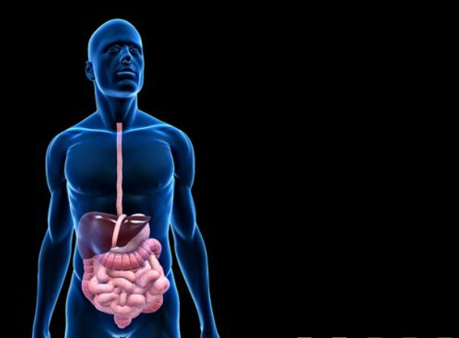

Gastriclipase
Produced by chief cells, it acts to hydrolyze fats into fatty acids and glycerol (less than 30% of lipid hydrolysis occurs in stomach)
- Mucus: Produced by gastric glands in stomach, it forms a thick slimy layer along the walls of stomach to protect them from being damaged due to action of chemicals produced in the organ (Johansson, Sjövall and Hansson, 2013).

Phase I
The first phase of digestion, also called cephalic digestion, occurs in the oral cavity and involves both mechanical and chemical procession of food.
Phase II
In stomach, second phase of digestion called gastric digestion occurs. Thick muscular walls of stomach undergo muscular contractions and relaxations to result in mechanical churning, a process which mixes digestive stomach enzymes with food (Biga et al., 2019). pH of stomach is acidic (1.5-3.5). This low pH kills bacteria in food and ‘unravels’ proteins making it easier for pepsin to act on them. Partially digested food in stomach is called chyme.
Phase III
The third phase of digestion, intestinal phase, initiates in duodenum. Fats present in chyme activate endocrine cells of inner duodenal lining to produce a hormone called cholecystokinin (Biga et al., 2019). This hormone acts on gall bladder releasing bile (produced by liver and stored in gall bladder) along the bile duct in the duodenum. Bile emulsifies (forming small globules) fats.

Oropharynx
- It is a part of pharynx which functions to push the ‘bolus’ of food via muscular contractions hence, facilitating the swallowing process (Treuting, Arends and Dintzis, 2018).
- Esophagus: It is a 25 cm long tube which pushes the food bolus from mouth to stomach via rhythmic contractions of muscles called peristalsis.

Large Intestine
- Ascending, transverse, descending and sigmoid colon
- The undigested and unabsorbed contents of food enter into large intestine via ileocecal valve.
- Any remaining nutrients and water are absorbed here and unabsorbed material is stored in semi-solid form called feces in sigmoid colon and rectum.
- The peristaltic movements of intestinal wall propel this excrete from anus via defecation (Biga et al., 2019).

Small Intestine
It is divided into three parts: duodenum, jejunum and ileum.
Duodenum
- The third phase of digestion, intestinal phase, initiates in duodenum.
- Duodenum receives digestive enzymes from pancreas via pancreatic duct. These include amylases, lipase and proteases (inactive enzymes: trypsinogen and chymotripsinogen and elastase) and several other enzymes (Freitas et al., 2018).
- As chyme enters into duodenum, it is highly acidic. For activation of digestive enzymes, it is made alkaline via action of bile, bicarbonate ions present in pancreatic secretions and biocarbonate-rich mucus released by Brunner’s glands in the duodenal lining.
  - Segmental contractions of small intestine mix chyme with digestive enzymes which act as amylase, maltase, lactase sucrose, trypsin, Chymoptrypsin and elastases, lipases and co-lipases.
Jejunum
Chyle moves via peristaltic movements from duodenum into jejunum where further absorption of food components occurs.
Ileum
Last part of small intestine which is involved in absorption of residual food components, water and bile acids and vitamin B12 occurs.

Stomach
It is a J-shaped organ with esophagus at its upper end and duodenum at its lower end. Four types of secretions are produced in stomach (Biga et al., 2019).
- Gastrin hormone: Produced by G cells within the gastric glands and stimulates the production of gastric juice. The secretion of this hormone is neuron-mediated in response to sight and smell of food (Biga et al., 2019).
- Gastric juice: Consists of sodium chloride and hydrochloric acid and is produced by inner lining of gastric mucosa.
- Digestive enzymes: Two types of digestive enzymes are produced in stomach.
- Pepsinogen (zymogen): Inactive enzyme produced by chief cells in gastric mucosa. After being converted into active form, pepsin, due to action of HCl in gastric juice, it breaks down proteins into polypeptides.

SalivaryGlands
These glands produce and secrete saliva which lubricates and softens the food when it is inserted into mouth.
Two types of salivary glands are (Treuting, Arends and Dintzis, 2018).
- Major salivary glands: Include three paired exocrine glands.
  - Parotid glands-Produce serous secretions
  - Sub-mandibular glands-Produce sero-mucous secretions
  - Sub-lingual glands-Secrete mucous fluid

- Minor salivary glands: 800-1000 glands located in oral mucosa, tongue, soft and hard palate and floor of mouth. The secretion of all of these glands is mucus that mainly functions in lubrication of oral cavity (Biga et al., 2019).

Mouth
Consists of (Treuting, Arends and Dintzis, 2018):
- Oral vestibule: Formed by lips, gums, cheeks and teeth
- Oral cavity proper: Consists of tongue, hard and soft palate and salivary glands

Location
- Head, neck, thoracic and abdominal cavities and pelvic region (Biga et al., 2019).
- Cephalic end: Mouth
- Caudal end: Anus

Digestive system consists of two parts (Biga et al., 2019):
1. Gastrointestinal/ alimentary tract:
- Consists of organs that are actively involved in digestion of food and absorption of nutrients
- Length: Varies in humans; approximately 8 to 10 meters
2. Accessory organs (Biga et al., 2019):
- Consists of organs that either store or secrete chemical substances that are passed into the alimentary canal via duct
- Salivary glands, liver, gall bladder and biliary duct and pancreas are the accessory organs
Parts of Gastrointestinal Tract
Gastrointestinal tract is divided into two parts (Biga et al., 2019):
1. Upper gastrointestinal tract: Consists of mouth (oral cavity), esophagus, stomach and duodenum (first part of small intestine)
2. Lower gastrointestinal tract: Extends from Jejunum (second part of small intestine) to the anus
The suspensory muscle of duodenum marks the division between upper and lower GITs (Biga et al., 2019).

Digestive System

