Conrod assignment
Engine of choice; Nissan RB26DETT
Introduction
In this report I will be providing some background information on the engine I have chosen, following that, I will be comparing 3 sets of graphs from 3 different rpms of a conrod in an engine. The engine I have chosen to evaluate is the RB26DETT made by Nissan. I chose this engine because I have always found it very interesting.
Brief history of the RB26DETT
The RB26DETT is a 2.6 litre (2,568cc) inline six cylinder manufactured by Nissan. The engine was produced from 1989 until 2002 for the Nissan skyline GTR line of cars ranging from the skyline GTR32 to the skyline GTR34. The block is made from cast iron and the head being made from an aluminium alloy. The valvetrain set up is DOHC 4 valves per cylinder (24 valves in total). The intake of the RB26DETT varies from other RB-series motors in that it has six individual throttle bodies (3 sets of 2 throttle assemblies that are joined together) instead of a single throttle body. The RB26DETT also uses a parallel twin-turbo system, using a pair of T25-type ceramic turbochargers set by the wastegates to limit boost pressure to 10 psi (0.69 bar), although the Skyline GT-R has a built-in boost restrictor to keep boost under 14 psi (0.97 bar).
The first 2.6 L RB26DETT was rated by Nissan at around 276BHP at 6,800 rpm and 353 NM; 260 lbf⋅ft of torque at 4,400 rpm. By the end of production, power levels had gone up to around 276 bhp at 6,800 rpm and 392 NM and 289 lbf⋅ft of torque at 4,400 rpm, not only because of developments and modifications to the engine, but also because of the "Gentlemen's Agreement" made between Japanese car manufacturers to limit the "advertised" horsepower of any vehicle to 276 BHP. The gentlemen’s agreement was agreed so that the customers were buying a car that they liked or that best suited their needs and not just because of the performance benefits. The RB26DETT is widely known and became quite popular for its strength and power potential, making it a modification friendly platform for tuners and aftermarket modifications in general.
Modification potential and limitations
As mentioned above the RB26DETT is a well-known engine for producing some serious power. In some cars they have been known to produce 1200BHP with some minor oil delivery mods and forged internals and of course more boost. From the factory the RB26DETT block suffers from oiling issues in the head. The oil galleries are too wide causing too much oil to pool in the head. To prevent this tuners fit restrictors and head oil drains. It is also well-known that the stock internals in the RB26DETT can handle 400BHP with no effect on reliability. All that is required is to add more boost, either by a big single turbo or by having two slightly bigger turbos. The RB26DETT also suffers from another issue when producing over 600bhp, and that is the block cracks between cylinders 3 and 4. It is not a major issue and is down to the block twisting. The area between cylinders 3 and 4 is thin in comparison to the rest of the block and hence therefore it is a week point.

Forces applied on the conrods

Figure [1]
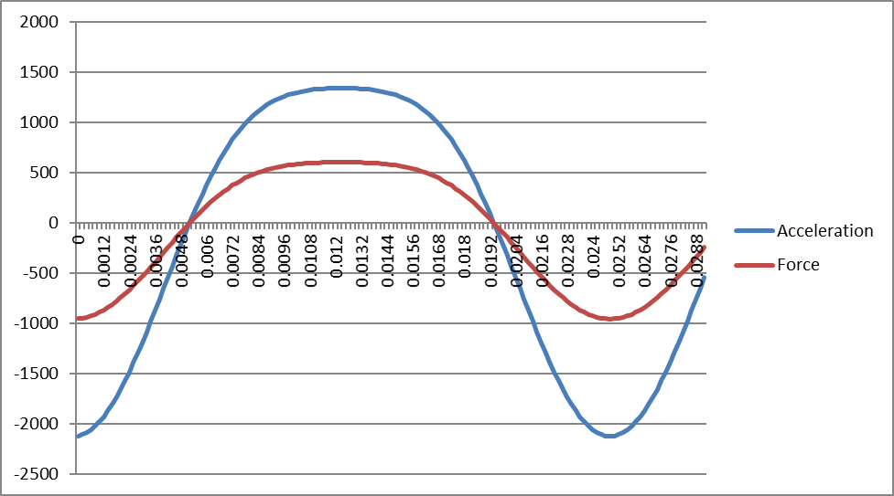
Above is [1] which is graph showing both the force and acceleration of the conrods in the RB26DETT at 2,400 rpm. The force is directly linked to the acceleration. Where the lines cross on 0, this indicates that the engine is either at bottom dead centre or top dead centre. This is because the con rod is neither going up nor down at this brief point. At 2,400 RPM the forces on the conrods is fairly low. Obviously, this is because the engine is not working that hard or producing peak power or peak torque. The power stroke is in negative figures as the piston is moving downwards, also it accelerates fast downwards and goes back up quicker than on the exhaust and compression stokes. This is because the piston and conrod are being forced down due to the combustion process.

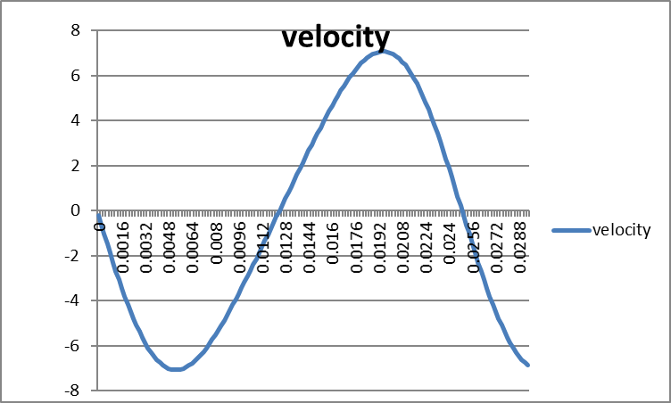
Figure [2]

The graph above [2] shows the velocity of the conrod at 2400 RPM. In this graph the power stroke is above the graph (positive figures). This can be seen because the velocity is higher on the power stroke because of the combustion process. The velocity is measured I meters per second (m/s). at peak velocity the conrod is going 7.076977187m/s.
Figure [3]
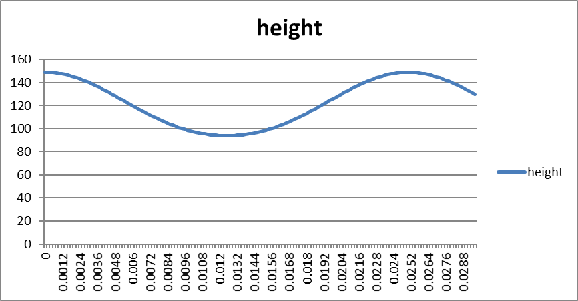
Above is [3] which is a graph that displays the height between the centre of the crankshaft and the top of the conrod at 2,400 RPM. As is clearly visible even though the conrod is a fixed length is stretches and compresses during the different strokes in the engine. The distance is measured in mm. The compression force on the conrod is at its highest during the power stroke. This is because the combustion process produces the most pressure in the cylinder which therefore puts the most about of strain and force on the conrod itself. The variation in height is also due to the conrod going up and down in the engine.
Figure [4]
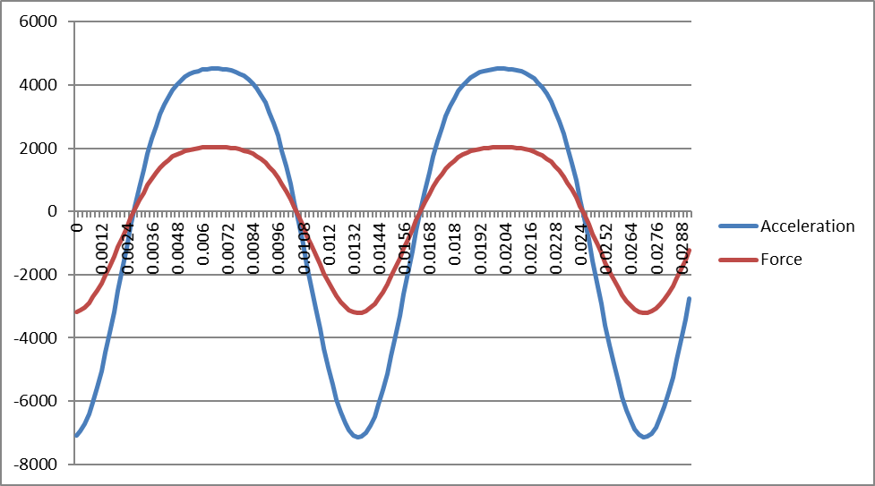
Above is figure [4] which is a graph showing the acceleration and force of a RB26DETT conrod at 4,400 RPM. This RPM is where the RB26DETT produces peak torque. The max force applied to the conrod is 2031.098378 (no units). This 3 and a bit times more than at 2,400 RPM. This is to be expected at the engine is not only rotating faster but the engine is also producing its peak torque at 4,400 RPM. Not only has the force increased but the conrod also accelerates faster. The value was around 1400 in [1] and it has increased to around 4,200 and 4,400 RPM. This is a significant increase.
Figure [5]
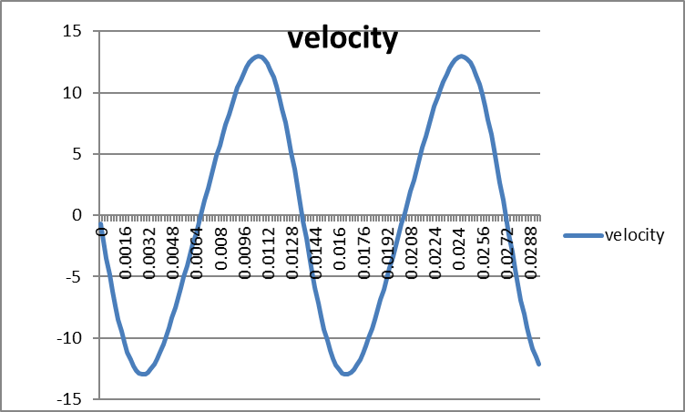
Above is figure [5] which is a graph that shows the velocity of the conrod at 4,400. Compared to [2] the velocity has only increased by 6m/s. There are two reasons for this, the first being that the engine speed is higher. The second is that the engine is producing peak torque at 4,400 RPM. Not only are the peaks higher, the graph is steeper, this indicates faster changes in velocity this is related to the increase in RPM from [2] to [5].

Figure [6]
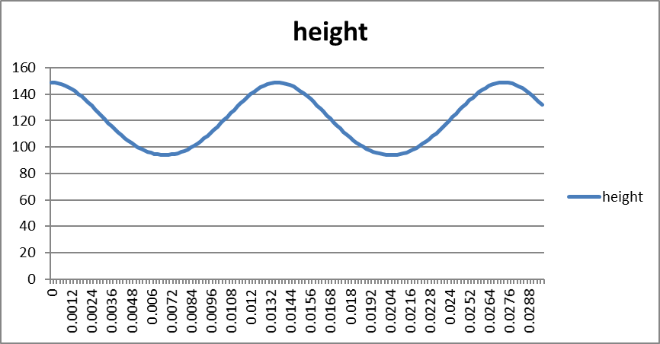
Above is figure [6] which is a graph showing the height of the top of the conrod in the RB26DETT in relation to the centre of the crankshaft. There is no change in height between [3] and [6], however there are more measurements due to the increase from 2,400 RPM to 4,400 RPM. This also means the lines are steeper as there are more measurements.
Figure [7]
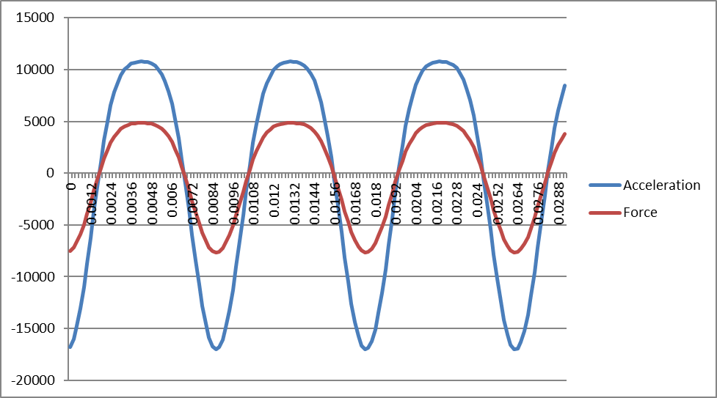
Above is figure [7] which is a graph that shows the acceleration and force of a conrod at 6,800 RPM. This is where the RB26DETT makes its peak power, so naturally the force and acceleration will be at its highest. The peak acceleration at 4,400RPM was 4,200, whereas at 6,800 RPM its 11,000. This is a huge increase in acceleration, it is almost 3 times greater with only an increase of 2,400 RPM. Not only has the acceleration increased, the force has also increased by 3,000 from [4] to [7]. The increase from [1] to [4] was only 1,400. The increase in RPM from [4] to [7] was only 400 RPM more than from [1] to [4], despite this the increase is sill bigger even despite the extra 400 RPM difference.

Figure [8]
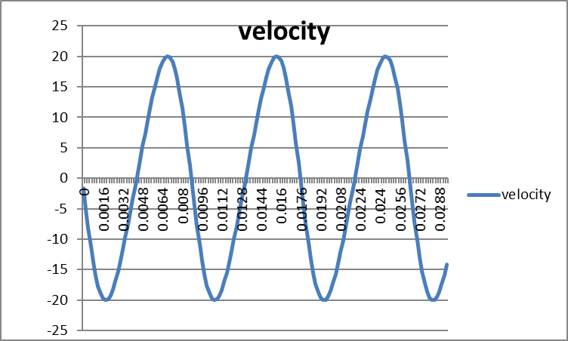
Figure [8] is a graph that shows the velocity of a conrod at 6,800 RPM. The peak velocity is 20m/s whereas in [5] it was 13m/s. This is an increase in only by 7m/s. the increase from [2] to [4] was 6m/s. Given that the increase in RPM from [2] to [5] was 2,000 RPM and the increase from [5] to [8] was 2,400 RPM, the difference is minimal despite the engine producing peak power at 6,800 RPM. This tells me that yes, the velocity is higher with more RPM as to be expected but the engine producing peak torque has a greater effect on the velocity of the conrod than more RPM and power.
Figure [9]
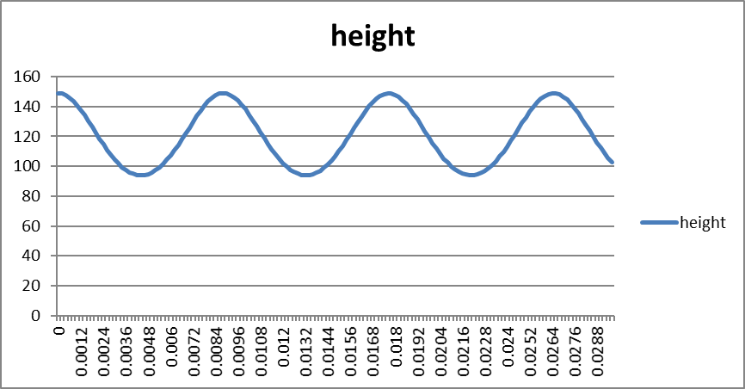
Above is figure [9] which is a graph that shows the height of the top of the conrod in relation to the centre of the crankshaft at 6,800 RPM. As with [6] there is no increase in distance, however as with [3] to [6] there are more measurements and therefore as with [3] and [6] the frequency is higher.

Conclusion
In conclusion I can say that the increase in acceleration and force between 2,400 RPM, 4,4000 RPM and 6,800 RPM was greatest from 4,400 RPM to 6,800 RPM. I believe this is due not only a bigger increase in RPM compared to 2,400 RPM to 4,400 RPM but the engine is producing its peak power at 6,800 RPM. The increase in velocity from 2,400 RPM, 4,400 RPM and 6,800 RPM was greater in value between 4,400 RPM and 6,800 RPM which was 7m/s, however the increase from 2,400 RPM to 4,400 RPM was 6m/s. To me the extra 400 RPM increase did not produce that big a jump in velocity which I find really interesting given that the RPM is higher and there was a bigger increase.
Reference list
Conrod length value; N/a, N./.A. N/A. GTRcouk. [Online]. [1 December 2019]. Available from: https://www.gtr.co.uk/forum/125318-rod-angles-vs-rod-lengths-rb26-rb28-rb29-rb30.html
General history of the RB26DETT; N/a, N./.A. unknown. Nissan RB engine. [Online]. [2 December 2019]. Available from: https://en.wikipedia.org/wiki/Nissan_RB_engine
Bibliography
Figure [1]; Graph showing force versus acceleration of a conrod in the RB26DETT engine at 2,400RPM.
Figure [2]; Graph showing the velocity of a conrod in the RB26DETT engine at 2,400RPM.
Figure [3]; graph showing the height of the top of the conrod in relation to the centre of the crankshaft in the RB26DETT at 2,400RPM
Figure [4]; graph showing the force and acceleration of a conrod in the RB26DETT at 4,400RPM
Figure [5]; Graph showing the velocity of a conrod in the RB26DETT at 4,400RPM
Figure [6]; Graph showing the height of the top of the conrod in relation to the centre of the crankshaft in the RB26DETT at 4,400RPM
Figure [7]; Graph showing the force and a acceleration of a conrod in the RB26DETT at 6,800RPM
Figure [8]; Graph showing the velocity of a conrod in the RB26DETT at 6,800RPM
Figure [9]; Graph showing the height of the top of the conrod in relation to the centre of the crankshaft in the RB26DETT at 6,800RPM

