Questions and Guidelines for Assessment Component 1


Changemakers: Creativity and Value Creation
Professions (BMHP5014)

Component 2: Poster and Pitch

Student name: Liliana Vladut
Student number:2411574
Lecturer’s name: Brian Mashumba

Table of contents
- Poster .............................................................................................................. 1
- Written Pitch .................................................................................................... 2
2.1 Introduction ............................................................................................... 2
2.2 Background ............................................................................................... 2
2.3 Innovation Description .............................................................................. 3
2.4 Impact on Health and Social Care ............................................................ 4
2.5 Public and Stakeholder Involvement ......................................................... 5
2.6 Policies, Services and Professional Links ................................................. 6
2.7 Conclusion ................................................................................................ 7
- Reference List ................................................................................................. 8

Task 1 Poster.

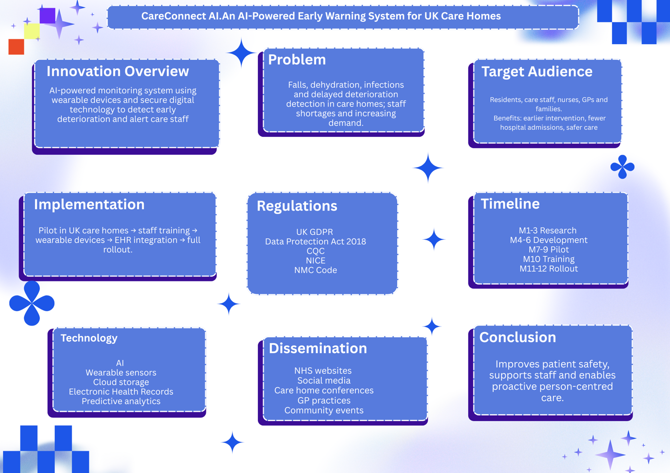
(poster created by Liliana Vladut using Canva ,2026)

Task 2:Pitch

CareConnect AI: An AI-Powered Early Warning System for UK Care Homes

Introduction
The increasing demand for high-quality health and social care services has highlighted the need for innovative solutions that improve patient safety while supporting healthcare professionals. One of the greatest challenges facing UK care homes is the early identification of health deterioration among older adults, particularly those living with multiple long-term conditions, frailty, or dementia. Delays in recognising changes in a resident’s condition can result in avoidable hospital admissions, poorer health outcomes, and increased pressure on NHS services (NHS England, 2019). CareConnect AI is an innovative digital monitoring system that combines artificial intelligence (AI), wearable technology, and secure health data systems to identify early signs of deterioration and alert care staff in real time. The innovation aims to enhance person-centred care by supporting earlier clinical intervention rather than replacing professional judgement. By integrating advanced technology into everyday care, CareConnect AI has the potential to improve resident wellbeing, strengthen workforce efficiency, and contribute to safer and more sustainable health and social care services.

Background
The UK population is ageing rapidly, leading to an increasing number of older adults requiring residential and nursing care. According to the Office for National Statistics, the proportion of people aged 65 years and over continues to rise, increasing demand for health and social care services. Many care home residents live with multiple chronic illnesses, dementia, reduced mobility, and frailty, making them particularly vulnerable to sudden deterioration in health. As a result, timely recognition of physical changes has become a major priority for improving patient safety.
Falls remain one of the most common causes of injury among older adults living in care homes. In addition to falls, dehydration, urinary tract infections, respiratory infections, and reduced mobility frequently lead to emergency hospital admissions when early warning signs are not recognised promptly. Evidence suggests that many of these admissions could be prevented through earlier assessment and intervention (NICE, 2023). However, care homes continue to face significant workforce pressures, including staff shortages, increased workloads, and growing complexity of resident needs. These challenges can reduce the amount of time available for continuous observation and limit opportunities to identify subtle changes in residents' health before their condition deteriorates.
Digital transformation has become a central objective within UK healthcare policy. The NHS Long Term Plan encourages greater use of digital technologies, artificial intelligence, and predictive analytics to improve patient outcomes while increasing efficiency across health and social care services (NHS England, 2019). Similarly, the Care Quality Commission emphasises the importance of safe, effective, and person-centred care supported by appropriate digital systems (CQC, 2024).
The Office for National Statistics (2023) estimates that 11 million people in the UK are 65 years of age or older, making up around 19% of the country's overall population. In England, almost 400,000 senior citizens dwell in residential and nursing care facilities. With almost 250,000 fall-related emergency hospital admissions among adults 65 and older each year in England, falls continue to be one of the most common causes of injury. Additionally, among the most frequent preventable reasons for care home residents to be admitted to the hospital are respiratory infections, UTIs, and dehydration. These numbers underline the necessity for cutting-edge technology like Care Connect AI and emphasise the significance of early detection of health decline.

Artificial intelligence has already demonstrated considerable potential in healthcare by analysing large datasets and identifying patterns that may not be immediately recognised by healthcare professionals. Rather than replacing nurses or care workers, AI can provide additional decision-support by continuously monitoring information and highlighting residents who may require urgent assessment. This proactive approach aligns closely with the principles of preventative healthcare, where intervention occurs before serious illness develops. Consequently, introducing intelligent monitoring systems such as CareConnect AI represents an opportunity to improve resident safety while supporting staff to deliver higher-quality care in increasingly demanding care environments.

Innovation Description
CareConnect AI is an intelligent digital monitoring system developed to improve the quality and safety of care provided in UK residential and nursing homes. Unlike traditional monitoring methods that rely on scheduled observations, the system provides continuous real-time monitoring of residents through wearable technology and artificial intelligence. The innovation has been designed to support healthcare professionals by identifying early signs of health deterioration before they develop into serious medical emergencies.
Each resident would wear a lightweight wrist device capable of recording physiological and behavioural information, including movement patterns, heart rate, sleep quality, physical activity, and prolonged periods of inactivity. The wearable device securely transfers this information to a cloud-based platform where artificial intelligence continuously analyses the data against each resident's normal health profile. Rather than relying on fixed thresholds alone, the AI system learns individual patterns over time, allowing it to recognise subtle changes that may indicate illness or deterioration.
When unusual changes are detected, such as an increased risk of falls, reduced mobility, dehydration, or abnormal heart rate patterns, the system immediately sends an alert to care staff through a secure mobile application. Healthcare professionals can then assess the resident, carry out appropriate observations, and decide whether further clinical intervention is required. This approach allows staff to respond proactively rather than waiting until symptoms become severe.
CareConnect AI would also integrate with existing Electronic Health Record (EHR) systems, allowing authorised healthcare professionals to access relevant information while maintaining compliance with the UK General Data Protection Regulation (GDPR) and the Data Protection Act 2018. The innovation does not replace professional judgement or direct patient care; instead, it strengthens clinical decision-making by providing additional information that supports safer and more timely interventions.
The innovation reflects Rogers' Diffusion of Innovation Theory, which suggests that new technologies are more likely to be adopted when they demonstrate clear advantages, are compatible with existing practice, and are simple for users to understand and implement (Rogers, 2003). By combining artificial intelligence with person-centred care, CareConnect AI offers a practical and scalable solution that supports both residents and healthcare professionals while contributing to the digital transformation of UK health and social care services.

Impact on Health and Social Care
The implementation of CareConnect AI has the potential to generate significant benefits for residents, healthcare professionals, care providers, and the wider NHS. The primary advantage is the earlier identification of health deterioration, enabling timely intervention before minor health concerns develop into serious medical emergencies. Earlier detection may reduce avoidable hospital admissions, shorten recovery times, and improve residents' overall quality of life. This supports the NHS commitment to preventative healthcare and the delivery of more integrated, person-centred services (NHS England, 2019).
For residents, continuous monitoring increases safety while maintaining independence and dignity. Unlike constant physical supervision, wearable technology allows individuals to continue their daily activities without unnecessary restrictions. Families may also experience greater reassurance, knowing that their relatives are being monitored continuously and that care staff will receive immediate alerts if concerns arise. This can strengthen trust between families and care providers while improving satisfaction with the quality of care.
Healthcare professionals would also benefit from improved clinical decision-making. Rather than replacing nurses and care workers, CareConnect AI supports professional judgement by providing additional evidence that helps staff prioritise residents who require urgent assessment. This may improve workload management, particularly in care homes experiencing staffing shortages, where professionals must care for multiple residents simultaneously. Artificial intelligence therefore acts as a clinical decision-support tool rather than an independent decision-maker (Topol, 2019).
From an organisational perspective, fewer emergency hospital admissions and improved preventative care could reduce healthcare costs while improving compliance with Care Quality Commission (CQC) quality standards. The innovation also supports the NHS Long Term Plan, which promotes the wider adoption of digital technologies to improve patient outcomes and increase service efficiency (NHS England, 2019).
Despite these advantages, successful implementation would require careful consideration of several challenges. Initial investment in digital infrastructure, staff training, cybersecurity, and ongoing maintenance may represent significant financial costs for some care providers. Furthermore, healthcare professionals may initially be hesitant to trust AI-generated recommendations without sufficient education and evidence of effectiveness. Ethical concerns surrounding data privacy, informed consent, and algorithm transparency must also be addressed to ensure that residents' rights remain fully protected (Floridi et al., 2018). Consequently, CareConnect AI should be viewed as a supportive technology that complements compassionate, person-centred care rather than replacing human interaction.

Public and Stakeholder Involvement
Successful implementation of CareConnect AI would require collaboration between a wide range of stakeholders throughout the planning, development, and evaluation process. Residents and their families should be actively involved to ensure that the technology reflects their needs, preferences, and expectations. Collecting regular feedback would help developers improve usability while ensuring that residents continue to receive person-centred care rather than technology-driven care.
Care home managers and frontline healthcare professionals, including nurses, care workers, occupational therapists, and general practitioners, would play a vital role in identifying practical challenges and supporting implementation within everyday practice. Their involvement is essential because they possess first-hand knowledge of clinical workflows and resident care needs. Involving staff during the design process may also improve acceptance of the innovation and reduce resistance to organisational change.
External organisations such as NHS England, the Care Quality Commission (CQC), technology developers, and academic researchers would also contribute to evaluating safety, effectiveness, and regulatory compliance. Working collaboratively with these stakeholders supports co-production, which is recognised as an important principle within modern health and social care. Co-production encourages shared decision-making between professionals and service users, resulting in innovations that are more effective, acceptable, and responsive to the needs of the people they are designed to support (NICE, 2021).
Care workers, nurses, and care home managers should contribute to the design, testing, and evaluation of CareConnect AI because they understand the daily challenges of providing care. Their feedback can help improve the system, making it practical and easy to use in everyday practice. Providing staff with training and opportunities to share their experiences can also increase confidence and encourage successful adoption.
General practitioners (GPs), occupational therapists, physiotherapists, and other healthcare professionals should work closely with care homes to ensure that alerts generated by the system lead to appropriate clinical decisions. Finally, technology developers and researchers should continue collecting feedback from all stakeholders to improve the system and ensure it remains safe, effective, and person-centred.

Policies, Services and Professional Links
The implementation of CareConnect AI aligns with several UK health and social care policies, professional standards, and regulatory frameworks that promote safe, effective, and person-centred care. One of the most significant policy documents is the NHS Long Term Plan, which highlights the importance of digital transformation, artificial intelligence, and data-driven healthcare to improve patient outcomes and reduce pressure on health services (NHS England, 2019). By supporting earlier detection of health deterioration, CareConnect AI contributes directly to these national priorities.
The innovation also supports the Health and Social Care Act 2012, which encourages integrated working between healthcare providers and social care organisations to improve service quality and patient outcomes (Department of Health, 2012). Through secure integration with Electronic Health Records, CareConnect AI promotes improved communication between care homes, general practitioners, hospitals, and multidisciplinary teams, enabling more coordinated care.
From a regulatory perspective, the system aligns with the Care Quality Commission (CQC) Single Assessment Framework, particularly the domains relating to safety, effectiveness, responsiveness, and person-centred care (Care Quality Commission, 2024). Continuous monitoring enables healthcare professionals to identify risks more quickly and respond appropriately, supporting organisations in meeting CQC quality standards.
Professional practice must also comply with the Nursing and Midwifery Council (NMC) Code, which requires nurses to prioritise people, preserve safety, practise effectively, and promote professionalism and trust (NMC, 2018). CareConnect AI strengthens these professional responsibilities by providing timely clinical information that supports evidence-based decision-making while ensuring that accountability remains with registered healthcare professionals.
Finally, the collection and processing of residents' health information must comply fully with the UK General Data Protection Regulation (UK GDPR) and the Data Protection Act 2018, ensuring confidentiality, informed consent, secure data storage, and appropriate access controls (Information Commissioner's Office, 2023). Maintaining strong governance arrangements is essential to build trust among residents, families, and healthcare professionals.

Conclusion
In conclusion, CareConnect AI represents an innovative solution capable of improving patient safety, enhancing person-centred care, and supporting healthcare professionals within UK care homes. By combining wearable technology, artificial intelligence, and secure digital health systems, the innovation enables earlier recognition of health deterioration, allowing timely intervention before conditions become more serious. This proactive approach has the potential to reduce avoidable hospital admissions, improve residents' quality of life, and increase the efficiency of health and social care services.
Although successful implementation requires investment, workforce training, robust cybersecurity measures, and careful consideration of ethical issues surrounding data privacy, the potential long-term benefits outweigh these challenges. Importantly, CareConnect AI is not intended to replace healthcare professionals but to enhance their clinical judgement through intelligent decision support. As the demand for high-quality care continues to grow alongside an ageing population, digital innovations such as CareConnect AI are likely to play an increasingly important role in delivering safer, more efficient, and more sustainable health and social care services. By supporting national healthcare priorities and promoting collaborative, preventative care, CareConnect AI demonstrates how technology can positively transform the future of care in the United Kingdom.

Reference List
Care Quality Commission (2024) Single Assessment Framework. London: CQC.
Department of Health (2012) Health and Social Care Act 2012. London: HMSO.
Floridi, L., Cowls, J., Beltrametti, M., Chatila, R., Chazerand, P., Dignum, V., Luetge, C., Madelin, R., Pagallo, U., Rossi, F. and Schafer, B. (2018) ‘AI4People—An ethical framework for a good AI society’, Minds and Machines, 28(4), pp. 689–707.
Information Commissioner's Office (2023) Guide to UK GDPR. Available at: https://ico.org.uk/ (Accessed: 17 July 2026).
National Institute for Health and Care Excellence (2021) Shared decision making (NG197). London: NICE.
National Institute for Health and Care Excellence (2023) Falls in older people: assessing risk and prevention (CG161). London: NICE.
NHS England (2019) The NHS Long Term Plan. London: NHS England.
Nursing and Midwifery Council (2018) The Code: Professional standards of practice and behaviour for nurses, midwives and nursing associates. London: NMC.
Office for National Statistics (2023) Living longer: older people and ageing in the UK. Newport: ONS.
Rogers, E.M. (2003) Diffusion of Innovations. 5th edn. New York: Free Press.
Topol, E. (2019) Deep Medicine: How Artificial Intelligence Can Make Healthcare Human Again. New York: Basic Books.

