UNIVERSITY OF WALES
TRINITY SAINT DAVID
Student: Hazra Bibi
Student number: 2420438
Programme: BSc Health and Social Care

Module: Protecting and Supporting Families in Health and Care
BMHP5021
Component 1: Presentation (Round-The-Table Group Discussion)
Protecting Children and Families: A Health Perspective on Five NSPCC Case Reviews

Panel role: Named Nurse for Safeguarding Children
Lecturers: Kennedy Obohwemu/Olufemi Oluranti

Submission date: 18.10.2026

Table of Contents
1. Introduction 3
2. Well-being and the Legal and Policy Framework 4
3. The National Picture 5
4. Professional Opinion on the Five Cases 7
Case 1: Child A 7
Case 2: Child F 8
Case 3: Child HN 8
Case 4: Adult A/Child A 9
Case 5: Theo 9
5. Conclusions 10
6. Recommendations 10
Reference List 11

Introduction
Good morning. In this round-the-table discussion, I am speaking as the Named Nurse for Safeguarding Children, representing the health partner on the panel. My role is to make sure that what health professionals know about a child, from midwives, health visitors, school nurses, GPs and hospital teams, reaches the multi-agency table at the right time (Department for Education (DfE), 2026a). Rather than examining a single case in isolation, I will offer a professional opinion on all five case reviews because, taken together, they reveal recurring patterns rather than one-off failures. To frame the discussion, I draw on the Adverse Childhood Experiences (ACEs) framework, which links abuse, neglect and household dysfunction to poorer health across the life course (Felitti et al., 1998; Bellis et al., 2015). Furthermore, I consider how children and families themselves perceive well-being, how partnership working succeeded or failed, and what current law and policy require. Finally, I draw conclusions and offer recommendations to strengthen multi- and inter-disciplinary practice.

2. Well-being and the Legal and Policy Framework
Before turning to the cases, it is important to clarify what well-being means to the people at the centre of them. Statham and Chase (2010) argue that well-being is multidimensional and partly subjective; children tend to describe it in terms of relationships, safety and being listened to, whereas professionals often measure it through developmental milestones and service contact. Consequently, a family may feel that they are coping while professionals see risk, or the reverse, and this tension is visible in every case below.
Legally, the Children Act 1989 places a duty on local authorities to promote the welfare of children in need (s.17) and to make enquiries where significant harm is suspected (s.47), while the Children Act 2004 (s.11) extends safeguarding duties to health bodies and the police. Following the Children and Social Work Act 2017, safeguarding partnerships of the local authority, the integrated care board, and the police now commission the practice reviews discussed here. In addition, the Domestic Abuse Act 2021 recognises children as victims in their own right, and the Care Act 2014 (s.42) governs adult safeguarding, including self-neglect. More recently, Working Together to Safeguard Children 2026 strengthens expectations about babies, domestic abuse and multiple harms (DfE, 2026a; NSPCC Learning, 2026), and the Children's Wellbeing and Schools Act 2026 introduces multi-agency child protection teams, a single unique identifier for children and a register of children not in school. Notably, these reforms directly address failures repeatedly identified by national reviews (Child Safeguarding Practice Review Panel, 2022).

3. The National Picture
To place the five cases in context, Table 1 summarises safeguarding activity in England for the year ending 31 March 2025.
Table 1: Key safeguarding indicators, England, year ending 31 March 2025
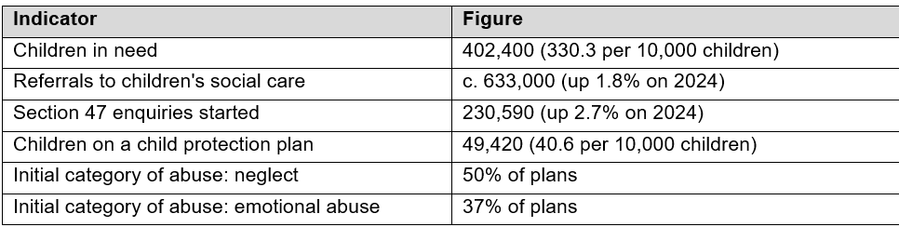
Source: DfE (2025)

Table 1 shows that almost five section 47 enquiries were started for every child on a protection plan (230,590 compared with 49,420). On the one hand, this suggests that agencies are vigilant; on the other hand, it means that many families experience an investigation without receiving a plan, and possibly without receiving help. Moreover, neglect remains the leading category of concern, which matters because neglect runs through most of the cases discussed below (DfE, 2025).
Figure 1 then tracks the number of children on protection plans over six years.

Figure 1: Children subject to a child protection plan at 31 March, England, 2020-2025
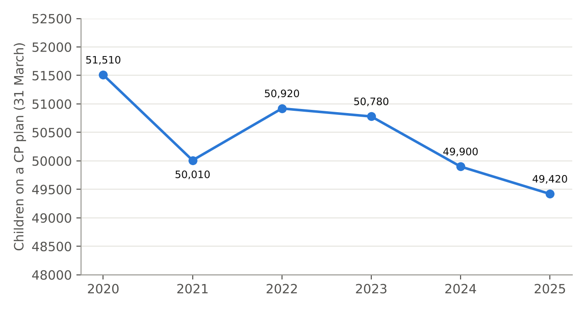
Source: DfE (2025)
As Figure 1 illustrates, the line falls gradually from 51,510 in 2020 to 49,420 in 2025, the lowest level since 2014, even though section 47 enquiries rose in the latest year (DfE, 2025). Critically, a falling number of plans is not automatically good news. It may reflect earlier family help; however, it may equally reflect thresholds rising under pressure, so that children such as Theo are stepped down from protection planning too early (Derby and Derbyshire Safeguarding Children Partnership (DDSCP), 2024).
Similarly, Figure 2 compares serious incident notifications, which local authorities must make when a child dies or is seriously harmed and abuse or neglect is known or suspected.

Figure 2: Serious incident notifications by outcome, England, 2019, 2025 and 2026
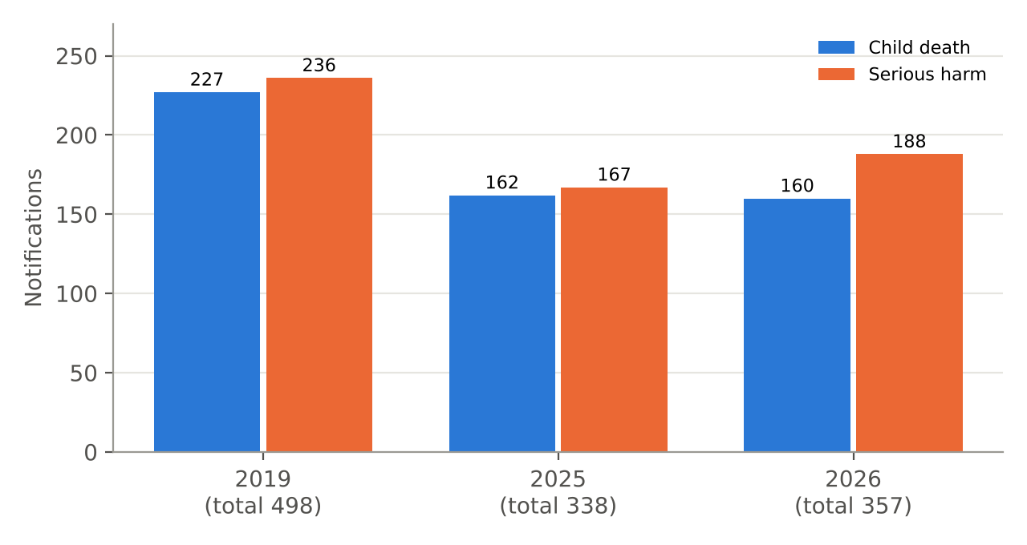
Source: DfE (2026b). Totals include a small number of notifications not classed as death or serious harm.
Figure 2 shows that total notifications fell from 498 in 2019 to 338 in 2025, but then rose to 357 in 2026, driven by serious harm, which increased from 167 to 188 (DfE, 2026b). Although the overall trend is encouraging, the DfE itself cautions that not all qualifying incidents are notified; therefore, I treat these figures as the visible tip of harm rather than its full extent. In my view, the 2026 rise in serious harm is a warning against complacency.
Finally, Table 2 links the five cases to the ACEs evidence, using the Welsh ACE Study, which surveyed adults about their childhood experiences.
Table 2: Prevalence of Adverse Childhood Experiences among adults in Wales,
linked to the five case reviews
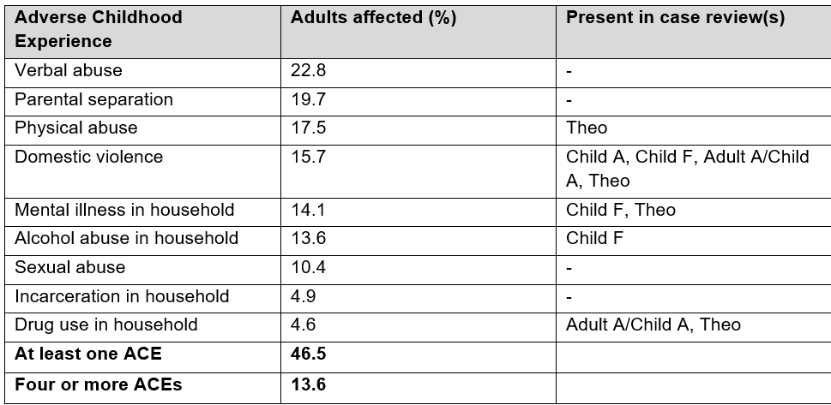
Source: Bellis et al. (2015, pp. 8, 29); case review column compiled from BSCP (2025), ESSCP (2026), Salford Safeguarding Adults Board and Salford Safeguarding Children Partnership (2024) and DDSCP (2024)

Table 2 shows that almost half of adults (46.5%) experienced at least one ACE and 13.6% experienced four or more. Importantly, adults with four or more ACEs had 14.2 times the odds of being a victim of violence and 20.4 times the odds of incarceration compared with those with none (Bellis et al., 2015, pp. 14-16). Therefore, the clustering of domestic abuse, parental mental ill-health and substance misuse in these cases is not coincidental; rather, it reflects the interacting parental risks that national analyses of serious case reviews have highlighted for many years (Brandon et al., 2020).

4. Professional Opinion on the Five Cases

Case 1: Child A
Child A was a three-year-old boy who died in early 2020; however, his death remained hidden until December 2022, when his parents disclosed that they had buried him in the garden of their former home (Birmingham Safeguarding Children Partnership (BSCP), 2025). The family had been known since 2015 for late antenatal care, homelessness, neglect and parental resistance, while coercion and control featured in the parents' relationship. From the family's perspective, well-being appears to have been defined by their own beliefs and a wish to avoid scrutiny, and Child A's own voice was entirely absent. In my opinion, the most troubling learning is that a child could disappear from professional view for almost three years without any agency raising the alarm. Missed appointments and refused immunisations were treated as administrative events rather than as signals of hidden harm, which echoes Ferguson's (2017) finding that children become invisible when professionals focus on parents. As the health representative, I would argue that universal services are the safety net here: a child missing from health visiting reviews should trigger a 'Was Not Brought' escalation, not a discharge letter. Furthermore, the review rightly states that culture and belief must inform practice but must never lower the threshold for protection.

Case 2: Child F
Child F was a 15-year-old girl who experienced a serious safeguarding incident in January 2024 while living with her father and half-sibling under a child in need plan (East Sussex Safeguarding Children Partnership (ESSCP), 2026). Significantly, she had already been subject to four previous plans because of neglectful parenting, she had witnessed domestic abuse, and adults caring for her had mental health and alcohol difficulties. In my view, four plans suggest a 'revolving door' in which each episode closed once immediate concerns eased, while cumulative harm was never fully analysed. Additionally, her mental health needs fell between services, and her sexualised behaviour was not consistently recognised as a possible indicator of abuse. Crucially, the review warns professionals not to rely on children to tell, because adolescents may minimise harm to protect their family. From a health perspective, once she was removed from school roll to home education, the school nursing service lost its main route of contact; consequently, the new register of children not in school is a welcome safeguard. I therefore agree with the review's recommendation to convene a core group whenever a child on a plan is removed from school.

Case 3: Child HN
Child HN concerns an adolescent whose neglect, including unmet health needs, was not recognised as neglect early enough; indeed, the partnership has since used this review as the foundation of its local learning on adolescent neglect (Herefordshire Safeguarding Children Partnership (HSCP), 2024). The perception of well-being is especially complex here, because professionals and parents can frame a teenager's missed appointments as a lifestyle choice rather than as a failure of parental care. In my opinion, this is where health professionals carry particular responsibility. Clinic non-attendance, unfilled prescriptions and repeated emergency attendances form a pattern that only becomes visible when shared, and therefore health must bring this chronology to the multi-agency table. Moreover, respecting a young person's growing autonomy does not remove parents' legal responsibility to meet their health needs under the Children Act 1989. Consequently, I would advocate replacing the language of 'Did Not Attend' with 'Was Not Brought' for under-18s, so that non-attendance prompts curiosity rather than discharge.

Case 4: Adult A/Child A
This joint review examined an adult's self-neglect alongside the neglect of the children in the same household, against a background of domestic abuse, including coercive and controlling behaviour, substance misuse and the restrictions of the Covid-19 pandemic (Salford Safeguarding Adults Board and Salford Safeguarding Children Partnership, 2024). From the family's perspective, cultural heritage shaped their lived experience; however, interpreters were used inconsistently, so their voice was not fully heard. In my view, the central weakness was that adult and children's services worked in parallel rather than together. Siblings were allocated to different social workers, adult and children's records sat on separate systems, and district nurses who struggled to gain access did not escalate effectively. As a health professional, I would argue that a 'Think Family' approach is not optional: where a parent's self-neglect is serious enough to prompt a Care Act 2014 (s.42) enquiry, the children in the home should automatically be considered under the Children Act 1989, and vice versa. Furthermore, the single unique identifier introduced in 2026 should help to connect these records in practice.

Case 5: Theo
Theo was a ten-month-old baby who died in his parents' care from injuries that were likely to have been inflicted (DDSCP, 2024). Both parents had long-standing difficulties with cannabis misuse, mental health and domestic abuse, and Theo's mother's pregnancy was concealed until a late emergency booking. Despite this, Theo and his sister were returned to their parents during the Covid-19 pandemic, protection plans ended once supervision orders were made, and the parents' own accounts were relied upon heavily (DDSCP, 2024, pp. 20-21). Most strikingly, police attended the home for a drug-related disturbance six weeks after the children returned but did not check on them, and a bruise on Theo's head was not properly explored. In my professional opinion, this case demonstrates the danger of optimism bias: cannabis use was normalised and discussed in terms of honesty rather than its impact on parenting (DDSCP, 2024, pp. 26-30). As the health partner, I would insist that any bruise on a non-mobile baby triggers the local bruising protocol and a paediatric assessment, and that health visitors are consulted before any reunification decision. Ultimately, as Munro (2011) argues, a child-centred system must keep the child's daily experience, not procedural compliance, at its centre.

5. Conclusions
In conclusion, the five cases show that current policy is broadly sound but inconsistently applied. Working Together 2026 and the Children's Wellbeing and Schools Act 2026 address the right issues, namely information sharing, babies, domestic abuse and children out of school; nevertheless, policy alone did not protect Child A, Child F, Child HN, the children in the Salford family or Theo. Instead, the recurring themes are invisible children, over-reliance on parental self-report, fragmentation between adult and children's services, and step-down decisions made without the whole partnership. Consequently, the impact of agencies' responses on children was cumulative harm, and in two cases death. Equally, each review shows that health professionals hold vital information, such as missed appointments, injuries and pregnancy history, which only protects children when it is shared and acted upon.

6. Recommendations
Therefore, from the health perspective, I recommend the following improvements to multi- and inter-disciplinary practice:
- Implement the single unique identifier quickly, so that health, education, police and social care records, including adult services, can be linked.
- Ensure that every new multi-agency child protection team includes a named health practitioner, and adopt 'Was Not Brought' pathways for all under-18s.
- Develop joint 'Think Family' protocols, so that adult safeguarding enquiries automatically consider the children in the household.
- Strengthen professional curiosity through reflective supervision, by triangulating parental self-report with direct observation and records from other agencies.
- Capture the child's voice through direct work, particularly with adolescents, rather than relying on children to disclose.
Above all, partnership working must be judged not by the number of meetings held but by whether the child is seen, heard and kept safe.

Reference List
Bellis, M.A., Ashton, K., Hughes, K., Ford, K., Bishop, J. and Paranjothy, S. (2015) Adverse Childhood Experiences and their impact on health-harming behaviours in the Welsh adult population. Cardiff: Public Health Wales NHS Trust.
Available at: https://www.wao.gov.uk/sites/default/files/2020-12/ACE_Report_FINAL.pdf (Accessed: 15/10/2026).

Birmingham Safeguarding Children Partnership (BSCP) (2025) Local child safeguarding practice review: Child A. Birmingham: BSCP. Available at: https://learning.nspcc.org.uk/case-reviews/recently-published-case-reviews (Accessed: 14/10/2026).

Brandon, M., Sidebotham, P., Belderson, P., Cleaver, H., Dickens, J., Garstang, J., Harris, J., Sorensen, P. and Wate, R. (2020) Complexity and challenge: a triennial analysis of SCRs 2014-2017. London: Department for Education.

Care Act 2014, c. 23. Available at: https://www.legislation.gov.uk/ukpga/2014/23 (Accessed: 15/10/2026).

Child Safeguarding Practice Review Panel (2022) Child protection in England: national review into the murders of Arthur Labinjo-Hughes and Star Hobson. London: HMSO.

Children Act 1989, c. 41. Available at: https://www.legislation.gov.uk/ukpga/1989/41 (Accessed: 15/10/2026).

Children Act 2004, c. 31. Available at: https://www.legislation.gov.uk/ukpga/2004/31 (Accessed: 15/10/2026).

Children and Social Work Act 2017, c. 16. Available at: https://www.legislation.gov.uk/ukpga/2017/16 (Accessed: 14/10/2026).

Children's Wellbeing and Schools Act 2026. London: The Stationery Office.
Department for Education (DfE) (2025) Children in need: reporting year 2025. London: DfE. Available at: https://explore-education-statistics.service.gov.uk/find-statistics/children-in-need (Accessed: 14/10/2026).
Department for Education (DfE) (2026a) Working together to safeguard children 2026: a guide to multi-agency working to help, protect and promote the welfare of children. London: DfE. Available at: https://assets.publishing.service.gov.uk/media/69c2c4ce380a2a73a7cf9df4/Working_together_to_safeguard_children_2026.pdf (Accessed: 15/10/2026).

Department for Education (DfE) (2026b) Serious incident notifications: reporting year 2026. London: DfE. Available at: https://explore-education-statistics.service.gov.uk/find-statistics/serious-incident-notifications (Accessed: 14/10/2026).

Derby and Derbyshire Safeguarding Children Partnership (DDSCP) (2024) Theo: local child safeguarding practice review. Derby: DDSCP. Available at: https://www.ddscp.org.uk/media/derby-scb/content-assets/documents/serious-case-reviews/ddscp_tds20_lcspr_final(2)_14.03.24.pdf (Accessed: 14/10/2026).

Domestic Abuse Act 2021, c. 17. Available at: https://www.legislation.gov.uk/ukpga/2021/17 (Accessed: 15/10/2026).

East Sussex Safeguarding Children Partnership (ESSCP) (2026) Local child safeguarding practice review: Child F. Lewes: ESSCP. Available at: https://learning.nspcc.org.uk/case-reviews/recently-published-case-reviews (Accessed: 13/10/2026).

Felitti, V.J., Anda, R.F., Nordenberg, D., Williamson, D.F., Spitz, A.M., Edwards, V., Koss, M.P. and Marks, J.S. (1998) 'Relationship of childhood abuse and household dysfunction to many of the leading causes of death in adults: the Adverse Childhood Experiences (ACE) Study', American Journal of Preventive Medicine, 14(4), pp. 245-258.

Ferguson, H. (2017) 'How children become invisible in child protection work: findings from research into day-to-day social work practice', British Journal of Social Work, 47(4), pp. 1007-1023.

Herefordshire Safeguarding Children Partnership (HSCP) (2024) Final report: local child safeguarding practice review Child HN. Hereford: HSCP. Available at: https://www.herefordshiresafeguardingboards.org.uk/wp-content/uploads/2024/03/Final-Report-LCSPR-Child-HN_Herefordshire-January-2024.pdf (Accessed: 12/10/2026).

Munro, E. (2011) The Munro review of child protection: final report - a child-centred system. Cm 8062. London: The Stationery Office.

NSPCC Learning (2026) Working Together to Safeguard Children 2026: summary of changes. London: NSPCC.
Available at: https://learning.nspcc.org.uk/research-resources/2026/working-together-to-safeguard-children-2026-summary-of-changes (Accessed: 12/10/2026).

Salford Safeguarding Adults Board and Salford Safeguarding Children Partnership (2024) Joint adults' and children's review: briefing document. Salford: SSAB and SSCP.
Available at: https://safeguardingchildren.salford.gov.uk/media/hy5bqk0j/sar-cspr-briefing-document-august-2024-v2.pdf (Accessed: 15/10/2026).

Statham, J. and Chase, E. (2010) Childhood wellbeing: a brief overview. Loughborough: Childhood Wellbeing Research Centre.

