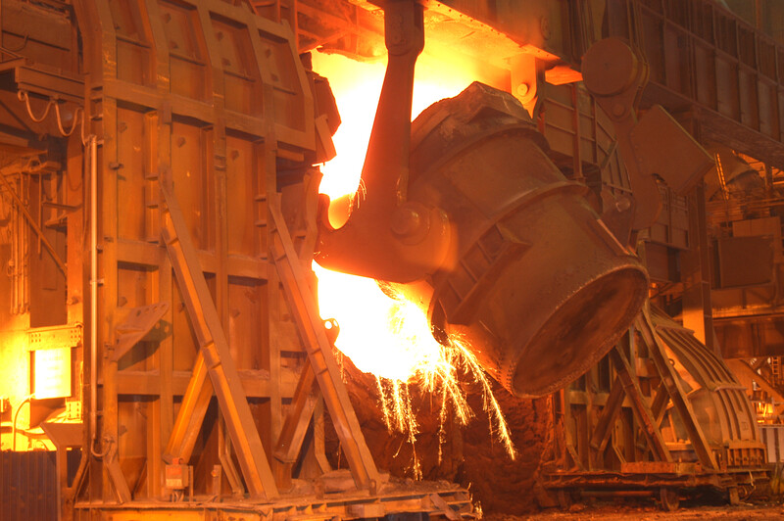
The Environmental Impact of a Basic Oxygen Steelmaking Plant
[Document subtitle]
Bradwell, Matthew | 5/19/23 | Advanced Manufacturing Operations

Declaration of Authenticity
‘This thesis is the result of the author’s original research. It has been composed by the author and has not been previously submitted for examination which has led to the award of a degree.’

Abstract
The steel making process can be divided into 5 processes. Blast furnace where the iron ore is converted to liquid iron. BOS Plant where the iron is converter to steel, casting where the liquid steel is cast into slab, hot rolling where the steel is hot rolled into sheets and cold rolling where cold steel is rolled into sheets. It will then go directly to the customer or to a downstream operations sector for further work or treatment. This dissertation will be focusing on the BOS Plant process. There are also multiple factors to how we can damage the environment. Ground contamination, destruction of habitats, water contamination or air quality. For this dissertation the focus will be applied to air quality and how the basic oxygen steelmaking process can have an effect on the environment through contaminating the air. This will allow focus onto the effect of particle matter, global warming and the effects on the local community. With the Port Talbot site being such a large steel making process there are a number of compliance obligations that will be discussed.

Table of contents
Contents
Declaration of Authenticity 1
Abstract 1
Table of contents 1
List of Figures & Tables 4
1. Introduction 5
2. Literature Review 6
2.1 Particulate Matter 6
2.1.1 PM10 levels 6
2.1.2 PM 2.5 levels 6
2.2 Social Impact 6
2.3 Greenhouse Effect & Global Warming 7
2.4 Net Zero 7
2.5 Visual Emissions 8
2.6 Aloatec Camera 8
3. The Process 9
4. Analysis 10
4.1 Compliance 10
4.1.1 Permit Compliance 10
4.2 ISO14001 Compliance 11
4.2.1 External Audit 11
4.2.2 Internal Audit 11
4.2.3 Asset Health Assessments 12
4.2.4 TCE 12
4.3 Aspects and Impacts register. 12
4.4 Emission Process Flow 13
4.5 Emission Calculation 13
5. Evaluation 14
5.1 The Cause 14
5.1.1 Scrap Types 14
5.2 Fume Extraction 16
5.2.1 Ducting 17
5.2.2 Chain Conveyer 17
5.2.3 Dampers 18
5.2.4 Bag Filters 18
5.2.5 Inlet Pressure 18
5.2.6 Fan Speed 19
5.2.7 Moisture 20
5.3 Silicon Levels 20
5.4 The Effects 20
5.4.1 Emissions 20
5.4.2 Fume 22
5.4.3 Complaints & Business Reputation 23
6. Improvements 23
6.1 Scrap Type Adjustment 23
6.2 Pouring Trials 25
6.3 Charge Delay 26
6.4 Capex 27
6.4.1 Fume extraction phase 2 capex 27
6.4.2 Mathematical Modelling System 27
6.4.3 CASOB 1 Ducting 28
6.4.4 Bag Filter Performance 28
6.4.5 Venturi Arrangement 28
6.4.5 New Bag Filer 28
6.4.6 DP Monitor & Broken Bag Detector 28
6.4.7 Spark Arrestor 29
6.4.8 Dust Transport System 29
6.4.9 Ducting Repairs 30
6.4.10 General Plant Fume Improvements 30
6.5 Risk Funding 30
6.5.1 Damper System 30
6.6 SLA 31
6.6.1 Blast Furnace SLA 31
6.6.2 Scrap Supplier SLA 31
6.6.3 TCE Work orders 31
7. Methods to improve 32
7.1 Meeting Structure 32
7.1.1 Daily Meetings 32
7.1.2 Weekly Meetings 32
7.1.3 Monthly Meetings 32
7.2 SLA 32
7.2.1 Scrap SLA 33
7.2.2 Blast Furnace SLA 33
7.3 Improvement Plans 33
7.3.1 TCE Work Orders 33
7.3.2 Fume Extraction 33
7.4 Competence 34
7.4.1 Training Sessions 34
7.4.2 Awareness eLearning 34
7.4.3 Community Engagement Sessions 34
7.5 Procedures 34
7.5.1 Early & Late Slop Procedures 35
7.5.2 Loss of fume extraction procedures 35
8. Results of improvements 35
8.1 Emission Reduction 36
8.1.1 Permit Breaches 36
8.1.2 Slopping Emissions 36
8.1.3 Charging emissions 37
8.2 Complaint Reduction 37
8.3 TCE Work Orders 38
8.4 Competency 38
8.5 Meeting Reporting Structure 39
9. Conclusion 42
10. Further Recommendations 43
10.1 Other scrap types 43
10.2 Reintroduction of high risk scrap types 43
10.3 Formal Competency 44
10.4 Other fume extraction 44
12. Reference to images 44
13. Works Cited 45

List of Figures & Tables
Figure 1 – Scrap used in comparison to emissions created
Figure 2 – Visual emission from the BOS Plant roof during 2023
Figure 3 – External complaints attributed to the BOS Plant
Figure 4 – Vessel Flaring trial of December 2022
Figure 5 – Vessel Flaring trial of January 2023
Figure 6 – Flaring severity biased on delay of charging
Figure 7 – Mathematical Sequencing
Figure 8 – Damper position during mathematical sequencing
Figure 9 – Number of Permit breached from the BOS Plant in 2023
Figure 10 – Number of visual slopping emissions in 2023
Figure 11 – Number of charging emissions in 2023
Figure 12 – External complaints attributed to the BOS Plant
Figure 13 – Closure rate of TCE work orders in 2023
Figure 14 – eLearning compliance during 2023
Figure 15 – Steel & Slab 2023 KPI

Introduction
This dissertation it will be focusing on the environmental impact of a basic oxygen steel making plant, this will include emissions produced during the process and the effect they have on the planet and the local community. With pressures from the government to become more sustainable, net carbon 0 targets and with focus on improvement of our environmental performance. Due to the processes that are conducted to create steel, emissions can occur and can cause adverse effects to those both inside and outside the process. To prevent these emissions, we have multiple fume extraction plants which are attached to individual processes to help reduce the impact of the emissions and fume during the process. As a part of the project, we will be looking at existing analysis of our fume extraction systems and collaborating with consultants to discuss methods we could use to improve the systems effectiveness. It will also be creating new analysis of the systems using third party consultants to decide if any changes have been made since the existing analysis has been conducted. We have multiple systems that we can use the gather the data / information needed, we will be looking into fan speeds, system pressure, temperature readings, time of emissions types of emissions using the internal Tata Steel systems. From the findings improvement plans can be created to implement improvements to the fume extraction systems. During the project we will also take statements from the local community on how it has affected their lives having a Steel Works less than a mile from there village. Due to the emissions created during the process it can cause fall out in the local community, this effects the residence of Port Talbot. Due to the fall out, complaints are raised against Tata Steel and claims can be made which costs the business. By the end of the project, we hope to have implemented many aspects of improvement to reduce the environmental impact of the BOS processes. This includes, lowering emissions levels, reducing complaints and claims against the business, reducing emissions from the processes and improvement in plant conditions.

Literature Review

2.1 Particulate Matter
Particulate matter is the particles within the atmosphere these are solids or liquids. The size of the particles can vary and as the size changes it can have difference effects on the human body. Particulate is released from the processes within the BOS Plant. We monitor the amount and size of particulate inside and outside of the plant. This is due to the health effects it can have on the human body; research has shown that particulate matter can have short term and long-term effects on humans, dependant on the size of the particle the effects are different but prolonged exposure to PM10 and PM2.5 can both result in death.

2.1.1 PM10 levels
PM10 is a particulate matter size which has a diameter of 10 micrometres or smaller, these are the more common air pollutants. PM10 can have long and short-term effects to the human body. The short-term effects can result in coughing and wheezing as PM10 can penetrate deep into the lungs cause the respiratory system not work as effectively. If someone has prolonged exposure to PM10 it can cause long term effects on the human body. Such as breaking down the respiratory system resulting in high blood pressure, heart attack, strokes and premature death. The World Health Organization stated in the global air quality guidelines for PM10 20ug/m3 is the annual average and 50ug/m3 for the 24hr mean.
(Organization, 2013) (Tornevi, 2022)

2.1.2 PM 2.5 levels
PM2.5 is a particulate matter size which has a diameter of 2.5 microns or less. These are much smaller than PM10 particles, these also have short- and long-term effects, PM2.5 can cause symptoms such as eye/lung/throat irritation, coughing, sneezing, runny nose and shortness of breath. The long term effects can be associated with increased rates of chronic bronchitis, reduced lung function, lung cancer and heart disease. The particulate size is so small it can penetrate superficial skin layers. The World Health Organisation updated the Qir Quality Guidelines in 2021 to show the annual average of PM2.5 is 5ug/m3 and the daily average is 15ug/m3.
(Diao, 2019)

2.2 Social Impact
Businesses can be easily affected by social media, there are multiple examples whereby a news article, tweet or social media posts has had a negative effect on a company’s reputation. This can have further effect than a “bad image”. Share prices can decrease, employees may leave the business and in some cases a reduction of sales can lead to the businesses liquidising. As it mentions “The impact of social media on corporate reputation”. “Social media may seem like a fad to the casual observer, but according to this research it cannot be ignored, the author asserts. None of the people interviewed believed its relevance in a reputational setting would fade, only that it would get increasingly important. As witnessed by Eltringham’s comments, social media is already shaping the news agenda of the BBC and other public broadcasters.”
As social media grows so does its influence, it is important that companies learn how to manage their social media image to ensure they are being received well by the public.
(Carroll, 2004) (Slee, 2021)

2.3 Greenhouse Effect & Global Warming
The greenhouse effects the sunlight hitting earth and reflecting into space, the rest becomes heat, over the years we have emitted chlorofluorocarbons these types of gasses destroy the ozone layer which deflects the sunlight. This means more sunlight is penetrating the planet and attributing to global warming. Global warming is also caused by the amount of Co2 being emitted. As more Co2 is emitted the hotter the globe will become. Global warming can lead to more extreme weather such as storms, heat waves, flood and droughts. Glaciers are also melting due to global warming this means sea levels are rising and resulting in increased floods. This has further impact on animals and species, global warming can destroy habitats for many species and reduce the population and could lead to extinction, hence effecting the food chain.
(Administration, 2023) (IEMA, 2021)
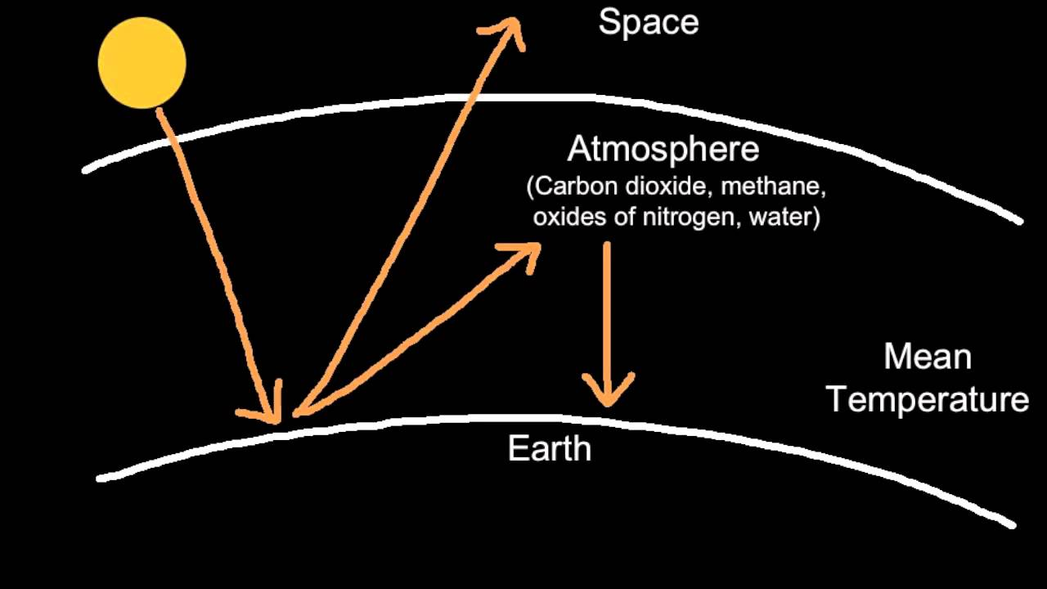
Image 1

2.4 Net Zero
Net zero is a scheme that most companies around the world are aiming to achieve, this is in line with government targets, guidance and legislation. Net zero is a company not emitting more Co2 than they produce. A company can still produce Co2 throughout the processes but must put mitigation in place to ensure there are activity where it is being recycled into the process or absorbed by natural processes. This can capture Co2 to make other products or planting trees and plants. As mentioned above global warming is increasing and is a key topic in today’s media. Lots of companies make there net zero targets very visible to attract sales, funding and grants. As it mentioned in the “Net Zero Strategy” article “The sooner we act on climate change the lower the costs will be. Globally, the costs of failing to get climate change under control would far exceed the costs of bringing greenhouse gas emissions down to net zero. The Office for Budget Responsibility concluded that there could be significant fiscal benefits from early action to transition to net zero, meaning the costs will be lower than if we delay”
The polluter pays scheme is the biggest influence on reduce carbon emissions, those who produce the most Co2 must pay the most in tax. This drives businesses to improve their polluter pays banding to reduce business costs. The sooner a company reduces its Co2 contribution the sooner their taxes will decrease. As the net zero schemes continue the taxes will increase, pushing businesses to improve their performance.
(Department for Business, 2022) (HM Government, 2021)

2.5 Visual Emissions
Visual Emissions are emissions that can be seen by the public, these emissions are an eye sore, dependant on the location of the visual emissions it can cause heavy media attention and have a negative effect on the business’s reputation. Visual emissions can also travel over communities and towns and can often cause fallout. This can damage people’s properties and vehicles. Visual emissions can be caused from all diverse types of processes and dependant on the process the emission can change colour. Some can be black (Coal), Orange (Iron), or grey (sinter). All of them are a hinderance to the public and heavily reported on. Visual emissions are often a result of lack of control rather than the process itself. A visual emission may not occur in every process but when control is lost, they can occur.

2.6 Aloatec Camera
Tata Steel have invested in a smart emission detection system. This is a camera that can automatically detection emissions. It does this by showing the colours in the field of review. The most occurring colours are normalised such as blues and whites for the sky and steam. Other colours such as orange and black are then detected by the system. The system user will then mark the image as a level 2 or 3 emission. The system learns from the user input to then automatic mark orange and back colours as emissions. This system is used widely across the Port Talbot Steel Works. It is linked to many KPI’s and improvement project. This allows the user to quickly assess the environmental performance rather than sitting through hours of CCTV footage.
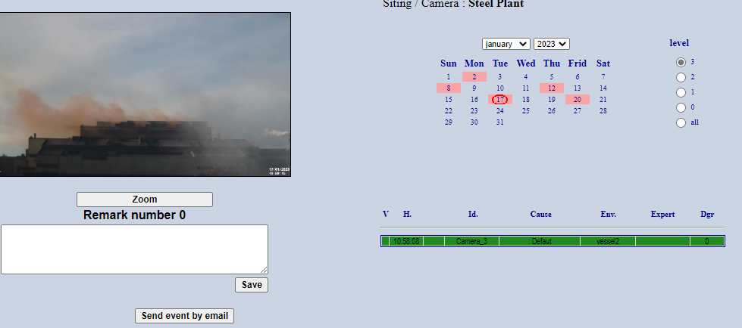
Image 2

The Process
Below is a basic break down of the steel making process. We first receive molten iron from the blast furnace this will be an average temperature of 1380 degrees. This will fill a ladle to 300ton. During this process, an emission will occur as the torpedo is poured the emission is captured via a fume extraction system. We have four 500ton cranes that will transport the ladles within the BOS Plant. The ladle will be picked up from the pour station and transported to the desulphurization process. This is where the iron will be treated with a nitrogen lance. Lime and Magnesium additions can be made during this process to adjust chemistry. Fume and emissions can also occur during the desulphurization period, this is capture by another fume extraction system. Whilst this process is taking place scrap steel will be placed into our vessel in readiness for the converter process. Scrap types can vary and have different properties, the scrap “menu” will change based on the grade of steel being made. The slag from the molten iron is taken away ready to be charged into the converter process. During this time an emission can, be created resulting in increased fume and emissions, this is controlled by a fume extraction system. A lance will then lower into the vessel and blow oxygen to mix the molten iron and scrap steel. When this process is taking place, the oxygen can interact with the iron and create an orange slop emission, these can often cause increased fume and external emissions as the fume extraction has little control over these emissions. Once the converter process has taken place the vessel will rotate and drop the molten iron into another ladle below. It will then be placed into a secondary steelmaking process. The CASOB systems are the Composition Adjustment by sealed argon bubbling – oxygen blowing processes. These systems can create an emission as the vessel is blown with oxygen, these are captured via a fume extraction system. The RD and RH degassing units refine the steel in a vacuum chamber, this creates lesser amounts of fume. Once the steel is put through one of these systems it is placed on a transfer car and placed in the Continuous Caster where the steel is casted into a mould and cooled using water jets.
(Lancashire, 2005)
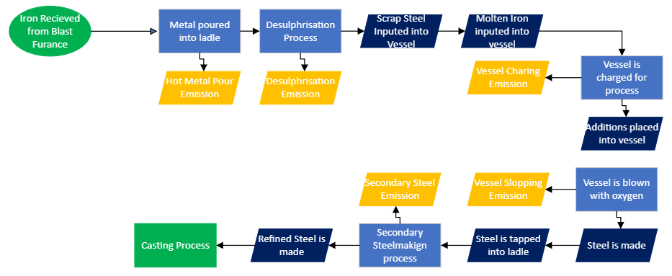
Image 3

Analysis

4.1 Compliance

4.1.1 Permit Compliance
The Port Talbot steel works site has a permit to operate, this permit is set by Natural Resource Wales, they are a large government agency in Wales that ensure the environment and resources of Wales are kept sustainable. They have the power to set a prohibition notice on a production area of asset if it is operating within the agreed permitted limits. Within the BOS Plant we have 6 permitted devices all of which are fume extraction systems.
(Natural Resource Wales, 2016)

4.1.1.1 Fan 3a
This fume extraction removes and captures the fume from the hot metal pour process. When tripping molten iron into a ladle lots of fume is generated through motors and bag houses the fume is pulled away from the process and through a bag filter house. This system is not to permit more than 15mg/m3 over an hourly average of emissions through the stack. This is monitor through a dust monitor attached to the stack. The live data can be accessed at any time.

4.1.1.2 Fan 3
This fume extraction system removes the fume from the desulphurisation process. When the molten iron is being mixed with nitrogen lime and manganese lots of fume is generated, much like fan 3a the fume is pulled through ducting to a bag filter house. Once it has gone through the bag filter house it will go up through the stack. This system has the same permitted level as fan 3a, 15mg/m3 over an hourly average of emissions.

4.1.1.3 Fan 5,6,6
This is 3 fume extraction system built to take fume away from one process which is the converter process. When the converter is being charged with molten iron on top of the scrap or when the converter is being blow with oxygen large amount of fume are generated, the fume extraction systems take this fume away though a bag filtration system. Each system has the same permitted level which is 15mg/m3 of emissions over an hourly average.

4.1.1.4 CASOB 2 Fume Extraction
This is the smallest fume extraction system, which is permitted, this takes the fume away from the CASOB 2 steel refining process. When the process is taking place fume can be generated. This is taken away from the fume extraction system which again has a permitted limit of 15mg/m3 over an hourly average.

4.2 ISO14001 Compliance
Tata Steel has achieved an accreditation to the ISO14001 standard, this is the international standards organization of an environmental management system. This is standard that helps the company improve their environmental and sustainability performance by ensure the correct systems are in place to reduce environmental impact.
(BSI Standards Publication, 2015)

4.2.1 External Audit
Tata Stee is audited external on this standard on annual bases, SGS are used to audit the company against this standard, every 3 years we will have a rectification of the standard which creates a more intense audit. 2 auditors will come to the site for the week and visit individual sites. They will then send the day auditing the process, improves and compliance against the standard. Any actions which may come from the audit will be tracked through our non-conformity report system.

4.2.2 Internal Audit
Alongside the external audit Tata Steel also has an internal audit team, they will also visit induvial areas throughout the year to audit them under the ISO14001 standard, any improvements needed against the standard will be recorded in the non-conformity reporting system.

4.2.3 Asset Health Assessments
To ensure that are assets can manage the amounts of fume from the process we have asset health assessments carried out on our systems. This will cover mechanical and electrical assessments. We do this using local engineers and external consultants.

4.2.4 TCE
Tata consultancy engineering is a consultancy company which is a part of the Tata Group. This company has many engineers which specialise in different assets. Within Tata Steel there are a handful of engineers that specialise in fume extraction systems. They visit the fume extraction systems on a regular basis to conduct assessments.

4.2.4.1 Electrical
During the electrical assessment they will assess the condition of many of the electrical components such as pressure transmitters, temperature monitors, damper feedback systems, data matrixes.
Following the inspection any improvements that are needed will be entered into an SAP system, this allows the engineers to track the open work orders and close them when the work is complete. Dates are set against the work orders, the compliance against these dates is tracked to ensure the work is being completed and being completed on time.

4.2.4.2 Mechanical
The mechanical inspection will cover the physical aspects of the fume extraction system. This will include damper condition, bag filter condition, bellows condition, fan casing and blade condition etc. Any improvement or work that is needed from these inspections will be reported an SAP and tracked to ensure the work is completed by the due date set.

4.3 Aspects and Impacts register.
As the site has the ISO14001 standard they will have an aspects and impacts register. This is a system that will state all the environmental impact of the business. The impact will then be risk assessed based on the impact it can cause to the environment. Following that any mitigation will be stated this can lower the risk assessment score based on the level of mitigation. The 3 highest risks per area will then have an improvement plan placed against it to lower the risk assessment score.
(Tata Steel Steel & Slab , 2023)

4.4 Emission Process Flow
Below the is the typical process flow of the fume extraction system, the fume will travel from the process through a ducting system to the bag filtration system thousands of bag filters will capture the dust as it pulled through the system. The motor will then pull the remaining dust through a set of bellows and through the stack where the emission is emitted. Throughout the process there are temperature monitors, flow transmitters, damper system, fan set point matrices and tachometers. All the data can be trended down to the minute and accessed by anyone within the business.
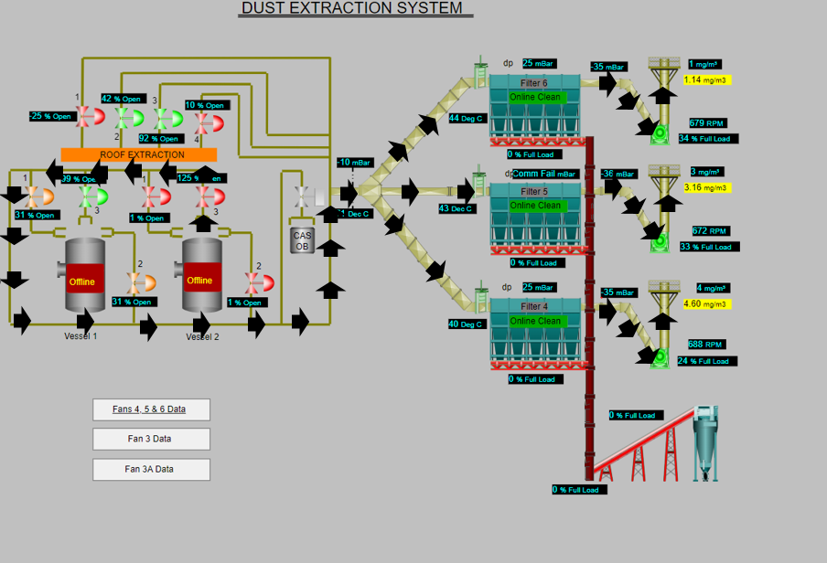
Image 4

4.5 Emission Calculation
From the beginning of 2022 the Port Talbot Tata Steel site has accumulated many complaints due to the environmental impact of the business. The complaints are divided into distinct categories to investigate and improve the performance. They are classed as noise, waste, visual emission and fallout. Visual emission and fallout complaints are the most received with the company receiving 69 visual emission complaints and 437 fallout complaints. If a fallout complaint is received a claim can be made for any damaged caused to people property, these claims can also be made within the business for anyone has had car damage. The external claims have calculated to £68,705 and the internal claims of 245 people has caused £46,472 in claims cost. This brings the total to £115,177 in claims cost.

Evaluation

5.1 The Cause
There are multiple causes to the BOS Plant having environmental effects, but they mostly surround fume extraction and the scrap that is used during the process. This has been found through multiple pieces of analysis across all systems. From the analysis we were able to draw root causes of the environmental effects. Below are all the causes that influence the environment. These causes will be worked through to draw an improvement plan to improve the environmental performance of the BOS Plant.

5.1.1 Scrap Types
To produce Steel, we must use scrap steel during the converter processes, this is where scrap steel is added into a vessel and molten iron is poured on top. Once blown with an oxygen lance it creates molten steel. We used multiple scrap types in the conveyer process but a selected few have poor effects during the process. As you can see from the analysis below, the 3 scrap types that have the biggest impact on the process are turnings tin can bail and incinerator scrap. The details of the scrap types are below.
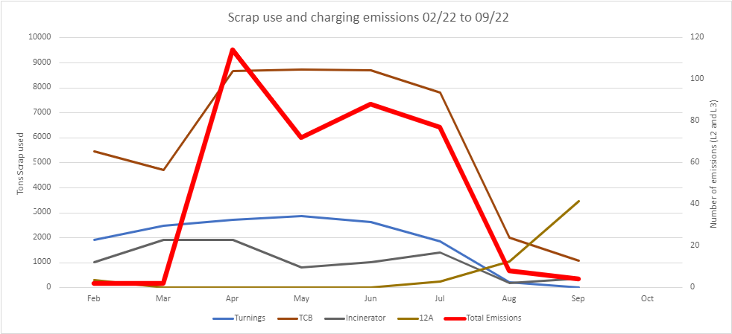
Figure 1

5.1.1.1 Tin Can Bails
Tin can bails are tinned products that have been bailed into cubes for easy of transportation, this scrap type can be contaminated with plastics from the bailing process, when this scrap is met with molten iron it results in the plastic being burned and creating a black process emission as the oils in the plastics are being melted. When analysis has been conducted on this scrap type it was found that these could be made up of 50% plastic, this causes an adverse effect on the steelmaking process. When 5 tonne of tin can bail are being used this could equal to 2.5 tonne of oil. These can lead to extreme emissions inside and outside the building.
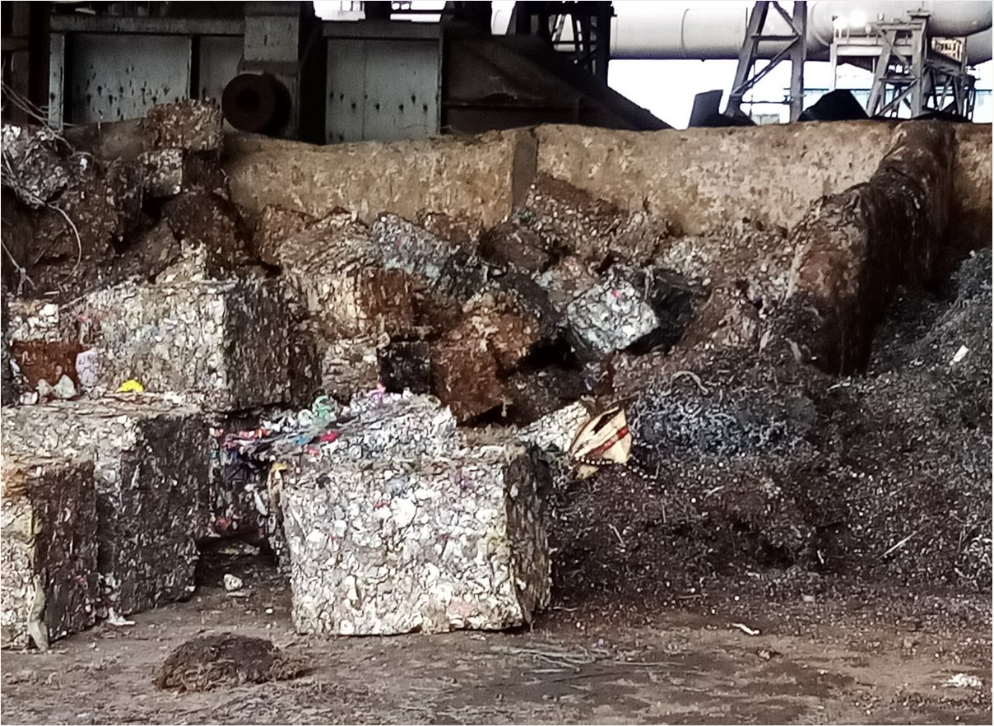
Image 5

5.1.1.2 Incinerator Scrap
Incinerator scrap is old waste scrap which has dried out, this is a cheap form of scrap and heavily used within the works area, can be found to have oil residue which much like the tin can bails is burned off in the process creating a black emission.
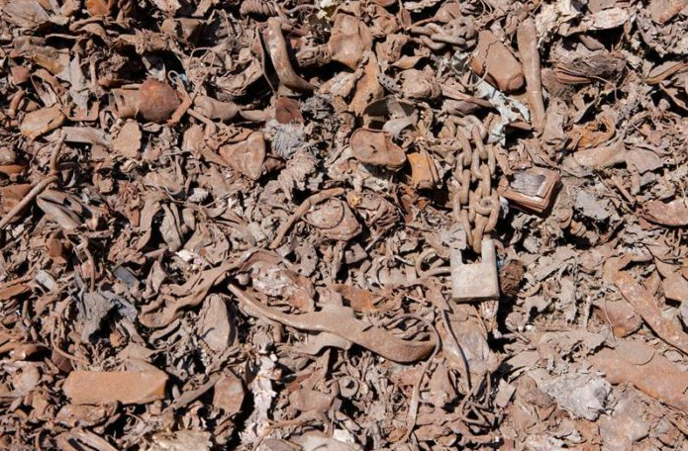
Image 6

5.1.1.3 Turnings Scrap
Turning scrap are by products / cut offs from metal cutting processes, as these processes often occur in workshop environments they can be surrounded by oil, this can result in the turnings being high in oil during the converter processes.
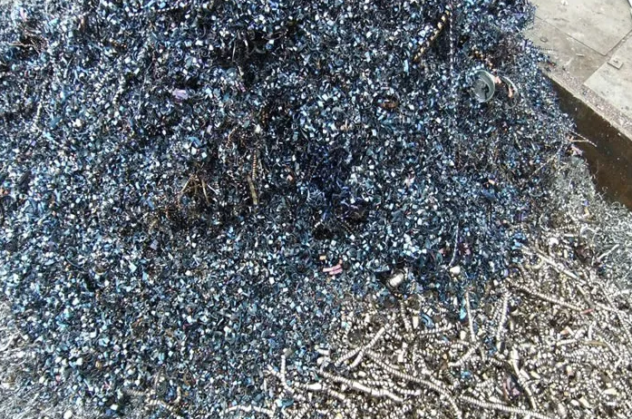

5.2 Fume Extraction
Across the BOS Plant there are 6 fume extraction systems, fan 3 covering the desuperization process, fan 3a covering the metal pouring station, secondary ventilation system covering the converter process, CASOB 2 fume extraction which controls the fume extraction on the CAS OB 2 secondary steel unit. There are multiple dampers around this system to aid fume extraction to each other’s systems, this is vital during plant maintenance when a fume extraction unit needs to be taken offline. Analysis has been conducted on all these fume extraction systems to baseline their performance; work orders have then been put in place to bring them back to standard.
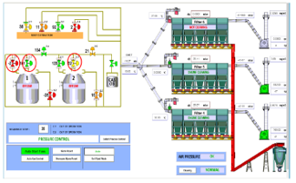
Image 8

5.2.1 Ducting
From the processes the fume must travel through ducting to reach the filtration systems, when assessments have been conducted on the ducting systems it was found that there were many holes which allows the system to lose pressure this results in less effective fume extraction and results in emission levels being higher.
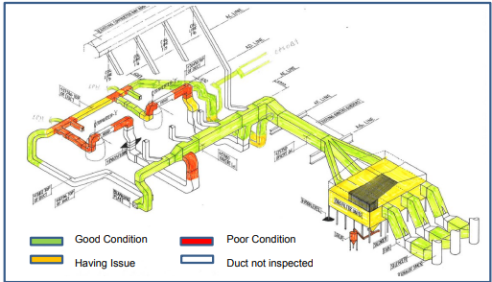
Image 9

5.2.2 Chain Conveyer
Our fume extraction systems have methods to remove the dust from the filtration systems to keep the system clear of dust and allow for effective fume extraction, when assessments have been carried out on these system they were found to be unserviceable, this meant that the dust from the bag filter systems is not being removed from the process and causing dust to overload the bag filters. This means less filtration is taking place and resulting in less effective fume extraction.

5.2.3 Dampers
The fume extraction systems have dampers, a number of these are manual dampers that can be opened when one piece of fume extraction is taken offline. These allow the other fume extraction systems to aid and help with the fume extraction off other processes. We have other dampers which are automatic which will open and close based on the process being conducted, these dampers are in place to aid fume extraction and lower and increase pressure throughout the system. When analysis has been conducted on these systems, they were found in a poor condition which prevent them from operating, this is causing adverse effects to the fume extraction.

5.2.4 Bag Filters
Our fume extraction systems used a bag filtration system which means the dust flows through the ducting into bags which have been coating in lime, this bags will then hold the dust filtering the air in the process, the air pulsing system will this force air down through the bag system clearing the bags of the dust, the dust will then drop into a hopper system where the dust is collected. Bag tests are conducted on the system which involves putting dye into the system to highlight broken or damaged bags, the results are then acted upon, and a bag filter change is conducted.

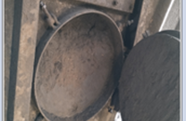
Image 10 & Image 11

5.2.5 Inlet Pressure
Throughout the fume extraction process the pressure throughout the system is extremely important, as pressure is kept and improved the efficiency of the fume extraction increases. The pressure gauge at the inlet ducting is often used to judge the efficacy of the system. When the system is operating with an average of more than -20mb we know the system is operating efficiently. Any valve under the -20mb work is needed to achieve the desired pressure. The system pressure is affected by the ducting condition, fan speeds, bag filter condition and air pulsing pressure. Once all these systems are working efficiently the system pressure improves.
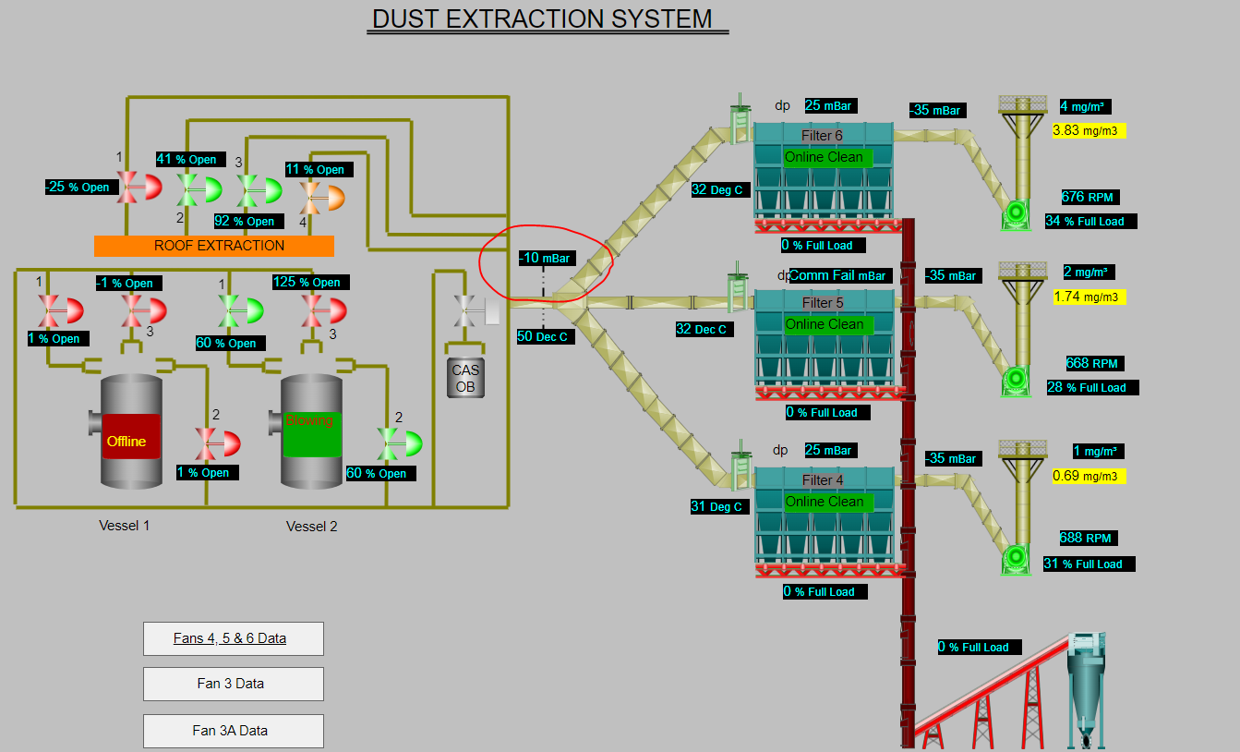
Image 12

5.2.6 Fan Speed
The speed of the fan is vital throughout the process. This dictates the rate that the fume will be pulled through the bagging plant and up through the stack. During the process when the fans are operating at 900rpm we find it is when they are at their optimum level of effectiveness. The speed of the fan can be changed manually but is also linked to a matrix which is designed to change the speed of the fan based on the process being conducted. The processes which cause the highest amount of dust will cause the fan speeds to increase. Although the fan speeds may not be achieved due to other aspects of the system. During fan inspections cracks can be found on the casing and blades. It is believed this is due to vibration issues. This limits the fans effectiveness as the speeds need to be controlled more to protect the asset health and to limit the damage.
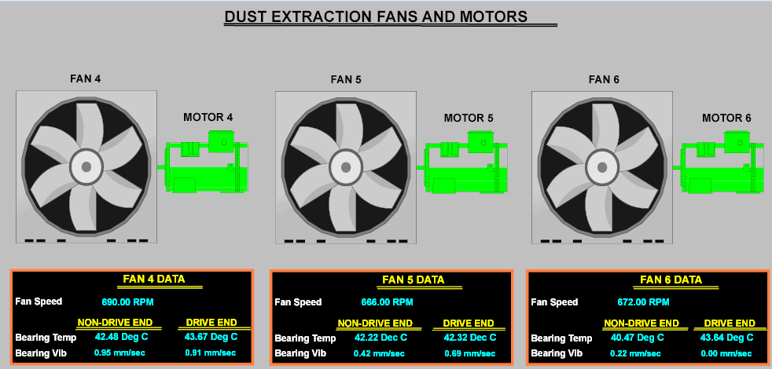
Image 13

5.2.7 Moisture
When analysis had been conducted on our fume extraction system, it was found that moisture was getting into the compressors system. This feeds the air pulsing system at the secondary ventilation fume extraction, with the excess moisture in the system the bags are not as effective and results in poor fume extraction.

5.3 Silicon Levels
During the blast furnace process, silicon levels within the hot metal can vary. This can be affected by the blast furnaces stability, the higher the silicon levels the more chance it has to react in the BOS process and create a slop emission. We have a SLA (service level agreement) with the blast furnace to keep the silicon levels within 0.3% – 0.7%. With these levels of silicon, we do not see emissions occurring, if the levels are below the SLA, it creates quality issues within the steel.

5.4 The Effects

5.4.1 Emissions

5.4.1.1 Charging Emissions
A charging emission is an emission that occurs during the charging process. This is where molten iron is being charged (poured) on top of the scrap steel inside the vessel. This is prior to the vessel being blown with oxygen. During this process, the fume extraction system attached to the converter should increase its speed and increase its system pressure to allow the fume to be taken away from the process. The dust should then travel through the ducting to the fume extraction plant, where the dust is captured in bags to filter the air and the fume should leave via the stacks. Due to the fume extraction plant not being efficient enough and the holes within the ducting it causes lack of fume extraction. Due to this the fume escapes through the building as it raises up to the roof. This is one of the reasons why the black emission in created. The other reason is due to the scrap types that are being used within the process. As stated above, the problematic scrap types burn oil or plastic during the charging process which is what turns the fume black. This emission can be seen below. The black emission can also result in fallout, this is where the particles will drop on to the surrounding area, this includes within the community, cars, windows, clothing as all been claimed for by the local community due to the fallout from Tata Steels processes. An examination of these claims can be seen in the image below.
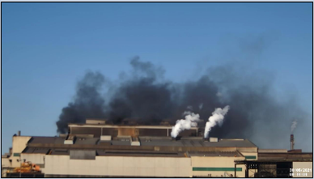
Image 14

5.4.1.2 Slopping Emissions
A slop emission will occur during the process of the vessel mixing the molten iron and scrap steel with an oxygen lance, this is known as during the blow. When the molten iron interacts with the oxygen based on a number of variables it can cause the oxygen and iron particles to react, causing an orange emissions. These emissions can be contained within the building causing a hazard for those in the area, and also cause a emission external to the building creating a visual emission for the community. These emissions can also cause fallout, resulting in iron particles falling out over the local community. Due to this being iron it makes it difficult to remove the fall out using traditional methods, this makes it awfully expensive for the company to pay for all of the fallout claims.
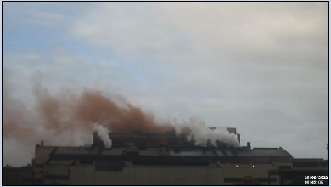
Image 15

5.4.2 Fume
During the converting process the vessel will blow with an oxygen lance. The fume extraction system attached to the converter should take the fume away from the process. However, due to lack of fume extraction it escapes through the vessel mouth, this leads to fume increasing inside the building, making the working conditions poor and creating a safety hazard. An example of the fume caused can be seen in the image below. This can also cause the crane drivers visibility to be impaired, this causes a process safety concern as it could lead to a LOC (Loss of Containment)
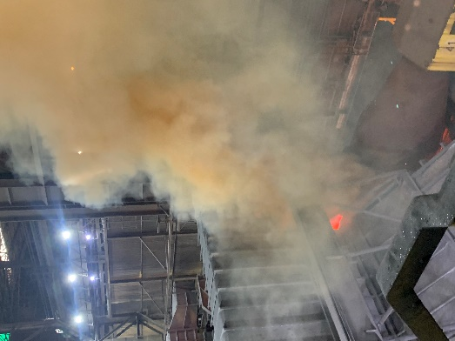
Image 16

5.4.2.1 Flaring
Due to the reaction that is caused during the charging process a flare / flame can occur. After analysis dependant on the scrap type used during the heat the flaring reaction can vary. It has been broken down into 3 reactions “Very Bad, Bad, Good”, this can be seen in the images below. From this process an excess of fume is caused creating an air quality hazard in the area, making it difficult for the employees to work in. This can also cause damage to the assets that are used to pour the molten iron into the vessel.
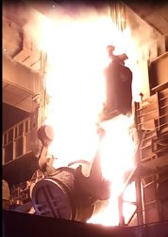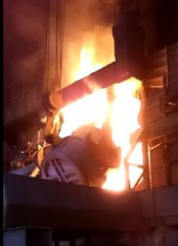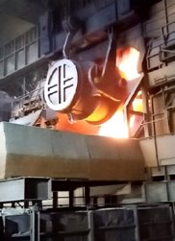
Image 17, Image 18, Image 19

5.4.3 Complaints & Business Reputation
Due to the emissions that are created complaints can be made towards the business from those living in the local community or those within the business. As we know this can cause an effect on the business in a monetary value but can also affect the businesses reputation. With social media there has been many online new reports and forum created showing a negative view on the business. This can go on to affect the businesses share price and effect the businesses stake holders. This can affect the moral through the business as there have been many claims made for fallout on cars. This can push those away from helping environment performance as they are being affected by the impacts.
(Smith, 2023 ) (Sullican, 2023) (Environment Complaints System, 2022) (Environment Complaints System, 2023)

Improvements

6.1 Scrap Type Adjustment
As we have learnt in the cause section the scrap types used during the process are causing an effect on the emissions that occur during the charging of the molten iron onto the scrap steel. Trials have been run with not including tin can bails incinerator and turnings scrap. During these trials there was a large effect on emissions. As you can see in the graph below when the trial began in August, we seen a significant reduction in visual emissions. The data was found using the Aloatec automatic emission detection system. This also influenced the number of external complaints we received. This improves the businesses environmental performance and reduces claims costs that are imputed following the complaints. The trials have come at a cost to the business, as the scraps that cause the emissions are the cheapest forms of scrap metal that are purchased. If all three scrap types were to be removed, it would cost the business 12 million pound. To ensure the trials are a success and tracked correctly the technical team have created an A3 improvement tracker about the project. Here they can track the actions they are taking to improve the performance and when they are planning to complete the action. This can then be used and review in regular meetings to track progress and feedback to senior management

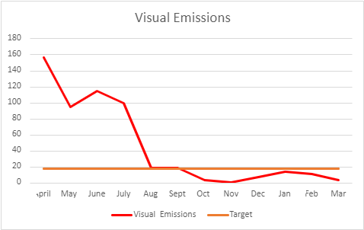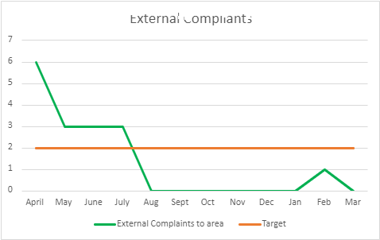
Figure 1 & Figure 2
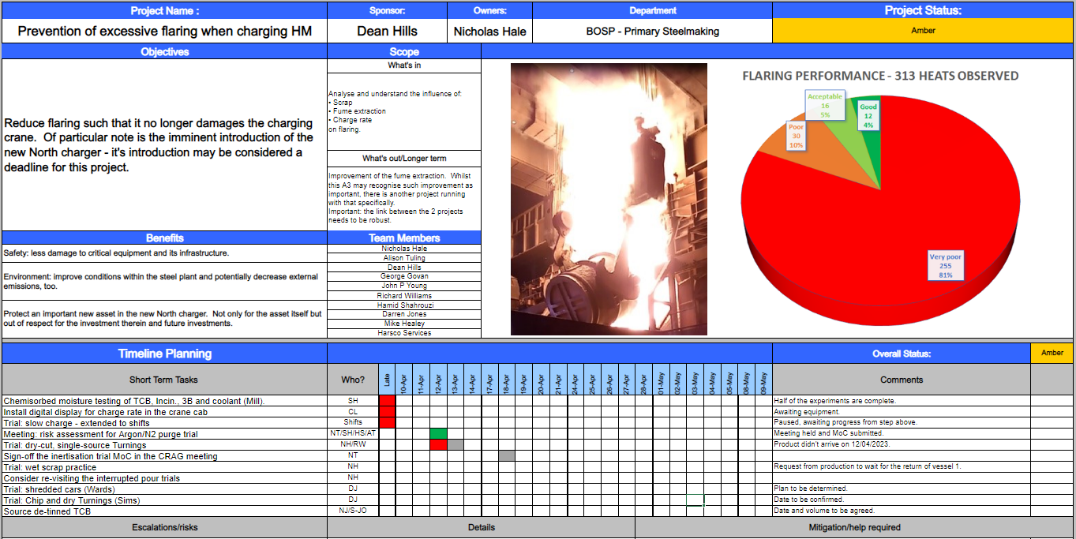
Image 20

6.2 Pouring Trials
During the project to control the scrap the rate of the pour has been considered. The rate of the pour is the speed that the molten iron is poured onto the scrap steel, the theory is that the quicker the pour the larger the emission it causes. The technical team has worked with the crane operators to trial a slow charge rate. The aim of this is to reduce the emission during the process. The trial started on 9th of December 2022 over 8 pours 4 of which were slower than the standard charge rate. As you can see from the results below the thesis was correct the 4 slower pour rates resulted in less emissions whereas the 4 standard pour rates resulted in increased emissions. This process was then trialled again on the 19th of January 2023 over 10 pours as you can see from the second trial the emissions were heavily reduced on when the slower pour rate was applied. This is clearing having an impact on emission as to be developed into a standard to improve environmental performance.
09/12/2022 Trial
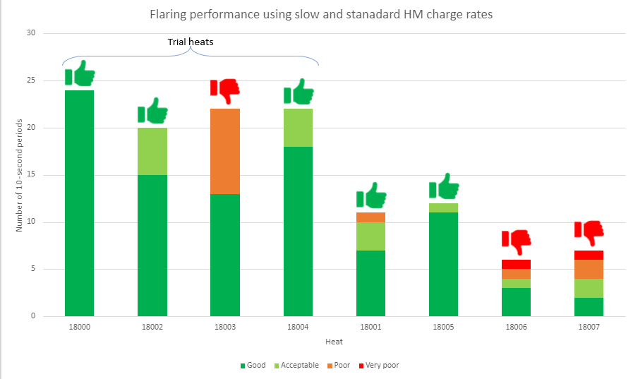
Figure 4
19/01/2023 trial
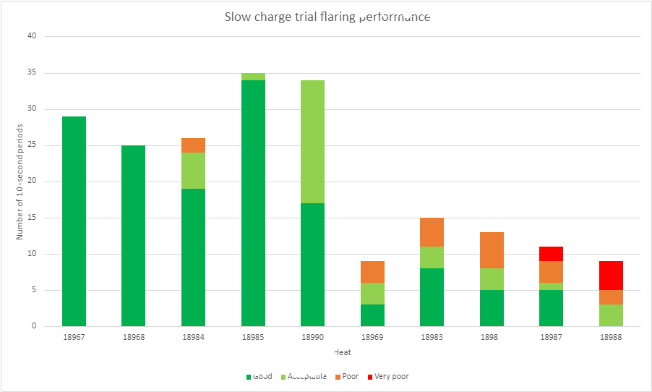
Figure 5

6.3 Charge Delay
Due to the temperature of the scrap, we are pouring molten iron onto cold scrap steel, we know that when molten iron is poured onto a cold surface an emission is caused causing iron particles to dissipate. A trial was run to leave the scrap steel in the vessel to heat and melt with the remaining heat. As you can see from the analysis below the trial was a success and we found that later the charge of the iron the small emissions were caused. This will have to be taken up with higher management as making this a standard would have product repercussions and reduce business revenue.
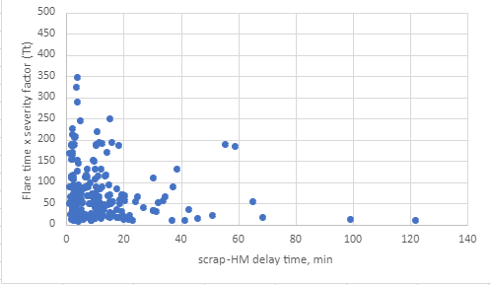
Figure 6

6.4 Capex
The business has a large capex funding which is used to invest in major projects around the UK operations. The capex funding for a single project is often to spread over a number of years to allow the implementation of the projects. Tata Steel also has its own dedicated capex project teams who will work alongside the works areas to deliver the capex projects. The schemes can run from engineering to occupation hygiene. Within the fund are a number of environmental improvement schemes.

6.4.1 Fume extraction phase 2 capex
There is an environmental capex project in place for the BOS Plant to improve the fume extraction from the converter process. This capex scheme covers multiple aspects of the fume extraction and looks to repair and upgrade the current system to improve the performance. The aspects of the fume extraction system the capex scheme covers are below.

6.4.2 Mathematical Modelling System
The fume extraction is linked to a mathematical modelling system which dictates the damper positions and fan speeds. This should give the required system pressure. The model is outdated and requires review. The software that was used is also outdated. Fluid Flow is now being used to decide a new model. This will allow us to redetermine the damper positions and improve pressure throughout the ducting and bag filter house.
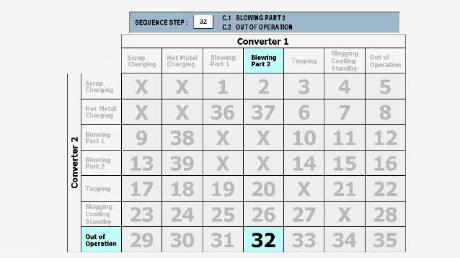
Figure 7
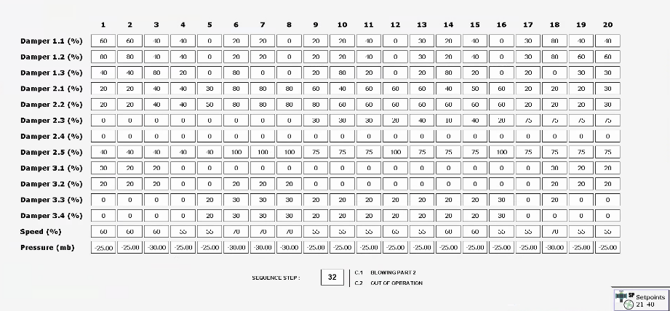
Figure 8

6.4.3 CASOB 1 Ducting
The secondary vent fume extraction plant currently has ducting and a damper opening to the CASOB 1 secondary steelmaking process. This is in place to aid fume extraction when the steel is being treated. The ducting is damaged, and damper is currently U/S not allowing for any fume extraction from the asset. There is funding within in the Capex scheme to renew the ducting and damper to the unit.

6.4.4 Bag Filter Performance
Within the bag filter performance capex scheme there are 3 aspects to improve the filtration system. Each of these will have a different purpose and outcome.

6.4.5 Venturi Arrangement
The venturi arrangement is redesigning the layout of the air pulsing system, this is to achieve greater pressure through the pulsing system to clean the bags and reduce moisture throughout the system.

6.4.5 New Bag Filer
The new bag filters will explore the different filtration bags on the market, some will have a different coating which will capture the dust more efficiently allowing less dust to travel through the stack and into the atmosphere.

6.4.6 DP Monitor & Broken Bag Detector
The differential pressure monitor will allow the system to track the pressure across all bag filters giving us a greater understanding of the asset health. The broken bag detector will detect broken bags within the filtration system. This will allow us to be more responsive to bag changes allowing for a constant efficient system.

6.4.7 Spark Arrestor
A spark arrestor will stop any sparks reaching the bag filter house, this will stop the filtration system catching on fire and causing broken bags. The temperature within the filtration house can often be very high which allows for fire to occur easily. This will prevent the filter house having to be taken offline.

6.4.8 Dust Transport System
There is a dust transportation system in red in the image below, this allows the dust to be transported from the hopper system to a silo externally to the filter house, this prevents the hoppers being overfilling with dust and becoming damaged. The transportation system is U/S and requires replacement. This will allow for constraint flow of dust throughout the process, this will aid the asset health and allow for greater pressures throughout the filtration house.
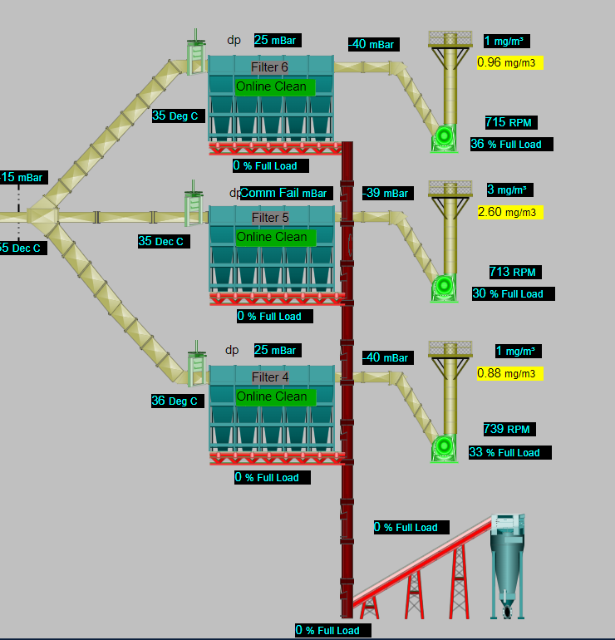
Image 21

6.4.9 Ducting Repairs
Throughout the fume extraction system there are many ducting routes, due to the heat that is generated throughout the converter process many parts of the ducting are damaged or holed, this causes pressure losses across the system. There is capex funding in place to replace the damaged pieces of ducting to resolve the pressure loss. The small holes pieces of ducting are to be managed by the local engineers, but the capex team is to be unitised to replace the major aspects of the ducting.

6.4.10 General Plant Fume Improvements
There are further plans to adapt the current fume extraction to aid the general fume throughout the plant, due to numerous raw materials being transported through the plant this can cause an increase of fugitive emissions and fume. Fume extraction hoods are to be placed onto the transporting systems to remove the fume from the transporting processes. There are also many lancing stations around the BOS plant that are used to remove skulls from the asset equipment, deskulling skulls can create heavy amounts of fume work is ongoing to find new fume extraction systems that can be used to remove fume from those processes.
(FIltrabit , 2023)

6.5 Risk Funding
Some improvements that are needed won’t sit in capex due to the cost being too low, but many are not in the annual budget due to cost. This will then sit in risk which can be given through the senior leadership team throughout the year. There are many environmental improvements within the risk register the main improvement is below.

6.5.1 Damper System
There are currently 4 extra roof dampers that can be used when the filtration plant is overwhelmed with fume. This damper can be opened to relieve pressure from the main system, these systems are currently U/S and require upgrading, work has begun on these through funding that has been allocated through the risk register. Once these are operating correctly, we will see an increase of pressure throughout the system.
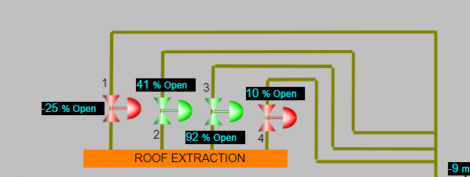
Image 22

6.6 SLA

6.6.1 Blast Furnace SLA
As previously mentioned, the level of silicon within the incoming molten iron can determine the probability of a slop occurring. To mitigate or lower the possibility of having elevated levels of silicon within the molten iron an SLA (service level agreement) could be put in place to ensure that the incoming silicon levels are below 0.7% this will allow for closer monitoring of the silicon levels and allow a reduction in emissions.

6.6.2 Scrap Supplier SLA
As discussed in the evaluation the scrap conditions are extremely poor and a main contributor to charging emissions. To ensure the scrap as per the product description and without any contaminates an SLA with the scrap steel suppliers would allow for closer monitoring of the scrap condition. Allowing Tata to challenge back on inefficient products. Supplier complaints can then be generated to claim compensation for the performance this should drive the suppliers to improve their performance.

6.6.3 TCE Work orders
As discussed, prior TCE have created a number of work orders for Tata Steel engineers to work through to improve the fume extraction performance. Tata would benefit to track the closure rates of the work orders to compare to improvements in the fume extraction systems. This will also drive the engineers to close the work orders at a quicker rate if performance is improving as the work orders are completed.

Methods to improve

7.1 Meeting Structure
Within the company, business performance is reviewed at multiple levels from daily to annually, this helps the business create a picture of what is required to make improvements to achieve KPIs. To ensure that environmental performance is reviewed and improving it is important that is it reviewed at all levels.
(Petera, 2021)

7.1.1 Daily Meetings
To ensure that environmental impacts are being addressed at the correct level and build as a part of Tata Steels daily management. Environmental impacts or reports should be raised and discusses as a part of the works areas daily morning meetings. This will allow for mitigation at the earliest opportunity to ensure minimal environmental damage is caused.

7.1.2 Weekly Meetings
Within the businesses weekly meetings, environmental reports should be trended and reported on, this will allow those who can directly affect the environmental performance to ensure that all mitigation is being put in place against the most reoccurring events. This will allow the business to be more initiative-taking in their environmental mitigation rather than reactive.

7.1.3 Monthly Meetings
Within the monthly meetings the results of mitigation should be discussed to determine their effectiveness, these meeting should also allow for problem solving and updated on any improvement plans that are ongoing to prevent environmental harm. The output of these meetings should be shared with the business management team to share the areas of focus and the threat to make them aware of any higher management support that may be needed.

7.2 SLA
Service level agreements are put in place with suppliers or customers to ensure the product that is being processed or bought is to the expected standard. If the product is not to the correct standard, it can cause damage, chemistry defects, safety defects and increase costs to the customer. By dedicating time to review the standard with the suppliers it will lead to the product being on standard and prevent harm to the business. Any issues can also be escalated directly. This can also build relationships with supplier and customers to keep steady performance.
(Overby, 2017)

7.2.1 Scrap SLA
Tata should like to implement service level agreements with their scrap suppliers as we know one of the main contributing factors to charging emissions is scrap quality. Ensuring that we maintain the correct levels of quality the SLA should be taking place once or twice a month along with auditing of the scrap quality before it enters the process to ensure what is being purchased is what is being supplied. This will allow the relationship with the supplier to grown and aid future communication.

7.2.2 Blast Furnace SLA
As we know the biggest contributor to slopping emissions is the silicon level within the molten iron from the blast furnace. To ensure our suppliers are aware of the impact the silicon levels are having it should be reviewed within the internal SLA, this will help grow the relationship with the supplier and better manage the incoming silicon levels. It would also be a benefit to take the blast furnace operators through training on the impacts of slopping and how silicon levels can have an effect, this will help those with a direct impact to have a greater understanding on the impact.

7.3 Improvement Plans
To ensure that there is focus on improving environmental performance it is extremely important that there are plans in place to increase mitigation around the environmental impacts. These plans should be tracked and stored in a central location to allow easy access and updated regularly.

7.3.1 TCE Work Orders
From the work the TCE engineers have completed on the fume extraction the work order that they have raised should be tracked closely to ensure the completion of work orders are being done within a reasonable time this is to ensure the fume extraction has the correct level of focus to improve the efficiency and reduce environmental impact.

7.3.2 Fume Extraction
To improve environment performance, we know there must be improvements made to our current fume extraction due to the status of the systems. This should focus on the major aspects that need improving such as a chain conveyor and the damper systems. The improvement plan should follow a standard template that is reviewed on a regular basis to ensure the improvements are being made. Once the improvements have been made it can be cross referenced with the system pressure to determine if the improvements are having an effect on the systems efficiency.

7.4 Competence
To make people aware of the environmental impact on the world there should be awareness / training sessions available, once the work force is aware on how they can affect the environment the culture may change within the business to increase the focus on the environmental impact of a basic oxygen steelmaking plant. Once the culture has changed and the work focus is aware those who can directly impact / mitigate environmental harm an improvement in environmental performance may be seen.
(Vickery, 1993)

7.4.1 Training Sessions
Training sessions for those who can directly impact / mitigate environmental impact would allow for greater awareness how each process within the BOS process can affect the environment. For example, an operator will have the ability to increase the fume extraction during the pouring process. Within the training session they can be taken through the procedures to follow when the emission levels increase. This will teach the operator how to react to mitigate the environmental damage quicker.

7.4.2 Awareness eLearning
To give the whole work force an overview of environmental impact on the world an environmental awareness eLearning would allow everyone to gain knowledge on how our processes can affect various aspects of environmental damage such as the green house effect or ground contamination. This would see an increase of environmental reports that can be actioned to prevent further environmental harm.

7.4.3 Community Engagement Sessions
Due to the high number of complaints that are received by the business it would be effective to launch community engagement sessions to give feedback to those who have complained to make them aware of the reasons of the emissions and what is being done about the emissions. This engagement may not reduce the number of complaints to the business but may reduce the negative view and reputation of the business.

7.5 Procedures
Within the business there are many procedures in place to be deemed competent to carry out one of the processes within the BOSP. As a part of those procedure there are environmental impact procedures. These should be reviewed on a regular basis and not just once when they are deemed competent. This will ensure any changes to the procedures are reviewed with those who affect the process directly.

7.5.1 Early & Late Slop Procedures
The early slop procedure should be reviewed with the operators to ensure it is understood and those who can affect the process are aware of how to apply the mitigation. This should also include that if the mitigation is not applied how, it can affect the environment. Once all operators have been taken through this process they are to be signed off as competent to mitigate environmental harm. An example of this would be to take the vessel operators through the early and late slop procedures once they are aware of the mitigation and can show how to apply the mitigation, we know they are competent and can be confined this will be done in the event of an emission. This would see a decrease in slop emissions that exit the roof and cause a visual emission.

7.5.2 Loss of fume extraction procedures
In case of an emergency where fume extraction system fails or is overwhelmed and only 1 fume extraction is available there is a procedure in place. This procedure sits on a central procedure site but is not built as a part of any training manuals. To ensure those who would be applying the procedure are aware of the actions and know how to apply the mitigation they should be taken through the procedure and show the training how they would follow the sets to ensure they are competent. This should limit the amount of permit breaches throughout the year and reduce extremely large emissions.

Results of improvements
Using improvement plans and KPIs there we aspirations to achieve the goals that were set at the beginning of the year. The improvement plans aimed to reduce the impact on the environment through focusing on the compliance to the NRW permit, emissions, engineering focus and competence. Using improvement plans we have achieved some of our goals and failed at other. Those areas which had failed will require more focus to prevent more environmental damage and harm.

8.1 Emission Reduction

8.1.1 Permit Breaches
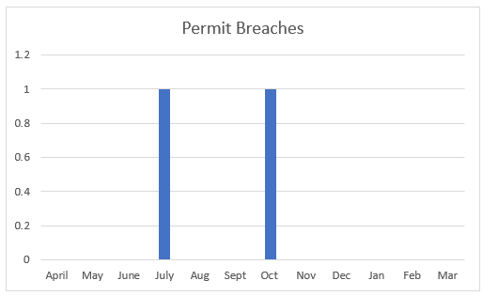
Figure 9
One of the aspects of the improvement plans was to improve environmental performance, one of the KPI linked to environment is the number of breaches to the permit. During the year we have seen a reduction of more than 50% in permit breaches from the prior year having 5. During 2023 there were no breaches due to exceeding the permitted limits set in the permit the two on the graph were due to losses of emission data. Work was done in late October to reposition the emission data controller boxes to new locations with this being done we have not seen a permit breach since.

8.1.2 Slopping Emissions
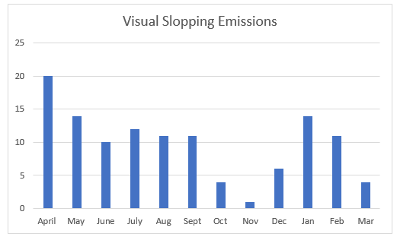
Figure 10
During 2023 the number of slopping emissions has been steady with an annual average of 10, the target at the beginning of the year was set at 8 which we have failed to achieve. The main root cause of this was due to instability at the blast furnace causing the silicon levels to increase. As we know this is a main contributor to slopping which is not in the control of the BOS Plant. Further work is to be done with the operators of the blast furnace to make them aware of the impact of high silicon levels. The other reason not to hit the target was due to the vessel life. When the vessel has been brough back from reline we know that the capacity is smaller this creates a high change of slopping, where there is usually 2 relines during the year 2022 – 2023 had 3. This is another main contributor to not achieving the target.

8.1.3 Charging emissions
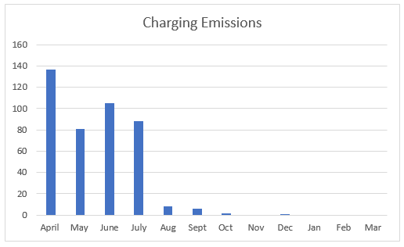
Figure 11
At the beginning of the year, we experienced the worst months for charging emissions with having 136 charging emissions during the month. Following the detailed emission problem solving work it was decided in August to remove the high-risk scrap steel material from the process. This has come at an excessive cost to the business as tin can bails, incinerator and turnings scrap are the 3 cheapest scraps to purchase. But the environmental improvement is clear from with graph with now in a position of 0 charging emissions during the month. This has dramatically changed the position of the KPI from red status to green status. From this the complaints received to the business has also seen an effect with less complaints being raised due to charging emissions

8.2 Complaint Reduction
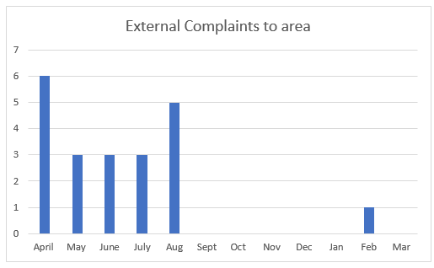
Figure 11
As you can see from the graph in August, we seen a dramatic change in the level of complaints that are being received to the works area, this is due to removing the high-risk scrap types from the process. This has led to less claims being made from the business and reducing its overheads. This has also improved the perception of the company as when attending a community session in September it was mentioned that the local community has seen fewer black emissions from the BOS plant and the business is being seen to be doing something about the emissions. This has also had positive feedback from natural resource Wales following an audit of the BOS plant on the 5/05/2023.

8.3 TCE Work Orders
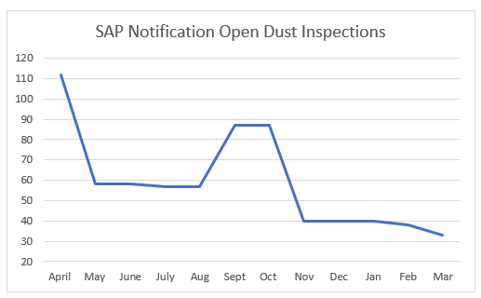
Figure 13
One of the other improvements wanted to impact was the closure of TCE work orders. As you can see form the graph since the focus was applied to closing the orders in April there has been a steady reduce in the number of open work orders. The BOS Plant now has only 33 open work orders which are being planned to all be closure out by the end of 2024. This is a significant improvement from the original 112 notifications that were originally raised. This has seen an improvement in our fume extraction with the pressure throughout the system improving but there is still work to be done to achieve the defined pressures.

8.4 Competency
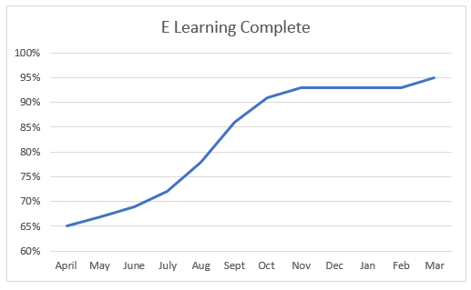
Figure 14
Focus was also applied to the Environmental Awareness eLearning starting the year the compliance was at 65% during the year the target of 95% was achieved. This allows for greater awareness of environmental awareness for all within the works area. Since the increase we have also seen an increase in the number of environmental reports that are raised, and we have also seen an improvement in the quality of the reports. This helps use find root cause with ease and allows us to put the correct mitigation in within a reasonable time.

8.5 Meeting Reporting Structure
During the year much work has been done to ensure that the environment is taking into condition at every meeting. This is to ensure that the correct level of focus is being applied to improve environmental performance. In the following meetings the following focus is applied.
Daily – Environment reports are reviewed along with any emissions from the day prior.
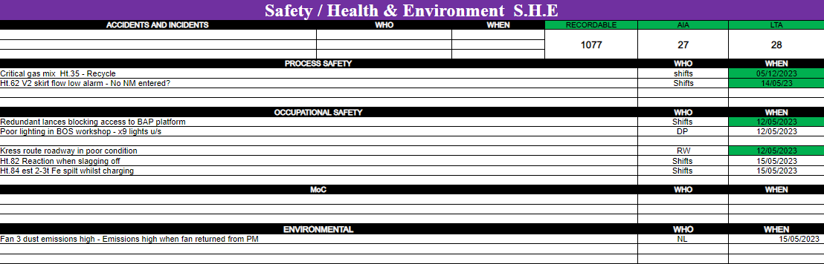
Image 23
Weekly – Trending of prior’s weeks environmental records and review of upcoming maintenance.
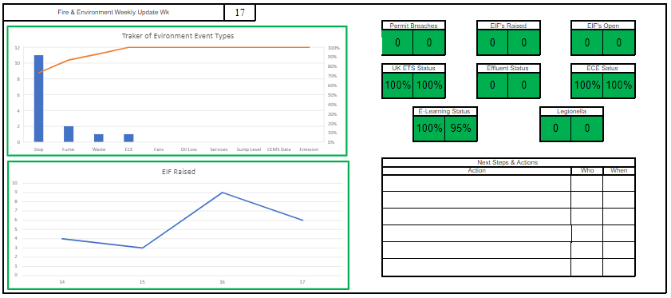Image 24
By-Weekly – Problem solving on trended environmental reports and update on environmental improvement plans.
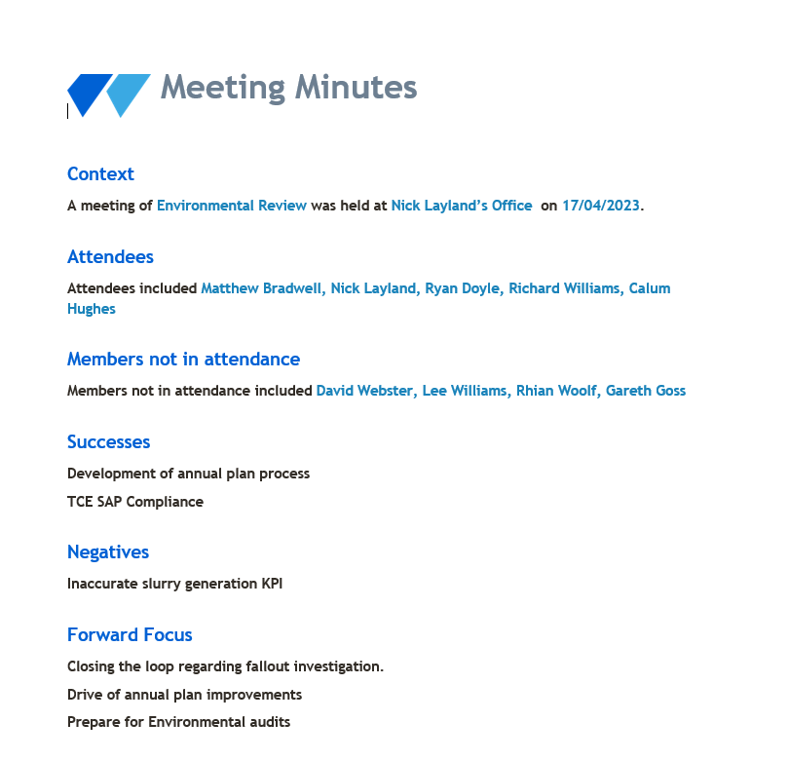
Image 25
Monthly – Review of KPIs and improvement plan status and escalation of any threats.
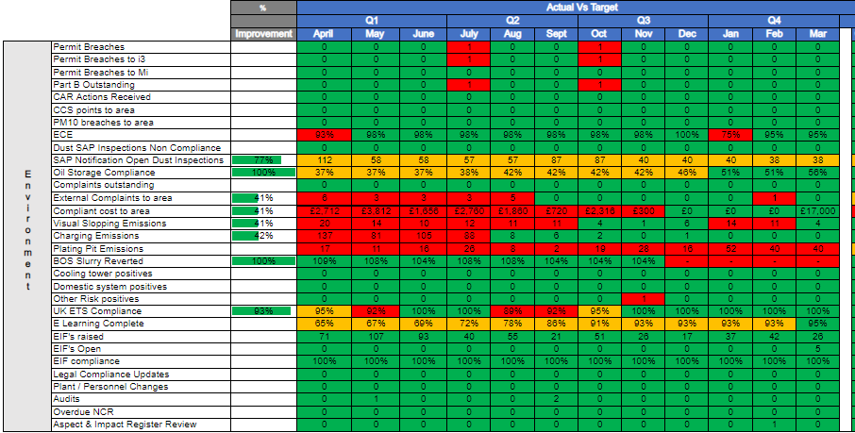

Figure 15
Annually - Management review of the year’s performance and key focuses for the next year.
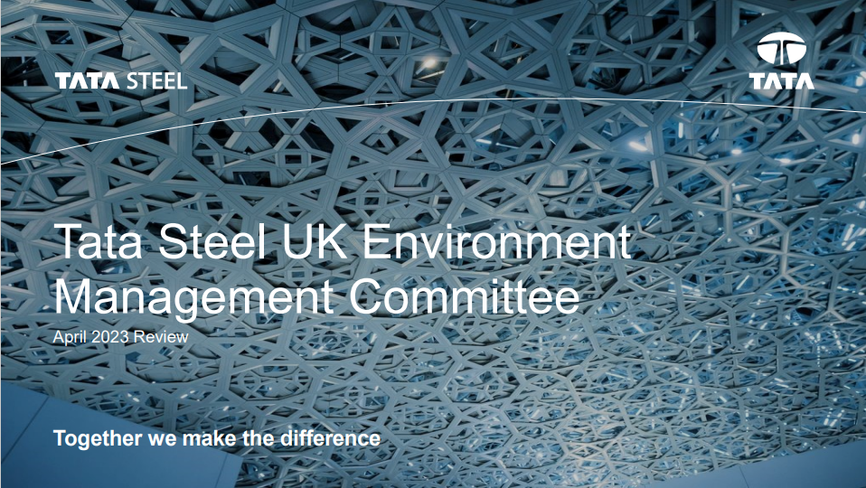
Image 26

9. Conclusion
In conclusion we can take from the literature review that there are many aspects to the environment especially on-air quality. All PM10 sizes can influence the human body affecting health and should be kept at a minimum to limit the damage on the human body. We know that many companies have targets in place to achieve zero emissions and net carbon zero goals, these goals are in line with the governments focus to reduce the impact to global warming and the greenhouse effect. These goals and targets are heavily reviewed by the public and a company environmental reputation can influence many aspects of the business such as perception and share price. We can see that the basic oxygen steelmaking process has many steps to take molten iron from the blast furnace and converter it into a cast slab. Throughout this process emissions can be caused due to the materials involved. There are a number of fume extraction points in place to mitigate the environmental damage. From the analysis we can see that the BOS Plant has 6 permitted devices all with a permitted daily limit of 15mg/m3. This permit is given by NRW (Natural Resources Wales) Any breaches of the permit can result in a change in the polluter pays schemes banding. Tata Steel is also accredited to ISO14001 to ensure there is a sufficient EMS (Environmental Management System) in place, this is in place to ensure that any system that are in place to mitigate environmental damage are professionally managed. We can also see that Tata Steel have had consultancy work conducted on here fume extraction system to baseline their performance and inspections carried out to identify where improvements are required. These inspections are spilt between mechanical and electrical to allow each discipline to focus on where the improvements are needed. We can see that due to the emissions that can be caused from the process claims can be made by those within the business and externally in the local community which can cause a hidden cost to the business. The emissions that are cause form the process is split into 2. Slopping emissions and charging emissions. Charging emissions are due to the scrap types used during the converter process. The use of tin can bail, incinerator and turnings scrap can cause a black visual emission. Whereas slopping emissions are cause by incoming silicon levels from the Blast Furnace and the life of the vessel. An overarching aspect to both emissions is the fume extraction. There are many aspects to the fume extraction that requires repairs to have an efficient fume extraction. By resolving this it will allow for less fume from the emissions in the working environment and reduce the harm to environment. There have many problem-solving sessions conducted by different disciplines within the business to improve environmental performance, from those sessions’ trials, actions and improvement plans have been created to action throughout the year. The scrap types were adjusted to remove the high-risk scrap types as a trial to figure out the effect. There is also capex funding in place to address ongoing issues with the fume extraction, this will require a full dedicated capex team. Risk funding is also in place to replace small aspects of the fume extraction. Service level agreement meetings have also been organised with the Blast Furnace and scrap suppliers to keep the management we have over the products that can cause environmental harm. To improve our environmental performance, we ensure that environmental aspects are reviewed at every level within the business. Ensuring that the environment is being discussed daily, weekly, monthly and years with the correct stakeholders. It was also important to review the competence of the business and those who can have a direct effect on environmentally damaging processes. The improvement plans were then put in place to reduce environmental damage. We have seen a more than 50% reduction in breaches to the permit from the priors’ years performance, there was also no breach of the permitted limit. Slopping emissions stayed at a steady rate with the main root cause being high silicon content in the iron which is out of the BOS Plants control. Since the adjustment of the scrap, we have seen a dramatic reduction in the charging emissions and complaints to the BOS Plant. Focus was applied to the work orders from TCE during the year there was a 79 reduction. The eLearning target of 95% was also achieved ensure an overall aware of the environment. The actions taken from the reach has seen a heavy reduction in charging emissions and complaints to the BOS Plant whilst also increase the environmental competency within the works area. There further work to be complete to reduce slopping emissions.

10. Further Recommendations

10.1 Other scrap types
The scrap types that were taken out to reduce environmental damage were the cheapest forms of scrap that were purchased by the business reduce the cost impact it would be recommended to look into alternative cheap scrap types and run trials much like the one that have already been carried out the determine there effectiveness within the converter process. From this cheap scrap types could be reintroduced into the process with the environmental damage that occurred in the past and increase business revenue.

10.2 Reintroduction of high risk scrap types
Once all repairs have been addressed on our fume extraction system the efficiency of the system may be able to cope with the fume that is generated during the charging process with the high risk scraps, its recommended that once the repairs have been made to the fume extraction to run additional trials with the high risk scrap types in order to increase revenue to the business.

10.3 Formal Competency
Focus has been applied to the businesses competency as a whole and to those who can directly impact the harmful environmental processes, it would be a benefit to the business to take those who are managing the environmental performance and who can impact the processes through officially recognised training such as NEBOSH environmental or IEMA practitioner courses this will widen the environmental competence for the business and will develop the awareness with allow those involved with environmental practices.

10.4 Other fume extraction
The current method of fume extraction within the BOS Plant is bag filtration systems, with modern technology there are new forms of fume extraction that are more efficient and require less downtime and maintenance. Its recommended to look into alternative fume extraction systems that could be applied to the converter process to reduce environmental harm.

12. Reference to images
Image 1 – Greenhouse gas effect
Image 2 – Aloatec automatic emission detection system
Image 3 – Basic Oxygen Steelmaking Process
Image 4 – Fume extraction Plant 4,5,6
Image 5 – Tin can bail
Image 6 – Incinerator scrap
Image 7 – Turning scrap
Image 8 – Fume extraction Plant 4,5,6
Image 9 – Fume extraction Plant 4,5,6 ducting
Image 10 – Fume extraction plant 6 hopper
Image 11 – Fume extraction plant 6 bag filter chamber
Image 12 - Fume extraction Plant 4,5,6
Image 13 – Fume extraction plant 4,5,6 fan speeds
Image 14 – Charing Emission
Image 15 – Slopping Emission
Image 16 – Fume from hot metal pour
Image 17 – Very bad flaring of the vessel
Image 18 – Bad flaring of the vessel
Image 19 – good flaring of the vessel
Image 20 – Flaring trial problem solving tracker
Image 21 - Fume extraction Plant 4,5,6
Image 22 - Fume extraction Plant 4,5,6 roof dampers
Image 23 – Primary Steelmaking DSUM (Daily Stand Up Meeting)
Image 24 – Primary Steel Making WSUM (Weekly Stand Up Meeting)
Image 25 – Environmental Review minutes
Image 26 – Annual Management Committee review

13. Works Cited
Administration, N. A. (2023, March 7). The Effects of Climate Change. Retrieved from The Effects of Climate Change: https://climate.nasa.gov/effects/
BSI Standards Publication. (2015). Environmental management. London: BSI Standards Publication.
Carroll, C. E. (2004). How the mass media influence perceptions of corporate reputation: Exploring agenda-setting effects within business news coverage. How the Mass Media Influence Perceptions of Corporate Reputation:, 24.
Department for Business, E. &. (2022). BEIS 2021 Net Zero Strategy Charts and Tables. London: Department for Business, Energy & Industrial Strategy .
Diao, P. (2019). Biomedicine & Pharmacotherapy. Natural compounds protect the skin from airborne particulate matter by attenuating oxidative stress, 9.
Dowrick, M. (2022). The people living in the shadow of a steelworks whose homes, clothes and even drinks turn pink from dust. Port Talbot: Wales Online.
Environment Complaints System. (2022). Report EC000VWST2R5N2G. Port Talbot: Environment Complaints System.
Environment Complaints System. (2023). Report EC000XXUVH6D32G. Port Talbot: Environment Complaints System.
FIltrabit . (2023, March 26). A new kind of solution. Retrieved from FIltrabit : https://filtrabit.com/
HM Government. (2021). Net Zero Strategy: Build Back Greener. London: HM Government.
IEMA. (2021). IEMA Foundation Certificate in Environment Management . Lincon : IEMA.
Lancashire, R. J. (2005, October 20). The BASIC OXYGEN STEEL (BOS) - making Process. Retrieved from The BASIC OXYGEN STEEL (BOS) - making Process: http://wwwchem.uwimona.edu.jm/courses/BOS.html
Matthews, J. (2022). Our homes are constantly being turned pink – it’s a living nightmare. Port Talbot: The Sun.
Morgan, C. (2022, July 25). INTERNAL Claim . Port Talbot , South Wales, Wales.
Natural Resource Wales. (2016, January 1). Permit with introductory note. The Environmental Permitting(England & Wales) Regulations 2016. Port Talbot , South Wales , Wales : Natural Resource Wales.
Organization, W. H. (2013). Health effects . Geneva: World Health Organization .
Overby, S. (2017, 07 05). What is an SLA? Best practices for service-level agreements. Retrieved from CIO: https://www.cio.com/article/274740/outsourcing-sla-definitions-and-solutions.html
Petera, P. (2021). The Influence of Environmental Strategy, Environmental Reporting and Environmental Management Control System on Environmental and Economic Performance. The Influence of Environmental Strategy, Environmental Reporting and Environmental Management Control System on Environmental and Economic Performanc, 1 - 20.
Report EC0009WA-ZWR52G. (2023). Report EC0009WA-ZWR52G. Port Talbot: Report EC0009WA-ZWR52G.
Slee, C. (2021). The impact of social media on corporate reputation. The impact of social media on corporate reputation, 10.
Smith, I. (2023 , February 3). Car paintwork damage, fallout. (M. Bradwell, Interviewer)
Sullican, K. (2023, February 10). BOS Plant Fallout. (M. Bradwell, Interviewer)
Tata Steel Steel & Slab . (2023). Aspects and Impacts Register . Port Talbot: Tata Steel .
Tornevi, A. (2022). Short-Term Associations between PM10 and Respiratory Health Effects in Visby, Sweden. Short-Term Associations between PM10 and Respiratory Health Effects in Visby, Sweden, 11.
Vickery, S. K. (1993). Production Competence and Business Strategy: Do They Affect Business Performance? Decision Sciences, 435 - 456.

