ACCA6026
Assignment Component 2

Data Warehousing and Data Mining Module
Morgan Dora 2327894 BSc Applied Computing

University of Wales Trinity Saint David, London Campus, E14 4HA Westferry Circus

Lecturer: Rajeev Nath

University of Wales Trinity Saint David, London Campus, E14 4HA Westferry Circus

Abstract
This report applies data-mining practices to an online retail customer dataset to identify patterns and support business intelligence (BI). The analysis examines demographic, spending, purchasing, satisfaction and engagement variables. Classification algorithms, including J48 and Random Forest, are evaluated using accuracy, precision, recall and AUC. Customer patterns are also explored to identify groups with different levels of value and engagement. The findings help to show, in a real-life practical approach, how data analysis can help retailers understand customer data, improve targeted marketing and make better customer-management decisions.

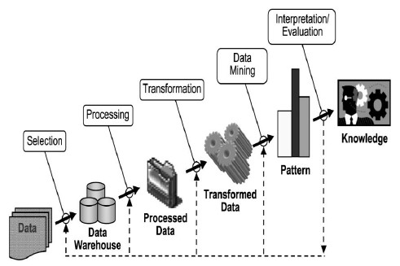
Fig 1: The flow of Data from processing to knowledge

Table of Contents
Abstract 1
Introduction 3
Task 1. 3
1.1: Purpose and Practice of Data Mining 3
1.3: Data Pre-processing and Post-processing 14
1.4: Sample Runs and Analysis Methods 17
1.5: Business Recommendations 26
1.6: Reflective Commentary 27

Introduction
Data mining is an important business practice because it helps organisations discover useful patterns in customer data and make informed decisions. This report uses Weka for data preparation and predictive analysis, while Tableau is used to explore the data and present key findings through clear visualisations. Data mining helps businesses examine customer data, identify behaviour patterns and recognise customers who may be likely to leave. This report uses Weka and Excel to analyse the Online Retail Customer Churn Dataset. It explores customer spending, purchases, returns, satisfaction and engagement. Classification models are developed and compared using accuracy, precision, recall and AUC. The results are then used to suggest practical ways retailers could improve customer retention

Task 1.

1.1: Purpose and Practice of Data Mining
Data mining is the analysis of complex, large business datasets after transformation. Recognising useful patterns and relationships and gives us deeper, detailed knowledge.
“Knowledge about the data is useful for data preprocessing, the first major task of the data mining process. The various attribute types are studied. These include nominal attributes, binary attributes, ordinal attributes, and numeric attributes. Basic statistical descriptions can be used to learn more about each attribute's values.” [1] It is the combination of statistics, machine learning and database techniques to turn raw data into usable information, which is needed for important business decisions. Common methods include classification and clustering.
“Finding frequent patterns plays an essential role in mining associations, correlations, and many other interesting relationships among data. Moreover, it helps in data classification, clustering, and other data mining tasks. Thus, frequent pattern mining has become an important data mining task and a focused theme in data mining research. [2]
In retail, data mining can analyse sales transactions, loyalty-card records, website activity and customer-service data. For example, market-basket analysis identifies products frequently purchased together, helping retailers improve product placement, bundling and cross-selling. Sales forecasting can predict future demand, allowing businesses to manage stock, staffing and promotions more effectively. Customer analytics helps businesses understand customer behaviour and value. Customers can be segmented according to purchase frequency, spending, preferences or demographics. These can be used for personalised and targeted advertisements, recommendations and other business operations. Classification models such as decision trees, logistic regression and Random Forest can use factors such as reduced spending, complaints, engagement levels and purchase frequency to estimate churn risk. Data mining also provides decision support through forecasts, recommended actions and risk analysis. This helps businesses make decisions using real, up-to-date data for marketing, pricing, and customer-related decision-making. For reliable results, high-quality data, appropriate evaluation and responsible treatment of privacy, security and potential bias are required.
1.2: Dataset Description and Exploration

    - Summary statistics and distributions

The Online Retail Customer Churn Dataset was obtained from Kaggle [2]. The file contains 1,000 customer instances and 15 attributes, or 15,000 populated cells. Eleven fields are numeric: Customer_ID, Age, Annual_Income, Total_Spend, Years_as_Customer, Num_of_Purchases, Average_Transaction_Amount, Num_of_Returns, Num_of_Support_Contacts, Satisfaction_Score and Last_Purchase_Days_Ago. Four are categorical: Gender, Email_Opt_In, Promotion_Response and the Target_Churn class. Customer_ID is an identifier rather than a meaningful predictor.
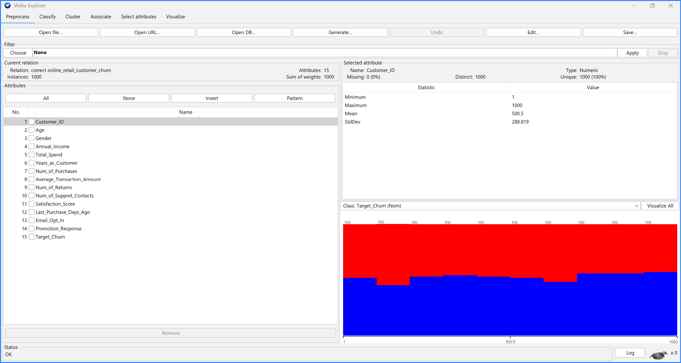
Figure 1. Weka Preprocess view of the correct Online Retail Customer Churn dataset, containing 1,000 instances and 15 attributes. Target_Churn is selected as the nominal class.

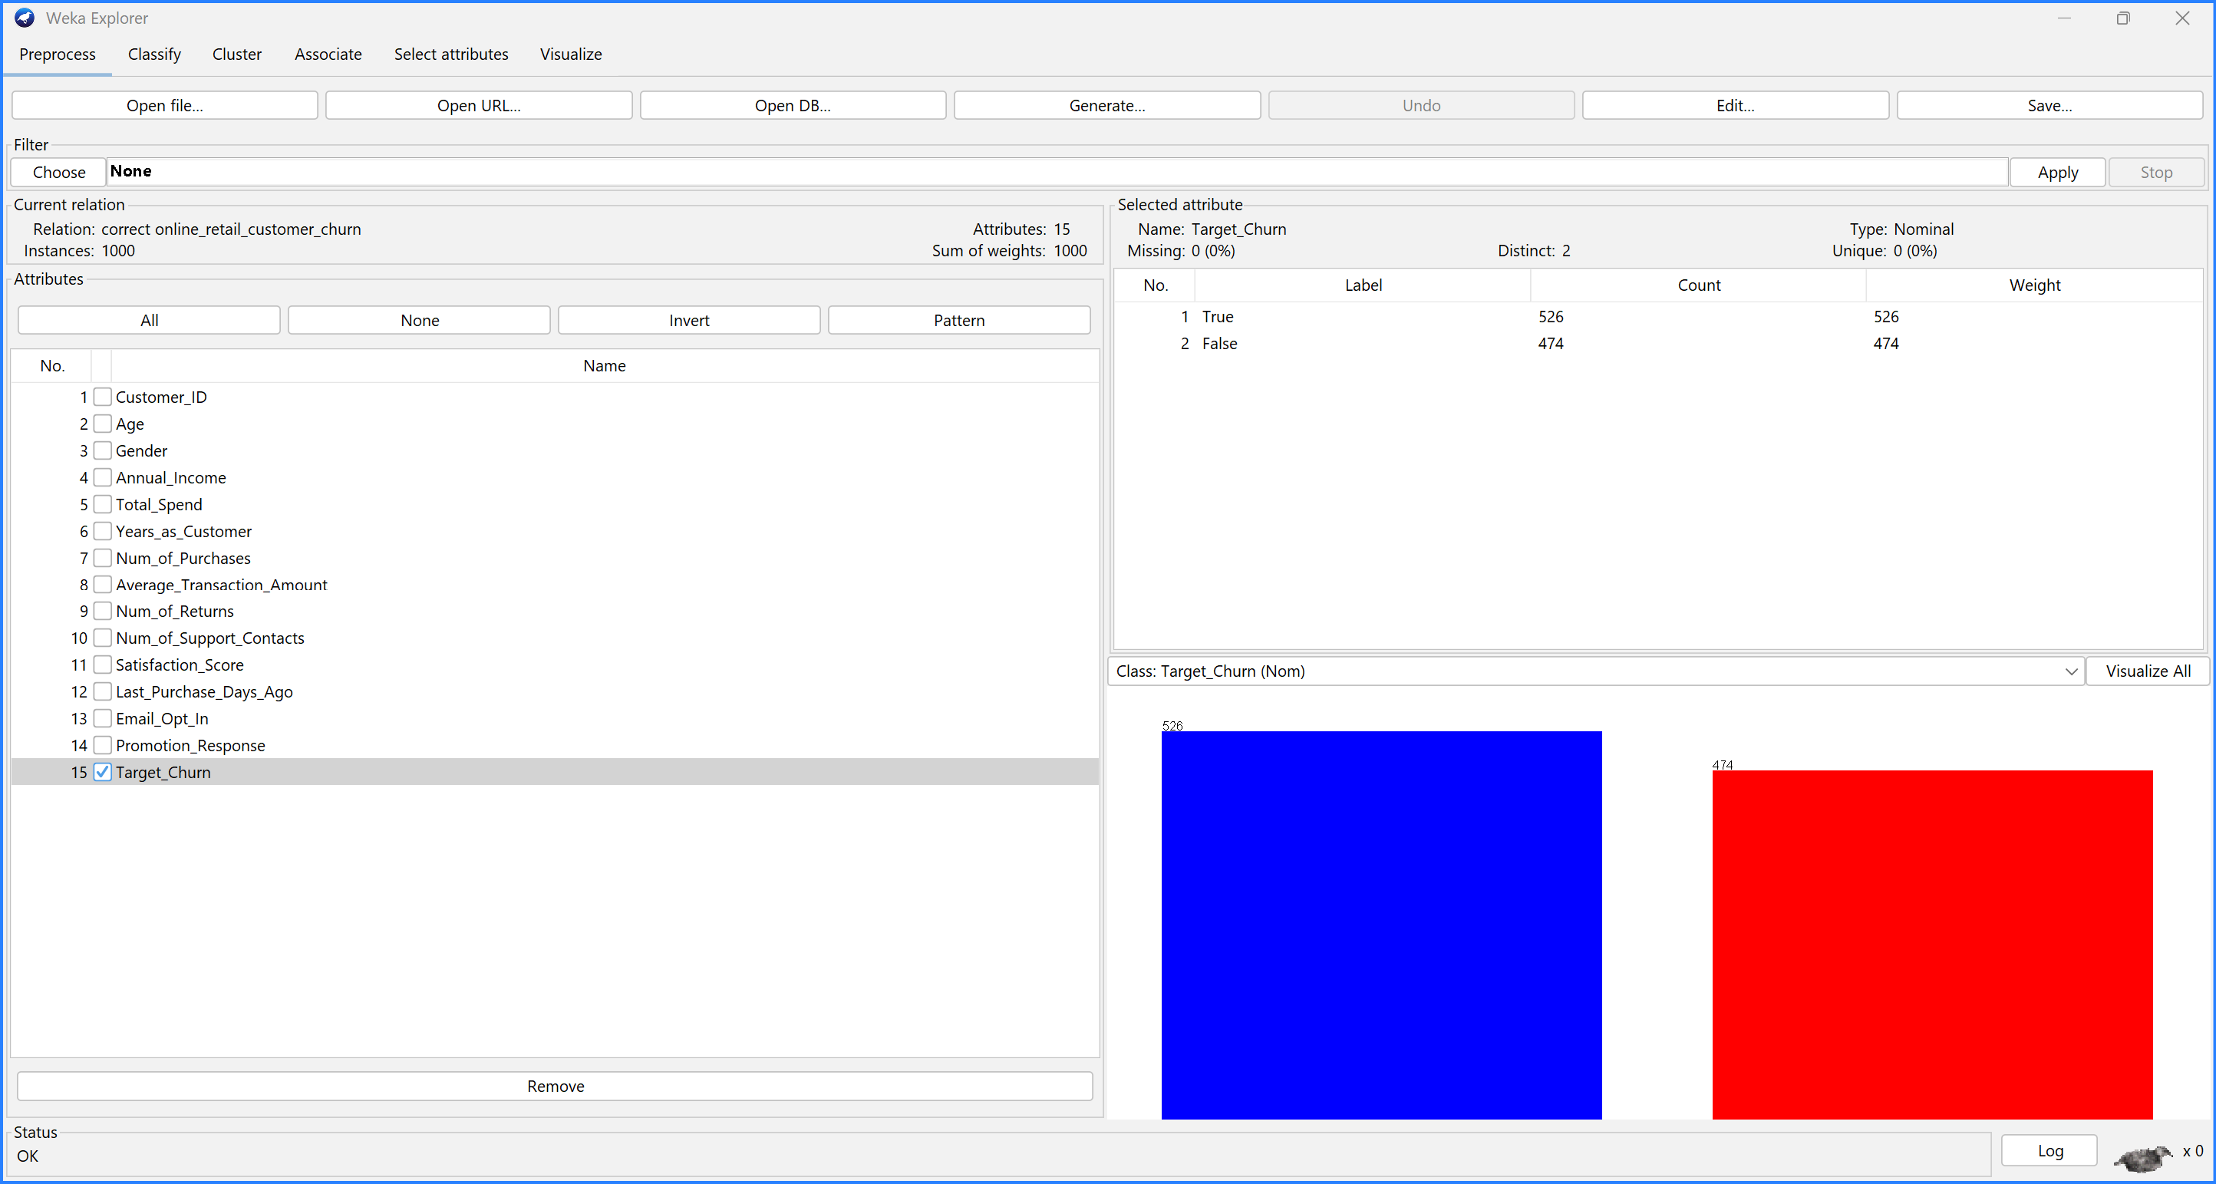
Figure 2. Distribution of the Target_Churn class in Weka: 526 churn customers and 474 non-churn customers.
The dataset is reasonably balanced: 52.6% versus 47.4%. SMOTE is not required.

1.2.2 Missing values
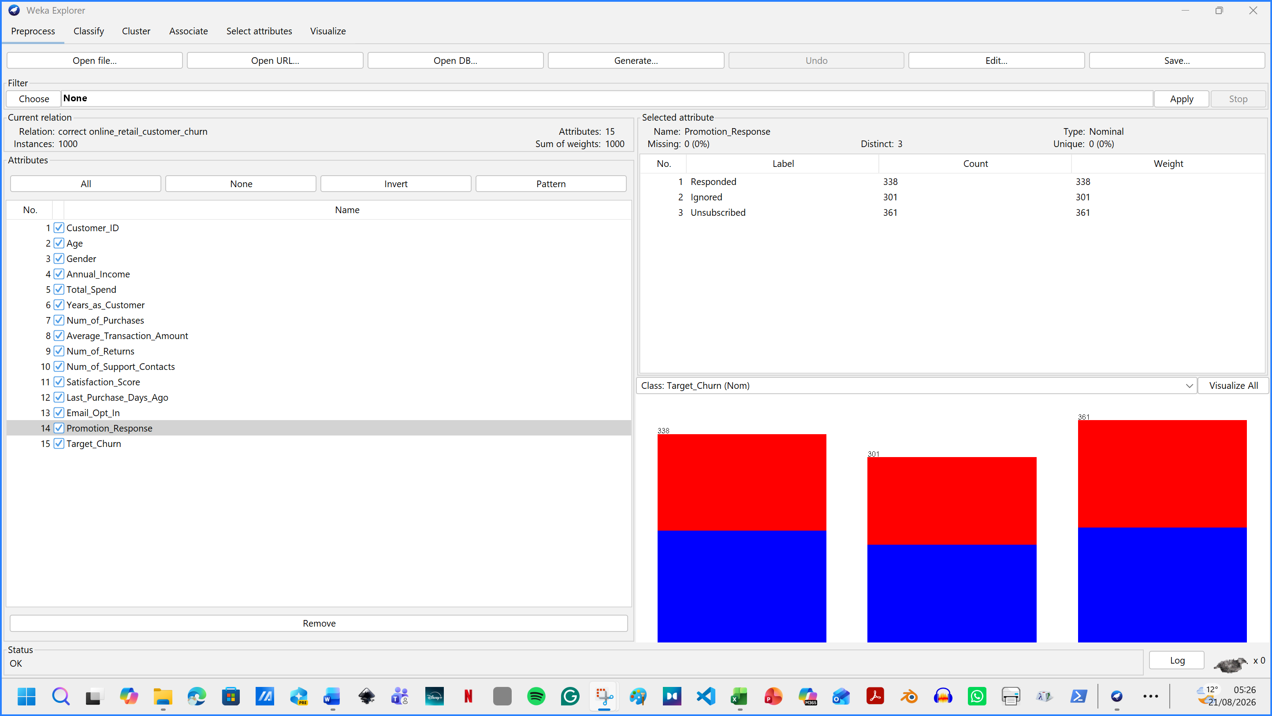
Figure 3. Weka reported no missing values across the 15 attributes.
Weka checks found no missing values, no duplicate rows and 1,000 unique identifiers. Instances were 1,000. Age ranged from 18 to 69 years (mean 43.27). Annual income ranged from 20.01 to 199.73 (mean 111.96), while total spend ranged from 108.94 to 9,999.64 (mean 5,080.79). Customers had made between 1 and 99 purchases, and the time since their last purchase ranged from 1 to 364 days. Gender was evenly distributed: 342 female, 334 male and 324 other. Email opt-in was also close to even, with 529 true and 471 false. Therefore, no observations were removed or imputed. If missing values had been present, the ReplaceMissingValues filter would have been used. The filter location is: unsupervised / attribute / ReplaceMissingValues.

1.2.3 Attributes and data types
The dataset contains 1,000 customers and 10 attributes. Customer_ID is a whole-number identifier, with a different value for every customer from 1 to 1,000. It should not normally be used to build a model because it does not describe customer behaviour. Age, Years_as_Customer, Num_of_Purchases, Num_of_Returns and Num_of_Support_Contacts are whole-number variables. Annual_Income, Total_Spend and Average_Transaction_Amount are decimal-number variables. Gender is a category with three options: Female, Male and Other.

1.2.4 Pre-processing in Tableau
The second method I used for preparation, exploration and visual presentation , was Tableau. I applied screenshots of the processes below.

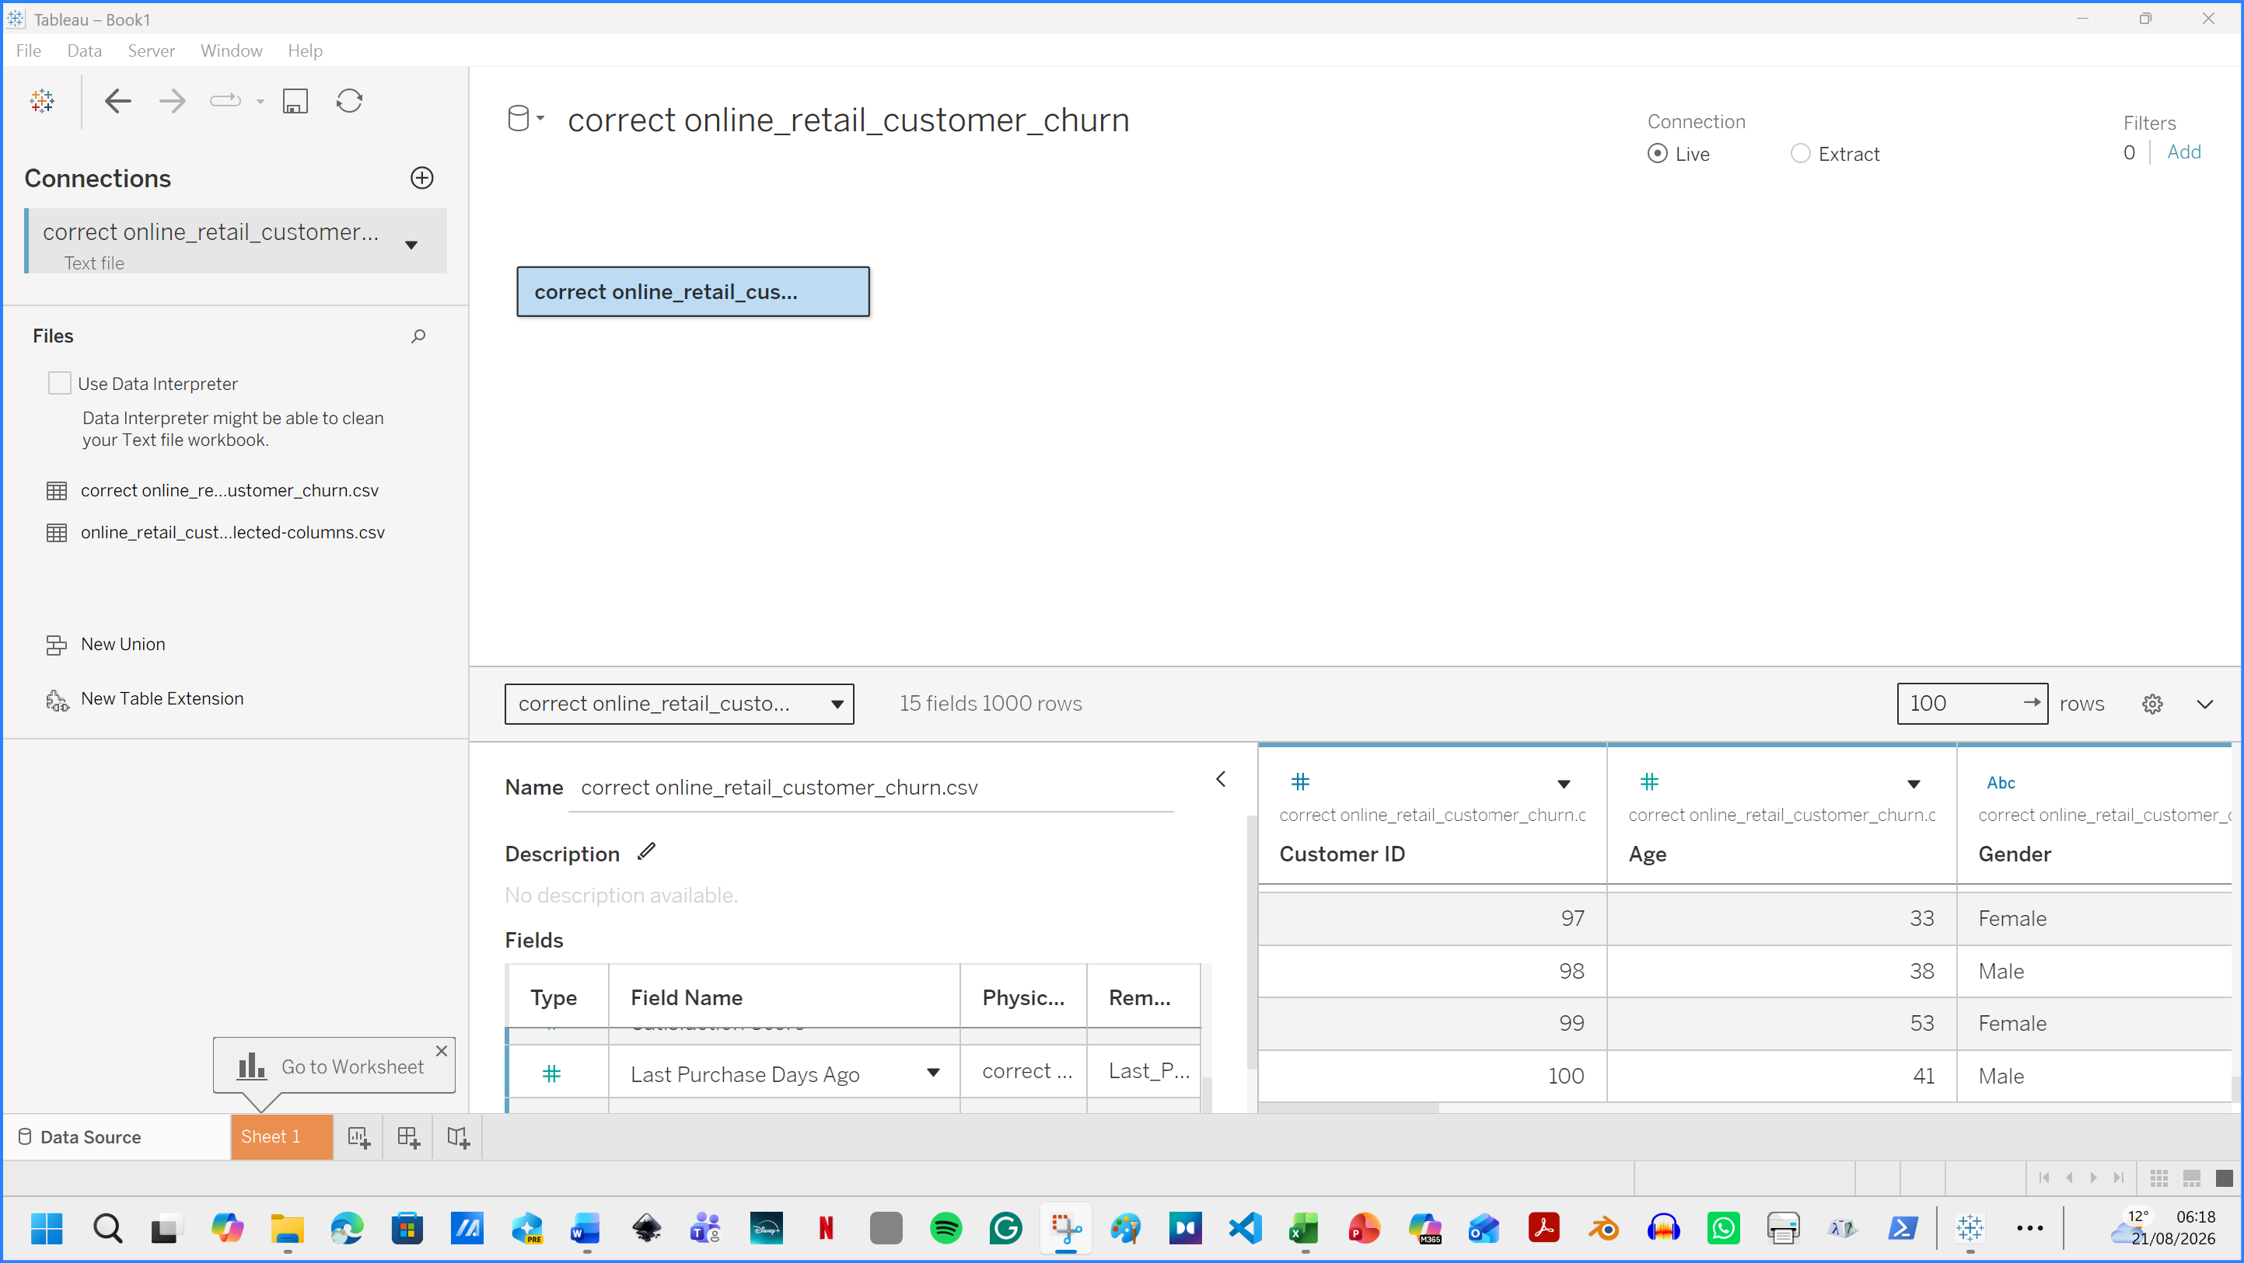
Figure 4. Tableau processing. Data Source view of the Online Retail Customer Churn Dataset containing 1,000 records and 15 attributes.

I Created a Churn Flag, then I clicked “Create Calculated Field” . I named it Churn Flag. Sheet 1 was renamed to Class Balance. Customer ID was dragged to Rows. Target Churn section was dragged to Columns. 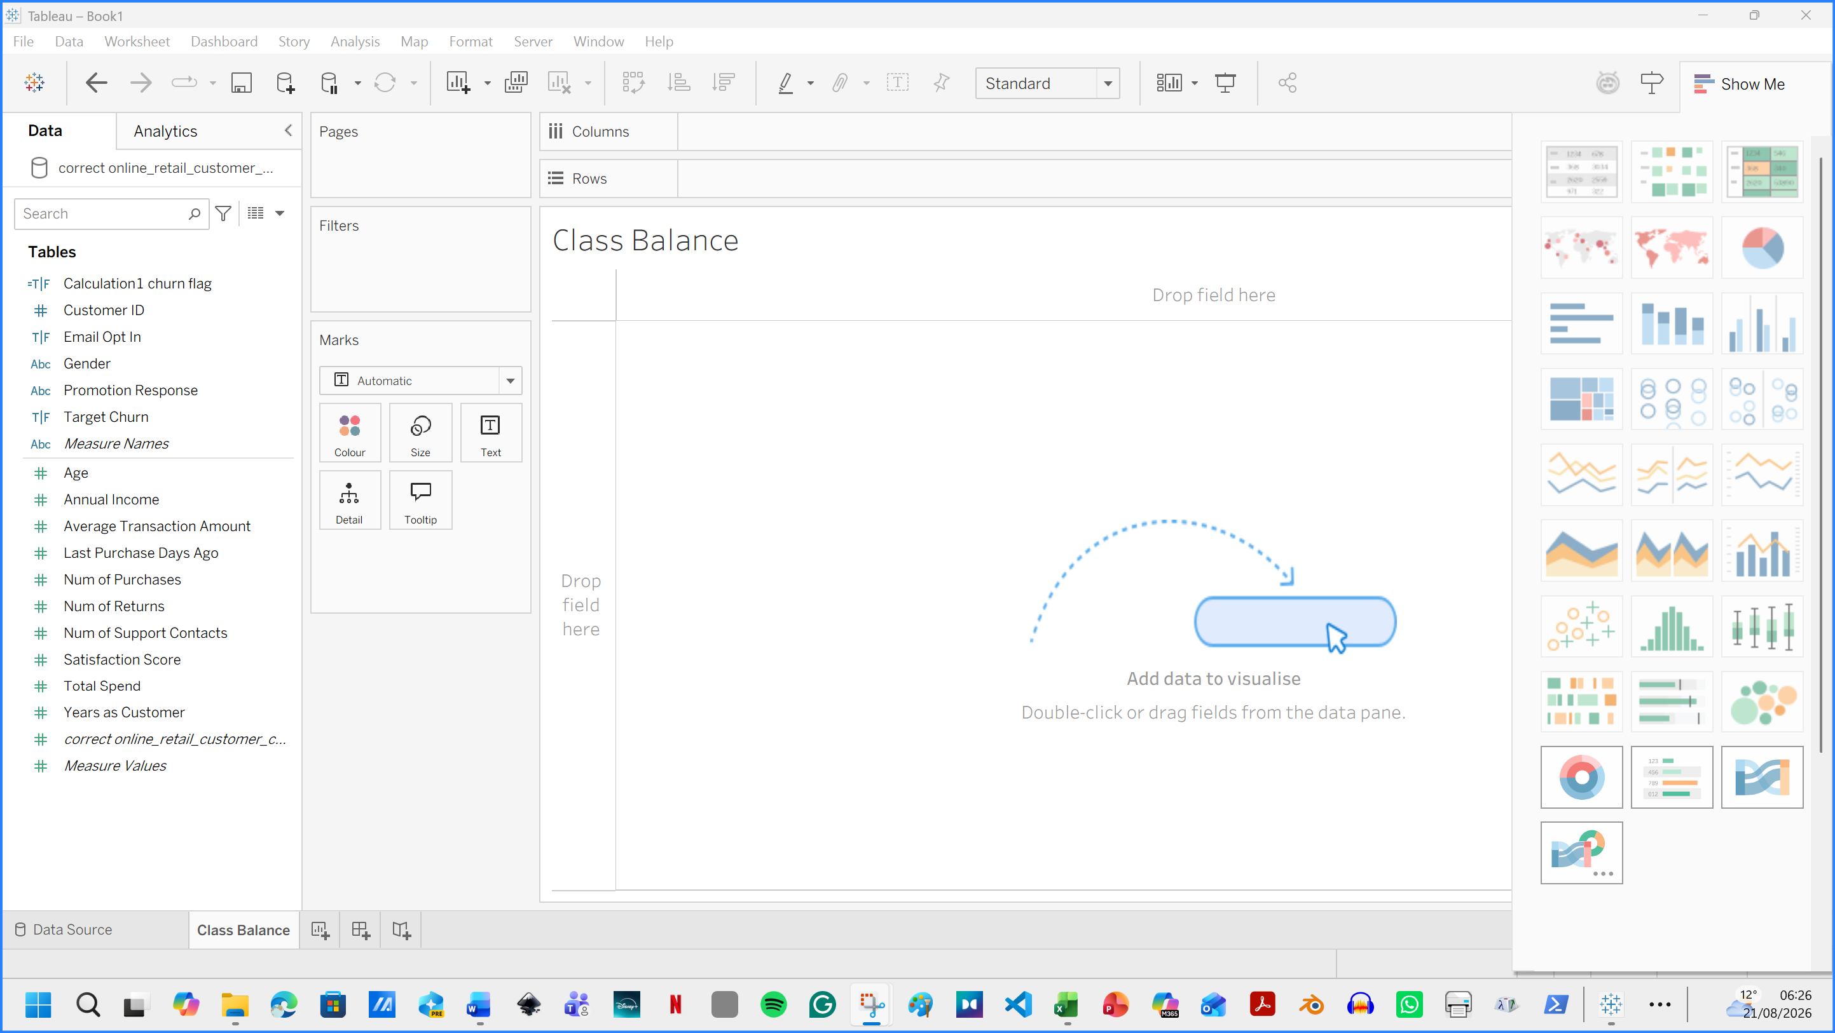
Figure 5. Sheet 1 was renamed to Class Balance.

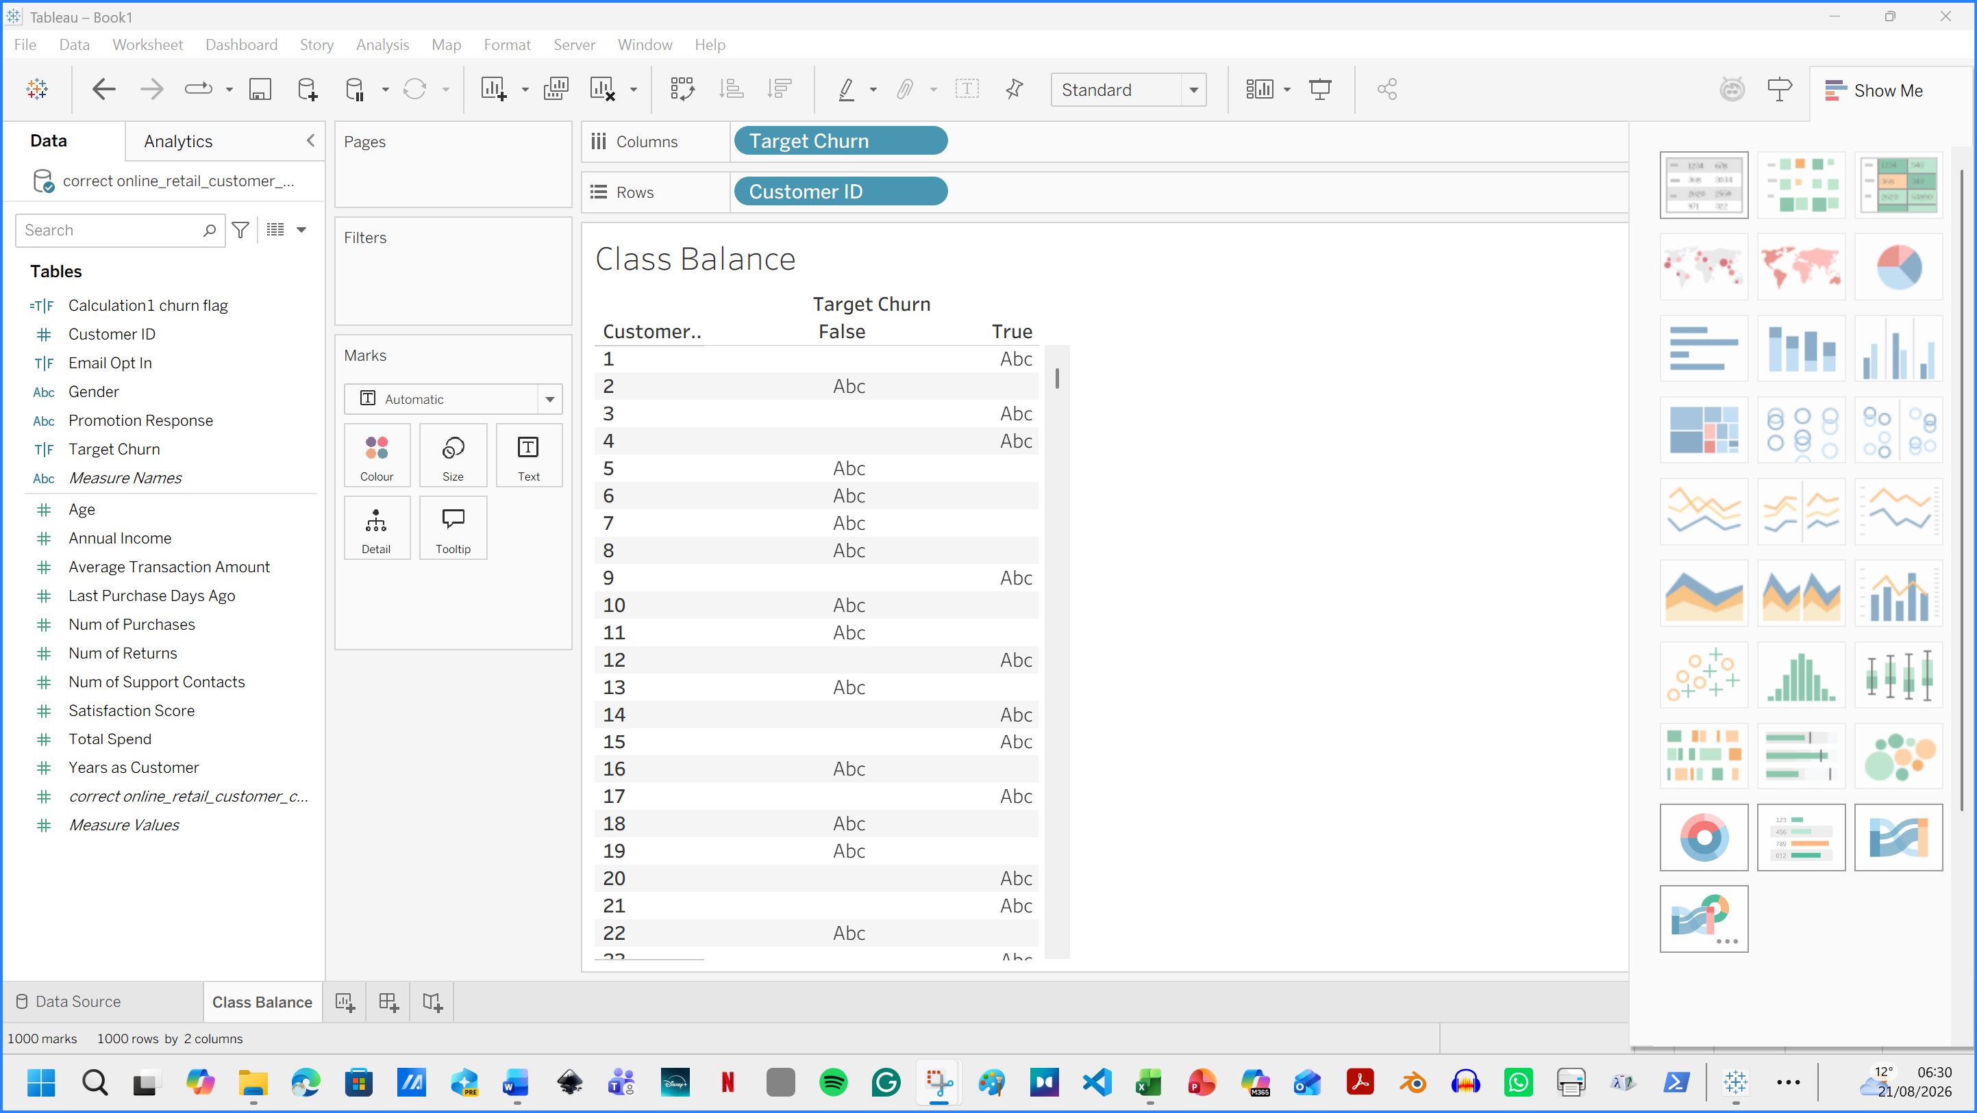
Figure 6. Customer ID was dragged to Rows. Target Churn section was dragged to Columns.

Upon clicking the Customer_ID field, a drop-down menu selection field offers options for Measure / Count ( Distinct). Next, at the Marks section, I selected Bar.

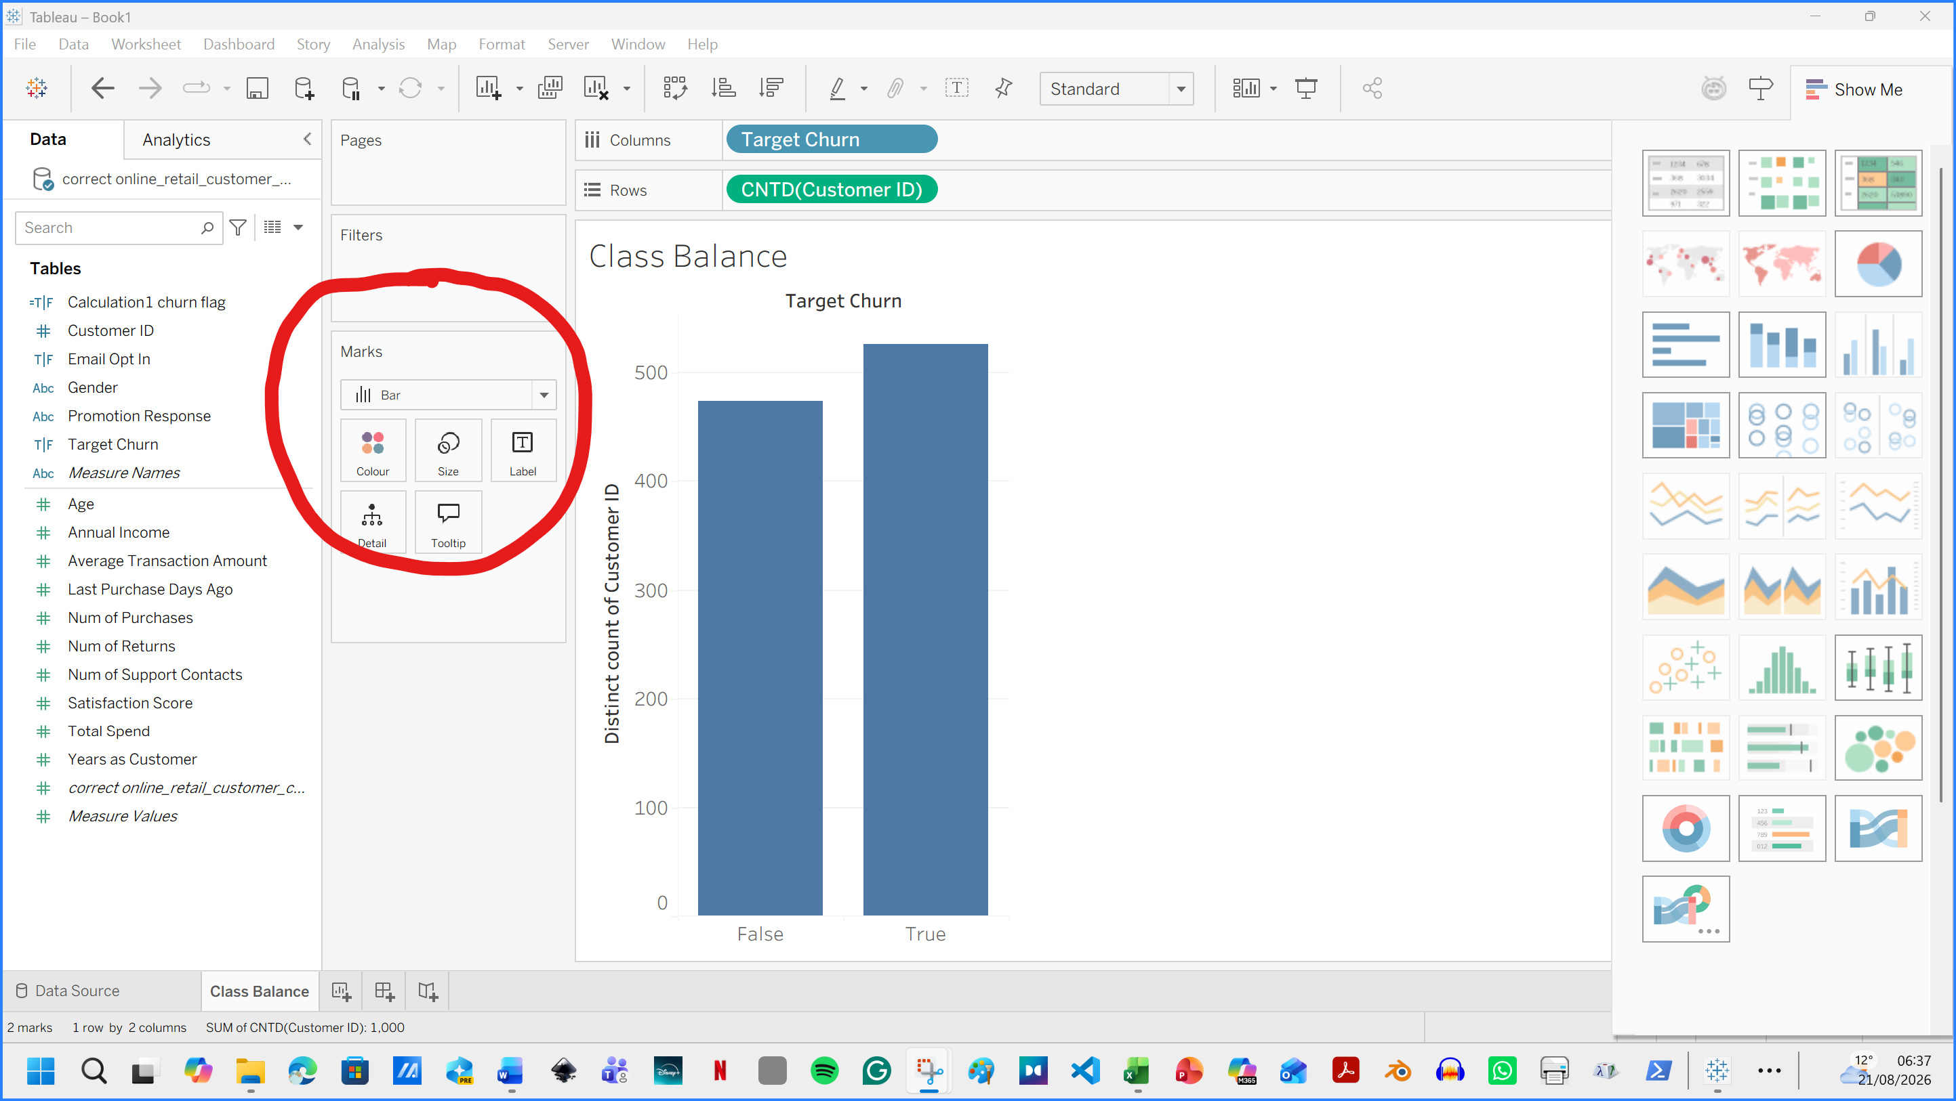
Figure 7. Marks section. Bar view was selected.

At the Marks section, I clicked on label and Show Mark Labels.
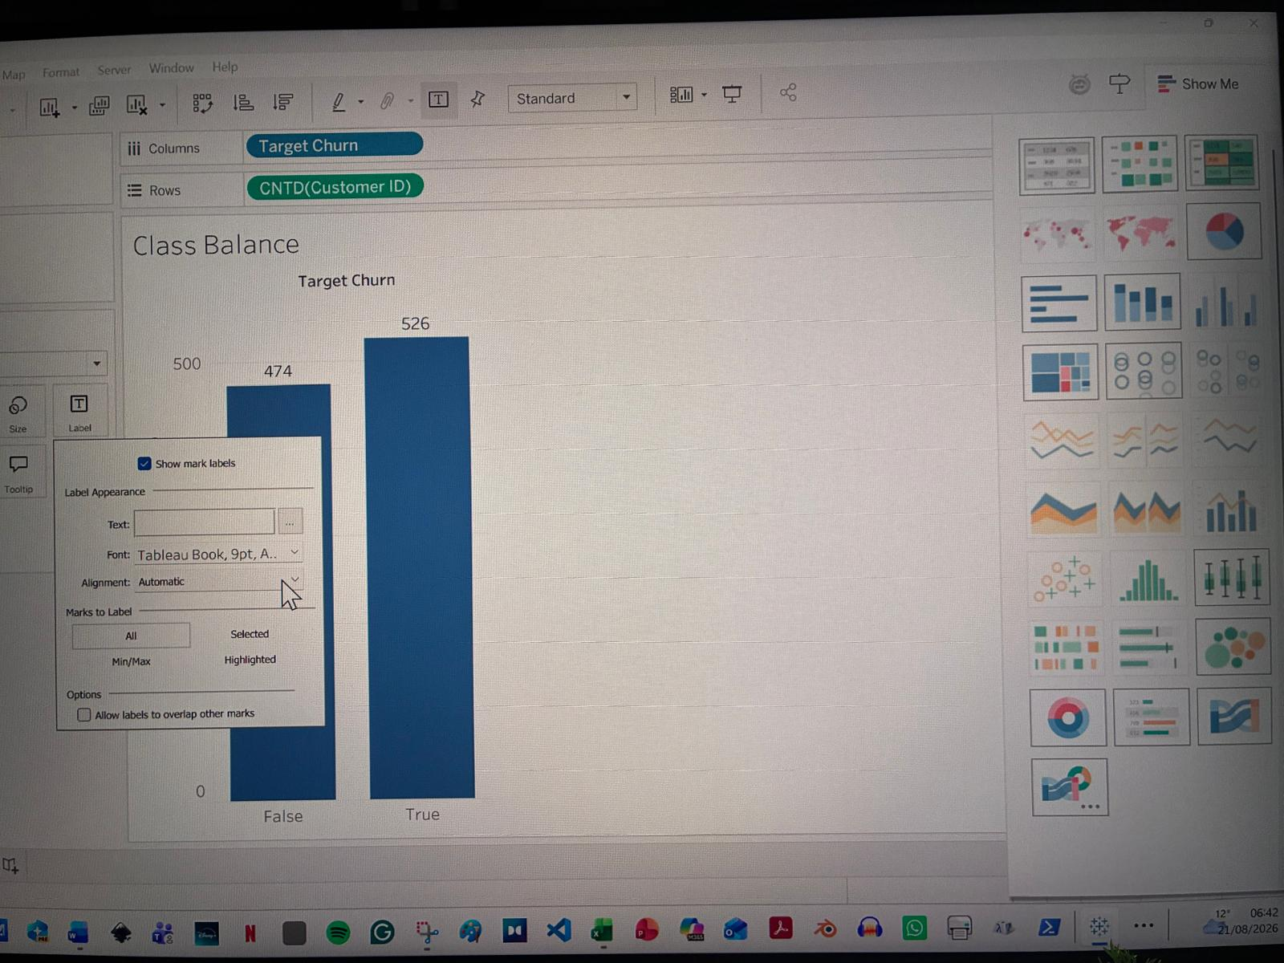
Figure 8: The image shows a data visualisation in Tableau, featuring a column chart with 'Target Churn' as the metric, and a selection of various settings for labelling and mark.
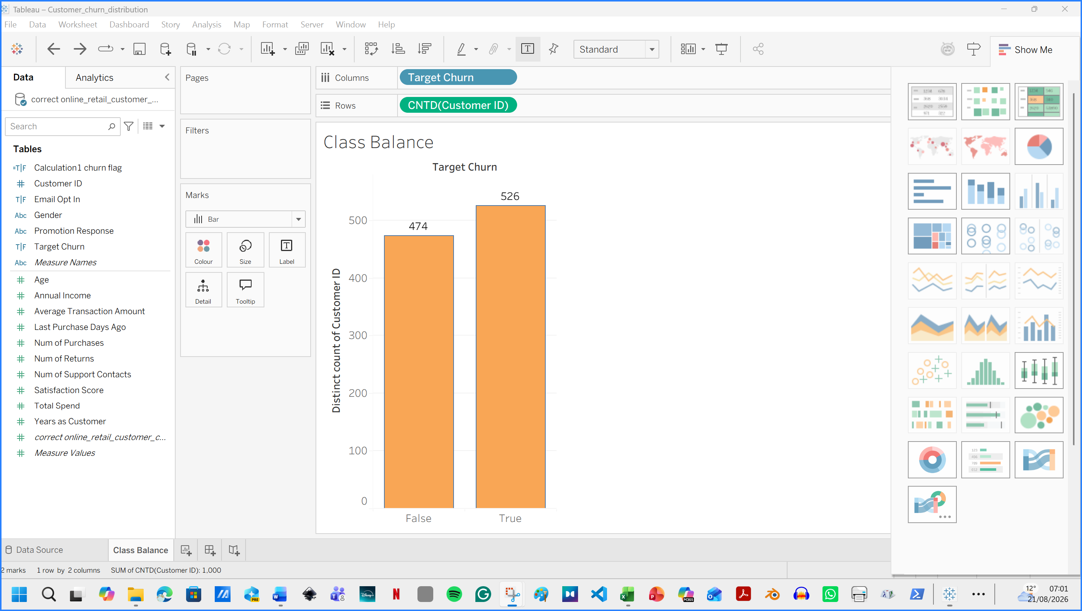
Figure 9. Customer churn distribution showing 526 churn customers and 474 non-churn customers.

A second Tableau worksheet was created: Churn by Satisfaction. Satisfaction_Score was added to Columns, and Churn Flag was added to Rows. The Measure was selected: Average. Marks was selected: Bar.
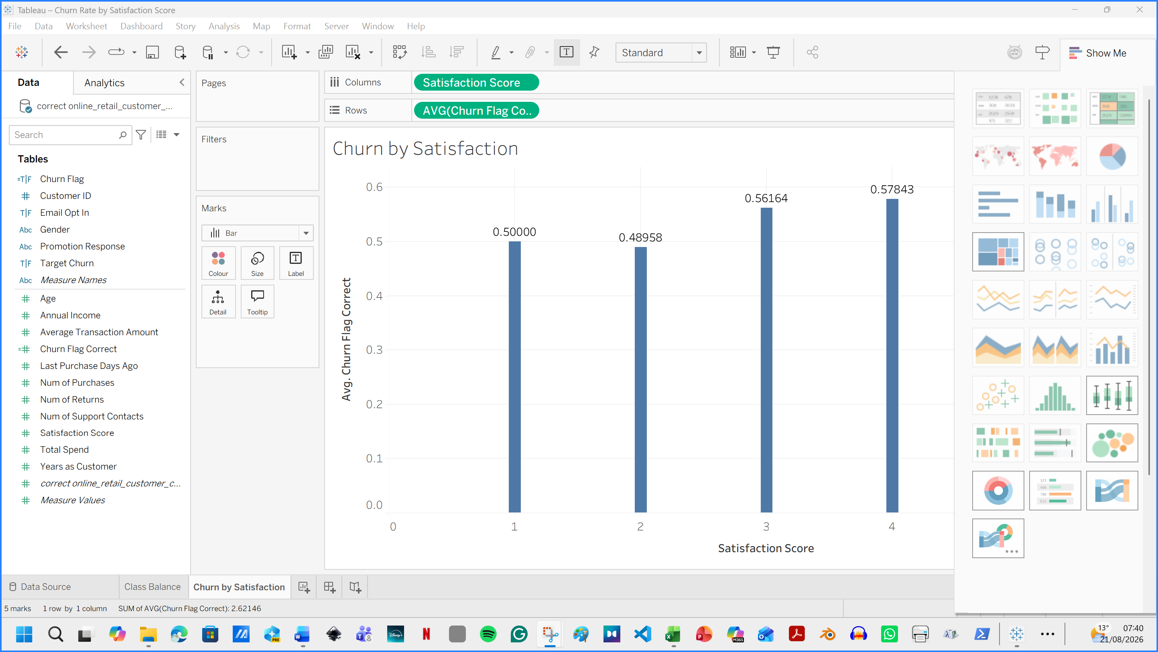
Figure 10. Second worksheet: Churn by Satisfaction

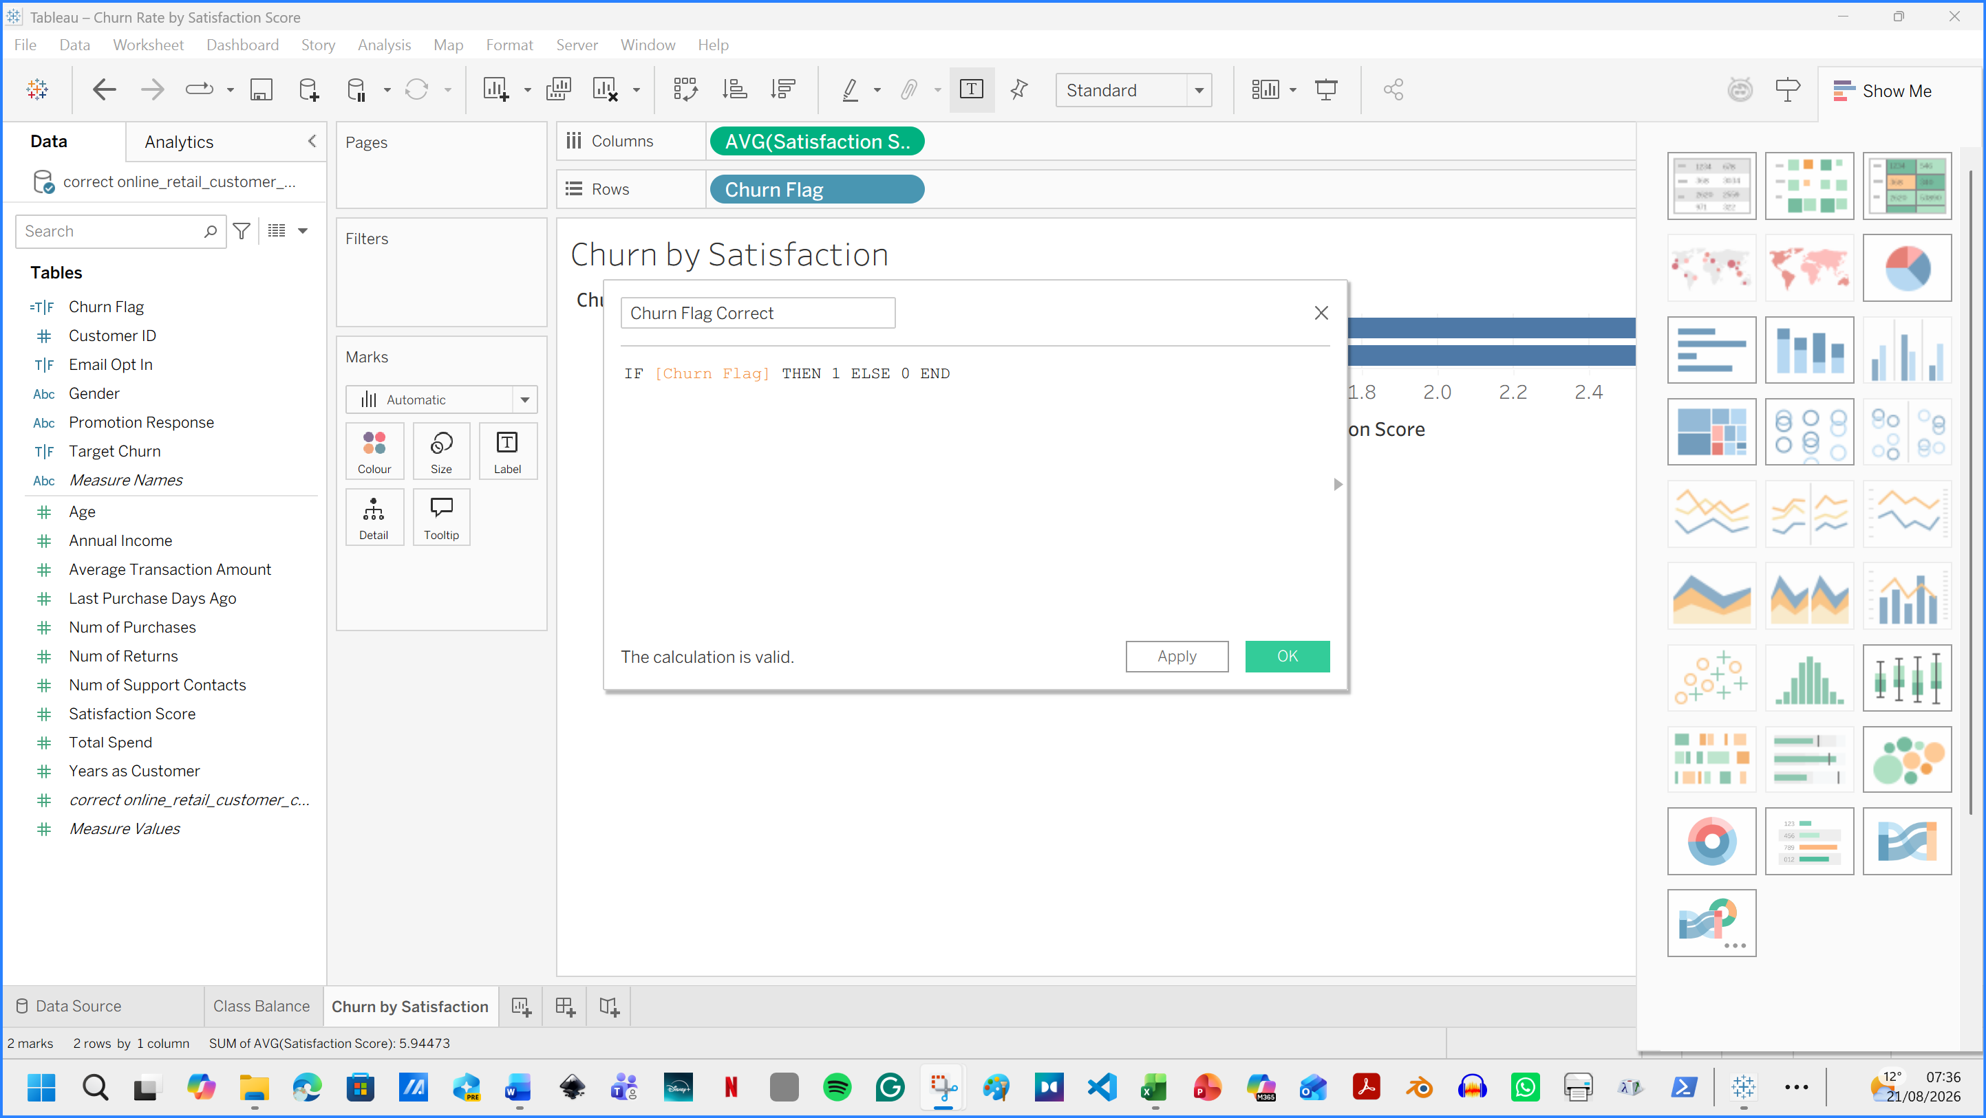
Figure 11. Worksheet settings applied.

The Satisfaction Score section was updated to Discrete instead of Continuous.
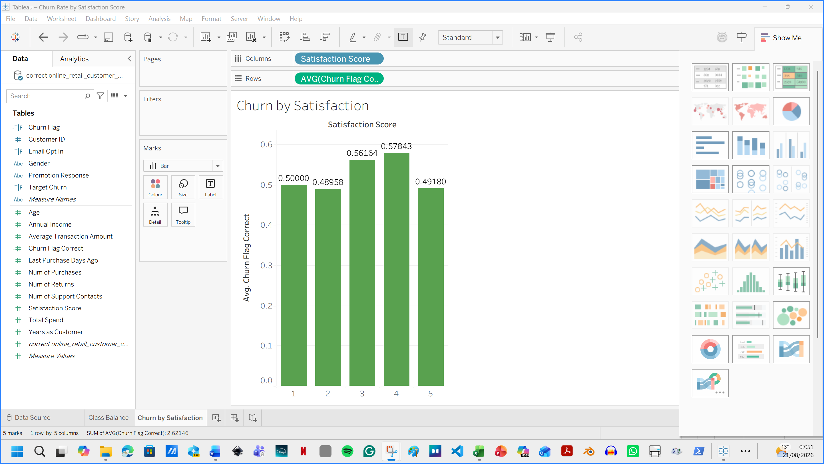
Figure 12. Correction of Satisfaction Score, as it was previously green and incorrectly applied as Continuous rather than Discrete.

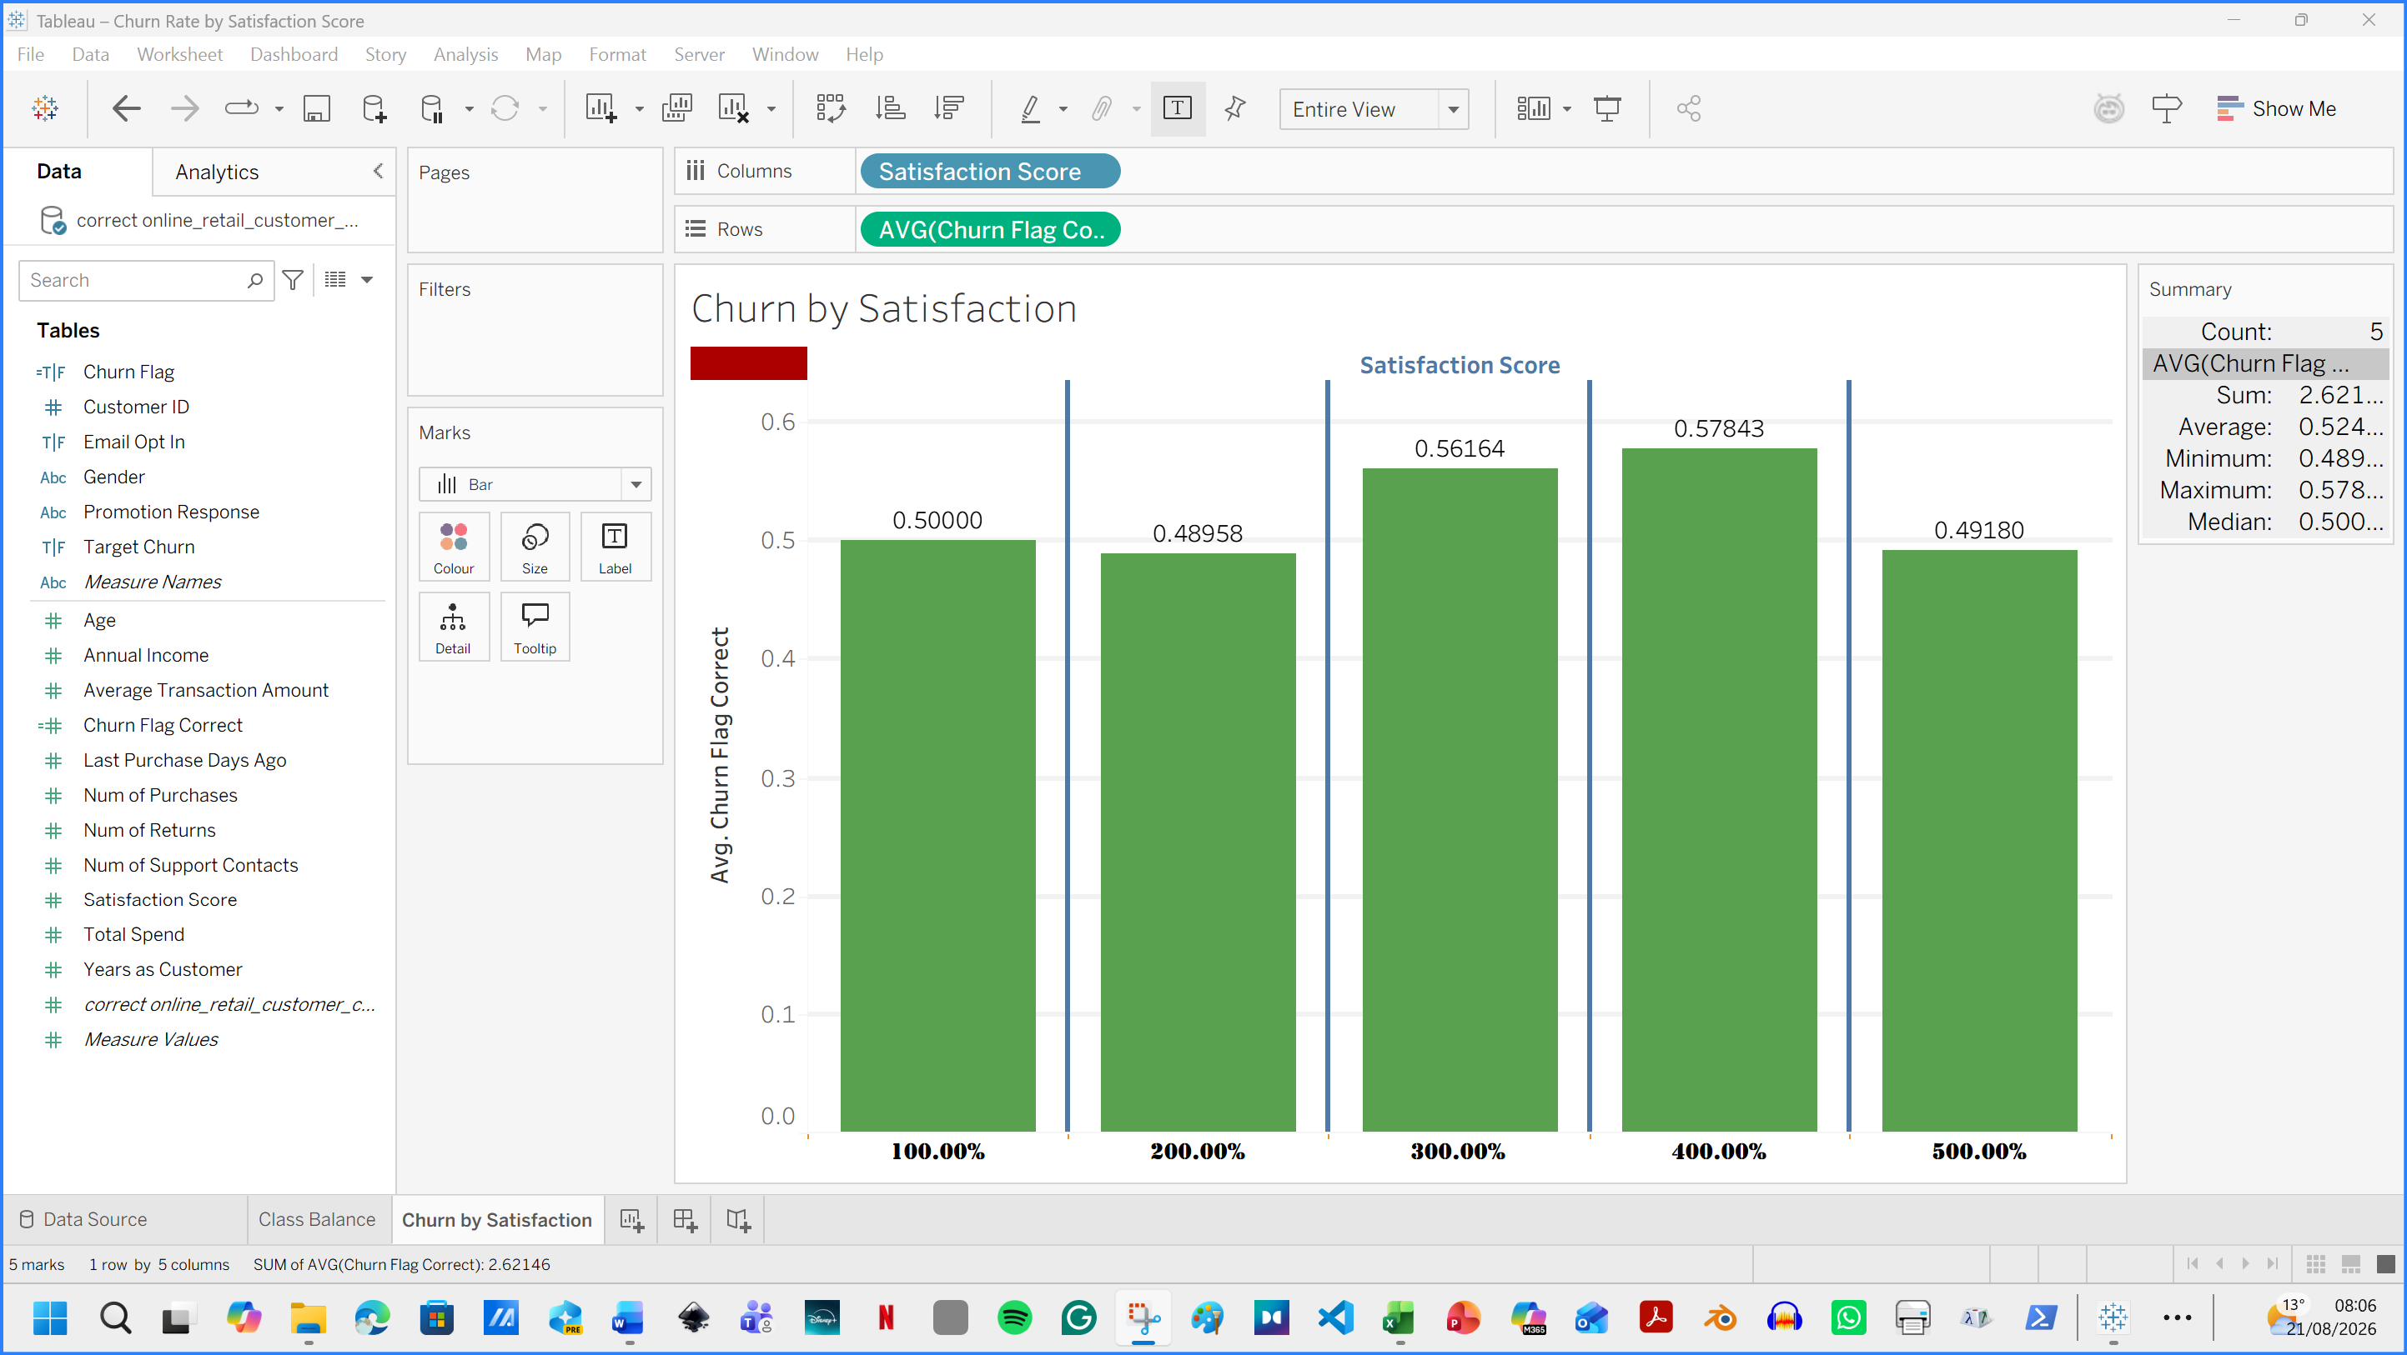
Figure 13. Corrected version, but it still contains an error. Satisfaction labels should be 1–5, not 100%–500%.

The Satisfaction_Score required some further assistance to fix the error. The problem was that the Number Format was set to Automatic by default. I changed the default number Format to Percentage. Therefore, in the Default Properties / Number Format / drop-down menu, I selected “Number (custom)”. Setting decimal places to Zero (0).

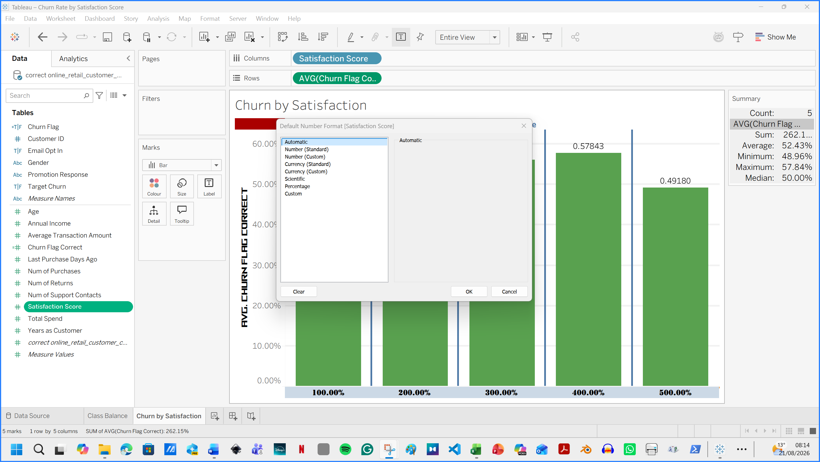

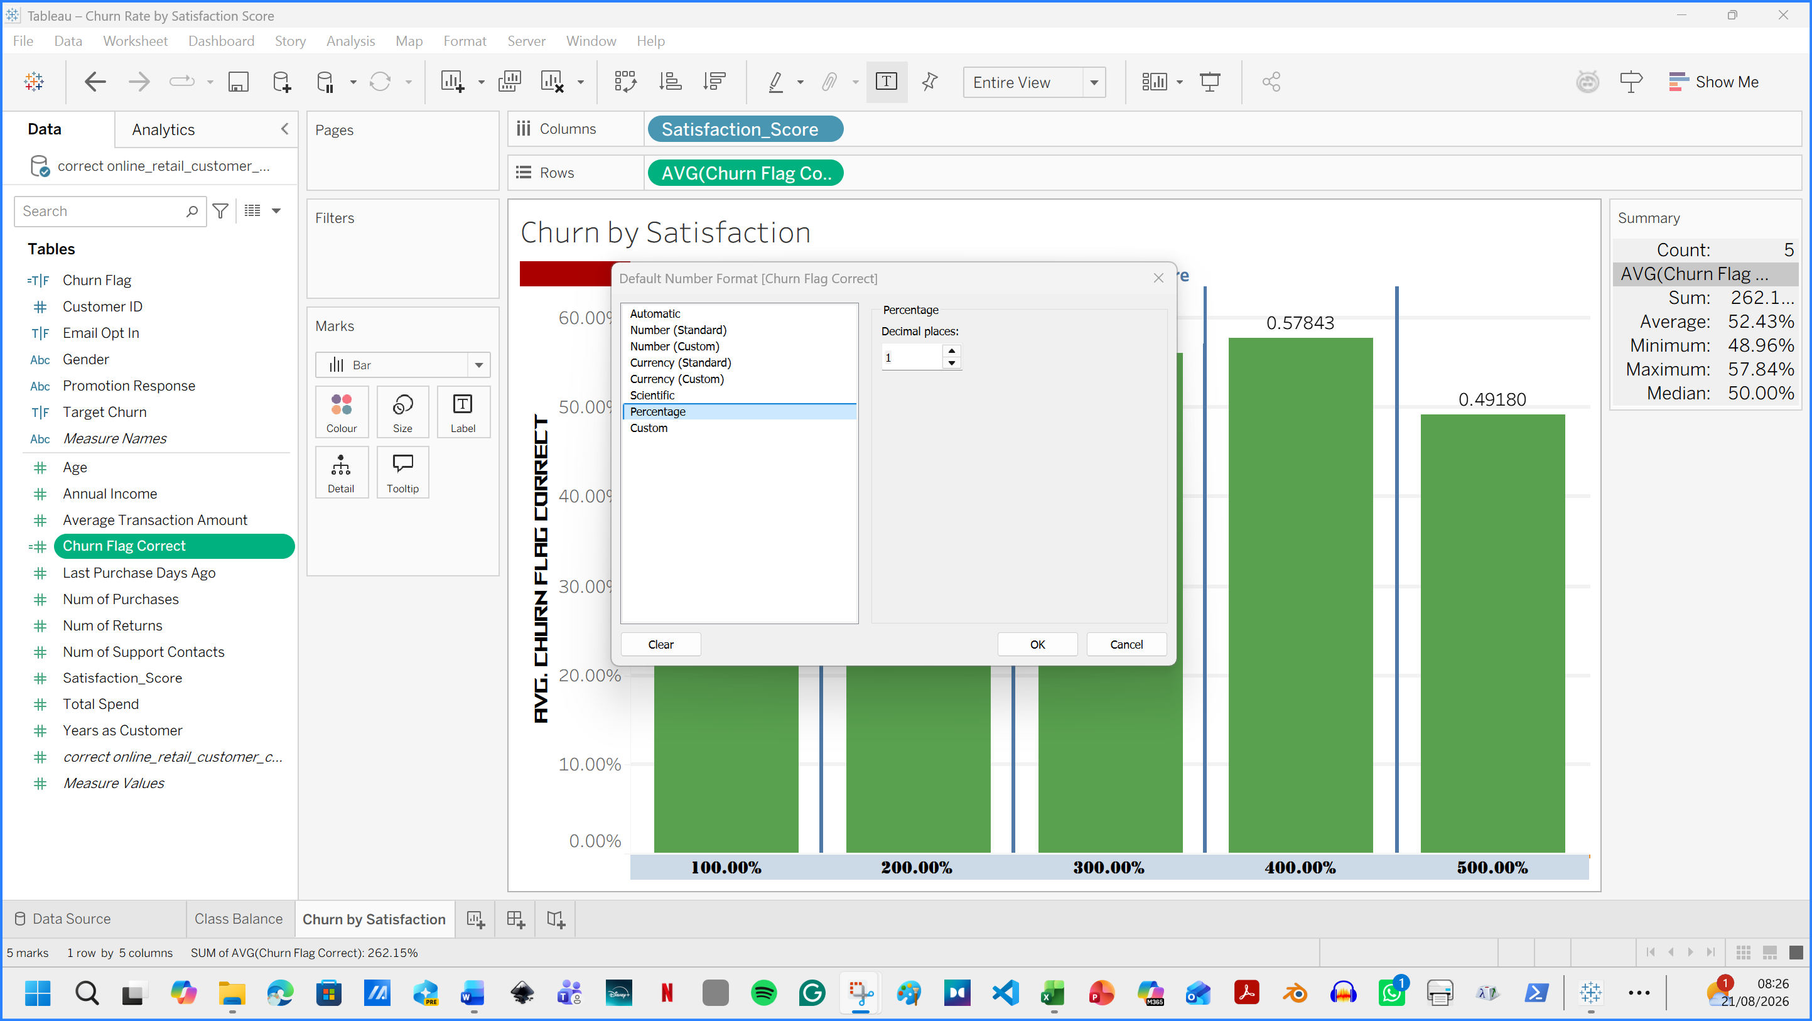
Figure 12. Second worksheet formatting

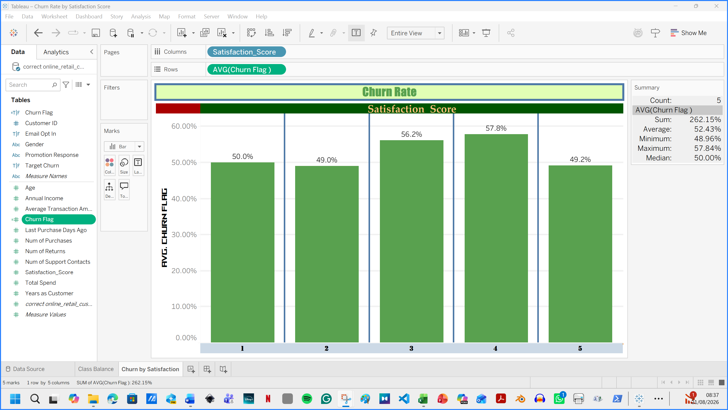
Figure 13. The Diagram was corrected

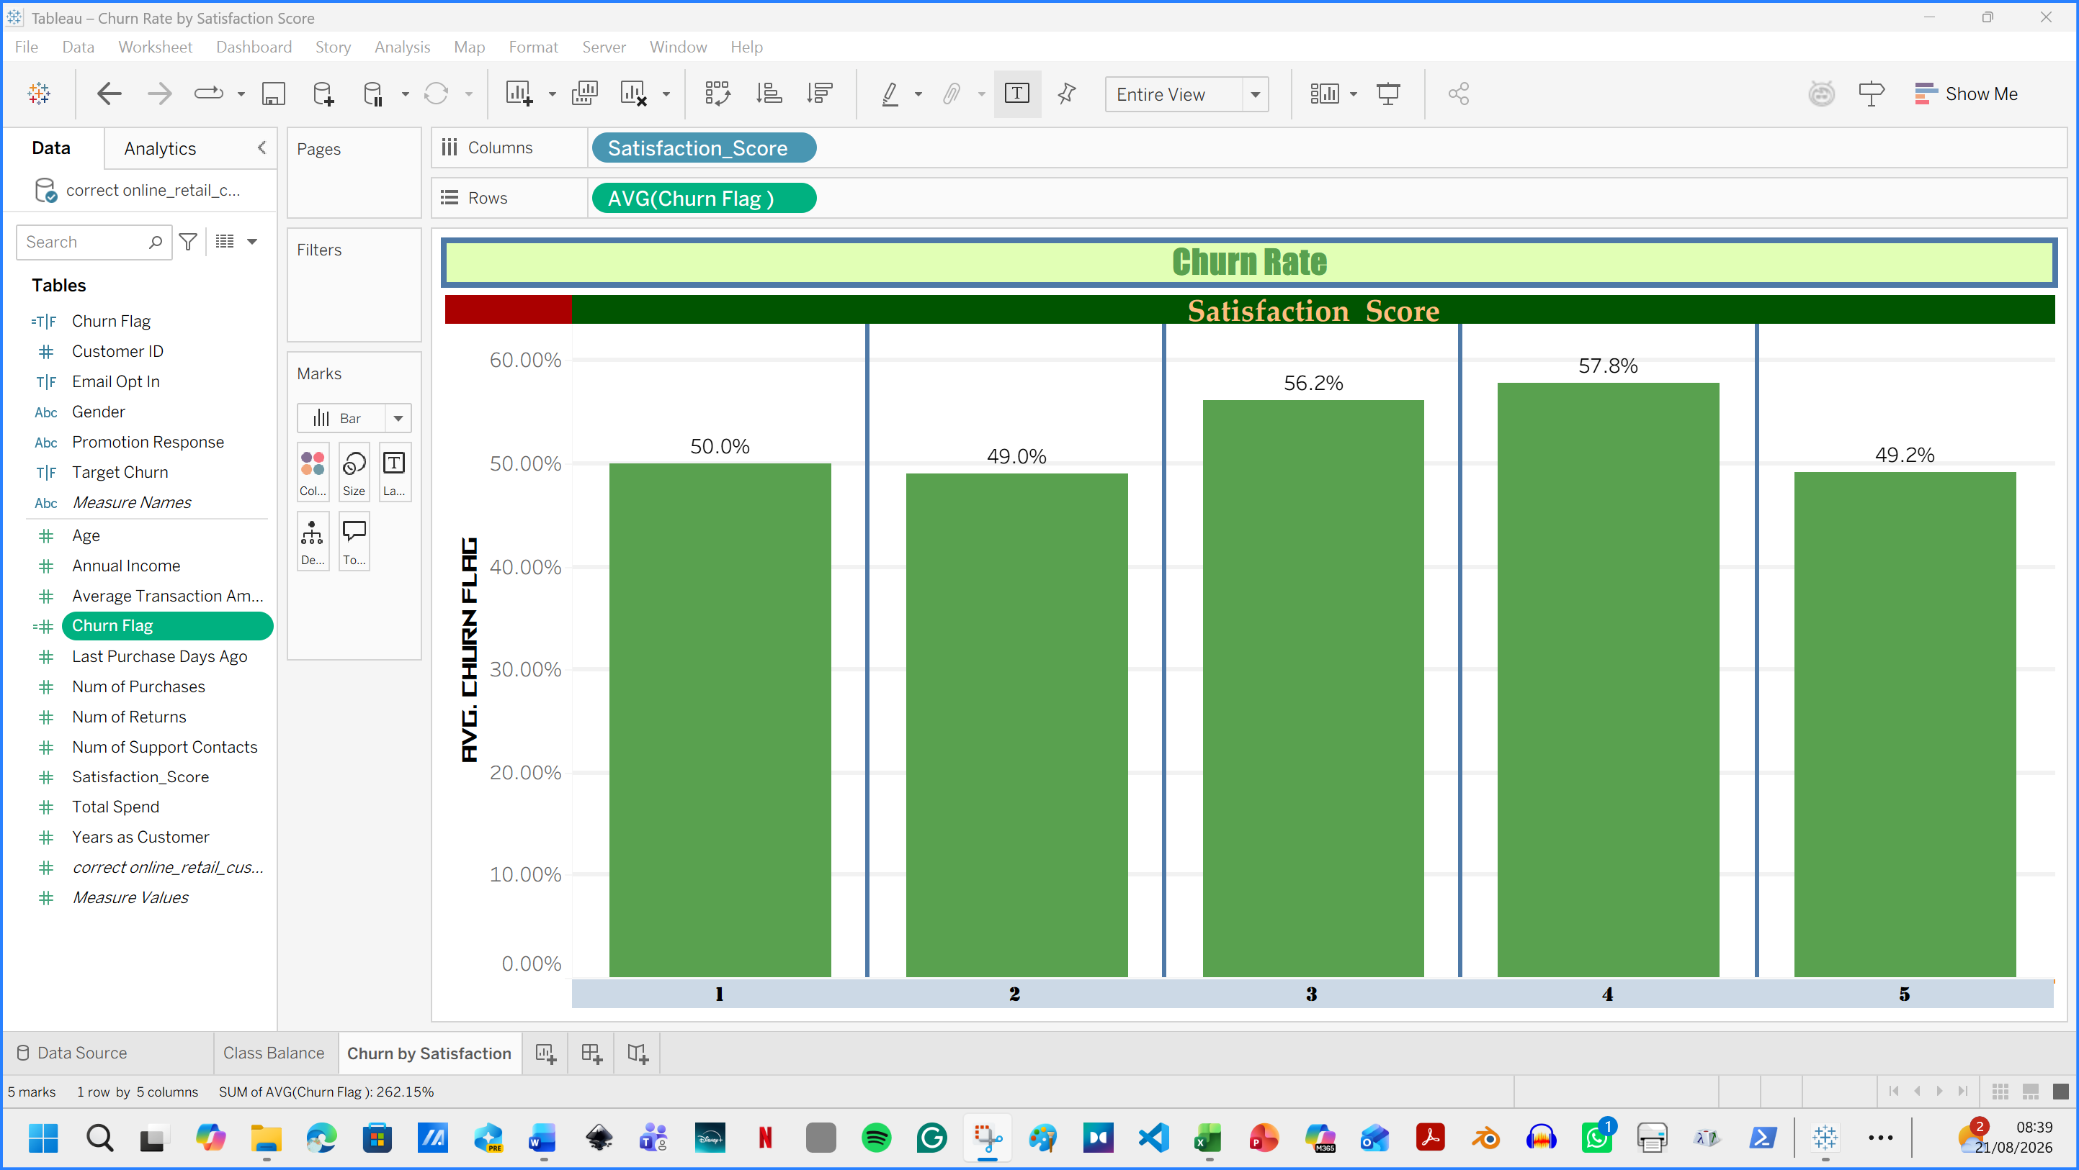
Figure 14. Summary panel hidden on the right; now full diagram visible.

1.3: Data Pre-processing and Post-processing
The dataset was examined in Excel and Weka to identify problems and ensure that the variables were usable for analysis. Each row represented one customer, while the columns described demography, customer transactions, and behavioural patterns. The Churn variable was selected as the target class.
- Removing Customer_ID
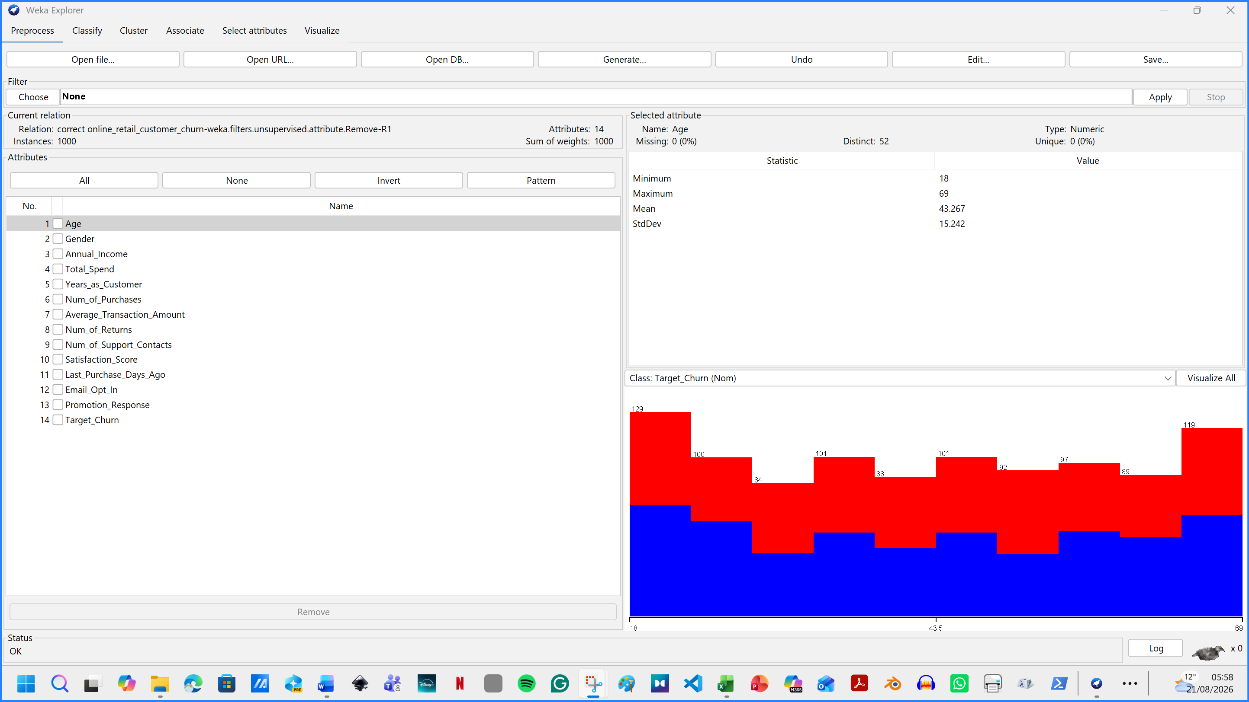
Figure 15. Removal of Customer_ID because it is a unique identifier with no predictive meaning.
Customer identifiers were removed because they uniquely identified individuals but provided no meaningful information for predicting behaviour.
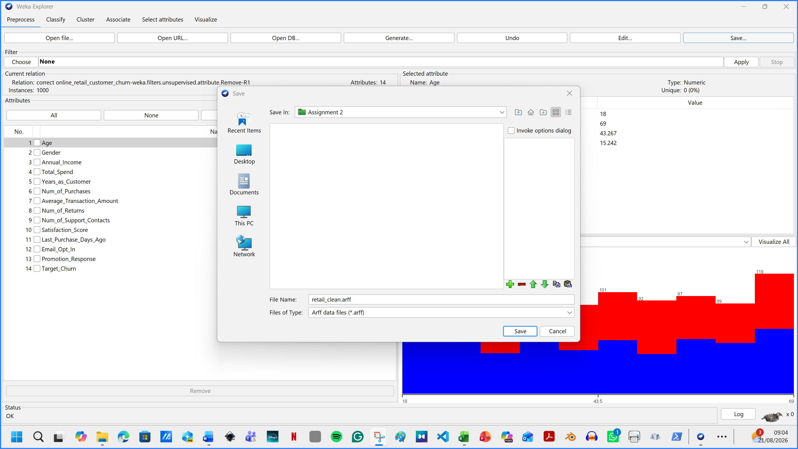
Figure 16. Saving the file as retail_clean.arff

- Data quality and handling missing values
There was no necessity for handling missing values, as Weka found no missing values. In case missing values were found, I would use, in the unsupervised section: attribute / ReplaceMissingValues.
- Encoding categorical variables
Gender, Email_Opt_In, Promotion_Response and Target_Churn were correctly recognised as nominal attributes. J48, Random Forest and Naive Bayes can use nominal attributes directly. For Logistic Regression and SMO, Weka internally constructs the required indicator representation; therefore, converting the class to a number was neither necessary nor desirable. An explicit NominalToBinary filter would be appropriate if a chosen algorithm required numeric inputs, but the Target_Churn class must remain nominal. Numeric variables were left in their original units for tree models. For clustering, the Standardise filter transformed continuous behaviour variables to comparable z-scores, preventing Total_Spend from dominating smaller-scale attributes such as returns and satisfaction

- Dataset balancing
The 52.6:47.4 class distribution was considered balanced. 52.6% = 526 customers with Target_Churn = True . 47.4% = 474 customers with Target_Churn = False.The dataset contained 526 churn customers (52.6%) and 474 non-churn customers (47.4%). Therefore, the classes were reasonably balanced.
No resampling or SMOTE was applied. SMOTE creates synthetic minority examples to address substantial imbalance but using it here would add artificial observations without solving the more important problem of weak predictor–outcome relationships.
“An approach to the construction of classifiers from imbalanced datasets is described. A dataset is imbalanced if the classification categories are not approximately equally represented.” [3]
In this dataset, churn and non-churn customers represented 52.6% and 47.4% of the observations, respectively. The classes were therefore considered reasonably balanced, and SMOTE was not required.

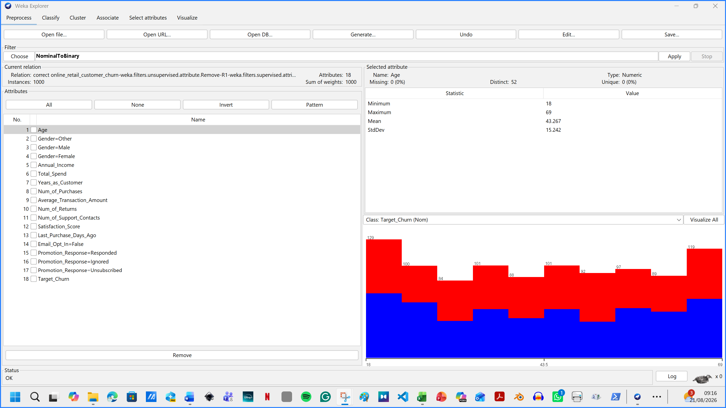
Figure 17. NominalToBinary encoding of categorical predictor variables while retaining Target_Churn as the nominal class.

1.4: Sample Runs and Analysis Methods
J48 was selected because it produces an interpretable decision tree showing the conditions associated with churn.

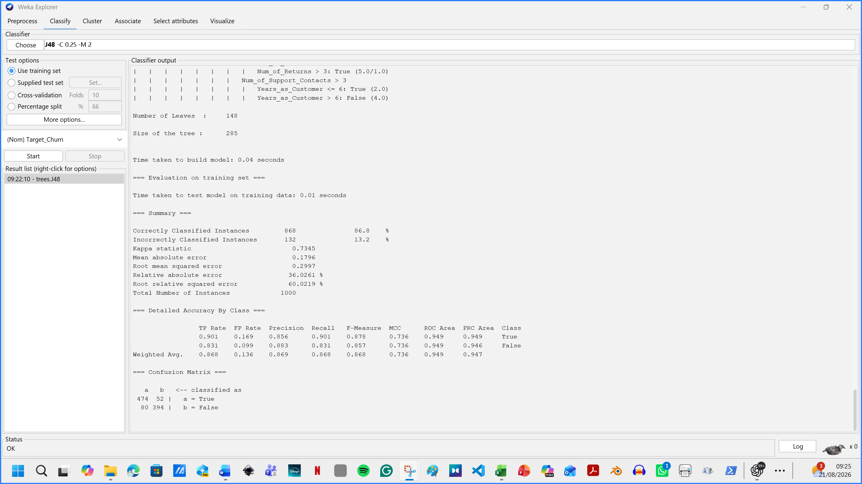
Figure 18. J48 Classifier output
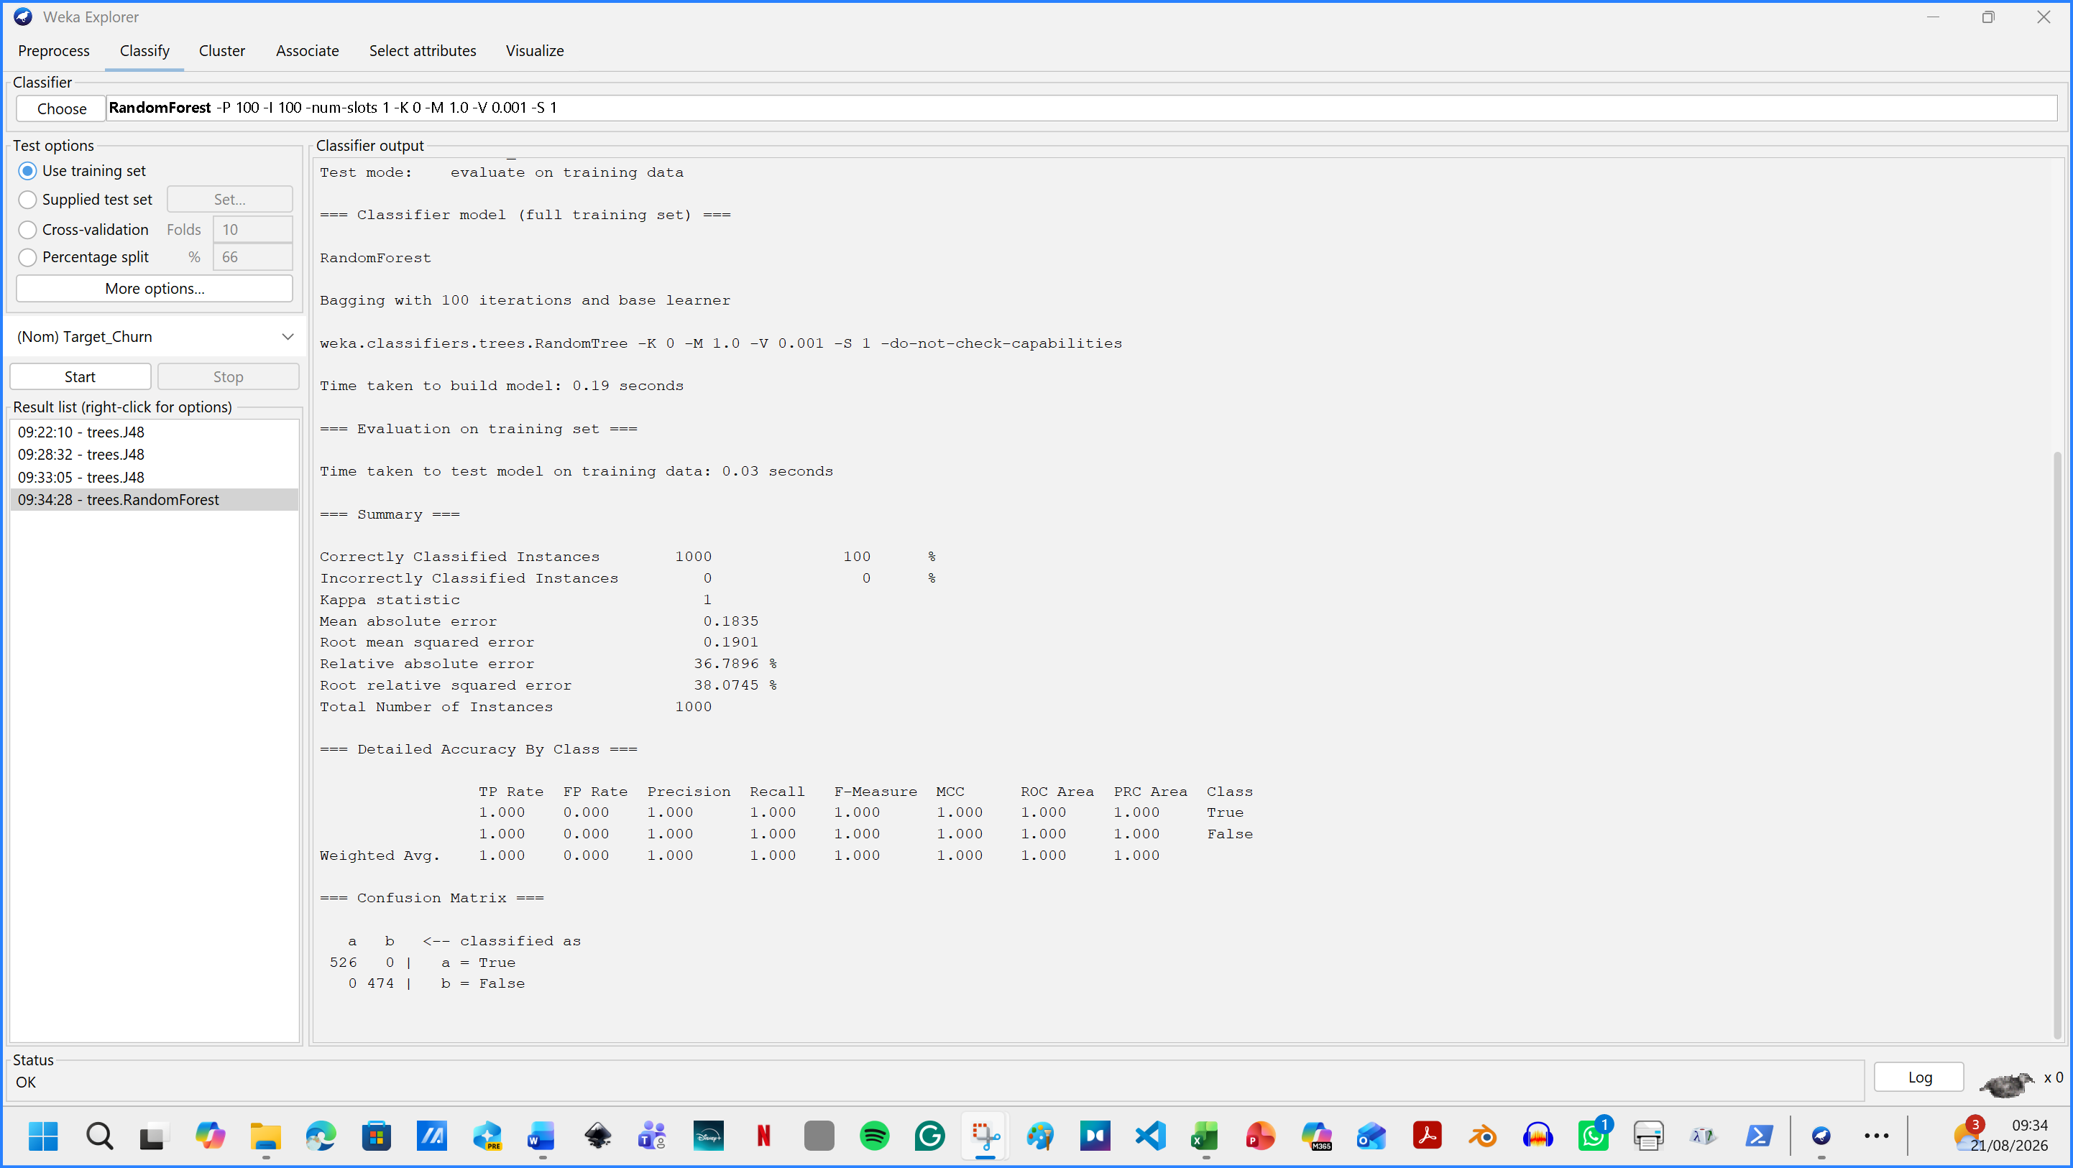
Figure 19. Applied classification: RandomForest [4]

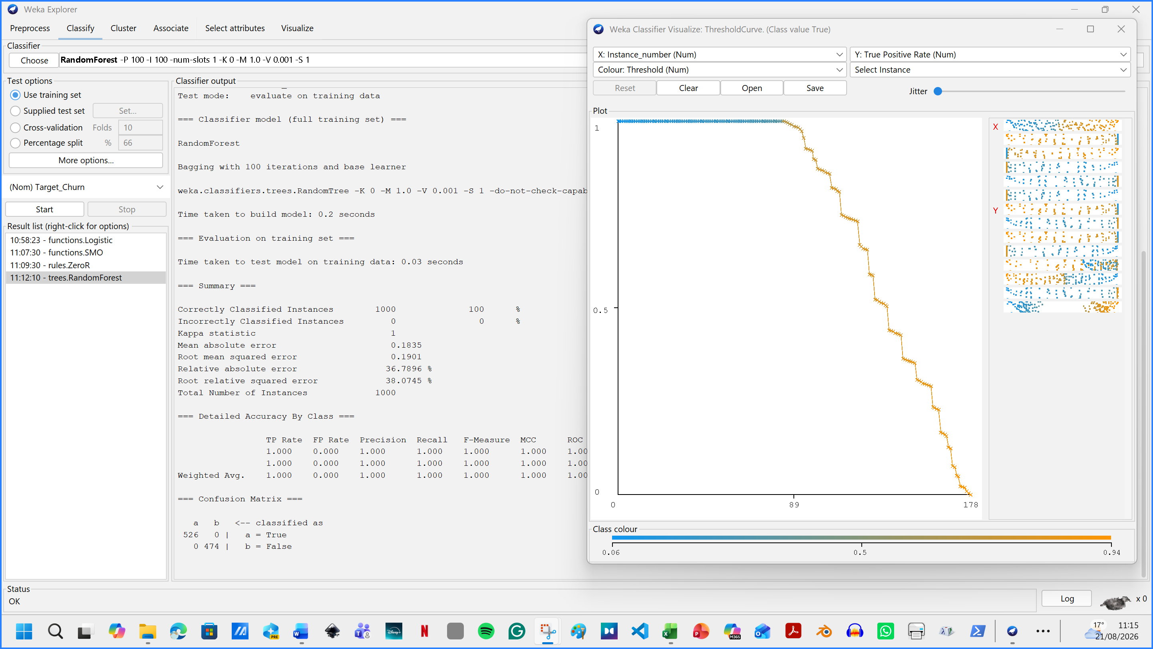
Figure 20. Random Forest – Visualise threshold curve = True
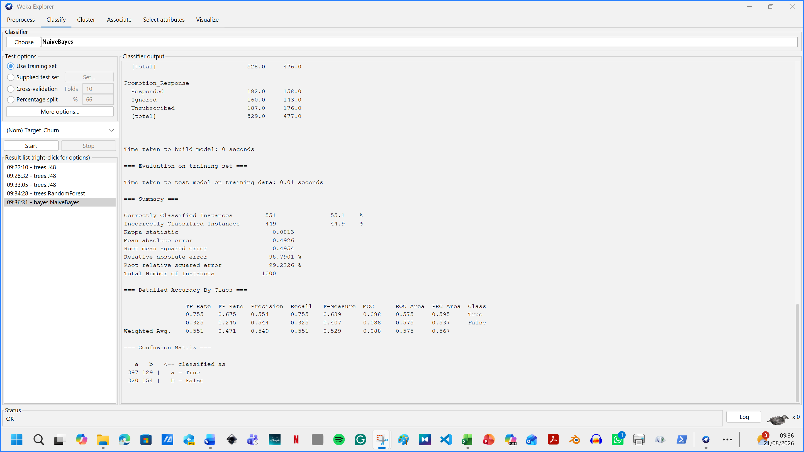
Figure 20. Classify: NaiveBayes

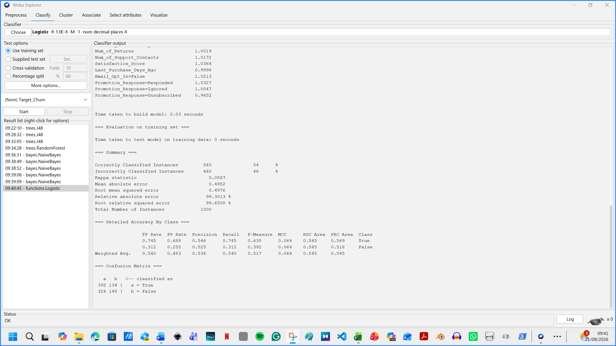
Figure 21. Function – Logistic model output. [4. 4. 5]

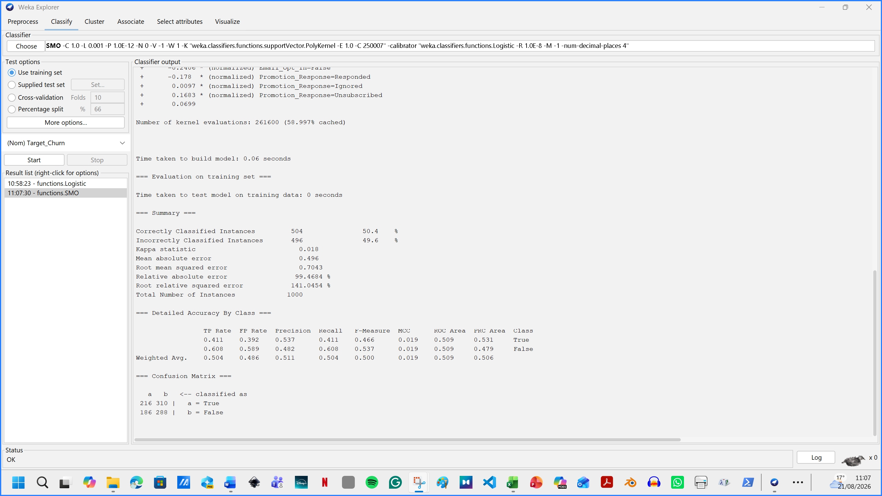
Figure 22. SMO output result [5]
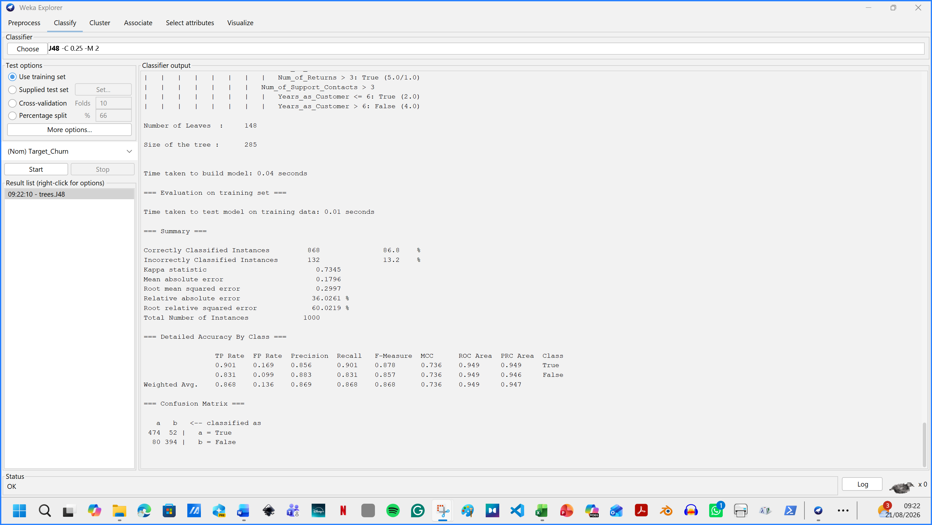
Figure 23. ZeroR model output

Evaluation metrics
Model | Accuracy | Churn precision | Churn recall | F1-score | ROC AUC
J48 | 86.8 % | 86.9% | 86% | 0.878 | 0.949
Random Forest | 100% | 1.000 / 100% | 100% | 1.000 | 1.000
Logistic Regression | 54% | 0.546 / 54.6% | 74.5% | 0.630 | 0.545
Naive Bayes | 55.1% | 0.554 / 55.4% | 75.5% | 0.639 | 0.575
SMO | 50.4% | 0.537 / 53.7% | 41.1% | 0.466 | 0.509
Accuracy is the proportion of all cases classified correctly. Churn precision is the proportion of predicted churners who actually churned, whereas churn recall is the proportion of actual churners successfully identified.
Table 1: Stratified ten-fold cross-validation results; churn is Target_Churn=True

- Feature selection and engineering
No engineered ratios were added because Total_Spend, purchase count and average transaction amount may have overlapping definitions; creating a ratio without a verified data dictionary could introduce misleading redundancy. For customer segmentation, age, gender and income were excluded so that clusters reflected actionable behaviour and engagement rather than protected or background characteristics. The clustering set therefore used spend, tenure, purchases, average transaction amount, returns, support contacts, satisfaction, recency, email opt-in and promotion response. Target_Churn was removed while clusters were estimated and then used only to describe cluster composition.
- Justification of algorithms
- J48 was selected because it produces an interpretable decision tree showing the conditions associated with churn.
- Random Forest combines many decision trees and was included because it can model complex relationships while reducing overfitting.
- Logistic Regression provides a clear statistical baseline and estimates the probability of churn.
- Naive Bayes is computationally efficient and provides a useful probabilistic comparison.
- SMO, Weka’s support vector machine implementation, was selected because it can identify a strong boundary between churners and non-churners in a multidimensional dataset.
- Unsupervised clustering
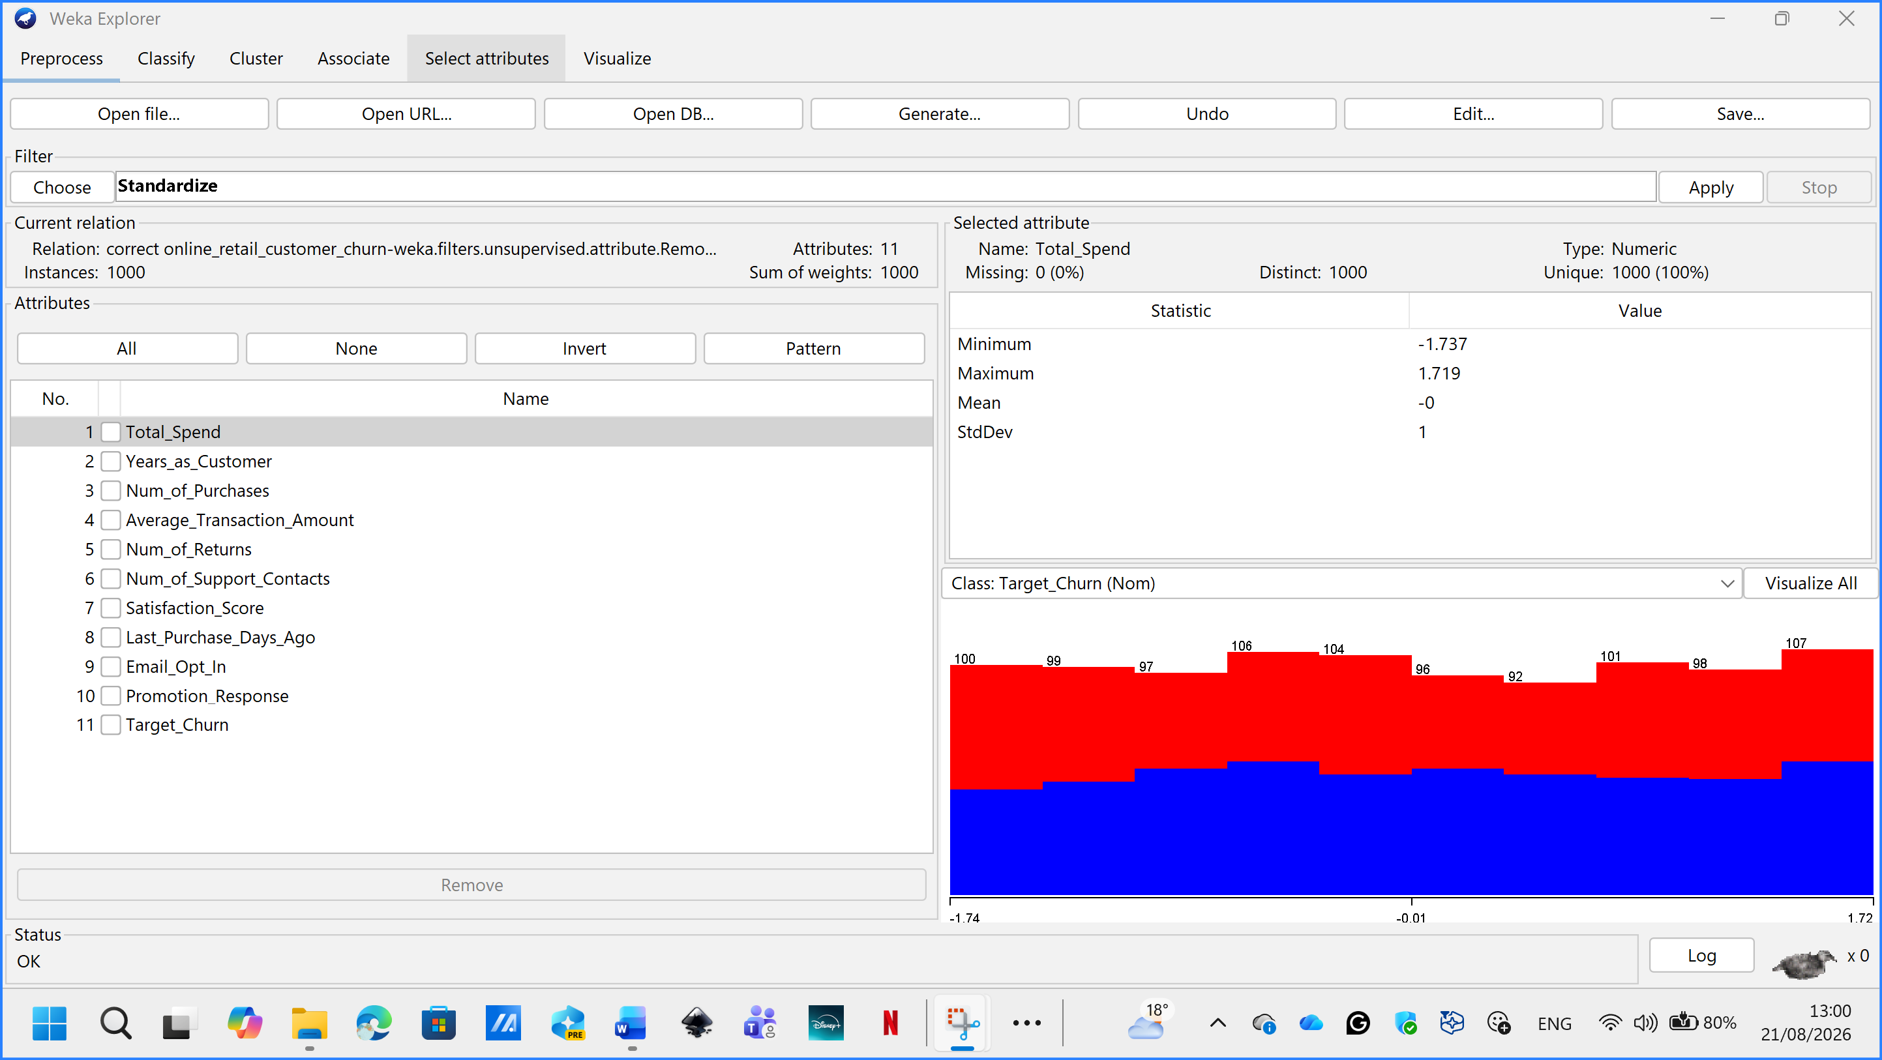
Figure 24. First 3 attributes removed, applied Standarize filter
I have selected two clustering algorithms:
- SimpleKMeans
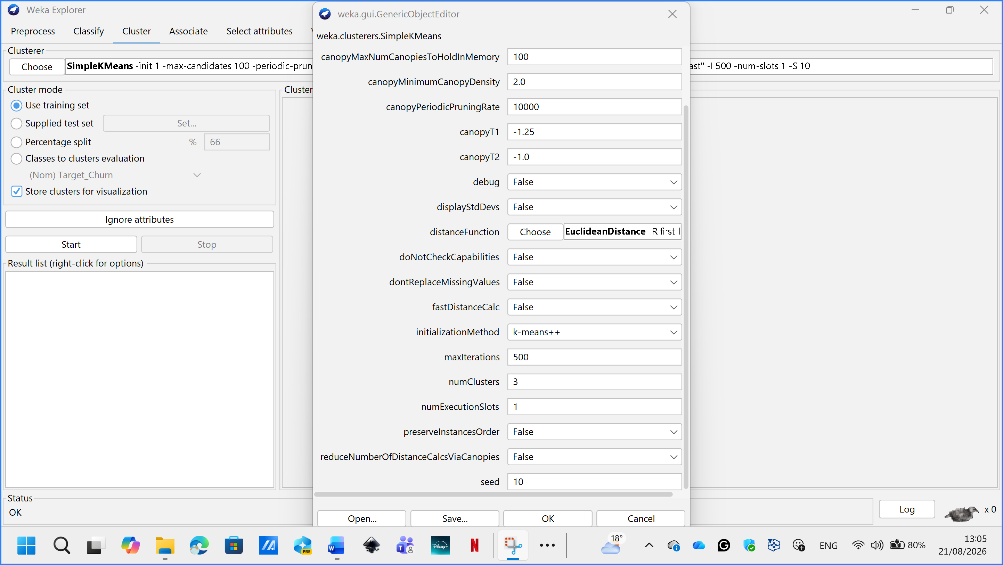
Figure 25. Cluster tab , SimpleKMeans model, 3 clusters, KMeans++ method 10seed.

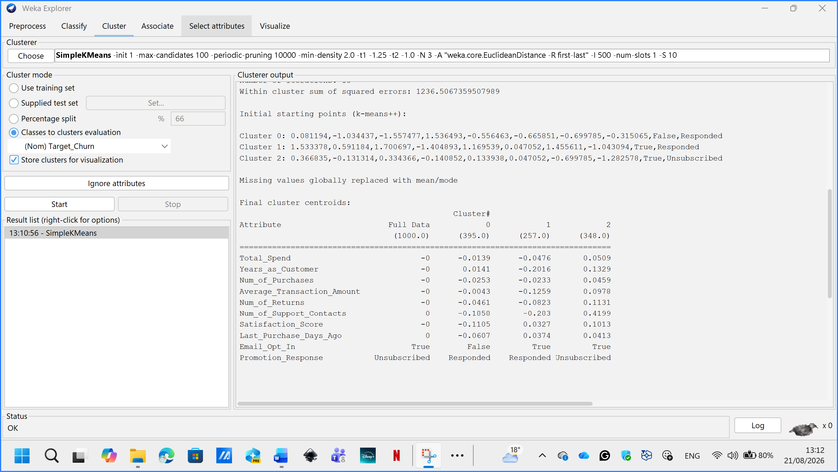
Figure 26. Cluster sizes

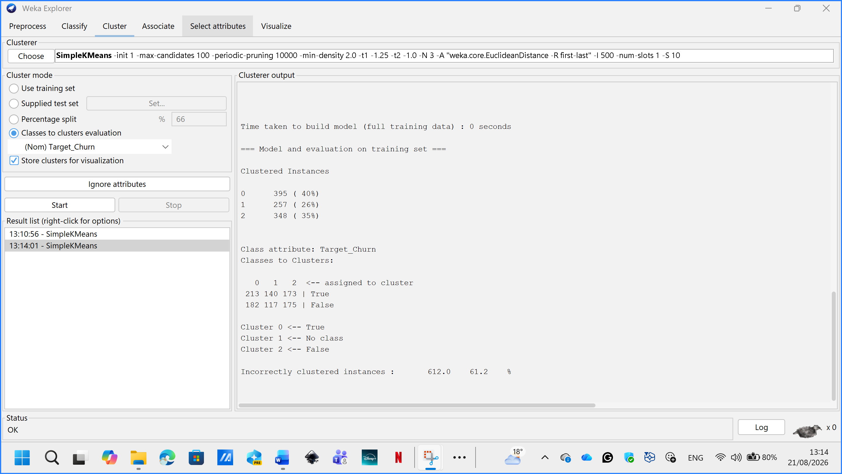
Figure 27. Classes-to-clusters evaluation

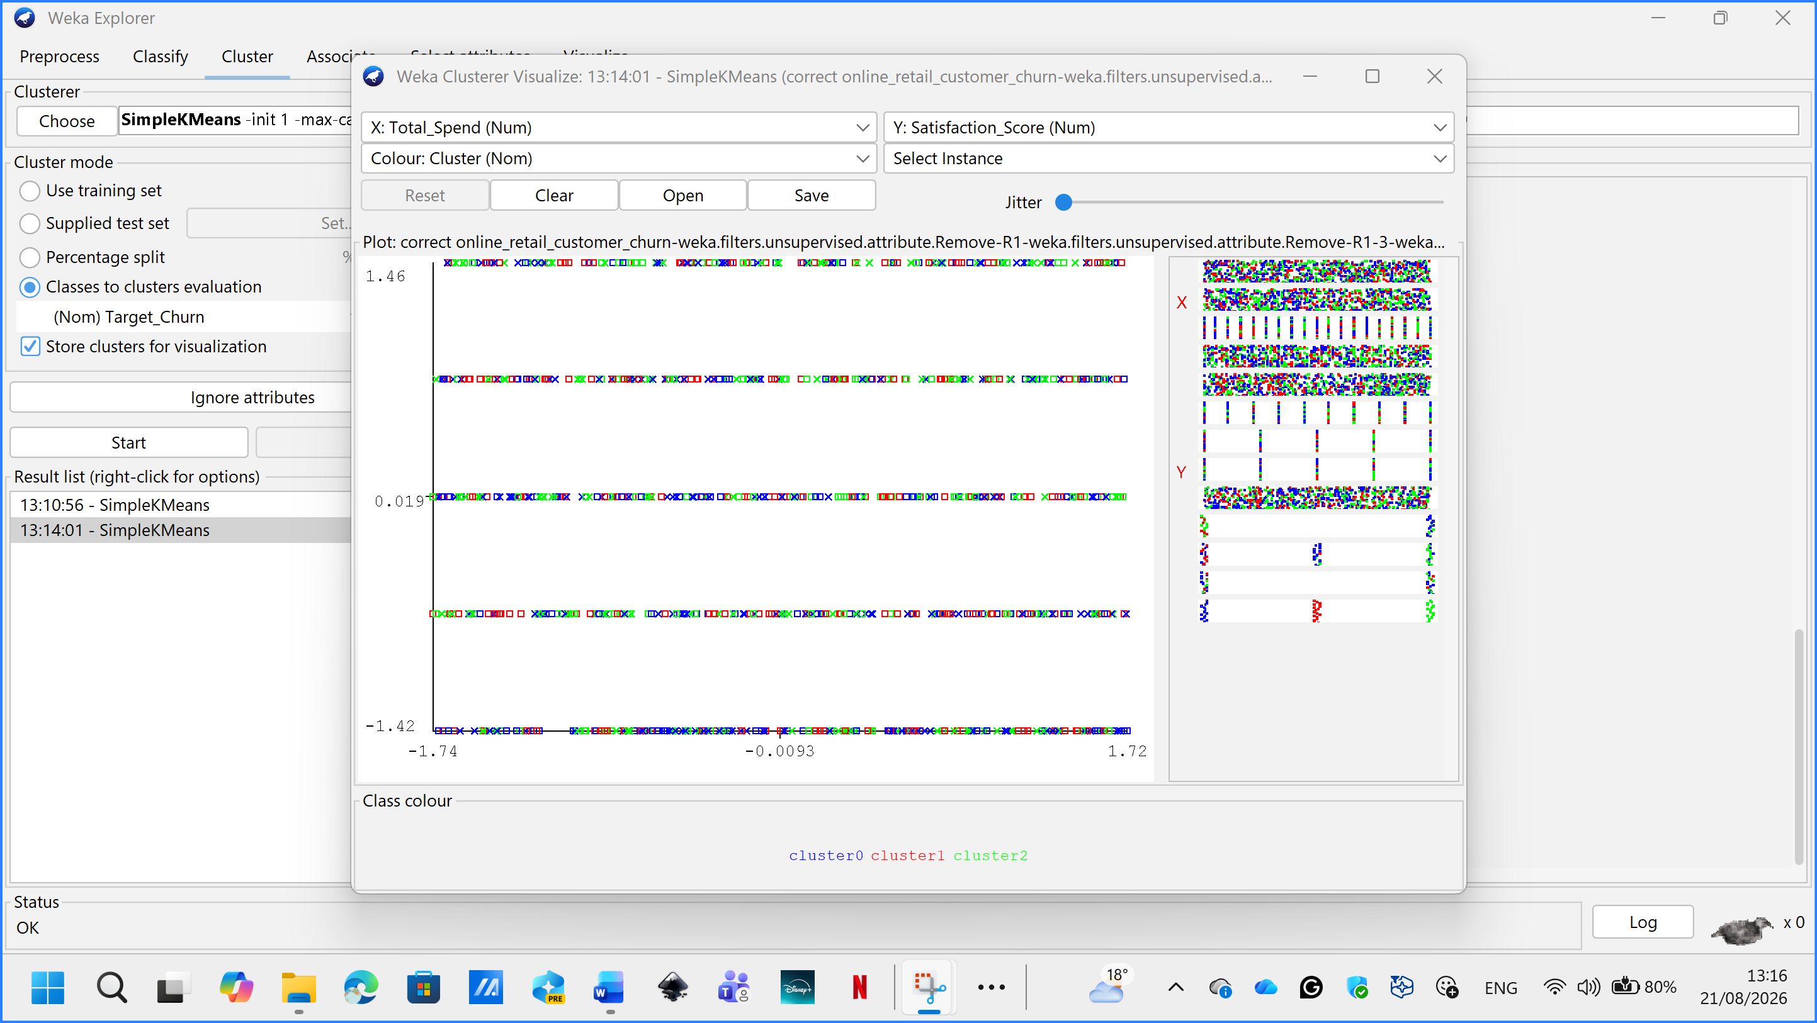
Figure 28. Visualize cluster assignments

- EM Clustering
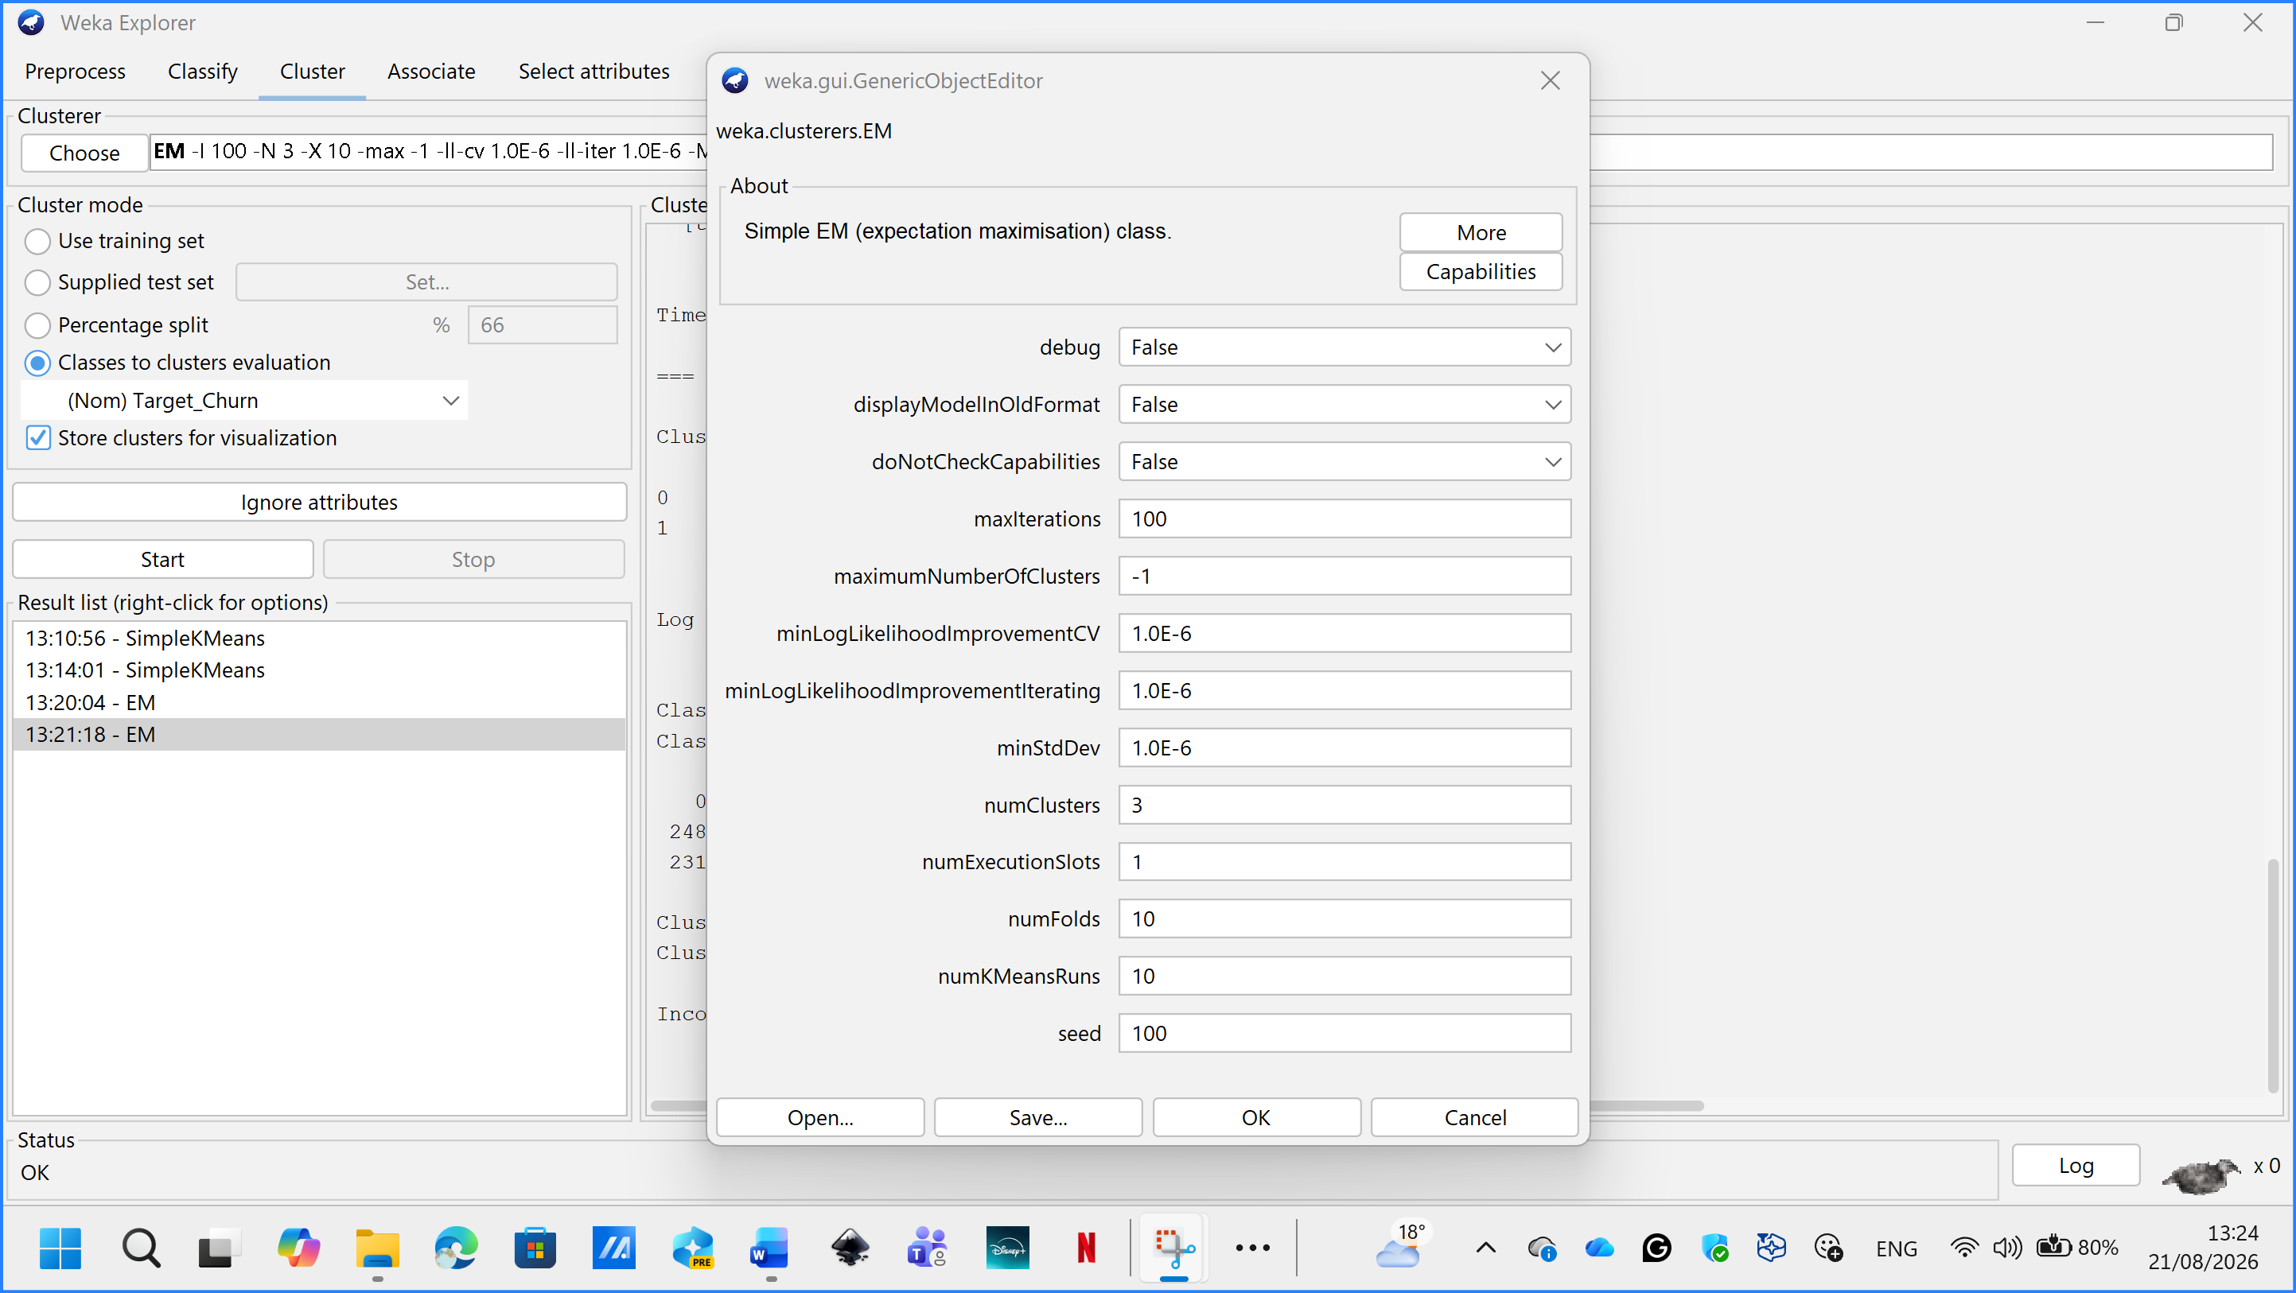
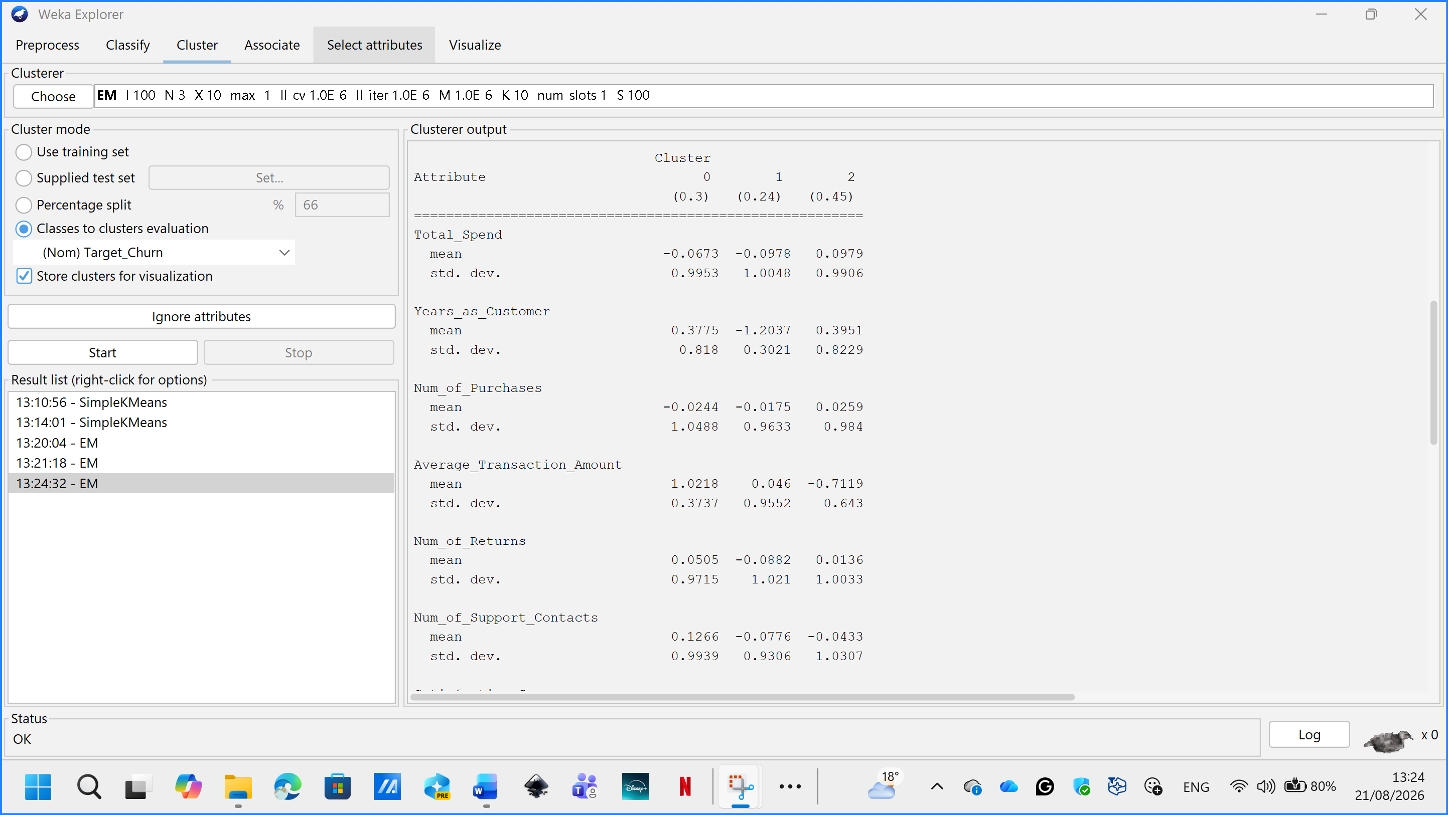
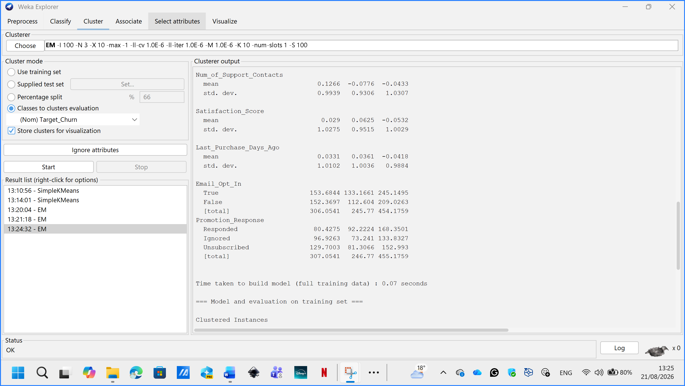
Figure 29, 30, 31: EM cluster information and class-to-cluster results
Customer Segmentation
Two clustering methods were used to group customers according to their behaviour. SimpleKMeans created three clusters. The first contained 39.5% of customers who had not opted into marketing emails. The second contained 25.7% of customers and represented customers who were more engaged with promotions. The third contained 34.8% of customers and included people with more support contacts and many who had unsubscribed. The churn rates for the three groups were 53.9%, 54.5% and 49.7%. These figures were quite similar, meaning the clusters were more useful for understanding customer engagement and service needs than for clearly separating churners from non-churners. Expectation Maximisation (EM) also created three customer groups. The first included established, higher-spending customers and had a churn rate of 47.4%. The second contained newer customers and had the highest churn rate at 56.8%. The third represented established, lower-spending customers and had a churn rate of 53.5%. The differences were relatively small, although the higher churn rate among newer customers suggests that better onboarding may be helpful. The clusters are more suitable for understanding customer needs and planning targeted services than for accurately predicting churn.
K-means segment | Size | Defining profile | Observed churn
Email-disengaged | 395 (39.5%) | No email opt-in; slightly fewer support contacts | 53.9%
Promotion-engaged | 257 (25.7%) | Opted in; 69% responded to promotion | 54.5%
Support-intensive / unsubscribed | 348 (34.8%) | Highest support contacts; many unsubscribed | 49.7%
Table 2. SimpleKMeans customer segments and post-hoc churn composition.

1.5: Business Recommendations
The current model should not yet be used to make decisions about individual customers because its performance was close to the basic ZeroR model. This could result in genuine churners being missed and unnecessary offers being sent to customers who are likely to remain. Retailers should first confirm how churn was defined and collect more useful historical data. This could include changes in purchase frequency, spending patterns, abandoned baskets, email activity, complaints, refunds and delivery problems. Future models should be tested using later customer data that was not used during training. The customer clusters may still support marketing decisions. Email-disengaged customers could be contacted through the website or customer-service channels. Promotion-engaged customers could receive relevant personalised offers. Customers with many support contacts or returns may need improved service, while newer customers could benefit from better onboarding. These strategies should first be tested on small customer groups, with retention, sales, costs and opt-out rates monitored.

1.6: Reflective Commentary
The analysis was useful, although most models did not perform well. One strength was that all five models were tested using the same ten-fold cross-validation method and compared with a basic ZeroR model. Accuracy, precision, recall and F1 score were considered instead of relying only on accuracy. Customer_ID was removed, and numeric variables were standardised for clustering. The main limitation was the dataset. It contained only 1,000 customer records and did not include purchase dates or changes in customer behaviour over time. The available attributes showed weak relationships with churn, which made accurate prediction difficult. Cross-validation measured performance within this dataset, but it did not show how the models would perform with future customers. The cluster results also depended on the selected attributes and number of clusters.Next time, I would use more detailed historical customer data and clearly define when a customer is considered to have churned. I would also test the final model on newer, unseen data and compare different clustering settings. This project showed that understanding the data and reporting weak results honestly are as important as selecting an algorithm.

References
[1] J. Han, M. Kamber and J. Pei, "2 - Getting to Know Your Data," in Data Mining: Concepts and Techniques (Third Edition), Boston: Morgan Kaufmann, 2012. pp. 39–82. doi: 10.1016/B978-0-12-381479-1.00002-2.
[2] J. Han, M. Kamber and J. Pei,Data mining : concepts and techniques, 3rd ed Ed. Waltham, Mass. ; Tokyo: Morgan Kaufmann, 2012. doi: 10.1016/C2009-0-61819-5.
[3] N. V. Chawla, K. W. Bowyer, L. O. Hall and W. P. Kegelmeyer, "SMOTE: Synthetic Minority Over-sampling Technique," vol. 16, pp.321–357, Jan 1 2002, doi: 10.1613/jair.953.
[4] Breiman, "Random forests," vol. 45, pp.5, 2001, doi: 10.1023/a:101093340.
[5] Tom Fawcett, L. Cinque and G. Placidi, "An introduction to ROC analysis," vol. 27, no. 8, pp.861–874, Jun 2006, doi: 10.1016/j.patrec.2005.10.010.

