BMSW4010
Learning in the Digital Era

Evidence of Learning (E-Portfolio)

Student Name : Natalie Skalkosova
Student ID : 2212439
Lecturer’s name : Christian Felices

Table of Contents
Introduction 3
Task 1 4
Section headings 4
Importance of the report section and its purpose 4
Task 2 5
Academic writing 5
Importance of academic writing 5
Task 3 6
Critical analysis 6
Understanding of Critical analysis and how it enhances the quality of work produced 7
Task 4 8
Sense of place and identity 8
Introduction 8
Place and Identity 9
Theories of identity 10
The sense of place 11
Conclusion 12
References 13

Introduction
The ability to critically analyses is what enables a students to comprehend knowledge and challenges with better clarity. Academic writing improves students' critical thinking and objectivity. The learner will acquire improved writing and research abilities for the workplace. Through academic writing, students will also be given the impression that work ethics are important. Academic writing and critical analysis go hand in hand very well because while writing an academic subject, a student must use critical thinking (Pereira et al, 2021).

Task 1

Section headings
If we skip to the modern style of teaching, there are many differences and adaptations of new technologies from the previous teaching style. E-portfolio is one of the new technology support that has been successfully used in learning and teaching students. Through the E-portfolio student got help by recording their work, goals, and achievements. Not only these works but also reflecting on their learning and sharing with their classmates is also possible. Well, E-portfolio is literally for document learning besides generating learning for the students (Mahasneh et al, 2020).
This assignment will describe academic writing and its importance to the students. Again, how critical analysis can help a student and improvise the quality of work will also be discussed. And finally, with a presentation describing the meaning of a sense of place and identity, this assignment will be completed. The reflection of learning can be expressed by assessment and reporting. Here, E-portfolio is a useful tool to assess the learnings of the student and by using it student can make a report on his learning (Syzdykova et al, 2021).
- Task 1- Section headings
- Task 2- Academic writing
- Task 3-Understanding of Critical analysis and how it enhances the quality of work produced
- Task 4- Sense of place and identity

Importance of the report section and its purpose
A report is a visual paperwork of what is learned. There are many courtesies that every student needs to follow during making any report for academics and also for any organization. The section in the report helps to intersect one unit with another. So, the report section can be called a basic unit of layout in reports. There are three types of report sections, generally used. The different section contains different things including fields, text, or graphics. This different section is used or contains different documentation which is dependent on the reporter (Citron et al, 2018).
Well, there are three kinds of the section that are generally used in reports they are Header, Detail, and Footer. Again, from another perspective, there are also three kinds of sections. Which is the Introduction, Body of the report, and Summary, Conclusion, and Recommendations. These differentiations are depending upon the user. The reporter will find out which section will be finalized for his report (Sjögren et al, 2022).

Task 2

Academic writing
Academic writing is formal and unbiased, clear and precise writing about a specific topic that should be focused and well-structured with the authentic source which makes the writing correct and consistent. Academic writing is a trend that is followed by Universities and Scholarly publications. But this academic writing is also believed as a writing style that could be used in essays, research papers, and also in dissertations. That is why academic writing has some rules that every writer should follow. The writing should not be personal, long-winded, emotive, or grandiose (Strobl et al, 2019).
Similarly, academic writing could be different on the different priorities or the writing producers. For example, for scientific writing, a student cannot write a clear report on his scientific methods and results. But a Business student can write a constructing convincing argument on an organizational strategy and make books as references. The main theme or motive of every academic writing is to provide certain information as effectively as possible (Cutri et al, 2021).

Importance of academic writing
Academic writing plays an important role in every University student’s life. Well, to complete the courses at universities the skill of writing has to be developed. In University, Professors and teachers spend many hours concerning the ability of academic writing of students. Well, academic writing allows a student to convey their understanding which is important for reflecting on the learned knowledge. Again, the analytical thinking increased by focusing strongly on the style and technique of writing of the students (Akhtar et al, 2020).
Academic writing enhances critical thinking and objectivity in student’s academic life. The student will get an enhanced professional life in writing and research skills. Not only those but also work ethics will be implied to the students through academic writing. As academic writing plays (almost) a central role in the academic arena it should be treated as important. Meaning, students share their knowledge and experience through this academic writing and this skill benefits them later (French et al, 2020).

Task 3

Critical analysis
Critical analysis is another tool to examine the students’ what they learned. So, critical analysis and writing about it is like showing or demonstrating the skills that a student or an individual can think critically. The skill of critical thinking is equally important in the academic field, and also in the professional field as a manager while making any decision. Well, critical analysis is the expression of a student’s or an individual’s interpretation and analysis of any work or specific topic (Mohammed et al, 2021).
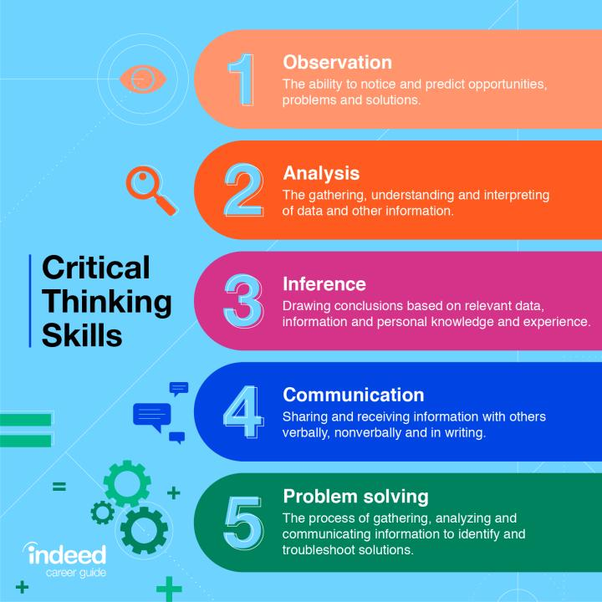
Figure: steps to critical thinking (Pastore et al, 2022)
The critical analysis could be about anything including a piece of literature, a movie, a TV program, a business process, an academic report, and so on (Pereira et al, 2021).

Understanding of Critical analysis and how it enhances the quality of work produced
Critical analysis is the skill that allows a student to have and present greater clarity on the issues and information that he processes. From the academy, students learn how to do critical analysis. And later they get the chance to prove their ability in the workplace. This skill is very crucial to the survival and renewal of all fields of learning. There is a strong relationship between academic writing and critical analysis. Because a student must think critically while writing an academic topic (Pereira et al, 2021).
In the working place, critical analysis is needed while making any decision. Well, everyone has to consider a range of possible approaches to solve any problem and arrive at a better solution. This is where critical analysis is needed the most. The professional field requires critical thinkers. Again, critical thinkers are happier, and being well-informed is a bonus for them (Joseph et al, 2020).

Task 4

Sense of place and identity


Introduction
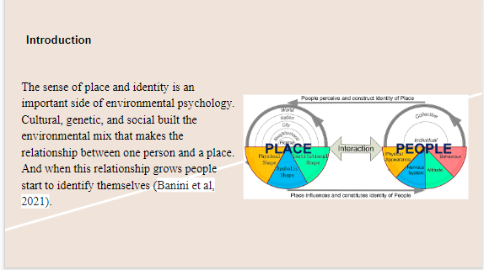

The sense of place and identity is an important side of environmental psychology. These two elements, place and identity, are connected and many other elements are related to these two. Cultural, genetic, and social built the environmental mix that makes the relationship between one person and a place. And when this relationship grows people start to identify themselves (Banini et al, 2021).

Place and Identity
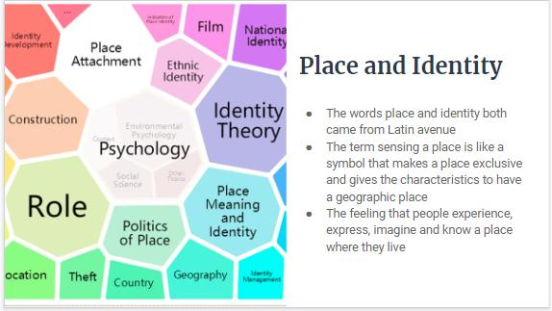
The words place and identity both came from Latin avenue. The term sensing a place is like a symbol that makes a place exclusive and gives the characteristics to have a geographic place. In another word, a sense of place is a feeling. The feeling that people experience, express, imagine and know a place where they live (Brown et al, 2019).

Theories of identity
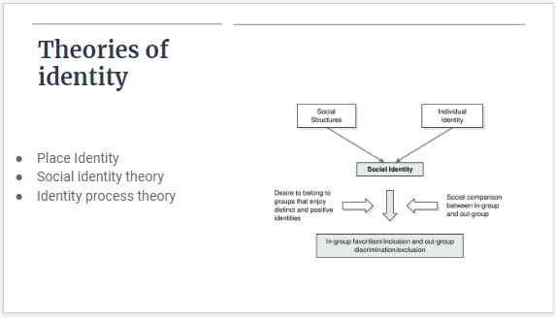
Place Identity: describes as the memories, conceptions, interpretations, and related feelings about a specific physical object (Ainsworth et al, 2019).
Social identity theory: this theory says that knowledge is a social belonging to the group and the emotions and values are conveyed to that individual (Blennow et al, 2019).
Identity process theory: the interaction between memory, consciousness, and organized construal characteristics (Ainsworth et al, 2019).

The sense of place
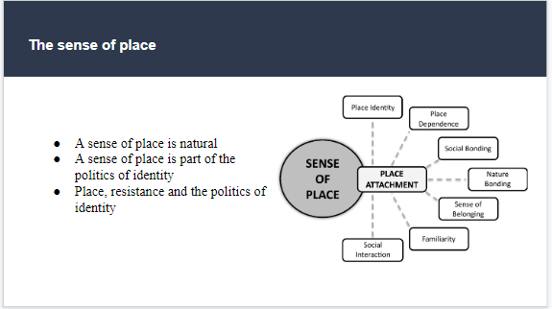
There are some perspectives on the sense of place. From one perspective, the sense of place is natural. Again, a sense of place is a part of the politics of identity. On the other perspective, place, resistance, and the politics of identity are the aspects of human identity (Blennow et al, 2019).
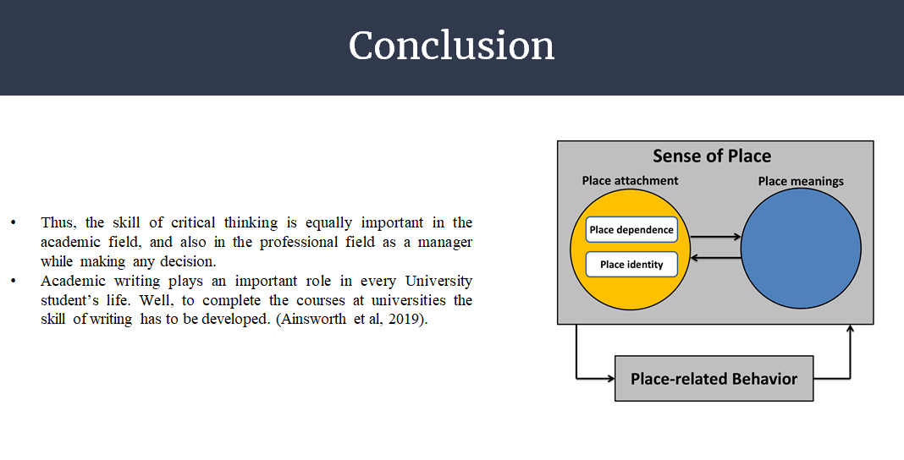
Thus, the skill of critical thinking is equally important in the academic field, and also in the professional field as a manager while making any decision. Academic writing plays an important role in every University student’s life. Well, to complete the courses at universities the skill of writing has to be developed.
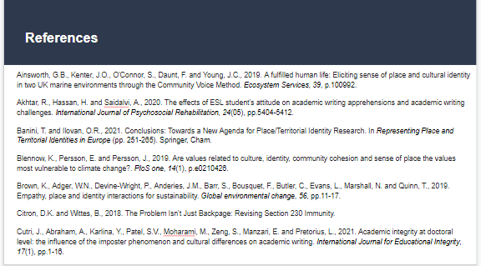

Conclusion
Academic writing is a crucial aspect of life for all university students. Well, developing writing skills is necessary to pass university courses. Professors and instructors devote a lot of time at universities to students' capacity for academic writing. Similar to this, academic writing may fluctuate depending on the writing creators or various objectives. For instance, a student cannot clearly describe his scientific techniques and findings in a report for scientific writing. The ability to communicate understanding via academic writing is crucial for helping students reflect on the information they have gained. By placing a lot of emphasis on the students' writing style and approach, analytical thinking once again improved (Akhtar et al, 2020).

References
Ainsworth, G.B., Kenter, J.O., O'Connor, S., Daunt, F. and Young, J.C., 2019. A fulfilled human life: Eliciting sense of place and cultural identity in two UK marine environments through the Community Voice Method. Ecosystem Services, 39, p.100992.
Akhtar, R., Hassan, H. and Saidalvi, A., 2020. The effects of ESL student's attitude on academic writing apprehensions and academic writing challenges. International Journal of Psychosocial Rehabilitation, 24(05), pp.5404-5412.
Banini, T. and Ilovan, O.R., 2021. Conclusions: Towards a New Agenda for Place/Territorial Identity Research. In Representing Place and Territorial Identities in Europe (pp. 251-265). Springer, Cham.
Blennow, K., Persson, E. and Persson, J., 2019. Are values related to culture, identity, community cohesion and sense of place the values most vulnerable to climate change?. PloS one, 14(1), p.e0210426.
Brown, K., Adger, W.N., Devine-Wright, P., Anderies, J.M., Barr, S., Bousquet, F., Butler, C., Evans, L., Marshall, N. and Quinn, T., 2019. Empathy, place and identity interactions for sustainability. Global environmental change, 56, pp.11-17. Raihan
Citron, D.K. and Wittes, B., 2018. The Problem Isn't Just Backpage: Revising Section 230 Immunity.
Cutri, J., Abraham, A., Karlina, Y., Patel, S.V., Moharami, M., Zeng, S., Manzari, E. and Pretorius, L., 2021. Academic integrity at doctoral level: the influence of the imposter phenomenon and cultural differences on academic writing. International Journal for Educational Integrity, 17(1), pp.1-16.
French, A., 2020. Academic writing as identity-work in higher education: forming a ‘professional writing in higher education habitus’. Studies in Higher Education, 45(8), pp.1605-1617.
Ibn-Mohammed, T., Mustapha, K.B., Godsell, J., Adamu, Z., Babatunde, K.A., Akintade, D.D., Acquaye, A., Fujii, H., Ndiaye, M.M., Yamoah, F.A. and Koh, S.C.L., 2021. A critical analysis of the impacts of COVID-19 on the global economy and ecosystems and opportunities for circular economy strategies. Resources, Conservation and Recycling, 164, p.105169.
Joseph, R., 2020. The theory of empowerment: A critical analysis with the theory evaluation scale. Journal of Human Behavior in the Social Environment, 30(2), pp.138-157.
Mahasneh, O.M., 2020. A Proposed Model for the University Students' E-Portfolio. Journal of Education and e-Learning Research, 7(1), pp.28-33.
Pastore, L.M., Basso, G.L. and de Santoli, M.S.L., 2022. Technical, economic and environmental issues related to electrolysers capacity targets according to the Italian Hydrogen Strategy: A critical analysis. Renewable and Sustainable Energy Reviews, 166, p.112685.
Pereira, V. and Bamel, U., 2021. Extending the resource and knowledge based view: A critical analysis into its theoretical evolution and future research directions. Journal of Business Research, 132, pp.557-570.
Sjögren, J., 2022. The Swedish outsider rule in chapter 57 section 5 ITA: Is the Swedish outsider rule applied in accordance with its purpose?.
Strobl, C., Ailhaud, E., Benetos, K., Devitt, A., Kruse, O., Proske, A. and Rapp, C., 2019. Digital support for academic writing: A review of technologies and pedagogies. Computers & education, 131, pp.33-48.
Syzdykova, Z., Koblandin, K., Mikhaylova, N. and Akinina, O., 2021. Assessment of E-portfolio in higher education. International Journal of Emerging Technologies in Learning (iJET), 16(2), pp.120-134.

