How important was the presence of a body or body parts for the function of medieval tombs and reliquaries?
“By inviting us to venerate the mortal remains of the martyrs and saints, the church does not forget that, in the end, these are indeed just human bones, but they are bones that belonged to individuals that were touched by the living power of God”
– Pope Benedict XVI (Bagnoli, 2010, 137)
This quote by Pope Benedict XVI makes clear the importance of medieval tombs and reliquaries having within them the bones of martyrs and saints. It implies that without these bones they are worthless, as it is the bones that have been touched by the “living power of God” that make them what they are (Bagnoli, 2010, 137). In a later book, Bagnoli discusses what reason the church can have for keeping the body parts of saints in reliquaries; he suggests that it is a way of keeping the saint alive, a means by which they can continue performing saintly duties from beyond the grave (Bagnoli, 2012, 104).
While it makes sense for reliquaries to have been built for specific saints, with particular body parts in mind, Hahn, in her 1997 book ‘The Voices of the Saints’ talks about how many reliquaries contain the body parts of more than one saint. In fact, “The second right arm at St. Gereon contained relics of some thirty saints including additional relics of Nereus and Achilleus” (Hahn, 1997, 21). This leads us to question whether or not a reliquary’s worth increases or decreases depending on what is inside it, does a reliquary having the bones of one saint make it less holy than one containing the bones of several? Not only this, but is a body part more precious than an item or object?
O’Floinn argues that for a reliquary to be meaningful it does not necessarily need to contain a human body part, as just a cloth that they wore, or an object that they handled, would still count as long as it had touched the saint’s skin (O’Floinn, 1994, 11). As reliquaries from the medieval period have been stolen, looted, and decayed over time, many have not survived, especially those that are said to contain bones and body parts. Because of this, the majority of surviving reliquaries are said to contain objects that have been associated with or have been in contact with saints (O’Floinn, 1994, 33).
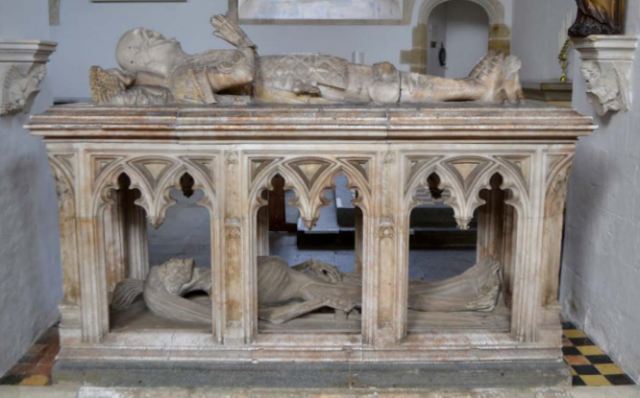
It is important to note, when questioning the significance of the presence of body parts for the function of a medieval reliquary or tomb, that the early Christians believed that separating parts of the dead body was disrespectful as it did not allow that person “the peaceful and respectful burial owed the dead” (Bynum, 1997, 3). In fact, during the late twelfth and early thirteenth centuries, it was believed that a person was not considered a saint until their remains had been placed within an altar, or a reliquary that rested upon the altar. In connection to this, “the earliest reliquaries tended to keep the bones of the saint together, often in a casket shaped like a sarcophagus” (Bynum, 1997, 3-4). Indicating that at this time it was considered disrespectful to the dead to separate their body parts.
Fig 1: The tomb of John Fitzalan at Arundel, Fitzalan Chapel. (Courtauld, 2016).
A good example of a type of tomb that relies on the body for its function is the transi tomb, which was popular during the fifteenth century for the upper classes in England and France (Adams and Barker, 2016, 80-81). These tombs had two levels, on the upper, there would be a figure showing how the deceased looked while they were alive, and underneath there would be a representation of that person’s decayed corpse. It seems that the purpose of these tombs is to remind the people viewing it that not only was the person important when they were alive but they still are even in death. It can be said that even though a body may not be in one of these tombs, they still use the image of the dead to make an impact. On the other hand, it is possible that a transi tomb may have been made for a person whose body has not been recovered or found. For example, William Fitzalan commissioned a transi tomb for his brother John (see fig 1) in the opinion that the cadaver on the bottom would serve in place of his actual body which was being held in France (Adams and Barker, 2016, 129). So when his body was recovered years later it would have changed the tomb’s function; from being a substitute to being a functional and decorated tomb.
However, by the central Middle Ages, bodies began to be divided and placed in reliquaries and displayed as fragments, rather than be kept as a whole (Bynum, 1997, 4). It is not possible to say exactly why this shift happened, but one suggestion may be that this occurred due to the difficulties faced by the people during this time, meaning that they sought religious help more often, and so the church was in need of further reliquaries to pass around. Another reason could be simply that the church wanted to spread its influence by showing off, using not only decorative reliquaries and tombs but by having many of them too; as having more could be seen as better.
An interesting story, presented in Malo’s 2008 book ‘The Pardoner’s Relics’, talks of a man named Brother Onion, whose job was to travel around and present reliquaries, taking money to allow people to view them. The story goes that Brother Onion’s friends one day swapped the supposed Feather of St Gabriel; which was actually a peacock feather, for a lump of coal without his knowledge, remarkably Brother Onion managed to convince his paying audience that the coal was a relic. He did this by placing it within a reliquary and telling the story of how he came to have it by travelling to Jerusalem. The people all believed him (Malo, 2008, 90-91).
This story shows that not only is it not necessary to have a body part, but any object could conceivably be accepted as a relic, whether it is one or not. It is the people’s beliefs that make a relic holy, not the actual relic itself. This concept is also investigated in Bagnoli’s 2010 article in which he writes that if a person were devout and faithful, then it did not matter what the reliquary looked like, as it was only what was inside that mattered. “They were asked to believe without seeing” as that is, after all, one of the main concepts of religion as a whole (Bagnoli, 2010, 140).
Malo’s story of Brother Onion also makes us question the validity of relics, if people will believe this tale of a piece of coal being a relic, what is to say the same cannot be done with any other object? Or even bones? In another story within the same book, a man named Girolamo finds the well-preserved body of a dead knight, he steals an arm and proclaims that it belonged to a saint due to its fresh state (Malo, 2008, 92). As well as this, it has been documented that many body parts found within reliquaries in the modern day actually belonged to animals.
Knowing that people were likely to steal relics or present unholy objects as such, “Claudius, Bishop of Turin from 1817 to 1827 argued that saints’ relics were no more important or holy than animal bones” (Bagnoli, 2010, 137). This is rather ironic coming from a priest, especially considering that many people within the religious hierarchy were keen on persuading their parishes that relics were real, even if the churches themselves did not know. Another way this was attempted was by putting fake relics inside fancy reliquaries, as the more elaborate and beautiful a reliquary was, the more esteemed the saint inside was considered to be (Bagnoli, 2010, 138).
Buettner claims that in some cases, the reliquary could be considered more important than the relic itself, this is because if a reliquary was more attractive then it would be more memorable (Buettner, 2005, 50). It is important at this time to discuss why reliquaries came into fashion at all, after all, why not just have the people come and visit the tomb? Christ himself is commonly referred to when talking about this subject, as Thiofrid says, “knowing that man cannot see and touch rotting flesh without being nauseated, he hid his body and his blood in the bread and wine, to which men are accustomed. Similarly, he has persuaded the sons of the Church to conceal and shelter the relics of the saint’s happy flesh in gold and in the most precious of natural materials so that they will not be horrified by looking at a cruel and bloody thing” (Bagnoli, 2010, 137).
This rather long quote is a reference to when the blood and body of Christ are given at Holy Communion via bread or wafer and wine, it suggests that it is this that made the Church decide to hide the body parts of saints within reliquaries rather than have them on display. In this instance Thiofrid is telling us that without something inside the reliquary, linking it to a saint or the church, then it is worthless and cannot function. I believe that Bagnoli has a similar concept; that the reliquaries are linked to what is inside them, if not by physicality then by worth. He writes “the riches of the reliquaries’ exteriors embodied the spiritual value of the bits of bone and dust they contained, their material worth was equated with spiritual merit” (Bagnoli, 2010, 137-138).
However, not everyone shares this view. Hahn argues that it is the reliquary that makes the relic meaningful in the first place, as without it, the relic would not be considered as important and may still be with the body. This is especially so, considering how many people believe that having the body part of a saint in a reliquary gives that reliquary the holy powers that the saint had whilst they were alive (Hahn, 1997, 28). Hahn goes further to suggest that it is possible that “the container ultimately supersedes the contained” (Hahn, 1997, 28).
These two arguments address the essay question directly, as both call into question the use and importance of body part relics within reliquaries. With one side suggesting it is the reliquary that gives the relic its significance, and the other proposing that without a reliquary a relic can still function but without a relic, a reliquary becomes useless. Both arguments have merit. Bagnoli’s idea that the material worth of a reliquary is only as much as the spiritual worth of the relic inside is agreeable and understandable, but so is Hahn’s view that the relic would not be as revered as it is if it were not for the reliquary itself. Especially when, as previously mentioned; the fancier and more adorned a reliquary, the more holy the relic inside is said to be. Both also call into question the idea of belief, as in, can we really believe in the power of a relic if we cannot see it?
A famous example of this would be the tomb of Jesus Christ. During the ninth, tenth and eleventh centuries many accounts surfaced detailing its appearance, the people who claimed they had seen it did not care that nothing of Christ remained. It is the fact that his body was once there, that made his tomb a religious and holy place for them (Pendergast & Valdez del Alamo, 2000, 21-22). This is an example of an, admittedly famous tomb, not needing to have something or someone in it, for it to still be a holy place.
In the thirteenth century, probably in response to the question of seeing is believing, the church started placing relics in transparent reliquaries. This was because, at that time, there was “an increased reliance on sight as a sensory perception through which God’s grace could be achieved” (Bagnoli, 2010, 141). Throughout the middle ages, the senses were viewed as links to God, with sight almost always being the most significant one. So it makes sense that around this time, belief was not deemed to be strong enough by itself; the people wanted to see the relics inside the reliquaries as they thought that this was a stronger link to God and would allow the relic to have more power on the viewer.
Many people believe that the bodies of the saints were “signs of their heavenly souls” (Bagnoli, 2012, 105). So by being allowed to view the body part(s) the people had a direct line of sight into the holiness of that saint. A similar practice had been taking place in the Byzantine East for many years before its popularity spread, as relics were often put on display without any sort of reliquary to hide them, not even a transparent one, and it was the bones of the saints themselves that were decorated (Bagnoli, 2010, 140).
Talking of decoration it is significant to mention the materials used in making reliquaries. As previously mentioned, the more decorative the reliquary the more holy the relic inside was supposed to be, but that is not all. Many were made from precious metals, which were considered to be virtuous and imperishable, much like the flesh of the saints themselves (Bagnoli, 2010, 138). A majority had precious stones adorning them, as it was believed by many that “the power to effect and to affect was expected of relics and stones alike, whether it was to bring physical and spiritual healing, to ensure good crop, to protect from enemies, or to secure health, salvation, good luck, love and wealth” (Buettner, 2005, 51). In fact, with precious stones having significance at this time, it could be said that reliquaries relied on them not only for their visual impact but also their meaning. As Buettner wrote, not only were they more attractive to look at than the relics, but also they themselves were believed to have healing and holy powers and could have been used to distract viewers from the relic(s) inside (Buettner, 2005, 47).
It is clear, however, that overall Buettner thought that relics were more holy and dear than the stones that adorned the reliquaries that held them. He writes that, even though “Many traditional cultures around the world believe that their very special dead would only survive if they were surrounded by hard metals and shining stones”, it is still obvious that no stone could claim to be “sacramental matter of the highest order” like a relic can (Buettner, 2005, 55-57). This is also briefly covered by Bagnoli who presents that because of “the reliance on materials in the art of the middle ages to evoke and, indeed, invoke the sacred” he would consider suggesting that all reliquaries, whether they are transparent or not, rely on the materials used to make them, rather than just the holiness of the relics themselves (Bagnoli, 2012, 106).
One of the most addressed questions when looking at medieval reliquaries is whether or not the shape of the reliquary reflects the item or body part inside it. Hahn talks about the most common ‘body type’ reliquary, one that is in the shape of an arm; she says that while it is possible that many arm reliquaries may have been supposed to house fragments “of an arm, hand or finger, it is clear that the arm shape is not closely tied to content” (Hahn, 1997, 22). In fact, Hahn believes that the ‘arm reliquary’ was the most sought after due to “its status as an active ‘limb’ of the saintly body” (Hahn, 1997, 22). By this she is referring to the actions made by the arms of saints in their lives, for example, arm reliquaries were sometimes used by priests to perform blessings, and so were not shaped for their contents, but for their actions (Hahn, 1997, 22). Another suggestion is that, rather than perform blessings, an arm reliquary could also be used to make the sign of the cross, an action commonly used within the Church, in anything from baptisms to everyday prayer. It is possible that that is why so many arm reliquaries show the fingers in the same position, which can be noted in figures 2 and 3 (Hahn, 1997, 23).
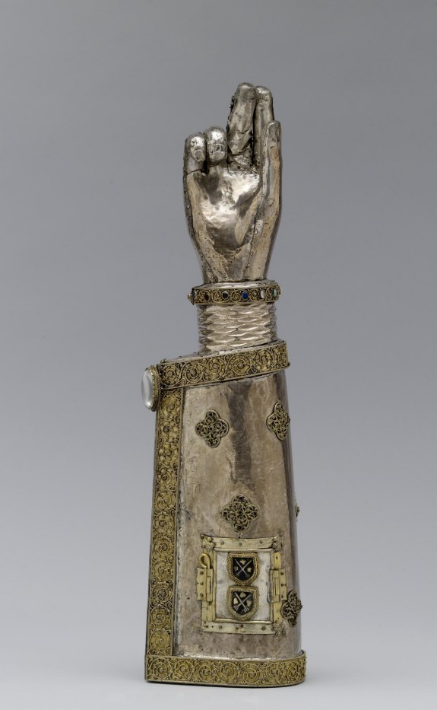
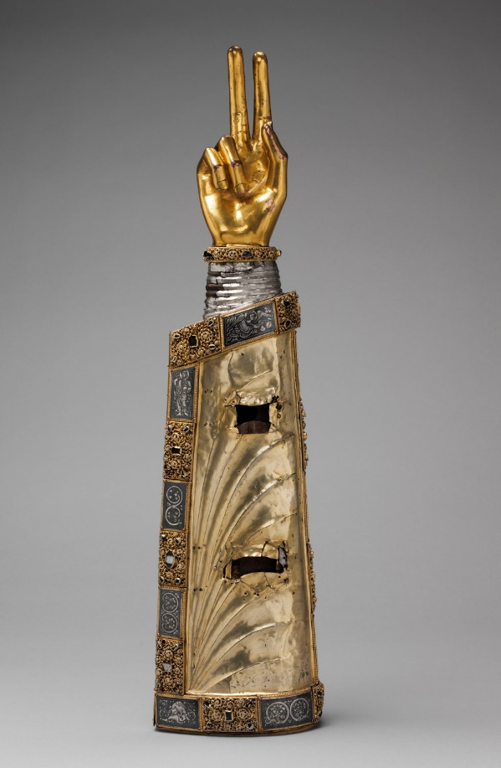
Fig 2 (L): Thirteenth Century Arm Reliquary, Saint unknown. (Metropolitan Museum of Art 2000-2017).

Fig 3 (R): Late Thirteenth Century arm Reliquary of St Pantaleon. (The Art Walters Museum n.d.).

This is backed up by Bynum, who writes that the shape of a reliquary would depend on its function rather than what was within it, as anything belonging to a saint was considered holy. This was why an arm bone was not necessary, unlike the arm shape, which was. Any body part of a saint can be used to perform a blessing, but not every action can show this (Bynum, 1997 4). Even into the late Middle Ages, where shaped containers began to house contact relics (shoes, clothing, etc) rather than body parts, it became common to find “shaped containers that do not hold within what is represented without, and… body parts contained in non-shaped containers” (Bynum, 1997, 4). This could also suggest that over time body parts and ‘contact relics’ of the supposed saints could have been moved around, are no longer in their original reliquaries, or are not even the real relics that were once supposed to be there.
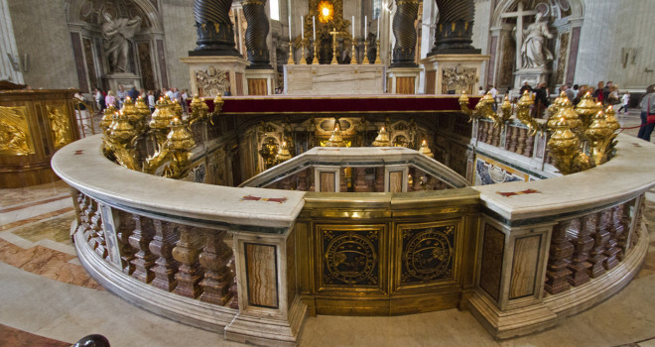
Fig 4: The Tomb of St Peter at St Peter’s Basilica, Rome. (Catholic Exchange, 2018).
The body of St Peter resides in its tomb at St Peter’s Basilica in Rome and is a good example of a body that remained whole while being used, viewed and touched by the people as a way to pray or to feel close to him. Originally the body was underneath the altar, and if a person wished to pray to him, they would have been allowed to touch the body with a cloth. This is different to the tomb of Jesus Christ as it is having the body in the tomb that makes this such a special place. People come to pray to him in the hope his holiness will bless them, much like how reliquaries are used to bless people too (Prendergast & Valdez del Alamo, 2000, 24).
The authors of Memory and the Medieval Tomb believe that for a reliquary or tomb to have meaning, it has to have the body or body parts of a saint present. “What more powerful means for pilgrims to identify themselves with the passion than to possess a relic connected with it or to retain the personal, intimate memory of direct access through sensory actions such as seeing, kissing and touching the sacred –“ body or relic (Prendergast & Valdez del Alamo, 2000, 26). As this quote makes clear, the authors believe that the most powerful way a relic or body can have an impact on people is if the people are allowed to see it, to touch it and even to kiss it; as this is how the holy properties can be given.
In summary, I believe that without a relic inside it, a reliquary cannot function as it exists only to house the relic, so surely if it is empty it cannot fulfil its purpose. As for medieval tombs, it appears that as long as the body of the person was once there then it is still a holy place, but if the body had never been there then it is not valued as such. Much like the reliquaries, it is not believed to have fulfilled its purpose, and so is not important.

Reference List
- Adams, A & Barker, J. 2016. Revisiting the Movement: 50 years since Panofsky’s Tomb Sculpture. London: The Courtauld Institute of art.
- Bagnoli, M. 2010. The Stuff of Heaven: Materials and Craftsmanship in Medieval Reliquaries. Treasures of Heaven: Saints, Relics, and Devotion in Medieval Europe exh. (Baltimore: The Walters Art Museum), pp 137-145.
- Bagnoli, M. 2012. Dressing the relics: Some Thoughts on the Custom of Relic Wrapping in Medieval Christianity. Matter of Faith: An Interdisciplinary Study of Relics and Relic Veneration in the Medieval Period. UK, The British Museum Press.
- Buettner, B. 2005. From Bones to Stones – Reflections on Jewelled Reliquaries. Reliquiare im Mittelalter, pp 43-59.
- Hahn, C. 1997. The Voices of the Saints: Speaking Reliquaries. Gesta. Vol 36. No 1, pp 20-31.
- Malo, R. 2008. The Pardoner's Relics (and why They Matter the Most). The Chaucer Review. Vol 43, No 1, pp 82-102
- O’ Floinn, R, 1994. Irish shrines and reliquaries of the middle ages. Town house & Country house, Ireland.
- Stamatis Pendergast, C & Valdez del Alamo, E (eds). 2000. Memory and the Medieval Tomb. UK, Ashgate Publishing Ltd.
Image References
- Catholic Exchange 2018. When they found the bones of St Peter. [Online] Available from http://catholicexchange.com/found-bones-st-peter. [Accessed on 05/01/18].
- Courtauld 2016. Revisiting the Monument: Fifty years since Panofsky’s Tomb Sculpture. London: The Courtauld Institute of art.
- Metropolitan Museum of Art 2000-2017. Arm Reliquary. [Online] Available from https://www.metmuseum.org/toah/works-of-art/47.101.33/. [Accessed on 05/01/18].
- The Art Walters Museum n.d. Arm Reliquary of St Pantaleon. [Online] Available from http://art.thewalters.org/detail/25190/arm-reliquary-of-saint-pantaleon/. [Accessed on 05/01/18].

