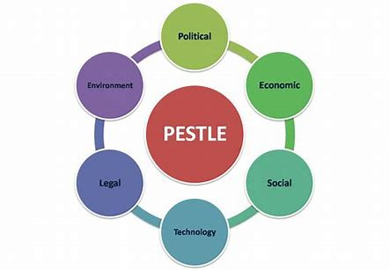
A critical examination of the PESTLE tool as a way of analysing the managerial and business environment for strategic planning

By Gemma Littlejohns, Assoc CIPD
Student number: 1550827
Word Count: 2,196

Contents
1.0 Executive Summary 2
2.0 An introduction to PESTEL 3
3.0 Examples of external factors impacting organisations 5
3.1 Political factors affecting Chwarae Teg 5
3.2 Political factors affecting People Strategy 6
3.3 Technological factors impacting a Health Board 6
3.4 Technological factors and People Strategy 8
4.0 Conclusion 9
5.0 Recommendations 10

1.0 Executive Summary
This report provides a short critical examination of the role PESTEL analysis has on the HR and business strategy of organisations. It provides some examples of how external factors have impacted the UK. It looks in more depth at the impact of political and technological factors on two different Welsh organisations and provides a recommendation along with costs for a third sector organisation at risk of closure.

2.0 An introduction to PESTLE
Businesses and organisations operate to provide goods or services. To remain operational, they will need to know that there is demand for their product and ensure they maintain sufficient supply to meet that demand. For example, a coffee shop will not survive if there is no demand for its coffee. Neither will it survive if there is a problem in its supply chain affecting its ability to meet customer demand for coffee. Therefore, they cannot operate in complete isolation from the external environment, so businesses must continually assess the external environment for any factors that might impact their ability to operate effectively.
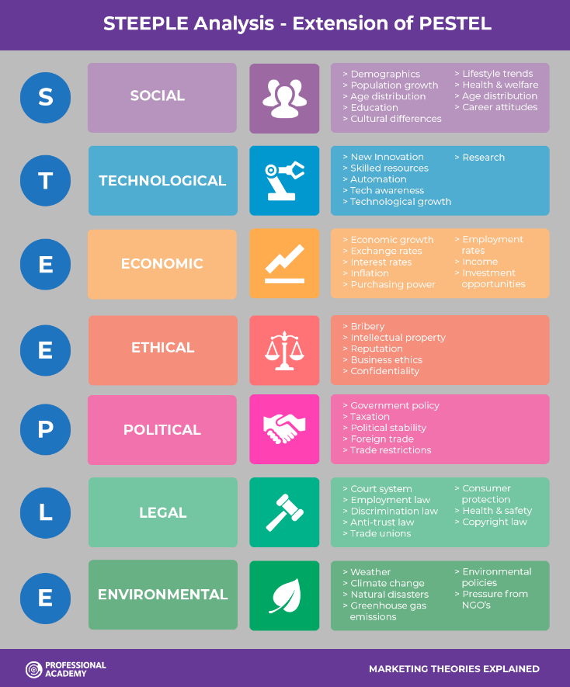
PESTLE is an acronym commonly used as a reminder of key factors to consider when assessing the external environment. In some cases, this has been extended to STEEPLE to include ‘ethical’ (fig.1).
Figure 1 STEEPLE and extension of PESTLE
(image taken from ProfessionalAcademy.com)
Each letter serves as a useful reminder of an external factor that often has a direct impact on an organisation’s ability to operate. A recent example of this is a report from the chairman of the City Pub Group chain who reported that a rise in VAT this new financial year leaves them with no choice but to increase their prices for customers (Yahoo News, 2022).
But it doesn't stop at the provision of goods and services. The ability to provide human labour to deliver services is also affected by the external environment. In an increasingly tight labour market employers have become even more creative in a bid to attract and retain top talent. London based PR firm, CommsCo, has recently given all staff a 5% pay rise to help them manage the rising costs of energy. This firm has very cleverly capitalised on an economic issue affecting its workforce to promote its employer brand (BBC News, 2022).
PESTEL/STEEPLE analysis as the tool itself isn't without its shortcomings. Let's take the process of ‘environmental’ analysis. This is divided into four stages: Scanning, Monitoring, Forecasting and Assessing. ‘Scanning’ involves general surveillance of all the STEEPLE factors and ‘Monitoring’ involves tracking trends. These then provide data and information that can enable ‘Forecasting’ to develop future projections to enable strategic decision making. Finally, the ‘Assessment’ pulls together the key questions regarding the external contexts that have strategic implications for the business. All of this takes time and during that time things can change quite quickly. A forecasting exercise in January 2020 wouldn't have anticipated a global pandemic commencing in March 2020. Six months ago, organisations would not have anticipated a major European country being involved in a humanitarian crisis and war or even considered the impact it would have on their productivity. At the time of writing this report, the World Trade Organisation has reduced its global trade growth forecast for 2022 to 2.5% citing continual global supply chain problems linked to the war, that started because of the pandemic (BBC News, 2022).
Additionally, a STEEPLE analysis requires continual resourcing. Effective external analysis requires human resource with a detailed understanding of the business and the context in which the organisation operates, as this enables them to stitch together the relevant external factors that impact operations. From the analysis, a people strategy is developed which also takes time to develop and implement.

3.0 Examples of external factors impacting organisations

3.1 Political factors affecting Chwarae Teg
Chwarae Teg is a small third sector organisation in Wales. Historically the organisation has survived on grant income from the Welsh Government (WG) and European Social Funds (ESF). As a result of Brexit, ESF will no longer be available. The organisation relies on its core team of staff to generate income from consultancy and management training. These business-critical roles are paid from WG and ESF funds, leaving the post-holders in precarious employment. “When faced with uncertainty, people in precarious employment are highly likely to carry out job-seeking activities” (Choper, et al., 2021). This leaves the organisation having to deal with a retention issue that has been brought about by an external issue.
The impact of Brexit can be felt by a cross-section of organisations across the country. The ending of free movement between the EU and the UK has reduced the UK labour market. Irrespective of whether an organisation like Chwarae Teg employs EU nationals, the availability of external talent can often be reduced by competition from other sectors (People Management, 2021). For instance, the transport industry. This industry was severely impacted by the shortage of HGV drivers. In desperation, haulage companies have been offering financial incentives to attract people from other sectors (The Telegraph, 2021). For organisations like Chwarae Teg, who cannot afford to pay £950 joining incentives, this further adds to the competition for talent as people consider alternative professions.
The UK Shared Prosperity Fund is the UK Government’s answer to filling the gap left by the European Social Fund. It is planning on making £2.6 billion available by March 2025 (GOV.UK, 2022). Pre-launch guidance states that the funding formula will be different from the ESF system, increasing the geographical areas that can access the fund. In turn, this increases competition for Welsh organisations like Chwarae Teg. Additionally, the fund has a different application process whereby decisions are made ‘locally’. Until further guidance is issued this could present difficulty for pan-Wales organisations like Chwarae Teg wishing to deliver pan-Wales services (ibid).
Competition for funding from Governments is further impacted by other charities. According to a paper by the Charity Commission, there are over 9,000 registered charities in Wales and like Chwarae Teg, 90% operate solely in Wales (Charity Commission, 2009). The Charity Commission hasn’t published a more recent report however since the global pandemic Companies House records show that Chwarae Teg’s income was down by 58% between 2018 and 2021 (Companies House, 2021), despite the appointment of a Fundraising and Grants Manager in 2020. This is likely to have been impacted further by people choosing to support charitable efforts about the war in Ukraine.

3.2 Political factors affecting People Strategy
With the limited time to utilise the last of the European Social Funds and the increased competition for further grant income, Chwarae Teg has implemented a growth strategy to focus on increasing commercial revenue by diversifying income streams. Unfortunately, this strategy relies on the aforementioned business-critical roles which are where the organisation is currently experiencing its highest staff turnover.
Chwarae Teg focuses much of its HR resources on recruitment activities to address its staff shortages. Whilst other employers can offer financial incentives and higher salaries Chwarae Teg can’t compete until it’s achieved its growth objectives and increased its income. Chwarae Teg must consider other elements of its employee value proposition to attract and importantly, retain candidates.
Chwarae Teg relies upon recruiting skilled and experienced people however, many employers are finding success in recruiting people with limited experience with the intention to develop them in the role. Chwarae Teg does not have a system in place to support this type of recruitment strategy. Neither does it have a retention strategy.

3.3 Technological factors impacting a Health Board
Hywel Dda University Health Board employs around 12,000 people and covers three counties in West Wales; Carmarthenshire, Pembrokeshire and Ceredigion. The Learning and Development Team have been tasked with re-developing their induction programme. Meanwhile, the organisation is in the early stages of a major digital transformation and any new services must be designed from a ‘digital first’ perspective. However, the 21st-century workplace is experiencing multiple generations simultaneously which places varying demands on Learning and Development (L&D) professionals when it comes to designing and delivering learning interventions.
Currently, Millennials account for 35% of our workforce (Hywel Dda University Health Board, 2021) and are reportedly better able to grasp emerging technology, and Gen Z’s (22% of our workforce) are described as being more resourceful and know how to search for relevant content on the internet (Pew Research Center, 2019). Conversely, a survey by Business in the Community (BITC), supported by Tata Consultancy Services (TCS) found that 62% of those in their 50s had not received any training in computer skills (Frith, 2017). However, whilst findings like this are seemingly commonplace, one should be cautious regarding assumptions about the abilities of older generations. The Pew Research Centre found that Boomers and Gen X are “heavy adopters of tech” but the type of tech varies with younger generations preferring mobile devices (ibid).
As an agile and ‘digital first’ workplace, this has to be a significant consideration in the design of the new corporate induction. It is worth noting that not all employees in the health board are allocated personal devices such as laptops. This means that many new employees such as health care support workers, nurses, domestics, and porters, are using personal devices to get through their corporate induction. The L&D Team will have to carry out detailed assessments and research to identify the correct delivery tools that are intuitive and/or familiar to our workforce. Additionally, broadband access shouldn’t be assumed.
The UK Government has primary responsibility for the country’s broadband policy and has committed to invest £5 billion in improving connectivity across the UK. Whilst not devolved to Wales, the Welsh Government do have some powers. They have used this to provide almost 733,000 properties across Wales with access to broadband through their Superfast Cymru programme in partnership with BT (Welsh Government, n.d.). To increase this further, the Welsh Government provides the Access Broadband Cymru grant scheme to fund or part-fund installation costs of new broadband connections for homes (Welsh Government, 2022. a). In addition, rural residents in Wales may be eligible for additional funding from the Welsh Government towards the cost of installing gigabit-capable broadband in their homes (Welsh Government, 2022. b).

3.4 Technological factors and People Strategy
Government support as mentioned is especially useful to employees of Hywel Dda as the geographical area is highly rural. Sharing this information with employees (and prospective employees) would be advantageous to ensure digital connectivity. This information could feature as part of their Learning and Development strategy as connectivity could be a barrier to learning.
Going forward, the L&D team must ensure adequate access to any technology introduced in line with the HDD Digital Transformation Strategy and accessibility in the wider community. In addition, any introduction of new or unfamiliar technology as part of the induction programme may require additional training resources.
The team will need to ensure that they create a range of resources that are accessible to all and if accessibility issues are identified, they will need to be addressed immediately.

4.0 Conclusion
For the likes of Chwarae Teg, a simple analysis just looking at political factors impacting the organisation, demonstrates how severe external factors can be. In the case of Chwarae Teg, it means they have to develop a new business strategy to diversify revenue and a people strategy to improve retention of business-critical roles. Without either, the organisation would be unlikely to survive.
Conversely, an analysis just looking at technology in the context of the L&D department for a huge public sector organisation like a Health Board shows that external influences have more of an impact on efficiency and effectiveness rather than the risk of closure. That said, the organisation must spend public funds in the most efficient way possible therefore investment in time and effort to address technological shortcomings should be a priority.
All in all, organisations can be quickly impacted by external factors that can change rapidly and organisational responsiveness to those changes can mean the difference between surviving and thriving.
The examples shared within this report demonstrate how external influences and people strategy are intrinsically linked. It stands to reason that the Human Resource function should be part of the analysis, playing a strategic role in the process.

5.0 Recommendations
A key recommendation for a small organisation like Chwarae Teg which is fighting for survival would be to create a strategic role within its HR structure. During the recent restructure the strategic HR role was made redundant leaving one operational HR role in situ. At present they do not have anyone in place to develop a retention strategy which is potentially costing the organisation around £3,000 per new hire (Glassdoor, 2020).
According to Reed Salary Guide for 2022, the average salary for an HR Manager in Wales is £41,800 (Reed, 2022). Table 1 shows the cost options for Chwarae Teg to employ strategic and operational HR roles. Utilising their HR Manager as a strategic function could cost an additional £4,700 however that is just a little more than the cost of one hire. This is arguably a small price to pay for a professional who could address the organisation’s retention issues and ability to deliver against the new business model.
As the table shows, the organisation pays a little above the market median for an HR Assistant however, even if they retained their current salary at an above-average cost of £2,150 per annum, it is likely to still be offset by the benefits brought about by the strategic manager.

Current Structure & Costs |  |  | Proposed Structure & Costs
HR (Operational) Manager | £37,200 |  | HR (Strategic) Manager | £41,800
HR Assistant | £24,350 |  | HR Assistant | £22,200
Total | £61,550 |  | Total | £64,000
Table 1 Structure & cost comparison between current and proposed structure costs for Chwarae Teg

