Name: Gabor Istvan Kovacs
Student Number: 2011284
Assignment Title: Data Handling and Business intelligence
Module Lecturer’s Name: Joy Botu

Table of Contents
Part 1 3
Part 2: 4
1. Students liking towards vanilla flavour ice-cream 4
2. Male and female students number 4
3. Mean and median participants number for strawberry and chocolate flavour 4
b) Most common data mining and text mining methods for business 6
Data mining methods 6
Text mining methods 7
c) Advantages and disadvantages of SPSS and Excel with practical examples 8
Advantages and disadvantages of SPSS 8
Advantages and disadvantages of Excel 9
Reference List 10

Part 1

 | Values
Row Labels | Sum of CrimeRate | Sum of Males | Sum of YouthUnemployment | Sum of HighYouthUnemploy | Sum of Wage | Sum of BelowWage | Sum of CrimeRate10
0 | 3221.1 | 30678 | 3028 | 14 | 17641 | 5366 | 3188.9
1 | 1610.9 | 15524 | 1459 | 1 | 7052 | 3752 | 1608.4
Grand Total | 4832 | 46202 | 4487 | 15 | 24693 | 9118 | 4797.3

Part 2:

Students liking towards vanilla flavour ice-cream
The mode is the category that has the most significant number of occurrences (or percentage). It is not the frequency itself that is the problem. As a result, if a student asks what the distribution mode displayed below is, the correct response is vanilla, not 1. It is probable to have one or more in the operation activity (Bordeleau et al. 2018). As a result, this kind of distribution is classified as multimodal or bimodal (if more than two modes). Uniform distributions are defined as those that do not have a distinct method. Below is the presentation of the ice-cream flavour liked by the students. Moreover, it is clearly visible that students liking vanilla flavoured ice cream is 1%.
Favourite flavours of Ice-cream
Vanilla: 1
Chocolate: 2
Strawberry: 3
Number of male=0
Number of female=1
Then total=0+1=1

Male and female students number
Row Labels | Sum of female
0 | 0
1 | 109
Grand Total | 109

Mean and median participants number for strawberry and chocolate flavour
Mean is referred to as "the average" in everyday speech. It is the uppermost central tendency measure. Moreover, the mean can use only with ratio or interval variables, which is the case with this measure. Due to its ability to consider the value of each observation, the mean gives the majority of data (Jalil and Hwang, 2019). The mean is more responsive towards outliers in comparison to the median. A single mean is unusually the number in the dataset that have a major impact on the mean. The mean is commonly represented by the variable with a line drawn through it. It is the sum of all the scores divided by the total number of scores.
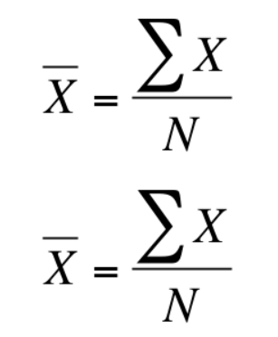
From the above equation, it is clear that the mean, X denote the significance of each case, whereas N indicates the cases total number. In this case, the sigma () is just instructing to totalling the scores. Therefore, mean calculation needs both addition and division (Kiani Mavi and Standing, 2018). Moreover, in a precise way, it cannot be employed with either ordinal or nominal variables, as previously stated. This is true for both race and year in excel.
The benefit of utilizing median is less sensitive to outliers. The term "outlier" refers to a single observation that differs significantly from the other values in a sample. From the given excel sheet, it is visible that there is no availability of male students. On the other hand, 1 is the female student (Bordeleau et al. 2018). As a result, explanation with the intention of much larger or smaller than the others in a sample can have a crash on some statistical way in such a way that they become very misleading, but the median is not affected by these types of observations. So, whether the smallest number is one, it still only counts as one in the overall scheme of the universe.
Ice cream
Mean | 1.815
Standard Error | 0.060598978
Median | 2
Mode | 1
Standard Deviation | 0.856998971
Sample Variance | 0.734447236
Kurtosis | -1.544769314
Skewness | 0.365980384
Range | 2
Minimum | 1
Maximum | 3
Sum | 363
Count | 200

b) Most common data mining and text mining methods for business

Data mining methods
Data mining has been around for a long time. As United Kingdom corporations struggled to deal with an ever-increasing amount of data produced by society in the 1990s, the term "Big Data" was first coined to describe the process. By 2029, the Bureau of Labour Statistics predicts that employment for computer and information research scientists would rise by 15% (Moscoso-Zea et al. 2019).
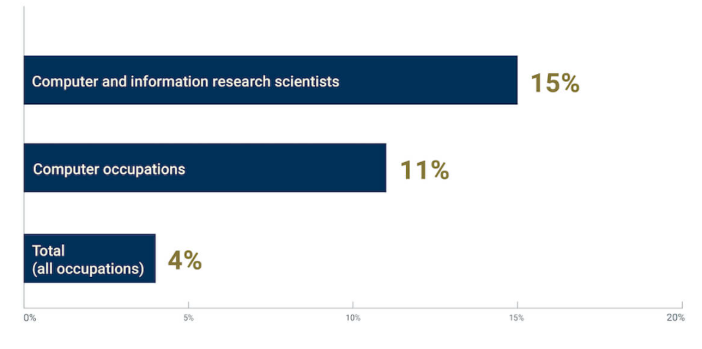
Figure: Projected UK Employment growth of computer and information research scientists, 2019-2029
Source: ()
There are various data mining methods available in the market that helps business to accomplish their goals and objectives. Below mentioned are the important data mining techniques-
Clustering
Data points are clustered into groups according to their similarities and differences, and this process is called clustering. As a result, data miners can make more educated conclusions about broad populations and their related habits by seamlessly dividing the data into subgroups. For instance, clustering is a valuable tool for firms better to manage their data (Llave, 2018). The usage of clustering models can help businesses determine the purchase of their specific products. This can assist shops in marketing their goods and services to a particular group of people or geographic area.
Data cleaning
Data cleaning is reorganising data, removing redundant or corrupted data, and filling in any missing information. The most useful data can be gathered for further analysis at the end of the process. For example, 95 percent of UK companies have been negatively affected by bad data (Kiani Mavi and Standing, 2018). It takes more time and resources to analyse erroneous data than it does to analyse right data, and it typically leads to incorrect insights. In the end, organisations suffer when their data is wrong, incomplete, or damaged, regardless of how well their models or algorithms are.
Machine learning
Computers can learn on their own using algorithms in a process known as "machine learning." Machine learning, a growing aspect of modern technology, teaches computers how to do jobs based on the data they have gathered, making them “smarter” (Wani and Jabin, 2018). For instance, companies can utilise computers to swiftly uncover data trends in sales, product use, purchasing habits and design business plans based on these insights with machine learning. For a variety of industries, this is a pressing issue.

Text mining methods
Text mining is an innovative medium of computer science. However, it has grown in popularity as the amount of relevant and valuable unstructured data has increased tremendously. Moreover, text mining has many techniques like sentiment analysis, classification and entity extraction and more to extract usable knowledge and information from text content. Even in the face of massive amounts of unstructured data, it is possible to discover patterns, trends, and insights (Szárnyas et al. 2018). As a result of its increasing acceptance, particularly in large businesses, this system is being pushed out of the way of irrelevant information and replaced with valuable information.
Risk management
Project failure is the lack of risk management. Risk Management Software depends upon text mining technology can considerably enhance the capability to alleviate risk in the financial industry, allowing for total control of thousands of petabytes and sources of text papers (Moscoso-Zea et al. 2019). Alongside, it gives the capacity to connect data and at the same time to have contact to the accurate data at the right moment.
Cybercrime prevention
Increasing the risk of online crimes results from the internet's anonymity and numerous communication options. Anti-crime software based on text mining and anti-crime intelligence makes it easier for businesses and law enforcement organisations to prevent internet crime (Llave, 2018).
Business intelligence
Large corporations rely on this procedure to uphold and support their decision-making processes. However, if a business got petabytes of internal and open source data then text mining can help them out get to the bottom of it quickly (Kiani Mavi and Standing, 2018). This ability to monitor thousands of sources and evaluate enormous data volumes is provided by applications like expert.ai Intelligence Platform.

c) Advantages and disadvantages of SPSS and Excel with practical examples

Advantages and disadvantages of SPSS
SPSS | Advantages | Disadvantages
 | SPSS is a inclusive statistical software | SPSS are expensive for student to purchase
 | Complex statistical tests are offered | Involves added training to exploit the available feature
 | Result interpretation is easy | Features are not as simple like Microsoft excel
 | Quick and easy data tables display | Appears to be time consuming for urgent job requirement
 | Expandable | Sometimes it is seen to be non expandable

Advantages and disadvantages of Excel
Excel | Advantages | Disadvantages
 | Stores data | Lack of security and control
 | Perform calculations | Prone to human error
 | Tools for data analysis | Hard to secure
 | Easy to visualize | Unsuitable agile business practices
 | Free templates to use | Cannot be done in quick basis
 | Automatic code | Not designed with collaborative work
 | Clean data | Difficult to test

Reference List
Bordeleau, F.E., Mosconi, E. and Santa-Eulalia, L.A., 2018, January. Business Intelligence in Industry 4.0: State of the art and research opportunities. In Proceedings of the 51st Hawaii International Conference on System Sciences. https://scholarspace.manoa.hawaii.edu/handle/10125/50383
Jalil, N.A. and Hwang, H.J., 2019. Technological-centric business intelligence: Critical success factors. Int. J. Innov. Creat. Chang. https://www.ijicc.net/images/Vol5iss2_/85_Jalil_P1499_2019R.pdf
Kiani Mavi, R. and Standing, C., 2018. Cause and effect analysis of business intelligence (BI) benefits with fuzzy DEMATEL. Knowledge Management Research & Practice, 16(2), pp.245-257. https://www.tandfonline.com/doi/abs/10.1080/14778238.2018.1451234
Llave, M.R., 2018. Data lakes in business intelligence: reporting from the trenches. Procedia computer science, 138, pp.516-524. https://www.sciencedirect.com/science/article/pii/S1877050918317046
Moscoso-Zea, O., Castro, J., Paredes-Gualtor, J. and Luján-Mora, S., 2019. A hybrid infrastructure of enterprise architecture and business intelligence & analytics for knowledge management in education. IEEE access, 7, pp.38778-38788. https://ieeexplore.ieee.org/abstract/document/8672110/
Szárnyas, G., Prat-Pérez, A., Averbuch, A., Marton, J., Paradies, M., Kaufmann, M., Erling, O., Boncz, P., Haprian, V. and Antal, J.B., 2018, June. An early look at the LDBC social network benchmark's business intelligence workload. In Proceedings of the 1st ACM SIGMOD Joint International Workshop on Graph Data Management Experiences & Systems (GRADES) and Network Data Analytics (NDA) (pp. 1-11). https://dl.acm.org/doi/abs/10.1145/3210259.3210268?casa_token=q6JLs0PrqxwAAAAA:_W43q8gvq4USX4YNXuFh66epoN7C2j4LotZWZaLbQH7zBQGZl_6MRMGHmFC0wQtV6W4wrverGMpw208
Wani, M.A. and Jabin, S., 2018. Big data: issues, challenges, and techniques in business intelligence. In Big data analytics (pp. 613-628). Springer, Singapore. https://www.sciencedirect.com/science/article/pii/S0268401217310320

