3/24/2025
University of Wales Trinity Saint David
London campus
E-Portfolio Link: https://2439672.wixsite.com/e-portfolio/table-of-cntents

Module Name: Learning In the Digital Era
Module Code: ACCA 4025

Student Name: Ammar Doudou
Student ID: 2439672
Group: 1

Lecturer’s Name: Koushik Modak

LDE Assignment 1
E-Portfolio
Table of Contents
Introduction 2
Main Body 2
Task 1: Essential Academic and Employment Skills for the future career Path 2
Task 1 (a): Report on Essential Academic and Employment Skills 2
Task 1 (b): Evaluation of Task 1 (a) based on Similarity report 2
Task 2: Collaborative Mind Map and Individual Poster 2
Mind Map (Collaborative) 2
Poster (Individual) 2
Task 3: Virtual Collaboration and RefWorks 2
Report on Virtual Collaboration 2
Step-by-step process of using RefWorks with visuals 2
Task 4: E-Portfolio Creation and Evaluation 2
Task 4 (a): E-Portfolio Creation 2
Task 4 (b): Illustrative Review of E-Portfolio tool Selection 2
Conclusion 2
References 2
Task 1 References: 2
Task 3 References: 2

Introduction
The development of contemporary technology has an impact on both your academic and professional lives. Modern technology is increasingly being used by colleges and businesses worldwide, which has an impact on global industries where labour displacement is a major issue. Learning how to use digital software and hardware demonstrates how advantageous it is for various individuals and organizations given the current advancements in digital tools.
These days, technology is altering practically every aspect of our life, including the way we work and learn. Modern digital technologies are being used by many colleges and businesses worldwide, and this change is having an impact on all industries, sometimes even displacing specific job kinds. The rapid advancement of technology has made proficiency with various software and gadgets highly valuable. These digital talents can facilitate people's lives, increase productivity, and assist companies in adjusting to a world that is changing quickly.

Main Body

Task 1: Essential Academic and Employment Skills for the future career Path

Task 1 (a): Report on Essential Academic and Employment Skills
It's important to have good academic and work-related skills to do well in college and in future jobs. Communication, teamwork, problem-solving, time management, and knowing how to use technology are some of the most useful skills [ [1]

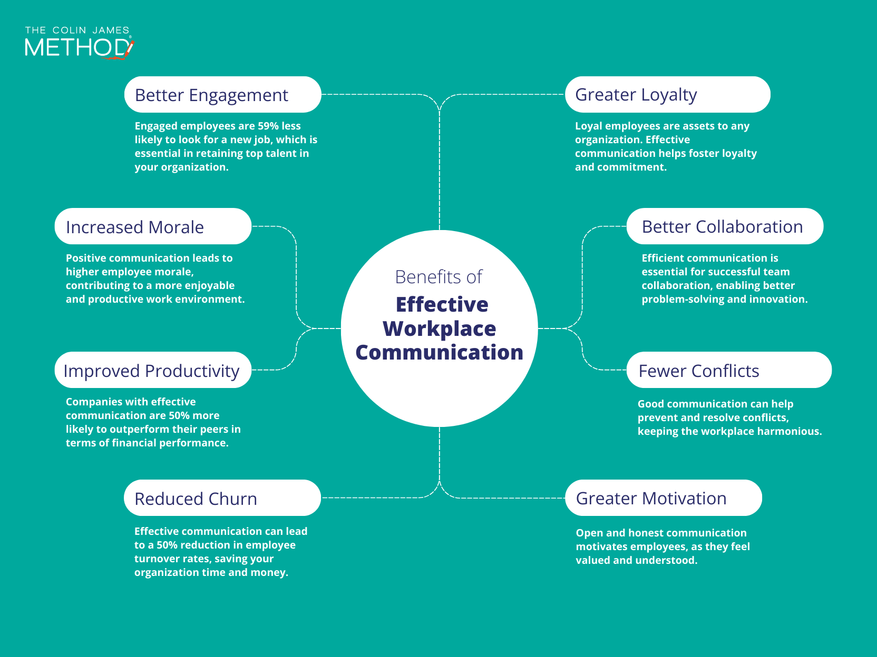
Figure 1. (add description here) [2], [3], [4], [5].

Communication is particularly crucial since it facilitates clear idea expression and mutual understanding. When working in a group, effective communication helps to avoid misunderstandings and gives everyone the confidence to voice their opinions. Additionally, teamwork is crucial because it allows individuals to leverage their own skills to accomplish a task more successfully [2]. Critical thinking and problem-solving abilities are also essential. When presented with obstacles, these skills enable people to make wise choices and come up with original solutions [3].Learners apply methods for problem-solving, for instance, when evaluating assignments or resolving technological problems. Additionally, time management is crucial since it keeps people organized and helps them achieve their objectives. Planning, establishing priorities, and avoiding procrastination are all components of effective time management, which lowers stress and boosts output [4]. these days, practically every industry uses technology, and proficiency with digital tools increases productivity and fosters teamwork.
I think these abilities will be very helpful in my future work as a software engineer. I will be able to interact and communicate well with clients and other developers. My ability to think critically and solve problems will help me create, test, and enhance software. I'll be able to keep organized, meet deadlines, and finish projects successfully with the aid of time management and digital skills. Developing these skills will enable me to succeed in college and pursue a lucrative career in software engineering. Technology is a big part of education and the profession in today's modern society. People who possess good digital abilities can efficiently use various software applications, conduct research, and communicate online [5].
these days, practically every industry uses technology, and proficiency with digital tools increases productivity and fosters teamwork.
I think these abilities will be very helpful in my future work as a software engineer. I will be able to interact and communicate well with clients and other developers. My ability to think critically and solve problems will help me create, test, and enhance software. I'll be able to keep organized, meet deadlines, and finish projects successfully with the aid of time management and digital skills. Developing these skills will enable me to succeed in college and pursue a lucrative career in software engineering.

Task 1 (b): Evaluation of Task 1 (a) based on Similarity report
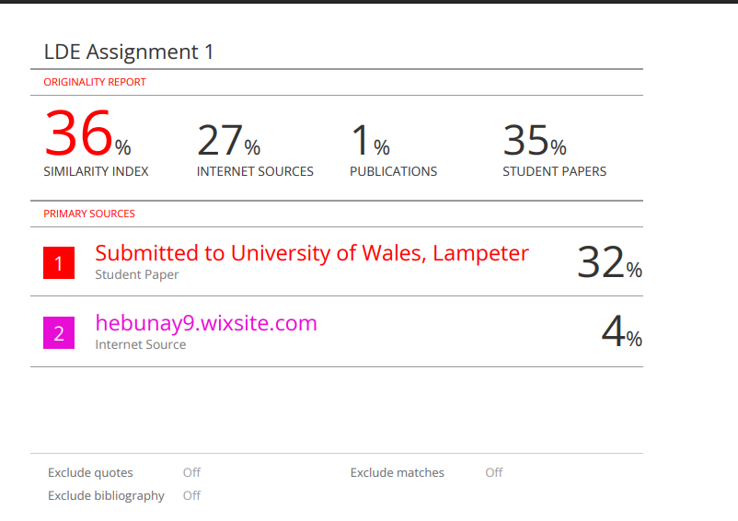

After my work was reviewed on Turnitin, I was given a respectable 36% similarity score. The references and a few commonly used essay sentences contained most of the matches. I can get a lower grade the next time by writing in my own words and refining my paraphrase.
Using the Generic Assessment Criteria, I would give myself a score of approximately 75 percent. I think my writing is clear, referenced, and organised effectively. I also showed that I understood the material well, but I could improve on the next assignments by going a bit further and conducting more research.

Task 2: Collaborative Mind Map and Individual Poster

Mind Map (Collaborative)
Mind Map linkhttps://mm.tt/map/3844884777?t=GMrjM5zdbd:

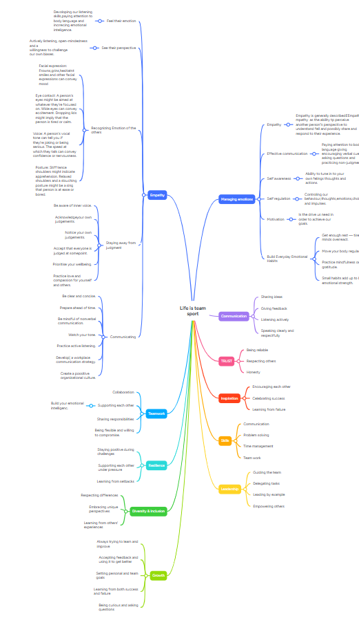
Poster link: https://www.canva.com/design/DAG5IgWAaWo/aecPgT4c75K51maGmRqhVg/view?utm_content=DAG5IgWAaWo&utm_campaign=designshare&utm_medium=link2&utm_source=uniquelinks&utlId=h632323824e

Poster (Individual)

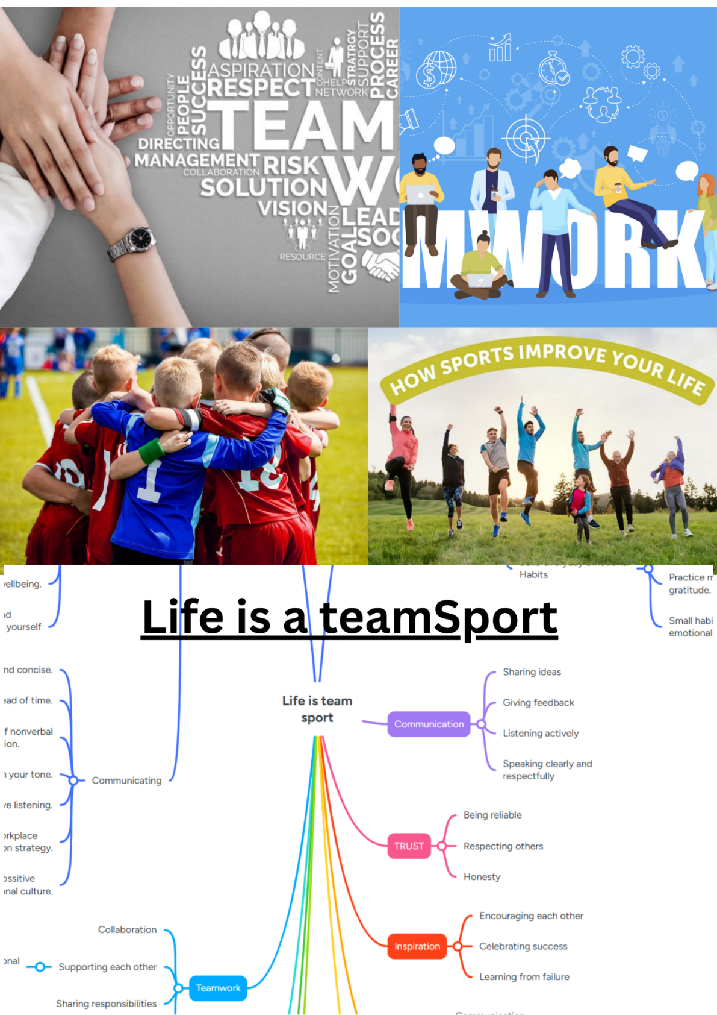

Task 3: Virtual Collaboration and RefWorks

Report on Virtual Collaboration

Virtual collaboration
Topic1: Forming a team
One of the most valued abilities in the business has always been teamwork. However, teams are increasingly being established and run online as remote and hybrid work become more prevalent. It takes careful preparation, effective communication, and an emphasis on connection and trust to create a virtual team [1]
Proper planning is the first step in creating a successful online team. Selecting individuals whose skills complement one another and ensuring that everyone is aware of their responsibilities and the team's goals are crucial. Clear communication becomes even more crucial when team members are geographically separated. Everyone can stay in agreement and prevent misunderstandings by using the appropriate tools, such as group chats, documents that are shared, and video meeting [2].
individual connections and trust are just as crucial in virtual teams as finishing duties. Trust doesn't develop on its own in an office setting because workers aren't given the opportunity to communicate organically. Rather, it must be developed by frequent check-ins, honest communication, and brief chances for team members to get to know one another. People are more likely to collaborate effectively and offer their finest thoughts when they are encouraged and at ease [3].
The way a virtual team operates is also greatly influenced by its leaders. A competent leader guarantees that each team member feels included, promotes involvement, and sets clear expectations. Establishing basic rules, such as how frequently the team meets or how they communicate updates, can help prevent misunderstandings and maintain team cohesion [4], [5], [6].
In general, creating a virtual team involves more than just technology. It's about connecting individuals in a way that facilitates communication, mutual trust, and a sense of community even when they are separated by great distances. Virtual teams can be just as powerful and productive as teams operating in the same space when these components are combined [4], [5], [6].

Step-by-step process of using RefWorks with visuals
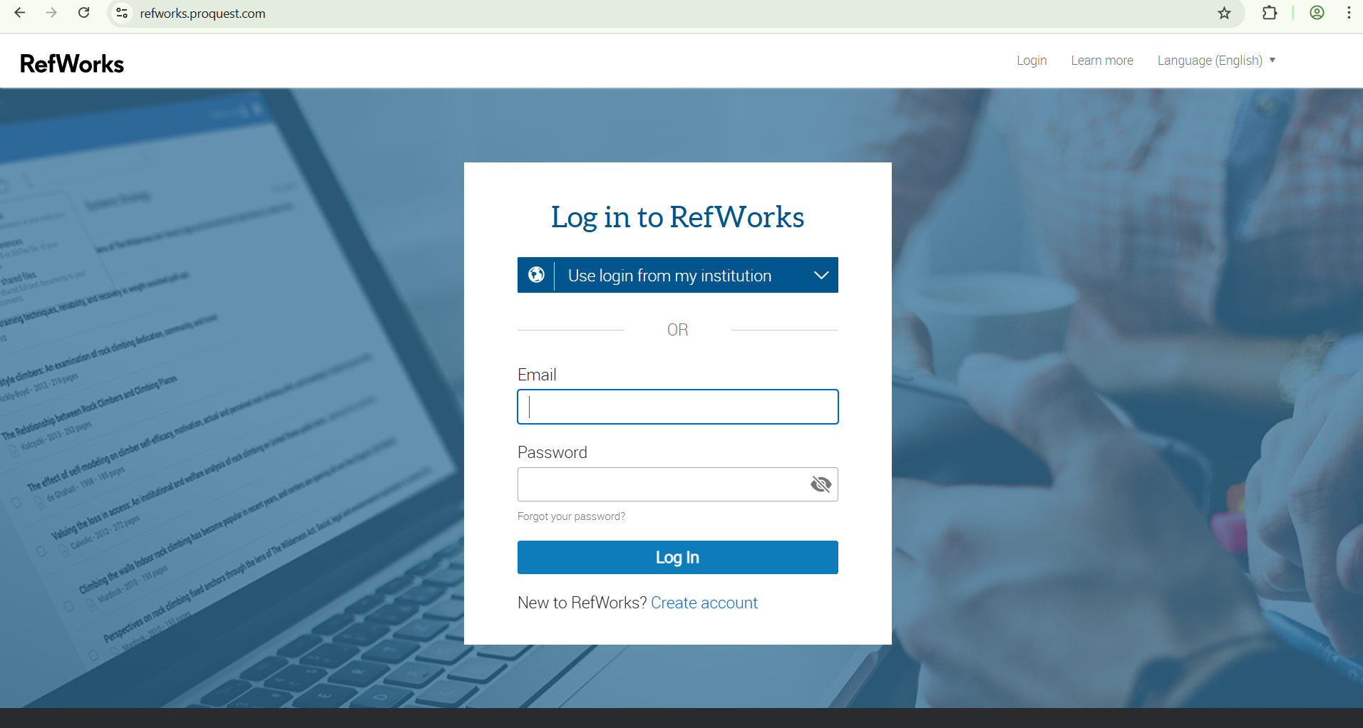

You must start by searching for RefWorks on Internet.
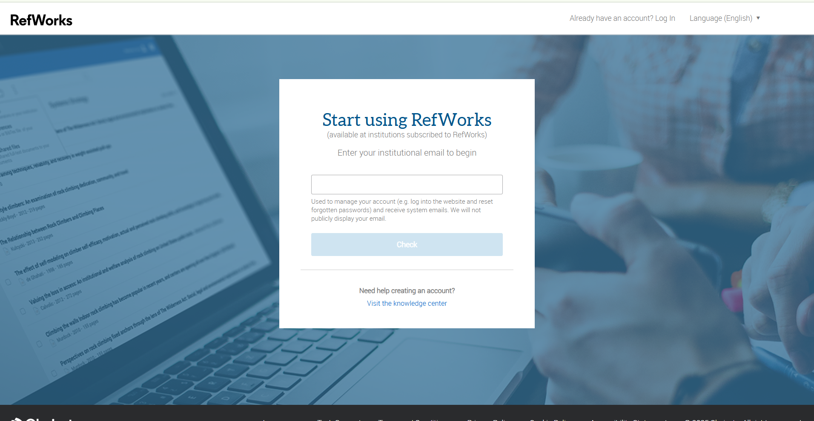

- On this page you must log in, if you already have an account.

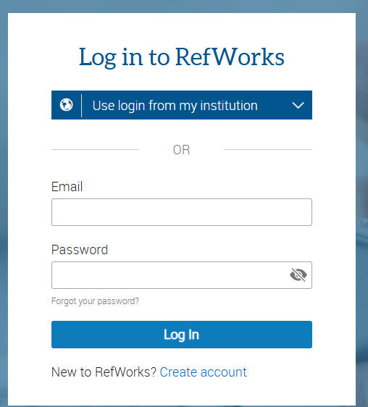

- Click "create account" if you don't already have one.
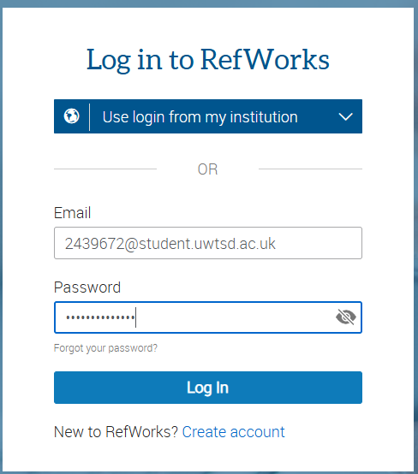

- Use your email address from the university.

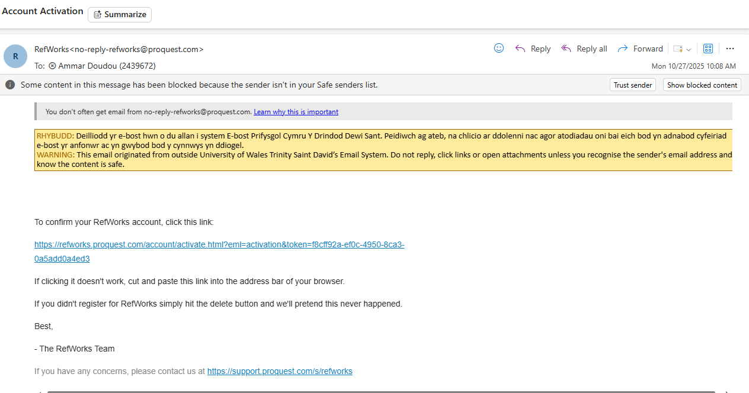

- You will receive a link to verify the activation of your RefWorks account after entering your email address.
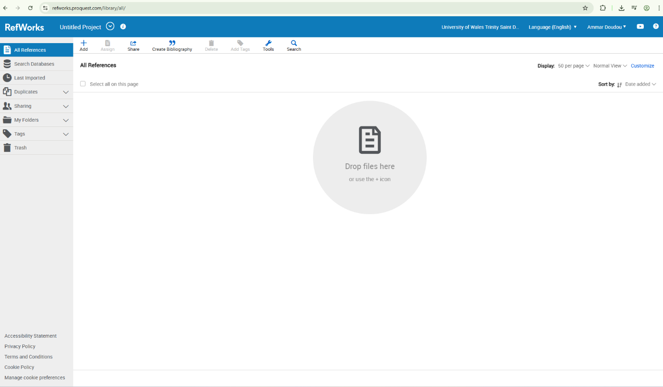

- Your main library, which is initially empty, will appear once you're inside RefWorks.

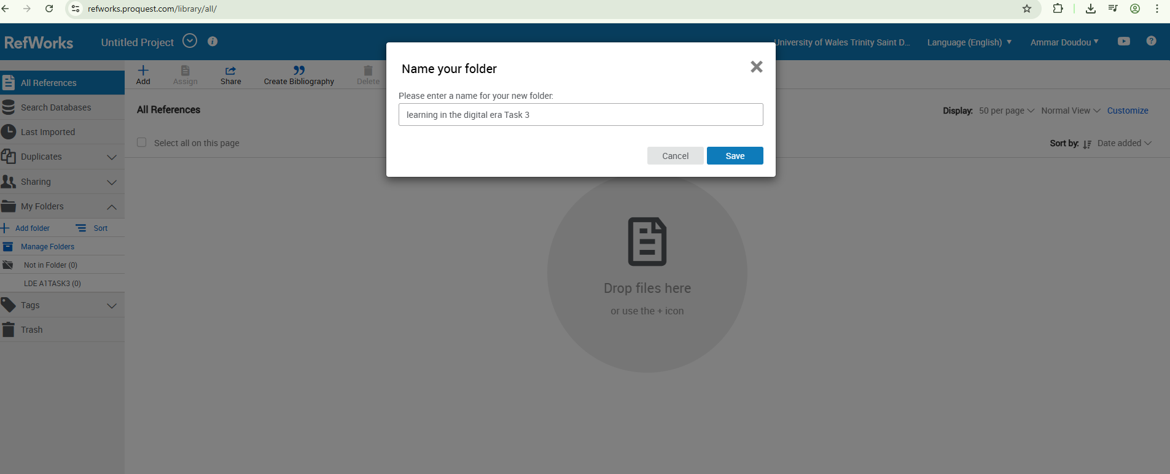

- You can make folders for every task in this way.

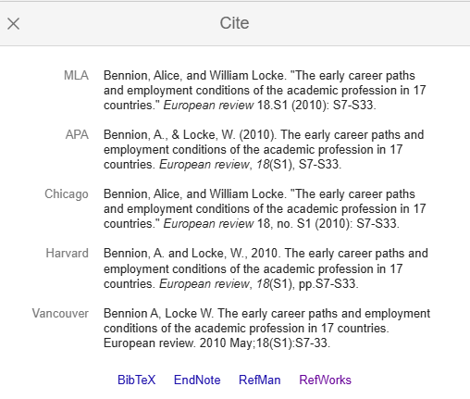

- Go to Google Scholar and search for your topic if you want to add references from online. When you click on Citations, a page will appear; when you click on RefWorks, your reference will be added to RefWorks.

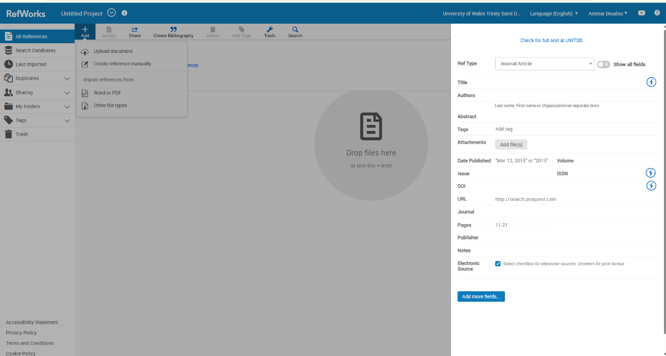
- To manually add references, simply click the add button and then select "crate reference manually."
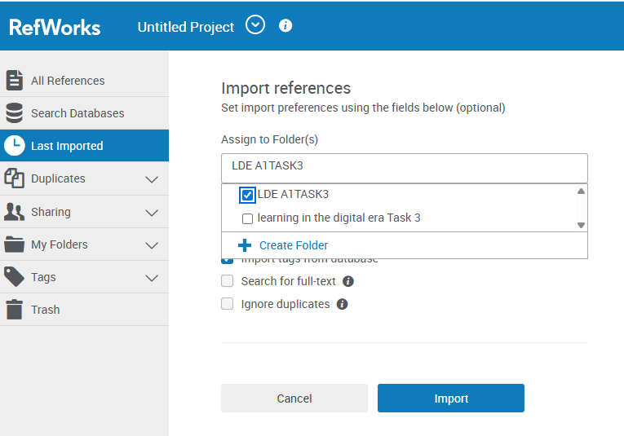

- The reference will be added when you click "import" on this page.

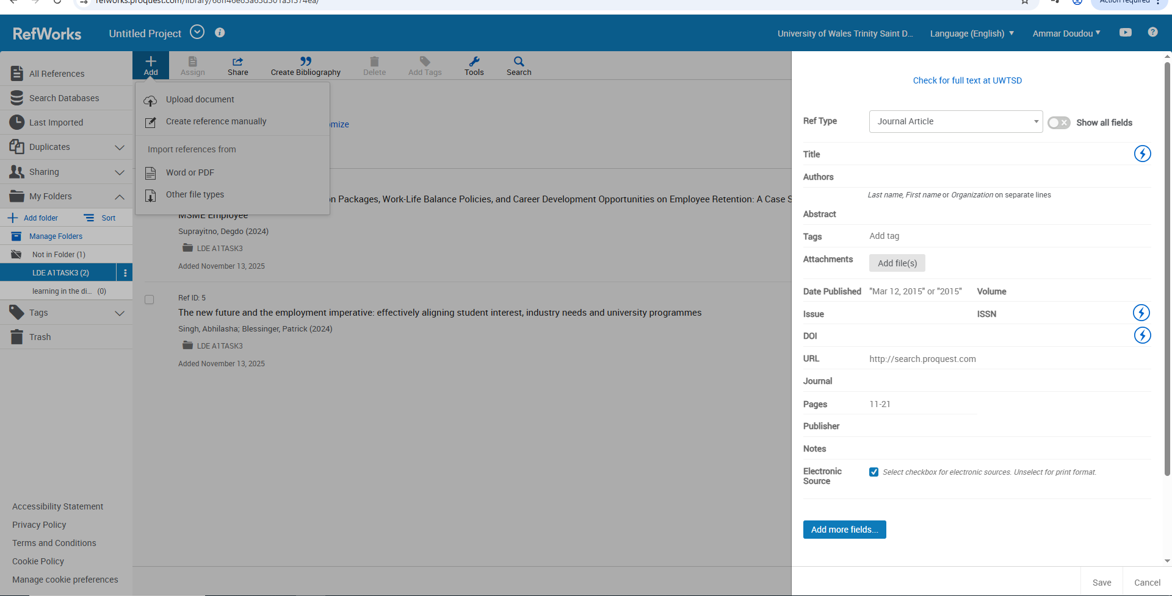
- This how you put your references click on add and it will add it.

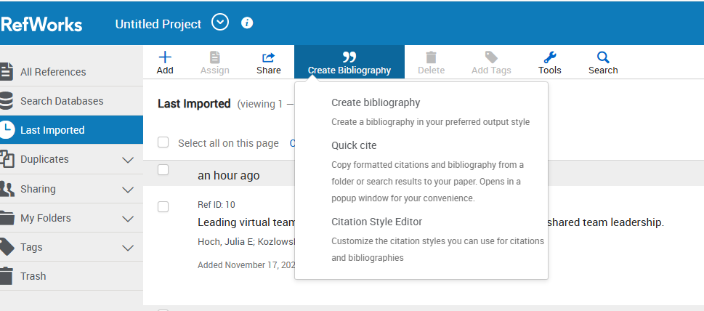

- To create bibliography, you need to click on create bibliography when you click on it will create for you.

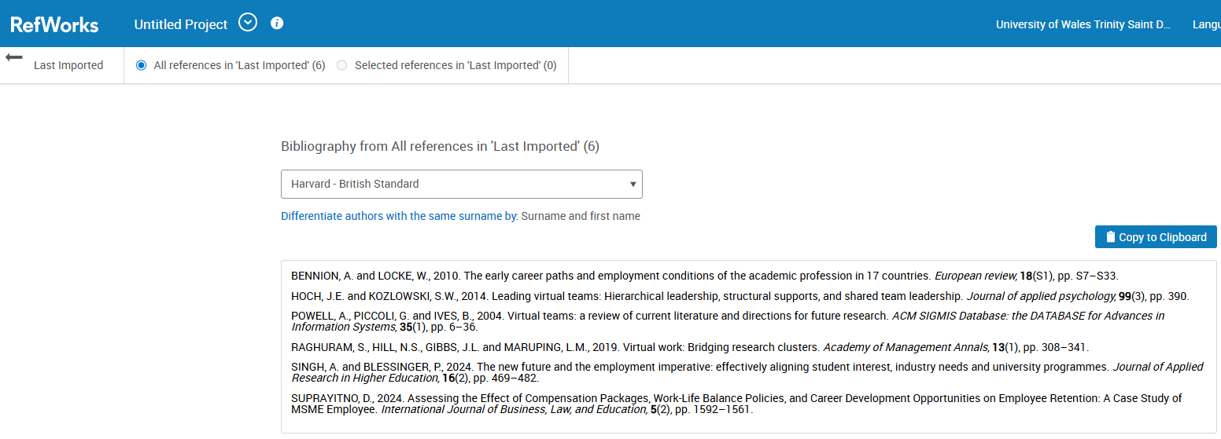
- This when bibliography been created

Task 4: E-Portfolio Creation and Evaluation

Task 4 (a): E-Portfolio Creation

Task 4 (b): Illustrative Review of E-Portfolio tool Selection

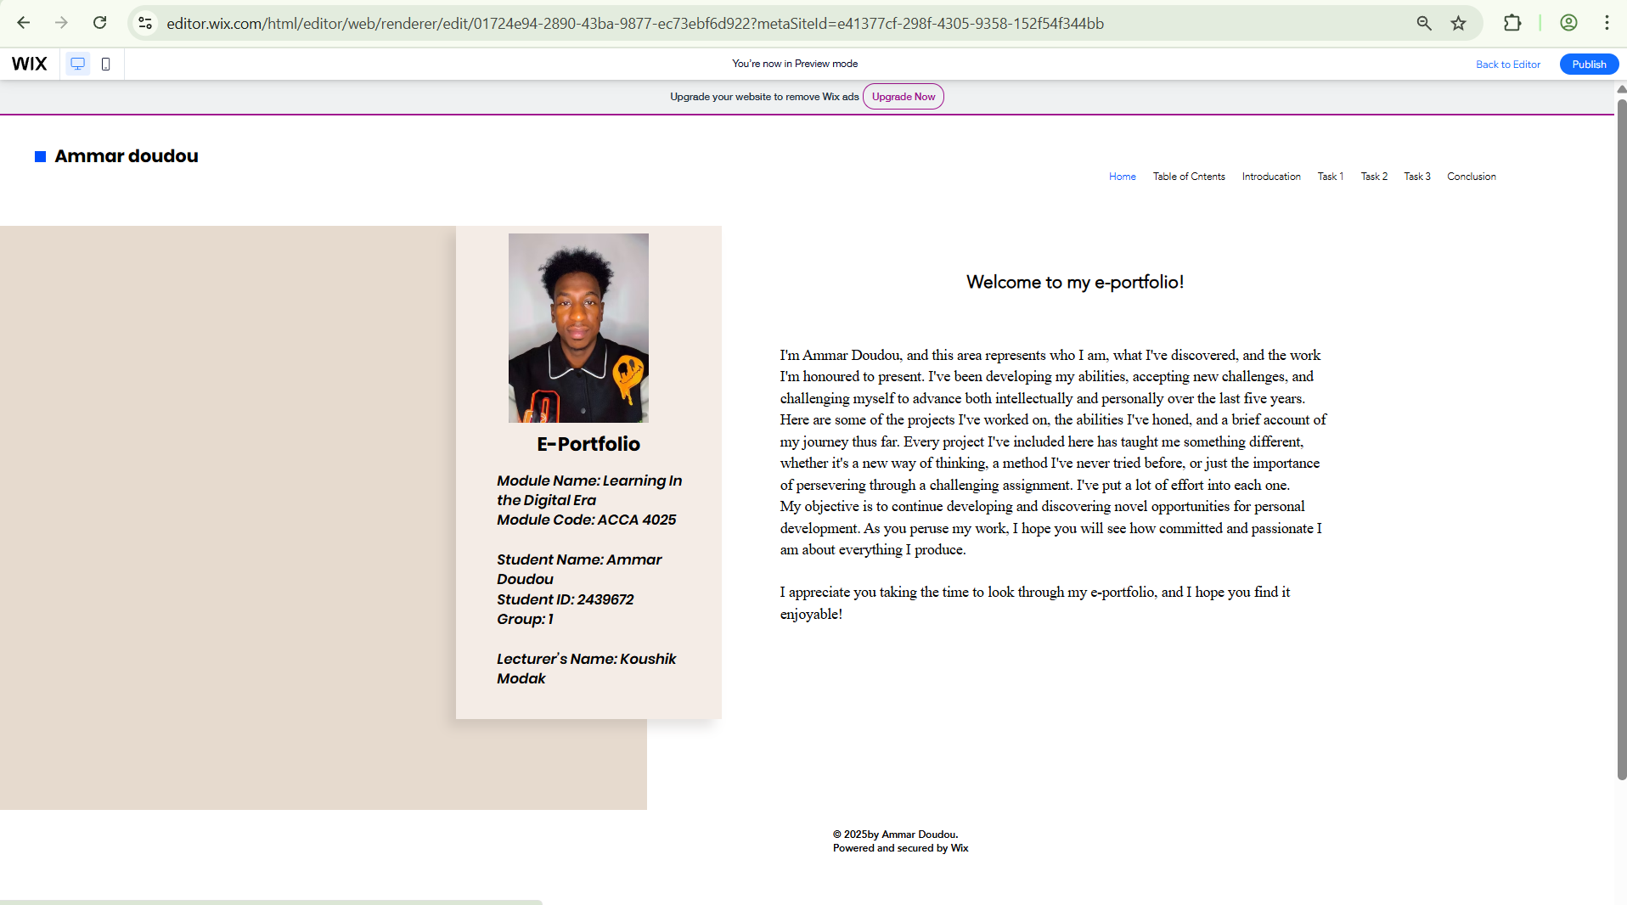
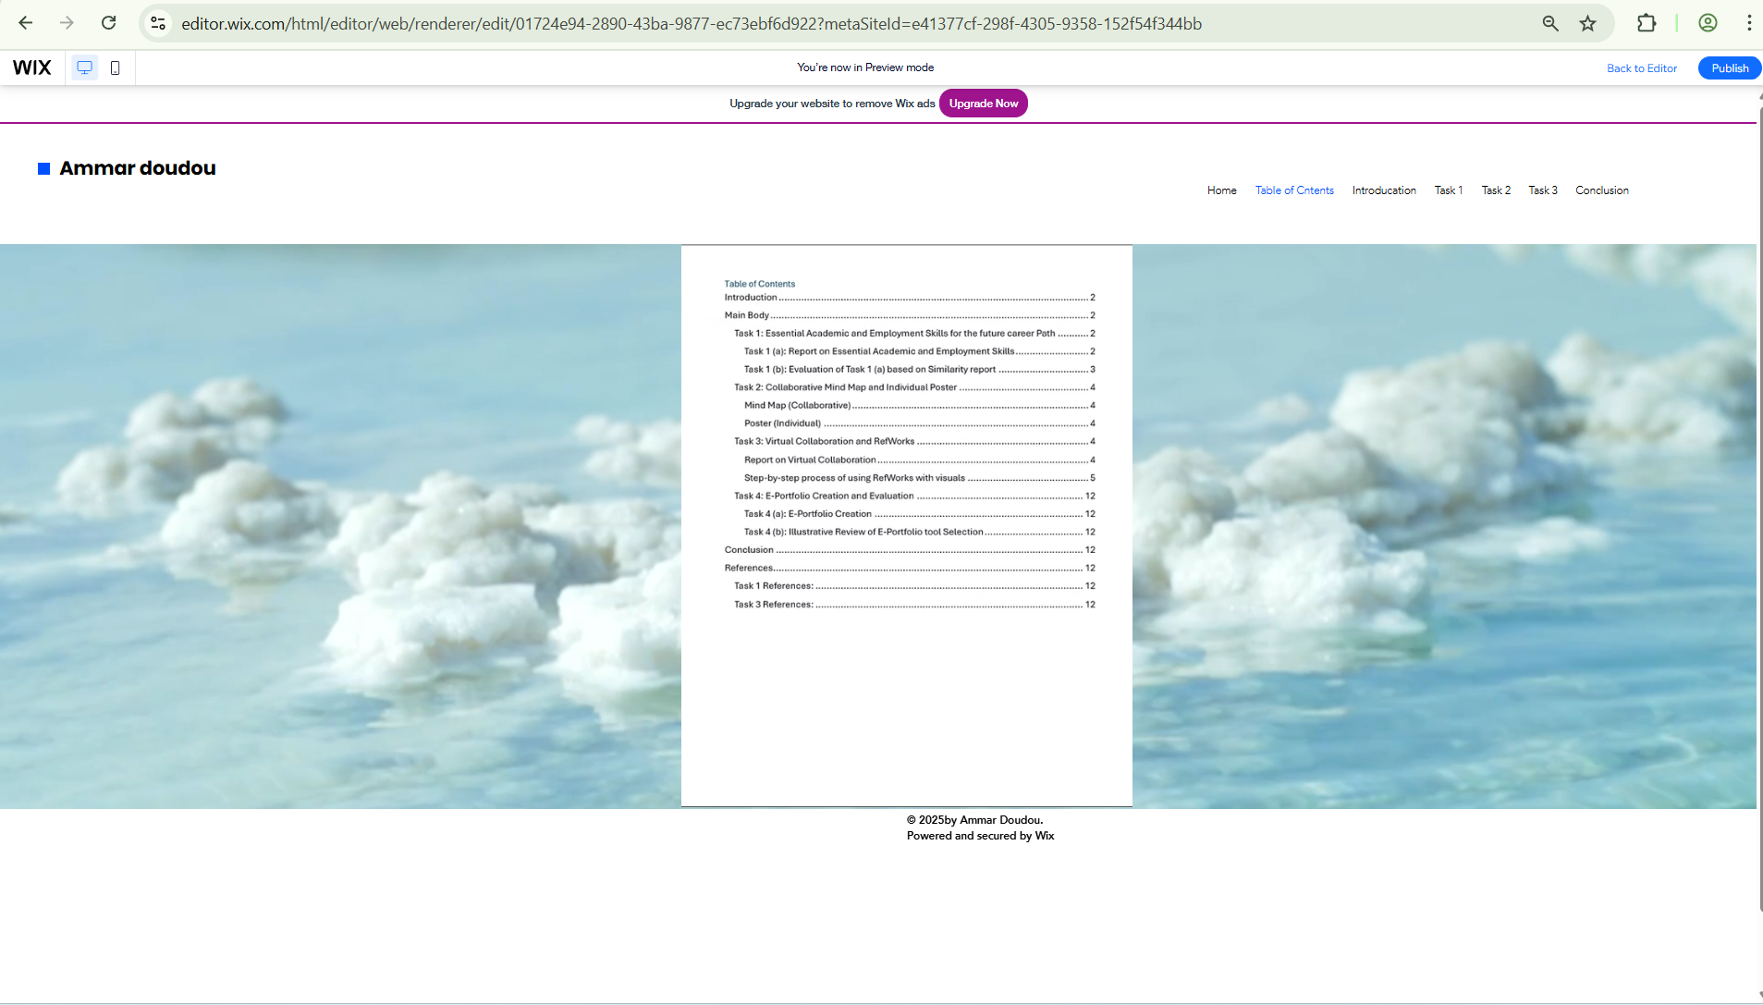

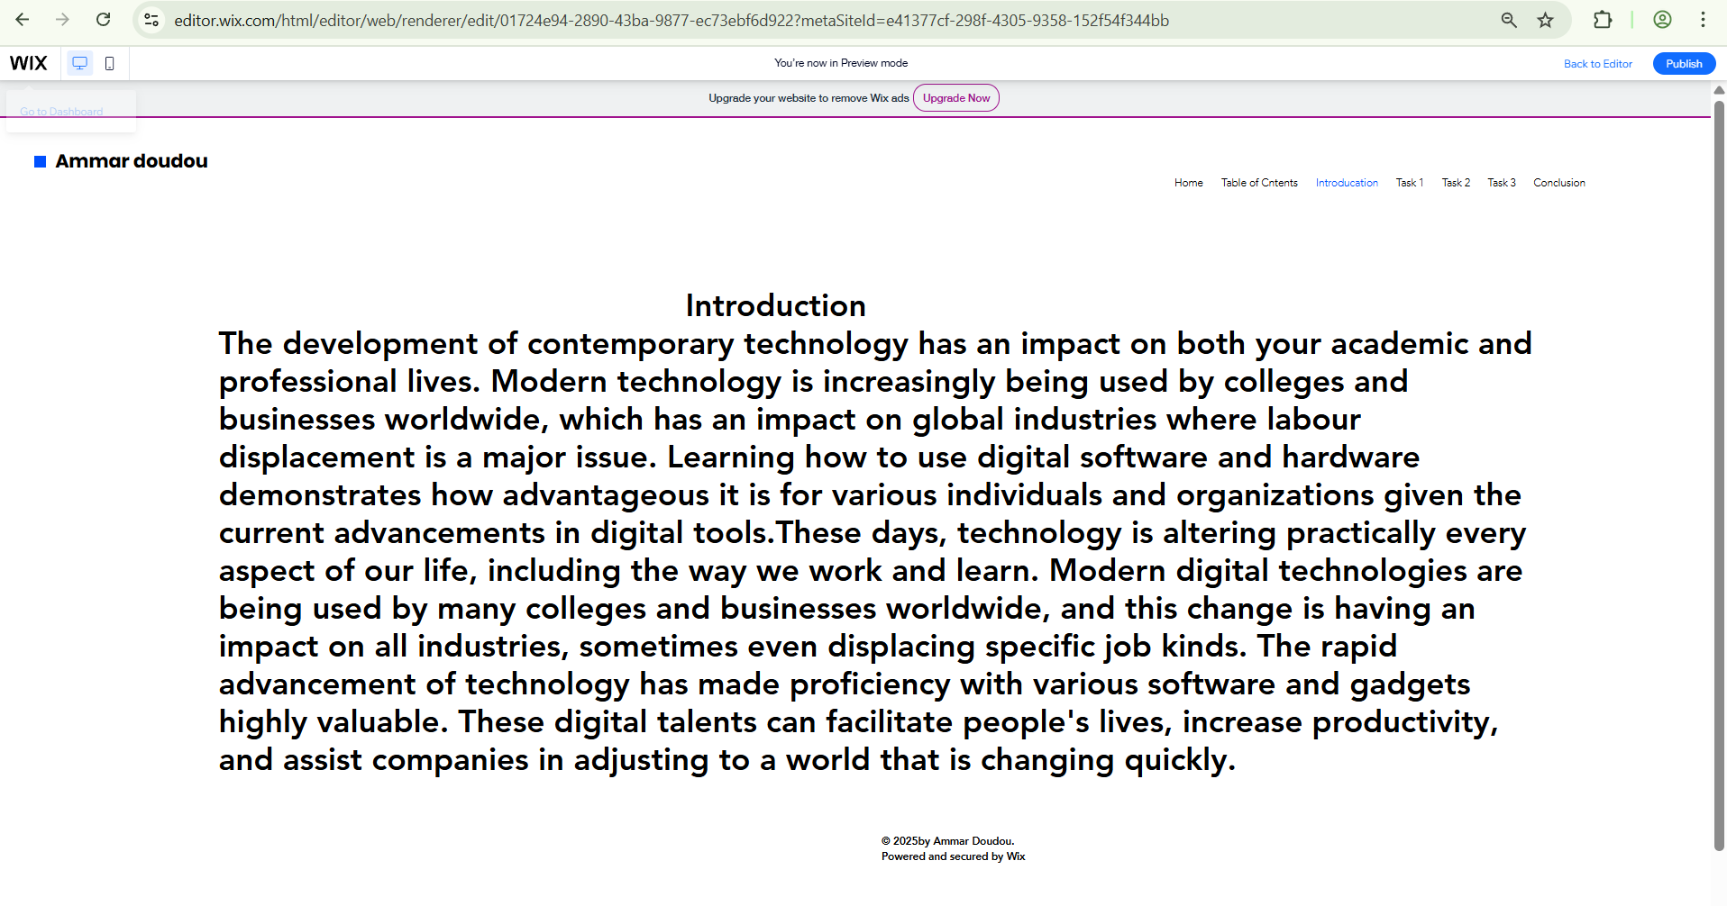

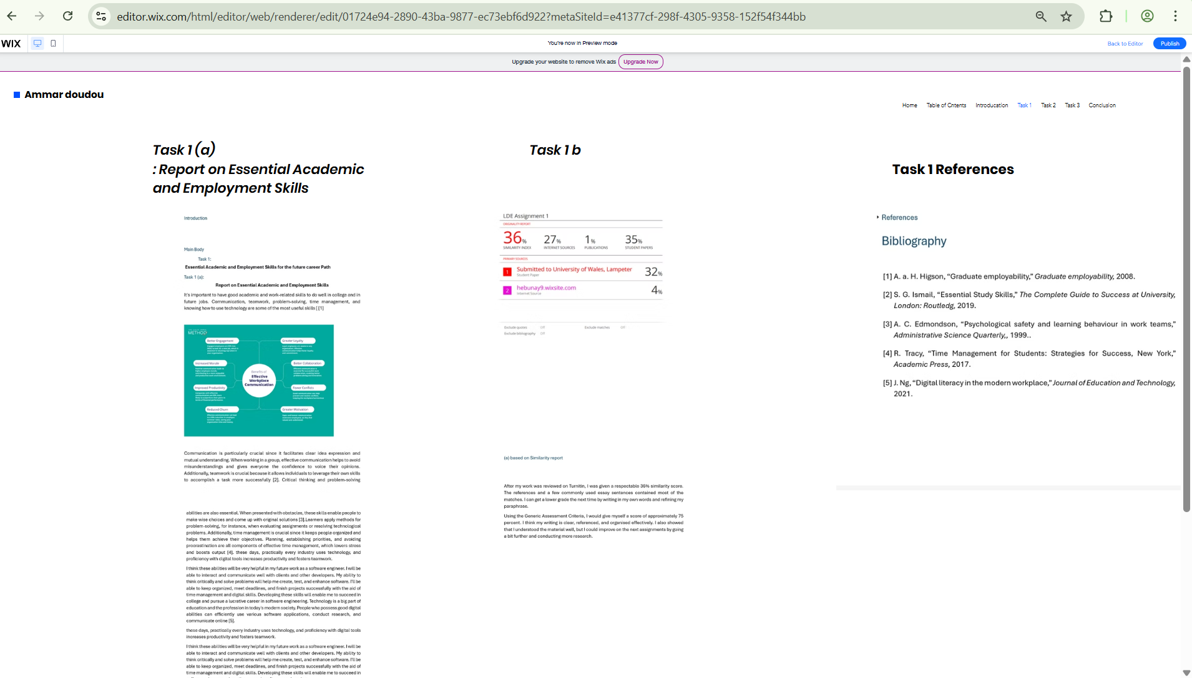

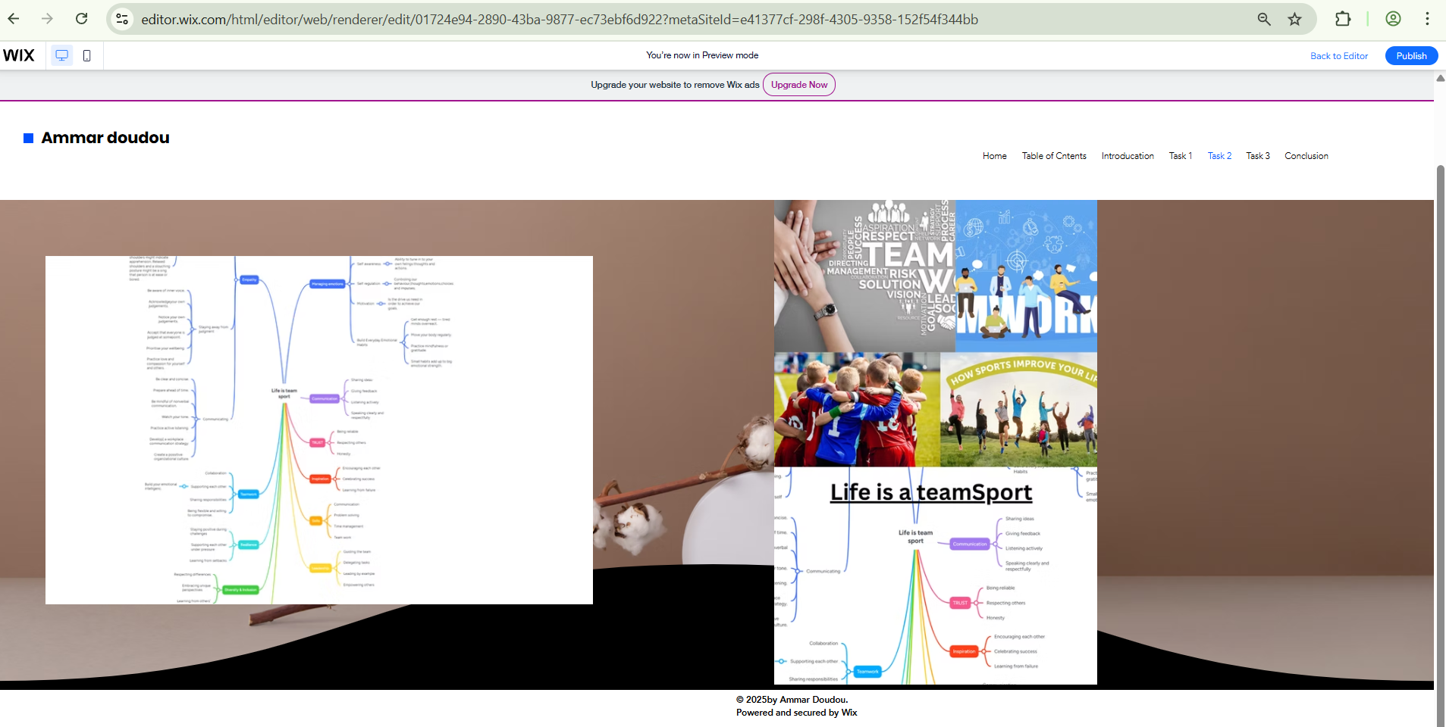

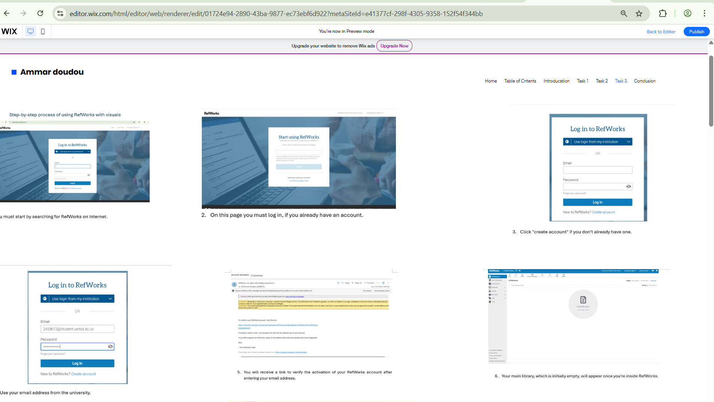

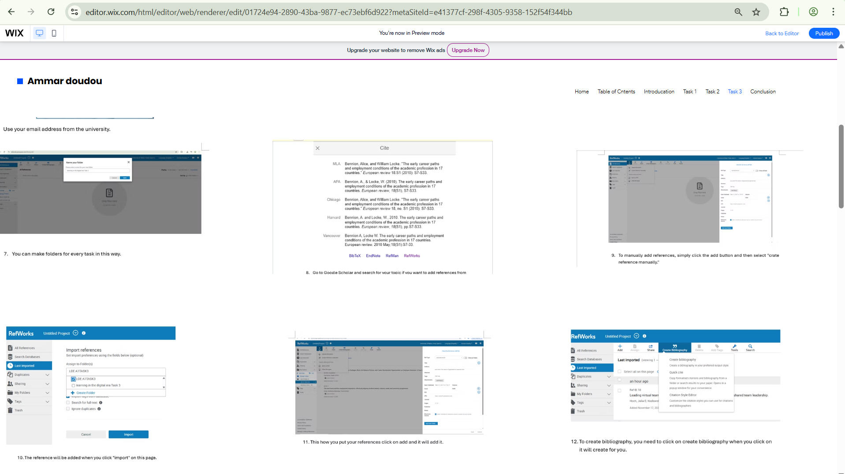

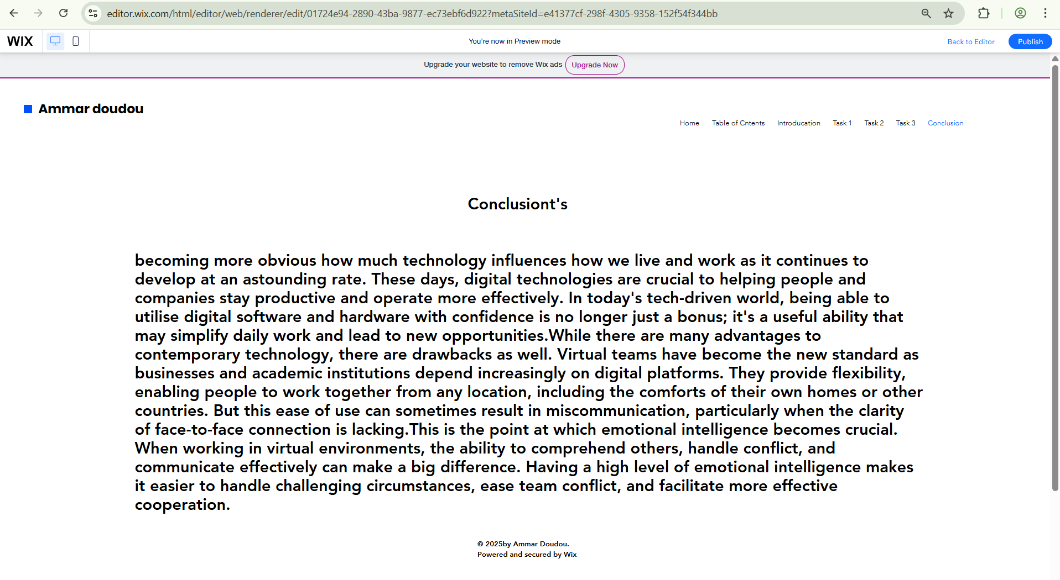

Task 4 (b): Illustrative Review of E-Portfolio tool Selection
I used Wix to develop my e-portfolio for my Learning in the Digital Era program, primarily because my instructor recommended it. I was pleasantly surprised by how easy the entire procedure was once I got going. Building a website feels less like a technical process and more like a creative one because to the Wix interface's simplicity and the way the options are arranged. It was simple for me to add sections, change layouts, and customise the appearance to fit my vision. What I value most about Wix is that it allows students to publish their work for free, making it much easier to create an e-portfolio that looks professional.

Conclusion

t's becoming more obvious how much technology influences how we live and work as it continues to develop at an astounding rate. These days, digital technologies are crucial to helping people and companies stay productive and operate more effectively. In today's tech-driven world, being able to utilise digital software and hardware with confidence is no longer just a bonus; it's a useful ability that may simplify daily work and lead to new opportunities.
While there are many advantages to contemporary technology, there are drawbacks as well. Virtual teams have become the new standard as businesses and academic institutions depend increasingly on digital platforms. They provide flexibility, enabling people to work together from any location, including the comforts of their own homes or other countries. But this ease of use can sometimes result in miscommunication, particularly when the clarity of face-to-face connection is lacking.
This is the point at which emotional intelligence becomes crucial. When working in virtual environments, the ability to comprehend others, handle conflict, and communicate effectively can make a big difference. Having a high level of emotional intelligence makes it easier to handle challenging circumstances, ease team conflict, and facilitate more effective cooperation.

References

Task 1 References:

Bibliography

[1] | A. a. H. Higson, “Graduate employability,” Graduate employability, 2008.
[2] | S. G. Ismail, “Essential Study Skills,” The Complete Guide to Success at University, London: Routledg, 2019.
[3] | A. C. Edmondson, “Psychological safety and learning behaviour in work teams,” Administrative Science Quarterly,, 1999..
[4] | R. Tracy, “Time Management for Students: Strategies for Success, New York,” Academic Press, 2017.
[5] | J. Ng, “Digital literacy in the modern workplace,” Journal of Education and Technology, 2021.

Task 3 References: ￼
BENNION, A. and LOCKE, W., 2010. The early career paths and employment conditions of the academic profession in 17 countries. European review, 18(S1), pp. S7–S33.
HOCH, J.E. and KOZLOWSKI, S.W., 2014. Leading virtual teams: Hierarchical leadership, structural supports, and shared team leadership. Journal of applied psychology, 99(3), pp. 390.
POWELL, A., PICCOLI, G. and IVES, B., 2004. Virtual teams: a review of current literature and directions for future research. ACM SIGMIS Database: the DATABASE for Advances in Information Systems, 35(1), pp. 6–36.
RAGHURAM, S., HILL, N.S., GIBBS, J.L. and MARUPING, L.M., 2019. Virtual work: Bridging research clusters. Academy of Management Annals, 13(1), pp. 308–341.
SINGH, A. and BLESSINGER, P., 2024. The new future and the employment imperative: effectively aligning student interest, industry needs and university programmes. Journal of Applied Research in Higher Education, 16(2), pp. 469–482.
SUPRAYITNO, D., 2024. Assessing the Effect of Compensation Packages, Work-Life Balance Policies, and Career Development Opportunities on Employee Retention: A Case Study of MSME Employee. International Journal of Business, Law, and Education, 5(2), pp. 1592–1561.

