Student Name: | Cristina Stici
Student Number | 1814630
Module No: | BMSK4003
Module Title | Digital Skills and Research methods
Lecturer | Balendran Kandasamy
Title | Early childhood education

Contents
Abstract 3
Introduction 3
Literature review 4
Benefits of early childhood education 5
Primary Research 5
Methodology 5
Conclusion 9
Recommendations 10
References 11

Abstract
Early childhood education is a fundamental aspect of a child’s growth. The quality of early childhood affects the child’s intellectual and social development. There are short term and long-term benefits of high-quality education at a young age. The main objective of early childhood learning is to prepare a child for formal learning. It equips them with developmental skills that are refined as they continue to grow and study. some of the skills that are acquired include learning, emotional and cognitive aspects. The study tries to uncover ways in which early childhood learning contributes to the growth of individuals.

Introduction
The world is continuously becoming a global and those that are born today determine the future. The experiences gained during early childhood build on the cognitive systems of individuals and helps them to reach their potentials (Cannella, 1997). However, most of the children do not get to reach their potential because of the barriers that they experience during their early years. Research by Young,2007 suggests that up to 219million children in developing countries do not get to reach their maximum developmental potential. Those growing in harsh conditions lack stimulation, good nutrition and health, and poverty. It impacts their lives negatively. In the United Kingdom, however, most of the population has access to quality education. However, it is still questionable if the education that is given during the early years of life has a positive impact on a child’s life.
This paper seeks to find out the current quality of early childhood education in London and its influence on a child’s growth and development. It utilizes academic resources or research that has already been conducted to build upon the Literature review. The data that is presented in the paper is also based on the research findings, from multiple sources.

What are the benefits of quality early childhood education?

Literature review
Besides the extensive research that has been conducted on early childhood education, there is increased attention on the European Union member states. The gender disparity that was previously there is constantly closing and more women have career aspirations. Societies have become very diverse in terms of linguistic and cultural terms. Formal childcare outside the home is very important (Morrison, 2007). The financial crisis that is currently there has caused the governments to spend much less on early childcare and more on the higher levels of education.
Unlike K-12 educational system that was developed where a big majority of the students attend schools that are funded by the local municipalities, on the other hand, early childhood education, has been identified to be a diverse form of the education system, from its funding to the curriculum (Bredekamp, 1997). As a result of the presence of a diverse system of delivery of this form of education, there exists a large number of changes in what can be identified as the curriculum and assessment of the students in the early childhood education setting.
In the recent past, there has been a push to reduce the educational sphere from the K-12 level pushing it into the early childhood educational setting (Berk, 1995). The aim of this is to create relatively concrete curriculum standards for young students. The idea of this is also to attract funds from the local, state and in other instances federal governments. The standards also have to be understood and how they will affect the level of education for the students (Dahlberg, 2004). The low standard of early childhood education has been identified to affect the curriculum of the K-12 students and their assessment processes. It is therefore essential for the relevant stakeholders to review the curriculum and come up with an improved funding system that will ensure quality is not compromised.

Benefits of early childhood education
According to research, the preschool children perform best when they receive care from their parents, peers and when they are not pressured to learn. Specialists argue that involving them in activities such as play helps to improve their social skills. Children generally relate well with other children than with adults. The school environment helps the children to share and cooperate.
Early childhood education also helps the children to perform well in school. It helps to build a strong foundation mentally, physically and socially. Good education at an early age improves the performance of the children. Some programs have already been established to ensure social development. Children have better attention spans when they are taught at an early age. As they grow, they get to experience new environments and get new friends that help them to grow intellectually. They can maintain a balance between listening and talking and to participate in groups.
Generally, children, that receive quality early childhood education are confident and they are curious about new things. They can face the challenges that come their way which in turn builds resilience. Early childhood education promotes talents and they grow up as all-rounded individuals who contribute positively to society.

Primary Research

Methodology

Data collection
Qualitative data collection methods were applied for the research. This research will utilize already recorded data to gather information regarding the subject from credible sources. The data collected will then be analyzed in-depth and an analysis of the recorded data provided. Recommendations regarding the study will follow after the conclusion of the conducted study.
Data collection tools
The main method of data collection was through academic sources such as journals and articles that have information about early childhood education. Recorded research and books will be utilized as well in sourcing information regarding the study.
Analysis
Early childhood education is recorded as the education a child goes through between birth and age 8. The neurons in a Childs's brain majorly develop between the date of birth and 3 years old. This thus means that the knowledge a child acquires between birth and age 8 is very critical. This shapes the Childs learning abilities and future developments. Early childhood education is a strong determinant of a Childs future. The graph below represents how language experiences are influenced by income of the family;
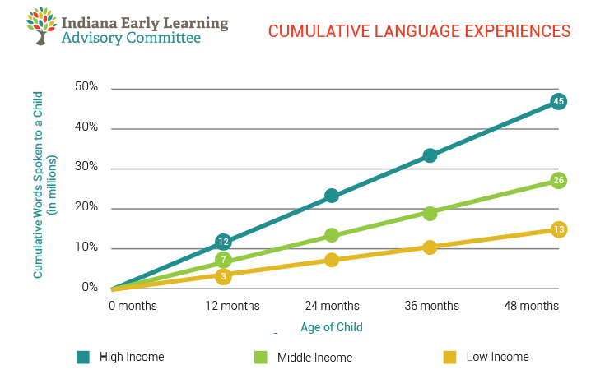

According to the data from this study, when love and affection are shown to a child in preschool education it goes a long way in improving the Childs social skills. Experts argue that it is important to involve children in activities such as playing. Exposing the children to interact with other children improves their social skills. This is because children relate easily to other children compared to how they relate to adults. This, therefore, means that schools help children learn to interact and cooperate with others. Child poverty is also rampant in many countries as evidenced in the graph below;
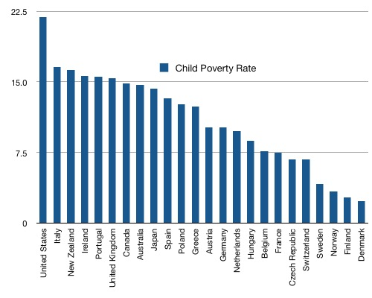
The United Kingdom is faced with the problem of child poverty. There are programs that have been established to encourage early childhood education.
Early childhood education plays a big role in improving Childs performance. Recorded research has it that children develop better attention spans if their education begins early. The programs developed and adopted in schools are meant to enable proper mental growth for children. The additional exposure to new environments and the different challenges they face among their peers gives them intellectual growth. The graph below represents the vocabulary growth of children;
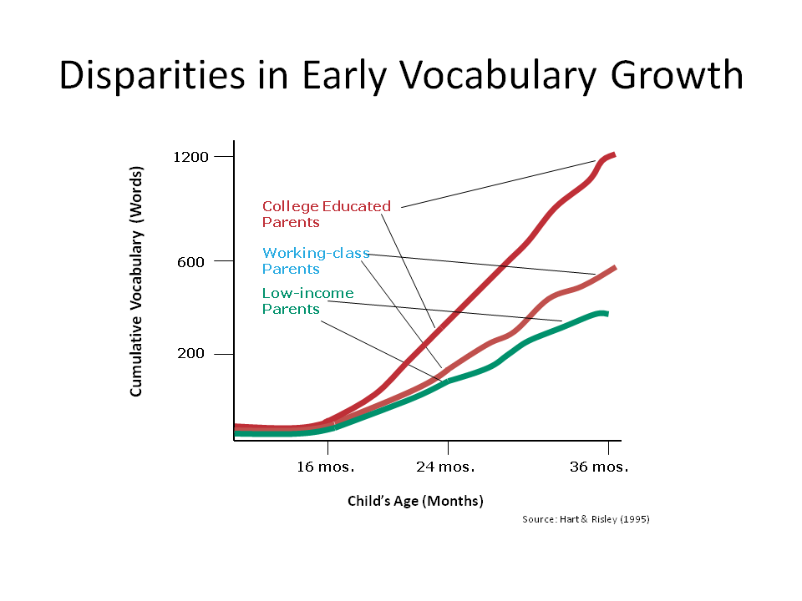
The quality of early childhood education that a child receives shapes the future of that child. As stated earlier the early age of a child is very critical in their mental development. Therefore exposing a child well-programmed early education is a way of ensuring the child has intellectual skills as well as proper ability to overcome challenges, have proper social skills and develop on their talents.
Every human has the needs required for every stage in their development. In this study, Mar slows hierarchy of needs was found effective in highlighting these needs. According to this hierarchy, a growing child needs food security, physical security, and emotional affection in order to have a healthy psychological development. This hierarchy emphasizes that Childs basic needs must be met in order to ensure healthy mental and physical growth.

Conclusion
In order for effective childhood education, the task should not be solidly left for schooling education systems. The parents play a big role in ensuring childhood education is effective positively. The environment the child is exposed to during childhood should be loving, supportive and educational. If the parents expose the child to traumatic childhood it damages a Childs mental well being and in the long run, the Childs physical health will be affected as well. The type of environment a parent exposes the child to should be one that will have a positive impact on the child rather than the opposite. Thus it is key to ensure that children are exposed to a healthy environment that enables their early educational growth to take form positively and effectively.
Given that early childhood education forms the base of a Childs future, the system of education that the child is subjected to should be of good quality. This means that exposing the child to quality childhood education is a way of ensuring the child has a successful future. This study indicates that there are researchers who have taken steps towards creating a guideline aiding in understanding and planning for the needs of a Childs early education.
Early childhood education should be considered as a key factor in a Childs development process. Proper early education results to a child who has well developed intellectual abilities have proper social skills, better approach towards challenges and as a healthy mental state. The education systems adopted in early education institutions aim in ensuring proper mental growth of children.

Recommendations
The importance of early childhood education cannot be emphasized enough. It is very key for every parent to prioritize early childhood education. The government would play a significant role in establishing measures to ensure that parents are educated on the importance of early childhood education and the means of how to go about it. The schools as well would play a significant role in reaching out to society and enlightening the public on the significance of early childhood education. Collective efforts in ensuring parents understand the need for early childhood education is a big step towards securing a successful future for the children. Understanding the importance of early childhood education will enable parents and the schools to maximize on ensuring that the young children receive the best quality of early education thus enabling them to acquire proper mental, physical and psychological development.
It is also very critical that parents understand the role they should play in the early education of a child. The Childs early education does not solidly depend on the schooling systems but falls on the hands of the parents as well. The parent is majorly responsible for providing a home environment that is mentally, physically and emotionally safe for the child. The parent is as well responsible for the moral upbringing of the child. What a parent exposes a child to greatly affect the Childs psychological well being which eventually affects their general well being. Therefore it is important for the parents to be educated on how best to support their child's early education at home. This parental awareness can be possible via governmental seminar initiatives and measures taken by schools to arrange forums specially designed to educate parents on the importance of early childhood education. Complete initiatives from parents and schools combined is a solid measure headed towards guiding proper mental, physical and emotional growth of children.

References
Cannella, G. S. (1997). Deconstructing Early Childhood Education: Social Justice and Revolution. Rethinking Childhood, Volume 2. Peter Lang Publishing, Inc., 275 Seventh Avenue, New York, NY 10001.
Berk, L. E., & Winsler, A. (1995). Scaffolding Children's Learning: Vygotsky and Early Childhood Education. NAEYC Research into Practice Series. Volume 7. National Association for the Education of Young Children, 1509 16th Street, NW, Washington, DC 20036-1426 (NAEYC catalog# 146)..
Bredekamp, S., & Copple, C. (1997). Developmentally Appropriate Practice in Early Childhood Programs.(Revised Edition). National Association for the Education of Young Children, 1509 16th Street, NW, Washington, DC 20036-1426.
Dahlberg, G., & Moss, P. (2004). Ethics and politics in early childhood education. Routledge.
Morrison, G. S. (2007). Early childhood education today. Kevin M. Davis.

