Dissertation: LCBB6000

Topic: An exploration of various impacts of culture in an Organisational Environment. A case study Hilton Hotel

Student Name: Carmen Elena Albert
Student ID: 2014069
Supervisor: Dr Gregory Cowan

Abstract

This research has introduced the subject of the chosen topic and explained a background overview of the organisational culture and the Hilton Hotels. It has discussed the research rationale, the aims and objectives of the research and the questions that are addressed in this research. It has explained the importance of the study of the chosen topic. The researcher has reviewed several works of literature in context with the organisational environment and the impact of culture on it in the companies of the hospitality industry like Hilton Hotels. Different research methods have described in this research. The research methodology that is associated with the concept of pragmatic research philosophy, deductive research approach, exploratory design, mixed method and acrostic anal study design. The researcher has followed specific data collection and analysis techniques. The data interpretation of the primary data collected through the survey, and secondary data through thematic analysis. Ten questions on the context of the study for primary research and ten articles for qualitative literature have been integrated for data analysis. Based on the discussion, it could be said that organisational culture could create a huge role organisational environment of the hospitality organisation Hilton. Lastly, the research has concluded by provided some measures of recommendations and explained the scope of the future study provided by this topic of research.

Table of Contents
Chapter 01: Introduction 5
1.1: Research Background 5
1.2: Research Rationale 5
1.3: Aim and Objective 8
1.4: Research Question 8
1.5: Significance of the Study 8
Chapter 02: Literature Review 9
2.1: Introduction 9
2.2: Concept of corporation culture in the industry of hospitality 9
2.3: Effects of organisational culture in the hospitality industry on productivity and employee motivation 9
2.4: Impacts of organisation culture on the brand images of the hospitality Industry 10
2.5: Changes that can be implemented in the corporate culture of the hospitality industry to increase productivity 11
2.6: Theoretical Framework 11
2.7: Conceptual Framework 15
2.8: Literature Gap 15
2.9: Summary 15
Chapter 03: Research Methodology 15
3.1 Research philosophy 16
3.2 Research approach 16
3.3 Research design 17
3.4 Research strategy 17
3.5 Sampling strategy 17
3.6 Data collection 18
3.7 Data analysis 18
3.8 Research timeline 18
3.9 Time Horizon 19
3.10 Ethical consideration 19
Chapter 04: Data Analysis and Discussion 20
4.1: Primary research 20
4.2: Secondary research 29
Chapter 5: Conclusion 37
5.1: Conclusion 37
5.2: Scope for the future study 38
References 39

Chapter 01: Introduction

1.1: Research Background
The organisational environment largely influences the operations carried out in the hotels. The organisational environment is the collection of surrounding institutions or factors that affect the organisation. Hilton Hotels is an international brand that has several operations in the country of the United Kingdom (Zeng, 2021). They are famous for their luxurious and aesthetically pleasing services that are available at premium rates to their customers. It has well-decorated rooms and excellent customer service that is highly satisfying to those who have experienced it. The idea of luxury gives the brand image a sense of exceptional quality and exclusivity. It is one of the top companies among the luxurious hotels in the hospitality industry of the world. The company first started to provide its services to their customers in 1925 with Conrad Hilton as its founder (Hilton, 2023). The first hotel was initially started in Texas in the US but they soon started to expand and have started to their holdings on a worldwide, large, global scale. In the year, 1943, it was the pioneer of coast-to-coast hotel chains in the US (Hilton, 2023). In 1848, it introduced the multi-hotel reservations system in the US (Hilton, 2023). By 2009, Hilton Hotels had already expanded to 76 countries which made it an internationally reputed brand in the hospitality industry (Hilton, 2023). In the year 2007, the Hilton Hotels were sold out to other people in the corporate world and were separated from the Hilton family bloodline who founded and developed it and no longer had any rights or connections to it. The company, however, has maintained a positive work or organisational culture among its workforce which has contributed towards the growth and expansion of the company bringing it large amounts of profits.

1.2: Research Rationale
The company or organisation of Hilton Hotels has been doing quite well in the recent few years. They have gone through rapid growth and developments in their operations and income revenues. The Covid-19 virus caused a global pandemic in 2020 throughout the world and affected all industries on a worldwide, global scale (Iacobucci, 2020). This caused most companies all around the world to shut down their operations due to the global lockdown that was imposed on every country to control the spread of the virus. My living experience during the pandemic, in Hilton London Metropole was that the hotel was open and have guests who were waiting for a charter fly to go home. Also NHS staff, doctors and nurses was our guest during the lockdown.
The hospitality industry was considered to be an industry of luxury and not necessity and therefore, it was decided that they too, would have to shut down their operations and close the business temporarily. The companies had to halt all of the operations and services that they provided towards their customers to shut down their business until further notice (Bryson, 2021). The Hilton Hotels, too had to be shut down and they faced severe losses due to this operation and had to remain in this position without earning any profits for almost a whole year (Grandey et al., 2021). However, when the company opened their services to their customers again, it also procured its losses and started to regain its revenues and profits, slowly but steadily (Ntounis et al., 2022). They also started to gain large amounts of profits which was only made possible through the hardships and organised work culture of their employees who made it possible. It has implemented various ideas of diversity and commits to the support of all communities which attracts a larger and wider range of customers towards its services (Hilton News, 2023)
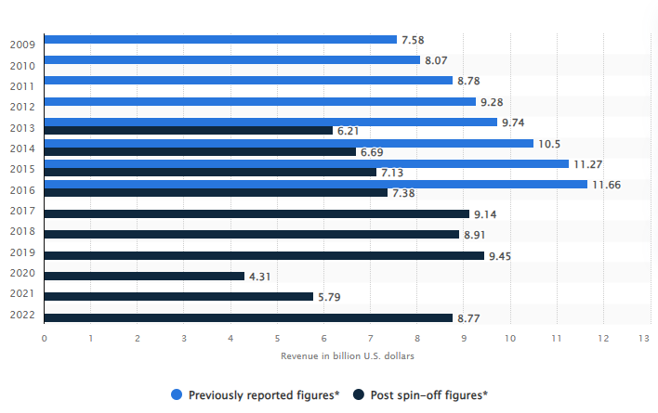Figure 1: The Revenue collected by the Hilton Hotels
(Source: Hilton, 2023)
The graph above shows the revenue collected by Hilton Hotels in the years 2009 to 2022. This depicts their recovery from the losses they faced during the pandemic and the steady level of income that their employees are bringing to the company. This has only been plausible for the employees and their work or corporate culture in the organisation which has motivated them to do better work that is both profitable and productive.
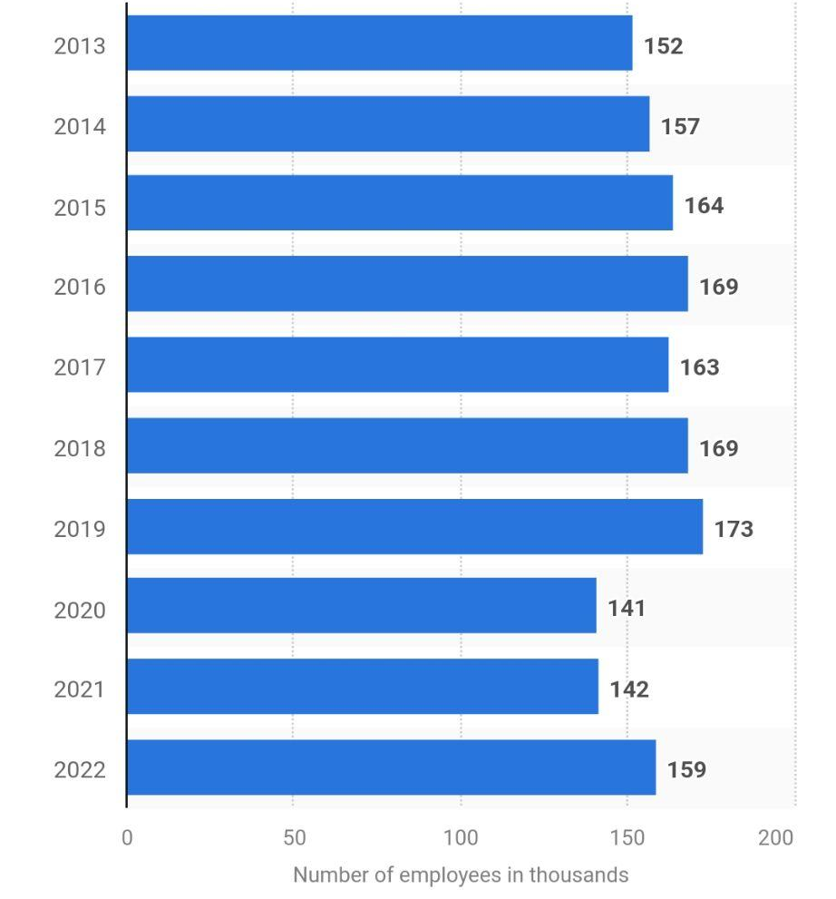
Figure 2: The number of employees working in Hilton Hotels
(Source: Statista, 2022)
The image above shows the large number of employees recruited by Hilton Hotels. Its positive work environment attracts more employees to work under the company and dedicate themselves towards its betterment.
Therefore, this research will focus on the study of the organisational culture of the employees working for Hilton Hotels. It will examine their behaviours and the management patterns implemented by the company on their staff to make them motivated and productive. It is important to study the working environment of Hilton Hotels and the positivity that they inculcate in their employees so that they can produce high-yielding results.

1.3: Aim and Objective
Aim
This research aims to study the influence of the organisational culture of the employees on the operations of the Hilton Hotel and the results it produces.
Objectives
- To observe the way that the cultural etiquette, manners, principles and frame of mind affect the Hilton Hotel.
- To examine the effect felt by the productivity and employee condition in the Hilton Hotel through the implementation of organisational culture.
- To analyse the influence of corporate culture on the Hilton Hotel’s brand image.
- To understand any changes required in employees and manager behaviour for effective organisational culture in Hilton Hotel.

1.4: Research Question
- How does the culture of the employees in terms of their etiquette, principles, frame of mind and manners affect the Hilton Hotel?
- How has the organisation's culture affected the productivity and employee motivation of the Hilton Hotel?
- How does the organisational culture affect the brand image of the Hilton Hotel?
- What changes that can be applicated to the employees or workers of the Hilton Hotel to manage their work behaviour and attitude for effective organisational culture?

1.5: Significance of the Study
The organisational culture plays a critical part in the productivity of an organisation or company. The culture of a corporation largely affects the employees, both experienced and new. The employees would feel more comfortable and confident in their work with a faster productivity rate if they are provided with a positive working environment. Therefore, it is important to study the organisational culture and how it influences an international hotel brand like the Hilton Hotel and observe it. Through this observation, it will be possible to analyse more ways to improve the productivity of a company for a better working environment and culture.

Chapter 02: Literature Review

2.1: Introduction
The scholastic writing that affirms, validates or represents the comprehension of an institutional literature based on a particular topic is called a literature review. It includes an analysis of the content of a piece of literature. This is also why it is known as a literature review instead of a literature report. This research has used literature reviews for the collection or gathering of appropriate and valid sources for a better understanding of the chosen topic. It has been used to examine the strong and weak points existing in the topic of concern which is to validate the need for organisational culture in the hospitality industry.

2.2: Concept of corporation culture in the industry of hospitality
According to Carvalho et al. (2019), the concept of corporate culture is an important aspect of the operation of a company. It determines the environment of work in an organisation or a company and also determines its growth and development. Organisational culture has several variations of implementation that can be used by the organisations according to their own choices and potential goals, aims or beliefs. The etiquette, manners and behaviour of an employee affect the people around them and influence the environment of the workplace. If the principles or values of a person align with the company’s aims and intentions, then they would feel more at ease in working with the company. The frame of mind of a person needs to fit with the conditions in the workplace so that they can comfortably work there without mental blockages or hindrances. Therefore, organisational culture is important in organisations for the smooth running of its operations with people that are adaptable or like-minded and can easily cooperate with each other and strive towards productivity. Deserti and Rizzo (2019) have discussed the limitations of the use of organisational cultures in a corporation, The organisational culture does not only come with benefits but also has several drawbacks that affect the company or the corporation.

2.3: Effects of organisational culture in the hospitality industry on productivity and employee motivation
As examined by Radojevic et al. (2019), almost every organisation tries to implement an organisational culture among their staff or their employees. This helps in the work of an organised workforce that eases communications while limiting misunderstanding or miscommunication as much as possible. This ensures a smooth flow of data or instructions among the members of the organisations. The use of these cultures in the hospitality industry helps the employees of this industry and its organisations get accustomed to the environment of the workforce in simpler terms. In the companies of industry of hospitality, the employees have to keep in check with the constant bookings and services that are asked for by their customers in swift actions without any trouble, miscommunication or delay. Customer service is highly affected by their behaviour towards them. Their adaptability towards the kind of client that they are serving builds up the satisfaction of the customers according to their experiences with the services provided and the interactions of the staff. The organisational culture helps build this productivity by preparing the employees for these situations and implementing polite and hospitable traits in them. However, Koc (2019) reviewed the conditions of the hospitality industry and the companies or organisations working under it and observed the failures of customer service. In several organisations, the company failed to implement the use of proper organisational culture or maintain it. This often ended up building toxic working environments that caused conflicts among the employees which resulted in poor customer service and productivity of work.

2.4: Impacts of organisation culture on the brand images of the hospitality Industry
In the discussion of Cabral and Jabbour (2020), the importance of green or sustainability and its implementation by companies of various industries were validated. According to Loučanová et al. (2021), various companies adopted a sustainable image for a better image for their company. This helped build customer and employee faith in the company and its image. Green organisational cultures promote the idea of sustainability among their employees who are well-educated about the green effects of the planet and help in its improvement and betterment. They are conscious about their actions and strategize company plans that are beneficial for both the company as well as the human society and the planet. This also helps the image of a company’s brand in the industry and among the public. They feel reassured about the company’s existence for the greater good and also feel more inclined to use their services to promote the idea of a green world. As was argued by Arjona-Fuentes (2019), there were various implications of this organisational culture among the workforce of the hospitality industry. The pretences of presentation of a company’s image among its employees often ended up being dissatisfying and disappointing. The members of the organisation became resistant to working for a company by betraying the ideals of virtue and that affected their work performance and job satisfaction. This also proved to be an issue for the customers who faced terrible service or felt the discomfort of the employees and began having a biased opinion about the organisation or the corporation. This resulted in a poor brand image due to the negative environment threatening the organisational culture.

2.5: Changes that can be implemented in the corporate culture of the hospitality industry to increase productivity
As explored by Hidalgo-Peñate et al. (2022), the understanding of an organisational culture produces better results and improvements among the employees. When they know the organisation better and are synchronised within the same or similar culture with their co-workers, it helps them be in tune with the operations of the organisation and work better. A better management system where the employees and their instructions work on the same page with transparency and good understanding is made plausible by the implementation of organisational in a corporation. Cabral and Jabbour (2020) discussed the effects of a cultural understanding of the employees about the company’s workings and operations. The employees understand the company from a different perspective and have a feeling or a sense of belonging when working in this cultural system of beliefs that they are inclined to attune to themselves. As discussed by Oriade et al. (2021), sustainability awareness among employees has helped build motivation among them, increasing the rate of productivity. However, they also mentioned the failure of these methods that could be used in certain areas, especially in developing countries or countries which are experiencing financial or economic troubles. The hospitality industry of the UK is suffering from the inflation that has been going on in the country. Ioannidis et al. (2021) discussed the performance of the hospitality businesses in the UK and the implementation of the sustainability organisational culture in them. The performances might have gained productivity but this could also often lead to burdensome work or highly-priced tools of work. This can cause issues in several businesses in the hospitality industry, especially if they are not already well-established.

2.6: Theoretical Framework

Edgar Schein’s Culture Theory
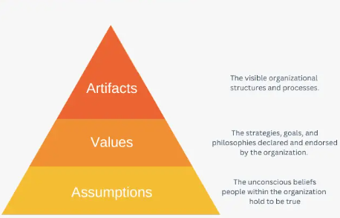
Figure 3: Edgar Schein’s Culture Framework Model
(Source: Schein, 2019)
The framework model of Edgar Schein’s theory based itself on the assumption that the development of culture occurs with the flow of time as the members or workers in an organisation subconsciously deal or adapt themselves to a situation of internal or external crisis (Schein, 2019). If they succeed in this development, then they extend this to their successors working in the organisation. The first part or level of this model represents the qualities or aspects of an organisation in the hospitality industry that can be easily communicated with the employees or individuals who are referred to as the artifacts (Schein, 2019). The second level includes the cultural values of the employees in the organisation (Schein, 2019). The final level includes the potential values of the employees based on assumptions (Schein, 2019).

Cultural Web Model Theory
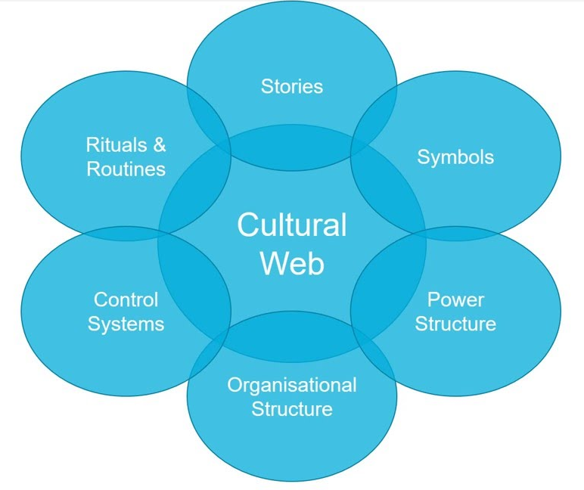
Figure 4: Cultural Web Model
(Source: Oh and Han, 2020)
The cultural web model was developed by Johnson and Scholes who called it the “paradigm” of the workplace or its environment (Oh and Han, 2020). It consists of six elements or factors which are the stories, rituals and routines, symbols, control systems, power structure, and organisational structure. These are the factors that affect the workforce environment of the hospitality industry and its companies. This theory or model was formed to experiment with an organisation’s working environment and project influences in them.

Maslow’s Theory of Hierarchical Needs
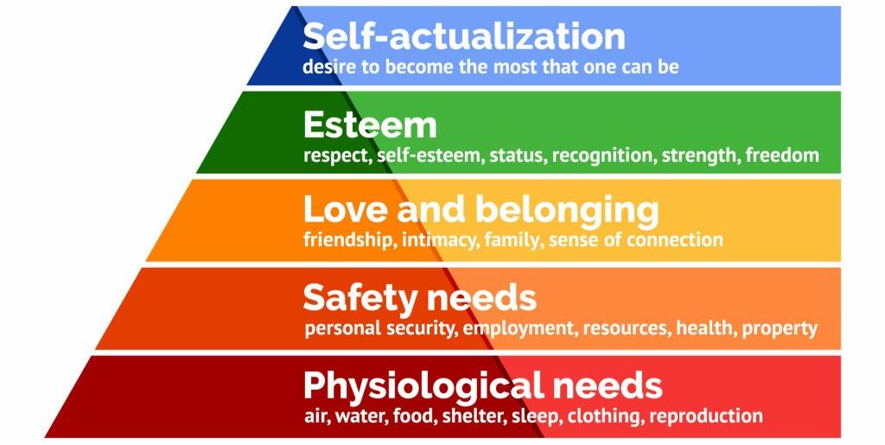
Figure 5: Maslow’s Theory
(Source: Noltemeyer et al., 2021)
Maslow has proposed a theory of needs in order with its hierarchy that can help improve the satisfaction felt by an employee working at the hospitality sector and increase their sense of motivation (Noltemeyer et al., 2021). The need for self-actualisation is important for an individual. Masllow’s theory explores these needs of self-actualisation, self-esteem, love or feeling of belongingness, safety requirements, and physiological and basic, necessity needs that are required to satisfy a person.

2.7: Conceptual Framework
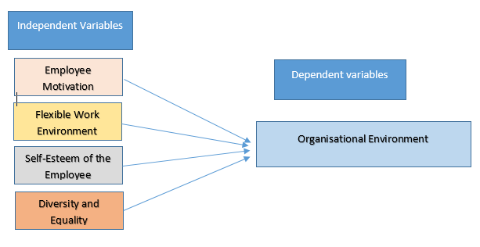
Figure 6: Conceptual Framework
(Source: Created Carmen Albert)

2.8: Literature Gap
The existing works of literature did not focus on certain aspects of this topic like the potential trends or alternatives of the organisational culture. This situation has created a literature gap in this study.

2.9: Summary
The chapter has properly reviewed the works of literature in context with the research subject and pointed out the valid points required to make its argument. The implementation of the discussed topics can influence the productivity of an organisation in the hospitality industry to help its growth and development.

Chapter 03: Research Methodology
Research methodology refers to the techniques and strategies that are used for conducting specific research related to any topic. In this context, Saunders’ research onion would be incorporated. 6 major stages in this particular research onion initiate sequential order for conducting the methodological interpretation of a research study (Saunders et al., 2019). The research methodology for the specific research is as follows.
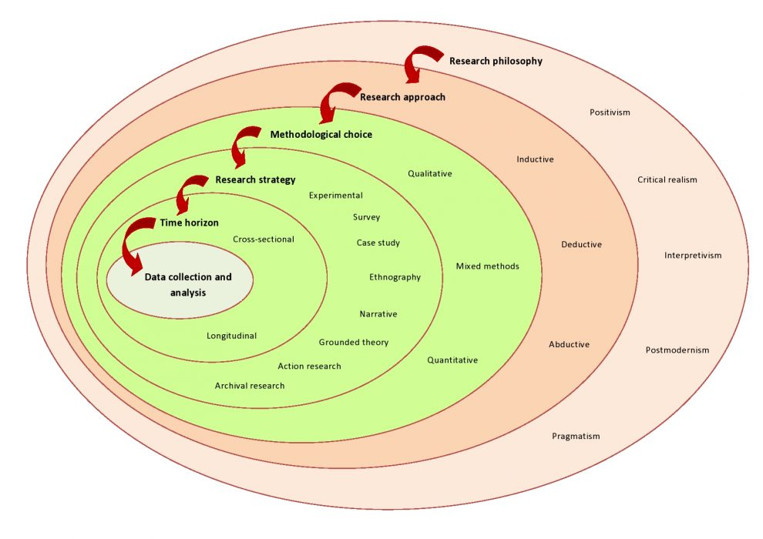
Figure 7: Saunders research onion
(Source: Saunders et al., 2019)

3.1 Research philosophy
Research philosophy is meant by the intrinsic belief about the process of collecting necessary data and interpreting them regarding a specific phenomenon. Among various types of research philosophy, pragmatism philosophy would be incorporated in this particular research. It refers to a flexible approach that is associated with the operational decision taken by the researcher to identify the most suitable process to find the overall outcome (Adams et al., 2014). The reason for incorporating pragmatism philosophy is that it would help in identifying an innovative and dynamic outcome regarding the questions of the research.

3.2 Research approach
A research approach is the procedure that helps the researcher to gather analyse and interpret the necessary data for establishing an outcome. There are three types of research approaches and among these, the deductive research approach would be selected for this particular research. The concept of the deductive approach incorporates theoretical interpretation, hypothesis testing and generalisation of the overall observation made in the report. The reason for choosing the deductive approach is that it would help in identifying the best possible outcome of the research based on both qualitative and quantitative data (D O’Gorman and Mclntosh, 2015).

3.3 Research design
Research Design refers to the establishment of the most important tools and techniques and creates a blueprint for the conduction of the overall study. There are four kinds of research designs and among them is the exploratory research design would be selected. Exploratory research design incorporates both quantitative and qualitative phases of data collection and interprets them as per the need of the research outcome (Duignan, 2016). The reason for choosing exploratory Research Design is that it would help in combining both primary and secondary data for identifying the most suitable outcome of the research.

3.4 Research strategy
Research strategy refers to the sequential approaches of methodological choice that integrated a range of components that would help in identifying the perspective of the research based on a specific idea. There are three types of research strategies and among them, the mixed method would be incorporated. The mixed method combines both the qualitative and the quantitative data in a single study to find out the solution to the research problem (Denscombe, 2012). The quantitative research would be associated with primary, original and raw data collection while the qualitative research would associate with the gathering and evaluation of secondary information or data with the help of thematic analysis.

3.5 Sampling strategy
The sampling strategy refers to the series of operations used for identifying the potential participant who would be associated with the process of collecting necessary data (Blaxter et al., 2010). In the context of primary quantitative analysis, 50 employees with the help of a random sampling strategy will be selected who are associated with the Hilton Hotel. On the other hand, for secondary qualitative analysis, journals would be adopted from the platform of Google Scholar that were published after 2016 in the English language.

3.6 Data collection
Data Collection is the process of gathering or assembling mandatory data from specific sources that would be used in the overall research process (Patton, 2014). In the context of Data Collection, the primary data will be collected from the target participants with the help of the survey question here that consist of 10 questions based on the topic. In the context of secondary data, the journal should be identified with the help of the Google Scholar platform.

3.7 Data analysis
Data analysis is the procedure of analysing and interpreting the necessary information with the use of proper tools and techniques (Adams et al., 2007). The primary data in this research would be collected with the help of the Excel sheet and for analysis, pie charts, histograms and bar graphs will be considered. In the context of secondary data analysis, a thematic analysis will be considered that would incorporate four themes focusing on the overall interpretation of the data.

3.8 Research timeline
The next table explain my schedule from the date, when I developing the research idea and till final review and submission date for my hospitality project.
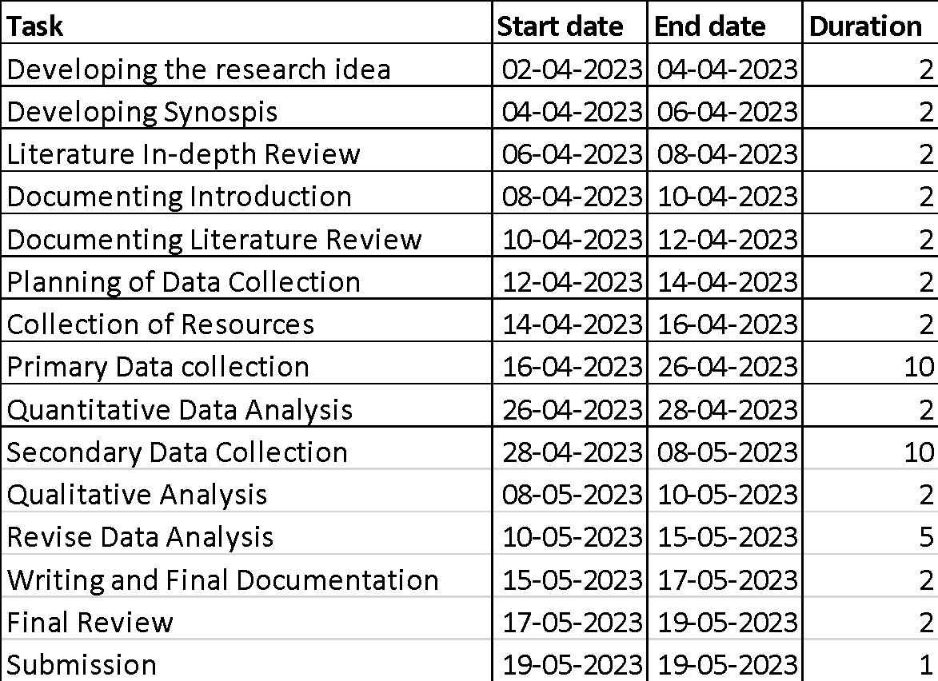
Figure 8: Research Timeline
Source: (Created by Carmen Albert)
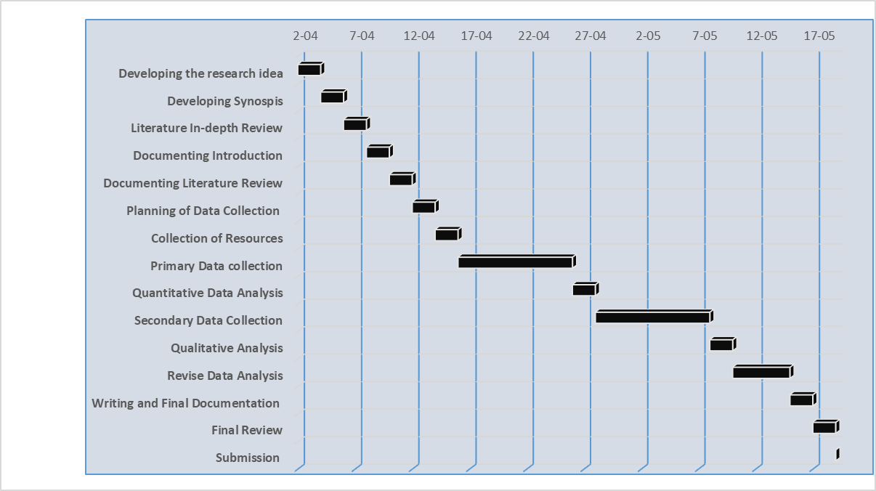
Figure 9: Gantt Chart
Source: (Created by Carmen Albert)

3.9 Time Horizon
The time horizon in research refers to the overall frame that involves the collection of data related to a specific time point. There are two types of time horizons that are to be associated with research and among them, a cross-sectional study would be selected for this particular research. A cross-sectional study refers to a short-term study that involves the collection of necessary data at a specific point in time rather than identifying repeated data collection (Curwin et al., 2013). In the context of both primary and secondary data in this particular research, it would be collected one time only from the target sources.

3.10 Ethical consideration
Ethical considerations refer to the principles that are associated with the overall research and guide the researcher in times of improving the ethical and moral validity of the outcome (Murray and Hughes, 2008). In the context of the primary research, the selection of the participant would be associated with specific consent for collecting and using their opinions and perspectives for conducting the research. The personal and demographic identification of the research sample would be protected according to the regulation of GDPR 2018 till the end of the research, and after the completion of the research, the personal information would be destroyed. In the context of secondary data, the journals that would be collected from the Google Scholar platform would affect referenced and in-texted to avoid any kind of plagiarism and other academic misconduct.

Chapter 04: Data Analysis and Discussion

4.1: Primary research
- How would you read the level of cultural diversity within your organisation Hilton Hotel?
Options | Total participants | Answer | Percentage
Very high | 50 | 22 | 44%
High | 50 | 10 | 20%
Moderate | 50 | 11 | 22%
Low | 50 | 7 | 14%
Table 1: Level of cultural diversity
(Source: Created by Carmen Albert)
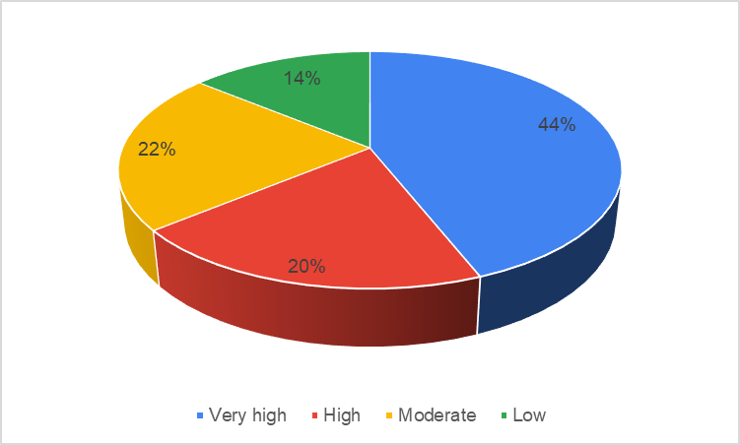
Figure 10: Level of cultural diversity
(Source: Created by Carmen Albert)
Discussion: The concept of cultural diversity in Hilton hotel is significantly high. The question , for the majority of participants was clear ,and the answers reflect, this thing.
- Do you think that cultural diversity in your organisation could contribute to workplace creativity and innovation?
Options | Total participants | Answer | Percentage
Yes | 50 | 21 | 42%
Moderately | 50 | 12 | 24%
No | 50 | 8 | 16%
Maybe | 50 | 9 | 18%
Table2: Impact of culture on workplace creativity and innovation
(Source: Created by Carmen Albert)
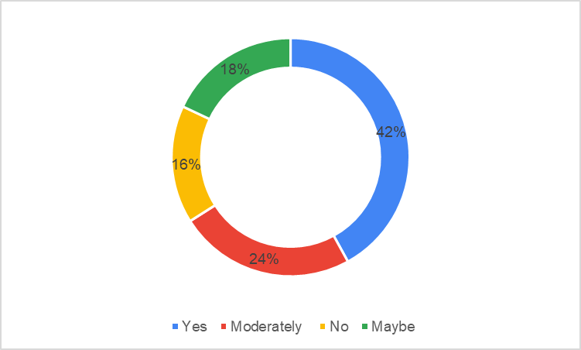
Figure 11: Impact of culture on workplace creativity and innovation
(Source: Created by Carmen Albert)
Discussion: most of the employees in the Hilton hotel states that affective cultural diversity could create a positive impact on creativity and innovation.
- Have you ever felt that you could not collaborate or communicate with your colleagues due to cultural differences?
Options | Total participants | Answer | Percentage
Yes | 50 | 6 | 12%
No | 50 | 17 | 34%
Frequently | 50 | 11 | 22%
Sometimes | 50 | 16 | 32%
Table 3: Prevalence of cultural difference
(Source: Created by Carmen Albert)
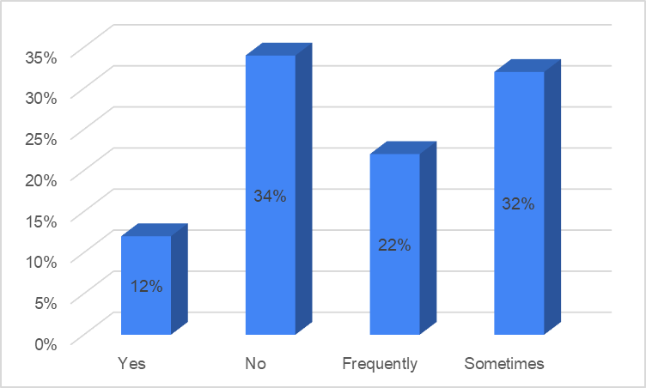
Figure 12: Prevalence of cultural difference
(Source: Created by Carmen Albert)
Discussion: the preference of cultural difference does not hinder the communication and collaboration in Hilton hotel, although more than 32% employees are associated with the prevalence of miscommunication.
- Do you think that organisational culture can play a positive role in employee motivation?
Options | Total participants | Answer | Percentage
Yes | 50 | 25 | 50%
No | 50 | 13 | 26%
Not sure | 50 | 12 | 24%
Table 4: Organisational culture on employee motivation
(Source: Created by the learner)
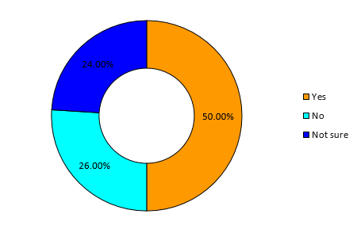
Figure 13: Organisational culture on employee motivation
(Source: Created by Carmen Albert
Discussion: half of the employees in Hilton hotel considered organisational culture as an effective tool for employee motivation.
- Have you ever witnessed any personal conflict in your organisation as a result of a misunderstanding?
Options | Total participants | Answer | Percentage
Yes | 50 | 19 | 38%
No | 50 | 9 | 18%
Frequently | 50 | 8 | 16%
Sometimes | 50 | 14 | 28%
Table 5: personal conflict for misunderstanding
(Source: Created by Carmen Albert)
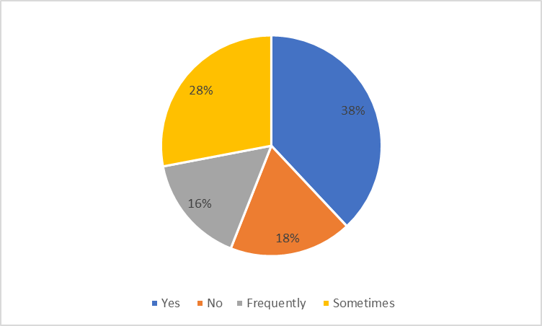
Figure 14: personal conflict for misunderstanding
(Source: Created by Carmen Albert)
Discussion: Although Hilton hotel effectively cultural diversity, there are several issues of personal conflicts due to misunderstanding between employees. Personally,I have experienced misunderstanding between housekeeping department and maintenance department, because of miscommunication, and different procedure to follow.
- What are your thoughts about all the employees in Hilton Hotel that are associated with promoting inclusivity and cultural sensitivity towards guests and others?
Options | Total participants | Answer | Percentage
Yes | 50 | 27 | 54%
No | 50 | 5 | 10%
Not sure | 50 | 18 | 36%
Table 6: promoting inclusivity and cultural sensitivity
(Source: Created by Carmen Albert)
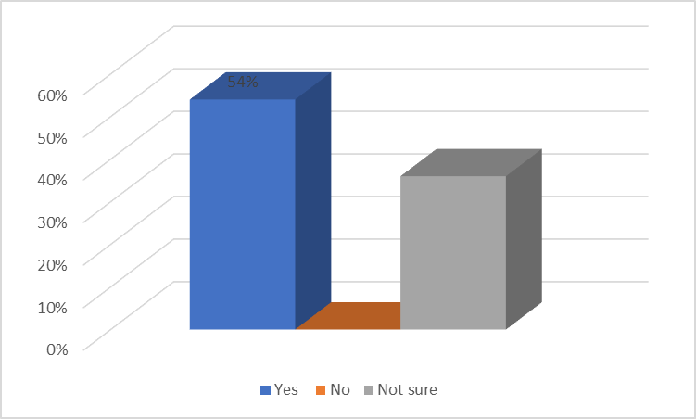
Figure 15: promoting inclusivity and cultural sensitivity
(Source: Created by Carmen Albert)
Discussion: more than half of the employees in the organisation think that their workplace effectively promotes inclusivity and sensitivity towards culture of other population associated with the organisation.
- Are there any policies for cultural differences and inclusivity in your organisation that you are aware of?
Options | Total participants | Answer | Percentage
Yes | 50 | 11 | 22%
No | 50 | 13 | 26%
Not sure | 50 | 26 | 52%
Table 7: policies for cultural differences and inclusivity
(Source: Created by Carmen Albert
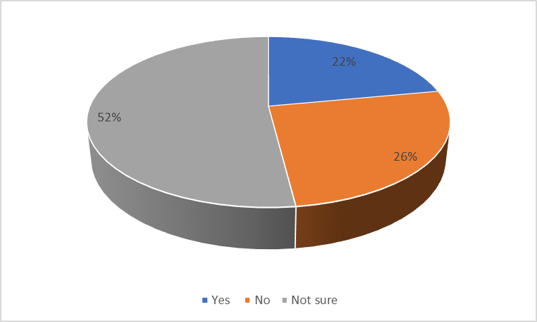
Figure 16: policies for cultural differences and inclusivity
(Source: Created by Carmen Albert)
Discussion: the organisation has initiated a range of policies for mitigating cultural differences between the employees, however there is a prevalent gap of training and employee knowledge.
- Do you think that the organisational culture could influence the decision-making system of higher authority?
Options | Total participants | Answer | Percentage
Yes | 50 | 29 | 58%
No | 50 | 5 | 10%
Not sure | 50 | 16 | 32%
Table 8: Influence of culture on decision-making
(Source: Created by Carmen Albert)
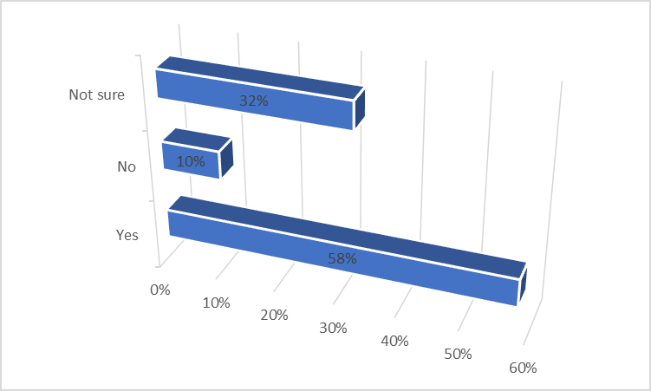
Figure 17: Influence of culture on decision-making
(Source: Created by Carmen Albert
Discussion: around 58% of the employees which is the most of the employee base has initiated the influence of culture on the decision-making scenario of higher authority of the organisation.
- Do you think that your workplace is associated with cultural diversity in the market that it is operating?
Options | Total participants | Answer | Percentage
Yes | 50 | 11 | 22%
No | 50 | 15 | 30%
Not sure | 50 | 24 | 48%
Table 9: cultural diversity in the market
(Source: Created by Carmen Albert)
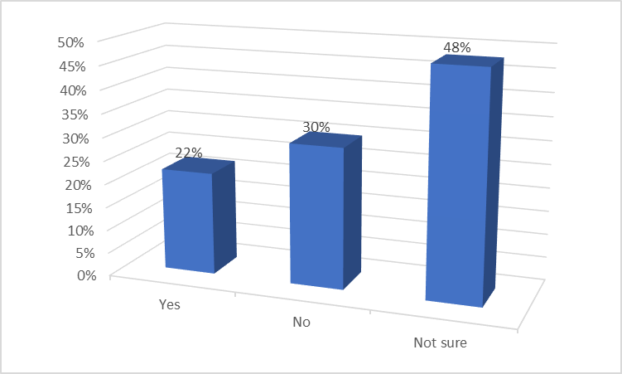
Figure 18: cultural diversity in the market
(Source: Created by Carmen Albert)
Discussion: the implementation of cultural diversity by Hilton is vague as per the opinion of most of the employees.
- To what extent do you think that the brand image of Hilton Hotel reflects the commitment towards cultural diversity in the Global market?
Options | Total participants | Answer | Percentage
High | 50 | 20 | 40%
Significantly | 50 | 12 | 24%
Moderately | 50 | 13 | 26%
Low | 50 | 5 | 10%
Table 10: Reflection on the commitment towards cultural diversity
(Source: Created by Carmen Albert)
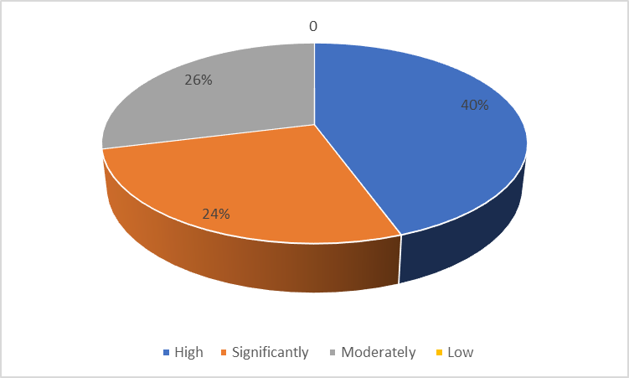
Figure 19: Reflection on the commitment towards cultural diversity
(Source: Created by Carmen Albert)
Discussion: most of the employees has stated that the commitment and reflection of the organisation towards cultural integration is significantly higher.

4.2: Secondary research
For secondary research I checked in literature reviews and found the related articles in Google Scholar.
Theme one: Importance of cultural attitude in the hospitality industry
Employee turnover is a critical problem in the setting of the hospitality industry across the globe as well as in the UK. According to this particular article, the culture of the organisation initiated a huge impact in the context of the excessive turnover rate of the employees. The absence of a collaborative and communicative culture within a hierarchical organisation creates extensive pressure in the context of employee wellbeing and motivation that creates a negative impact on the context of employee execution and productivity of the organisation. Voluntary turnover is the most common form of employee turnover that is significantly affected by the context of organisational culture (Park and Min, 2020).
The second article focuses on the concept of the orientation of new employees within an organisation for reducing the overall concept of role conflict and ambiguity. In an organisational culture, inter-group behaviour creates a huge role in the context of role confusion and ambiguity among new employees. On the other hand, the attitudinal and behavioural consequences are also highly dependent on the role of culture related to task performance within the hospitality organisation. The inactive implementation of culture reduces the operational activity and disrupts the service procedures which could also create a severe impact on the coordinating mechanism of the employees (Raub et al., 2021).
The third journal specifies the concept of corporate social responsibility and organisational culture on the repetition of the organisation as well as its performance. As per this journal, customer satisfaction is one of the most important contents that creates a huge impact on the context of organisational culture. Similarly, cross-cultural competence and crisis management and conflict resolution is also important part of the process of navigating difference and implementation of positive brand image and reputation. In other words, cultural attitude is crucial in the context of the hospitality industry as it helps in shaping the introduction with the customers improving job satisfaction and effective crisis management (González Rodríguez et al., 2019).
Theme two: Impact of organisational culture on the productivity and performance of the employees
The fourth article is associated with the concept of entrepreneurial orientation as well as an organisational culture that could create an impact on aspects like job satisfaction employee performance and organisational commitment. The finding also states that there is a positive, optimistic and important impact of organisational dedication to job contentment on employee results which is thoroughly driven by an entrepreneurial mindset and organisational culture. However, the leadership strategy of the organisation exhibits a direct impact on the performance of the employees which is also shaped by the establishment of the culture by the internal and external employees of the organisation. Similarly, the positive work environment and effective employee engagement are also closely connected to the context of organisational culture and the activity of the employees (Soomro and Shah, 2019).
The fifth article is associated with the concept of employee performance, human resource flexibility organisational culture, competence of the employees and job satisfaction. Based on this particular article it can be said that the ability of the individual to perform a certain work, the interest and effort by the employees to the work and the support initiated by the higher authority of the organisation are associated with the establishment of proper employee performance. Similarly, these three components are also the major factors that establish the concept of organisational culture. Alternatively, the adaptation of culture could positively influence the performance of the employees which is formed by the combined effort of the HRM system and the structure of the organisation (Sabuhari et al., 2020).
Effective digitisation has caused a huge impact in the context of organisational culture. This particular aspect has more importantly shown in the section on communication and collaboration systems that breaks down geographical boundaries, flexibility and the remote working system improved agility and speed of operations, and data prevent decision-making system. This particular journal has stated that the supervision criteria through digitalisation have also been effectively changed and it could be identified as a transformative impact on organisational culture. The digital landscape is more associated with a specific type of culture that is internally related to change management continuous learning intercultural collaboration and implementation of ethical values and beliefs (Martinez Caro et al., 2020).
Theme three: Interrelationship between organisational culture and brand image in hospitality industry
The concept of brand image in an organisation is highly dependent on the factors like overall performance of the organisation, the capability of the organisation to meet the demand of the customers and the situational cognition of the brand. The concept of sustainability is also a driving factor for brand image and brand reputation, especially in the hospitality industry. For example, the organisation Hilton Hotel has effectively incorporated digitised value and sustainability practices in their organisational culture and it has created a huge positive impact in the context of the globe. However, in the context of developing countries, the reputation of global brands like Hilton is also highly associated with social sustainability that games attention from multi-faceted industries and customer orientation (Oriade et al., 2021).
The concept of corporate brand strategy is a renowned term in the context of multinational industries that helps in creating an effective distinction between the products and services of other existing brands. The corporate personality is an effective component that helps in establishing the experience impressions feelings knowledge and belief of the individual employees working in an organisation. The promise of the organisation towards the employees, corporate experience and employee relationship management is the most significant part of corporate brand strategy that creates a huge impact on the culture of the organisation (Foroudi, 2020).
Theme four: Probable strategies to improve the workplace attitude and behaviours in the hospitality industry
Employee turnover is a significant problem in the context of the hospitality industry and this particular journal states that there is a huge impact on the context of organisational culture. Positive employee satisfaction and the maintenance of the overall well-being of the employees could create a huge impact in the context of this particular service-oriented industry. The role of human resource could also be incorporated in this particular section (Ghani et al., 2022).
The tenth journal is associated with talent management strategies that establish a huge impact in the context of organisational culture. These talent management strategies would be incorporated with the activities like onboarding and orientation of the employees, performance management by providing specific guidance and instruction to the task, providing equal opportunities for learning and development, and incorporation of proper positive and negative reinforcement strategies. The concept of leadership, as well as the establishment of transparent communication and efficient employee recognition, could also be a potential strategy for improving organisational culture (Marinakou. and Giousmpasoglou, 2019).

Chapter 5: Conclusion

5.1: Conclusion
The implementation of organisational culture can have several positive influences on the companies of the hospitality industry. This study has helped examine and analyse the importance and validity of these ideas and concepts. Hilton Hotels have been using organisational culture to develop their employment potential and produce better and more productive results for their company.
This study has conducted a survey to determine the current condition of Hilton Hotels in the hospitality industry of the UK market. Both primary and secondary research has been conducted to determine the need and importance of an organisational culture. The Hilton Hotels have been doing fairly well in the past few years. Despite the losses it faced when it was hit with an instruction of shutting down for almost a whole year and the number of losses it faced, it was still a company that stood forth instead of toppling down. Their use of organisation culture to motivate their employees to provide better customer service and experience is what makes them one of the top companies in the UK as well as worldwide.
The organisational culture is beneficial for both the employees and the workforce as well as the customers. Through its implementation the employees can experience a positive mood in their workplace which can help- them develop and hone their skills. They will also be more confident in their work and be able to be more comfortable. This affects the way they interact with the customers who also have a higher satisfaction rate when interacting with experienced and satisfied employees who are in a good mental or head space. It is indeed so that organisational culture has several drawbacks or limitations that it can face. However, the number of merits or advantages it has due to its implementation is enough to compensate for its limitations.

5.2: Scope for the future study
This research will prove to be beneficial for Hilton Hotels. This study will help them understand and evaluate the factors affecting their company in the hospitality industry and the factors of motivation and determination in their employees. This can help them reach a higher ground and morale of their workers. This study will help them, treat their employees better as well as provide them with a better working environment to boost productivity and sales and improve the reputation of the company in future.

References
Adams, J., Khan, H.T. and Raeside, R., 2014. Research methods for business and social science students. SAGE Publications India.
Adams, J., Khan, H.T., Raeside, R. and White, D.I., 2007. Research methods for graduate business and social science students. SAGE publications India.
Arjona-Fuentes, J.M., Ariza-Montes, A., Han, H. and Law, R., 2019. Silent threat of presenteeism in the hospitality industry: Examining individual, organisational and physical/mental health factors. International Journal of Hospitality Management, 82, pp.191-198.
Blaxter, L., Hughes, C. and Tight, M., 2010. EBOOK: How to Research. McGraw-Hill Education (UK).
Bryson, J.R., 2021. COVID-19 And The Immediate And Longer-Term Impacts On The Retail And Hospitality Industries: Dark Stores And Turnover-Based Rental Models,‘. Living With Pandemics: Places, People & Policy.
Cabral, C. and Jabbour, C.J.C., 2020. Understanding the human side of green hospitality management. International Journal of Hospitality Management, 88, p.102389.
Carvalho, A.M., Sampaio, P., Rebentisch, E., Carvalho, J.Á. and Saraiva, P., 2019. Operational excellence, organisational culture and agility: the missing link?. Total Quality Management & Business Excellence, 30(13-14), pp.1495-1514.
Curwin, J., Slater, R. and Eadson, D., 2013. Ouantitative Methods For Business Decisions.
D O'Gorman, K. and MacIntosh, R., 2015. Research methods for business and management: A guide to writing your dissertation. Goodfellow Publishers Ltd.
Denscombe, M., 2012. Research proposals: A practical guide: A practical guide. McGraw-Hill Education (UK).
Deserti, A. and Rizzo, F., 2019. Embedding Design in the Organisational Culture: Challenges and Perspectives. Design Culture Objects and Approaches, pp.39-51.
Duignan, J., 2016. A dictionary of business research methods. Oxford University Press.
Foroudi, P., 2020. Corporate brand strategy: drivers and outcomes of hotel industry’s brand orientation. International Journal of Hospitality Management, 88, p.102519.
Ghani, B., Zada, M., Memon, K.R., Ullah, R., Khattak, A., Han, H., Ariza-Montes, A. and Araya-Castillo, L., 2022. Challenges and strategies for employee retention in the hospitality industry: A review. Sustainability, 14(5), p.2885.
González-Rodríguez, M.R., Martín-Samper, R.C., Köseoglu, M.A. and Okumus, F., 2019. Hotels’ corporate social responsibility practices, organizational culture, firm reputation, and performance. Journal of sustainable tourism, 27(3), pp.398-419.
Grandey, A.A., Sayre, G.M. and French, K.A., 2021. “A blessing and a curse”: Work loss during coronavirus lockdown on short-term health changes via threat and recovery. Journal of occupational health psychology, 26(4), p.261.
Hidalgo-Peñate, A., Nieves, J. and Padrón-Robaina, V., 2022. The influence of employees’ knowledge, organisational commitment, and culture on the innovativeness of vocational educational. Knowledge Management Research & Practice, 20(5), pp.755-766.
Hilton News, 2023. Hilton Hotels & Resorts Latest News. [online] Available at: https://stories.hilton.com/brands/hilton-hotels [Accessed 4 Jul. 2023].
Hilton, 2023. The Story of Hilton. [online] Available at: https://stories.hilton.com/history [Accessed 4 Jul. 2023].
Iacobucci, G., 2020. Covid-19: UK lockdown is “crucial” to saving lives, say doctors and scientists.
Ioannidis, A., Chalvatzis, K.J., Leonidou, L.C. and Feng, Z., 2021. Applying the reduce, reuse, and recycle principle in the hospitality sector: Its antecedents and performance implications. Business Strategy and the Environment, 30(7), pp.3394-3410.
Koc, E., 2019. Service failures and recovery in hospitality and tourism: A review of literature and recommendations for future research. Journal of Hospitality Marketing & Management, 28(5), pp.513-537.
Loučanová, E., Šupín, M., Čorejová, T., Repková-Štofková, K., Šupínová, M., Štofková, Z. and Olšiaková, M., 2021. Sustainability and branding: An integrated perspective of eco-innovation and brand. Sustainability, 13(2), p.732.
Marinakou, E. and Giousmpasoglou, C., 2019. Talent management and retention strategies in luxury hotels: evidence from four countries. International Journal of Contemporary Hospitality Management, 31(10), pp.3855-3878.
Martínez-Caro, E., Cegarra-Navarro, J.G. and Alfonso-Ruiz, F.J., 2020. Digital technologies and firm performance: The role of digital organisational culture. Technological Forecasting and Social Change, 154, p.119962.
Murray, N. and Hughes, G., 2008. Writing up your university assignments and research projects: A practical handbook. McGraw-Hill Education (UK).
Noltemeyer, A., James, A.G., Bush, K., Bergen, D., Barrios, V. and Patton, J., 2021. The relationship between deficiency needs and growth needs: The continuing investigation of Maslow’s theory. Child & Youth Services, 42(1), pp.24-42.
Ntounis, N., Parker, C., Skinner, H., Steadman, C. and Warnaby, G., 2022. Tourism and Hospitality industry resilience during the Covid-19 pandemic: Evidence from England. Current Issues in Tourism, 25(1), pp.46-59.
Oh, S.Y. and Han, H.S., 2020. Facilitating organisational learning activities: Types of organisational culture and their influence on organisational learning and performance. Knowledge Management Research & Practice, 18(1), pp.1-15.
Oriade, A., Osinaike, A., Aduhene, K. and Wang, Y., 2021. Sustainability awareness, management practices and organisational culture in hotels: Evidence from developing countries. International Journal of Hospitality Management, 92, p.102699.
Park, J. and Min, H.K., 2020. Turnover intention in the hospitality industry: A meta-analysis. International Journal of Hospitality Management, 90, p.102599.
Patton, M.Q., 2014. Qualitative research & evaluation methods: Integrating theory and practice. Sage publications.
Radojevic, T., Stanisic, N. and Stanic, N., 2019. The culture of hospitality: From anecdote to evidence. Annals of Tourism Research, 79, p.102789.
Raub, S., Borzillo, S., Perretten, G. and Schmitt, A., 2021. New employee orientation, role-related stressors and conflict at work: Consequences for work attitudes and performance of hospitality employees. International journal of hospitality management, 94, p.102857.
Sabuhari, R., Sudiro, A., Irawanto, D. and Rahayu, M., 2020. The effects of human resource flexibility, employee competency, organizational culture adaptation and job satisfaction on employee performance. Management Science Letters, 10(8), pp.1775-1786.
Saunders, M.N.K., Lewis, P. and Thornhill, A., 2019. Research methods for business students (8. utg., s. XXVI, 741).
Schein, E.H., 2019. A new era for culture, change, and leadership. MIT Sloan management review, 60(4), pp.52-58.
Soomro, B.A. and Shah, N., 2019. Determining the impact of entrepreneurial orientation and organizational culture on job satisfaction, organizational commitment, and employee’s performance. South Asian Journal of Business Studies, 8(3), pp.266-282.
Statista, 2022. Hilton: employee numbers 2013-2018 | Statista. [online] Available at: https://www.statista.com/statistics/297758/number-of-hilton-worldwide-employees/ [Accessed 4 Jul. 2023].
Zeng, L., 2021. Analysis of Hilton Worldwide Hotel Group’s Transnational Operation Strategy. Academic Journal of Business & Management, 3(11), pp.20-27.

