

Student’s Name | Catalina Medina
Student’s ID: | 1806473
Module Number: | BMSW5104
Module Title: | Managing Projects In The Organization
Lecture’s Name: | Dr. Kenny Tang

INTRODUCTION 3
Project Management 3
1 Project risk management 3
Risk management plan 4
Risk Identification 5
Risk register 5
Risk analysis 6
Risk response 6
Mitigate risks, control risk 6
2. Project Time management 7
Plan schedule management 7
Plan Activities 8
Plan resources 8
Milestone 8
Monitoring and control 9
3. Plan, Monitor and control 9
Project Implementation 9
Gantt chart 11
Kotter’s 8 step change management model 11
Greiner’s Life Cycle Model 13
Stakeholder identification 15
Stakeholder mapping 16
Personal Development 17
Gibbs reflection cycle: 17
Belbin theory – 18
Personal development plan 20
CONCLUSION 21
REFERENCES 22

INTRODUCTION
Project management is the practice of initiating, planning, executing, controlling, and closing the work of a team to achieve specific goals and meet specific success criteria at the specified time. The primary challenge of project management is to achieve all the project goals within the given constraints.
The present report will lay emphasis on BBC worldwide that is a content company. It is the commercial subsidiary of BBC which has been headquartered in London. The vision of the company is to build a BBC brand, audiences and is also expecting financial returns. The company has been involved in building its brand reputation and is also trying to engage more consumers.
The project is based upon that firm and is making changes in the structural reorganisation from divisional to geographic lines of management. It will highlight project risk management, project time management. Report will also focus on project implementation plan. The Kotter’s change management model will also be discussed.
This will be about changes which will be implemented by BBC worldwide in order to grow and achieve their goals and objectives. The assignment will also lay emphasis the 8 Step Kotter model. It wills also reflect upon the personal development plan through Gibbs reflective model
.

Project Management

1 Project risk management
It is a process that helps minimising the potential risk in the project management. Each and every task are performed within an appropriate timer interval. So, as it can easily achieve the desirable goal and objective of the project (Lin and Huang, 2020). During project execution, BBC has identified unexpected events that directly it affects in the process, people, technology and resources which are involved in the project.
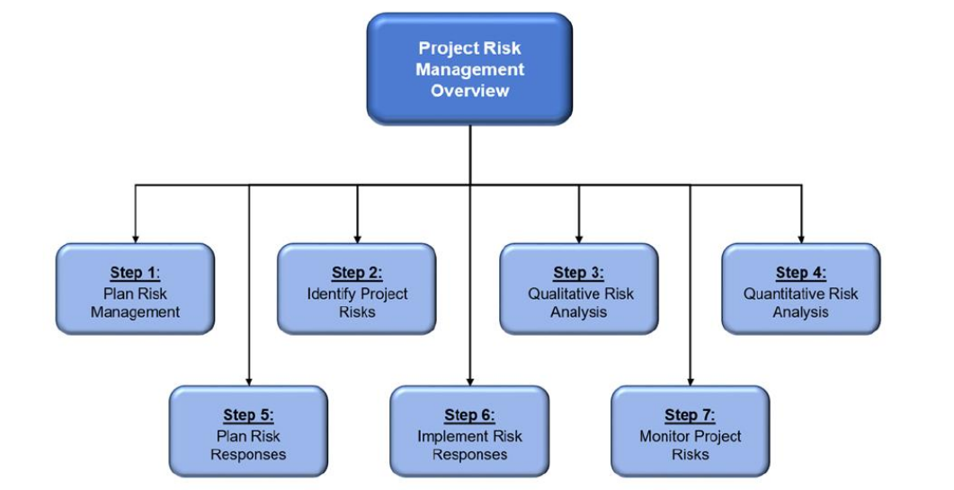
Fig.1 Project Risk Management Overview. Source by OTC
Project risk management has mainly covered different activities and processes of planning for risk identification, management. In order to analyse the project risk, response planning, monitoring and implementation on the project. However, Risk is a phenomenon that has physical, cultural, monetary, and social aspects. The consequences of risk events go far beyond the immediate physical harm to financial or physical properties, persons, or environments that influence the way a society works, and people think. (Loosemore. M,)
BBC worldwide would be unable to create the best culture and make that happen. Therefore, risk needs to be well managed to reduce the consequences of negative events. It would also increase the possibilities of positive events.

Risk management plan
An effective risk management plan requires understanding the conducive BBC worldwide risk culture. In BBC worldwide, there are large number of executive ongoing initiatives to improve how risk is managed in the BBC worldwide (Okereke, 2020). These include identifying organization’s risk management training requirement at each level. In order to update the procedure guidance for managing entire risks within an organization
The BBC worldwide has identified, implemented, initiative aimed at improving its risk management activities. However, it would be beneficial from a formal plan that clearly brings these processes together to set specific direction, priorities and scope for risk management in BBC worldwide. Afterwards, it has started to focus on the development plan which is training all international staff and took them through the workshops mainly because they needed to behave like a global company also to learn to work together. As per designed new framework that will support for HRM to handle the large number of information. Therefore, BBC worldwide project manager focuses on to identifying the risk with the help of a risk management plan. The BBC’s Management of Risk, (NAO. Review presented to the BBC governor’s Audit Committed, September 2006)

Risk Identification
It is the simplest way to plan and minimizing the chances of causing, damage to the equipment. In order to identify the sensible measure which easily control risks at workplace (Reed and Angolia, 2020). The identification of risk at BBC worldwide is by analysing the potential event that might occur, and how it affects the BBC worldwide ability. In this way, it will require for successfully implementing an effective strategy to achieve its goal and objective.
Project and operational levels are the strongest link between the objective and risk (Reed and Angolia, 2020). Sometimes, it indicates management identification of risk which is easily associated with wide range of strategies. It involves technical, financial, Environmental, Economic and social risks.
In BBC worldwide we have identified the cultural issue because many people already use traditional method to collect information or data. Sometimes, it is difficult for BBC worldwide to target the existing customers. In this way, BBC Worldwide staff would need to feel empowered and also putting more customers and audiences first and take smart risks due to design and efficient framework. BBC worldwide changing from divisional to geographic change in the content. Afterwards, they can represent the content dynamically way to a new framework design.

Risk register
It is based on the well-structure documentation that mainly capture the various risks, threats in the system. In BBC worldwide, the executive team known as (WEx), and Global leadership team (GLT) also the BBC Execute Board are responsible persons who are performing different task and also implement action mitigation to reduce risk within organization.
The risk register has been provision for containing a unique number, category, current risk assessment and description. It provides brief ideas about the risk register which include the full detail of risk. Sometimes, Provision is generally made for prevention action which help to reduce the probability of occurrence (Scott and et.al., 2020). The risk register module within project risk tracking system also integrated with another project controls. It allows for the project manager to interact with other team members, reviewing risk independently.

Risk analysis
It is the method of identifying and analyzing potential threat, issues that could affects on the business projects. The process can be done when BBC worldwide will try to avoid or mitigate risks. Risk analysis can be done into two different ways: Qualitative and Quantitative.
Qualitative analysis is based on the two-direction risk and identify the probability of occurrence along with axis (Walker, 2020). In this way, it helps for information representation of a new framework design project. BBC worldwide risk is reconfigured business from divisional to geographic lines of management. On the other hand, Quantitative is based on the numerical data which mainly gathered as per analysis in mathematic ways. BBC worldwide risk is to deliver sustainable financial returns.

Risk response
It is an important part for controlling and maintaining the entire framework within project development. It is mainly depending on the decision-making whereas multiple stakeholder deals with technical, financial risk during framework design. In BBC worldwide, risk response includes the certain steps to minimize threat during project (Reed and Angolia, 2020). Therefore, project manager ensures opportunities for minimizing the probability and its consequences.

Mitigate risks, control risk
After examining the risk, it is an essential thing to implement action mitigate for controlling consequence of risk during framework otherwise, it directly affects on the entire processing. In this way, BBC worldwide apply certain action to eliminate risk within system.
- Move away silo working, improve trust and respect, take personal accountability.
- Work together across London and the regions
- Ensure tools and resources are fit for purpose also Increase the opportunities for development.

2. Project Time management
Project time management refers as an ability to organise the plan the time spent on activities in a daily basis. BBC worldwide has been selected the time management which increases productivity and effectiveness in the new framework project development.
It can be defined as a process for identifying the different components in the project management. As per analysed. It can be a design or developed timeline, schedule to do the task in step by step manner (Reed and Angolia, 2020). The project time management needs to undergo with various activities. it includes monitoring, planning, scheduling and controlling. These always support for enhancing overall performance as well as efficiency of the project.
BBC worldwide begin its activities in October 2012, announced a structural reorganisation.
Clarifying strategy in April 2013.
Experience the Culture drive in October 2014.
The change process, Conversation with GLT September 2014.
Worldwide workshops October/November 2014. The workshops were on average three hours long
Leaders in identifying the changes, December 2014.
Change initiative 2014-2015
New office 2015.

Plan schedule management
This process is mainly carried out as a communicating schedule, maintaining and development. These activities are performed within specific time intervals. The Schedule is a term in framework design that is mainly used in different portfolio, programme. The time schedule ensures that everything must be completed on time.
BBC worldwide stared the project in October 2012 and conclude in April 2015.
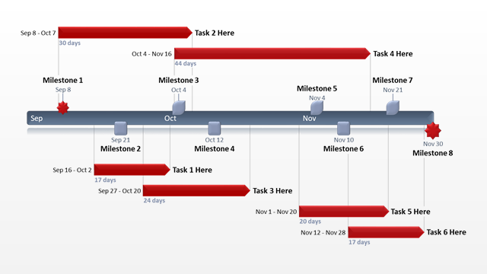
Fig. 2 Plan schedule template

Plan Activities
It is mainly includes capital expenditure, production planning, budgeting and analysis. These are important thing that need to the manage in proper manner. Afterwards, BBC account employee work as to meet the department manager expectation (Reed and Angolia, 2020). Everything is based on the realistic ways and investment on yearly basis.

Plan resources
It is based on the plan that can define how physical resources, workforce is managed and controlled. Resource planning is essential for using in framework design. in this way, it can be achieved in a suitable goal and objective (Lin and Huang, 2020) . It can be possible when planning support to examine necessary things. Therefore, it assists to accomplish the success in project development.

Milestone
In project time management, Milestone termed out as a method that start and finish project activities in step by step manner. Sometimes, it can be used as project life cycle that always support to measure progress of project and achieve goals. BBC worldwide should use this effective tool which provides facility to manage different activities in a proper manner. Furthermore, it can be used as a tool which indicates the completion of project task, commencement and define conclusion of project management plan.

Monitoring and control
It is defined as controlling and monitoring project activities that help for tracking overall performance of a project through suitable plan. This process always assists to determine a gap between process and planning (Lin and Huang, 2020). Afterwards, it can easily help in tracking, regulating the project development processes in a systematic manner.

3. Plan, Monitor and control
BBC worldwide has made an effective plan which mainly covered all necessary information related risk, threat, time schedule, resources, equipment’s. These are important things which are included in the project plan. Afterwards, As a move towards the next step while checking the availability of members, how they can participate in different planning phases (Lin and Huang, 2020). In project execution, various senior executive consult with stakeholder and monitor the activities. in this way, it becomes easier to find out the essential needs and requirements. Afterwards, it may be verifying the quality control and deliverable best framework project to client. However, a project manager always tries to monitor as well as control the entire project scope in future. On regular basis, it would be better to cross check the availability of the project while delivering the project on time.
Apart from that, a project manager of BBC worldwide needs to use tools for checking the various threats in order to monitor the activities of enterprise process and measure the risk effectively.

Project Implementation

Project implementation plan can be defined as the process in which the project is been represented in a structured format. This represents all the activities that will be going on in the firm and would be beneficial for the firm. It can also be taken as managing the base line for the project and help BBC worldwide in measuring the performance level of the firm while implementing the changes in organization (Van der Voet and Vermeeren, 2017).
This will also help organization in analysing the quality of the steps which has been taken by them during the implementation plan. The planning will also be done related to the project implementation plan. It has also been analysed that there are various steps that needs to be followed during the new experience the culture drive plan. It has also been analysed that while implementing the plan BBC worldwide also needs to analyse the risk factors related to it.
This analysis of risk will help the firm in overcoming the risk aspects. It is also necessary for the firm to analyse the budget of technological software that will be used to deliver digital innovation by company. This will assist them in achieving their goals and objectives and will also help them in growing. It has been analysed that during the time of implementation the goal of project needs to be cleared. This will help the firm in increasing the chances of gaining more success related to project. It has also been analysed from the report that project manager must also be involved in analysing the scope related to project. This will help them in analysing the success rate of project.
When project related to increase growth from international markets and closer to customers has been implemented, then the firm must be involved in providing training related to it. This will assist them in increasing morale value of workers. It has also been analysed that risk related to project must be analyse. It has also been analysed that, for this project managers need to maintain the risk register. This will assist the firm in overcoming the risk that will be faced by them during the implementation of project. It has also been analysed that the implementation methodology must also be prepared by the project manager. They also need to check-upon the Content that has been used by their competitors so that they will be able to gain competitive advantage, this will assist BBC worldwide in making their project more successful.

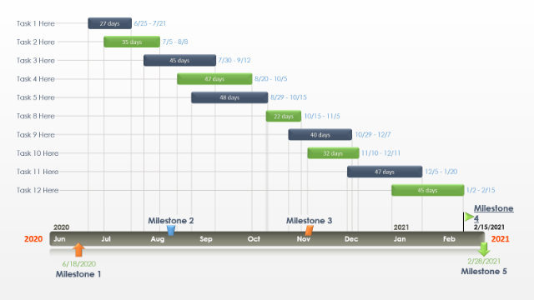

Fig.4 Gantt’s Chart

Gantt chart
The various implementation steps have been followed by BBC worldwide in this. These steps are really necessary during the time of implementation process. This will assist the firm in achieving goals and objectives. Gantt chart can be taken as the representation of all activities that will be done during the time of implementing the changes. It will be necessary for the firm to be involved in analysing the risk factors and also be involved in following the steps related to work break down structure. The project will be implemented by analysing the risk factors associated with it. This will help the firm in overcoming the risk factors.

Kotter’s 8 step change management model
Kotter’s identify various factors that can assist BBC worldwide in achieving their goals and objectives and also making their new change project successful.
Create Urgency: The first step is to analyse the opportunities related to the change management process which will be implemented by the firm. They need to see why the changes are important and also changes must be implanted by the firm on urgent basis. It has also been analysed that BBC worldwide have to adjust and seize the prospects for potential growth around the world also be in connection with what customers demand so in October 2012 it started a structural reorganisation from divisional to geographic lines of management.
Form a powerful coalition: Identifying the influential drivers of change in the organisations also the main stakeholders, asking for their support and contribution to the whole project. In this company must be involved in motivating employees about the changes that have been implemented by them. Benefits related to changes must be explained to workers (Van Rossum and et.al., 2016).
BBC worldwide has a CEO Tim Davie, Worldwide Executive Committee (WEx) the executive team are also members of Global Leadership Team (GLT) and The BBC Executive Board has responsibility for the overall supervision of BBC worldwide. The two parts of the organisation are closely aligned to move the project forward.
Create a vision for change: Organization needs to be involved in making employees understand about their vision and why the firm has been involved in asking to change something.
BBC worldwide CEO Tim Davie one of the first things he did was explain the transition purpose. Build the reputation and Brand of the BBC. Deliver sustainable financial return and Build a World-class media company. CEO role was clear about the strategy and create the best culture and make that happen. He will also make the roles and responsibilities of workers clear, so that no chaos exists.
Communicate the vision: Quite often, convey the vision transition effectively and convincingly. Link the plan to all the important things such as performance reviews, trainings, etc. BBC worldwide give to the employees new training to be the best on a global platform, few months after BBC worldwide started to experience the culture drive.
Remove obstacles: During the change management process, it has also been analysed that BBC worldwide needs to be involved in removing obstacles during the change process through workshops, survey, feedback and conference. This will help them in increasing productivity and operational efficiency of the firm.
Create short term wins: In this BBC worldwide employees help change the process based on their skills and talent, continued development, innovative and creative environment also global excellence during the time when changes have been implemented. This will assist the firm in creating employee satisfaction.
Build on the change: BBC worldwide achieve quality improvement by individual review of the success storeys and learning from those individual experiences measuring the performance level of employees.
Make it Stick: Ensure the change becomes an integral part of your organisational culture and is visible in every aspect of your organisation. This will help BBC worldwide in enhancing productivity as well as operational effectiveness of the firm (Brones, de Carvalhoand de Senzi Zancul, 2017).

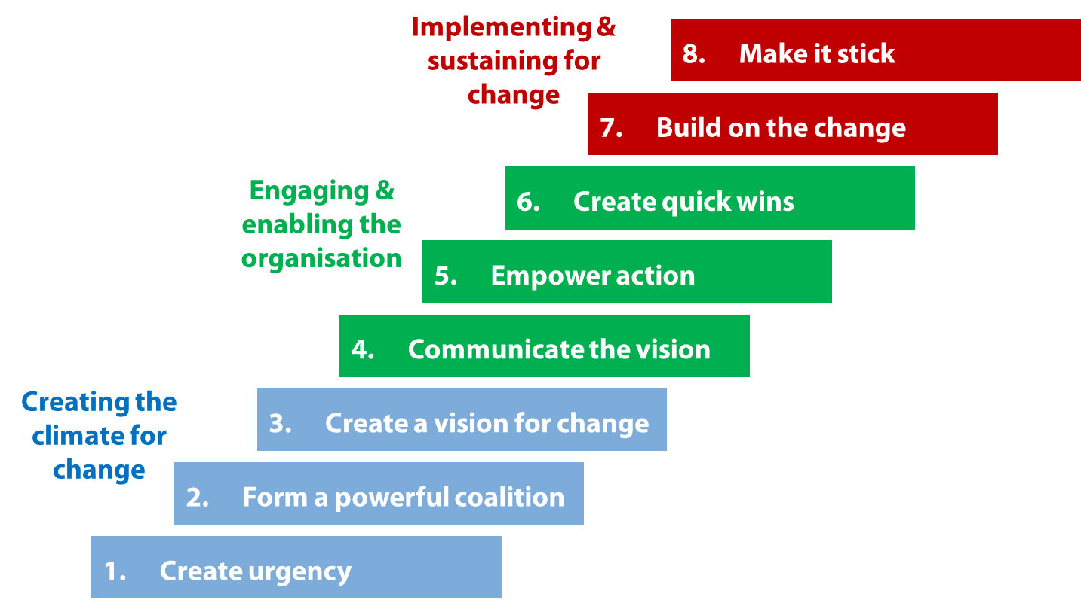

Greiner’s Life Cycle Model
Greirner’s model provides detail about the phases which the organization goes through during the time of changes which has been implemented. It shows the curve that organisation is been growing continuously and enhancing their efficiency.
Growth through creativity: Development continues in a more organised communications environment, budgets and emphasis on different tasks such as marketing and production. Incentive schemes replace stocks as a financial reward.
However, there comes a time when the products and processes become so numerous that one person does not have enough hours in the day to manage them all, In this BBC worldwide must be engaged in bringing out the most creative ideas in order to grow. This will assist them in enhancing their brand value as well as brand reputation. It will also help firm in increasing their profitability as well as sales and revenue. This will assist organisation in achieving their goals and objectives.
Growth through direction: It has also been analysed that effective communication must be used by BBC worldwide when implementing new ways of promoting the culture drive (Lewis, Cantore,and Passmore, 2016). They also need to provide guidance to each department and set their directions. This will help the company in enhancing their operational efficiency.
Growth through delegation: During the time of change management process, BBC worldwide must also be involved in delegating tasks so that every employee can become responsible during the time of changes. This will help organisation in enhancing skills and abilities of employees which is necessary for growth of company.
Growth through coordination and monitoring: It has also been analysed that BBC worldwide when implementing change must also be involved in monitoring the performance level of employees. This will assist them in analysing the gaps in their services. It will also help them in increasing the firm’s productivity.
Growth through Collaboration: According to this phase BBC worldwide can also gain growth while collaborating with any other organisation. This will assist them in expanding their business, and more market area will be gained by them. They also need to check-upon the Content that has been delivery by their competitors so that they will be able to gain competitive advantage.
Growth through extra organizational solutions: In this BBC worldwide can be involved in analysing more creative solutions to the problems when change process has been implemented. This will assist organisation in increasing their business performance and also it will be useful in achieving their goals and objectives.

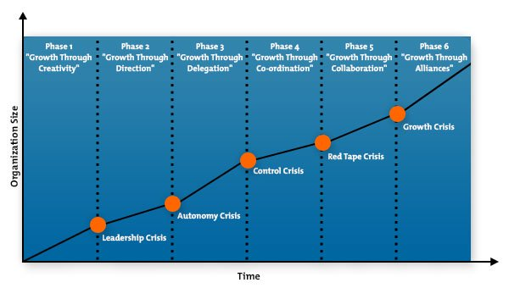

Fig.6 Greiner’s Curve

Stakeholder identification
A stakeholder is any person, party, group or organisation with an interest in the outcome of a programme or project, either as a result of having a positive or negative effect on it or as a result of having a positive or negative influence on the operation (Freeman and Reed 1983) BBC worldwide during the time of implementation process various stakeholders like CEO Tim Davie, Worldwide Executive Committee (WEx) the executive team are also members of Global Leadership Team (GLT) and The BBC Executive Board has responsibility for the overall supervision of BBC worldwide plus 1800 employees be engaged in this project in order to make it successful. It is necessary for the organisation to keep stakeholders satisfied as it will help them in achieving set goals and objectives.
The stakeholders can be identified by Clarkson (1995) describes. Internal stakeholders as 'one without whose continued involvement the company cannot exist as an ongoing concern.' These groups include primarily shareholders, workers, consumers and suppliers, and the public sector: governments and communities that provide services, control organisational operation, and impose taxes. The Organization and the primary stakeholders rely heavily on one another.
External stakeholders, such as those who influence or affect the company, or are influenced or affected by it, but do not participate in transactions with the company and are not necessary to its survival. The External stakeholder groups include competition, media, trade unions and (special interest) support groups. While these groups have no contract or authority with the company and the company is not dependent for their survival on these groups, they the cause major disruption to the business (Clarkson, 1995).
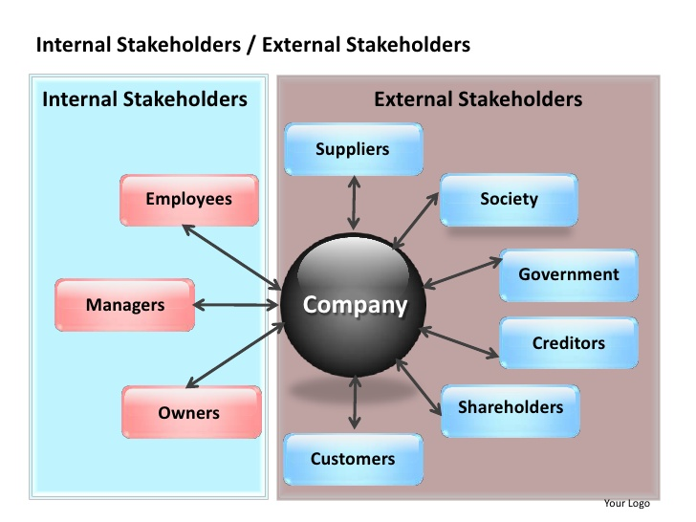

Fig.7 Stakeholders Identification source by Freeman.

Stakeholder mapping
All stakeholders are not created equal, according to Mendelow's Power-Interest Grid. They 're different in terms of their power over your project and interest. So, how do you deal with the various stakeholder categories? That is where the Framework for Stakeholders comes in. Analysis by stakeholders is so important to project success. This matrix is basically been used in order to analyse and identify our stakeholder group base on power and interest. The stakeholders need to be kept satisfied by fulfilling their needs and demands. This will help the organization in building up satisfaction level of all stakeholders (Hayes, 2018). BBC worldwide also needs to be involved in keeping the stakeholders informed about the changes that have been implemented by them. This will help them in increasing the satisfaction level of workers. This will also help them in growing and achieving objectives.
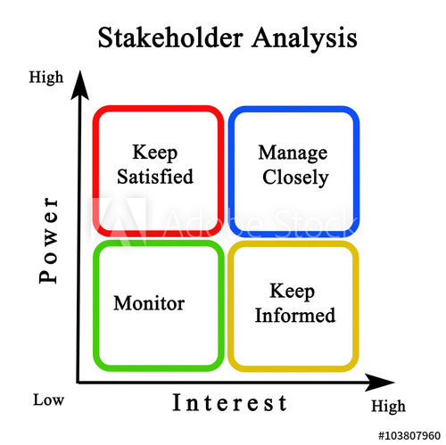
Fig.8 Stakeholders Analysis source Mendelow

Personal Development

Gibbs reflection cycle:
The cycle helps to analysing and evaluating entire situation that you going through in any experience.
Description- After many years of not studying i prepared myself to go back to university. This means that I have to organise my time as to carry on working and at the same time look after my son.
Feelings- Before taking this decision I analysed that it would be difficult but not impossible. I felt a little nervous, but I knew that the course I took on was for people like me, so I decided to relax and understand that there are people like me. Maybe not in the same situation but something similar, what scared me the most was speaking in class because English is my second language.
Evaluation- I was left with two positive conclusions from this experience, one that you should always follow your dreams no matter the circumstances and the other one is that constancy makes one learn despite my age and first language.
Conclusion – with a bit of effort I am in my second year, it has not been easy but I was able to continue, we only need to learn to overcome the obstacles that arise and just carry on.
Action- managing our time is the basic principal and learning to have a Good communication is essential at home as to encourage a good team and like this everyone can help each other, and I can carry on studying.


. Fig.9 Gibb’s Reflective Cycle

Belbin theory –
this theory is used to describe roles of team members.
Shaper -They easily solve problem in efficient way. They see obstacles as opportunity for enhance.
Implementor- they are those who turn idea into concept and then implement it. They are disciplined and organized.
Complete finisher- these people are very punctual about project deadline.
Coordinator- the people who are coordinator act as leader and maintain coordination within team. They guide and direct people on what they must perceive.
Team worker- they are those who provide support to others
Resource investigator – the people who find out external sources for support and use them as resource.
Plant- people who come up with new ideas and implement them.
Monitor evaluator- these people analyse and evaluate ideas which are given by others. Then, they give weight to each idea and find out benefit and drawbacks of each. This makes easy to take decision and implement it.
Specialist – they are specialized in their job and skills and feel proud on their skills and knowledge. often, they help as expert in it and give advice and highly commit in their area.
Which Skills I would like to acquire in the future:
Some skills that I poses at the moment are social skills and communication skills, both of these have been my strongest points through out my life however for 2023 I would like to develop my writing and critical skills and for the 2025 I would like to have better IT skills and maybe work on my patience.
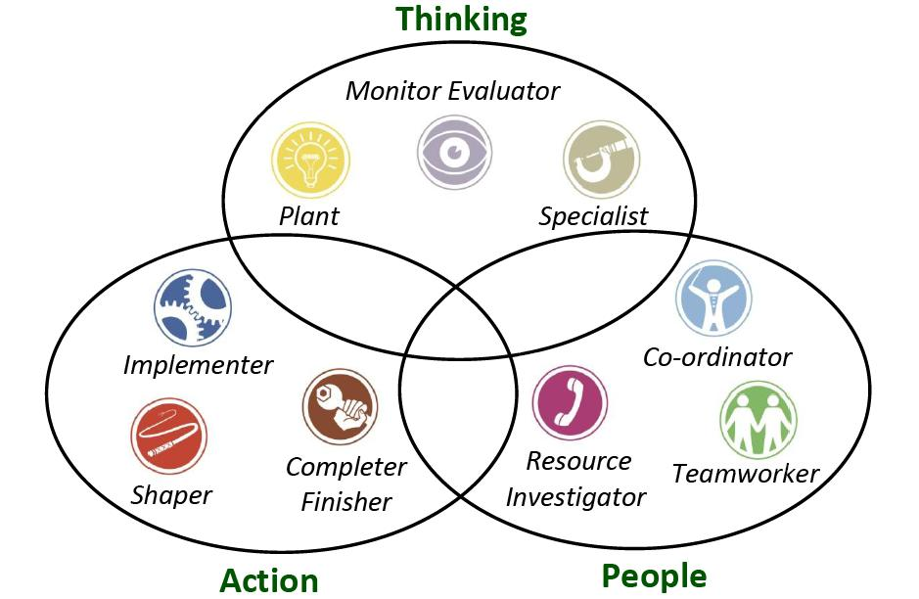
Fig.10 Belbin’s 9 Team Model

Personal development plan

I analysed that while working in project there were certain areas in which I was lacking. This highly impacted on my performance. So, I realised that I must develop a PDP which will help me to improve my weak areas. This will also help me in strengthening my strong skills as well. With this I will be able to grow and develop. Thus, the plan is as follows

Skills | Objectives | Resources | Time
Decision making | I need to improve it so that I am able to analyse situation and take decision. It will help me in taking proper decision. | For that I will solve case studies and get involve in meetings. I will also search in Internet to get some tips on it. | 1 month
Communication skills | I should enhance this as it will enable me to interact with people in effective way. I can become a good communicator | I will read book and watch video on YouTube on how to improve this skill. | 3 weeks
Interpersonal skills | I must improve my listening, reading, and other skills. This will help me in my growth and development | Here, I can attend training or seminar. Moreover, I will take help of expert and read books related to it. | 2 weeks

CONCLUSION
From the above report it has been summarized that BBC worldwide has been involved in making use of the work productivity in them. Their main objective was to increase growth in the international market and be admired from the outside and loved from the inside. In order to do this the company had to change a few things to adapt to the new challenge. However, workers found this change as something out of the norm and we a little apprehensive towards this. BBC Worldwide had to work alongside with them to promote understanding and lead them to believe that it was something good. This was one of the risks towards the changes that were being done, also the whole organisation had to adapt to the new business model and the restructure that it all meant, silo working was also something that could endanger the project. Nonetheless BBC had to convince everyone that this new culture would be better for everyone so they decided to work on workshops that would involve everyone and get their employees into talking about what they love about the organisation, if they agree with the culture ambition and hear their thought, all of this is done in order to get everyone on board and make them see that their collaboration and thoughts are important for the organisation. This is how they make their project as successful as possible.
These theories have assisted BBC worldwide in adjusting to the changes and making employees get motivated to adjust to changes. This has assisted the firm in achieving their goals and objectives. It has also helped the firm in growing and successfully implementing the changes as well as providing training related to changes to employees. This has helped the firm in increasing its skills and capabilities.

REFERENCES
Brones, F.A., de Carvalho, M.M. and de Senzi Zancul, E., 2017. Reviews, action and learning on change management for ecodesign transition. Journal of Cleaner Production, 142, pp.8-22.
Doppelt, B., 2017. Leading change toward sustainability: A change-management guide for business, government and civil society. Routledge.
Clarkson, M. 1995. ‘A stakeholder framework for analyzing and evaluating corporate social performance’, Academy of Management Review, 20(1): 92-117
Freeman.E and Reed. D. 1983. Stock holders and Stakeholders: A new perpective on Corporate Governance, ed., Corporate Governance. Los Angeles, UCLA extension press.
Hayes, J., 2018. The theory and practice of change management. Palgrave.
Lewis, S., Cantore, S. and Passmore, J., 2016. Appreciative inquiry for change management: Using AI to facilitate organizational development. Kogan Page Publishers.
Lin, S. and Huang, D., 2020. Project Risk Management. In Project Management Under Internet Era (pp. 209-246). Springer, Singapore.
Okereke, O.C., 2020. Achieving Successful and Sustainable Project Delivery in Africa: How to Implement Effective and Efficient Project Management Practices and Policies. CRC Press.
Reed, A.H. and Angolia, M.G., 2020. Risk management usage and impact on information systems project success. In Start-Ups and SMEs: Concepts, Methodologies, Tools, and Applications (pp. 1065-1084). IGI Global.
Scott, M. and et.al., 2020. Climate change impacts in the Middle East and Northern Africa (MENA) region and their implications for vulnerable population groups. Planning Theory & Practice. 21(2). pp.1-30.
Van der Voet, J. and Vermeeren, B., 2017. Change management in hard times: Can change management mitigate the negative relationship between cutbacks and the organizational commitment and work engagement of public sector employees?. The American Review of Public Administration, 47(2), pp.230-252.
Van Rossum, L and et.al., 2016. Lean healthcare from a change management perspective. Journal of health organization and management.
Walker, D.P., 2020. The BBC in Scotland: The First Fifty Years. Luath Press Ltd.

