Cheng Chen (2305261)
University of Wales Trinity Saint David
BSc Applied Computing
L4 - Operating Systems
(ACCA4022)
Contents
Introduction 2
Operating systems 3
Key functions of general Operating Systems 6
Memory and process management: 6
System Security: 8
Device Management: 12
File and Directory Management: 13
Network management. 14
Use of Windows OS CLI commands. 20
Use of Linux OS CLI commands. 25
Use of Windows OS scripts. 28
Use of Linux OS scripts. 35
Conclusion: 36
Appendices 37
Reference list 41

Introduction
An operating system (OS) is the program that, after being initially loaded into the computer by a boot program, manages all of the other application programs in a computer. [1] which manages and controls the use of computer hardware resources (such as processors, memory, storage, input/output devices), and provides a friendly and efficient working environment for users and applications. An operating system acts as an interface between the software and different parts of the computer or the computer hardware. [2] It is responsible for handling task scheduling, memory management, file system management, user interface and other functions to enable the computer to run various applications smoothly and provide required services.

Operating systems
- Windows operating system
A family of operating systems developed by Microsoft and widely used in personal computers and corporate environments. Provides a user-friendly graphical user interface and a rich ecosystem of applications.
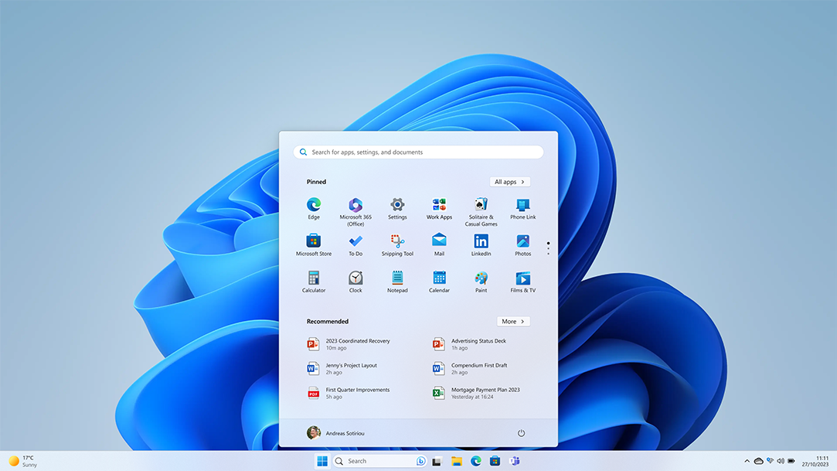
Latest Windows 11 User Desktop [3]
- macOS operating system
An operating system developed by Apple and designed for use with Apple's Mac line of computers. It is known for its elegant user interface, stability and security.

MacOS Big Sur Desktop [4]
- Linux OS
An open-source Unix-like operating system that is highly customisable and flexible, widely used in servers, embedded systems and personal computers. Has a variety of distributions such as Ubuntu, Fedora and Debian.

Ubuntu 23.10 User Desktop [5]
- iOS
Apple's mobile operating system for its iPhone, iPad and iPod Touch devices. It has a smooth user experience, good performance and security.

IOS 17 [6]
- Android OS
Mobile operating system developed by Google for smartphones, tablets and other portable devices. Has an open ecosystem and extensive application support.

Android 11 [7]

Key functions of general Operating Systems

Memory and process management:
Memory management is the process of controlling and coordinating a computer's main memory.[8] The operating system is responsible for managing the allocation of the computer's memory resources and overseeing the various processes running on the computer.

To observe system processes, CPU, and memory management:
Windows: Press CTRL-ALT-DEL to access 'Task Manager' for a list of running processes. Use 'TASKLIST' in CMD for the same info. 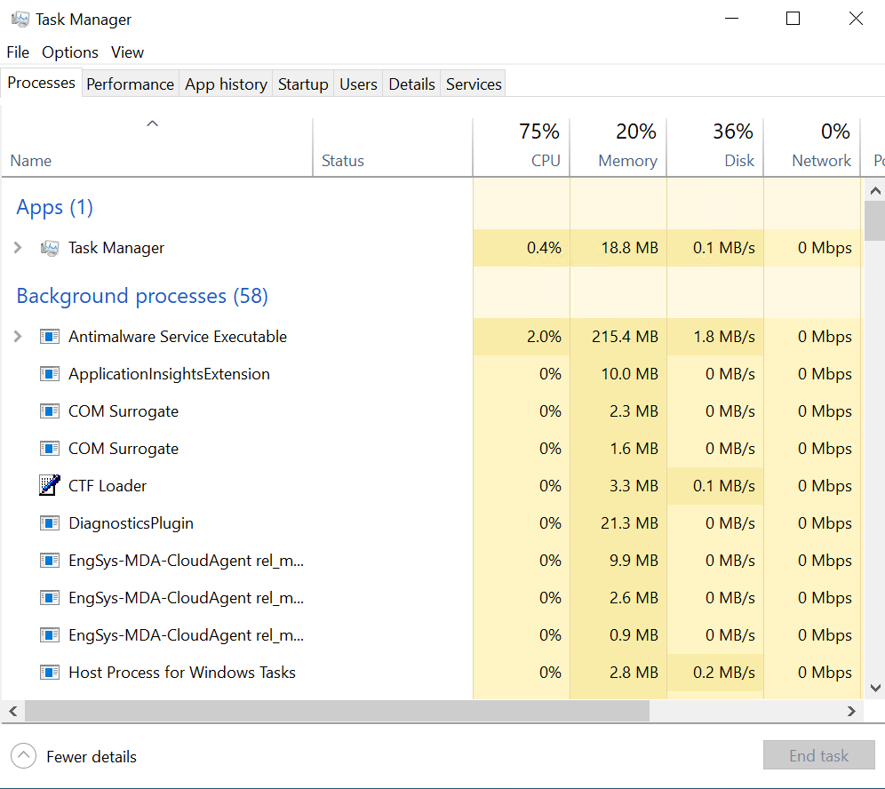
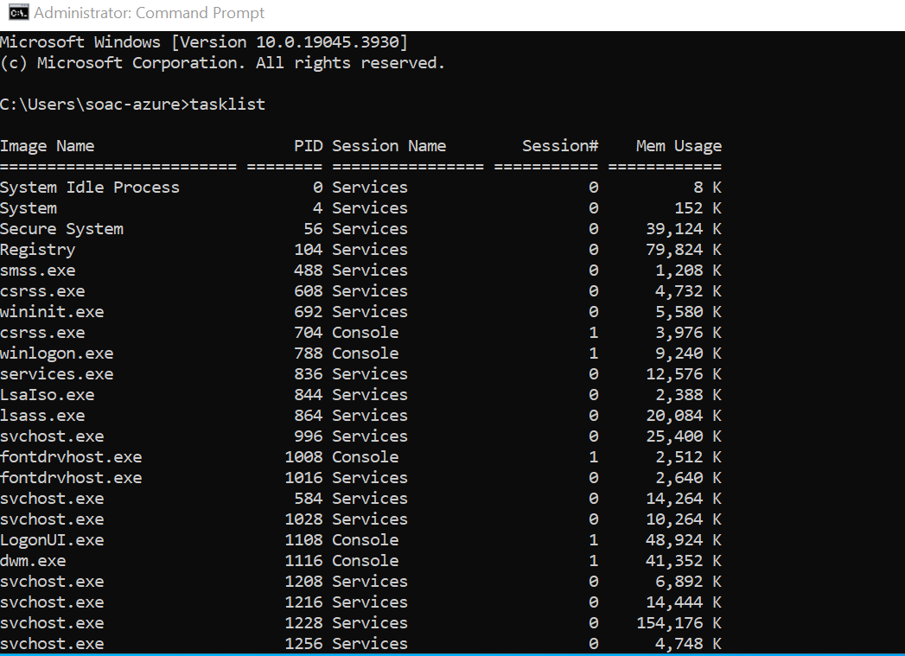
Use 'TASKLIST' in CMD for the same info.

Linux: Utilize terminal commands such as 'ps', 'top', or 'htop' for process monitoring. 'ps aux' shows all running processes and memory usage.
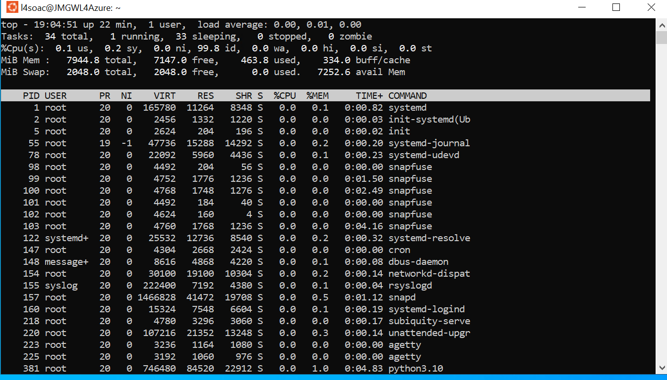
Mac: Open 'Activity Monitor' in the "Utilities" folder to view and manage running processes.

System Security:
OS security refers to specified steps or measures used to protect the OS from threats, viruses, worms, malware or remote hacker intrusions.[9] The operating system provides security features including user authentication, access control, file encryption, and security mechanisms against malware.

- User authentication:
Only authorised users can access system resources. This can be done through passwords, biometric information, etc.
Windows Sign-in options
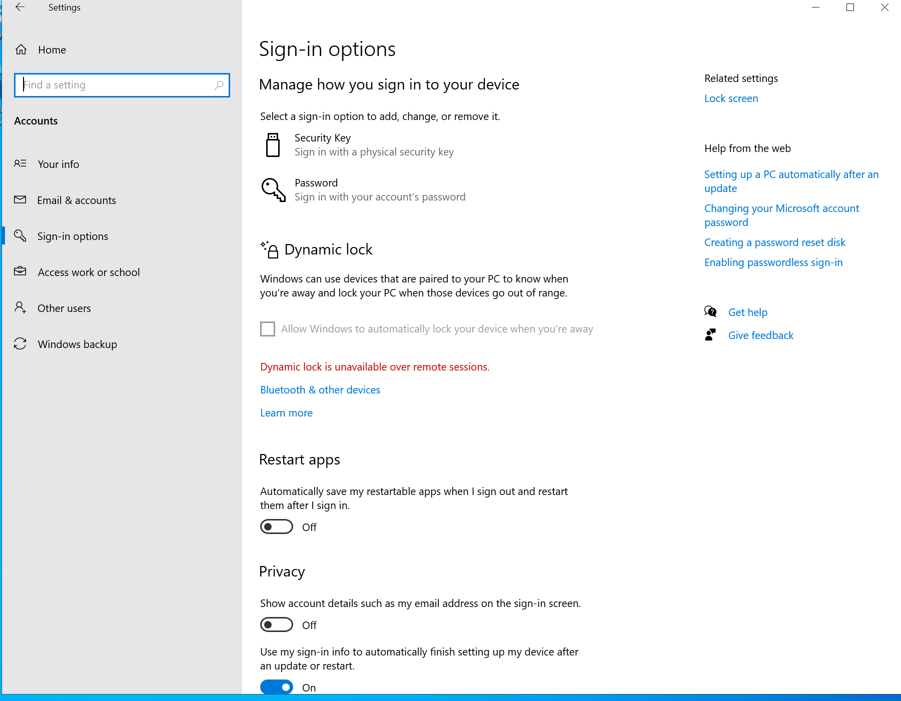
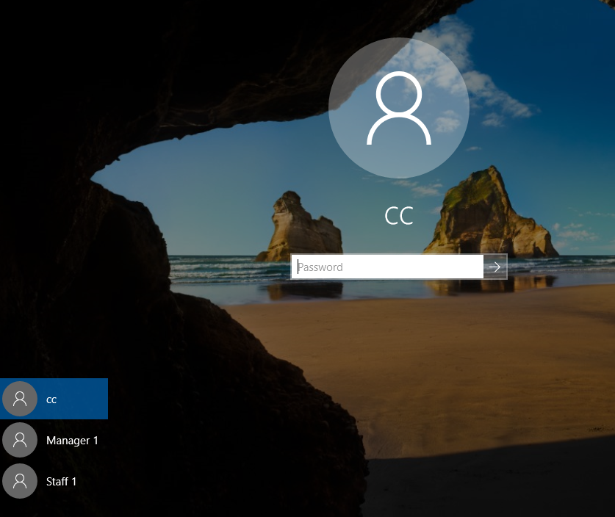
User need password to login in

- Access control:
Controls user access to system resources so that users can only access files to which they have permissions.
Shared Folders: Users can share folders on the local network and set appropriate permissions to control who can access the contents of the folders.

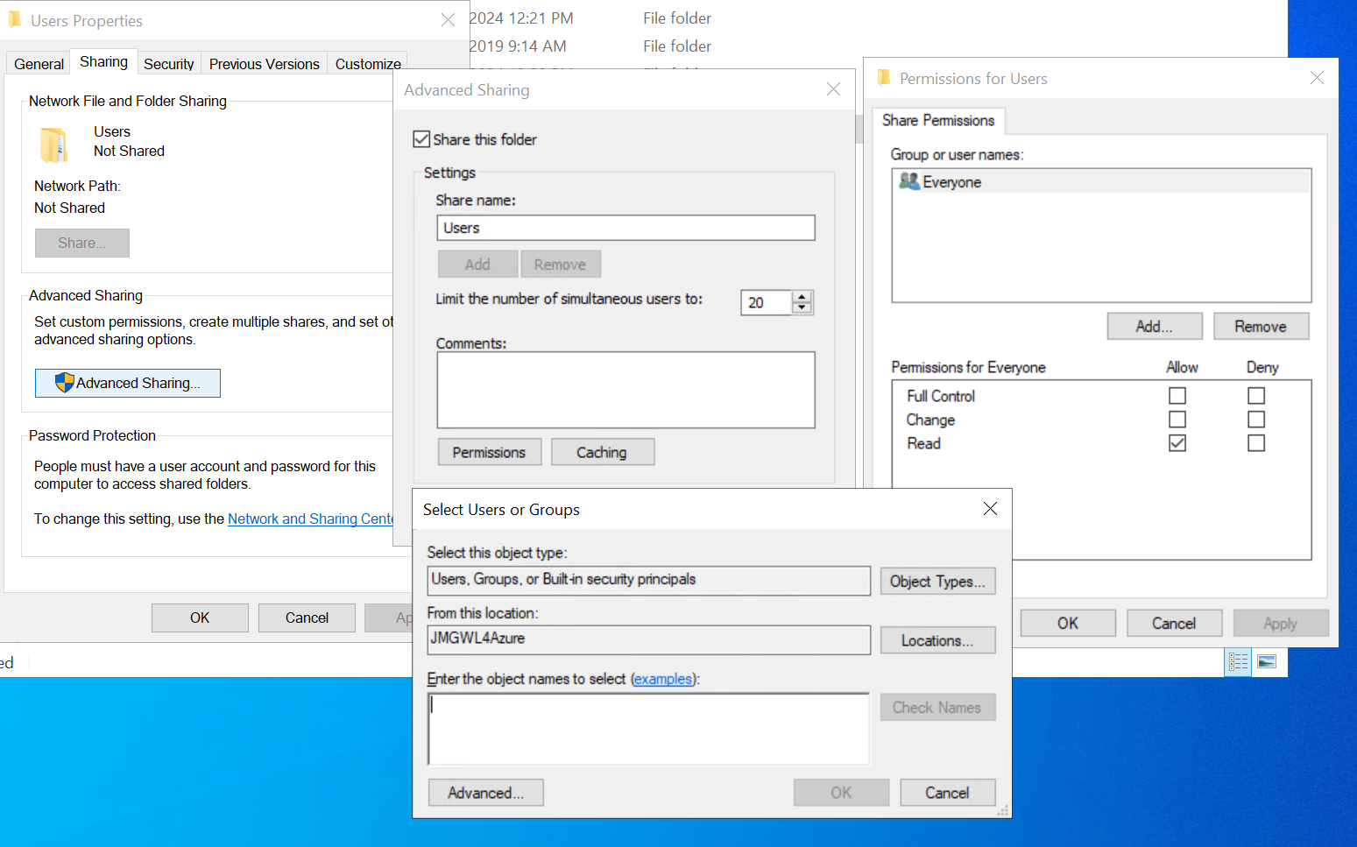

- File encryption:
Storing files encrypted to prevent unauthorised access. Only users with permissions can access these files.
BitLocker is a feature in the Windows operating system that encrypts specific volumes to prevent unauthorised visitors from accessing data.
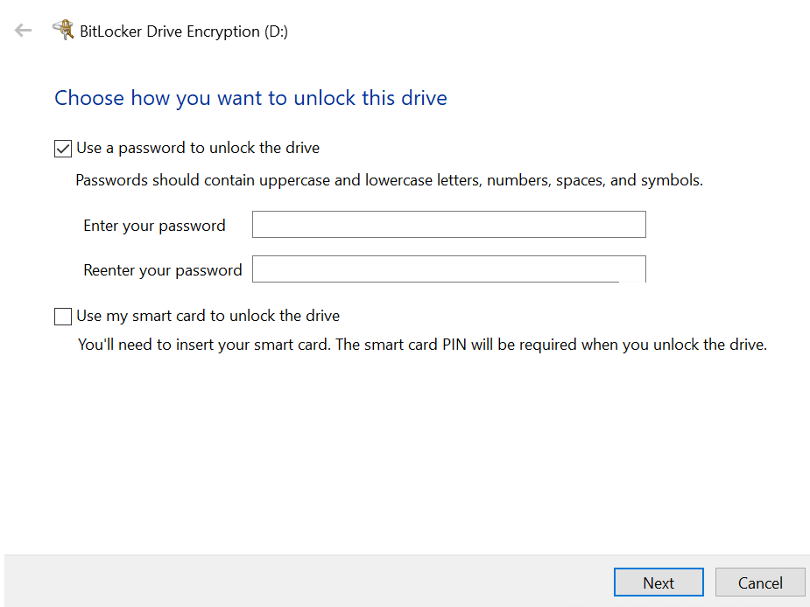

- Security mechanisms against malware:
The operating system provides anti-virus software, firewalls and other security tools to detect and block malware attacks.
Windows Defender It is a built-in protection tool in the Windows operating system designed to protect computers from security threats. 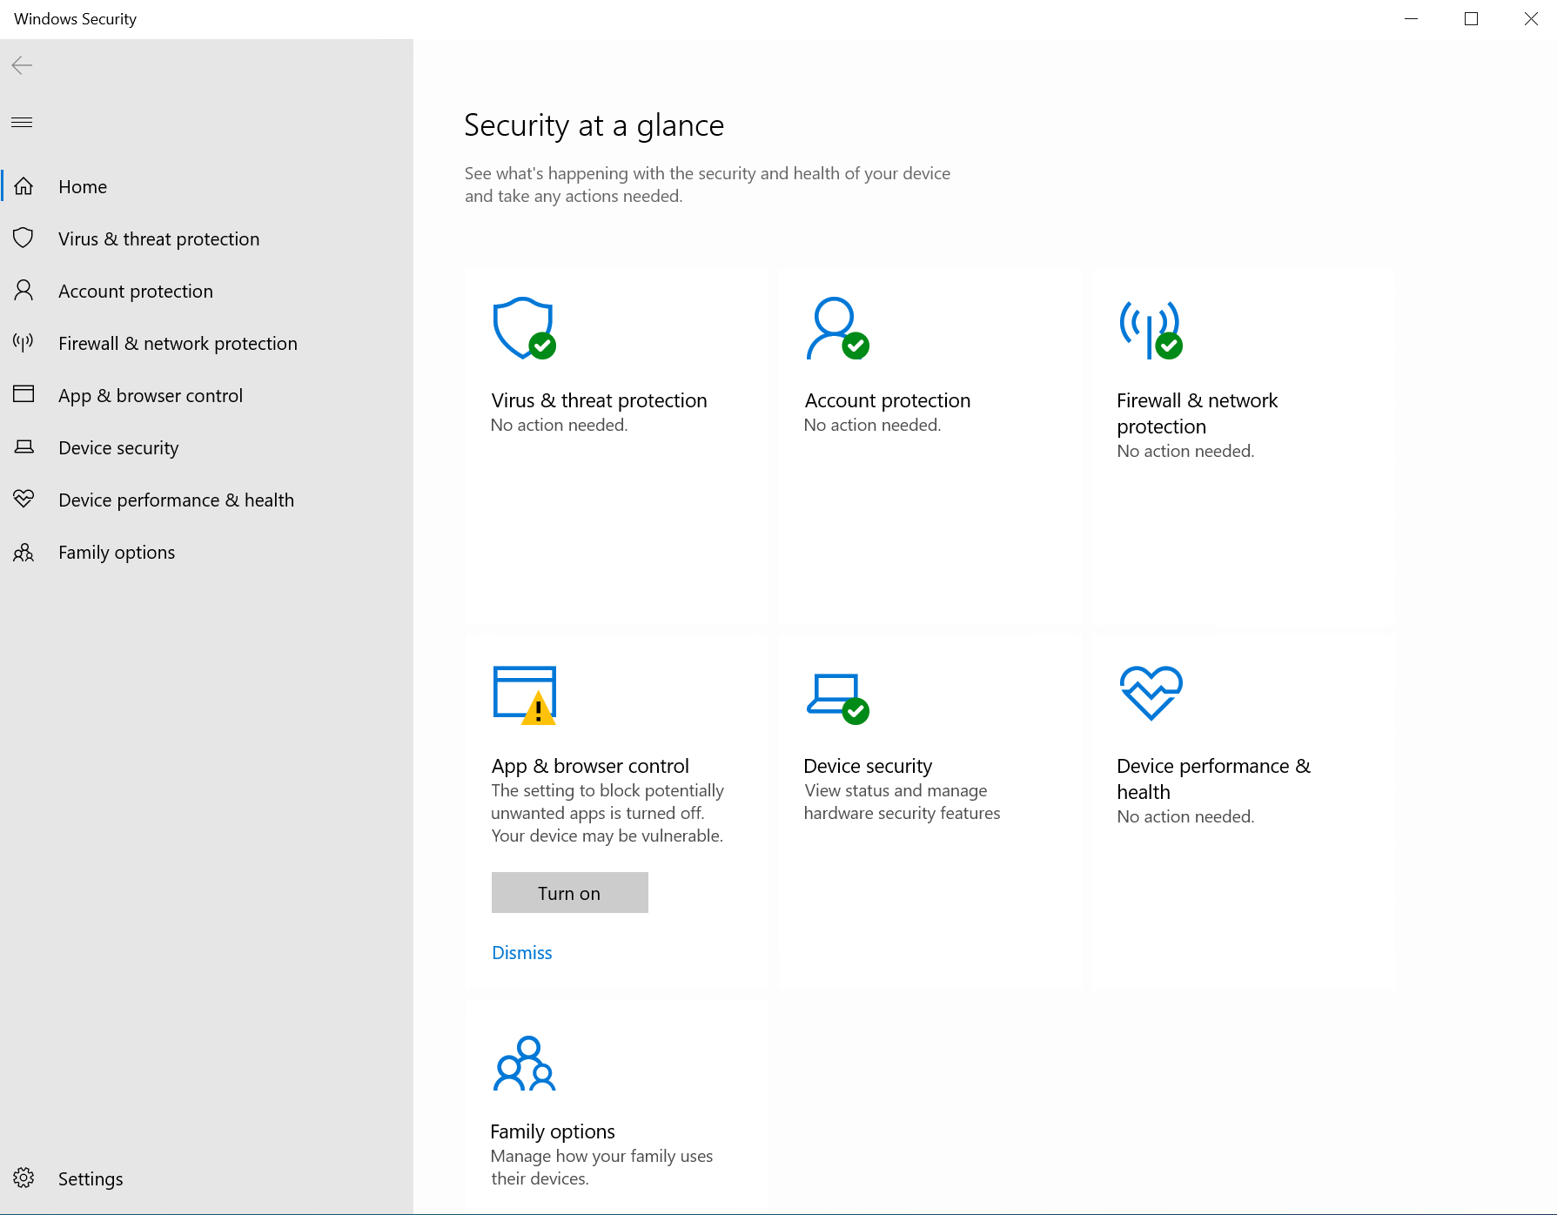

Device Management:
The process of implementation, operation, and maintenance of a device by an operating system is called device management.[10] The operating system oversees the management of a variety of input/output (I/O) devices, including keyboards, mice, printers, and storage devices.

Device Manager is a tool of the Windows that is used to manage the hardware devices.
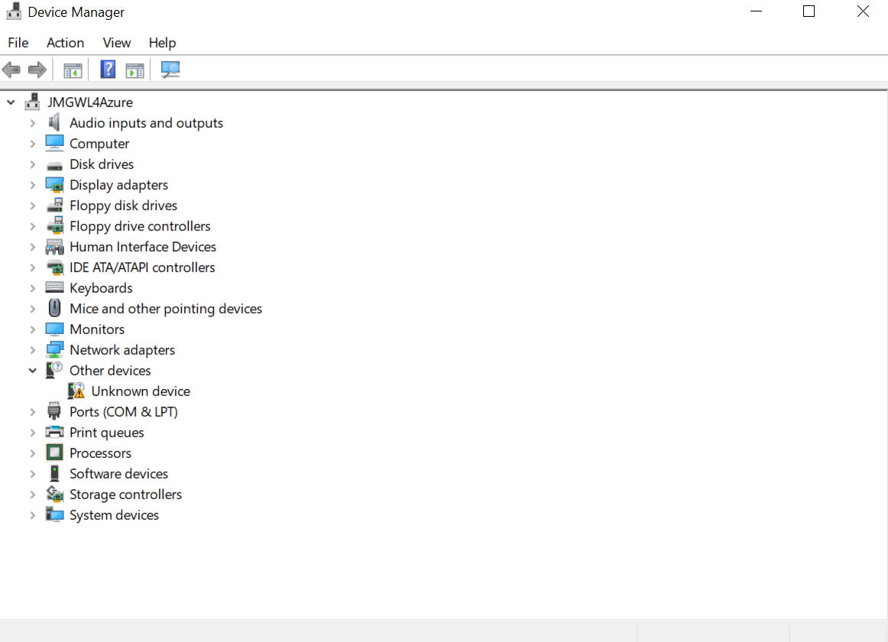

File and Directory Management:
Directory is a place/area/location where a set of file(s) will be stored.[11] The operating system provides management functions for the file system, including file creation, reading, writing, and deletion, as well as directory creation and management.

Using “nano filename”, to open or create a file using the nano text editor on Unix and Linux systems.
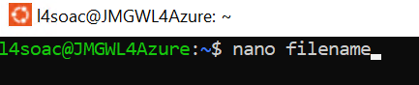
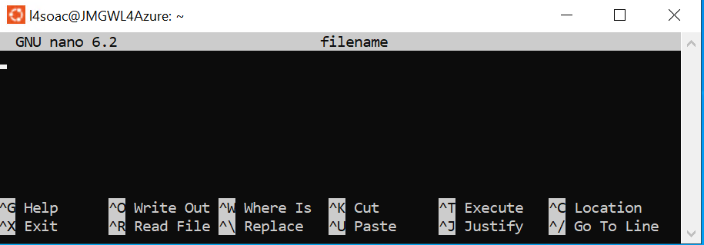
Typing keywords directly into the search box. windows will search for matching files in the current folder and its subfolders.
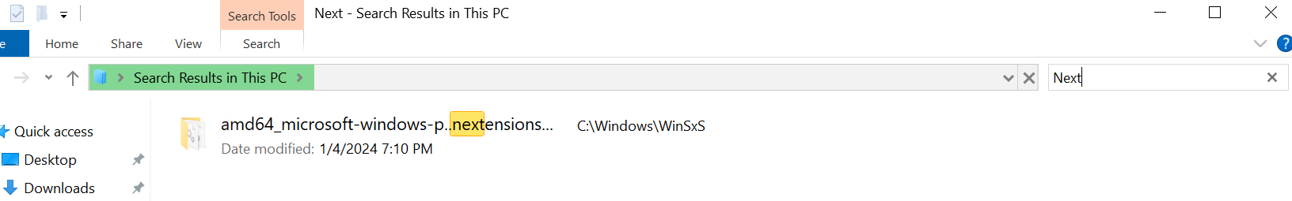

Network management.
Manages various network protocols such as HTTP, TCP/IP, FTP, handles IP addresses and network interfaces. Operating systems are responsible for establishing connections and managing data transfers.
Using “ipconfig” to see IP configuration.
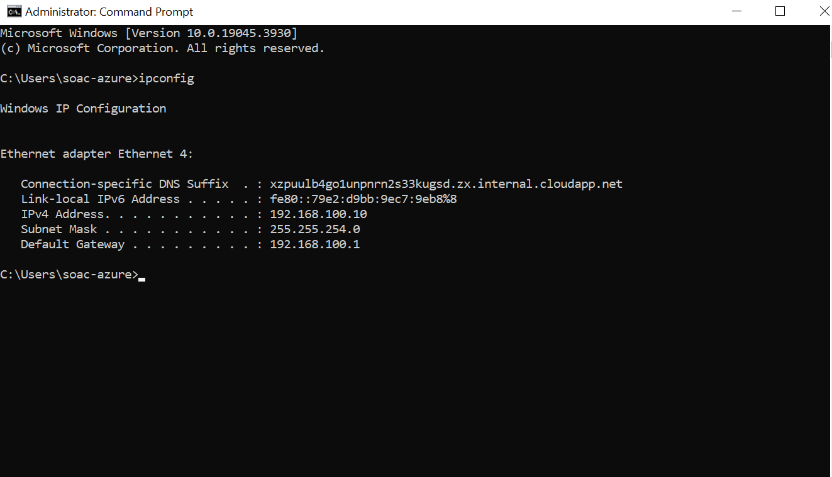
Network status on Task manager.
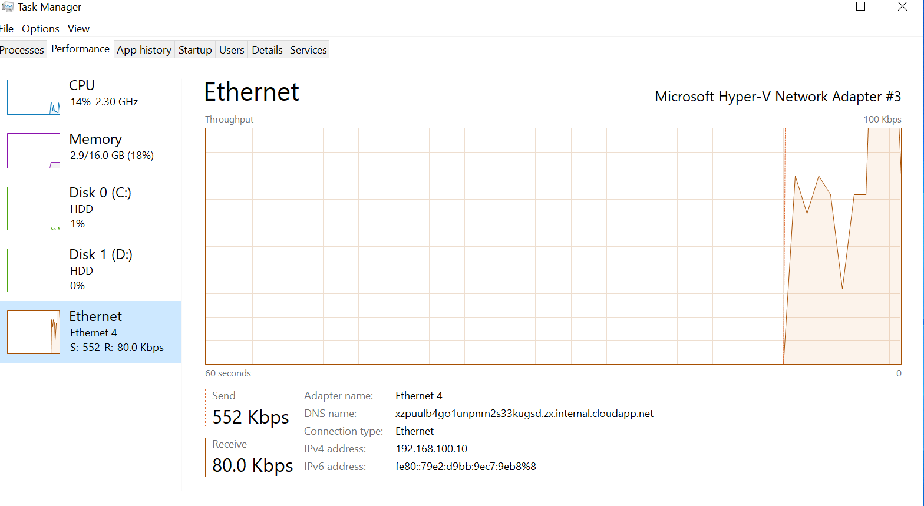

System performance monitoring & management
- Disk Management
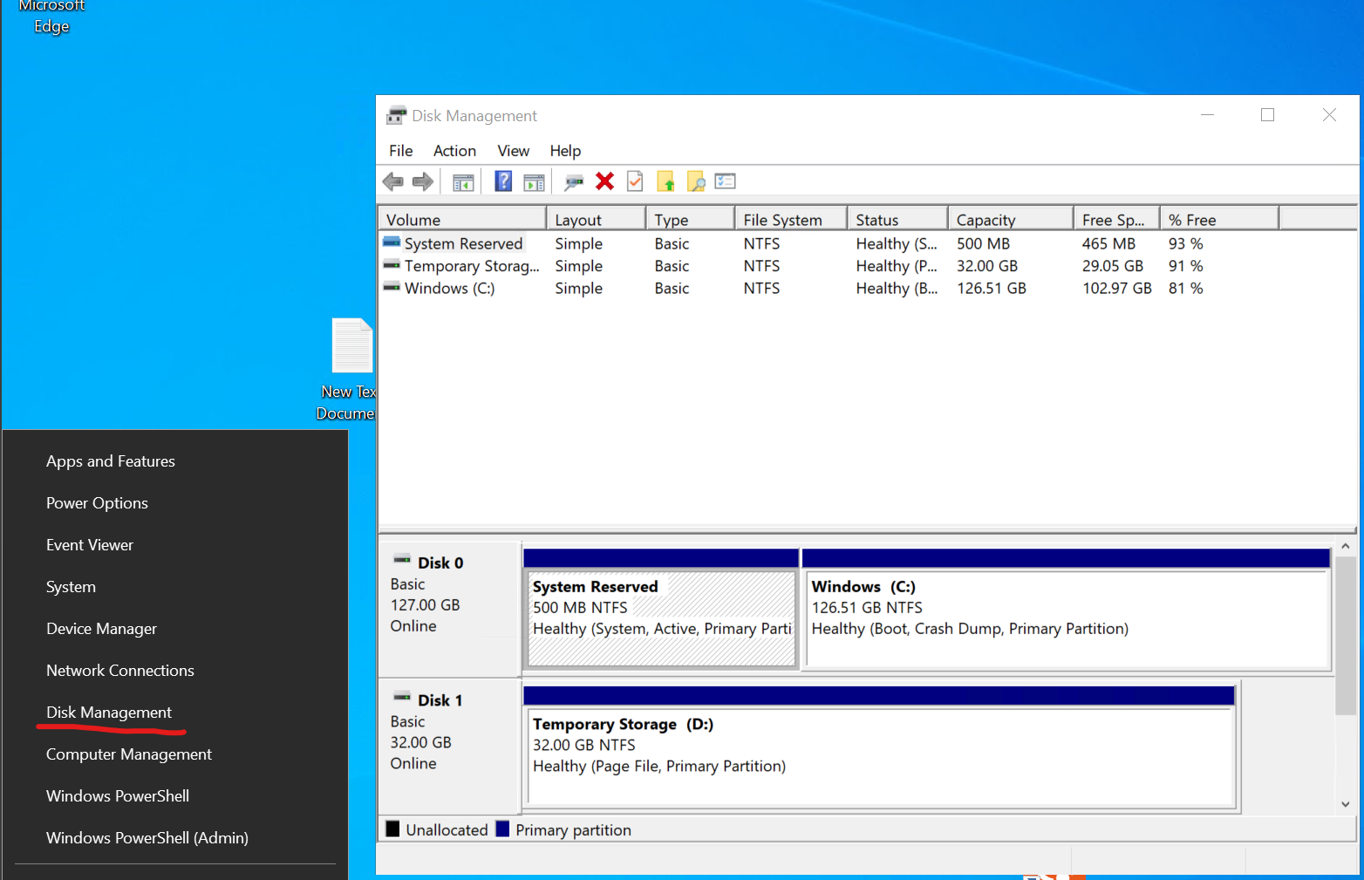
- Computer Management 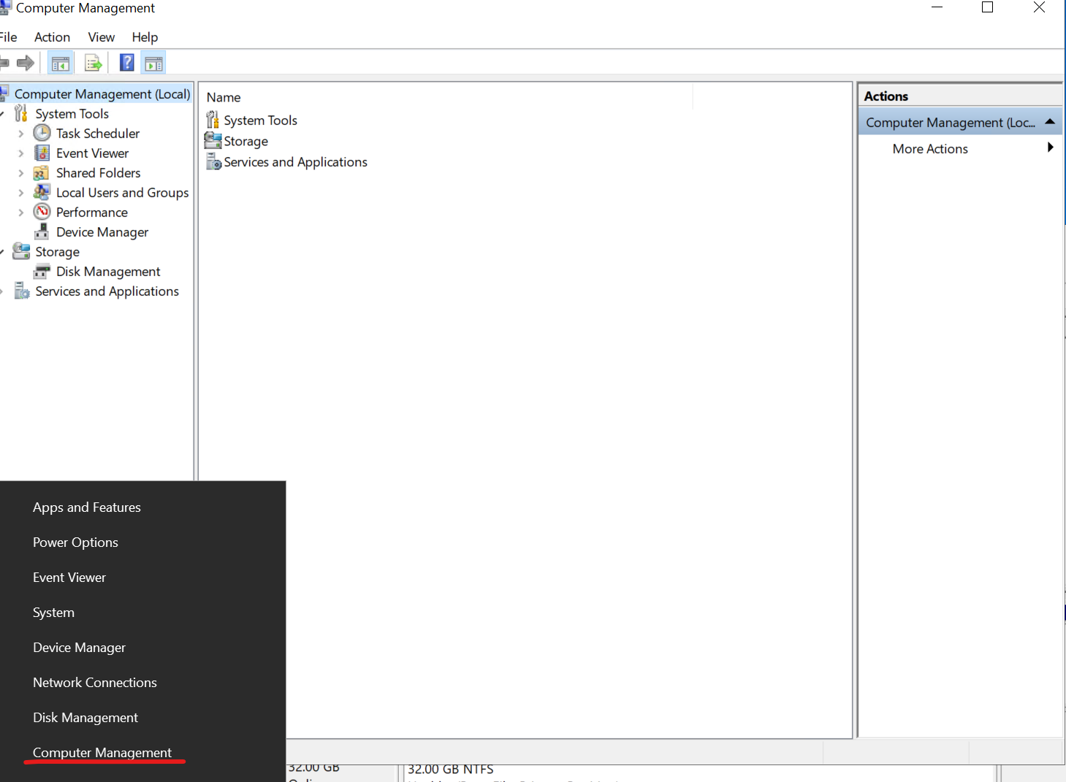
- 'Resource Monitor' enables real-time monitoring of system performance. such as CPU utilization, memory usage, and network traffic
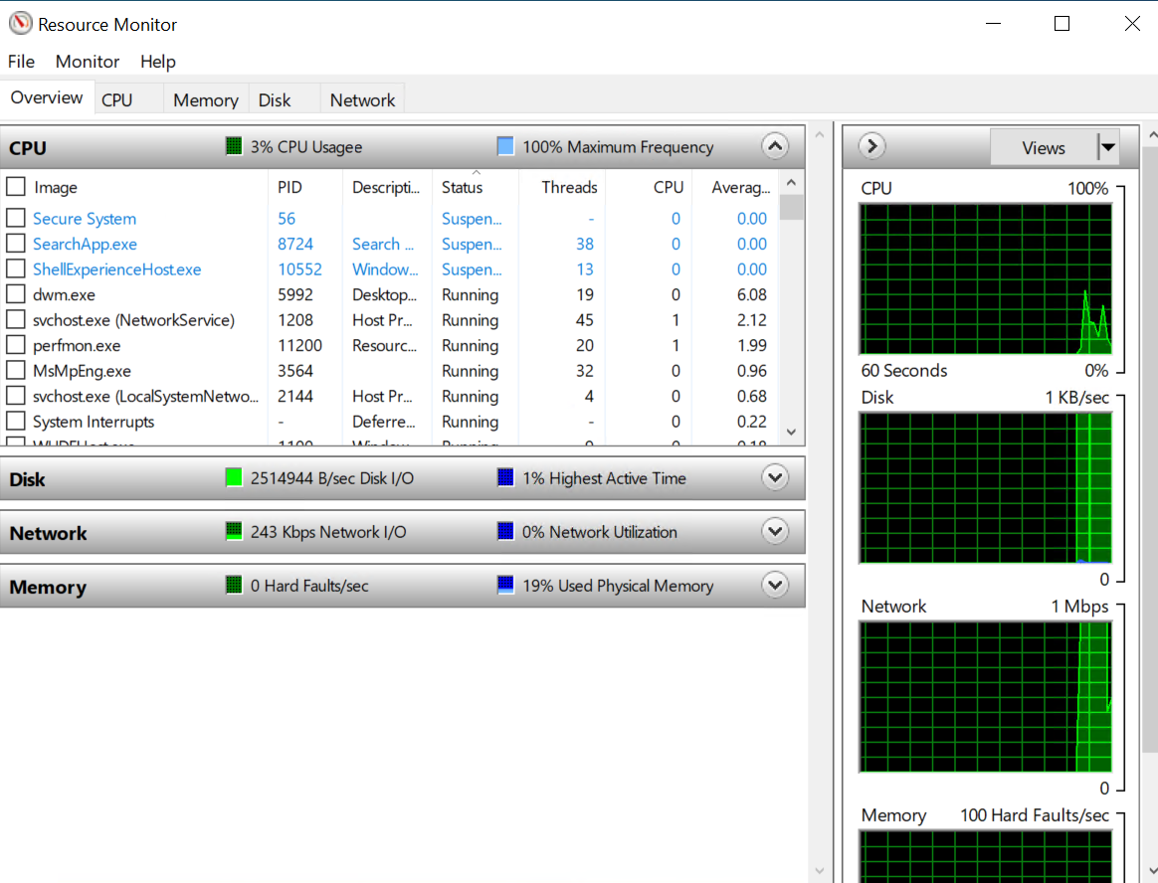

- Performance monitor
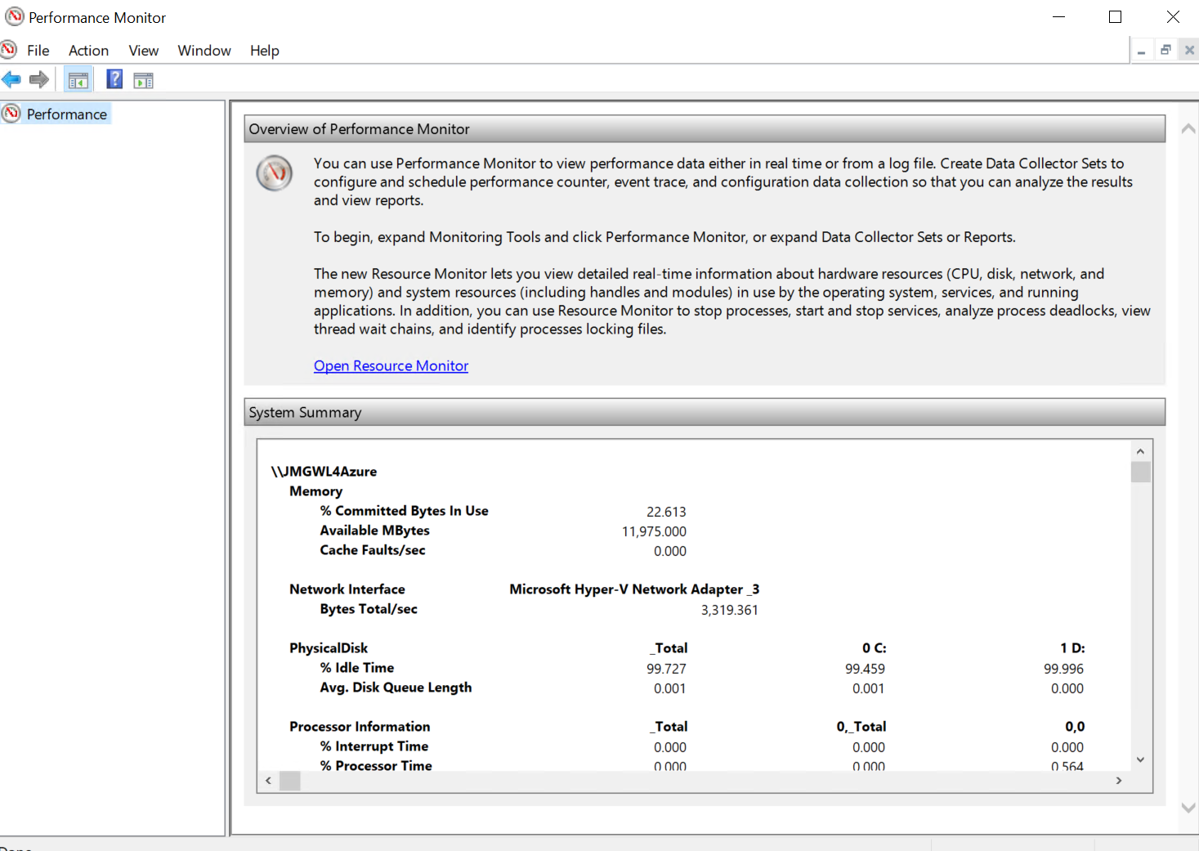
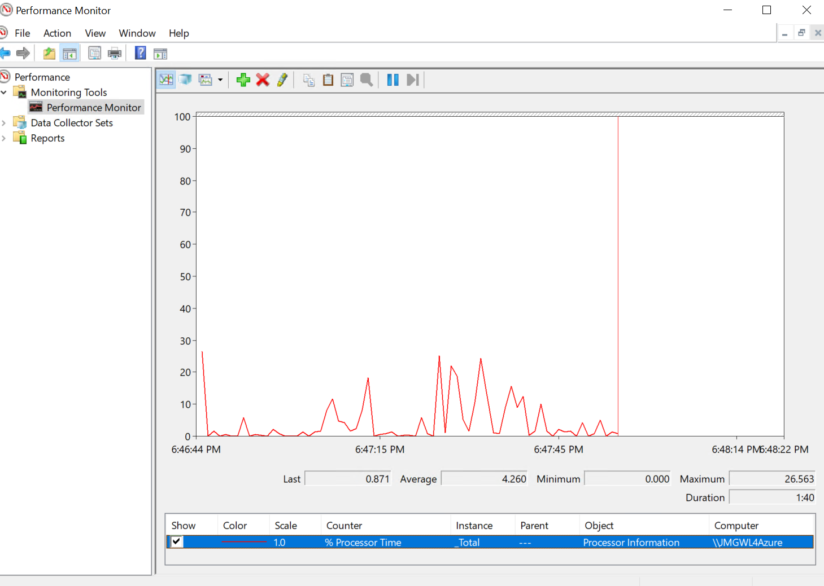
- Event viewer
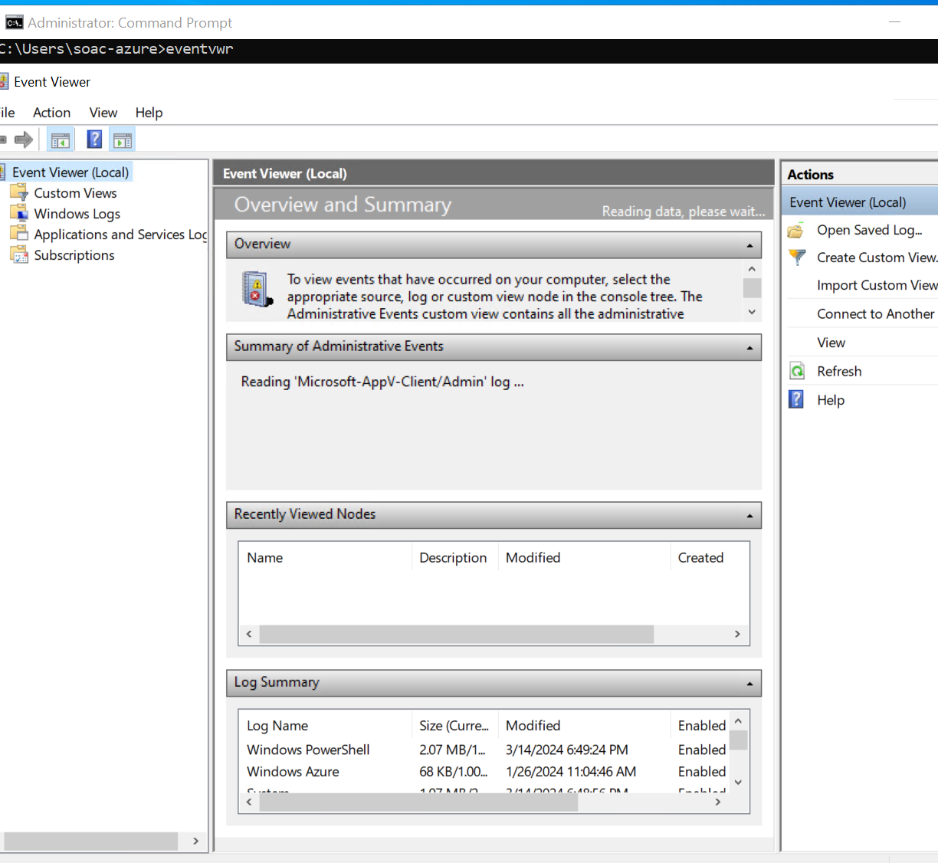
- Reliability monitor 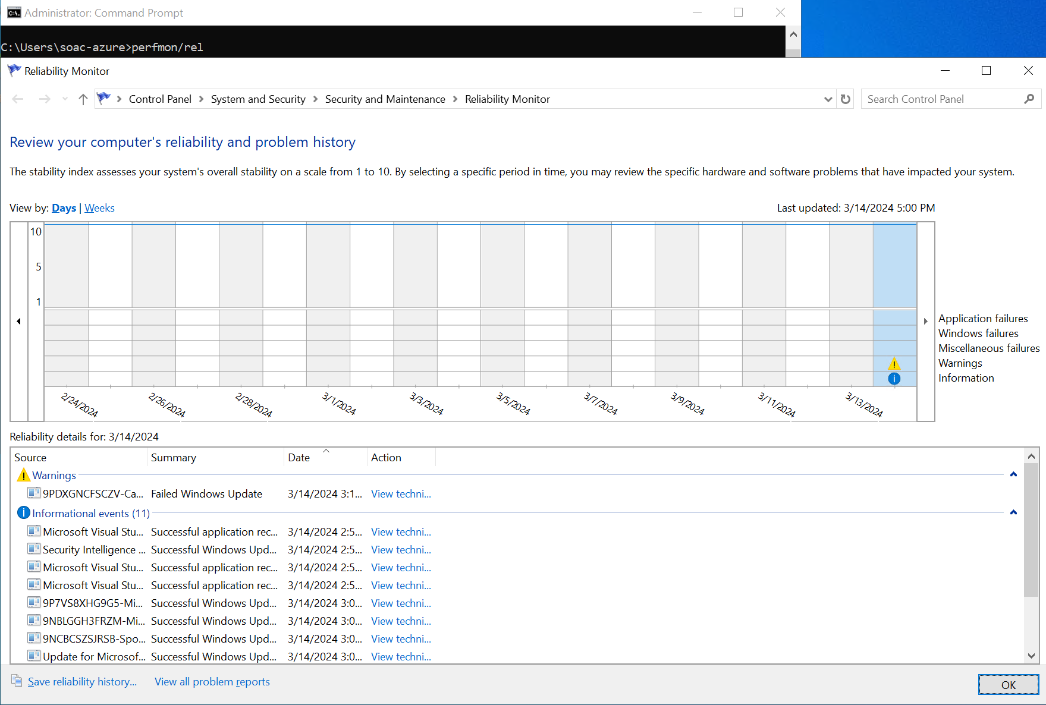

- Windows File System
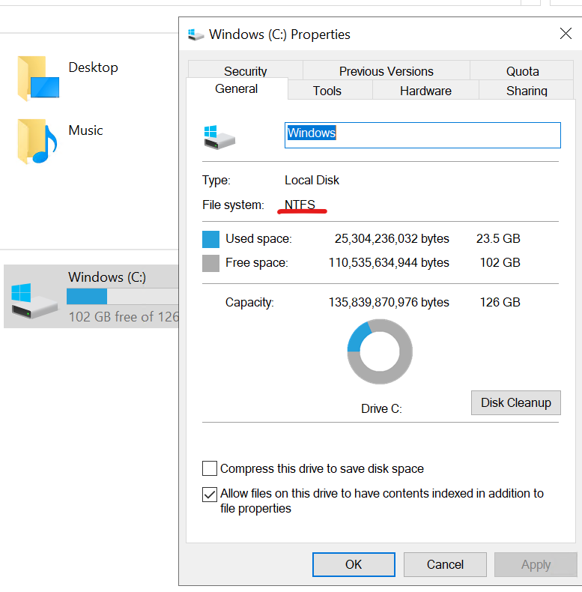

Use of Windows OS CLI commands.
CLI is a command line program that accepts text input to execute operating system functions.[12] These commands enable users to interact with the operating system via a command line interface instead of a graphical user interface (GUI).
- dir: Lists the files and folders present in the current directory.
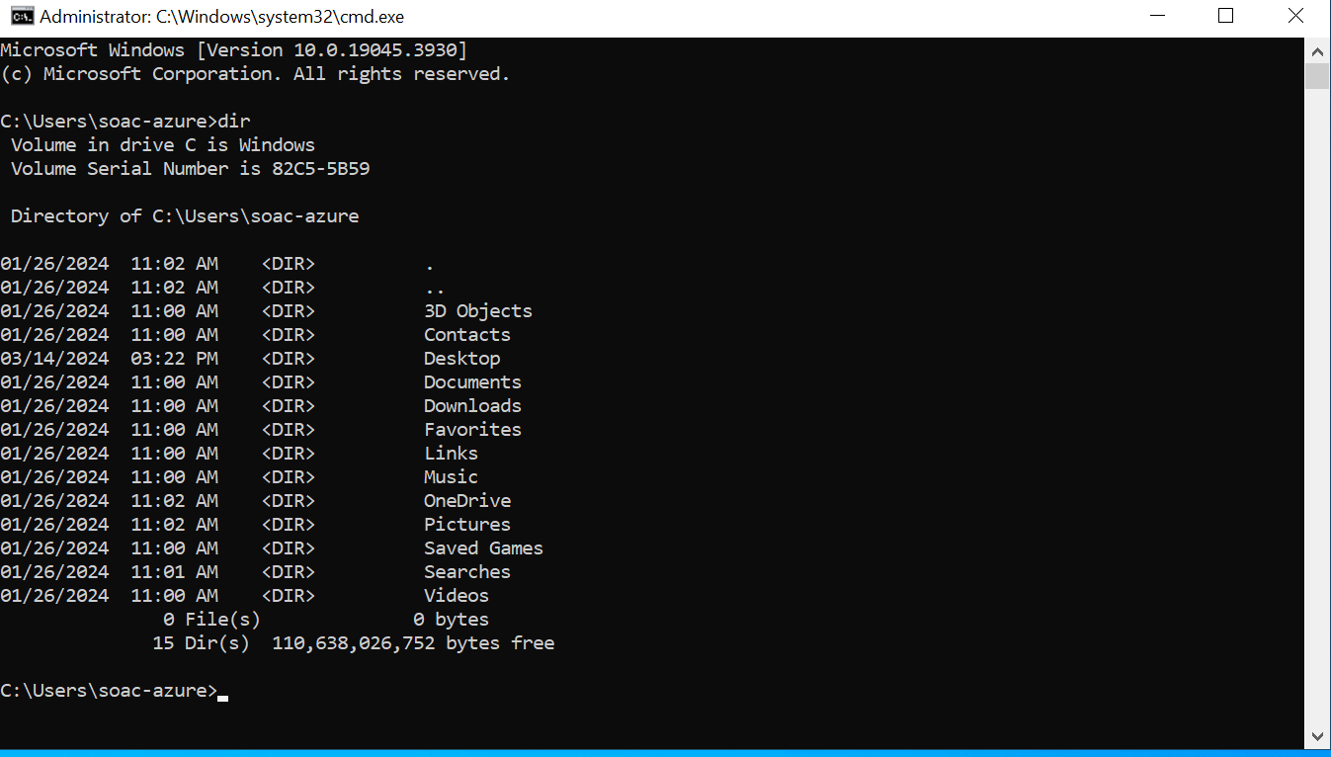
The dir command is a very common tool in Windows operating systems. Displays a list of a directory's files and subdirectories. [13]
- cd: Change current directory。
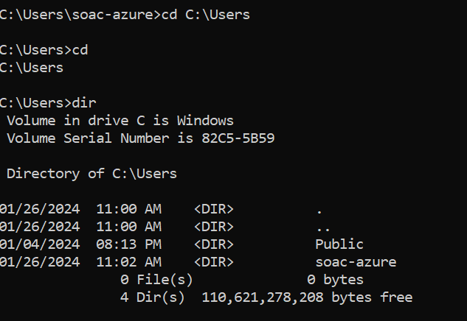
Switch to the current user's home directory: cd
- mkdir：Create a new folder.
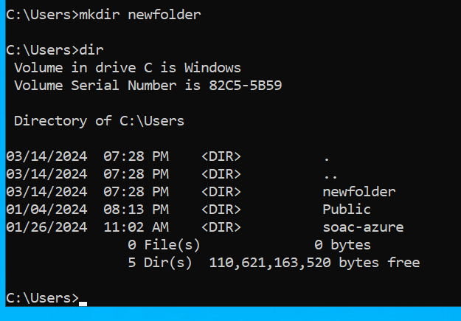
Create a new directory called "newfolder" in the current directory: mkdir newfolder
Create a txt named "test" in the specified path: mkdir C:\Users\test.txt
- del：Delete the file.
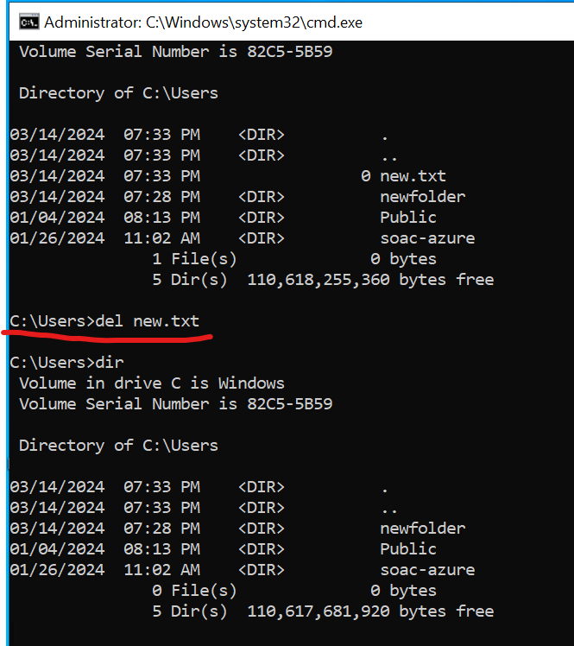
Delete a file in the current directory: del new.txt
Delete a file in the specified directory: del C:\Users\new.txt
- copy：Copy the file.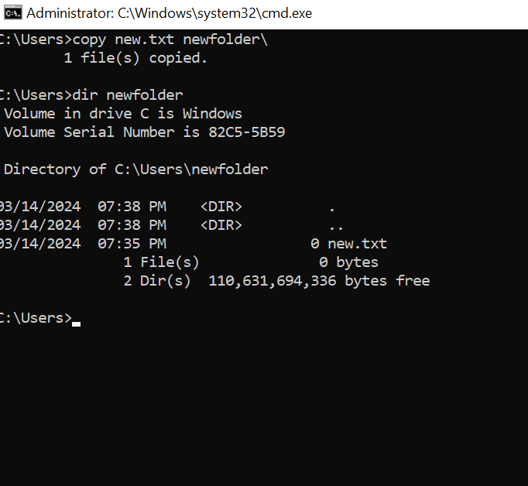
Copy a file to the target location: copy file.txt C:\Destination
- ren：Rename the file.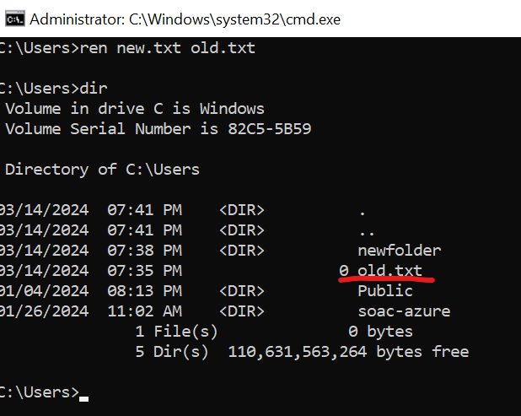
Rename the file "old.txt" to "new.txt": ren old.txt new.txt
- tasklist：Shows a list of processes currently active or running.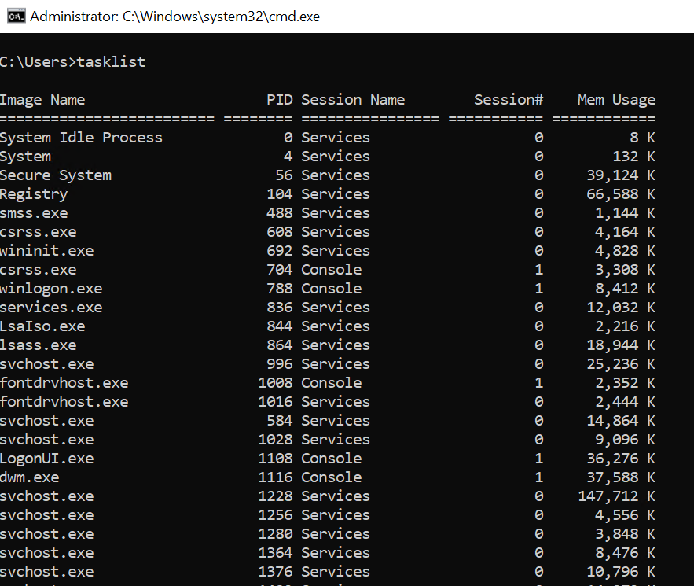
TaskList displays all running applications and services with their Process ID (PID) This can be run on either a local or a remote computer.[14] The tasklist command is a convenient way to view currently running processes on the command line.
- taskkill：Terminate the process.
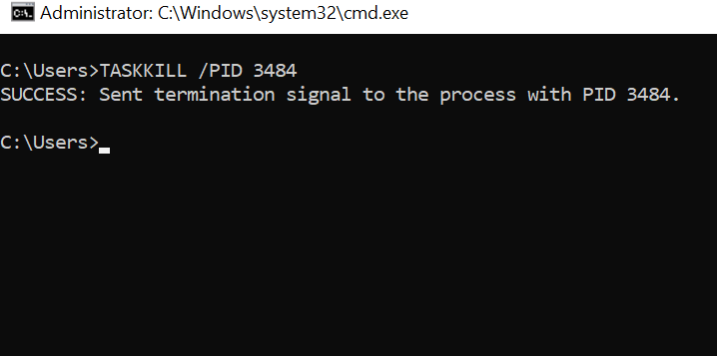
Terminate the process with the specified PID: taskkill /pid 3484
The taskkill command is a powerful tool for managing system processes and can be used to quickly terminate problematic processes or free up system resources.
- ipconfig：Displaying Network Configuration Information
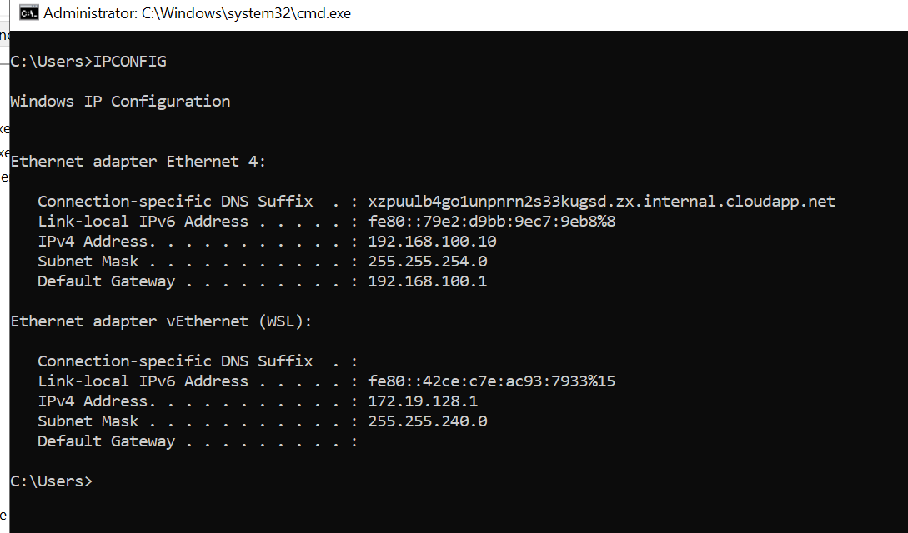
Show all details of the current network connection: ipconfig /all
The ipconfig command is used to display information about your network configuration and refresh DHCP and DNS Settings.[15] The command is useful for diagnosing network connectivity problems and configuring network settings.
- powercfg : Manage and configure the system's power settings
It allows you to manage many aspects of power plans (also known as power schemes). [16] Allows users to view current power configuration information, create new power plans, export and import power configurations, and more.
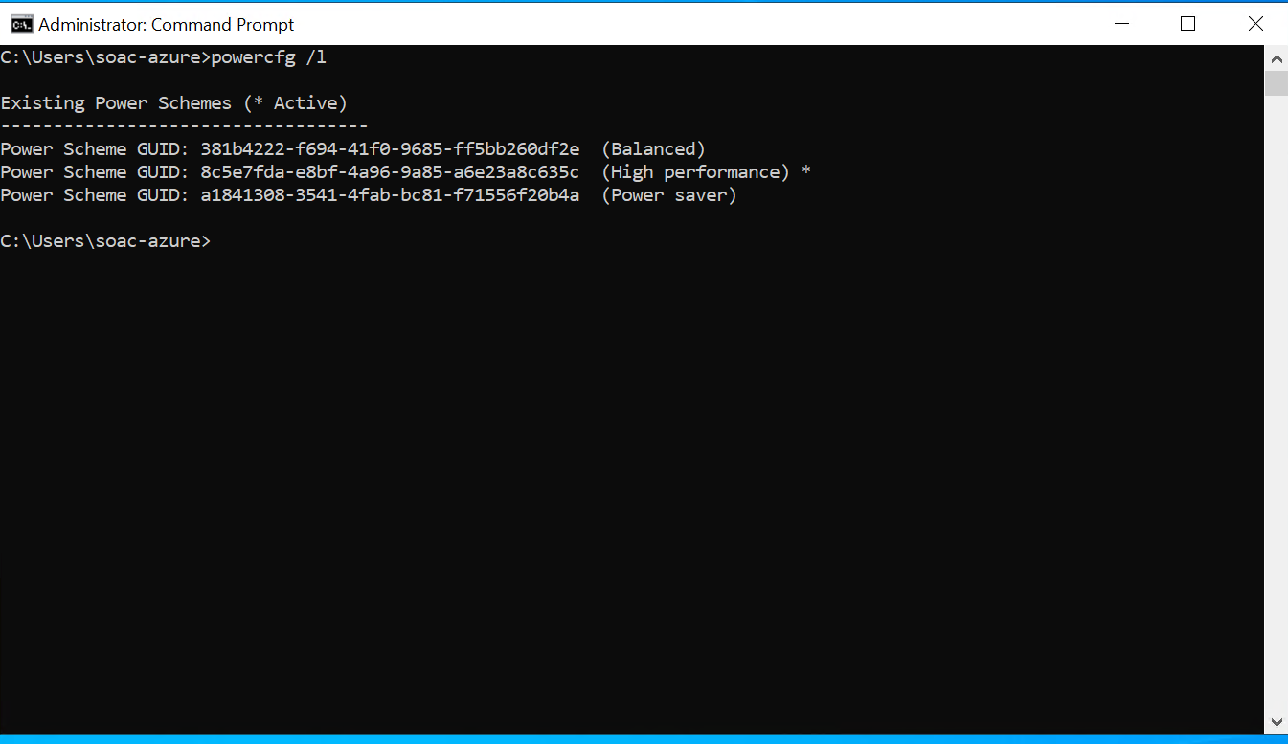
View all power plans on the current system: powercfg /l

Use of Linux OS CLI commands.
The Linux command line is a text interface to your computer. [17] The command line interface provides users with direct interaction capabilities with the operating system, enabling them to execute diverse operations like file and directory management, software installation, and system configuration.

Creating users and groups on a Linux system can be done using various command line tools. Here's how to use the Bash command:
- Creating a Group:
sudo groupadd mygroup
This command creates a new group named "mygroup". on Ubuntu, only users in the sudo group can use the command to gain elevated permissions. [18]
- Creating a User:
sudo useradd -m -s /bin/bash username1
The command creates a new user named "username". The flag -m is used to create a home directory for the user, while -s /bin/bash sets the user's default shell to Bash.
Setting Password for the User:
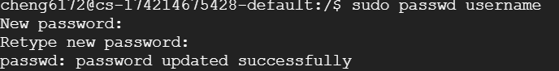
sudo passwd username
This command sets a password for the user "username".
- Adding User to Group:
sudo usermod -aG mygroup username1
This command adds the user "username1" to the group "mygroup".
- Viewing User and Group Information:
id username1
This command displays the user ID (UID), group ID (GID), and supplementary groups for the user.
- Listing Users:
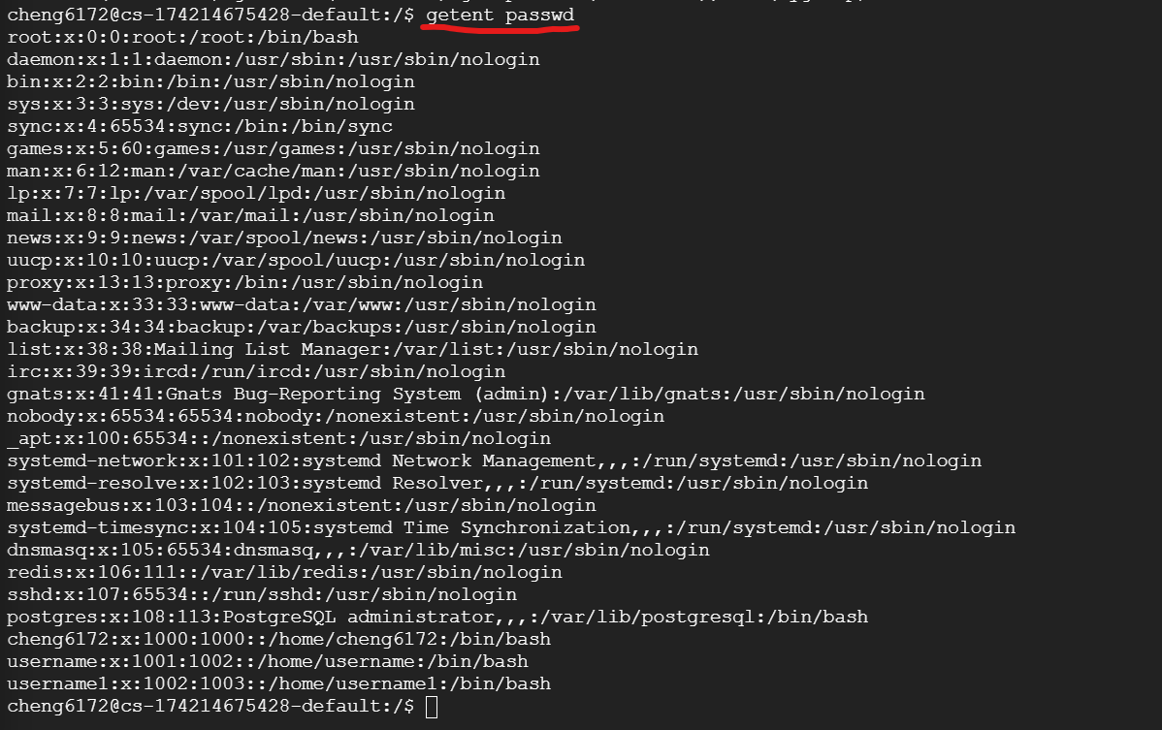
getent passwd
This command lists all users in the system. getent is a Linux command that helps the user to get the entries in a number of important text files called databases.[19]
- Listing Groups:
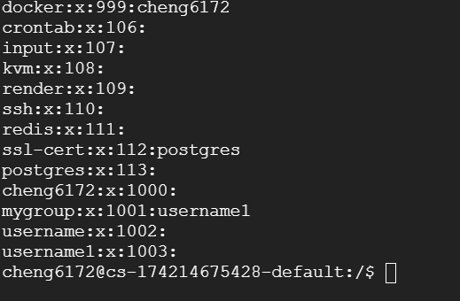
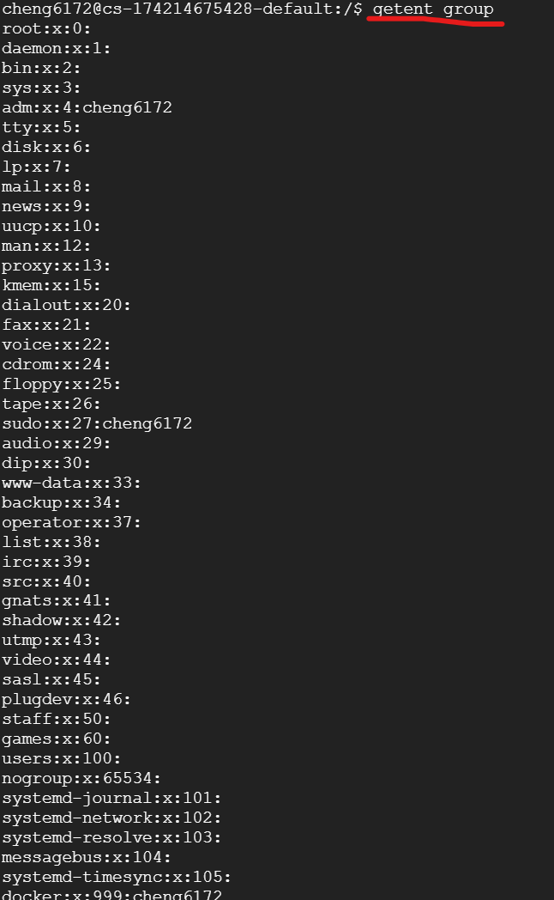
getent group
This command lists all groups in the system.
- Changing User's Password:
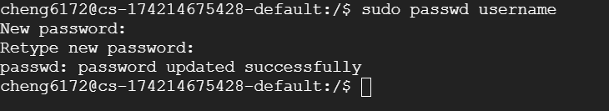
sudo passwd username
This command allows the user to change their password.
- Deleting User:
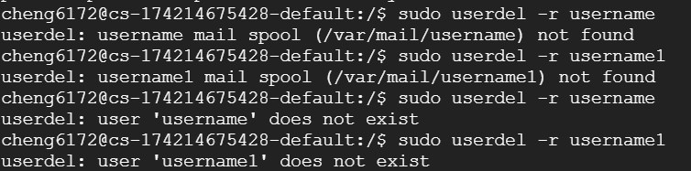
sudo userdel -r username
This command deletes the user "username" and removes their home directory (-r flag).
- Deleting Group:
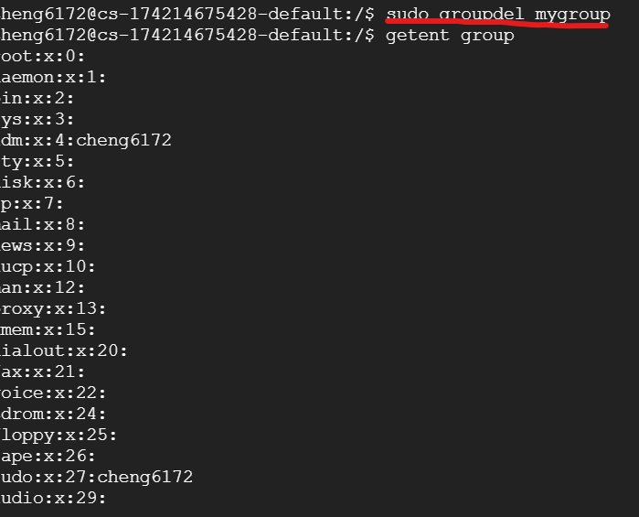
sudo groupdel mygroup
This command deletes the group "mygroup".
sudo enables users to run programs with the security privileges of another user, by default the superuser. [20]

Use of Windows OS scripts.
Windows Script Host provides an environment in which users can execute scripts in various languages that use various object models to perform tasks. [21] These script files are usually written using Windows batch (Batch) scripts with a .bat or .cmd file extension. Windows scripts can perform a variety of tasks.
- Creating BAT files
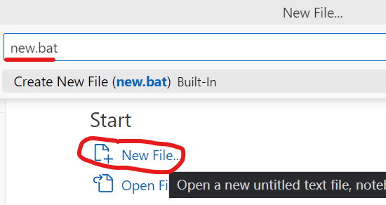
Using VS Code Create .bat file.
- Variables:
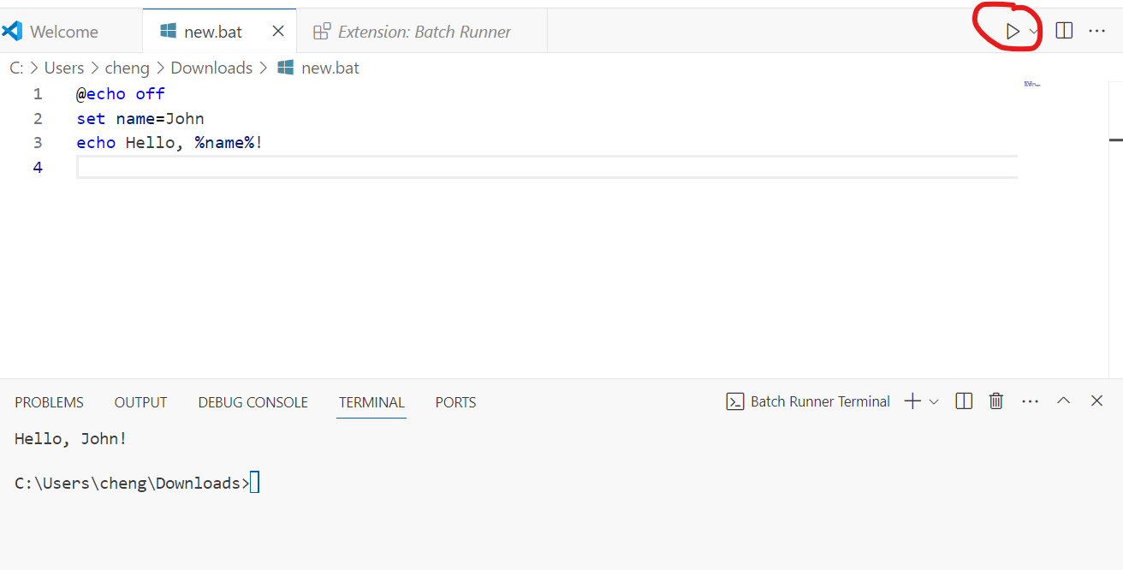
A variable is a unit of memory in which values are stored. [22] Used to store and retrieve data within a script. In batch scripting, variables are declared using the set command followed by the variable name and value.

- Goto command:
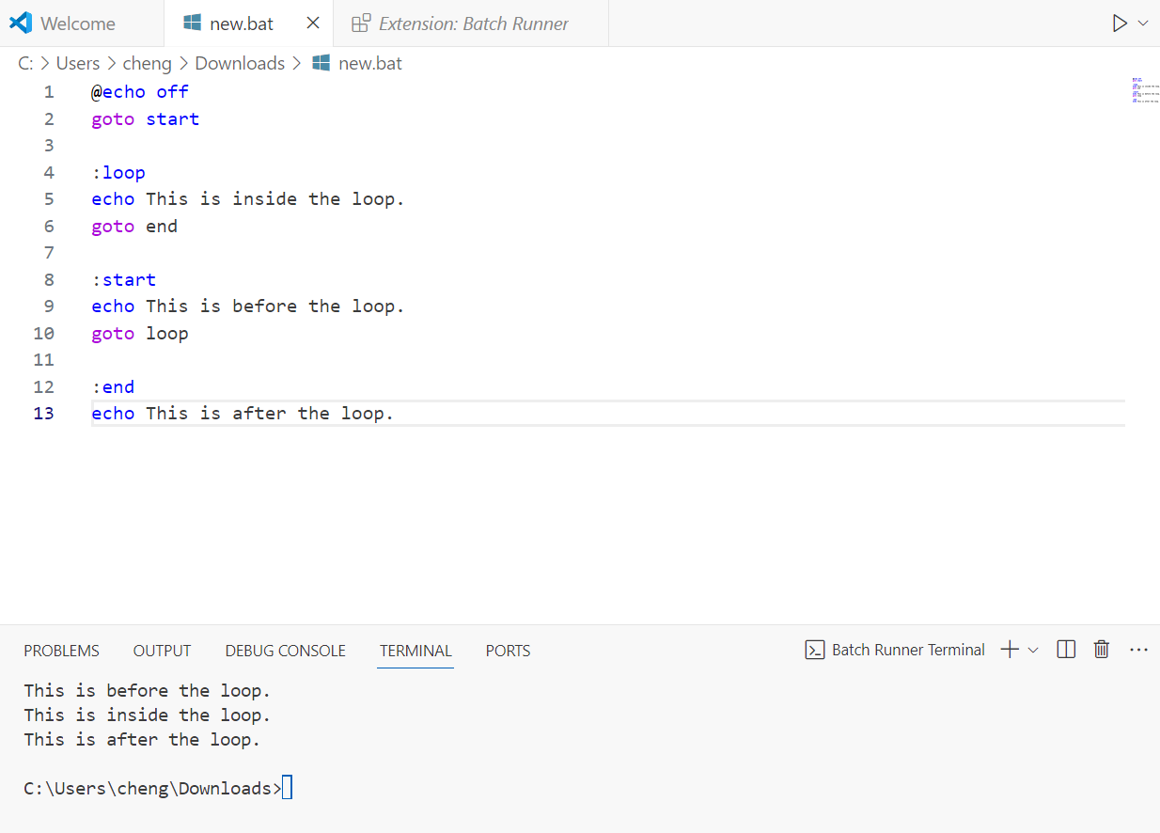
Transfers control to a specific label within the script. It's commonly used for looping and conditional branching.

- if statement:
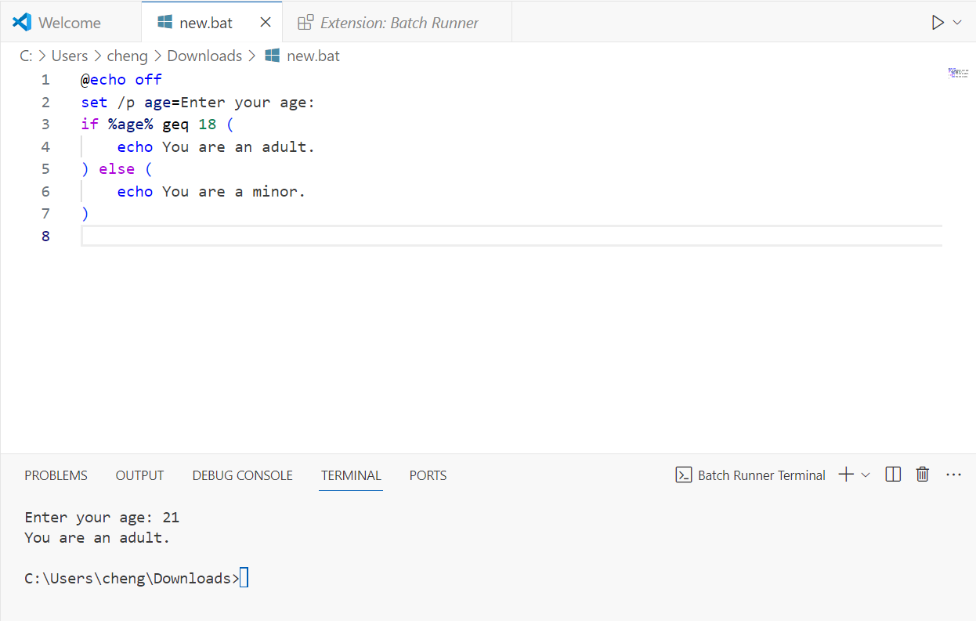
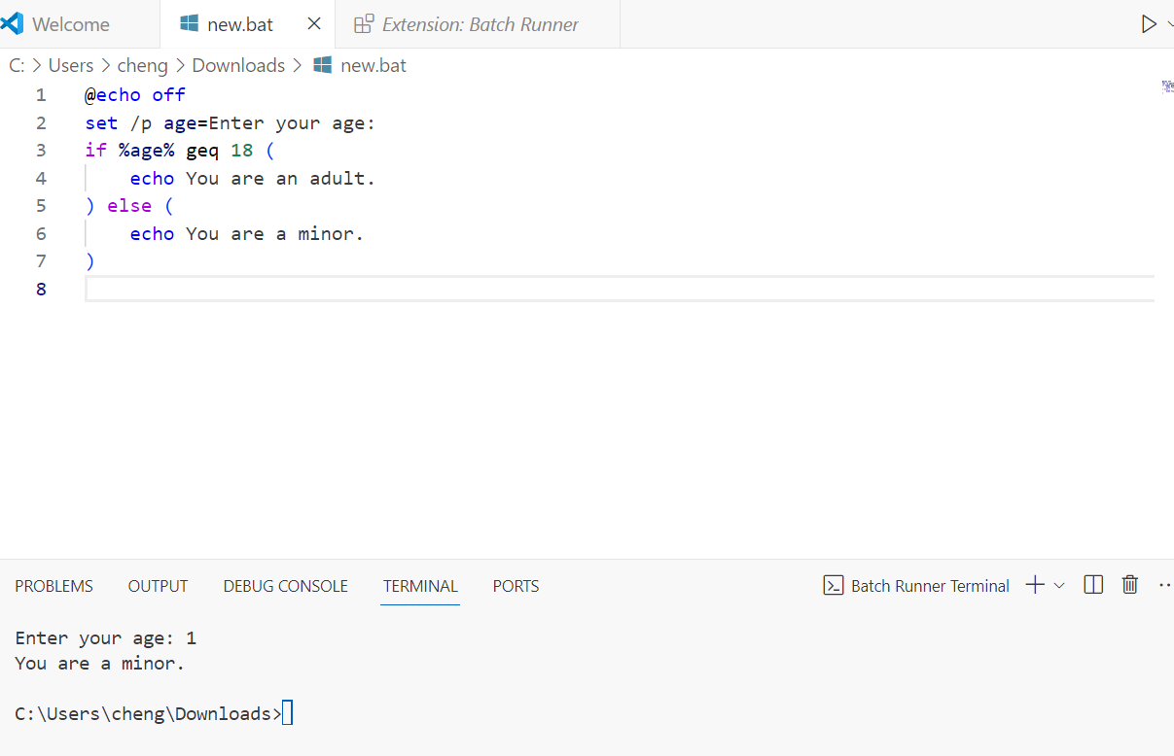
Allows conditional execution of commands based on the evaluation of an expression. It checks whether a certain condition is true or false and executes commands accordingly.

- for Loop:
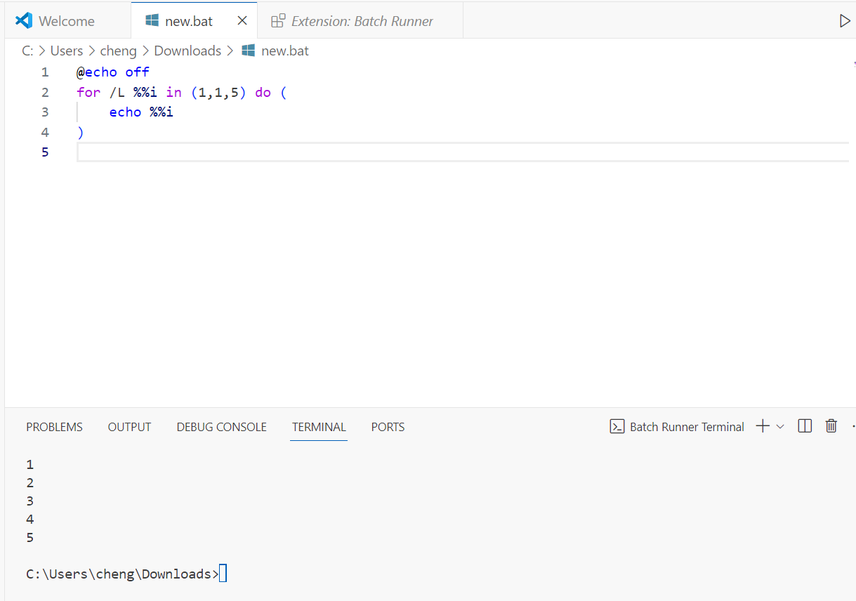
Iterates over a sequence of values or a list of items. It's commonly used for repeating a set of commands a specific number of times or processing files and directories.

- Array:
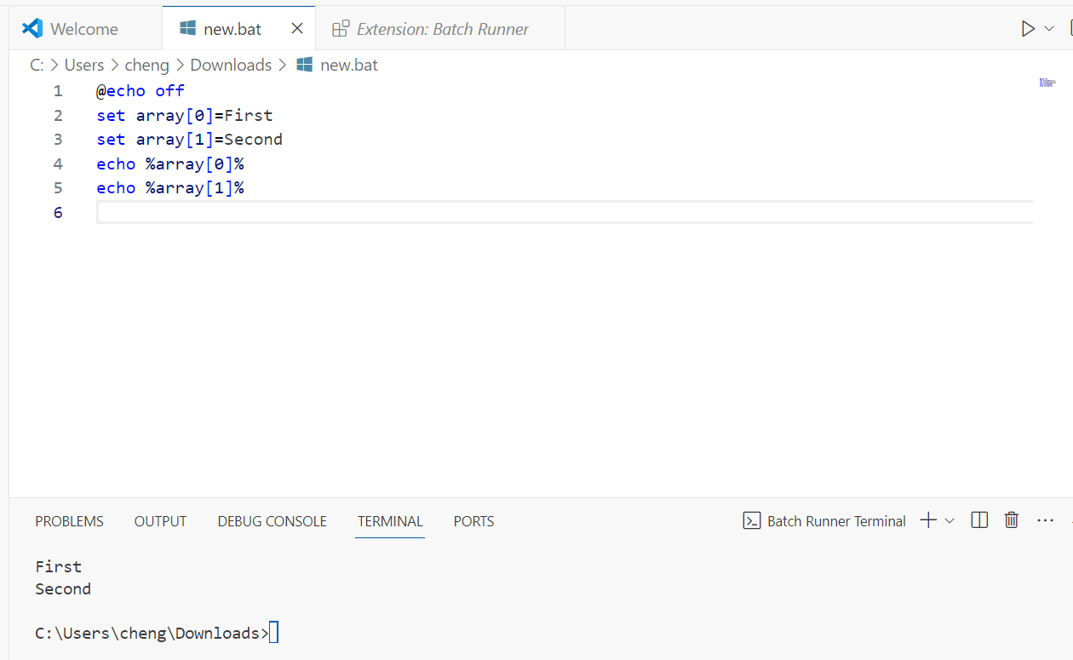
While batch scripting doesn't have native support for arrays, you can simulate them using variables with indexed names. Each element of the "array" is represented by a separate variable.

- Function:
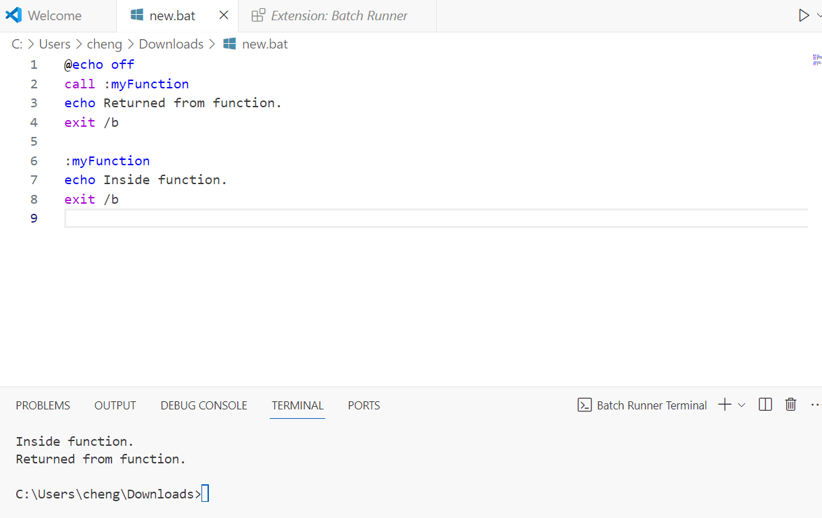
A reusable block of code that performs a specific task. Although batch scripting doesn't have built-in support for functions, you can create subroutines using labels and the call command to achieve similar functionality.

- User Input /p switch:
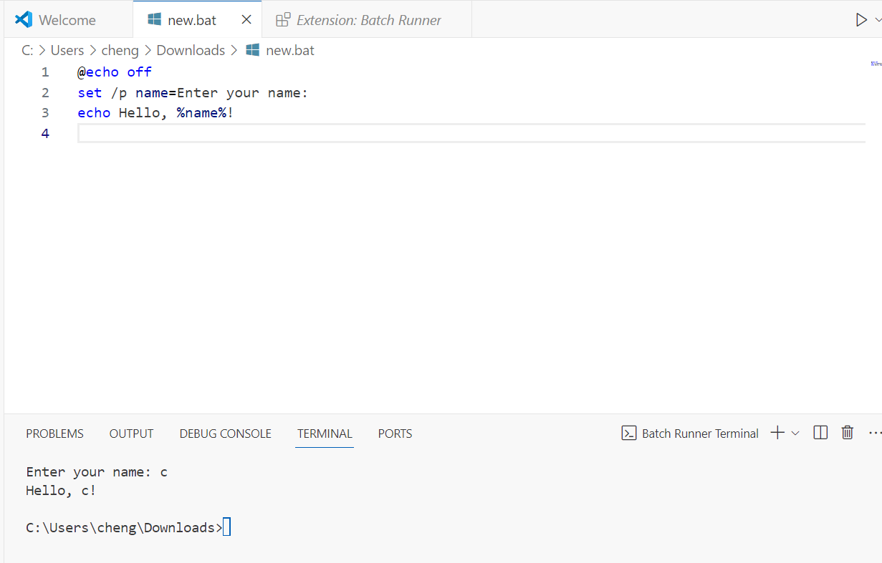
Allows the script to prompt the user for input during execution. It's commonly used to accept user input for variables or parameters within the script.
- List Files in Directory:
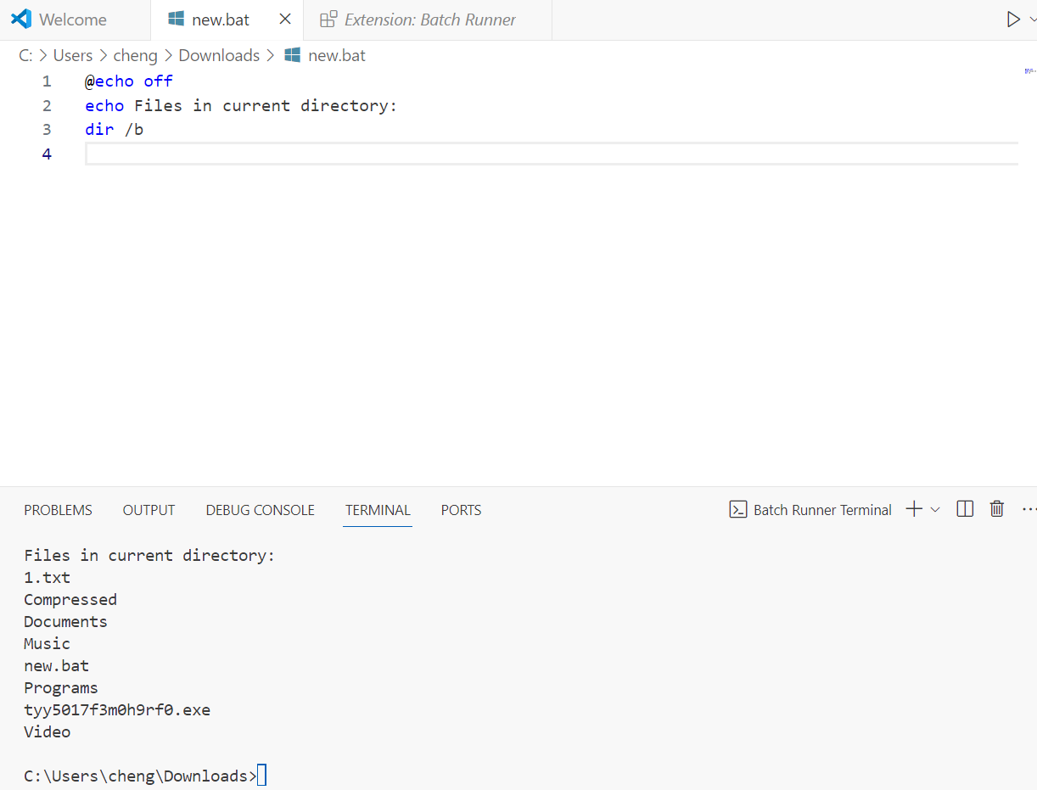
This script lists all files in the current directory in a simple format using the dir /b command. The DIR command is a powerful Windows Command Prompt function that lists all files and subdirectories contained in a specific directory. [23]

- Rename Files with Prefix:
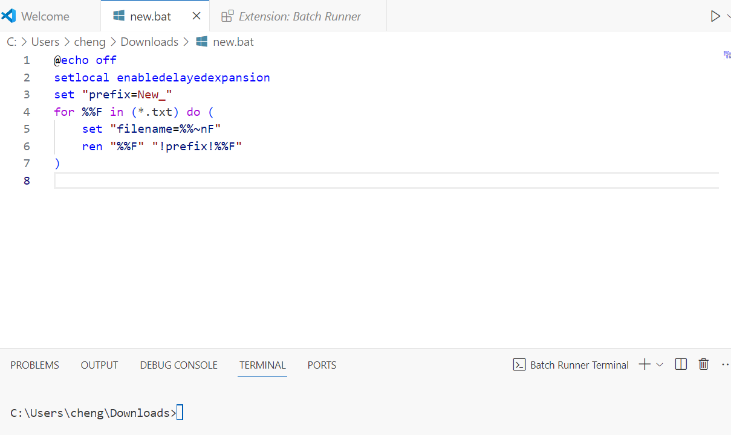
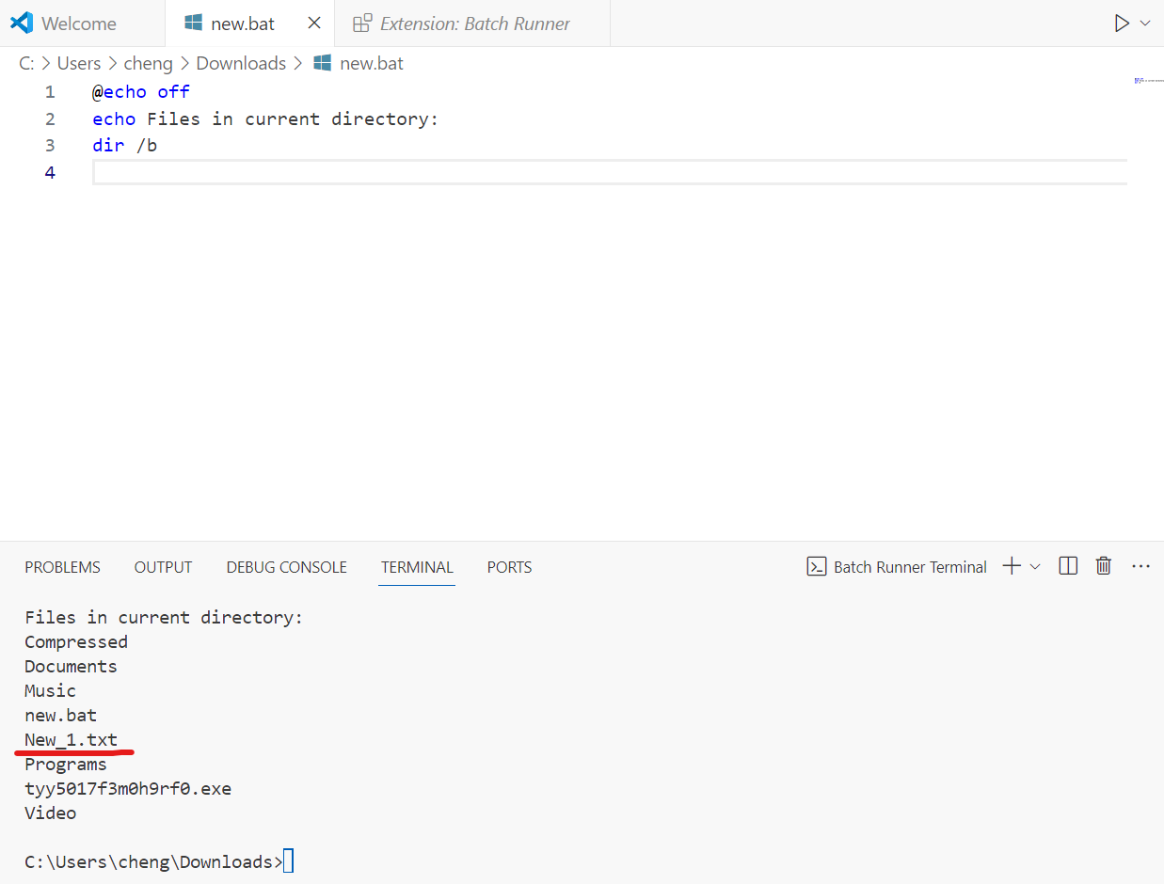
This script renames all .txt files in the current directory by adding a prefix "New_" to their filenames.

- Check Disk Space:
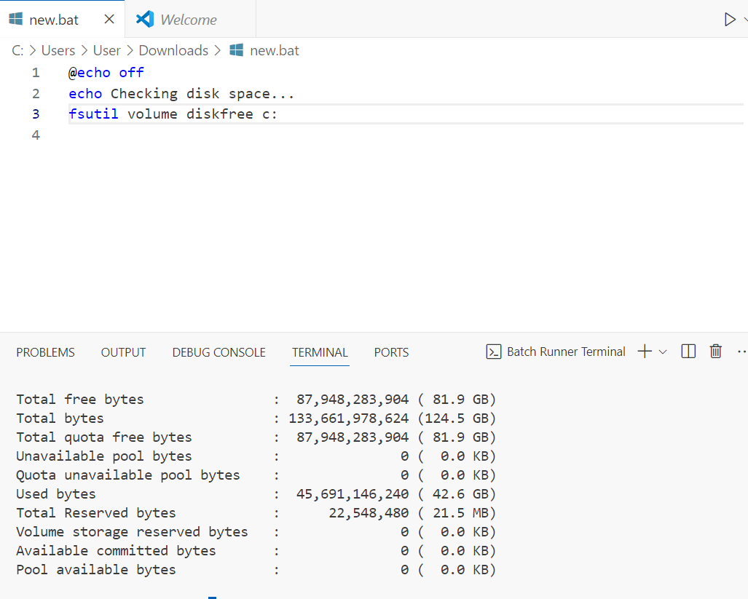
This script checks the available disk space on the C: drive using the fsutil volume diskfree command and displays the results. The fsutil command allows a Windows user with administrative privileges to query or enable symlinks on a Windows 10 system.[24]

Use of Linux OS scripts.
Linux OS scripting involves using scripting languages like Bash, Python, Perl, or Ruby to automate tasks, perform system administration, and develop applications within the Linux operating system environment. Below are ten key features of Bash scripting in a Linux environment. A Bash script is a plain text file which contains a series of commands. [25]
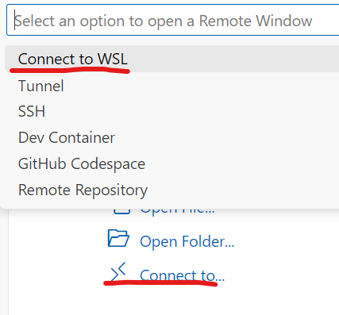
Using VS Code to connect WSL running Linux OS scripts.
- Shebang Line
A special line at the beginning of a script that tells the operating system which interpreter to use when executing the script. [26] The shebang line at the beginning of the script tells the system which interpreter to use. In Bash scripts, it typically looks like #!/bin/bash.
- Variables:
Bash allows you to define and use variables without explicitly declaring their data types. 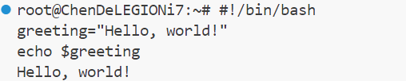

- User Input:
Capturing and processing data entered by users through various interfaces. [27] Bash scripts can interact with users by reading input from the keyboard.
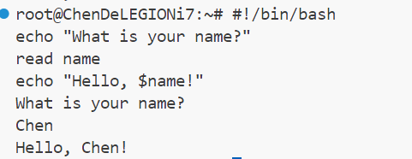
- Conditional Statements:
Bash supports conditional statements like if, else, and elif for decision-making in scripts.
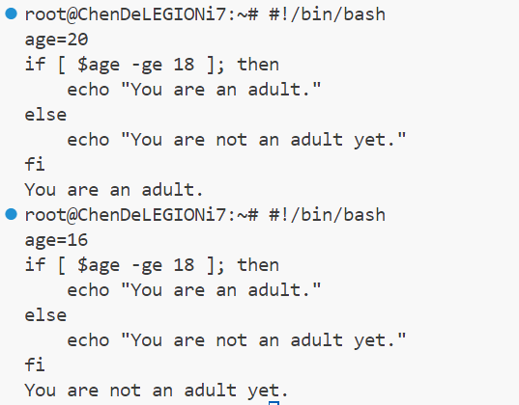
- Loops:
Bash provides different types of loops such as for, while, and until for iterating over lists of items or until a condition is met.
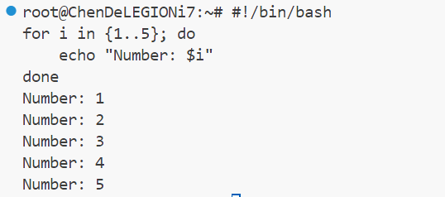

- Functions:
Bash allows you to define reusable blocks of code as functions.
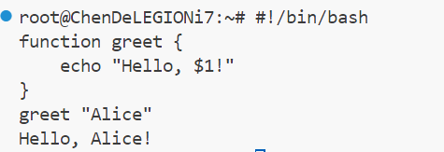
- Command Substitution:
Bash allows the output of a command to replace the command itself within a script.
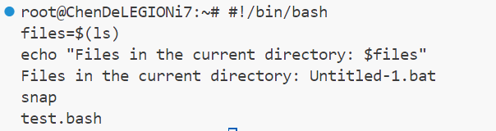
- File Operations:
Bash can handle file operations such as creating, deleting, reading, and writing files.
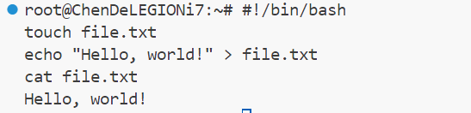
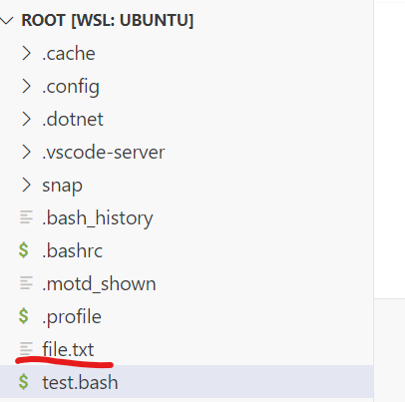

- String Manipulation:
Bash offers various string manipulation operations like concatenation, substring extraction, and length calculation.
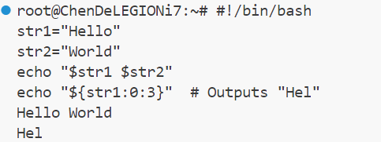
- Environment Variables:
Bash allows access to environment variables, which store information about the environment in which the script is running.
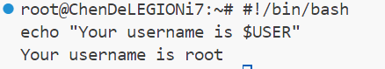

Conclusion
Operating systems serve as the foundational software that facilitates crucial functions in computing environments. The key functions of general operating systems encompass memory and process management, system security, device management, file and directory management, and network management. These functions collectively ensure the efficient operation and security of computer systems.

The utilization of command-line interfaces (CLI) and scripting further enhances the capabilities of operating systems. Windows OS CLI commands offer users a range of tools for system management tasks, such as file manipulation and network configuration. Similarly, Linux OS CLI commands, including utilities like ls, grep, and ipconfig, provide users with powerful tools for system administration and automation.

Moreover, scripting in both Windows and Linux environments enables users to automate repetitive tasks and customize system behaviour to meet specific requirements. Windows OS scripts, written in languages like PowerShell, facilitate automation of tasks such as system maintenance and software deployment. In contrast, Linux OS scripts, predominantly written in Bash, offer users the flexibility to automate system configurations, data processing, and more.

The integration of CLI commands and scripting capabilities in Windows and Linux operating systems empowers users to effectively manage and optimize their computing environments, enhancing productivity and efficiency in various computing tasks and applications.

Appendices
- Getting started with Google Shell Cloud:
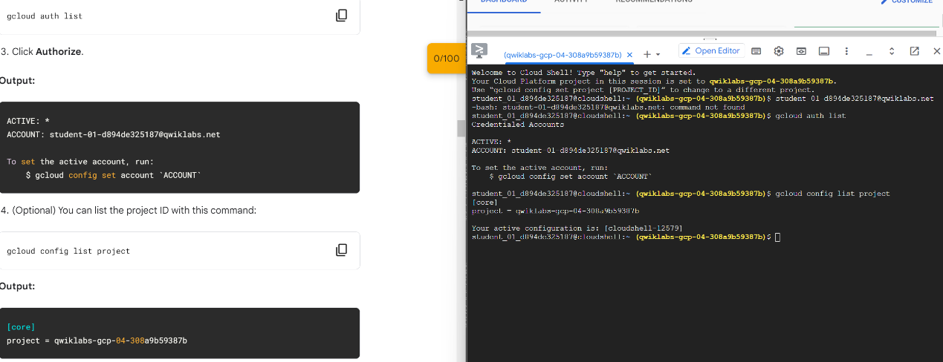
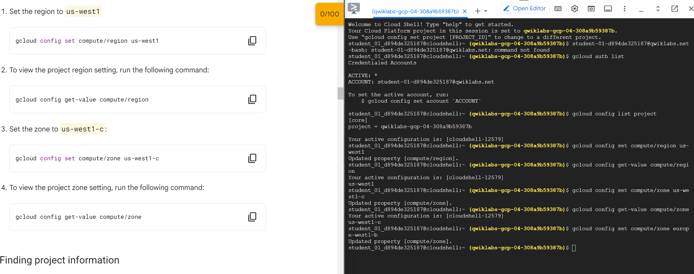
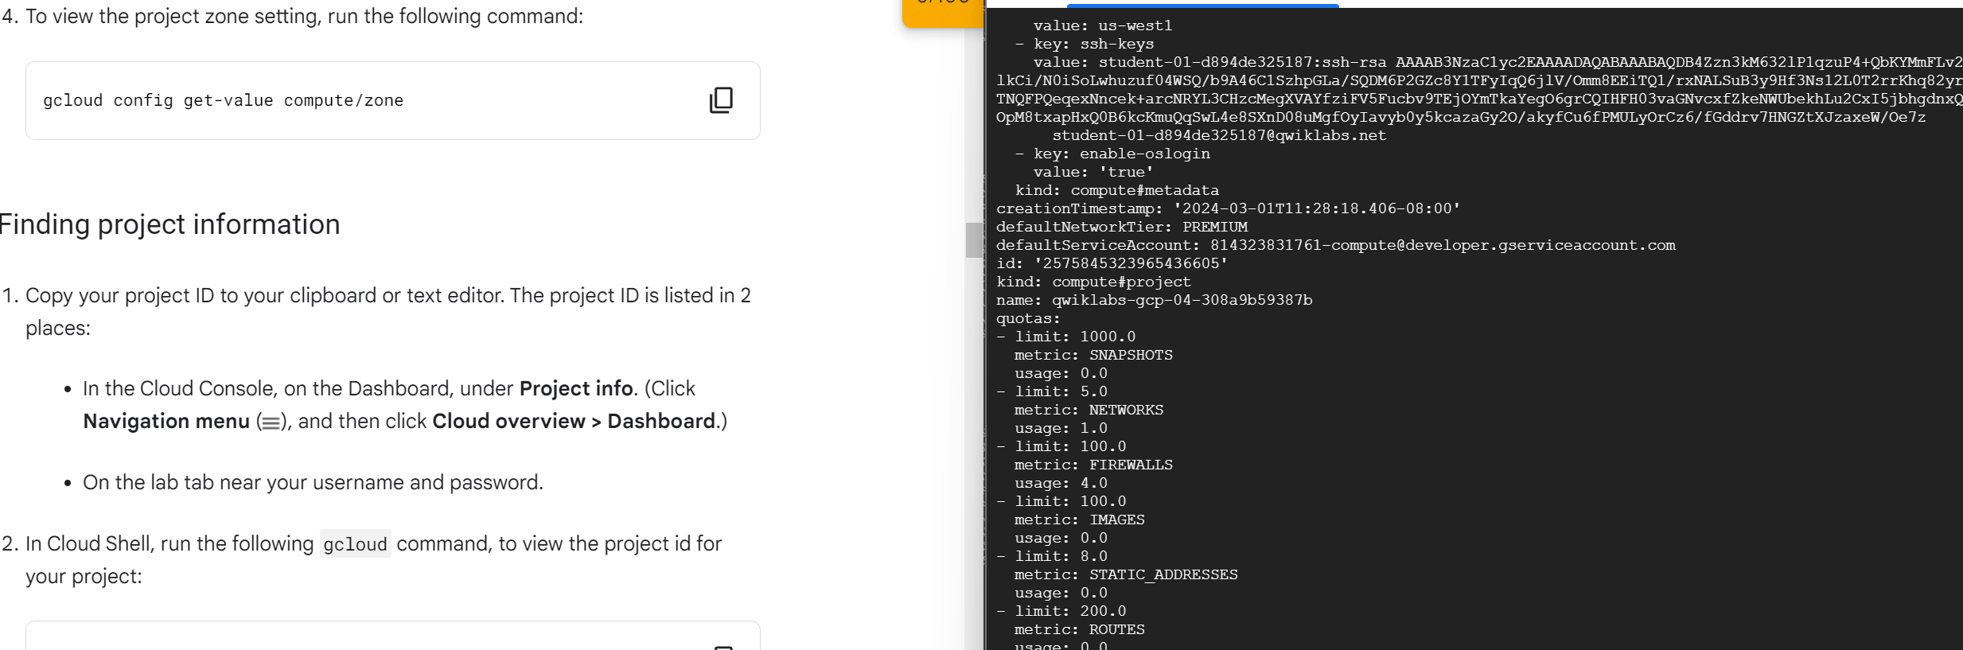
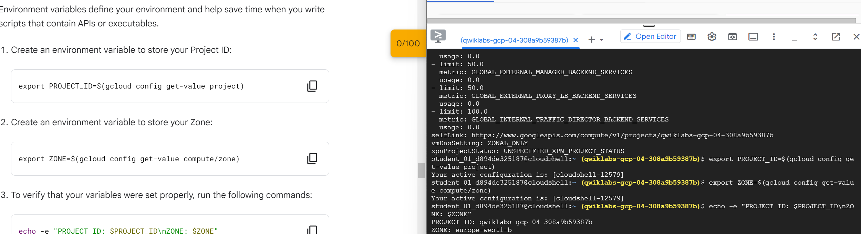
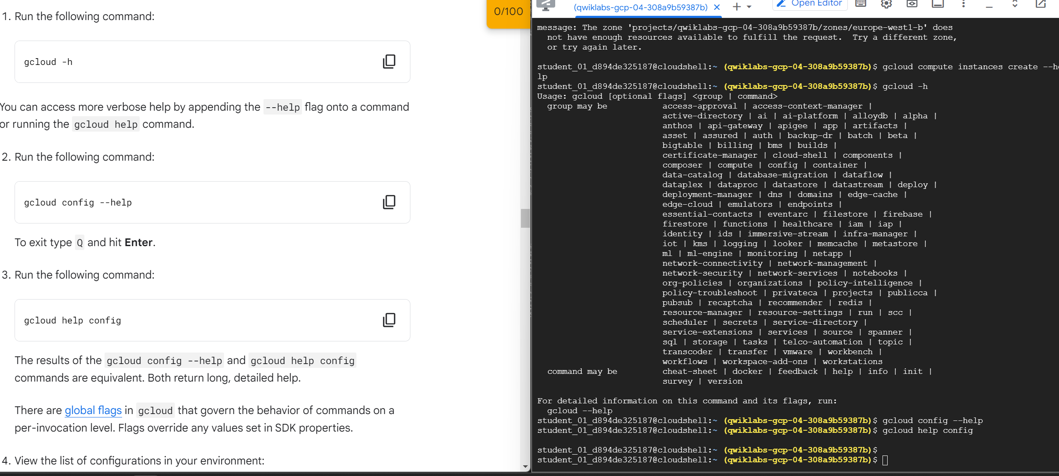
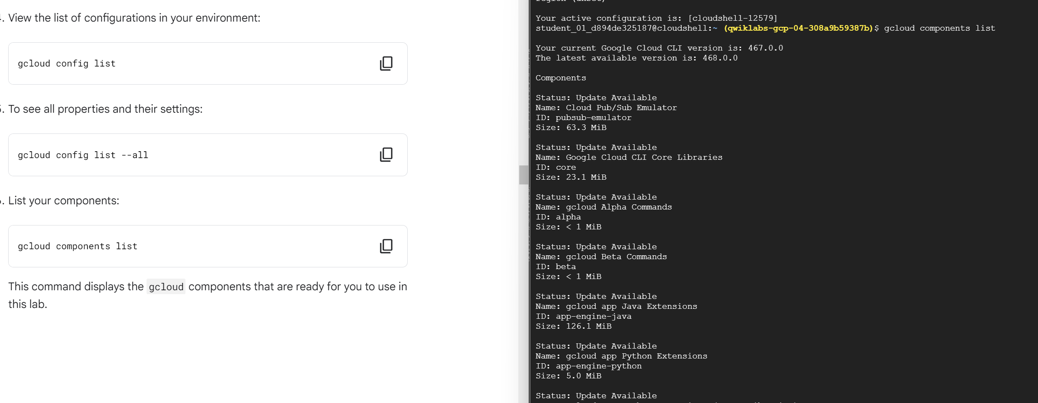
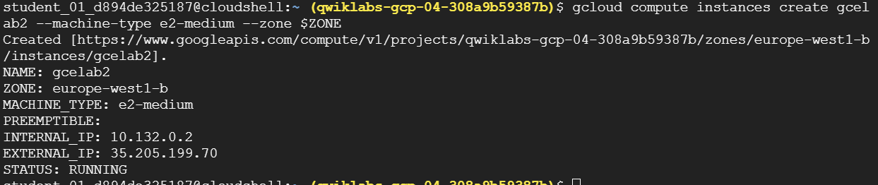
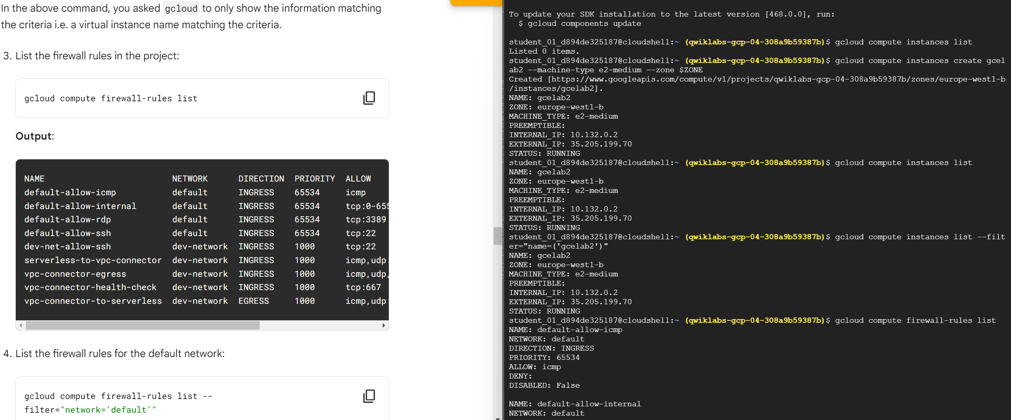
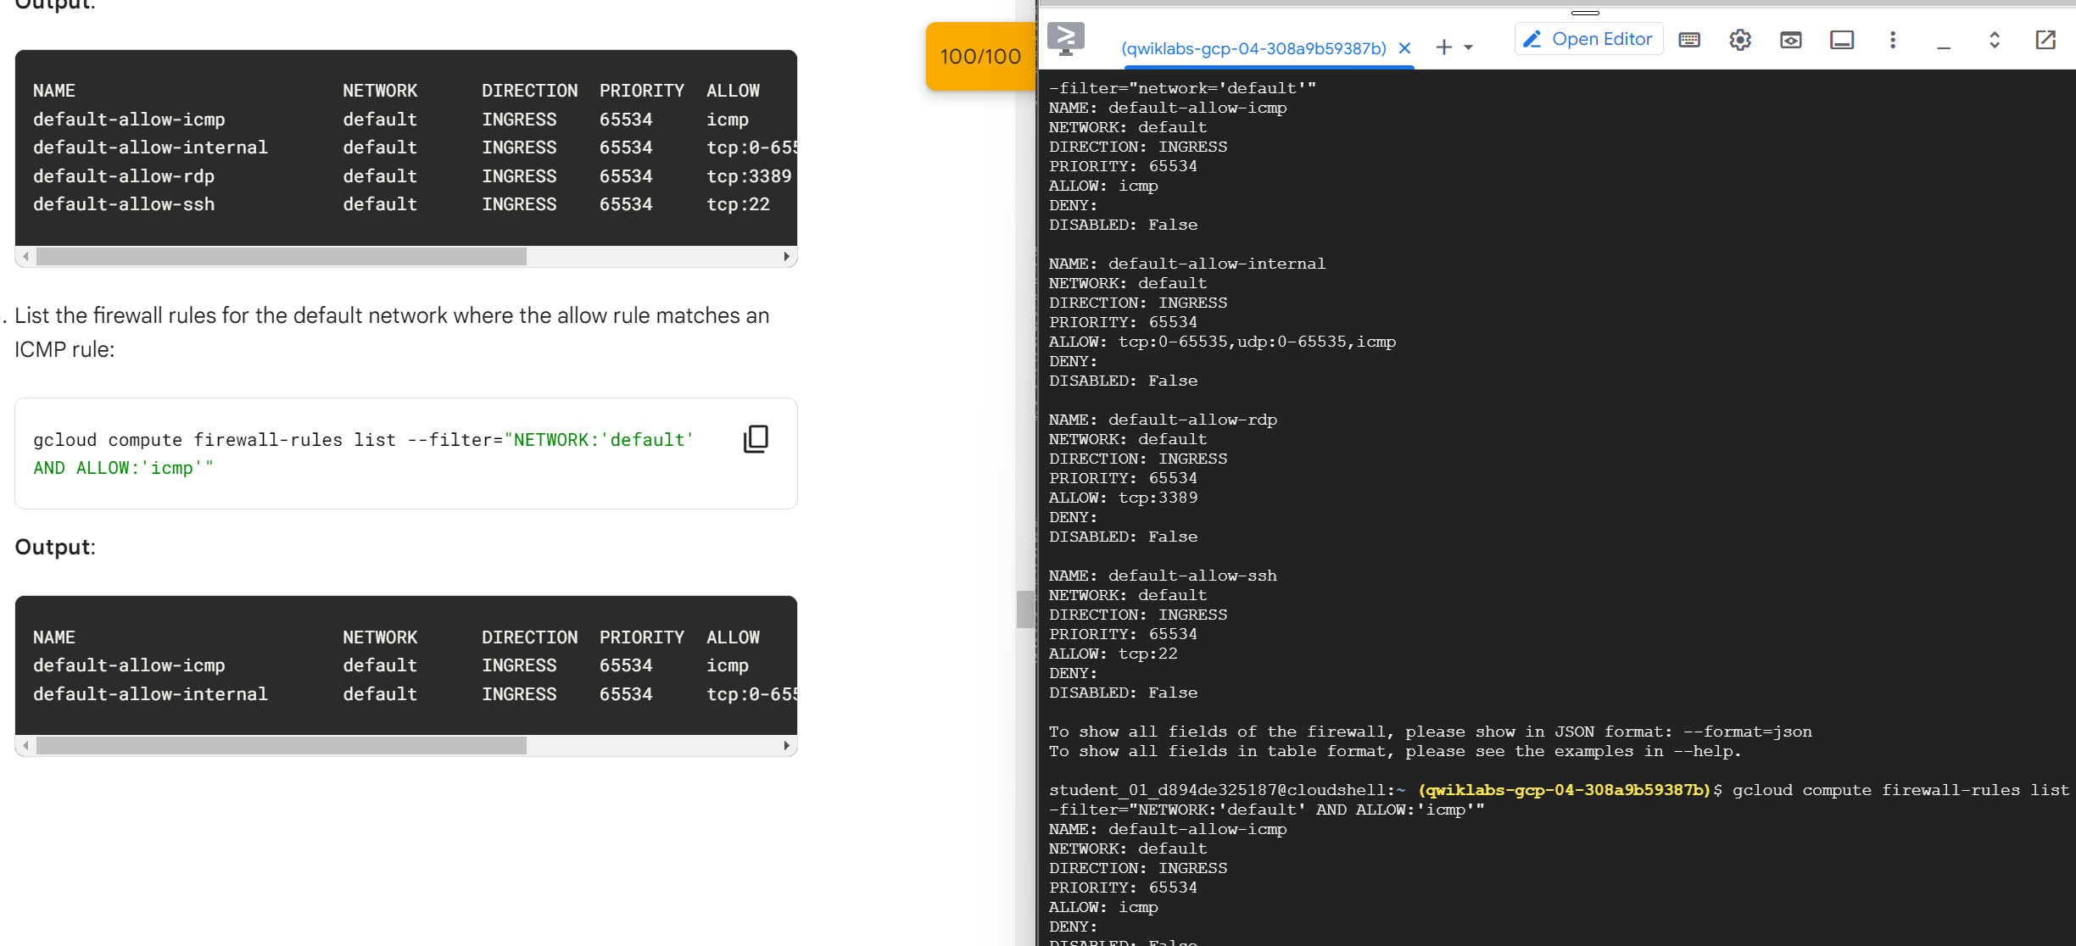
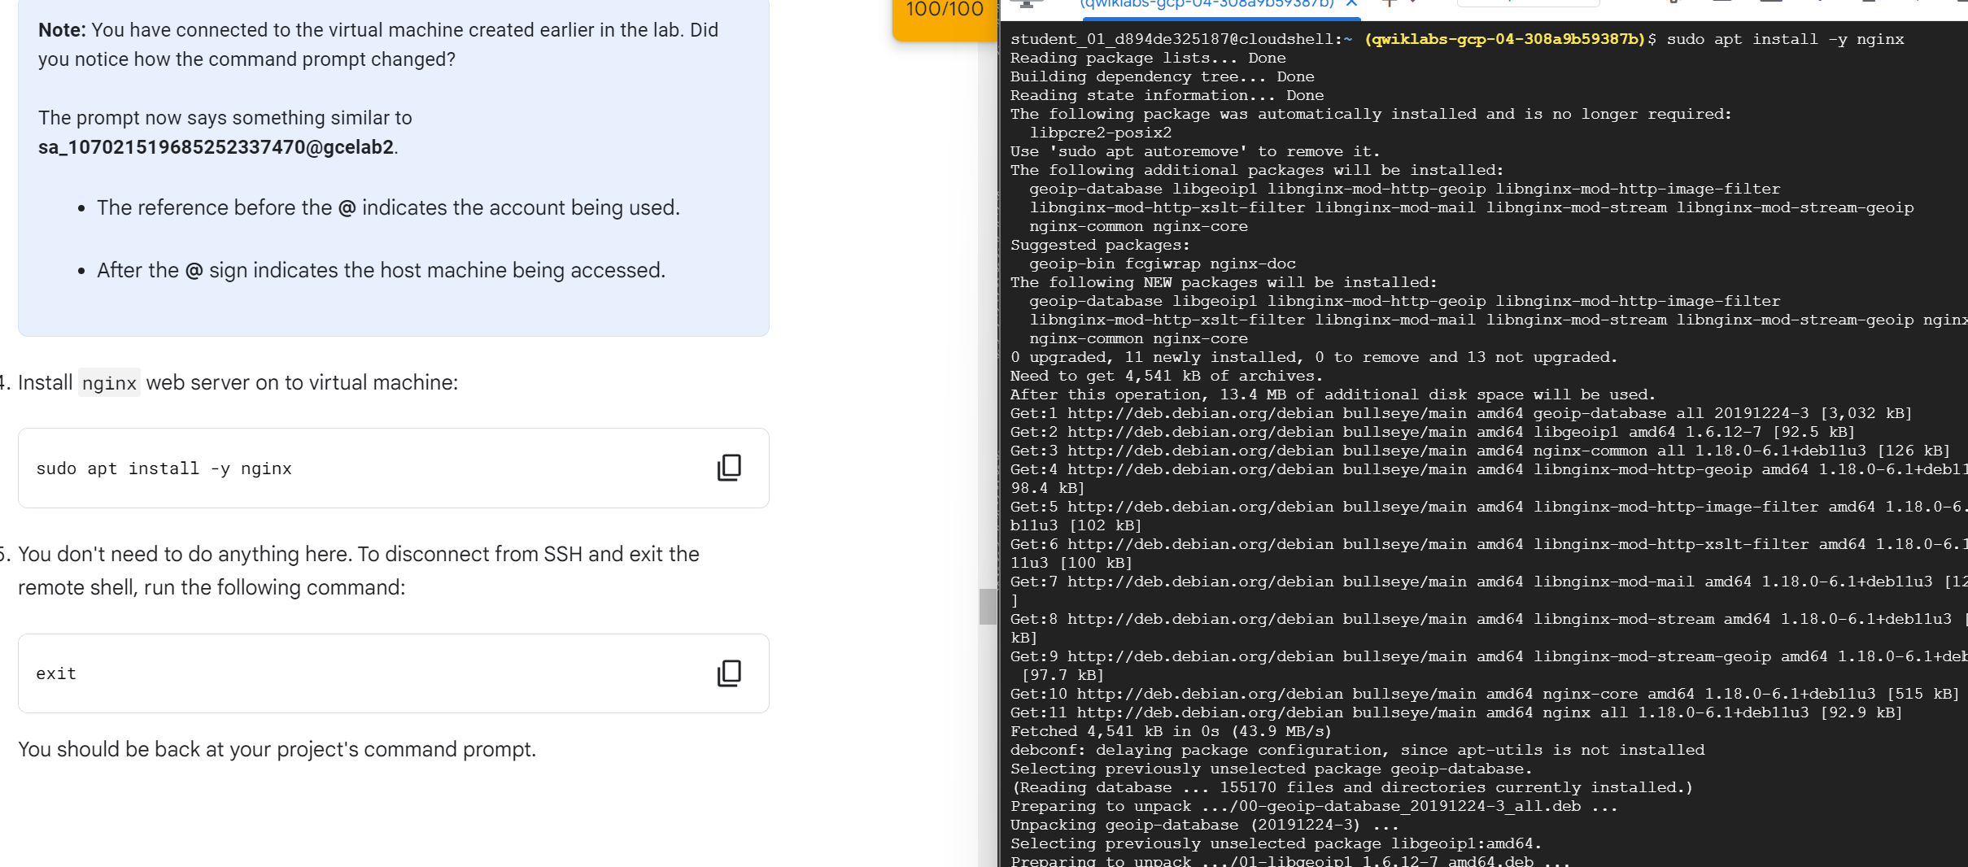
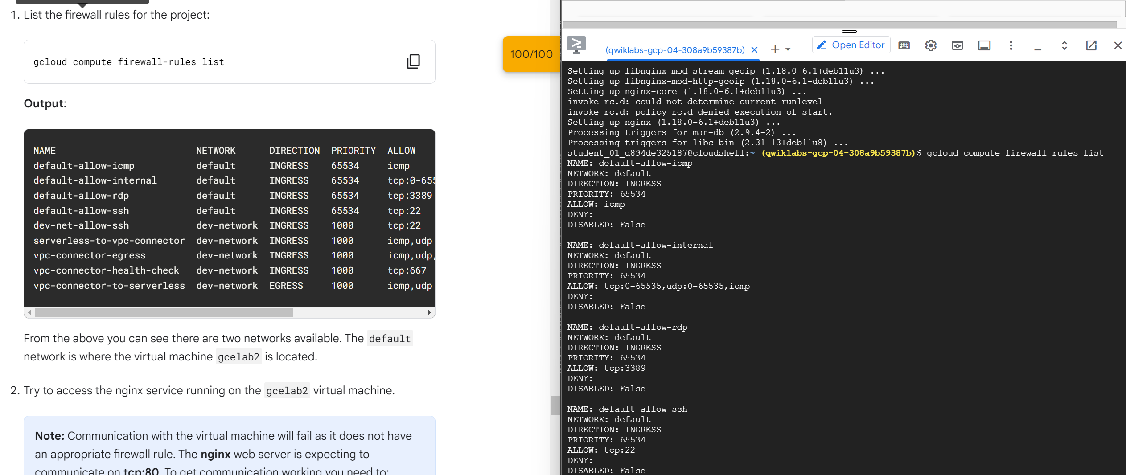
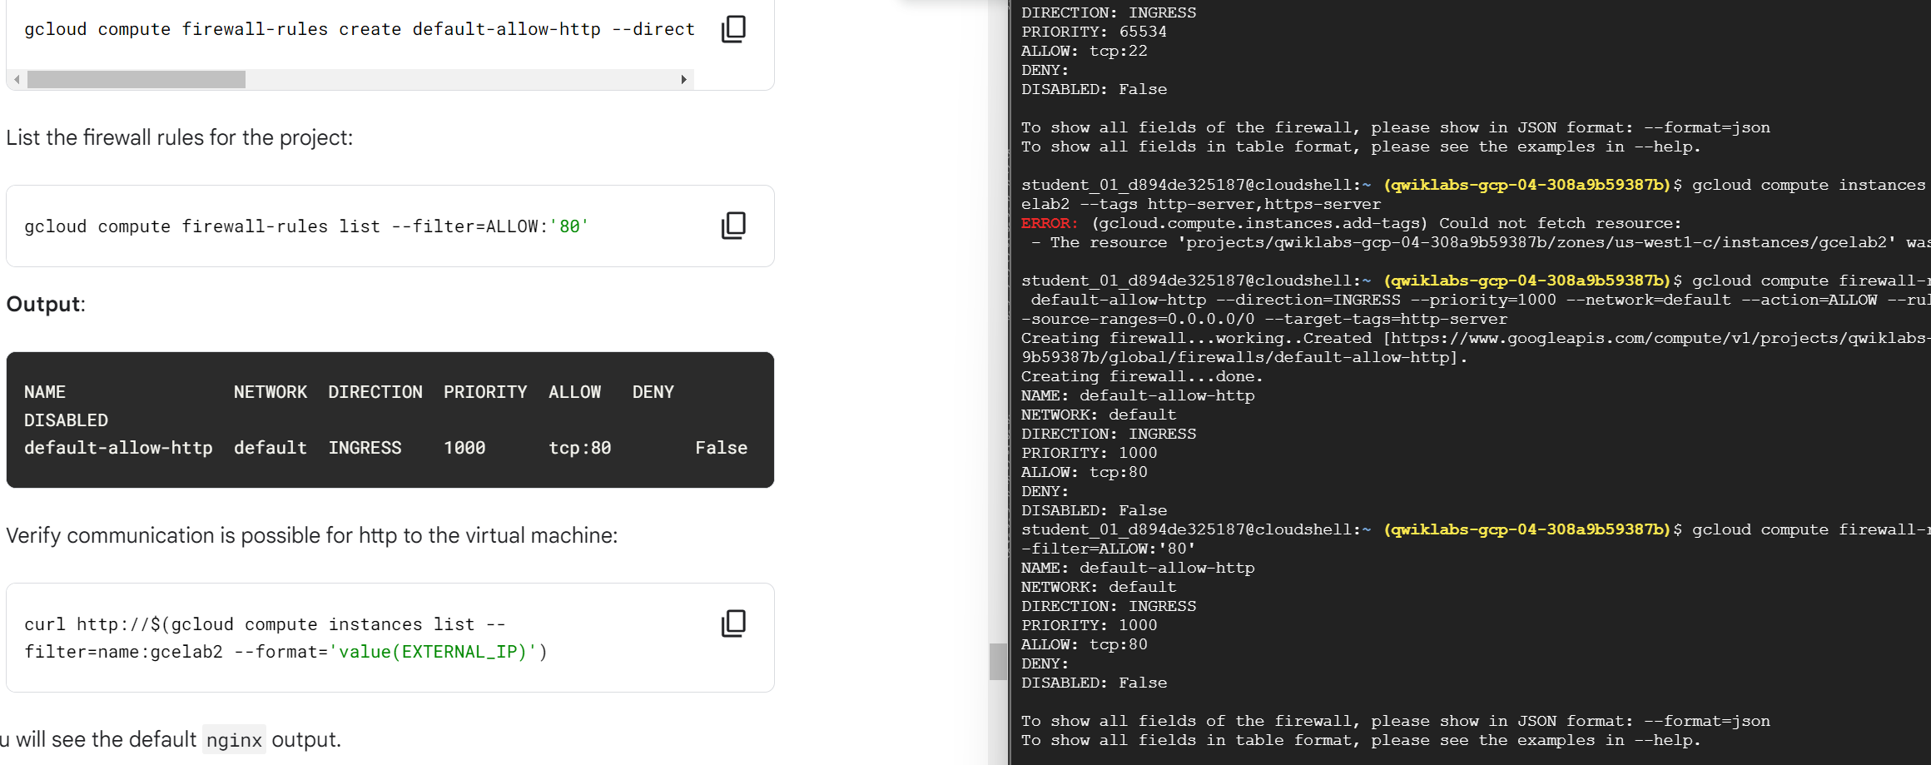
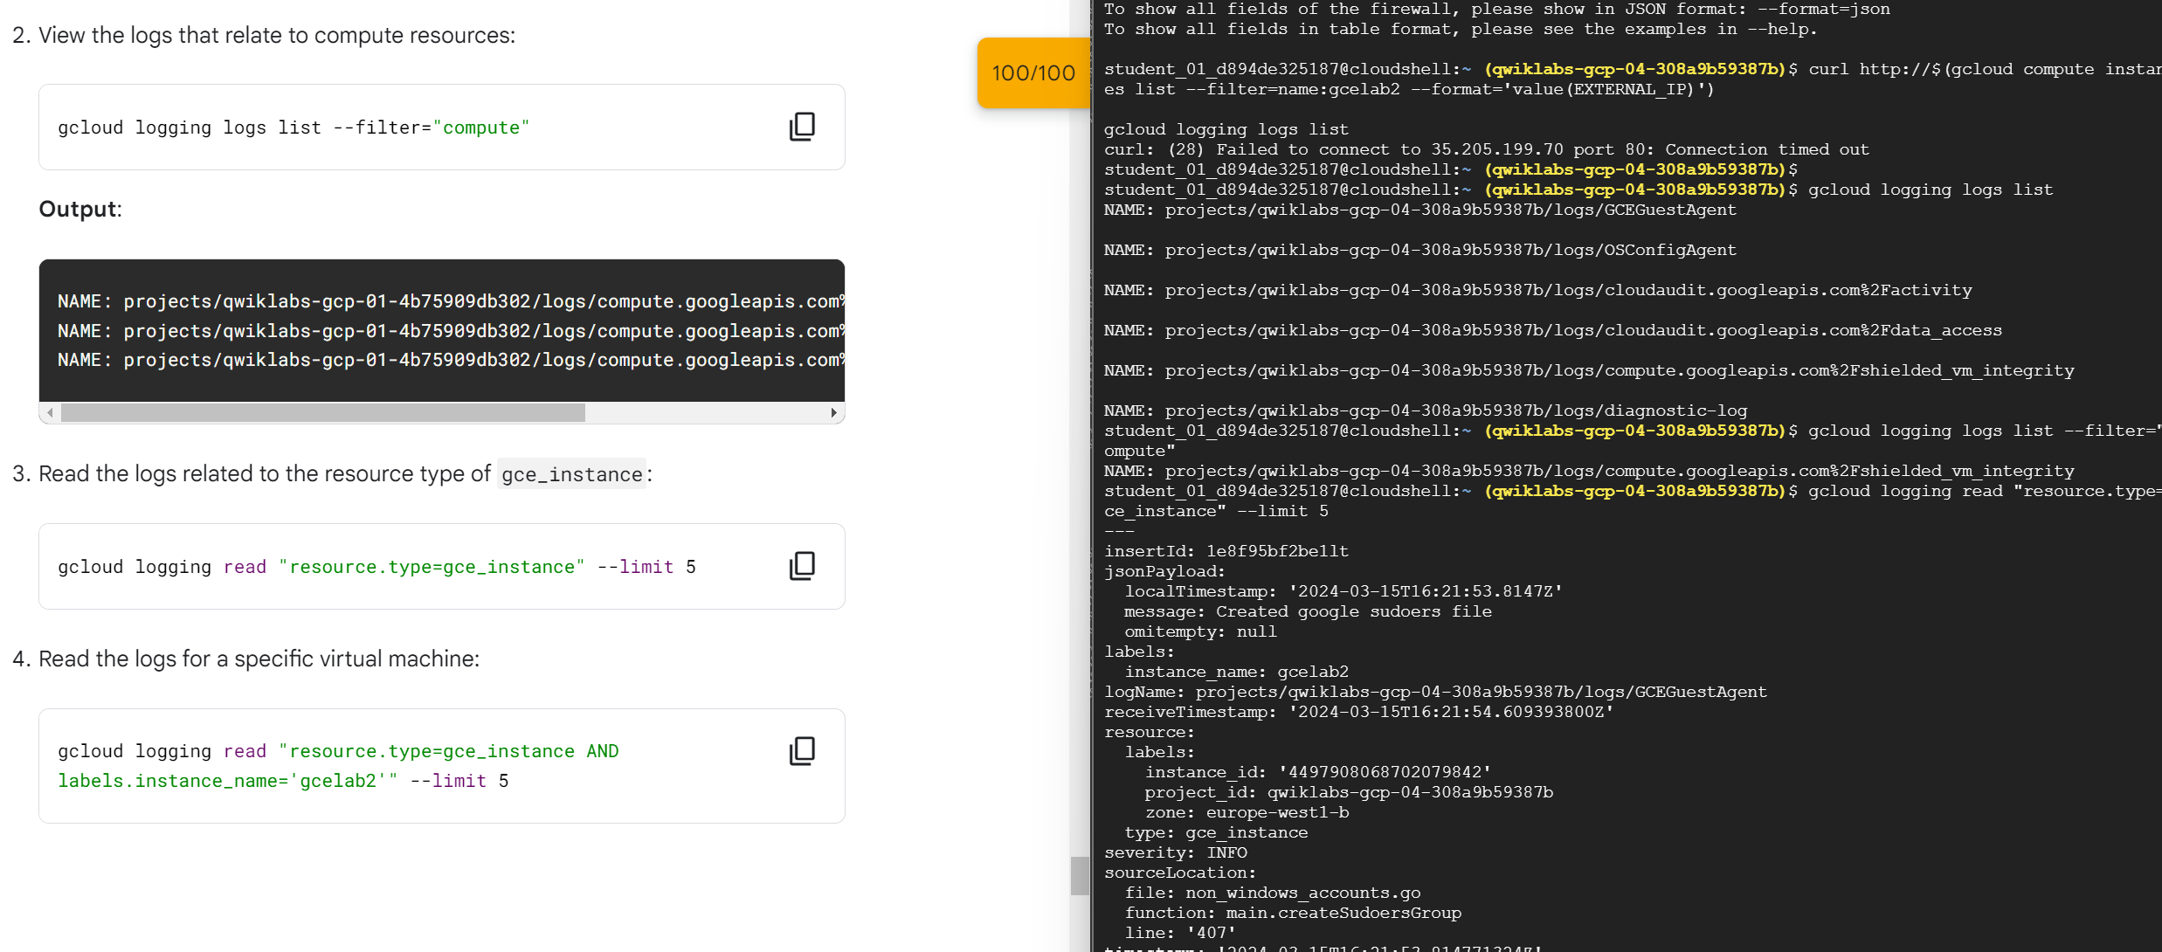

Reference list
[1] “What is an Operating System (OS)? Definition, Types and Examples.” https://www.techtarget.com/whatis/definition/operating-system-OS (accessed Feb. 01, 2024).
[2] “What is an Operating System?,” 2021. https://www.geeksforgeeks.org/what-is-an-operating-system/ (accessed Feb. 01, 2024).
[3] https://img-prod-cms-rt-microsoft-com.akamaized.net/cms/api/am/imageFileData/RW1f2Ox
[4] File:MacOS Big Sur Desktop.png - Wikipedia
[5] File:Ubuntu 23.10 Mantic Minotaur Desktop English.png - Wikimedia Commons
[6] File:iOS 17 Homescreen.png - Wikipedia
[7]https://upload.wikimedia.org/wikipedia/commons/7/71/Pixel_4a_Android_11_Launcher.png
[8] “What is memory management in a computer environment?” https://www.techtarget.com/whatis/definition/memory-management (accessed Mar. 14, 2024).
[9] “Operating System Security.” https://www.techopedia.com/definition/24774/operating-system-security-os-security (accessed Mar. 14, 2024).
[10] “Device Management in Operating System,” 2023. https://www.geeksforgeeks.org/device-management-in-operating-system/ (accessed Mar. 14, 2024).
[11] “File and Directory Management.” https://www.tutorialspoint.com/computer_concepts/computer_concepts_file_directory_management.htm (accessed Mar. 14, 2024).
[12] “What is CLI.” https://www.w3schools.com/whatis/whatis_cli.asp (accessed Mar. 14, 2024).
[13] “dir.” https://learn.microsoft.com/en-us/windows-server/administration/windows-commands/dir (accessed Mar. 14, 2024).
[14] “Tasklist - Display all running applications - Windows CMD - SS64.com,” Accessed: Mar. 14, 2024. [Online]. Available: https://ss64.com/nt/tasklist.html.
[15] “How Do I Use Ipconfig In the Command Prompt or Terminal?,” Accessed: Mar. 14, 2024. [Online]. Available: https://support.intermedia.com/app/articles/detail/a_id/27175/~/how-do-i-use-ipconfig-in-the-command-prompt-or-terminal%3F.
[16] M. H. last updated, “How to use powercfg to control power settings on Windows 10,” 2021. https://www.windowscentral.com/how-use-powercfg-control-power-settings-windows-10 (accessed Mar. 14, 2024).
[17] “The Linux command line for beginners.” https://ubuntu.com/tutorials/command-line-for-beginners (accessed Mar. 15, 2024).
[18] C. Hoffman, “Add a User to a Group (or Second Group) on Linux,” 2017. https://www.howtogeek.com/50787/add-a-user-to-a-group-or-second-group-on-linux/ (accessed Mar. 15, 2024).
[19] “getent command in Linux with examples,” 2019. https://www.geeksforgeeks.org/getent-command-in-linux-with-examples/ (accessed Mar. 15, 2024).
[20] Cohen, Noam (May 26, 2008). "This Is Funny Only if You Know Unix". The New York Times. Archived from the original on January 22, 2018. Retrieved April 9, 2012.
[21] “wscript.” https://learn.microsoft.com/en-us/windows-server/administration/windows-commands/wscript (accessed Mar. 15, 2024).
[22] “about Variables - PowerShell.” https://learn.microsoft.com/en-us/powershell/module/microsoft.powershell.core/about/about_variables?view=powershell-7.4 (accessed Mar. 15, 2024).
[23] B. Gavin, “How to Use the DIR Command in Windows,” 2018. https://www.howtogeek.com/363639/how-to-use-the-dir-command-in-windows/ (accessed Mar. 15, 2024).
[24] “IBM Documentation,” Apr. 08, 2021. https://www.ibm.com/docs/en/zos/2.4.0?topic=clients-using-commands-windows (accessed Mar. 15, 2024).
[25] “What is a Bash Script? - Bash Scripting Tutorial,” Accessed: Mar. 17, 2024. [Online]. Available: https://ryanstutorials.net/bash-scripting-tutorial/bash-script.php.
[26] “Using Shebang #! in Linux Scripts.” https://www.tutorialspoint.com/using-shebang-hash-in-linux-scripts (accessed Mar. 17, 2024).
[27] “Understanding User Input in Software Development | Reintech media.” https://reintech.io/terms/category/user-input-handling-software-development (accessed Mar. 17, 2024).

