
Project Planning
ACHMA5007
ACHA5012

BEng, Automotive Engineering

231600
Niall Hindmarch
Contents
Introduction 3
Team structure 4
Gantt chart 8
Preliminary Bill of Materials 10
Summary Gantt Chart 12
Further Project Improvement Analysis 13
Conclusion 14
References 15

Introduction
I am tasked with the comprehensive strategic planning and execution of a performance enhancement initiative for an automotive platform. This project demands the application of advanced engineering principles (such as extensive uses of Bilstein Dampers, applications of advanced composites and aero balance), commencing with the empirically derived benchmark of the current vehicle performance. To test the high-fidelity vehicle dynamics model with an industry standard simulation, VI Grade is needed as it requires meticulous integration of sub-system parameters that is inclusive of the chassis, suspension, powertrain, braking and tyre. VI Grade has mandatory model validation against on road data which confirms the credibility of using in real world. With the simulation data and a detailed data acquisition plan, analysis and comparison can be performed to make the correct decision on improving the chassis and powertrain to the most optimal stage.
Throughout the whole project there are numerous tests as we try to develop all aspects of the vehicle with a process of design, build, develop and test protocol. This project requires meticulous planning, providing a provisional bill of materials detailing the estimated costs and critical supplier lead times, however, the risk of system mitigation is non-negotiable as there cannot be any step overs or cutting edges to minimalise the chances of failure. Project progression will be prominent; as a team, we have clear objectives and milestones along the way. This optimises the team collaboration as we use Belbin’s model to align our individual skills and personality traits to each defined role along with their respective responsibilities.

Team structure
My core responsibility in this project is the role of vehicle dynamics modelling specialist. This requires deep technical understanding and methodical analysis. This includes leading the entire simulation track, from parameter collection (T1) through to the performance analysis (T5). I am responsible for validating the precision in the VI Grade model (T2, T3, T4), ensuring that the output demonstrates the required R² > 0.95 correlation with the benchmark data. Failure to reach this standard will result in compromising the entire project’s ability to recommend the accuracy of design modifications and my critical position as everything is liable to me. The depth aligns precisely with Belbin’s team role as I contribute in-depth knowledge and skills that are rare within a team, by providing the technical credibility that is necessary for the complex simulation requirements (Belbin, 2010). My second role is being the Completer Finisher as I am required to stand by the rigorous standards, staying on point with the meticulous detail required for data accuracy, model validation, and the final presentation of simulation results.
Nia has been assigned the role that is highly specialised in braking and tyre sub-system and implementation lead. This role requires an iterative approach to analysis and attention to regulatory compliance to ensure the project deliverables translates effectively from simulation to reality. Her core accountability involves three distinct phases, first, she must conduct a regulatory and technical audit. Doing this audit is crucial preparation towards the identification of components such as callipers, discs and pads etc. then forth, Nia is required to do measurement and recording of the wheel clearances. Wheel clearances are prerequisite for assessing the compatibility for high performance callipers and research into the regulations that may be applicable for example, the Welsh Sports & Saloon Car Championship.
Secondly, Nia has the responsibility for the empirical performance assessment phase, this requires analysis of previous vehicle data which includes the thermal profiles of the braking system and dynamic tyre behaviour. With the analysis we can then determine the efficiency, temperature management, and system performance so we can review the potential upgrades. The component upgrades could be racing grade callipers or performance discs. This assessment aligns with her Belbin trait Monitor Evaluator, as she applies analysis and judgement to prevent any non-compliant modifications, thereby safeguarding the projects budget and timeline (Belbin, 2010).
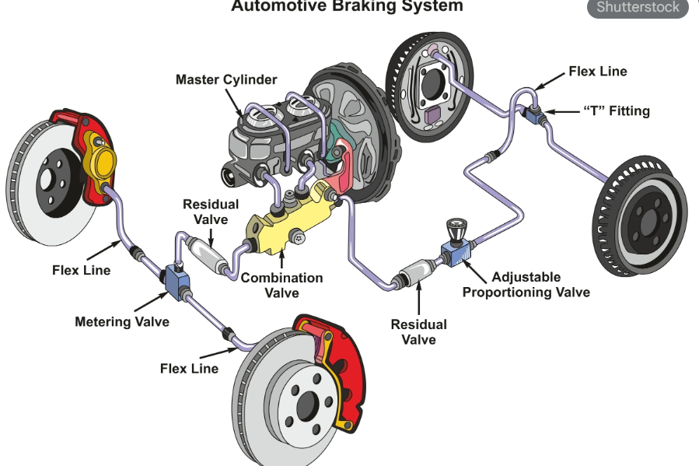
Image (1) Gemini
In the last and final phase, Nia is required to oversee the practical execution and implementation phase which includes the component procurement and precise installation of the upgraded system and multi-compound tyres. The final phase requires no margin to error on the proper fitment, clearance, and alignment as it ensures the safety of the vehicle and matches the competitive standards/regulations. Nia’s perseverance confirms her rightness to acquire for the Completer Finisher role as she guarantees the physical output and safety of the project despite the risks of failure. Not only guaranteeing the physical output, but she also ensures the safety standards are met and the performance is optimal before track testing is authorised (Belbin, 2010).

Luke’s role is focusing on the suspension dynamics specialist and model integrator; this role is crucial to ensuring the structural and kinematic fidelity of the final simulation. His main obligation is to form a detailed analysis and representation of virtual suspension systems. This begins with extensive research and collection of existing vehicle data, containing wheelbase, track width, vehicle mass, unsprung mass, and suspension geometry of both the plus four and six systems. Data of these forms the essential foundation for modelling that integrates with my own role. Luke then advances to construction of the virtual model using Wingeo, creating a suspension model that reflects the measured geometry and subject to kinematic simulation to predict the behaviour.
An important verification step is next, when the simulated kinematic predictions are verified through the practical tests, analysis and comparison is crucial to see the link between the simulation (virtual) and physical tests, with that data you can see how accurate the Wingeo environment is. The comparison and analysis then prove the Monitor Evaluator Belbin’s role, confirming that all outputs are credible data and sound judgement (Belbin, 2010). The final function is to be the Primary Model Integrator, as Luke then takes the suspension and geometry data and coalescing it with data from the other team members such as myself to create the final Morgan model in VI Grade.

Josh is the designated Chassis development and testing lead. He is expected to have accountability to maintain structural integrity analysis and validation of the modifications made on the vehicle platform. The job is divided into two distinct stages: analysis and validation.
The analysis stage focuses on understanding the limitations and performance of the chassis structure. Starting with research into the chassis development, which requires a complete review of structural performance under racing conditions. The research details stress analysis, where Josh calculates stress, strain, and torsion applied to the chassis structure under extreme load conditions, for example, high G-force cornering and longitudinal torsion. The analytic work is essential for identifying potential structure risks and solutions towards them risks, for example if a structure is weak in one area, we can research strength improvements. Furthermore, Josh is required to work closely with Luke as they are both working on kinematic adjustments, so the structure stays at true integrity with no compromises nor risks.
In the validation stage, direct assessment of the project’s performance modifications is involved. Josh is liable for managing and fulfilling the test upgrades, which implies the modification components is on the vehicle real-world dynamic testing. This testing process demands accurate data recording to capture the before and after performance measurements. To summarise, Josh leads the comparison of results from the current year to previous years. Comparisons like this is critical as it monitors the difference in performance with lap times, and structural health between standard and upgraded modifications. The data confirms the performance improvements with numerical data which symbolises how driven focus Josh is which also aligns with the Shaper Belbin’s model as he guides the team towards meeting objectives and verifying final delivery (Belbin, 2010).

Lastly, Jay and Kiera are jointly assigned to powertrain development specialists with responsibility for the entire design and life cycle of a new high-performance intake system. They both must conceptualise and validate the manufacturing and analysis to ensure the upgrade produces performance gains over the standard system.
The design and research ‘phase’ are the foundational stage. This includes research into multiple intake system design plans, material selections, and packaging concerns for the Morgan vehicle. This affects the designing task as it progresses from sketches to a finalised design which is formed on SolidWorks software. The creativity process of the designing aligns with the Plant Belbin role as they are expected to generate the innovative solutions that will support the technical modification (Belbin, 2010).
In the implementing and validation ‘phase’ there is a conversion of the digital design into a functional component. Beginning with manufacturing from a specific design that is picked with a specified material that has been selected. Jay and Kiera’s next stage is testing this intake system on the vehicle, doing demanding testing sessions to assess the real-world performance. Finally, after thorough testing, the analysis stage begins by reviewing the data and comparing the performance differences between the standard intake system and the new modified version. Analysis of the data will show any potential faults or issues and determine the effectiveness of the improvements. This phase also aligns with Implementor Belbin’s role, as it concludes structured execution and production ensuring the theoretical design is transferred to a successful physical product.

Gantt chart
The following chart outlines the project plan for the VI Grade simulation, spanning a total of 160 estimated working hours. The schedule has been adjusted to begin in January 2026 and runs slightly into March 2026 with the total working days being 50. This is structured to make sure that model validation is completed before any design analysis begins.
Task Description | Predecessor | Duration  (Days) | Estimated Hours | Start Date | Finish Date (Estimated)
Collect all vehicle parameters | - | 5 | 20 | 05/01/2026 | 09/01/2026
Develop base vehicle model (VI Grade) | T1 | 8 | 35 | 12/01/2026 | 21/01/2026
Initial model integration and verification | T2 | 4 | 15 | 22/01/2026 | 27/01/2026
Model validation against benchmark data | T3 | 10 | 40 | 28/01/2026 | 10/02/2026
Performance improvement simulation and analysis | T4 | 15 | 50 | 11/02/2026 | 03/03/2026
Risk mitigation review (R1 and R2) and documentation prep | T5 | 3 | 10 | 04/03/2026 | 06/03/2026
Section report write up and presentation prep | T6 | 5 | 30 | 09/03/2026 | 13/03/2026

  - Milestones Gateway
T1-T3: M1 Parameter data freeze.
T4: G1 95% Model fidelity achieved.
T5-T6: M2 Design recommendation finalised.
T7: M3 Section report complete.
M1: Formal sign off that all necessary vehicle parameters have been collected from everyone within the project.
G1: The VI Grade model must achieve correlation coefficient of R² > 0.95 compared to real-world test data as it is mandatory before proceeding to design simulation.
M2: Completion of all simulation tests and generation of a formal proposal for chassis and power train improvements.

Preliminary Bill of Materials
The financial viability and resource planning for the performance development project are summarised below in the preliminary bill of materials table. The project has a long-lead items required for the chassis, braking and powertrain modifications, from the initial assessment/research and the simulation/testing strategy. Costs of these parts are based on market research for applicable race grade components, and the lead times are based on the building times with the add-ons for testing/simulation stages. The total estimated cost for the parts is £6,850 with the possibility for shipping and unforeseen taxes. As you can see below, VI Grade licensing has been added as a fixed operational cost as it is essential for model validation.
Item | Name of individual in lead of the role | Estimated Unit cost (£) | Estimated Lead times (weeks) | Justification
High-performance calliper upgrade kit | Nia | 2500 | 6 | Necessary to handle increased thermal load
Custom high flow intake system | Jay/Kiera | 1200 | 4 | To deliver powertrain performance gains through simulation
Set of race compound tyres (dry and wet) | Nia | 1500 | 2 | Essential for track testing and performance comparison with compliance with regulations
Telemetry and data acquisition | Myself/Josh | 1000 | 3 | Used for collecting road data and validate VI Grade model
VI Grade | myself | 650 | 1 | Operational cost for all modelling and analysis
Reinforcement material | Josh | 501 | 1 | For local structural improvement during stress analysis

Summary Gantt Chart
The table below provides a timeline for the entire project, linking the specific roles of the team (research, modelling, design, simulation, building, and testing). The schedule is defined by the path which runs through model validation and component lead times.
Overall group task | Responsible lead | Duration(days) | Start date | Finish date | Key Milestones
Research and data | Luke/Nia | N/A | 06/10/2025 | TBD | Data freeze
Vehicle Dynamics modelling | Myself | N/A | 05/01/2026 | TBD | Model Fidelity
Structural Intake design | Josh/Jay/Kiera | N/A | 14/11/25 | TBD | Design Finalised
Procurement and manufacturing | Nia/Josh | N/A | TBD | TBD | Components Procured
Physical Build and installation | Nia/Jay/Kiera | N/A | TBD | TBD | Modification complete

Further Project Improvement Analysis
While the current project is managed through the use of Belbin aligned roles and strict gateway controls, several opportunities exist for improving efficiency and risk mitigation in future projects. The core area for improvement resides in the integration methodology between the VI Grade and physical parts. Currently the lead time is scheduled parallel to the finalisation, however, a future improvement could be the digital twin pre-procurement protocol. This would involve simulation specialist (myself) creating simplified models of all components such as calliper kit and intake manifold earlier in the schedule. Doing this would allow virtual fitment analysis before any purchases are placed, which would improve the financial risk and lead time, meaning it would limit the long lead time and risk/error margin.
Furthermore, the team dynamic can be improved through cross functional protocols especially with the model validation against benchmark data as it is a high-risk part. This part relies on the quality and format data that is provided by Nia and Luke as they are leads in suspension and braking. In the future, we could schedule mandatory data format workshops during the research phase, these workshops would establish standardised data structures. This would reduce the time lead. Finally, a better management plan of costs would be beneficial instead of lump sun contingency, in the future, projects should be allocated a fixed percentage for cost contingency to each lead role. Benefits of this would be a decrease in financial risk if an unforeseen issue arises.

Conclusion
This report has detailed the strategic planning for the vehicle performance enhancement project, confirming its structure and viability for successful completion. The project is founded on clear methodology, developing from benchmarking from VI Grade simulation to verifiable physical application and testing. Analytical planning is secured through the preliminary bill of materials, which justifies the £6,900 investment in lead components. Whilst the overall summary Gannt chart provides a timeline for project governance.
The considered planning of team roles from myself leading VI Grade validation to Josh doing the testing/completion ensuring the accountability of each milestone/task is clear, aligning with the skills of each leader. The achievement of model fidelity remains the most critical early-stage dependency, addressing all risks through planning and committing to improvements, the team is positioned to deliver the objective that is required by the managing director. Guaranteeing a successful outcome is crucial.

References
Belbin, R.M. (2010) Management Teams: Why they succeed or fail. 3rd ed. Oxford: Butterworth-Heinemann.
[Image 1] (2025) [Photograph]. Available at: uploaded:image.png-e03d418a-7530-436f-b5b7-5a81534c90a3 (Accessed: 05 December 2025).
Welsh Sports & Saloon Car Championship Regulations 2025. Available at: [ https://www.wrda.co.uk/assets/files/2025%20Champ%20Regs%20%20Published%20Copy.pdf ] (Accessed: 05 December 2025).

