

Assessment 1 – Reading Task Template
Upload your photo of your A3 in-class notes here:
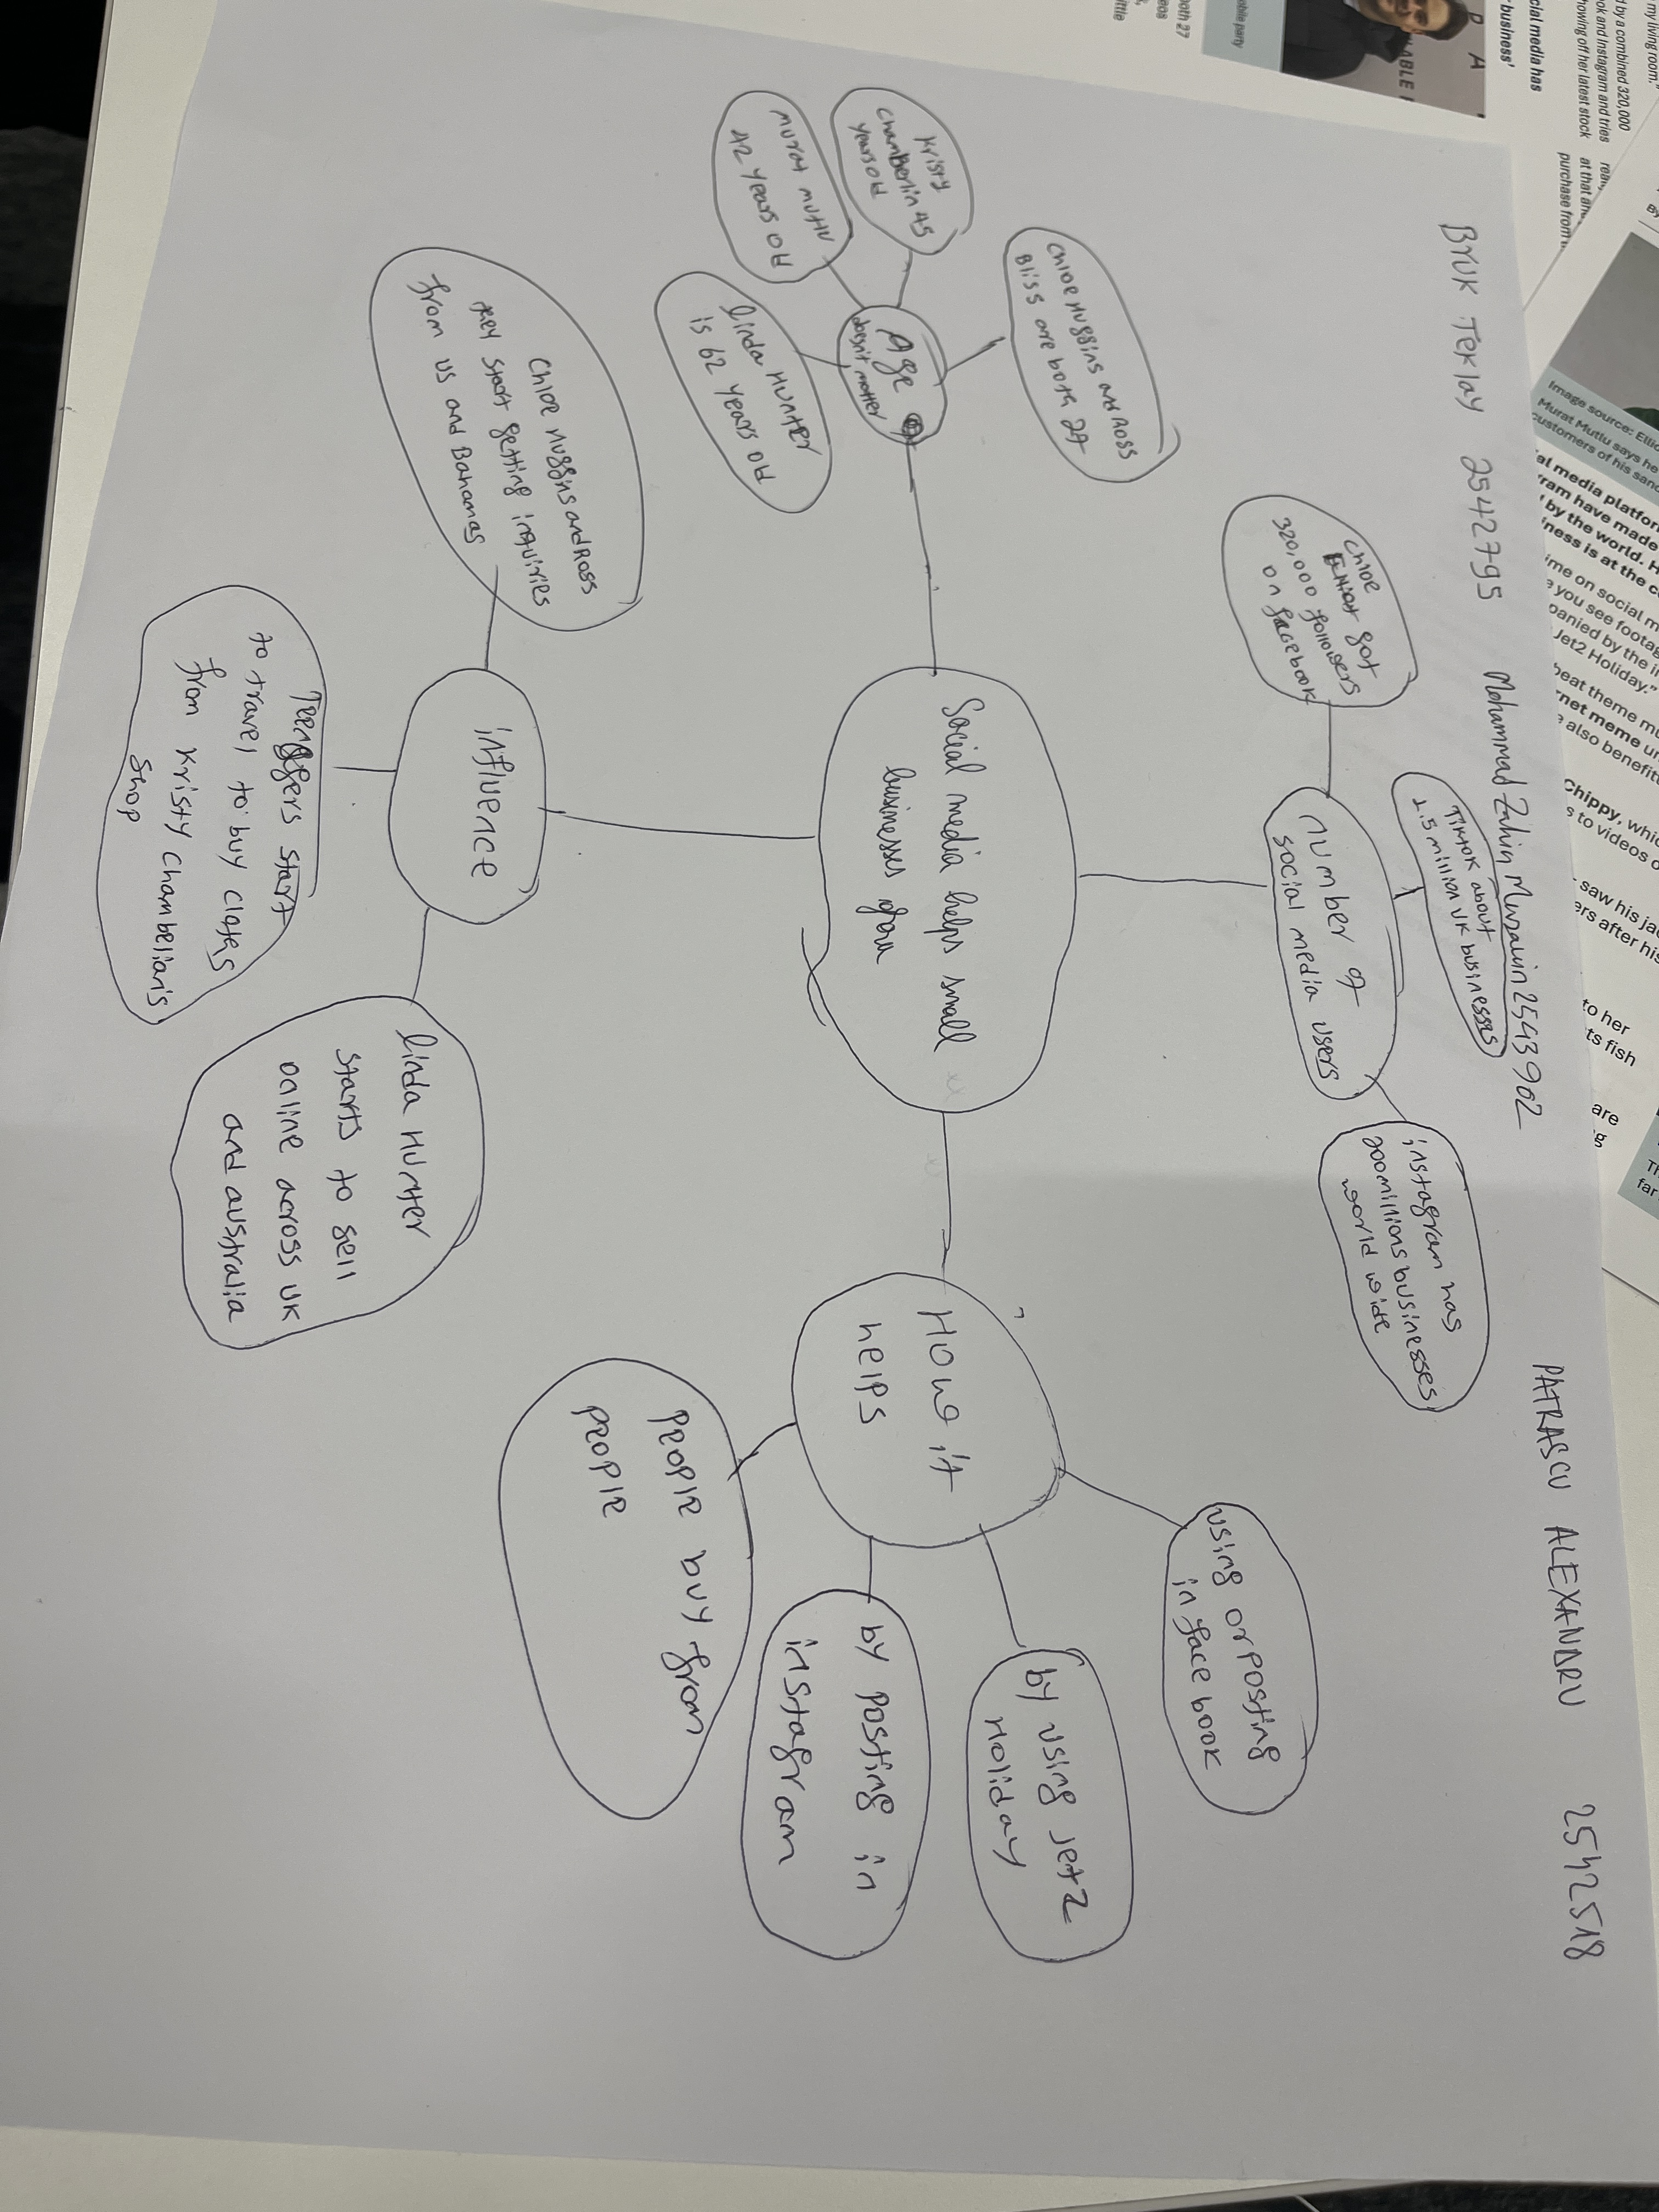

1. Answer these questions using the sentence starters below
a. What is the main idea of the text?
The main idea of the text is about how social media platforms became an important marketing tool for businesses.
b. What are two key points?
One key point is that customers are travelling from long distances to try food from a shop in Basildon.
Another key point is that a business owner moved his business fully online and ships inside and outside of UK
c. What part of the text did you find most important? Why?
The most important part is where the owner has moved his business fully online because it proves that social media and internet gives a lot of opportunities to everyone.
d. Was anything unclear or difficult to understand?
For me it wasn’t difficult to understand the text.
e. How did your group help you understand the text better?
My group helped me by working together to understand better the main topics of the article and taking key notes which helped us to create the mindmap.
2. One sentence reflection
Question: What did you find challenging about this task?
The hardest part was to find the most important key points about the main topic for creating the mindmap.

