Problem Solving and Decision Making
Student Name: Samia Waseem
Student ID: 2123965
Lecturer Name: Charles Nimoh
Table of Contents
Introduction 3
the nature of the problem 4
impact of the complex problem on employees and Proper Care 4
A PESTLE analysis of the macro-environmental factors contributing to the Staff Shortage issue 5
cause-and-effect analysis 8
solutions to absenteeism and their implementation 9
CONCLUSION 10
References 11

Introduction
As it can be seen in the case, the main problem is to retain employees as nurses and other staffs in the adult social care. Adult social care organizations in UK are facing serious trouble of staffing issues regardless the government help. Proper Care organization, which is a UK adult care provider has been facing major consequences with the staff shortages and thus it become impossible to retain their care quality. As a consultant of Proper Care this paper aims at analysisng their problems with staffing issues and provide them appropriate solution of the issue.

the nature of the problem
The major problem identified with Proper care is their staffing shortages. Nurses do not want to continue their job in an adult healthcare organization. Patients' well-being may be jeopardized in hospitals and other healthcare institutions that have an inadequate number of registered nurses on duty (Bierman, Bonini and Hausman, 2022). Shortages of nurses lead other nurses to do overwork. In addition, nurses who are overworked may miss important facts or fail to completely interact with their patients. Because of this, patients may have an unfavorable opinion of the performance of the nurse. When the multitude of patients admitted on a unit reaches the maximum limit per nurse that has been established according to safety and quality requirements, short-staffed shifts are likely to occur on that unit. Sadly, this kind of thing happens on a regular basis in almost all of the departments that make up each and every hospital. Long-term nursing, clinics, and stand-alone institutions are all impacted, since each encounter increases in the number of patients from one shift to the next.
There are a number of factors that contribute to understaffing, including decreases to budgets, nurses approaching retirement age, and a lack of nursing faculty to educate new nurses.

impact of the complex problem on employees and Proper Care
The number of patients a nurse is responsible for is the primary factor that determines their workload. Additional patients cause time to be stretched shorter, which places an unrealistic expectation on nurses to provide excellent care in a shorter amount of time. It is essential for facility technology purchasers, administration, and stakeholders to have a solid understanding of the unexpected implications that might arise from inadequate personnel numbers.
- Falls
Patient call lights may be used more aggressively if the call lights aren't responded when nurses are spending less time with every patient (ERDİL, 2022). Falls may result in astronomical medical bills. Because of a shortage of employees, healthcare facilities cannot take any chances with delayed reactions to bed alarms that detect a "fall risk."
- Problems with Medication
The importance of paying attention to details cannot be overstated in nursing. When nurses are under time pressure, they have a greater tendency to overlook details that they normally would have observed. The nurses are the last fail safe in adult care giver hospitals, despite the presence of a variety of other safeguards. This fail safe has the potential to fail whenever nurses are overworked due to the whole short-staffed shift, which may lead to disastrous medication mistakes.
- Ulcers and Bed Sores
Patients being unable to move about much need to have scheduled transfers during the day to prevent pressure ulcers from forming. Patients need to be turned by a least of two members of staff. Nonetheless, nurses frequently turn patients by herself since other staff members remain busy, which is a certain method to hurt one's back. Another difficult choice for the empathic nurse to make: put her own safety at risk or expose the patient to the possibility of developing bed sores.
- Burnout
When patient ratios are appropriate, nursing is a physically and emotionally draining profession. The greater the number of inadequate shifts that nurses are required to work, the more quickly they will get burned out (Grant, 2020). It costs hospitals an approximate of $60,000 to substitute RNs and may lose nurses their jobs when they experience burnout.
- Patient (Dis)satisfaction
The capacity of a nursing hospital to acquire new patients and keep existing ones is directly proportional to the amount of feedback received from customers. When patients have to wait a long time for pain medicine or examinations, they are more inclined to give a negative rating to their overall experience at the clinic. As a result, the true revenue-generating potential of a hospital resides in the danger.

A PESTLE analysis of the macro-environmental factors contributing to the Staff Shortage issue
- Political Factors
Proper Care are unable to provide definitive information about the effects that Brexit will have on the it, several economic and political professionals have offered their perspectives on the topic. The shortage of available funds is one of the most pressing problems at hand. They are sending a great deal of medical supplies and pharmaceuticals to the UK from a variety of locations inside the EU. After the Brexit occurs, this will undoubtedly cause a commotion in the markets, and they will be forced to contend with a severe shortage of essential medicines. The absence of sufficient employees will also be a significant issue. Proper Care employs a significant number of people who were born in other countries than the UK (Haeussler, Paul and Wood, 2020). As a direct result of Brexit, there would be a reduction in the continuous supply of skilled people. as a result, the Healthcare will experience a shortage of workers.
- Economic Factors
Proper Care was under pressure to lower the pay of its workers due to a combination of factors, including a shortage of resources and different economic restrictions. As a direct consequence of this, a significant number of their staff members quit their jobs, and new employees with less qualifications took their place. Even though the economic crisis happened ten years ago, its repercussions are still being keenly felt inside it since it is unable to function at the same level as before.
In addition, the government of the UK has implemented a number of austerity programs as a response to the recent economic collapse. One of these steps consisted of reducing the budgets of a number of different governmental entities (Wilke and Ritter, 2019). Even though there was no direct impact on their finances, several of these austerity programs nonetheless had an indirect impact on the Proper Care. The crisis had already put the organization in a difficult financial position, and the austerity policies were imposed on top of that.
- Social Factors
The average lifespan of people living in the United Kingdom is rising at a startlingly quick pace. Because of the disparity in the sizes of the populations of the several generations, this is a phenomenon that occurs on a worldwide scale. And unfortunately, as we get older, our health concerns also increase (Milani, 2021). Due in part to the fact that both diabetes or cancer are conditions that are associated with advancing age, their prevalence rates continue to rise. This has resulted in more strain being placed on the Proper Care, and in its present form, it has proven increasingly difficult for the organisation to deliver excellent care to the increasing number of patients who need it.
- Technological Factors
The general advancements in medical technology have resulted in a dramatic increase in the service quality provided by Proper Care (Welcome to Proper Care Home, 2022). All medical facilities in the UK are required to include at least some cutting-edge technology, which may include intricate scanning equipment and other instruments. The Proper Care has indeed been enabled to utilize these technology breakthroughs to give all of its patients with healthcare that is both of high quality and of a prompt nature. The development of new technologies has also contributed to an improvement in the quality of the educational system for medical professionals. This ultimately helps Proper Care by making it possible for them to employ more people with relevant skills. Even if there are still concerns with inadequate staffing in the Proper Care, there seems to be reason to have optimism that with the assistance of more contemporary medical centers, they may be able to solve this issue.
- Legal Factors
If a patient's relative feels that the healthcare system has treated them unfairly, they may choose to seek legal redress on their loved one's behalf (Roy and Berger, 2018). In many instances, this is the case. The National Health Service (NHS) has been a party to a significant number of lawsuits brought by dissatisfied patients. But Proper Care is currently tasked with addressing this novel and costly component. In addition, the practise of seeking legal redress over medical institutions is becoming more commonplace all around the globe.
However, the majority of patients looking for legal courses might be reduced if services are improved with the help of technological advancements and staff members get proper education.
- Environmental Factors
The production of medical goods results in a significant amount of the hazardous waste that is now being generated around the globe. In addition to the ongoing catastrophe that their environment is now experiencing, there is a great deal of strain being placed on all medical institutions (Murphy, 2019). There is a significant amount of pressure placed on them to handle their garbage and assets with the utmost caution.
It has instituted a number of reforms in order to reduce the environmental damage caused by the disposal of medical waste.

cause-and-effect analysis
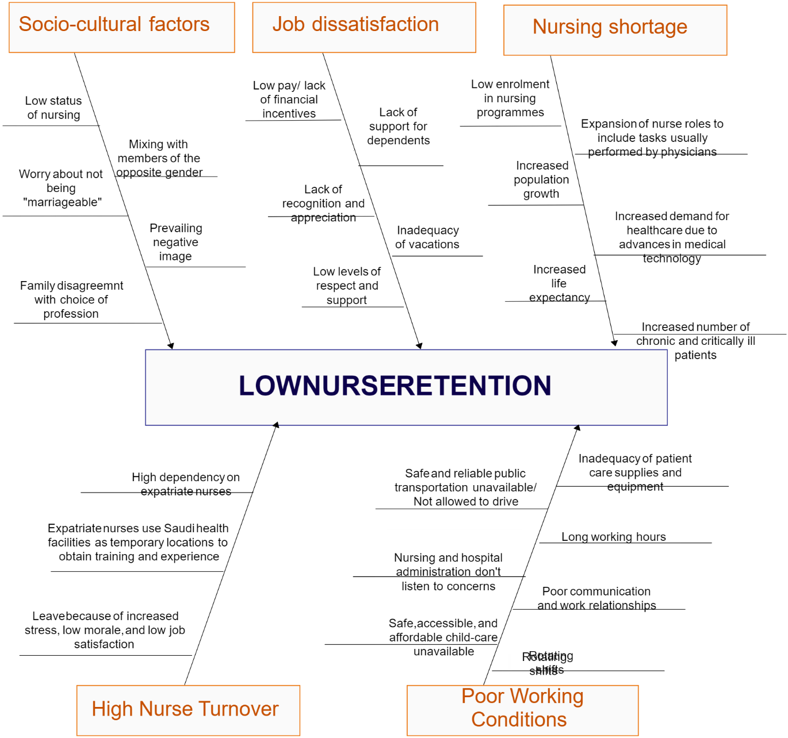

Low nurse retention of Proper Care is due to various reasons. As it is seen in the diagram that the social factors of nurse retention are due to that women do not feel it is a respectable job and sometime, they also fear of their marriage. Due to poor incentives and respect high job dissatisfaction also cause low nurse retention (Palepu and Healy, 2018). When nurses believe that they are not getting adequately compensated for their work, it is one of the key factors that contributes to job discontent. Checking what other people are getting paid for doing the same amount of work or even less work might be one approach for them to arrive at this decision. It is ultimately detrimental to workers' levels of productivity if their employers fail to acknowledge the need for them to strike a good balance between their personal and professional lives. A focus that is too much placed on work may often cause nurses to experience emotions of isolation and dissatisfaction. They need downtime in order to refresh themselves mentally and physically before returning to the workplace. According to the findings of several pieces of research, the normal worker is susceptible to a broad variety of undesirable physically and mentally repercussions when they do not take regular breaks from their place of employment. Whenever an employee is unable to take time off for vacation, they put themselves at a greater risk of being burned out on the work and producing fewer effective results. In the long run, these nurses will have less of an impact and will be less valued.

solutions to absenteeism and their implementation
It is imperative that healthcare businesses place a strong emphasis on the retention of nurses by ensuring that their workplaces are both productive and encouraging. The American Nurses Association (ANA) suggests to firms that they should enable registered nurses to collaborate on the development of flexible employment schedules for their respective units (Roy and Berger, 2018). When deciding how many nurses to hire, the ANA recommends that employers take into account the following factors:
- The situation of patients according to their degree of complexity, acuteness, or degree of stability
- The total number of patients that were discharged, admitted, or transferred to the unit
- The amount of nursing education, competence, and abilities possessed by the staff
- The capacity of the medical care facility
- Help with the technology, as well as extra resources
It is vital for employers to prevent skilled nurses from leaving the workforce in order to maintain patient care and protect the patients’ health (Valiris and Glykas, 2022). Nurses give attention and watch out for the well-being of adult patients. It is possible for nurses to contribute to better patient care and guarantee that patients are content with the care they get if they are empathic, devoted, and alert in addition to having the appropriate nursing training.

CONCLUSION
It is possible that a general improvement in working conditions and payment could aid in the provision of proper care to mitigate their situation. When providing appropriate care, it is important to remember that nurses should be handled in a respectful manner. They may also opt to train their nurses by themselves and prepare them for their organisation.

References
Bierman, H., Bonini, C. and Hausman, W., 2022. Staff management. Homewood, Ill.: Irwin.
ERDİL, A., 2022. Health and Social Care. JOURNAL OF CURRENT DEBATES IN SOCIAL SCIENCES,.
Grant, D., 2020. Employee retention. Business Process Management Journal, 22(1), pp.75-88.
Haeussler, E., Paul, R. and Wood, R., 2020. Adult healthcare service UK.
Milani, F., 2021. Management Competency in Health and Social Care.
Murphy, C., 2019. Financial Management in Health and Social Care. Business Information Review, 22(3), pp.189-198.
Palepu, K. and Healy, P., 2018. STAFF MANAGEMENT. Mason, Ohio: South-Western.
Propercare.com. 2022. Welcome to Proper Care Home. [online] Available at: <https://www.propercare.com/> [Accessed 24 June 2022].
Roy, A. and Berger, P., 2018. Fund raising in Health and Social Care. Journal of Business-to-Business Marketing, 12(3), pp.27-57.
Valiris, G. and Glykas, M., 2022. Managing Employees in today's Business. Business Process Management Journal, 10(4), pp.445-480.
Wilke, R. and Ritter, T., 2019. Health Service and Staff Management. Journal of Business-to-Business Marketing, 13(3), pp.39-64.

