12 March 2024

Gareth Jenkins
Student number 99091195

What does the study of archaeological remains – ancient burials, cemeteries, and tombs of the Natufian culture in the Levant tell us about ancient burial practices and/or beliefs in an afterlife?
HPHP4002 Death, Burial and the Afterlife.
What does the study of archaeological remains – ancient burials, cemeteries, and tombs of the Natufian culture in the Levant tell us about ancient burial practices and/or beliefs in an afterlife?

The Levant has been an important area of archaeological study for the Palaeolithic and Neolithic periods, and many of the key issues of human development are connected to it (Finlayson, 2014, p.122). The Epipaleolithic in the Levant is roughly comparable to the European Mesolithic (C.22,000 -10,00 BP) (Clark, 2012, p. 295). One of the main characteristics of the late Epipaleolithic Natufian (c. 14,600–11,500 B.P.) is the presence of a high number of graves and the complexity and variability of burial practices (Richter et al. 2019, p.440).This essay will examine archaeological records from investigations at a number of Natufian burial sites and will examine the various funerary practices identified. The essay will discuss what can be established about the Natufian burial practices and their belief in the afterlife. Figure 1 is a map of the Levant showing the locations of the major Natufian burial sites.

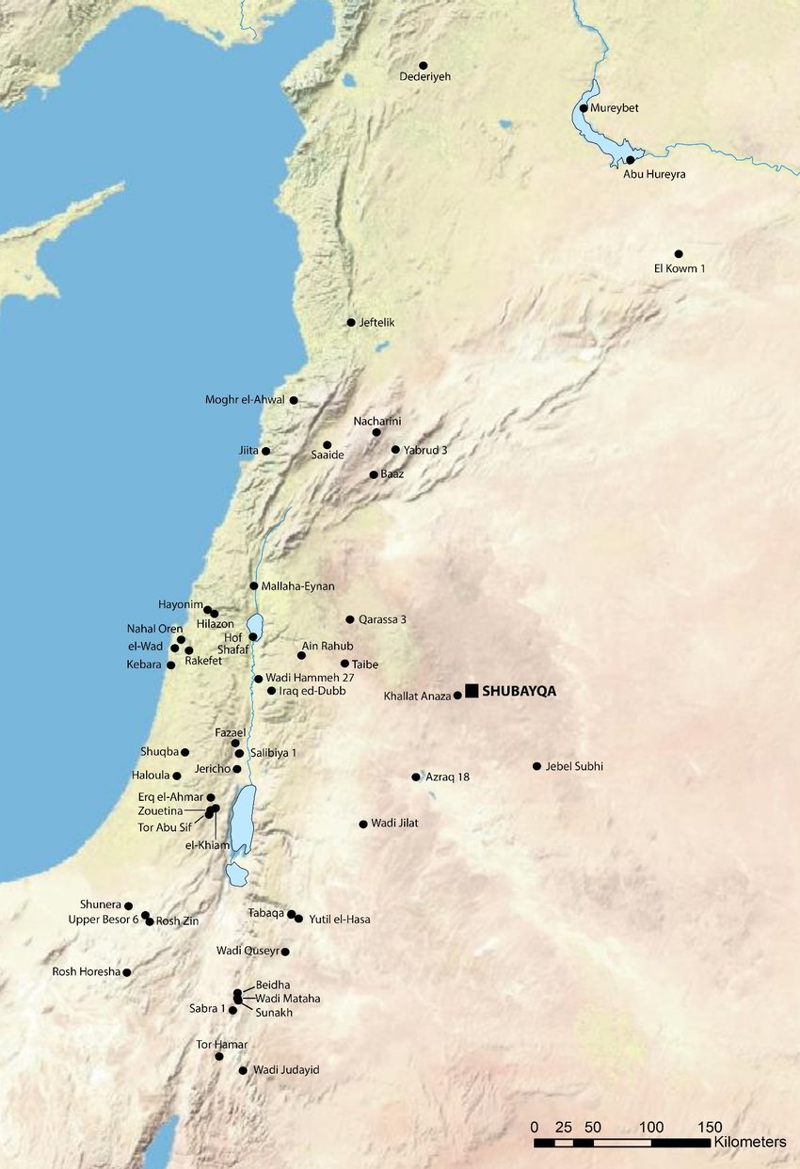
Figure 1. Map showing major Natufian burial sites in the Levant (Pedersen & Richter, 2016, p.382)
Populations in the Levant rose throughout the Natufian period due to an increase in a sedentary lifestyle. More occupation sites were produced to cater for the larger populations, and these sites were occupied for longer periods of time. This resulted in an increase in social complexity, dwellings, and burials, as well as ornamentation, and technology such as the production of punches and awls (Clark, 2012, p: 296-297).

The Natufian culture was first identified and named by the English archaeologist, Dorothy Garrod during excavations at Shukba in the Judean Hills, in 1928 (Boyd, 1999, p.209). “As it will be convenient to have a name for this culture, I propose to call it Natufian, after the Wady en-Natuf at Shukba, where we first found it in place”(Garrod, 1929, p.222).

Throughout her excavations at Shukba, and also at el-Wad on Mount Carmel, Garrod discovered a wide variety of burials. Beaded headgear and necklaces made of shells were found in some of the tombs. Additionally, a wide range of burial customs were evident in some of these burials, including variations in the number of people interred in graves and burial positions. Both primary and secondary inhumations were also evident. The quantity and variety of burial customs identified grew during the ensuing years as more and more ancient Natufian sites were found (Richter et al. 2019, p.440).

At El-Wad, according to Garrod, there were six groups of skeletons in group graves that held people with decorated heads and other body parts. Each cluster contained two to ten skeletons, and five of the clusters included at least one skeleton with notable adornment. One skull had an uneven layer of shells on its surface, while a child's skull had 32 gazelle phalange beads covering it. Three of the skulls included well-preserved sets of dentalium shell beads. The shells on every skull, according to Garrod, used to be fastened to a cap that had not been preserved (Wyllie & Hole, 2012, p.707). Figures 2 to 4 below are reconstruction drawings of what the dentalium shell bead caps may have looked like, next to photographs published by Garrod in 1937 (Wyllie & Hole, 2012, pp. 715-717).

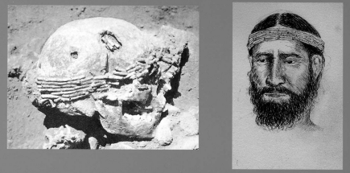
Figure 2. Reconstruction of a beaded skull cap found at el-Wad (Wyllie & Hole, 2012, p.716).

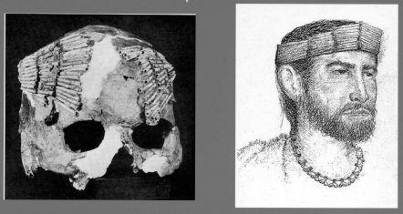
Figure 3. Reconstruction of a beaded skull cap found at el-Wad (Wyllie & Hole, 2012, p.715).

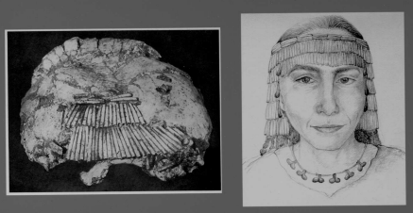
Figure 4. Reconstruction of a beaded skull cap found at el-Wad (Wyllie & Hole, 2012, p.717).

Another notable approach in funeral practice, particularly with regard to the younger members of the community, is found at the early to late Natufian site of Shubayqa 1 in northeastern Jordan. Eighty percent of the burials in Shubayqa 1 are of children, newborns, and babies. A few of these burials had red ochre on them. A similar treatment which had been noted at the early Natufian site of Azraq 18, a location that is close to and generally contemporaneous with Shubayqa 1, possibly indicating cultural connections and similarities between the two sites. There is also a suggestion that the use of red ochre was a method of blood symbolism (Richter et al. 2019, pp.440-454). Figure 5 below is a drawing showing position of ochre traces on a neonate burial at Shubayqa 1, and examples of the stained bones.

At Shubayqa 1, there is a correlation between ground stone tools and burials, especially considering the prevalence of ochre staining on several of the tools. This, along with evidence that ochre was used in the processing of hides, appears to imply that some of the remains were covered with ochre-decorated textiles or skins prior to burial (Richter et al. 2019, pp.440-443). Scholars have proposed that ground stone tools may have served a deeper symbolic purpose than just being functional objects, and that they reflected social interactions and transmitted a particular set of ideas and beliefs, such as in burial rituals (Richter et al. 2019, p. 453).
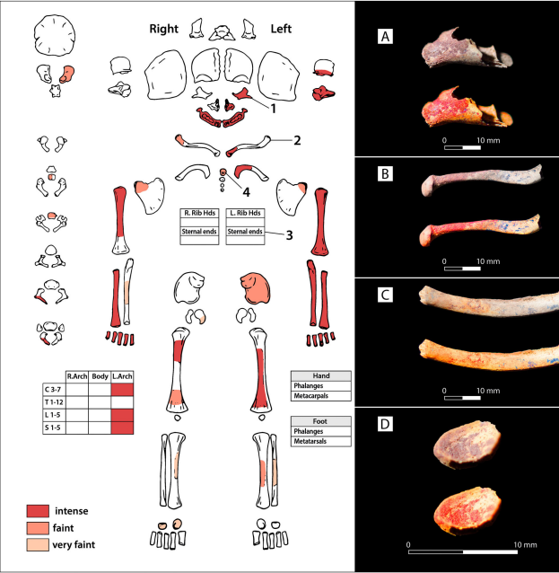
Figure 5. Drawing showing position of ochre traces on a neonate burial at Shubayqa 1 and examples of the stained bones (Richter et al. 2019, p.448).

In addition to the use of ochre and the likely wrapping of the remains in hides or textiles,
Shubayqa 1 offers a vision into the link between the spaces of the living and the dead. Subfloor burials within dwellings found at the site, which are not uncommon during this period, have been suggested to imply that ownership and ancestry may be connected to the relationship between human bodies and dwellings (Richter et al. 2019, p. 451). Figure 6 is a photograph of a stone pavement within a structure under which were found the remains of six immature adults.
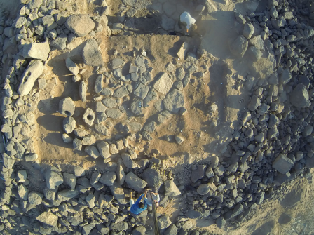
Figure 6, photograph of a stone pavement within a structure under which were found the remains of six immature adults (Richter et al. 2019, p.445).
The Raqefet cave is situated on the eastern flank of Mount Carmel in a wadi. At Raqefet Cave there are no signs of settlement, and it is thought to have served largely as a burial ground for a neighbouring settlement, in contrast to el-Wad, where settlement evidence as well as burials have been found. Investigations at Raqefet cave have found 29 adult and child graves (Barzilai, et al. 2017, pp. 1137-1151).

Around eighty ‘human made bedrock holes’ (HBHs) were found all over the floor at Raqefet cave. A human skeleton was discovered at the top of one. The shape and size of the HBHs suggests that they were put to use for a range of purposes, some of which could not have involved the processing of food or minerals and may have been for burial. The HBHs close to the tombs are thought to have been a part of a significant burial complex at the location and were not haphazardly placed. It has been proposed that a few of them serve a symbolic purpose having been carved especially for use in funeral ceremonies. The cave complex is dominated by single burials, which are unique for this period, and it has been referred to as being a mournful and sombre area. There is a clear leaning towards burying their dead on their back in a west-east direction, and there are indications of disturbances to the graves from successive burials in the same place (Nadel et al. 2008, pp.59-131; Lengyel & Bocquentin, 2005, pp. 271-283). Additionally, it has been suggested that food remains found within the graves to be a representation of funerary feasts as opposed to household waste collected before the tombs were dug (Barzilai et al, 2017, p.1141).

There is evidence that these feasts may have included the consumption of gazelle, small animals, and occasionally a larger ungulate (wild boar, fallow deer, and most likely aurochs). It is speculative to estimate how many people attend these rituals. Numerous individuals may have been present at a feast due to the high and vault-shaped cave roof. It is possible that the participants were few due to the moderate amount of game consumed. It has therefore been inferred that Raqefet Cave was a place where irregular burial customs were carried out by bands of Natufians who ascended the rocky slope to the cave, consumed foods that were readily available, and buried the dead, intentionally gathering their food remnants into the grave before filling it in with dirt and rocks. It is suggested evidence of a cohesive social structure (Yeshurun & Bar-oz, 2013, p. 511-524).

Similar funerary practices have also been found at Hilazon Tachit, in Israel. Hilazon Tachit is a small burial cave containing the graves of at least twenty-eight people. One grave is an oval basin carved out of the bedrock and was used to bury an elderly woman, believed to be a shaman. The grave also held animal bones and artefacts made of flint. With the right femur, pelvis, and spine resting against the grave's curved wall, the body was placed in an unusual position, on its side. The knees were bent inwards while the legs were spread apart (Grosman & Munro, 2008, p.17665; Munro & Grosman, 2010, p. 5362).

The grave contained the body parts of several animals, which is very uncommon. These include two stone marten skulls, the wing tip of an eagle, the tail of an auroch, the pelvis of a leopard, two tortoise shells, the forearm of a wild boar and a male gazelle horn (Grosman & Munro, 2008, p. 17668). Figure 7 is a reconstruction drawing of this burial showing the body posture and position of the grave goods.
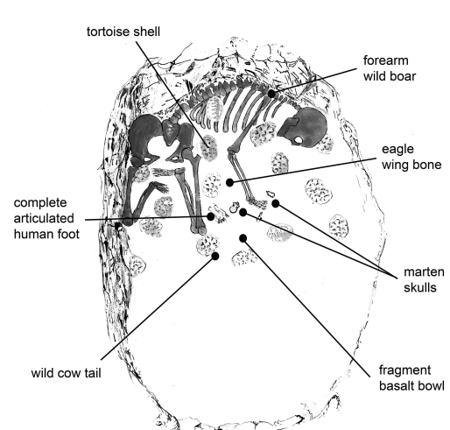

Figure 7. Reconstruction drawing of the burial showing the body posture and position of the grave goods (Grosman & Munro, 2008, p. 17667).

This burial is unlike any other burial in the Natufian period. It is suggested that it shows a cultural identity that distinguishes this period as having unique social practices, and new burial practices (Grosman & Munro, 2008, p.17668).

Further unique burial practices have been evidenced at Ein Mallaha and Hayonim in northern Israel, where burials of humans accompanied by domesticated wolfs and dogs have been discovered. The evidence suggests some kind of special relationship between humans and animals during this period. One such burial at Mallaha is of an elderly human, of undetermined sex, who lies with their hand on the body of a puppy, believed to be either a wolf or a dog, of about 3-5 months old. These discoveries are significant because they corroborate evidence of interactions between humans and canids during the Epipalaeolithic period. Among the Natufian burials, the puppy burial is distinctive and provides evidence of an affectionate rather than culinary relationship between it and the deceased (Davis, 1978, pp. 608-610). Figure 8 is a photograph of the burial and shows the human’s hand on the puppy in the top left corner of the grave.

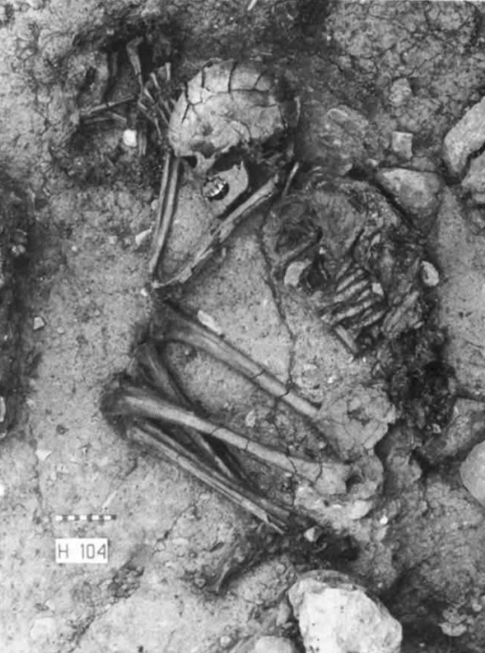
Figure 8, photograph of the burial and shows the human’s hand on the puppy in the top left corner of the grave (Davis, 1978, p. 608).

A further unique burial of the Natufian period was discovered at Ayn Qasiyya near the Azraq Oasis, Jordan. The semi-articulated remains of an individual were discovered and were named Ayn Qasiyya 1. Found within a marsh deposit the remains have been dated as the oldest human remains found in Jordan at between 19,800 and 20,400 cal BP. The skeleton is of a relatively small male and was buried in a very unusual position. It has been established that the body was buried in an upright sitting position and that the limbs were tightly flexed towards the torso. The skull was leaning forward and resting on the knees. It is therefore suggested that the body was bound or wrapped in some kind of cloth, which deteriorated over time and decomposition, resulting in the body collapsing. It implies that the deceased are seen as pliable, movable, and non-fixed entities (Richter et al. 2009, pp.321-331). Figure 9 is a suggested reconstruction of Ayn Qasiyya 1’s original posture and its collapse during decomposition.

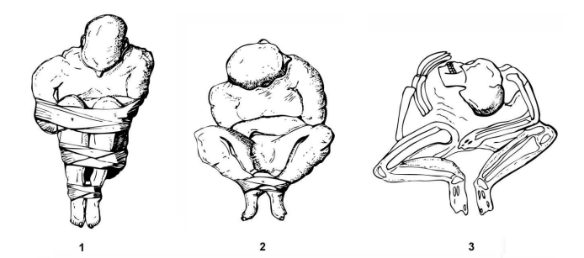

Figure 9, A suggested reconstruction of Ayn Qasiyya 1’s original posture and its collapse during decomposition (Richter et al. 2009, p. 328).

Overall, the Natufian culture marks a significant transitional period in human history. It saw a change from hunter-gatherer societies that were nomadic to permanent communities with intricate social and economic systems. Domestication of animals was apparent. They placed various values on their deceased. It has been said that Natufian burial customs serve as a way to build solid boundaries between groups, reduce ecological dangers, and foster close social bonds. Although certain burial sites exhibit a standardisation of funeral procedures, other sites exhibit inter-site diversity. Grave pits were excavated and occasionally decorated with grave goods and stones. People were buried beneath floors made of stone. Wrappings tinted with ochre were used to bury children. Reburial was customary. These characteristics represent a heterogeneous range of behaviours among various Levantine communities (Davis, 1978, pp.608-610; Lengyel & Bocquentin, 2005, pp.271-283; Richter et al. 2009, pp.321-331; Richter et al. 2019, pp.440-455).

Bibliography.
Bahn, P. (Ed.) (2002) Written in Bones: How Human Remains unlock the Secrets of the Dead. Quintet Publishing Ltd.
Baker, J. L. (2016) The Funeral Kit: Mortuary Practices in the Archaeological Record. London: Routledge.
Barzilai, O. et al. (2017) ‘Radiocarbon dating of human burials from Raqefet Cave and contemporaneous Natufian traditions at Mount Carmel. Antiquity, 91 359,pp. 1137-1154. Cambridge University Press. Available at: https://doi.org/10.15184/aqy.2017.136 (Accessed: I March 2024).
Bocquentin, F. & Garrad, A. (2016) ‘Natufian collective burial practice and cranial pigmentation: A reconstruction from Azraq 18 (Jordan),’ Journal of Archaeological Science: Reports, No. 10, pp.693-702. Available at: DOI: 10.1016/J.JASREP.2016.05.030 (Accessed: 24 February 2024).
Bonogofsky, M. (2003) ‘Neolithic Plastered Skulls and Railroading Epistemologies.’ Bulletin of the American Schools of Oriental Research, No. 331, pp. 1-10. The American Schools of Oriental Research. Available at: http://www.jstor.org/stable/1357755 (Accessed: 24 February 2024).
Boyd, B. (1999) “Twisting the kaleidoscope” Dorothy Garrod and the ‘Natufian Culture,’ in Davies, W. & Charles, R. (Eds.), Dorothy Garrod and the Progress of the Palaeolithic: Studies in the Prehistoric Archaeology of the Near East and Europe. Oxford: Oxbow Books, Chapter 15, pp.209 - 223.
Boyd, B. (2001) ‘The Natufian Burials from el-Wad, Mount Carmel: Beyond Issues of Social Differentation.’ Journal of Israel Prehistoric Society, No. 31, pp; 185-200. Available at: http://www.jstor.org/stable/23380247 (Accessed: 15 February 2024).
Byrd, B. F. & Monahan, C. M. (1994) ‘Death, Mortuary Ritual, and Natufian Social Structure.’ Journal of Anthropological Archaeology, 1995, No. 14, pp.251-287. Available at: DOI:10.1006/jaar.1995.1014 (Accessed: 24 February 2024).
Chamberlain, A. T. & Pearson, M. P. (2004). Earthly Remains: The history and science of preserved bodies. London: British Museum Press.
Clark, G. A. (2012) The Cantabrian Mesolithic and the Epipaleolithic in the Levant – a Brief Comparison. Available at: https://www.academia.edu/7231596/The_Cantabrian_Mesolithic_and_the_Epipaleolithic_in_the_Levant_a_Brief_Comparison (Accessed: 10 March 2024).
Croucher, K. (2012) Death and Dying in the neolithic Near East. 1st ed. Oxford: Oxford University Press.
Croucher, K. (2017) ‘Keeping the dead close: grief and bereavement in the treatment of skulls from the Neolithic Middle East,’ Mortality, Routledge. Available at: DOI: 10.1080/13576275.2017.1319347 (Accessed: 26 February 2024).
Current World Archaeology, (2020) New Neanderthal discoveries at Shanidar Cave. Vol. 9, issue 100, no. 4, p. 6.
Davis, S. J. M. (1978) Evidence for domestication of the dog 12,000years ago in the Natufian of Israel. Nature, Vol.276, pp.608-610. Available at: doi:10.1038/276608a0 (Accessed: 15 February 2024)
Devlin, Z. L. & Graham, E. J. (Eds.) (2015) Death Embodied: Archaeological approaches to the treatment of the corpse. Oxford: Oxbow Books.
Eitam, D. & Schoenwetter, J. (2020) ‘Feeding the Living, Feeding the Dead: The Natufian as a Low-Level Food Production Society in the Southern Levant (15,000-11,500 Cal PB).’ Journal of the Israel Prehistoric Society, No. 50, pp. 44-77.
Finlayson, B. (2014) Introduction to the Levant During the Neolithic Period, in Killebrew, A. E. & Steiner, M. (Eds.) The Oxford Handbook of the Archaeology of the Levant: c. 8000 – 332 BCE. Chapter 9, pp: 122-133. Oxford: Oxford University Press.
Garrod, D.A.E, (1929) Excavations in the Mugharet el-Wad, near Athlit, April-June 1929. Quarterly Statement of the Palestine Exploration Fund 61: 220-222.
Garrod, D. A. E. (1931) ‘Mesolithic Burials from Caves in Palestine.’ Man, vol. 31, 1931, pp. 145–46. Available at: https://doi.org/10.2307/2791371 (Accessed: 4 March 2024).
Garrod, D. A. E. (1962) ‘The Middle Palaeolithic of the Near East and the Problem of Mount Carmel Man: The Huxley Memorial Lecture 1962.’ Journal of the Royal Anthropological Institute of Great Britain and Ireland, Vol. 92, No. 2, pp.232-259. Available at: https://www.jstor.org/stable/2844261. (Accessed: 4 March 2024).
Grosman, L. and Munro, N. D. (2008) ‘A 12,000-year-old Shaman burial from the southern Levant (Israel).’ Anthropology, Vol.105, No.46, pp. 17665-17669. Available at: www.pnas.org/cgi/doi/10.1073/pnas.0806030105 (Accessed: 24 February 2024).
Insoll, T. (2011) The Oxford Handbook of the Archaeology of Ritual and Religion. 1st edn. Oxford: Oxford University Press. Available at: https://doi.org/10.1093/oxfordhb/9780199232444.001.0001 (Accessed: 27 February 2024).
Jock, A. M. (2023) ‘An African-study of the contribution of Neanderthals to funeral rituals,’ Theologia Viatorum 47(1), a173, Available at: https://doi.org/10.4102/tv.v47i1.73 (accessed: 13 February 2024).
Kenyon, K. M. (1954) ‘Excavations at Jericho.’ The Journal of the Royal Anthropological Institute of Great Britain and Ireland, Vol. 84, No. 1, pp.103-110. Available at: https://www.jstor.org/stable/2844004 (Accessed: 29 February 2024).
Kenyon, K. M. (1979) Archaeology in the Holy Land. Fourth Edition. London: Ernest Benn Limited.
Knusel, C. J. & Schotsmans, E. M. J. (Eds.) (2022) Routledge handbook of Archaeothanatology: Bioarchaeology of Mortuary Behaviour. London: Routledge.
Lengyel, G. & Bocquentin, F. (2005) ‘Burials of Raqefet Cave in the context of the Late Natufian.’ Journal of the Israel Prehistoric Society, No. 35, pp.271-284. Available at: Burials of Raqfet Cave in the context of the Late Natufian - CORE (Accessed: 24 February 2024).
Maher, L. A. et al. (2021) Life, Death, and the Destruction of Architecture: Hunter-Gatherer Mortuary Behaviours in Prehistoric Jordan. University of Cambridge. Available at: httpd://www.repository.cam.ac.uk (Accessed; 24 February 2024)
Munro, N. D. and Grosman, L. (2010) ‘Early evidence (ca.12,000 B.P.) for feasting at a burial cave in Israel.’ Anthropology, Vol.107, No. 35, pp.15362-15366. Available at: www.pnas.org/cgi/doi/10.1073/pnas.1001809107 (Accessed: 24 February 2024).
Nadel, D. (1994) ‘Levantine Upper Palaeolithic – Early Epipalaeolithic Burial Customs: Ohalo II As a Case Study.’ Paleorient, Vol. 20, No.1, pp.113-121. Available at: http://www.jstor.org/stable/41492570 (Accessed: 1 March 2024).
Nadel, D. et al. (2008) ‘The Late Natufian at Raqefet Cave: The 2006 Excavation Season.’ Journal of the Israel Prehistoric Society, No. 38, pp.59-131.
Otaegui, A. A. et al. (2016) ‘Shubayqa 6: A new Late Natufian and Pre-Pottery Neolithic A settlement in north-eats Jordan.’ Antiquity, Vol. 90 354, pp. 1-5. Available at: doi:10.15184/aqy.2016.182 (Accessed: 24 February 2024).
Pearson, M. P. (2010) The Archaeology of Death and Burial. The History Press.
Pedersen, P. N. & Richter, T. (2016) Preliminary analysis of the Late Natufian ground stone from Shubayqa 1, Jordan.’ Journal of Lithic Studies, Vol. 3, pp. 379-402. Available at: doi:10.2218/jls.v3i3.1647 (Accessed: 11 March 2024).

Pettitt, P. (2002) ‘The Neanderthal dead: exploring mortuary variability in Middle Palaeolithic Eurasia.’ Before farming (4) pp. 1-19. Available at: https://www.researchgate.net/publication/265379507_The_Neanderthal_dead_exploring_mortuary_variability_in_Middle_Palaeolithic_Eurasia (Accessed: 13 February 2024).

Pettitt, P. (2011) The Palaeolithic Origins of Human Burial. Oxford: Routledge.
Pettitt, P. (2022) Homo Sapiens Rediscovered: The Scientific Revolution Rewriting Our Origins. London: Thames & Hudson Ltd.
Richter, T. et al. (2009) ‘An Early Epipalaeolithic sitting burial from the Azraq Oasis, Jordan.’ Antiquity, Vol.84 (2010), pp. 321-334. Available at: http://antiquity.ac.uk/ant/84/ant840321.htm (Accessed: 1 March 2024).
Richter, T. et al. (2017) ‘High Resolution AMS Dates from Shubayqa 1, northeast Jordan Reveal Complex Origins of Late Epipalaeolithic Natufian in the Levant.’ Science Reports 7:17025. Available at: https://doi.org/10.1038/s41598-017-17096-5 (Accessed: 1 March 2024).
Richter, T. et al. (2019) ‘Ochre, Ground Stone, and Wrapping the Dead in the Late Epipalaeolithic (Natufian) Levant: Revealing the Funerary Practices at Shubayqa 1, Jordan.’ Journal of Field Archaeology, 44:7, 440-457, Available at: DOI: 10.1080/00934690.2019.1645546 (Accessed: 26 February 2024).
Scarre, C. (Ed.) (2021) The Human Past: World Prehistory and the Development of Human Societies. Fourth Edition. London: Thames & Hudson.
Shimelmitz, R. et al. (2017) ‘The Upper Paleolithic and Epipaleolithic of Sefunim Cave, Israel.’ Quaternary International No. 464 (2018), pp.106-125. Available at: http://dx.doi.org/10.1016/j.quaint.2017.05.039 (Accessed: 24 February 2024).
Trinkaus, E. & Svoboda, J. (2006) Early Modern Human Evolution in central Europe: The People of Dolni Vestonice and Pavlov, pp.15-26. New York: Oxford University Press.
Wyllie, C. & Hole, F. (2012) Personal Adornment in the Epi-Paleolithic of the Levant. Available at: https://www.academia.edu/6752280/PERSONAL_ADORNMENT_IN_THE_EPI_PALEOLITHIC_OF_THE_LEVANT (Accessed: 10 March 2024).
Yeshurun, R. and Bar-Oz, G. (2013) ‘ The social role of food in the Natufian cemetery of Raqefet Cave, Mount Carmel, Israel.’ Journal of Anthropological Archaeology, Vol. 32, pp. 511-526. Available at: http://dx.doi.org/10.1016/j.jaa.2013.09.002 (Accessed: 1 March 2024).

