Michele Chiarello - 1805745
ACUA6000 – Data centre technologies
Prepared for: Md Sadeque Imam Shaikh

Data Centres Technologies: An overview of the most common design techniques

Michele Chiarello
BSc (Hons) Cloud Computing
University Of Wales Trinity Saint David
London SW9 6EJ, United Kingdom
1805745@student.uwtsd.ac.uk

Abstract—Cloud Computing Technologies represent the standard for companies and enterprises that want to deliver reliable and in-line with current trends services to their customer base. The rapid growth of online businesses, the increased workload and data traffic during the last decade, this mainly due to Web Apps and Big Data [1], brought Service Providers not only to expand their infrastructures to accommodate these needs but even to find out new design strategies to improve their performances, reliability and sustainability. Sustainability is indeed an important aspect to keep into consideration during the development of a Data Centre, for the safeguard of the environment and the reduction of CO2 emissions and electricity consumption. This paper aims to introduce the reader with an overview on different Data Centres Technologies concepts, by comparing the different architectures and network topologies implemented in previous iterations of cloud infrastructures and explaining the reason behind the choices made during the development of the UWTSD Data Centre design.
Keywords—Cloud Computing Technologies, Data Centre, Software as a Service, Platform as a Service, Infrastructure as a Service, Service Provider, Server Farm.

Introduction
As computation progressively moves to the cloud, more and more companies have moved their businesses on the web, increasing the demand for new and more powerful infrastructures. Cloud Computing Technologies (CCT) represent indeed the nowadays standard for enterprises to deliver their services to customers.
They allow enterprises to run their businesses into an internet-based environment, making them highly profitable and in-line with new trends, without the need to invest a huge amount of money into infrastructures. [1] Infrastructures are indeed created and maintained by Service Providers, that offer these resources on a pay-as-you-go basis and in different shapes. The most common are:

- Software as a Service (SaaS)
- Platform as a Service (PaaS)
- Infrastructure as a Service (IaaS)

To support the always growing demand for these services, the number of servers in today’s Data Centres is increasing exponentially [2], bringing more and more challenges while designing efficient and cost-effective Data Centres (DC) whilst safeguarding the environment making use of alternative energy and cooling sources.

Many pieces of research in DC design field have focused their attention on the development and use of network topologies and architectures that overcome issues such as oversubscription and loops, proposing and designing nearly optimal transport protocols network topologies etc.

Based on the contribution that previous researchers have done in these fields, this paper aims to give the reader a wide view of the main aspects to keep into consideration while developing a DC. The document is organised as follow.
The first part is used to give a basic overview of Data Centres Technologies, explaining the goals, roles, architecture models and their evolution as well as some concepts such as Storage Area Networks and Load Balancing.
The second part starts with the overview of different designs and network topologies, comparing and explaining the different concepts such as Server Farms, going in details on the way they work and can be
implemented in the topology.

The third section focuses on the possible solution that UWTSD could put in practice to develop the DC it needs to build to centralise its operation as a result of the merging of two different universities.
Following the conclusions section, which concludes the paper.

Overview of Data Centre Tecnologies
According to [2] [3], Data Centres are critical infrastructures that enable enterprises, that in nowadays shared architectures take the name of Tenants [1], to operate their business around the clock or based on their needs.
As visible in Figure 1, DCs usually consist of Routers, Switches, racks of Servers (Used for the hosting of Private and Public web applications, Databases etc), Load balancers, firewalls, power and cooling equipment. The number of devices operating in these facilities is constantly increasing due to the adoption of In Cloud services which is increasingly taking hold thanks to the high users’ number who take advantage of them daily. The network layer that allows these resources to work together as a whole takes the name of Fabric. Fabric is indeed the interconnection between Switches and resources that allow an architecture in which all resources and switches can connect to each other resource (computing or storage) [4]. The role of DCs in nowadays business operations is to grant the resiliency of every enterprise while lowering the operational costs.

To be able to reach customers’ expectations, Service Providers need to develop infrastructures that meet certain requirements, such as Availability, Scalability, Security, Performance and Manageability and to do so, the development of a DC needs to focus on the right choosing and implementation of Architecture, Network Topology and Protocols.

The following chapters of the literature will focus on the analysis and comparison of the most common Architectures and Network Topologies used during Data Centres development, to suggest the most appropriate solution to UWTSD.
One of the goals of this research is in-fact the proposal of the right design for a Data Centre that UWTSD needed to build after its formation, following the merging of TSD and SMU.
To note that both of the previous institutions had their ICT infrastructures. Therefore, the study will focus on possible aggregation solutions that could be adopted by unifying them, reshaping their DCs if needed.
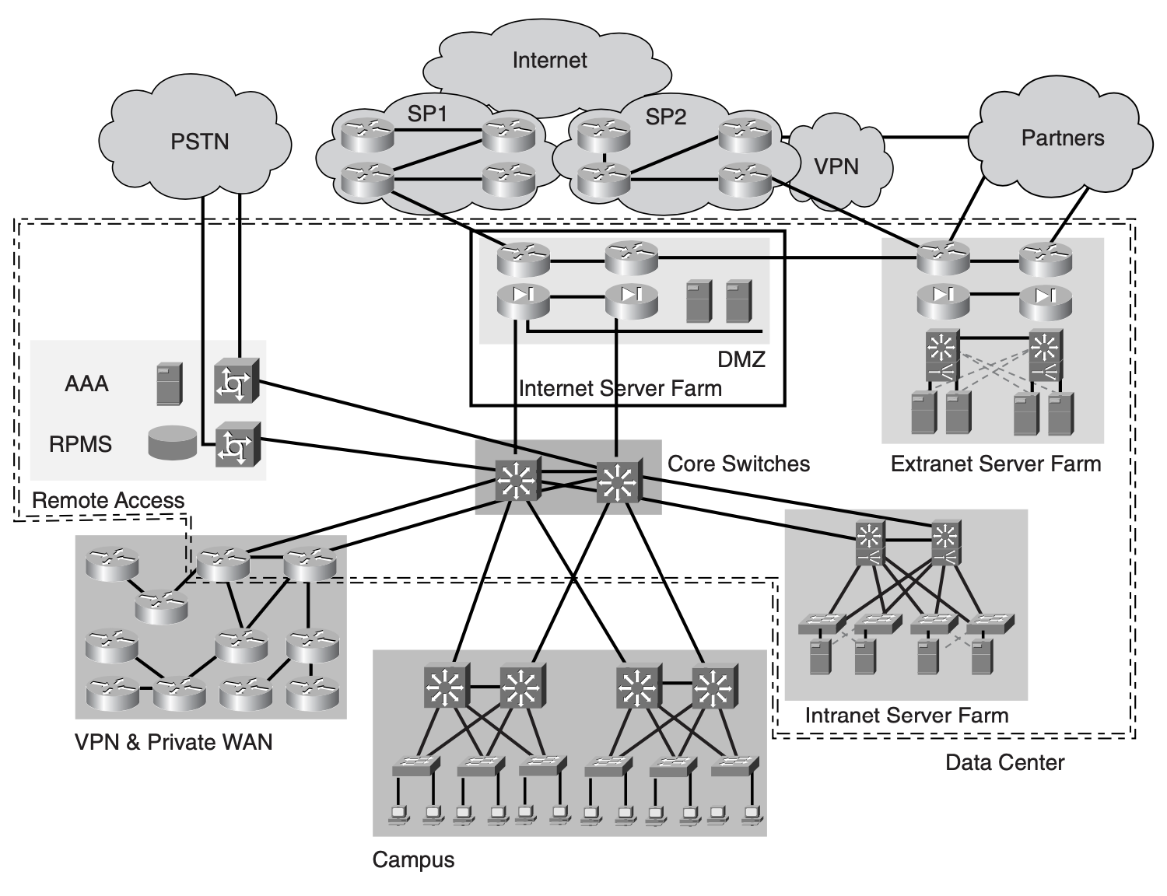
Figure 1. Data Centre example. Source [3]

Data Centre Architecture
As applications’ architecture continues to evolve over the years, adapting to needs brought by various trends, even DC architecture design needs to evolve to support the always growing data load created by online apps and users. Thus, the need to build infrastructures that make use of high performances, safe and scalable architectures. Until recently, Client/Server application model was the standard that enterprises all over the world used to deliver content to their customers. This model relies on the fact that the customer (Client) gets access to companies’ shared resources, accessible by paying a fee that can take the shape of Software License or Service Subscription, from a thick client that provides the interface to explore them. The logic of the business is handled by the Server that replies to the client’s queries with data interpreted by the client-side application. It is possible to say that the Client software acts as a part of the whole application since it requires to be installed on hardware that supported it in order to work properly [3].

Client/Server application model opened the world to the apps we use in our daily life. This architecture evolved with the advent of the first web-based applications that use Thin Clients instead. Here, the Web Browser acts as a bridge between the interface for the software and the server-side located service. In this case, the whole application hosted on the server-side as the Client is represented by the hardware used by the user. The user can interact with it freely (games, free office suites etc.) or on a pay-as-you-go basis if the required applicative it’s part of a proprietary software package. Although the migration from Thick to Thin Clients made possible for developers to create more unified server-side software (increasing software availability), companies are also required to develop Data Centres based on the n-tier architecture, that makes use of different Tiers (Layers) to separate the services used by the software. In this way is possible to have a more manageable and scalable infrastructure.

Multitier Architecture

The term Multitier Architecture refers to Data Centres in which a logical and Physical separation is made between the various components that allow the software to operate.
These components are often represented by the Front End and the Back End of the software. Front End includes Web Servers, used to bridge applications interface to the Back End in which the Application/Database servers are located. In the past, most Data Centres were designed making use of specific Multitier topologies, more specifically 3-TIER and 2-TIER (more commonly known as Collapsed Core Design).
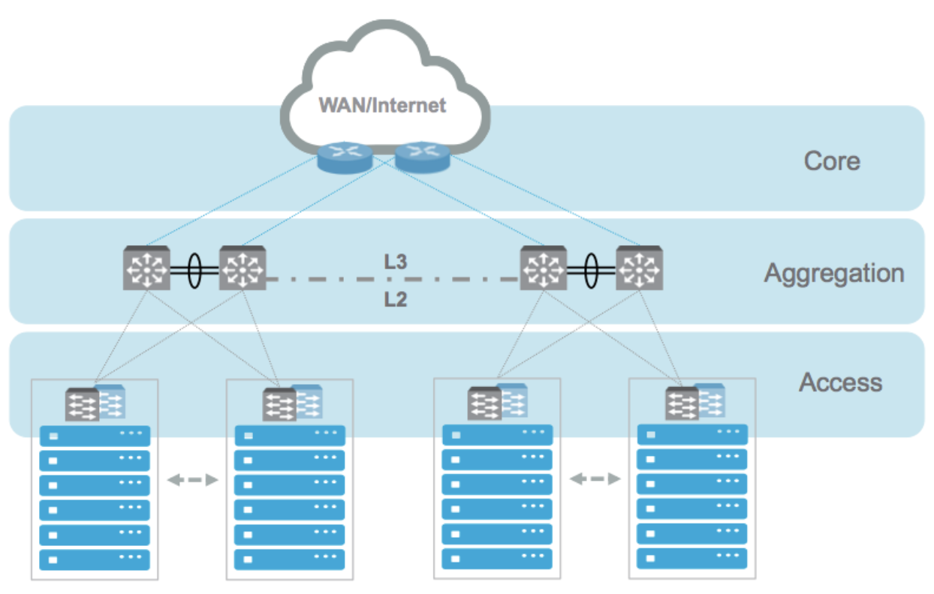
Figure 2. 3-TIER Topology. Source [16]

Core Layer

Core layer is the backbone of a Data Centre. It provides high-speed switching for all data traffic that goes in and out of the DC by making use of a Layer 3 routed fabric (Traffic moving in and out from a DC takes the name of North-To-South Traffic). It is developed in such a way to avoid any point of failure. Core layer uses Layer 3 switches and routers to eliminate latency, during the forwarding of packets, that might result in a loss of performances.

Aggregation Layer

The aggregation layer is where all West-To-East communication happens. West-To-East traffic is made by packets that travel from and to the devices representing the DC fabric.
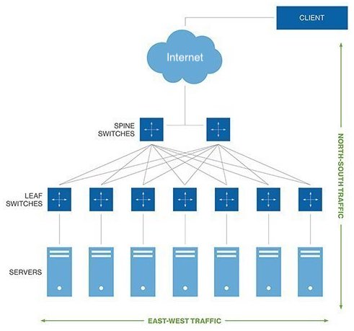
Figure 3. North-To-South and West-To-East network traffic representation. Source: Author

Aggregation layer makes use of Multilayer Switches (L2 and L3) that forward the traffic coming from the lower Access Layer where all the servers of the Data Centre are located.
To the Aggregation Layer take also part Load Balancers, Intrusion Detection Systems (IDS) and Firewalls that operates to improve the performances while keeping safe the equipment in the lower layer.

Access Layer

The final and lower layer of the 3-TIER topology is the Access Layer, where all the servers and the connections to Storage Area Networks (SAN) are located.
Access layer is provided with Layer 2 connectivity, marked by the implementation of STP (Spanning Tree Protocol) and VLANs.

Storage Area Networks

Storage area networks, also referred as SAN and located into the lower logical layer of a DC, are the part of the infrastructure hosting all the storage and the devices whose access from the servers located within the Access Layer is allowed by fast transport media such as FCIP (Fibre Channel Over IP).
This layer includes Fibre Channel Switches and routers that support different protocols used to bring connectivity to the devices in these networks.

Data Centre Services
Although the use of devices such as Layer 2 and 3 Routers and Switches is remained more or less the same during the last few years, the incremental use of Cloud Computing services and the increasing popularity of the Multi-Tenant model used to deliver the same typology of services to different customers (Tenants) as well as the properties that characterise CCT, contributed to development of DCs more challenging.

According to [3], the effort and more challenging aspects to keep into consideration during the design phases are:

- Scalability
- Flexibility
- High Availability

Wanting to give a more in-dept explanation of what these characteristics refer to, it is possible to say that: Scalability is the capability for a Data Centre to sustain a rapid change in resources demand without impacting performances.
Scalability can be achieved in two different ways, by scaling up or out DC resources.
Scaling Up is achievable by improvements on the software side, so that all the available resources can be used managed in the appropriate way.

Scaling Out, on the other side, is achievable by adding physical resources to the DC. It is important to note that this solution is not always the best choice and it depends by the utilised network topology. This topic is deepened in the next chapters, after the introduction of the different Server Farms types.

Server Farms Typologies

In the previous chapters of the literature, we gave an introduction to the different key aspects to keep in mind during the development of a DC. Now that the reader has a clearer idea of the different terms’ meaning, it is possible to start with the explanation of concepts such as Server Farm (SF). The goal of this chapter is to give a brief introduction to the most common Server farm typologies, examining their usage scenario to be able to give an appropriate suggestion to UWTSD.
It is important to remember that being UWTSD an educational environment, it has a large customer base that needs to be reached by different online services. Moreover, being born by the merging of two institutions means it has campuses located in different cities, therefore requires a connection that allows sharing resources (private and public) within the organisation.

Before starting with the explanation, it is better to give a definition for SF.
SF are rooms into a DC, used to group a particular type of Server (Cluster) whose duty is to deliver a certain service. Based on the typology of offered service, this takes a different name.
As visible in Figure 1, exist three Server Farms types:

- Intranet SF
- Extranet SF
- Internet SF

According to [3], “Server farms are at the heart of the Data Center. In fact, Data Centers are built to support at least one type of server farm.”

Intranet Sever Farms

As the name clearly states, Intranet SF are made by server clusters whose aim is to host applications used by internal users only. These type of SF takes care to deliver critical internal applications, important for the enterprise’s business.

Users of these services are usually located locally or, in the case of UWTSD in campus.
Resources are also accessible through the internet if required, making use of VPN (Virtual Private Network) technologies, that allow to extend the internal LAN remotely, where the user is located.

Extranet Sever Farms

With the name Extranet SF is meant an aggregation of servers that give access to a set of services and resources to trusted users. In this SF typology, the end user is known to the enterprise and has the permission to use internal resources and application.
The access to the internal network, the intranet, is often secured by firewalls and therefore, the user cannot compromise the confidentiality of internal data.

Internet Sever Farms

Internet SF is very common in all typologies of enterprises, as is used to deliver web services and information regarding the company to the whole world.
In this implementation, only a web browser is required to the user for the access, that can freely take advantage of the public information shared by companies.

Internet SF are often used to host services such as websites and e-commerce, but even portals accessible by trusted users that need to use more generic applications shared on the internal network.

UWTSD may implement an Internet SF to give access to students for the downloading of digital resources shared during their classes and access to their personal data, such as marks and personal information.

Internet Server Farms can be located into the enterprise’s DC but even externally to it. In this case, they take the name of Internet Data Centres or IDC and work on the same basis as every CC service. They use a shared infrastructure that is managed by the service provider to lower the costs and avoiding investing more capital on hardware and physical resources.

Network Topologies
Another important aspect to evaluate after having chosen the right services to deliver is related to networking. It is important indeed choosing the right network topology as it has a direct impact on aspects such as network capacity, latency, fault tolerance, efficiency and reliability. [2]

According to [2], DC network topologies can be divided into four main categories, each of those, have been developed and proposed with the goal to efficiently interconnect the devices of the DC fabric, trying to bring the best performance to end users.

These are:

- Tree-based topologies (i.e. Fat-Tree [5] and Portland [6])
- Recursive-defined topologies (i.e. DCell [7] and BCube [8])
- Hybrid Networks (i.e. Helios [9])
- Direct Networks (i.e. Cam-Cube [5], Small-World [10] etc.)

Also, they can be categorised based on the approach they use to forward the traffic (packets).
Switch-centric architectures are the most common implementation in DCs. As the name says, they provide network connectivity making use of Switches.
Server-centric on the other side leaves this duty to the servers, that must have enough data ports to accomplish this duty.

Although Server-centric topologies (BCube, DCell etc.) bring some advantages that might seem good at a first look, given from the fact for example a server cannot be independent from the network and the duties of fault tolerance and load balancing are assigned to the Operating System, reducing the costs, it is clear that every server would need a certain number of network interfaces to connect the others, making impractical the scalability of the infrastructure.
Moreover, a server could compromise the overall performance if it became a bottleneck for the network traffic and the infrastructure may waste too much energy since, even if the server would be in idle could not be put in standby mode.

Whilst many solutions can be implemented to handle the networking side of a DC, one in particular took place in recent years. This, due the increasing server-to-server workload which modern DC are subjected to. As previously mentioned in Chapter III, section C of the paper, server-to-server traffic is represented by all the packets travelling through the network (West-To-East) to ensure that Cloud Applications tasks, often executed on more than one server on a per job basis reach their destination without any delay [11].

Leaf – Spine Topology

Modern DC facilities use the so-called Leaf-Spine network topology instead of the classical 3-TIER to satisfy speed and fault tolerance requirements standards increased by Cloud Computing Technologies.
The design is fairly simple and does not require too much effort if more devices need to be added to increase the capability of the infrastructure.
As visible in Figure 4, this topology is achievable by using two layers of interconnected switches that are configured to create a Mesh network. A requirement to correctly implement it is that each Leaf Switch must be connected to each Spine Switch.

To achieve redundancy, LS topology requires that all the downlink ports of Spine Switched are connected to a Leaf. The number that indicates how many downlink ports a Spine Switch has is indicated using the character p. In the case of the figure, p = 8.
The same happens for the Leaf switches, whose number of uplink ports used to connect to the Spine take the name of q. As per image, q = 4.

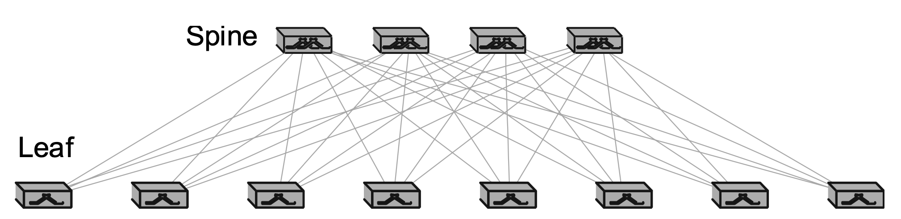
Figure 4. Leaf-Spine Network Topology. Source: Author

As [12] explain in their research, the major benefit that LS topology brings, is that each host of the fabric is at most 2 hops away from another, continuing to explain that this is a great advantage over other topologies such as Fat Tree [12] which see this number increasing to a minimum of 3.
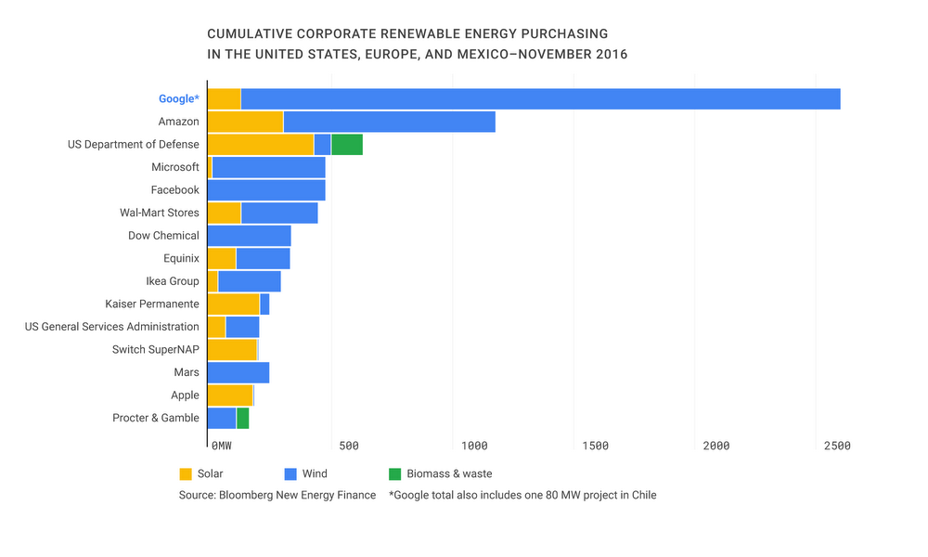
Figure 5. Corporations renewable energy 2016. Source: [14]

This same advantage might result in a drawback, since the number of switches could be higher than the number of ports available to connect each leaf, but this is circumventable by adding a new layer of switches that take the name of Super Spine. Since this could bring the reader that adding another layer might transform the topology in a Fat-Tree one, [12] also adds: “…it is not a Fat Tree because there is not a dependence of parameter K... Therefore, such a three layer topology may be considered as a loose Fat Tree, without the arithmetic constraints attached to it...”

To conclude, it is worth mentioning that Leaf-Spine is the most convenient network topology to use while developing a DC, as it can be implemented using commodity switches, without being bind to a specific manufacturer with proprietary standards.

Load Balancing
As the paper proceeds towards the end, where the sustainability issue is introduced and the author draws his conclusion on the possible implementation that UWTSD could use in its DC, another important aspect that must be cited regards Load Balancing (LB). Load Balancing is the practice to spread the workload created by user requests toward the DC. The most common techniques of LB implementation contemplate the use of specialised devices called “Load Balancers” that make use of LB algorithms implemented in their software. To note is that these algorithms can be implemented on servers as well, although the best approach is to use specific devices that deal with just this aspect. Load balancers are introduced into the design not only to increase scalability and availability aspects of the infrastructure, but they are also important in case of natural disasters. In fact, they allow the use of multi-sites Data Centres (Geo Replication) to provide a continuity of the services even if part of the infrastructure become unavailable.

Sustainability
The last aspect that the paper analyses before to pass to the conclusions, regards the Sustainability problem.
Although many novel approaches have been developed and there are many solutions that can be implemented to reduce the energy wastage within Data Centres premises, the issue currently persists. This because many infrastructures are old and fossil fuel is still used as a primary source of mass energy production [13]. Despite this, many Big Tech enterprises such as Apple, Google and Facebook are trying to implement as much renewable energy as possible, to reduce pollution and energy waste [14]. Figure 5 represents a graph in which is possible to see how these companies are contributing to the safeguard of the environment. This as a demonstration that something is changing in the tech industry.
Despite the sustainability issue is something that is still present in elder infrastructures, new Data Centres started to implement system such as liquid cooling to recover as much thermal energy as possible, to recycle it for the production of geothermal energy and hot water [13].
This current trend will surely grow in the next few years, thanks also to the good example given by Big Tech, that promote renewable sources implementation.

Conclusions and Recommendations

The topics examined in this paper aimed at the research of the right technologies to suggest to UWTSD the right idea for the development of the required Data Centre, needed due to the merging of two universities.
As seen in the previous chapters, the development of the right infrastructure is not always simple, as many aspects need to be properly evaluated, before to jump into conclusions.
With the help of the documents used to create the literature review, the author identified a few aspects that may help the university to develop and deploy the right infrastructure, without suffering of performance loss while keeping costs as lower as possible.

In particular, the DC should use a Leaf-Spine network topology and implement 2 server farms to grant access to employees and students for the use internal applications as well as the University website. These would be:

- Internet Server Farm
- Intranet Server Farm

Regarding the initial investment that the organisation should make for the development of the facility and the physical infrastructure, would be advisable for the previous DCs to be migrated to a shared architecture model as the initial investment would be kept low and the Service Provider would take care of keeping data safe implementing security and geo replication solutions.

Another possible alternative would be to keep both the current ICT infrastructures used previously to deliver services to both the businesses, reshaping the facilities to implement the above-mentioned design and connecting the two branches using a fiber connection.

To conclude, although both the implementation would be achievable, the author would suggest the use of the first implementation as it would be faster to put in place and helpful for the environment.

References

[1] | M. Chiarello, "ACCC5000 - Cloud Computing Technologies: Overview of Cloud Computing," UWTSD, London, 2020.
[2] | Z. S. Y. X. M. H. Ting Wang, "Rethinking the Data Centre Networking: Architecture, Network Protocols, adn Resource Sharing," vol. 2, pp. 1481-1487, 2014.
[3] | M. P. Mauricio Arregoces, "Data Centers Defined," in Data Center Foundamentals, Indianapolis, Cisco Press, 2009.
[4] | Juniper Networks, Inc., "Learn About Data Center Fabric Fundamentals," April 2015. [Online]. Available: https://www.juniper.net/documentation/en_US/learn-about/LA_DCFabricsFundamentals.pdf. [Accessed December 2020].
[5] | A. L. A. V. M. Al-Fares, "A scalable, commodity data center network architecture," in ACM Conf. Data communication (SIGCOMM 2008), 2008.
[6] | R. M. e. al., "Portland: A scalable fault tolerant layer 2 data cener network fabric," in ACM SIGCOMM Comput. Commun. Rev., 2009.
[7] | H. W. K. T. L. S. Y. Z. S. L. C.Guo, "DCell: A scalable and fault-tolerant network structure for Data Centers," in ACM SIGCOMM Comput. Commun. Rev., 2008.
[8] | C. G. e. al., "BCube: A high performance, server centric network architecture for modular data centers," in ACM SIGCOMM Comput. Comm., 2009.
[9] | N. F. e. al., "Helios: A hybrid electrical/optical switch architecture for modular data centers," in ACM SIGCOMM, 2010.
[10] | B. E. S. J.-Y. Shin, "Small-world datacenters," in Proc.2nd ACM Symp. Cloud Computing, 2011.
[11] | T. E. Mohammad Alizadeh, "On the Data Path Performance of Leaf-Spine Datacenter fabics," in 2013 IEEE 21st Annual Symposoum on High-Performance Interconnects, San Jose, 2013.
[12] | S. A. K. G. C. J. Pedro Juan Roig, "Modelling a Leaf and Spine Topology for VM Migration in Fog Computing," IEEE, Palma de Mallorca, Spain, 2020.
[13] | G. F. J. A. S. F. Khosrow Ebrahimi, "A review of data center cooling technology, operating conditions and the corresponding low-grade waste heat recovery opportunities," Elsevier, Villanova, USA, 2014.
[14] | U. Hölzle, "We’re set to reach 100% renewable energy — and it’s just the beginning," 6 December 2016. [Online]. Available: https://blog.google/outreach-initiatives/environment/100-percent-renewable-energy/. [Accessed January 2021].
[15] | Cisco, "Cisco Global Cloud Index 2015–2020," 15 November 2016. [Online]. [Accessed December 2020].
[16] | WMware, Artist, Classic Core/Aggregation/Access Layer Topologies. [Art]. 2020.

