Name: Samuel Jones
Student Number: 2024633
Assignment: L4 - Introduction to Web and Database Concepts (ACCA4023)

Date: 16/04/2021

Contents
Section 1: Introduction: 1
Section 2: Requirements: 1
Section 3: Target audience: 2
Section 4: Relevance: 2
Section 5: Implementation: 2
Section 6: W3 HTML Checker: 4
Section 7: Evaluation: 6
Section 8: SEO (Search Engine Optimisation): 6
Section 9: Usability 6
Section 10: Accessibility 7
Section 11: Sleevewear Sportswear Ltd Website analysis 7
Section 12: Accessibility 9
THE CODE SECTION
Section 1 index.html & css 11
Section 2: Products.html & css 18
Section 3: About Us 26
Section 4: Gallery 32
Section 5: Contact us 39

Section 1: Introduction:

This report contains the work that I had designed and developed for a fictitious company named Sleevesports Ltd. The report contains all relevant sections from the website including screenshots, in depth summary and website standards.

Section 2: Requirements:

The website is completely fictitious, meaning that every content within the website does not exist and has been made up. The purpose of the website is to be a sportswear store, where customers can view products and purchasing them. Along with the products that are available on the site, there is a gallery of contents designed to win the approval of the customer, succumbing to the idea of purchasing the item.

I’ve ensured that all contents on the website are accessible and minimally intensive on the browser, maintaining a performance stable relationship between the client and a server (in this case it’s hosted locally, meaning a server is not needed to run the website).

Section 3: Target audience:

The target audience is all ages, ensuring that I’ve included accessibility methods for those who are visually impaired, or have trouble accessing different action points on the website. To create a target audience, I’ve purposefully implemented a design where it meets the eye of the client. The red, black, and white contrast maintains a minimalistic approach, although adds subtle saturation to avoid a dull atmosphere. When designing the website, I always had in mind the respective audience that I’m attempting to engage. With a minimal approach, there’s opportunity for all audiences to browse the website and understand each section.

Section 4: Relevance:

Sleevesports Ltd website is relevant to all persons who engage with physical exercise and are looking to further add to their wardrobe with the newest, fashionable items whilst maintaining the fitness comfortability in their garments.

Section 5: Implementation:

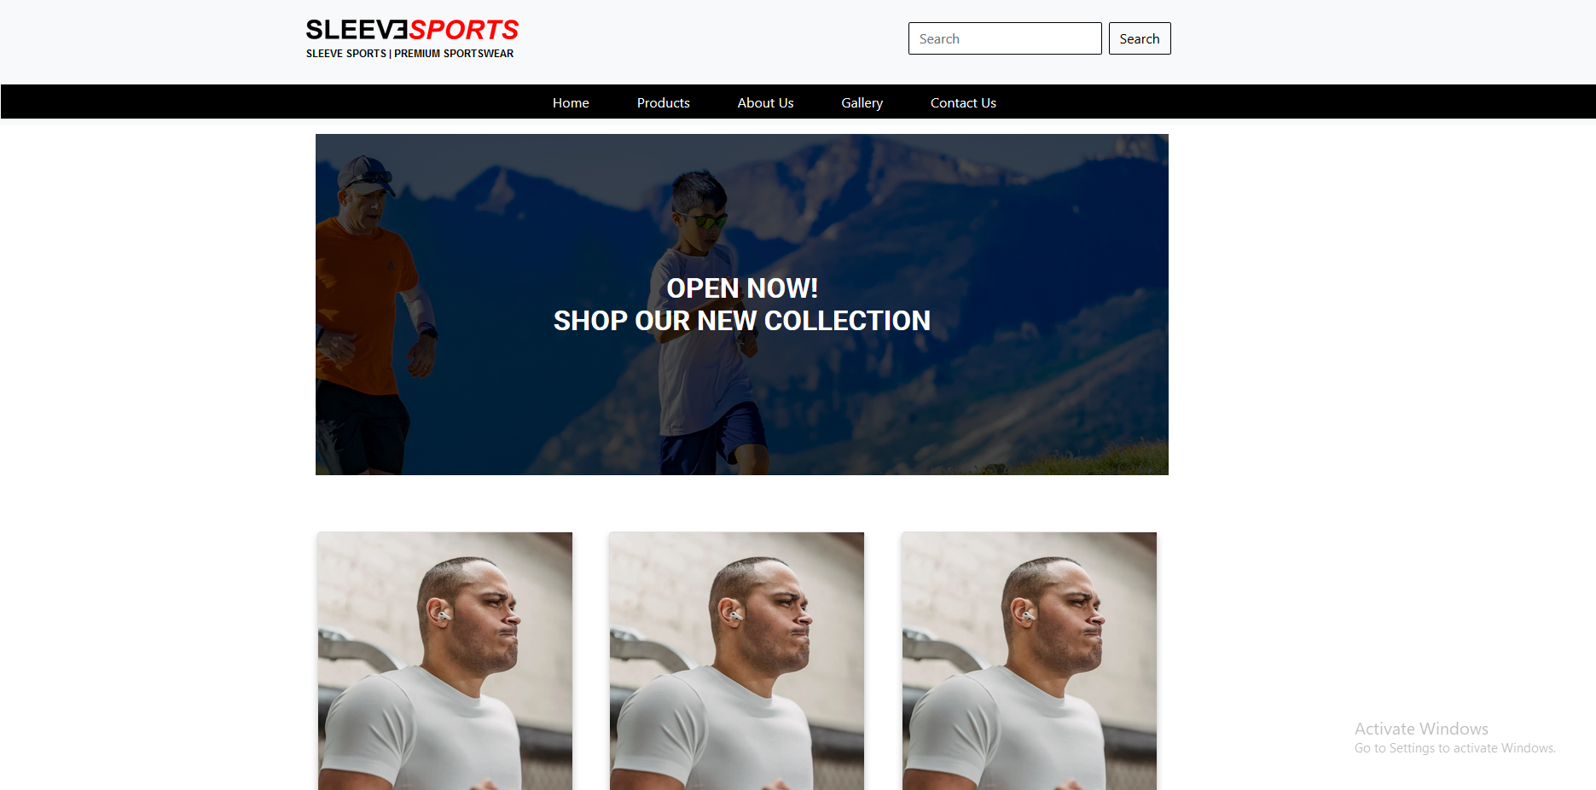
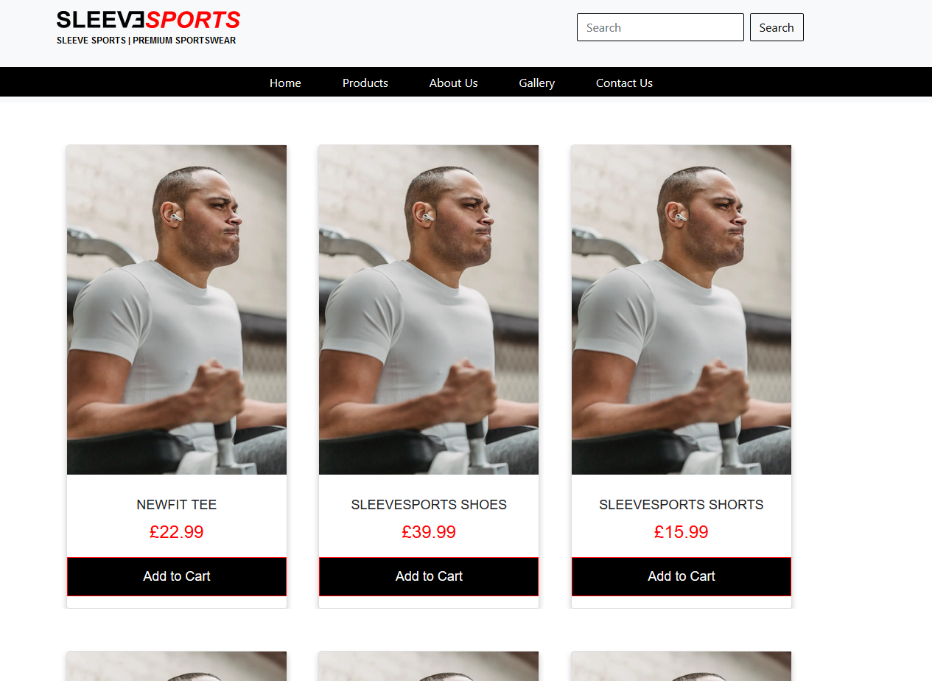
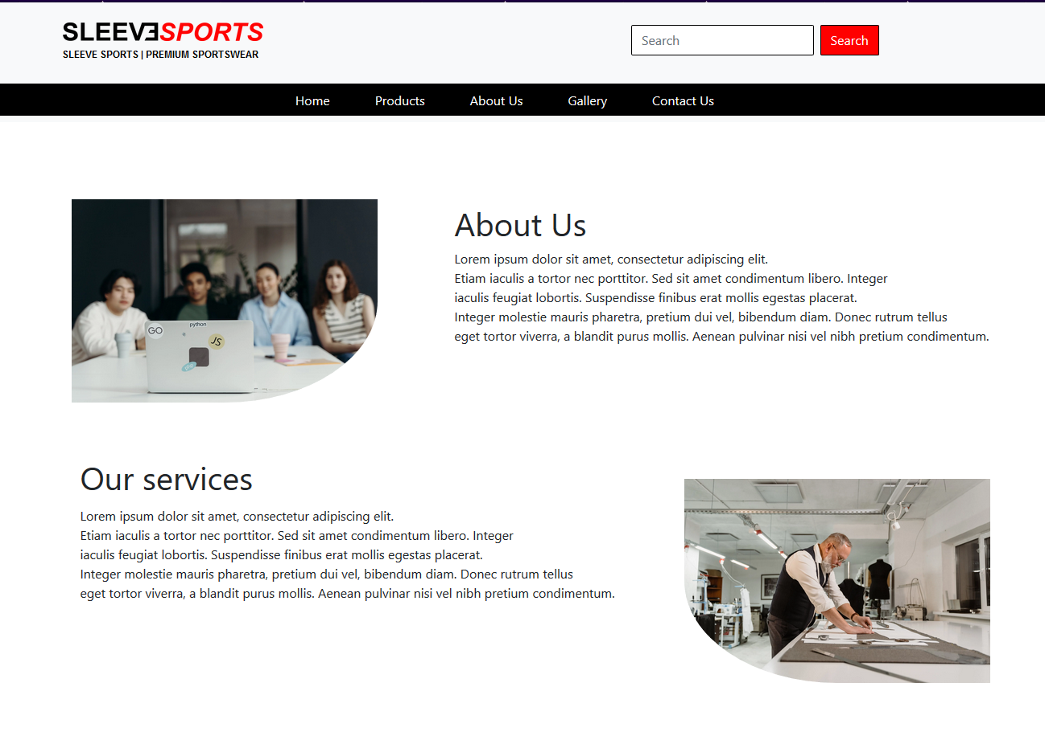
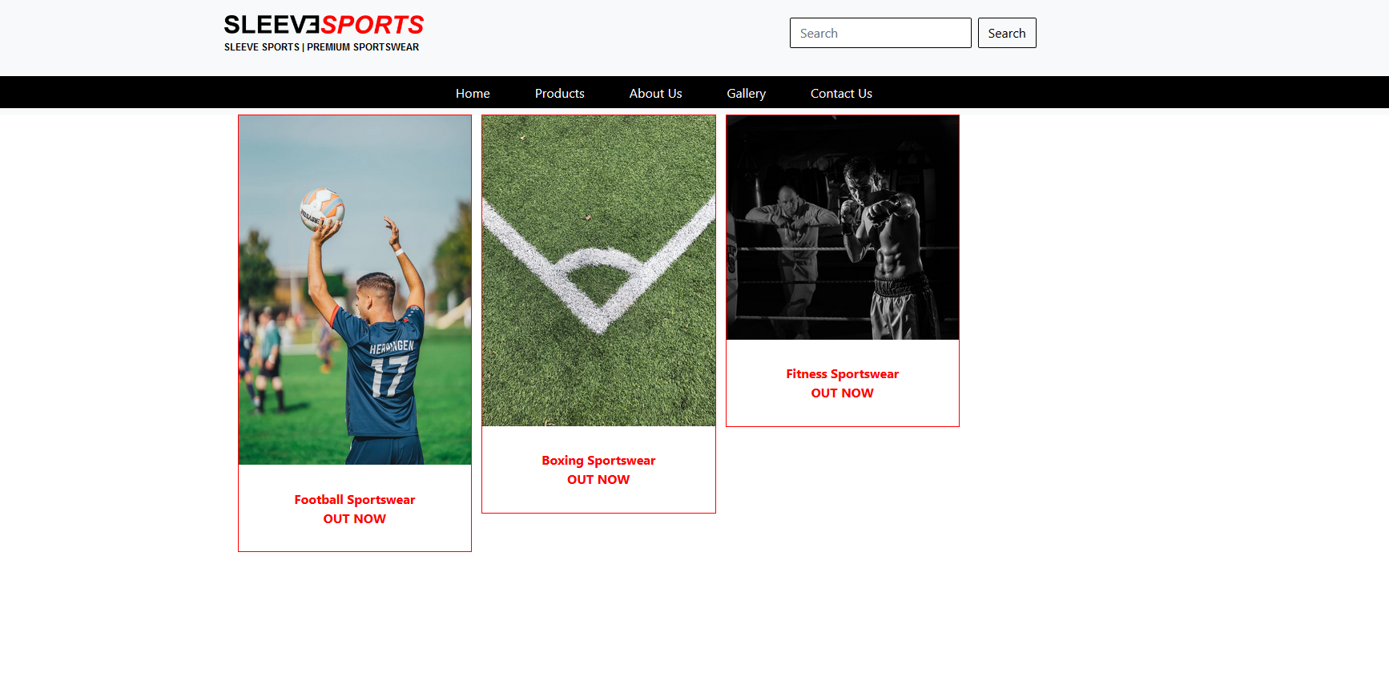
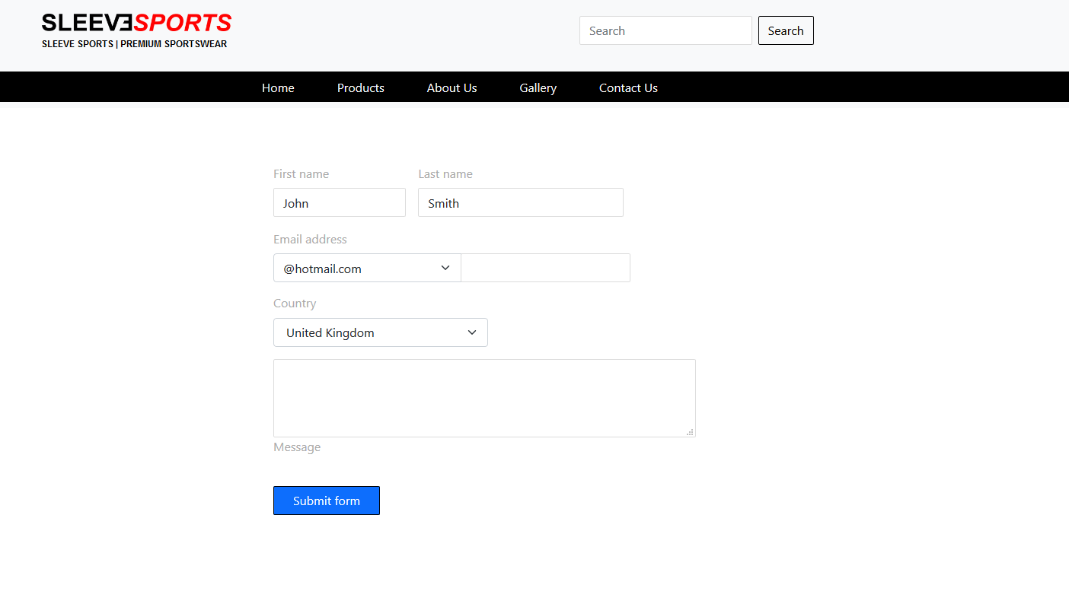

Section 6: W3 HTML Checker:

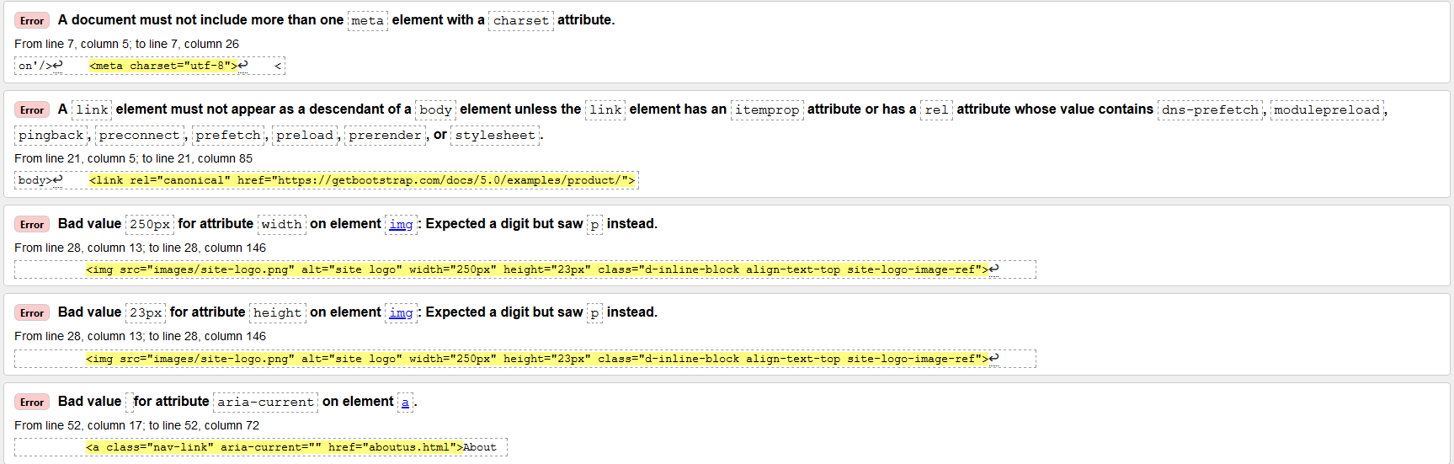

Errors:

- A document must not include more than one meta element with a charset attribute.
  - Cause:
    - Duplicated meta tag on the page
  - Fix:
    - Remove the duplication.

- A link element must not appear as a descendant of a body element unless the link element has an itemprop attribute or has a rel attribute whose value contains dns-prefetch, modulepreload,
  - Cause:
    - HTML does not like for the Bootstrap link to be within the body element, it requires the link to be outside of the body.
  - Fix:
    - Move the link for the bootstrap out of the body element, or insert them after where the meta tags are placed

- Bad value 250px for attribute width on element img: Expected a digit but saw p instead.
  - Cause:
    - Because the code snippet has the width set at 250px in HTML format, there’s no need for the code to have ‘px’ next to 250 since HTML already recognised the digit to be ‘px’.
  - Fix:
    - Remove ‘px’ after 250 in the width tag

- Error: Bad value 23px for attribute height on element img: Expected a digit but saw p instead.
  - Cause:
    - Same as above (3rd error)
  - Fix:
    - Same as above (3rd error)

- Error: Bad value for attribute aria-current on element a.
  - Cause:
    - ‘aria-current’ is an empty tag, rendering to be worthless
  - Fix:
    - Remove the tag ‘aria-current’

CSS Validator (http://jigsaw.w3.org/css-validator/validator):

No errors.

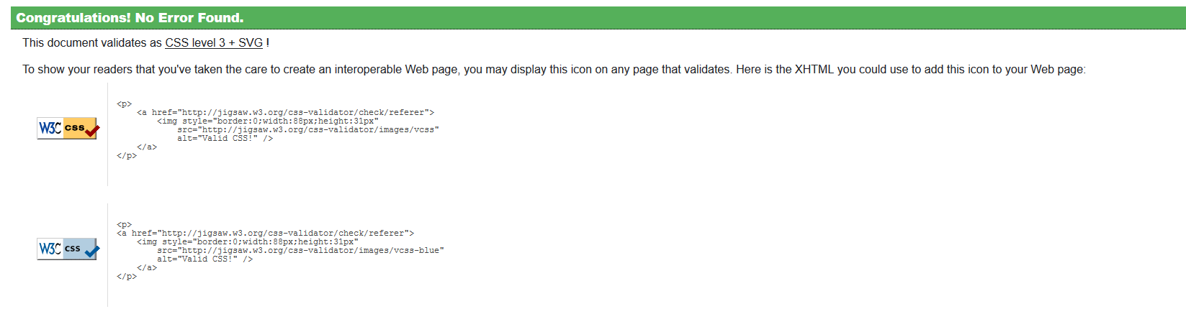

Section 7: Evaluation:

Competitors rule the market with their up-to-date clothing and knowledge on topics that are not well known to the public right away. For each competitor, a small business seems to struggle to compete in the race to achieve customers reaching their website. With ecommerce in play, it is becoming notoriously difficult for small businesses to be seen. Especially with Google Ads, the big businesses that are on top of the market dominate the front pages of the search engine.

Each website from the big businesses in the same industry have gone through rigorous website changes to maintain performance and design to their targeted audience. When designing your own website, it’s imperative that each aspect is taken into consideration to heighten the chances that Google recommends your website. This is commonly known as SEO (Search Engine Optimisation).

Section 8: SEO (Search Engine Optimisation):
SEO is very important when designing a website, it critically defines whether your website will be seen when a person searches for a website that you have thought of. Your business may have the best products or support, however the best website is analysed through different factors and SEO is definitely one of the most critical ones.

SEO
What is SEO?

Search Engine Optimisation (SEO) is the process of including and implementing methods to your website to increase the chance of becoming visible when its relevancy is being searched by a user. The complex understanding of this process is to include relevant words, tags and HTML code to attract the algorithm of the search engine, which outputs the best results to the user based on their search.

When a user uses search engines such as Google, an algorithm behind the scenes so to speak crawl pages on their search engines. These bots collect information on all the pages and analyse the indexes while creating factors such as ranking factors or signals. While it analyses the indexes, it creates an output and effectively determines how the pages are going to be ordered in the search results.

Bots often categorise these websites into ranking factors, which is well known to professional website developers. These ranking factors are also known as the Periodic Table of SEO Factors. These categorised factors are organised into six main categories and located based on it’s importance to SEO.

The Search Engine Optimisation is a tremendously important marketing tool for all businesses that offer ecommerce. Google does not share their search volume data; however, it is estimated Google processes approximately 70,000 search queries every second, translating to 5.8 billion searches per day and approximately 2 trillion global searches per year. The average person conducts between three and four searches each day. [1](Prater, 2019 )

Section 9: Usability

Usability is vital for every website, it controls what the visitors can interact with. Some websites focus on the user interface, which determines how the website should look but they often depreciate how easy the user can navigate. Websites that focus on the aesthetics and visuals lack the importance of usability, and as such end up on the low end of the visibility scale.

A website can visually be pleasing to look at, however if a user cannot find the information they’re looking for, they are due to become frustrated. The importance of the website relies on how easy the user can navigate, and find any information needed otherwise the bounce rate of the website will increase and furthermore, create a poor experience which would mean less traffic and a steady/deep decrease in conversions.

Most websites (81%) fail to satisfy the most basic Web Accessibility Initiative Category. In addition, the results of the evaluations undertaken by disabled users show that they have characteristics that make it very difficult for those who are blind, to make use of the services provided. [2]

  - Few (19%) websites comply even with the lowest priority checkpoints for accessibility.[2]
  - All categories of disabled user consider that site design stake insufficient account of their[2] specific needs.
  - Blind users, who employ screen readers to access the web, although not alone in being disadvantaged, are particularly disadvantaged by websites whose design does not take full account of their needs [2]
(TSO, 2004)

Section 10: Accessibility

Website accessibility is where a website (including tools and technologies) is designed for those who are particularly disadvantaged, or those with disabilities. Specifically, it includes features that help those navigate through the website and contribute to the web. Video captions are a prime example for those who have trouble hearing, helping them understand the voices that talk. These tools have revolutionised the web, ensuring that everyone has the accessibility to navigate the web with help if needed.

Accessibility has a clear role in the build up of designing a website. Establishing a design with accessibility in mind creates reassurance and an excellent customer relationship with the website and maintaining an increase in conversion whilst increasing the time on the website. With a website not being accessible, the user will become frustrated with the lack of guidance, likely decreasing conversion rates and time on the website.

- 71% of disabled customers with access needs will click away from a website that they find difficult to use.[3]
- Those customers who click away have an estimated spending power of £11.75 billion in the UK alone, around 10% of the total UK online spend in 2016.[3]
- 82% of customers with access needs would spend more if websites were more accessible.[3]

(Williams & Brownlow, 2016) [3]

Section 11: Sleevewear Sportswear Ltd Website analysis

Usefulness

With the research that has been done, I’ve designed the website to ensure that it creates a source where the users are able to freely navigate the website and use it’s utilities easily, with those who are disabled in mind. I recognise the importance of creating a useful website, whilst sustaining the minimalistic/simplistic approach ensuring that those who are disadvantaged are navigating the website with no pressure.

Creating the website, I decided that there should be no complex navigation tools. The simplistic navigation bar indicates the easiness of the usability of the website. Sustaining a 3-way colour pallet (red, black, white) creating a sufficient contract between foreground and background colours. These include links, colours, buttons. I’ve ensured that all of these important factors are highlighted and clear, defining that the object is of important matter to the user.

Recommendations for future use:

In future updates to the website, I believe that decreasing the amount of material and increasing the amount of text is essential. This step is to create an environment where text-to-speech is accurate and recognisable for the user.

Though I must ensure that there’s not an exaggerated amount of text, where information is being hidden or prolonged time to reach.

Search Engine Optimisation

On the website, I’ve clearly outlined the methods and keywords to contribute to optimising the search engine and increasing the chance of my website coming up at the top of the results, or near at least. While the sports industry is smothered in retailers offering different products, it’s imperative that the code behind the website also creates a better chance of becoming visible.

Methods
Firstly, I thought about the SEO when I had the company idea in mind. In this instance, I had to be creative with the name of the company, and how I can add probably keywords that are common within the industry.

For example, the company that I had made up was named Sleevesports Sportswear Ltd. This gives an advantage already since the word ‘Sleeve’ is commonly referred for garments, however this isn’t going to be a catchy name that everyone would recognise. Therefore, I included the keyword ‘sports’ in the name to further aid the optimisation. ‘Sleevesports’ is completely fictitious, and probably most times that’s not enough for the SEO to pick up on, in which this case I added the ‘Sportswear’ on the end to ensure that when crawling the website, the keyword ‘sportswear’ will become transparent what the website is offering. Below the keywords and the logo behind the brand, I added a description of the services which was: “SLEEVE SPORTS | PREMIUM SPORTSWEAR”. This description accurately conveys to the algorithm further of what the website is trying to achieve, and what target audience I’m attempting to reach.

Keywords: “Sleeve”, “Sports”, “Sportswear”, “Sleeve Sports”, “Premium sportswear”.

Titles and descriptions:

In the meta tags in the code, I added the title:
<title>Sleeve Sports Ltd Premium Sportswear</title>
And the description:
<meta name="description" content="Premium sportswear for all ages and sexes">

The title and the description will further add fuel to the SEO, providing the bots again with a description and title of what the website is offering.

Adding alt-text:

In some instances, some pictures may take a long time to load, or furthermore never load at all. In these circumstances, the SEO doesn’t see these images and completely ignores them. When an image is given alternative text on the website, it displays on the website what image should be there and it gives a description, which SEO bots really do appreciate. For ex:
<img src="images/site-logo.png" alt="site logo" width="250px" height="23px" class="d-inline-block align-text-top site-logo-image-ref">

On the website:

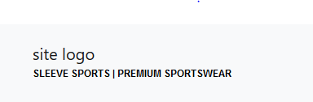

Reviewing this, I’ll change the description to “Sleeve Sports Logo” which purposefully aims to give the bots a better understanding.

Section 12: Accessibility

I’ve ensured, with guidance from WGAC, that my website maintains up to standard and allows all
users regardless of their disadvantages to navigate through the website and understand each section. The website contains information that can be seen due to the perfect contrast that doesn’t impair any person’s vision.

Perceivable
- Text alternatives
  - I’ve provided accurate descriptions of each tag which are not text content.
- Adaptable
  - I’ve implemented a responsive code to ensure that on any size device, the screen stays the same without losing information.
- Distinguishable
  - The foreground and background are easy to separate, making it easier for users to see and hear content

Operable
- Enough time
  - The website is responsive and the performance is quick, and gives the user more time to read and use content.
- Seizures or physical reactions
  - Nothing on the website (as far as I’m aware) can trigger a seizure or physical reactions as all content is solid and doesn’t flash.
- Navigable
  - The website contains a ‘Search’ box, where the user can easily find the information or content they’re looking for

Operable
- Readable
  - The text and information on the website is easily readable. Creating a non-complex description creates an easy understanding of what the website is trying to tell users.
- Input assistance
  - I’ve ensured that I’ve implemented data validation to ensure that the fields can help users correct mistakes and avoids any errors.
    - For ex: In the ‘Contact Us’ page, I’ve developed an idea that tells the user that their email address might not seem correct.

Contrast:

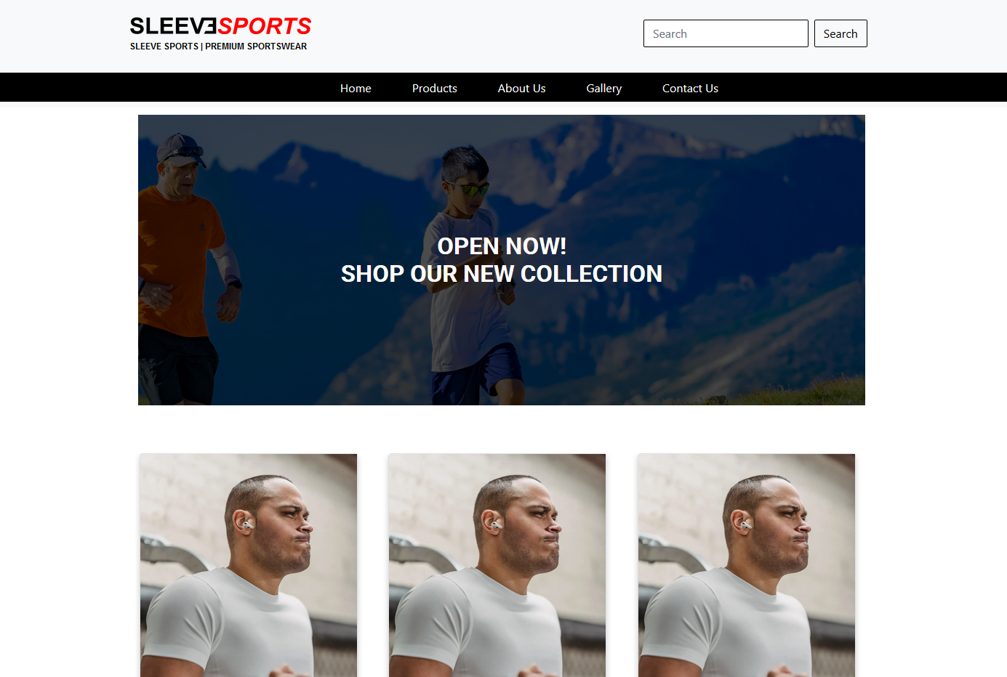
Result:
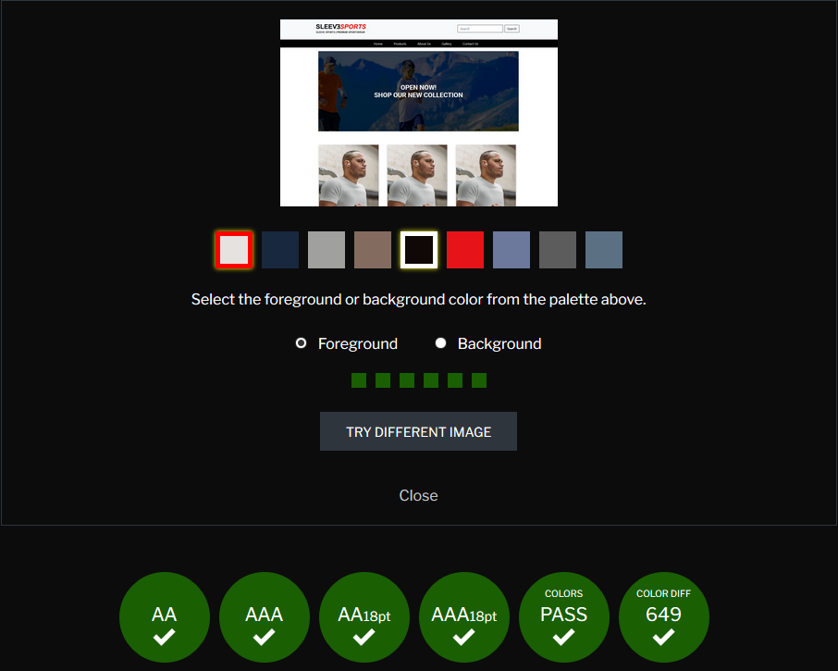

Website: https://contrastchecker.com/

References:
[1] (Prater, 2019 )
https://blog.hubspot.com/marketing/google-search-statistics
[2] (TSO, 2004)
https://www.city.ac.uk/__data/assets/pdf_file/0004/72670/DRC_Report.pdf
[3] (Williams & Brownlow, 2016)
http://www.clickawaypound.com/cap16finalreport.html
Images from https://www.pexels.com/ (Royalty free)

The code is below
Table of contents

Index.html

Section 1 index.html & css
<!DOCTYPE html>
<html lang="en">
<head>
<meta charset="utf-8" />
<title>Sleeve Sports Ltd Premium Sportswear</title>
<link rel='icon' href='favicon.ico' type='image/x-icon'/>
<meta charset="utf-8">
<!--SEO tag for telling search engine how they should crawl website-->
<meta name=”robots” content="index, follow">
<!--Responsive website for different devices-->
<meta name="viewport" content="width=device-width, initial-scale=1">
<meta name="description" content="Premium sportswear for all ages and sexes">
<meta name="author" content="Samuel Jones">
<!-- Stylesheet link -->
<link href="style.css" rel="stylesheet">
<!--Bootstrap link-->
<link href="https://cdn.jsdelivr.net/npm/bootstrap@5.0.0-beta2/dist/css/bootstrap.min.css" rel="stylesheet" integrity="sha384-BmbxuPwQa2lc/FVzBcNJ7UAyJxM6wuqIj61tLrc4wSX0szH/Ev+nYRRuWlolflfl" crossorigin="anonymous">
</head>

<body>
<link rel="canonical" href="https://getbootstrap.com/docs/5.0/examples/product/">
<!-- Bootstrap core CSS -->
<link href="/docs/5.0/dist/css/bootstrap.min.css" rel="stylesheet" integrity="sha384-BmbxuPwQa2lc/FVzBcNJ7UAyJxM6wuqIj61tLrc4wSX0szH/Ev+nYRRuWlolflfl" crossorigin="anonymous">
<!--Code start-->
<nav class="navbar navbar-light bg-light main-nav">
<div class="container-fluid">
<a class="navbar-brand" href="#">
<img src="images/site-logo.png" alt="site logo" width="250px" height="23px" class="d-inline-block align-text-top site-logo-image-ref">
<h2 class="nav-bar-brand-title main-text">SLEEVE SPORTS | PREMIUM SPORTSWEAR</h2>
</a>
<form class="d-flex">
<input class="form-control me-2" type="search" placeholder="Search" aria-label="Search">
<button class="btn btn-light" type="submit">Search</button>
</form>
</div>
</nav>

<nav class="navbar navbar-expand-lg navbar-light bg-light under-nav-bar">
<div class="container-fluid">
<button class="navbar-toggler" type="button" data-bs-toggle="collapse" data-bs-target="#navbarSupportedContent" aria-controls="navbarSupportedContent" aria-expanded="false" aria-label="Toggle navigation">
<span class="navbar-toggler-icon"></span>
</button>
<div class="collapse navbar-collapse" id="navbarSupportedContent">
<ul class="navbar-nav me-auto mb-2 mb-lg-0">
<li class="nav-item">
<a class="nav-link active" aria-current="page" href="#">Home</a>
</li>
<li class="nav-item">
<a class="nav-link" href="products.html">Products</a>
</li>
<li class="nav-item">
<a class="nav-link" aria-current="" href="aboutus.html">About Us</a>
</li>
<li class="nav-item">
<a class="nav-link" aria-current="page" href="gallery.html">Gallery</a>
</li>
<li class="nav-item">
<a class="nav-link" href="contact.html">Contact Us</a>
</li>
</ul>
</div>
</div>
</nav>

<div class="module mid">
<h2>OPEN NOW! <br> Shop our new collection</h2>
</div>

<div class="container-product">
<div class="card">
<img src="https://images.pexels.com/photos/6455959/pexels-photo-6455959.jpeg?auto=compress&cs=tinysrgb&dpr=2&h=750&w=1260" alt="Sportswear Top" style="width:100%">
<h1 class="item-desc">NEWFIT TEE</h1>
<p class="price">£22.99</p>
<p><button>Add to Cart</button></p>
</div>
<div class="card">
<img src="https://images.pexels.com/photos/6455959/pexels-photo-6455959.jpeg?auto=compress&cs=tinysrgb&dpr=2&h=750&w=1260" alt="Sportswear Top" style="width:100%">
<h1 class="item-desc">SLEEVESPORTS SHOES</h1>
<p class="price">£39.99</p>
<p><button>Add to Cart</button></p>
</div>
<div class="card">
<img src="https://images.pexels.com/photos/6455959/pexels-photo-6455959.jpeg?auto=compress&cs=tinysrgb&dpr=2&h=750&w=1260" alt="Sportswear Top" style="width:100%">
<h1 class="item-desc">SLEEVESPORTS SHORTS</h1>
<p class="price">£15.99</p>
<p><button>Add to Cart</button></p>
</div>
</div>

<footer class="footer">
<div class="container-footer">
<ul class="footerlist">
<li><a href="home.html">Home</a></li>
<li><a href="products.html">Products</a></li>
<li><a href="aboutus.html">About Us</a></li>
<li><a href="gallery.html">Gallery</a></li>
<li><a href="contact.html">Contact Us</a></li>
</ul>
</div>

</footer>
<!--Bootstrap recommends inserting Bootstrap javascript link towards the bottom of body tag-->
<script src="/docs/5.0/dist/js/bootstrap.bundle.min.js" integrity="sha384-b5kHyXgcpbZJO/tY9Ul7kGkf1S0CWuKcCD38l8YkeH8z8QjE0GmW1gYU5S9FOnJ0" crossorigin="anonymous"></script>
</body>
body {
background-color: white;
font-family: Arial, Helvetica, sans-serif;
}

.navbar-brand {
margin-left:19% !important;
margin-top: 10px;
overflow: hidden;
}

.nav-bar-brand-title {
color: black;
font-family: Arial;
font-weight: bold;
font-size: 12px;
margin-top: 5px !important;
}

.form-control, .btn {
border-color: black !important;
border-radius: 2px !important;

}
.btn:hover {
border-color: red !important;
border-radius: 2px !important;
}

form-control:active {
border-color: red !important;
border-radius: 2px !important;
}

.navbar-light .navbar-nav .nav-link {
color: white !important;
}

.navbar-nav{
margin-left: 34%;
padding-right: 5% !important;
display: inline;
}

li:hover a {
text-decoration: none;
background-color: red;
color: white;
}

li {
margin-right: 40px;
}

.img-fluid {
margin-top: 5%;
margin-left: 7%;
}

.img-fluid:hover {
background-color: black !important;
}

.centered-text {
position: absolute !important;
top: 50% !important;
left: 50% !important;
transform: translate(-50%, -50%) !important;
}

.container-lg {
position: relative;
text-align: center;
}

.d-flex {
margin-right: 27% !important;
}

.under-nav-bar {
background-color: black !important;
}

.navbar-expand-lg .navbar-collapse {
background-color: black;
}

.module {
background:
linear-gradient(
rgba(0, 0, 0, 0.7),
rgba(0, 0, 0, 0.7)
),
url("images/royalty-free.jpg");
background-size: cover;
text-align: center;
width: 1000px;
height: 400px;
margin: 10px 0 0 10px;
position: relative;
float: left;
margin-left: 20%;
}

.mid h2 {
font-family: 'Roboto', sans-serif;
font-weight: 900;
color: white;
text-transform: uppercase;
margin: 0;
position: absolute;
top: 50%;
left: 50%;
font-size: 2rem;
transform: translate(-50%, -50%);
}

* {
box-sizing: border-box;
}

.card {
box-shadow: 0 4px 8px 0 rgba(0, 0, 0, 0.2);
max-width: 300px;
margin: auto;
text-align: center;
font-family: arial;
}

.container-product{
margin-top: 25%;
margin-right: 17%;
overflow: hidden;
display: flex;
justify-content: space-between;
padding-left: 19%;
padding-right: 10%;

}

.price {
color: red;
font-size: 24px;
}

.card button {
border: 1px solid red;
padding: 12px;
color: white;
background-color: #000;
text-align: center;
cursor: pointer;
width: 100%;
font-size: 18px;
}

.card button:hover {
background-color: red;
color: black;
}
.item-desc {
font-size: 18px;
margin-top: 10%;
}

.footer {
background-color: black;
height: 300px;
width: 100%;
margin-top: 10%;
}

.footerlist {
list-style-type: none;
margin: 0;
padding: 0;
width: 200px;
margin-left: 50%;

}

li a {
display: block;
color: white;
padding: 8px 16px;
text-decoration: none;
}

Section 2: Products.html & css

Products.html & products.css

<!DOCTYPE html>
<html lang="en">
<head>
<meta charset="utf-8" />
<title>Sleeve Sports Ltd</title>
<link rel='icon' href='favicon.ico' type='image/x-icon'/>
<meta charset="utf-8">
<!--SEO tag for telling search engine how they should crawl website-->
<meta name=”robots” content="index, follow">
<!--Responsive website for different devices-->
<meta name="viewport" content="width=device-width, initial-scale=1">
<meta name="description" content="Premium sportswear for all ages and sexes">
<meta name="author" content="Samuel Jones">
<!-- Stylesheet link -->
<link href="products.css" rel="stylesheet">
<!--Bootstrap link-->
<link href="https://cdn.jsdelivr.net/npm/bootstrap@5.0.0-beta2/dist/css/bootstrap.min.css" rel="stylesheet" integrity="sha384-BmbxuPwQa2lc/FVzBcNJ7UAyJxM6wuqIj61tLrc4wSX0szH/Ev+nYRRuWlolflfl" crossorigin="anonymous">
</head>

<body>
<link rel="canonical" href="https://getbootstrap.com/docs/5.0/examples/product/">
<!-- Bootstrap core CSS -->
<link href="/docs/5.0/dist/css/bootstrap.min.css" rel="stylesheet" integrity="sha384-BmbxuPwQa2lc/FVzBcNJ7UAyJxM6wuqIj61tLrc4wSX0szH/Ev+nYRRuWlolflfl" crossorigin="anonymous">
<!--Code start-->
<nav class="navbar navbar-light bg-light main-nav">
<div class="container-fluid">
<a class="navbar-brand" href="#">
<img src="images/site-logo.png" alt="site logo" width="250px" height="23px" class="d-inline-block align-text-top site-logo-image-ref">
<h2 class="nav-bar-brand-title main-text">SLEEVE SPORTS | PREMIUM SPORTSWEAR</h2>
</a>
<form class="d-flex">
<input class="form-control me-2" type="search" placeholder="Search" aria-label="Search">
<button class="btn btn-light" type="submit">Search</button>
</form>
</div>
</nav>

<nav class="navbar navbar-expand-lg navbar-light bg-light under-nav-bar">
<div class="container-fluid">
<button class="navbar-toggler" type="button" data-bs-toggle="collapse" data-bs-target="#navbarSupportedContent" aria-controls="navbarSupportedContent" aria-expanded="false" aria-label="Toggle navigation">
<span class="navbar-toggler-icon"></span>
</button>
<div class="collapse navbar-collapse" id="navbarSupportedContent">
<ul class="navbar-nav me-auto mb-2 mb-lg-0">
<li class="nav-item">
<a class="nav-link active" aria-current="page" href="index.html">Home</a>
</li>
<li class="nav-item">
<a class="nav-link" href="products.html">Products</a>
</li>
<li class="nav-item">
<a class="nav-link" aria-current="page" href="aboutus.html">About Us</a>
</li>
<li class="nav-item">
<a class="nav-link" aria-current="page" href="gallery.html">Gallery</a>
</li>
<li class="nav-item">
<a class="nav-link" href="contact.html">Contact Us</a>
</li>
</ul>
</div>
</div>
</nav>

<div class="container-product">
<div class="card">
<img src="https://images.pexels.com/photos/6455959/pexels-photo-6455959.jpeg?auto=compress&cs=tinysrgb&dpr=2&h=750&w=1260" alt="Sportswear Top" style="width:100%">
<h1 class="item-desc">NEWFIT TEE</h1>
<p class="price">£22.99</p>
<p><button href="product-page.html">Add to Cart</button></p>
</div>
<div class="card">
<img src="https://images.pexels.com/photos/6455959/pexels-photo-6455959.jpeg?auto=compress&cs=tinysrgb&dpr=2&h=750&w=1260" alt="Sportswear Top" style="width:100%">
<h1 class="item-desc">SLEEVESPORTS SHOES</h1>
<p class="price">£39.99</p>
<p><button>Add to Cart</button></p>
</div>
<div class="card">
<img src="https://images.pexels.com/photos/6455959/pexels-photo-6455959.jpeg?auto=compress&cs=tinysrgb&dpr=2&h=750&w=1260" alt="Sportswear Top" style="width:100%">
<h1 class="item-desc">SLEEVESPORTS SHORTS</h1>
<p class="price">£15.99</p>
<p><button>Add to Cart</button></p>
</div>
</div>
<div class="container-product">
<div class="card">
<img src="https://images.pexels.com/photos/6455959/pexels-photo-6455959.jpeg?auto=compress&cs=tinysrgb&dpr=2&h=750&w=1260" alt="Sportswear Top" style="width:100%">
<h1 class="item-desc">NEWFIT TEE</h1>
<p class="price">£22.99</p>
<p><button>Add to Cart</button></p>
</div>
<div class="card">
<img src="https://images.pexels.com/photos/6455959/pexels-photo-6455959.jpeg?auto=compress&cs=tinysrgb&dpr=2&h=750&w=1260" alt="Sportswear Top" style="width:100%">
<h1 class="item-desc">SLEEVESPORTS SHOES</h1>
<p class="price">£39.99</p>
<p><button>Add to Cart</button></p>
</div>
<div class="card">
<img src="https://images.pexels.com/photos/6455959/pexels-photo-6455959.jpeg?auto=compress&cs=tinysrgb&dpr=2&h=750&w=1260" alt="Sportswear Top" style="width:100%">
<h1 class="item-desc">SLEEVESPORTS SHORTS</h1>
<p class="price">£15.99</p>
<p><button>Add to Cart</button></p>
</div>
</div>
<div class="container-product">
<div class="card">
<img src="https://images.pexels.com/photos/6455959/pexels-photo-6455959.jpeg?auto=compress&cs=tinysrgb&dpr=2&h=750&w=1260" alt="Sportswear Top" style="width:100%">
<h1 class="item-desc">NEWFIT TEE</h1>
<p class="price">£22.99</p>
<p><button>Add to Cart</button></p>
</div>
<div class="card">
<img src="https://images.pexels.com/photos/6455959/pexels-photo-6455959.jpeg?auto=compress&cs=tinysrgb&dpr=2&h=750&w=1260" alt="Sportswear Top" style="width:100%">
<h1 class="item-desc">SLEEVESPORTS SHOES</h1>
<p class="price">£39.99</p>
<p><button>Add to Cart</button></p>
</div>
<div class="card">
<img src="https://images.pexels.com/photos/6455959/pexels-photo-6455959.jpeg?auto=compress&cs=tinysrgb&dpr=2&h=750&w=1260" alt="Sportswear Top" style="width:100%">
<h1 class="item-desc">SLEEVESPORTS SHORTS</h1>
<p class="price">£15.99</p>
<p><button>Add to Cart</button></p>
</div>
</div>

<footer class="footer">
<div class="container-footer">
<ul class="footerlist">
<li><a href="home.html">Home</a></li>
<li><a href="products.html">Products</a></li>
<li><a href="aboutus.html">About Us</a></li>
<li><a href="gallery.html">Gallery</a></li>
<li><a href="contact.html">Contact Us</a></li>
</ul>
</div>

</footer>
<!--Bootstrap recommends inserting Bootstrap javascript link towards the bottom of body tag-->
<script src="/docs/5.0/dist/js/bootstrap.bundle.min.js" integrity="sha384-b5kHyXgcpbZJO/tY9Ul7kGkf1S0CWuKcCD38l8YkeH8z8QjE0GmW1gYU5S9FOnJ0" crossorigin="anonymous"></script>
</body>

body {
background-color: white;
font-family: Arial, Helvetica, sans-serif;
}

.navbar-brand {
margin-left:19% !important;
margin-top: 10px;
overflow: hidden;
}

.nav-bar-brand-title {
color: black;
font-family: Arial;
font-weight: bold;
font-size: 12px;
margin-top: 5px !important;
}

.form-control, .btn {
border-color: black !important;
border-radius: 2px !important;

}
.btn:hover {
border-color: red !important;
border-radius: 2px !important;
}

form-control:active {
border-color: red !important;
border-radius: 2px !important;
}

.navbar-light .navbar-nav .nav-link {
color: white !important;
}

.navbar-nav{
margin-left: 34%;
padding-right: 5% !important;
display: inline;
}

li:hover a {
text-decoration: none;
background-color: red;
color: white;
}

li {
margin-right: 40px;
}

.img-fluid {
margin-top: 5%;
margin-left: 7%;
}

.img-fluid:hover {
background-color: black !important;
}

.centered-text {
position: absolute !important;
top: 50% !important;
left: 50% !important;
transform: translate(-50%, -50%) !important;
}

.container-lg {
position: relative;
text-align: center;
}

.d-flex {
margin-right: 27% !important;
}

.under-nav-bar {
background-color: black !important;
}

.navbar-expand-lg .navbar-collapse {
background-color: black;
}

.module {
background:
linear-gradient(
rgba(0, 0, 0, 0.7),
rgba(0, 0, 0, 0.7)
),
url("images/royalty-free.jpg");
background-size: cover;
text-align: center;
width: 1000px;
height: 400px;
margin: 10px 0 0 10px;
position: relative;
float: left;
margin-left: 20%;
}

.mid h2 {
font-family: 'Roboto', sans-serif;
font-weight: 900;
color: white;
text-transform: uppercase;
margin: 0;
position: absolute;
top: 50%;
left: 50%;
font-size: 2rem;
transform: translate(-50%, -50%);
}

* {
box-sizing: border-box;
}

.card {
box-shadow: 0 4px 8px 0 rgba(0, 0, 0, 0.2);
max-width: 300px;
margin: auto;
text-align: center;
font-family: arial;
}

.container-product{
margin-top: 3%;
margin-right: 17%;
overflow: hidden;
display: flex;
justify-content: space-between;
padding-left: 19%;
padding-right: 10%;

}

.price {
color: red;
font-size: 24px;
}

.card button {
border: 1px solid red;
padding: 12px;
color: white;
background-color: #000;
text-align: center;
cursor: pointer;
width: 100%;
font-size: 18px;
}

.card button:hover {
background-color: red;
color: black;
}
.item-desc {
font-size: 18px;
margin-top: 10%;
}

.footer {
background-color: black;
height: 300px;
width: 100%;
margin-top: 10%;

}

.footerlist {
list-style-type: none;
margin: 0;
padding: 0;
width: 200px;
margin-left: 50%;

}

li a {
display: block;
color: white;
padding: 8px 16px;
text-decoration: none;
}

Section 3: About Us
Aboutus.html & aboutus.css

<!DOCTYPE html>
<html lang="en">
<head>
<meta charset="utf-8" />
<title>Sleeve Sports Ltd</title>
<link rel='icon' href='favicon.ico' type='image/x-icon'/>
<meta charset="utf-8">
<!--SEO tag for telling search engine how they should crawl website-->
<meta name=”robots” content="index, follow">
<!--Responsive website for different devices-->
<meta name="viewport" content="width=device-width, initial-scale=1">
<meta name="description" content="Premium sportswear for all ages and sexes">
<meta name="author" content="Samuel Jones">
<!-- Stylesheet link -->
<link href="aboutus.css" rel="stylesheet">
<!--Bootstrap link-->
<link href="https://cdn.jsdelivr.net/npm/bootstrap@5.0.0-beta2/dist/css/bootstrap.min.css" rel="stylesheet" integrity="sha384-BmbxuPwQa2lc/FVzBcNJ7UAyJxM6wuqIj61tLrc4wSX0szH/Ev+nYRRuWlolflfl" crossorigin="anonymous">
</head>

<body>
<link rel="canonical" href="https://getbootstrap.com/docs/5.0/examples/product/">
<!-- Bootstrap core CSS -->
<link href="/docs/5.0/dist/css/bootstrap.min.css" rel="stylesheet" integrity="sha384-BmbxuPwQa2lc/FVzBcNJ7UAyJxM6wuqIj61tLrc4wSX0szH/Ev+nYRRuWlolflfl" crossorigin="anonymous">
<!--Code start-->
<nav class="navbar navbar-light bg-light main-nav">
<div class="container-fluid">
<a class="navbar-brand" href="#">
<img src="images/site-logo.png" alt="site logo" width="250px" height="23px" class="d-inline-block align-text-top site-logo-image-ref">
<h2 class="nav-bar-brand-title main-text">SLEEVE SPORTS | PREMIUM SPORTSWEAR</h2>
</a>
<form class="d-flex">
<input class="form-control me-2" type="search" placeholder="Search" aria-label="Search">
<button class="btn btn-light" type="submit">Search</button>
</form>
</div>
</nav>

<nav class="navbar navbar-expand-lg navbar-light bg-light under-nav-bar">
<div class="container-fluid">
<button class="navbar-toggler" type="button" data-bs-toggle="collapse" data-bs-target="#navbarSupportedContent" aria-controls="navbarSupportedContent" aria-expanded="false" aria-label="Toggle navigation">
<span class="navbar-toggler-icon"></span>
</button>
<div class="collapse navbar-collapse" id="navbarSupportedContent">
<ul class="navbar-nav me-auto mb-2 mb-lg-0">
<li class="nav-item">
<a class="nav-link active" aria-current="page" href="index.html">Home</a>
</li>
<li class="nav-item">
<a class="nav-link" href="products.html">Products</a>
</li>
<li class="nav-item">
<a class="nav-link" aria-current="page" href="aboutus.html">About Us</a>
</li>
<li class="nav-item">
<a class="nav-link" aria-current="page" href="gallery.html">Gallery</a>
</li>
<li class="nav-item">
<a class="nav-link" href="contact.html">Contact Us</a>
</li>
</ul>
</div>
</div>
</nav>

<div class="container-about">
<img class="teamimg"src="https://images.pexels.com/photos/7437491/pexels-photo-7437491.jpeg?auto=compress&cs=tinysrgb&dpr=2&h=750&w=1260" alt="background image of our team">
<div class="image-inline">
<h1 class="inline-img">About Us</h1>
<p class="description">Lorem ipsum dolor sit amet, consectetur adipiscing elit. <br>
Etiam iaculis a tortor nec porttitor. Sed sit amet condimentum libero. Integer<br>
iaculis feugiat lobortis. Suspendisse finibus erat mollis egestas placerat.<br>
Integer molestie mauris pharetra, pretium dui vel, bibendum diam. Donec rutrum tellus<br>
eget tortor viverra, a blandit purus mollis. Aenean pulvinar nisi vel nibh pretium condimentum.<br> </p>
</div>
</div>
<div class="container-second">
<img class="factoryimg"src="https://images.pexels.com/photos/6765067/pexels-photo-6765067.jpeg?auto=compress&cs=tinysrgb&dpr=2&h=750&w=1260">
<div class="image-inline">
<h1 class="services-inline">Our services</h1>
<p class="services-description">Lorem ipsum dolor sit amet, consectetur adipiscing elit. <br>
Etiam iaculis a tortor nec porttitor. Sed sit amet condimentum libero. Integer<br>
iaculis feugiat lobortis. Suspendisse finibus erat mollis egestas placerat.<br>
Integer molestie mauris pharetra, pretium dui vel, bibendum diam. Donec rutrum tellus<br>
eget tortor viverra, a blandit purus mollis. Aenean pulvinar nisi vel nibh pretium condimentum.<br> </p>
</div>
</div>
<div class="interested-footer">
<h1 class="bottom-sticky">Interested? Contact us!</h1>
<div class="d-grid gap-2 col-1 mx-auto">
<button class="btn btn-primary btn-interested" type="button" onclick="location.href = 'contact.html';">Contact Us</button>
</div>
</div>

<footer class="footer">
<div class="container-footer">
<ul class="footerlist">
<li><a href="home.html">Home</a></li>
<li><a href="products.html">Products</a></li>
<li><a href="aboutus.html">About Us</a></li>
<li><a href="gallery.html">Gallery</a></li>
<li><a href="contact.html">Contact Us</a></li>
</ul>
</div>

</footer>
<!--Bootstrap recommends inserting Bootstrap javascript link towards the bottom of body tag-->
<script src="/docs/5.0/dist/js/bootstrap.bundle.min.js" integrity="sha384-b5kHyXgcpbZJO/tY9Ul7kGkf1S0CWuKcCD38l8YkeH8z8QjE0GmW1gYU5S9FOnJ0" crossorigin="anonymous"></script>
</body>
body {
background-color: white;
font-family: Arial, Helvetica, sans-serif;
}

.navbar-brand {
margin-left:19% !important;
margin-top: 10px;
overflow: hidden;
}

.nav-bar-brand-title {
color: black;
font-family: Arial;
font-weight: bold;
font-size: 12px;
margin-top: 5px !important;
}

footer {
height: 100% !important;
}

.footerlist {
list-style-type: none;
margin: 0;
padding: 0;
width: 200px;
margin-left: 50%;

}

li a {
display: block;
color: white;
padding: 8px 16px;
text-decoration: none;
}

li:hover a {
text-decoration: none;
background-color: red;
color: white;
}

li {
margin-right: 40px;
}

.img-fluid {
margin-top: 5%;
margin-left: 7%;
}

.img-fluid:hover {
background-color: black !important;
}

.centered-text {
position: absolute !important;
top: 50% !important;
left: 50% !important;
transform: translate(-50%, -50%) !important;
}

.container-lg {
position: relative;
text-align: center;
}

.d-flex {
margin-right: 27% !important;
}

.under-nav-bar {
background-color: black !important;
}

.navbar-expand-lg .navbar-collapse {
background-color: black;
}
.form-control, .btn {
border-color: black !important;
border-radius: 2px !important;

}
.btn:hover {
border-color: red !important;
border-radius: 2px !important;
}

form-control:active {
border-color: red !important;
border-radius: 2px !important;
}

.navbar-light .navbar-nav .nav-link {
color: white !important;
}

.navbar-nav{
margin-left: 34%;
padding-right: 5% !important;
display: inline;
}

.footer {
background-color: black;
height: 100px;
width: 100%;
margin-top: 20%;

}

.teamimg {
height: 20%;
width: 20%;
margin-top: 5%;
margin-left: 20%;
border-bottom-right-radius: 50% 50%;
}

.image-inline {
z-index: -1;
position: absolute;
margin-top: -13%;
margin-left: 45%;
}

.factoryimg{
height: 20%;
width: 20%;
margin-top: 5%;
margin-left: 60%;
border-bottom-left-radius: 50% 50%;
}

.services-inline {
z-index: -1;
position: absolute;
margin-top: -5%;
margin-left: -70%
}

.services-description{
margin-left: -70% !important;
margin-top: 4%;
}

.bottom-sticky{
margin-top: 10%;
margin-left: 40%;
}

.btn-interested {
margin-top: 10%;
}

.btn {
background-color: red !important;
color: white !important;
border-color: white;
}

Section 4: Gallery
Gallery.html & gallery.css
<!DOCTYPE html>
<html lang="en">
<head>
<meta charset="utf-8" />
<title>Sleeve Sports Ltd</title>
<link rel='icon' href='favicon.ico' type='image/x-icon'/>
<meta charset="utf-8">
<!--SEO tag for telling search engine how they should crawl website-->
<meta name=”robots” content="index, follow">
<!--Responsive website for different devices-->
<meta name="viewport" content="width=device-width, initial-scale=1">
<meta name="description" content="Premium sportswear for all ages and sexes">
<meta name="author" content="Samuel Jones">
<!-- Stylesheet link -->
<link href="gallery.css" rel="stylesheet">
<!--Bootstrap link-->
<link href="https://cdn.jsdelivr.net/npm/bootstrap@5.0.0-beta2/dist/css/bootstrap.min.css" rel="stylesheet" integrity="sha384-BmbxuPwQa2lc/FVzBcNJ7UAyJxM6wuqIj61tLrc4wSX0szH/Ev+nYRRuWlolflfl" crossorigin="anonymous">
</head>

<body>
<link rel="canonical" href="https://getbootstrap.com/docs/5.0/examples/product/">
<!-- Bootstrap core CSS -->
<link href="/docs/5.0/dist/css/bootstrap.min.css" rel="stylesheet" integrity="sha384-BmbxuPwQa2lc/FVzBcNJ7UAyJxM6wuqIj61tLrc4wSX0szH/Ev+nYRRuWlolflfl" crossorigin="anonymous">
<!--Code start-->
<nav class="navbar navbar-light bg-light main-nav">
<div class="container-fluid">
<a class="navbar-brand" href="#">
<img src="images/site-logo.png" alt="site logo" width="250px" height="23px" class="d-inline-block align-text-top site-logo-image-ref">
<h2 class="nav-bar-brand-title main-text">SLEEVE SPORTS | PREMIUM SPORTSWEAR</h2>
</a>
<form class="d-flex">
<input class="form-control me-2" type="search" placeholder="Search" aria-label="Search">
<button class="btn btn-light" type="submit">Search</button>
</form>
</div>
</nav>

<nav class="navbar navbar-expand-lg navbar-light bg-light under-nav-bar">
<div class="container-fluid">
<button class="navbar-toggler" type="button" data-bs-toggle="collapse" data-bs-target="#navbarSupportedContent" aria-controls="navbarSupportedContent" aria-expanded="false" aria-label="Toggle navigation">
<span class="navbar-toggler-icon"></span>
</button>
<div class="collapse navbar-collapse" id="navbarSupportedContent">
<ul class="navbar-nav me-auto mb-2 mb-lg-0">
<li class="nav-item">
<a class="nav-link active" aria-current="page" href="index.html">Home</a>
</li>
<li class="nav-item">
<a class="nav-link" href="products.html">Products</a>
</li>
<li class="nav-item">
<a class="nav-link" aria-current="page" href="aboutus.html">About Us</a>
</li>
<li class="nav-item">
<a class="nav-link" aria-current="page" href="#">Gallery</a>
</li>
<li class="nav-item">
<a class="nav-link" href="contact.html">Contact Us</a>
</li>
</ul>
</div>
</div>
</nav>

<div class="gallery-container">
<div class="responsive">
<div class="gallery">
<a target="_blank" href="https://images.pexels.com/photos/6507966/pexels-photo-6507966.jpeg?auto=compress&cs=tinysrgb&dpr=2&h=750&w=1260">
<img src="https://images.pexels.com/photos/6507966/pexels-photo-6507966.jpeg?auto=compress&cs=tinysrgb&dpr=2&h=750&w=1260" alt="Football sportswear" width="600" height="400">
</a>
<div class="desc">Football Sportswear<br>OUT NOW</div>
</div>
</div>

<div class="responsive">
<div class="gallery">
<a target="_blank" href="https://images.pexels.com/photos/927437/pexels-photo-927437.jpeg?auto=compress&cs=tinysrgb&h=750&w=1260">
<img src="https://images.pexels.com/photos/3571065/pexels-photo-3571065.jpeg?auto=compress&cs=tinysrgb&dpr=2&h=750&w=1260" alt="Boxing Sportswear" width="600" height="400">
</a>
<div class="desc">Boxing Sportswear<br>OUT NOW</div>
</div>
</div>

<div class="responsive">
<div class="gallery">
<a target="_blank" href="https://images.pexels.com/photos/258007/pexels-photo-258007.jpeg?auto=compress&cs=tinysrgb&dpr=2&h=750&w=1260">
<img src="https://images.pexels.com/photos/258007/pexels-photo-258007.jpeg?auto=compress&cs=tinysrgb&dpr=2&h=750&w=1260" alt="Fitness Sportswar" width="600" height="400">
</a>
<div class="desc">Fitness Sportswear<br>OUT NOW</div>
</div>
</div>
</div>

<footer class="footer">
<div class="container-footer">
<ul class="footerlist">
<li><a href="home.html">Home</a></li>
<li><a href="products.html">Products</a></li>
<li><a href="aboutus.html">About Us</a></li>
<li><a href="gallery.html">Gallery</a></li>
<li><a href="contact.html">Contact Us</a></li>
</ul>
</div>

</footer>
<!--Bootstrap recommends inserting Bootstrap javascript link towards the bottom of body tag-->
<script src="/docs/5.0/dist/js/bootstrap.bundle.min.js" integrity="sha384-b5kHyXgcpbZJO/tY9Ul7kGkf1S0CWuKcCD38l8YkeH8z8QjE0GmW1gYU5S9FOnJ0" crossorigin="anonymous"></script>
</body>
body {
background-color: white;
font-family: Arial, Helvetica, sans-serif;
}

.navbar-brand {
margin-left:19% !important;
margin-top: 10px;
overflow: hidden;
}

.nav-bar-brand-title {
color: black;
font-family: Arial;
font-weight: bold;
font-size: 12px;
margin-top: 5px !important;
}

.form-control, .btn {
border-color: black !important;
border-radius: 2px !important;

}
.btn:hover {
border-color: red !important;
border-radius: 2px !important;
}

form-control:active {
border-color: red !important;
border-radius: 2px !important;
}

.navbar-light .navbar-nav .nav-link {
color: white !important;
}

.navbar-nav{
margin-left: 34%;
padding-right: 5% !important;
display: inline;
}

li:hover a {
text-decoration: none;
background-color: red;
color: white;
}

li {
margin-right: 40px;
}

.img-fluid {
margin-top: 5%;
margin-left: 7%;
}

.img-fluid:hover {
background-color: black !important;
}

.centered-text {
position: absolute !important;
top: 50% !important;
left: 50% !important;
transform: translate(-50%, -50%) !important;
}

.container-lg {
position: relative;
text-align: center;
}

.d-flex {
margin-right: 27% !important;
}

.under-nav-bar {
background-color: black !important;
}

.navbar-expand-lg .navbar-collapse {
background-color: black;
}

.pict{
display: inline-block;
width: 20% !important;
height: 20% !important;
}

.gallery-container {
margin-left: 10%;
}

div.gallery {
border: 1px solid red;
}

div.gallery:hover {
border: 1px solid red;
}

div.gallery img {
width: 100%;
height: auto;
}

div.desc {
padding: 30px;
text-align: center;
font-weight: bold;
color: red;
}

.responsive {
padding: 0 6px;
float: left;
width: 20%;
}

.footer {
background-color: black;
height: 300px;
width: 100%;
margin-top: 10%;

}

.gallery-container {

overflow: hidden;
border-image: 2%;
margin-left: 20% !important;

}

.footerlist {
list-style-type: none;
margin: 0;
padding: 0;
width: 200px;
margin-left: 50%;

}

li a {
display: block;
color: white;
padding: 8px 16px;
text-decoration: none;
}

Section 5: Contact us

<!DOCTYPE html>
<html lang="en">
<head>
<meta charset="utf-8" />
<title>Sleeve Sports Ltd</title>
<link rel='icon' href='favicon.ico' type='image/x-icon'/>
<meta charset="utf-8">
<!--SEO tag for telling search engine how they should crawl website-->
<meta name=”robots” content="index, follow">
<!--Responsive website for different devices-->
<meta name="viewport" content="width=device-width, initial-scale=1">
<meta name="description" content="Premium sportswear for all ages and sexes">
<meta name="author" content="Samuel Jones">
<!-- Stylesheet link -->
<link href="gallery.css" rel="stylesheet">
<link href="contact.css" rel="stylesheet">
<script src="script.js"></script>
<!--Bootstrap link-->
<link href="https://cdn.jsdelivr.net/npm/bootstrap@5.0.0-beta2/dist/css/bootstrap.min.css" rel="stylesheet" integrity="sha384-BmbxuPwQa2lc/FVzBcNJ7UAyJxM6wuqIj61tLrc4wSX0szH/Ev+nYRRuWlolflfl" crossorigin="anonymous">
</head>

<body>
<link rel="canonical" href="https://getbootstrap.com/docs/5.0/examples/product/">
<!-- Bootstrap core CSS -->
<link href="/docs/5.0/dist/css/bootstrap.min.css" rel="stylesheet" integrity="sha384-BmbxuPwQa2lc/FVzBcNJ7UAyJxM6wuqIj61tLrc4wSX0szH/Ev+nYRRuWlolflfl" crossorigin="anonymous">
<!--Code start-->
<nav class="navbar navbar-light bg-light main-nav">
<div class="container-fluid">
<a class="navbar-brand" href="#">
<img src="images/site-logo.png" alt="site logo" width="250px" height="23px" class="d-inline-block align-text-top site-logo-image-ref">
<h2 class="nav-bar-brand-title main-text">SLEEVE SPORTS | PREMIUM SPORTSWEAR</h2>
</a>
<form class="d-flex">
<input class="form-control me-2" type="search" placeholder="Search" aria-label="Search">
<button class="btn btn-light" type="submit">Search</button>
</form>
</div>
</nav>

<nav class="navbar navbar-expand-lg navbar-light bg-light under-nav-bar">
<div class="container-fluid">
<button class="navbar-toggler" type="button" data-bs-toggle="collapse" data-bs-target="#navbarSupportedContent" aria-controls="navbarSupportedContent" aria-expanded="false" aria-label="Toggle navigation">
<span class="navbar-toggler-icon"></span>
</button>
<div class="collapse navbar-collapse" id="navbarSupportedContent">
<ul class="navbar-nav me-auto mb-2 mb-lg-0">
<li class="nav-item">
<a class="nav-link active" aria-current="page" href="index.html">Home</a>
</li>
<li class="nav-item">
<a class="nav-link" href="products.html">Products</a>
</li>
<li class="nav-item">
<a class="nav-link" aria-current="page" href="aboutus.html">About Us</a>
</li>
<li class="nav-item">
<a class="nav-link" aria-current="page" href="gallery.html">Gallery</a>
</li>
<li class="nav-item">
<a class="nav-link" href="contact.html">Contact Us</a>
</li>
</ul>
</div>
</div>
</nav>

<form class="row g-3 needs-validation contactform" novalidate>
<div class="col-md-2">
<label for="validationCustom01" class="form-label">First name</label>
<input type="text" class="form-control" id="validationCustom01" value="John" required>
<div class="valid-feedback">
Success
</div>
</div>
<div class="col-md-3">
<label for="validationCustom02" class="form-label">Last name</label>
<input type="text" class="form-control" id="validationCustom02" value="Smith" required>
<div class="valid-feedback">
Success
</div>
</div>
<div class="second-row">
<div class="col-md-5">
<label for="validationCustomUsername" class="form-label">Email address</label>
<div class="input-group has-validation">
<span class="form-select" id="validationCustom04">@hotmail.com</span>
<input type="text" class="form-control" id="validationCustomUsername" aria-describedby="inputGroupPrepend" required>
<div class="invalid-feedback" onshow="invalidred()">
Please enter a valid email address.
</div>
</div>
</div>
<div class="col-md-3">
<label for="validationCustom04" class="form-label country-label">Country</label>
<select class="form-select" id="validationCustom04" required>
<option selected disabled value="">United Kingdom</option>
<option value="Afganistan">Other</option>
</select>
</div>
</div>

<div class="form-outline mb-3 msgbox">
<textarea class="form-control" id="message" name="message" rows="3"></textarea>
<label class="form-label" for="message" style="margin-left: 0px;">Message</label>
<div class="form-notch">
<div class="form-notch-leading" style="width: 9px;">
</div>
<div class="form-notch-middle" style="width: 60px;">
</div>
<div class="form-notch-trailing">
</div>
</div>
</div>
<div class="col-15">
<button class="btn btn-primary sub-btn" type="submit" >Submit form</button>
</div>
</form>

<footer class="footer">
<div class="container-footer">
<ul class="footerlist">
<li><a href="home.html">Home</a></li>
<li><a href="products.html">Products</a></li>
<li><a href="aboutus.html">About Us</a></li>
<li><a href="gallery.html">Gallery</a></li>
<li><a href="contact.html">Contact Us</a></li>
</ul>
</div>

</footer>
<!--Bootstrap recommends inserting Bootstrap javascript link towards the bottom of body tag-->
<script src="/docs/5.0/dist/js/bootstrap.bundle.min.js" integrity="sha384-b5kHyXgcpbZJO/tY9Ul7kGkf1S0CWuKcCD38l8YkeH8z8QjE0GmW1gYU5S9FOnJ0" crossorigin="anonymous"></script>
</body>

.contactform {
height: 100%;
width:60%;
}

.msgbox{
width: 50% !important;
}

.contactform {
margin-left: 35% !important;
margin-top: 3% !important;
}

.form-label {
color: darkgrey;
}

.form-control {
border-color: gainsboro !important;
}

.country-label {
margin-top: 5%;
}

.messagesuccess {
color:green;
visibility: visible;
margin-left: 5%;
}

.sub-btn {
width: 140px !important;
}

.nav-links {
color: white;
text-decoration: none;
display: inline;
}

footer {
height: 100% !important;
}

.footerlist {
list-style-type: none;
margin: 0;
padding: 0;
width: 200px;
margin-left: 50%;

}

li a {
display: block;
color: white;
padding: 8px 16px;
text-decoration: none;
}

end

