Object Analysis: Figure of a Seated Goddess

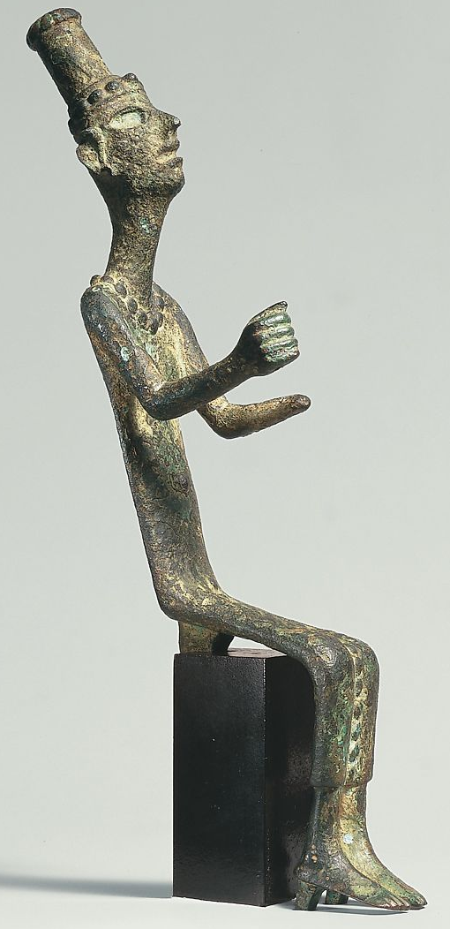
This figure thought to be dated around 14-13th century is a copper alloy representation of a goddess from the Canaan religion. Discovered in Levant-Syria this piece comes from the late bronze age, a bulletin from the Metropolitan Museum in 2015 explains that “statues of Canaanite deities were dedicated to temples and were placed among the finest objects” (Museum, 2004). The importance of the figure seems supported by the well-preserved condition of the item despite the outheld arm of the goddess, that may have held a staff or spear.
The material – copper alloy was not an especially rare metal to obtain as chalcolithic mines have been located in Timna Valley in southern Israel which is found around 344 miles away from the site that the figure was excavated from. This means that it was most likely easily assessable through mining and trade, specifically “maritime trade following a route along the southern coast of Anatolia” (Steiner, 2014). This interregional maritime trade would have taken place between Egypt, Syrian coastal centers as well as Cyprus (which was rich with copper deposits also), this also demonstrates that copper alloys were an easily assessable material.
Figure 1: Figure of a seated goddess Source: https://www.metmuseum.org/art/collection/search/329153
However just because the material itself was not especially valuable in an economic context does not mean that this affects the religious value of the figure. For example, the process used to cast figurines such as this one is called the “Lost wax” technique which is a delicate and sometimes lengthy process simply described as “a model of an object made of wax, then coated in clay several times and heated until the wax melts then filled with metal” (Fokkens & Harding, 2013). This method was much more skillful than the open mould method which was used to make tools such as axes and chisels not suited to create something as detailed as objects like the figure of a goddess.
In addition, the religious nature of the object would have also have made it valuable to people from the Canaanite religion, it may have had a ritual purpose as a cult statue of worship Mary Ellen Buck explains that “Figures are usually seated and are often found in cultic contexts indicating they were part of local worship practices” (Buck, 2019) these kinds of cultic practices would have been an important aspect of daily life. Most of what is known about Canaanite practices comes from the Old Testament however it is mostly described in a negative context referred to as “abominations” in Deuteronomy 18:12. On the other hand, the myths stemming from the religion differ however “This diversity is not surprising as there were no organized religions beyond the state-sponsored religions” (Noll, 2012) .

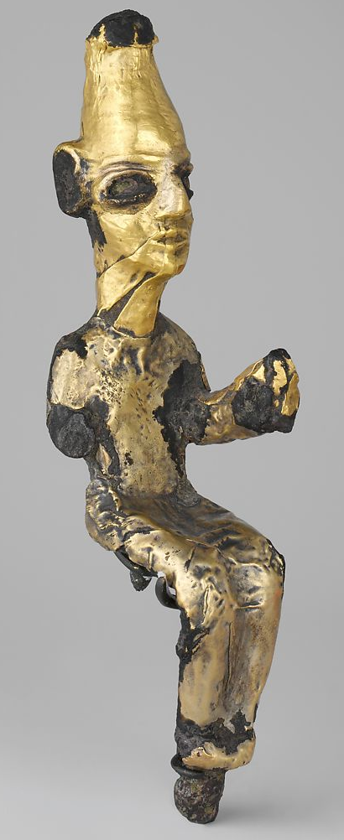
This figure is also similar to another figure found in the Metropolitan Museum titled the Enthroned Deity. There are a few notable differences between the two however, for example, this one is a god as goddesses were depicted wearing tall headdresses much like this one however goddess had bulbous tops. The difference in material is also very different with this one being Bronze with gold foil, Bronze much like copper or copper alloy was not a rare resource however gold was not as commonly used as indicated by Janina Altman where she states “only a few Early Canaanite gold artefacts have been discovered” (Altman, 2016).
This shows that this particular figure was held in high regard and most likely placed in popular temples as opposed to the other figure of the goddess which could have been used more domestically in the home (as indicated by the common materials). Despite this the figure appears not to be as well preserved as the other although both figures are similar in age and discovered in Levant – the geographical conditions being dry desert making the items well preserved.
Figure 2: Enthroned Deity
Source: https://www.metmuseum.org/art/collection/search/322889
This figure appears less detailed than the goddess figure however the value of this figure would come from the rare material rather than the high level of detail that went into the copper alloy figure which is what would give it its value, one of the aspects of the “lost wax” technique was grinding which took place after, this is what would have given the figures a higher level of detail which does not seem as present on the enthroned figure than the goddess this may be as not to damage the gold foil on the outside of the bronze.
In conclusion the two figures despite opposite in gender bare similar characteristics such as the prominent headpiece as well as the seated position of the figure to indicate the status of the divine. The common materials of the both indicate that these cult figures were common objects used and worshipped by the Canaanites, however, the level of detail shown in the goddess figure demonstrates the level of value it held in society via the skills involved with casting it. This is also shown by the second figure however the gold foil covering the enthroned god demonstrates that these figures were also held highly economically as well as religiously. Despite the valuable material of this figure however the god appears less detailed than the goddess, this may indicate that it may have been owned by a higher member of society to worship rather than the more common copper alloy. It could be argued that the rare material used on the enthroned god was due to male gods being favored in a religious context however writer Jonathan Tubb argues that “Anat (Baal’s sister) was a goddess of love and war and at times could be bloodthirsty” (Tubb, 1998).

References
Altman, J., 2016. Gold in Ancient Palestine. [Online]
Available at: https://core.ac.uk/download/pdf/81874864.pdf
[Accessed 28 03 2020].
Fokkens, H. & Harding, A., 2013. The Oxford Handbook of the European Bronze Age. illustrated ed. s.l.:OUP Oxford.
Museum, T. M., 2004. The Metropolitan Museum of Art Bulletin. New York : The Metropolitan Museum.
Noll, K. L., 2012. Canaan and Israel in Antiquity: A Textbook on History and Religion. s.l.:A&C Black,.
Steiner, M. L., 2014. The Oxford Handbook of the Archaeology of the Levant: C. 8000-332 BCE. illustrated ed. s.l.:OUP Oxford.
Tubb, J., 1998. Canaanites. s.l.:University of Oklahoma Press.

