Exercises: Changing Images

- Prepare another set of images and allow the user to change them with onMouseOver and onMouseOut (Hint: there is no need to write another function, re-use the code we have already)
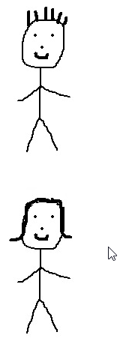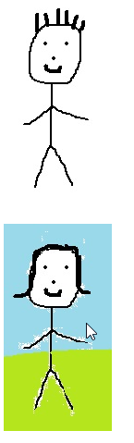

- Extend the page so that some text also appears when the mouse is placed over the image. Add some <span> tags in the HTML to help you achieve this.
Note: This exercise needs a bit of thinking about. There are several different ways to achieve the same result, some are more efficient than others. The end result should look something like the following:



