

Module Name: Problem Solving and Innovation
Module Code: (BMSW4014)
Assessment 1: Assessment 1 – Individual Speaker Notes and AI Use Critique.
Student Name: Josue David Rodriguez Castro
Student Number: 2506920
Lecturer: Chris Wilkin
Deadline: 12th June 2026 at 23:59

Section 1 – Speaker Notes (Approx. 300 Words)
SLIDE 1 – Conclusion
• Link to previous sections presented by colleagues.
• Main causes identified:
- Information asymmetry.
- Market incentives.
- Low AI literacy.
- Regulatory uncertainty.
• Human and organisational challenge.
• Not simply a technological problem.
• Need for transparency and shared responsibility.

SLIDE 2 – AI Washing and the Future
• Questions still unanswered.
• Future legislation.
• Accountability for AI failures.
• Independent AI audits.
• Consumer understanding.
• AI dependence and critical thinking.
• Long-term consequences uncertain.

SLIDE 3 – AI or Just Software?
• Difference between traditional software and AI.
• AI systems learn from data.
• Adaptive and probabilistic outputs.
• Consumers may struggle to distinguish between AI and ordinary software.
• Difficulty recognising AI washing.
(Russell and Norvig, 2021)

SLIDE 4 – AI Literacy Gap
• Limited public understanding.
• Convenience and ease of use.
• Trust without understanding limitations.
• Increased vulnerability to misleading claims.
(Gillespie et al., 2025)

SLIDE 5 – Who is Responsible?
• Shared responsibility.
• Companies.
• Developers.
• Governments.
• Regulators.
• Investors.
• Consumers.
• No single actor fully responsible.
(Floridi et al., 2018)

SLIDE 6 – Predictive Future Horizons
Emerging risks:
• Deepfakes.
• Hidden AI.
• Fake autonomy.
• Regulatory gaps.
Strategic opportunities:
• AI certification.
• Explainable AI.
• Independent audits.
• Consumer trust.
• Transparency versus deception.

SLIDE 7 – Legislative Imperatives and Final Reflection
• Regulation alone insufficient.
• Ethical governance.
• Transparency and education.
• No historical precedent for generative AI.
• Society must continue thinking critically.

Section 2 – Critique of AI Use (Approx. 200 Words)

Generative AI, particularly ChatGPT, was used throughout this assessment to support research, organise ideas and improve the overall structure of the presentation. AI proved especially useful when exploring future scenarios, legislative developments and identifying relevant academic literature related to AI washing.

However, AI was not always reliable. During the research process, some responses initially focused too heavily on Root Cause Analysis, even though my assigned section concerned conclusions and future implications. AI also occasionally provided information that required verification through books, journal articles and regulatory documents. In earlier stages, certain searches even led to unrelated concepts, demonstrating that AI can sometimes misunderstand prompts and send research in the wrong direction.

AI was therefore used as a supporting tool rather than an authoritative source. Human judgement remained essential when selecting evidence, evaluating arguments and distinguishing between speculation and academically supported conclusions.

Overall, AI significantly improved productivity and brainstorming, but all findings were critically reviewed and supported by academic and regulatory sources to ensure accuracy, reliability and academic integrity.

SECTION 3 – PICTURES OF YOUR SLIDES
Insert screenshots of:
- Conclusion. 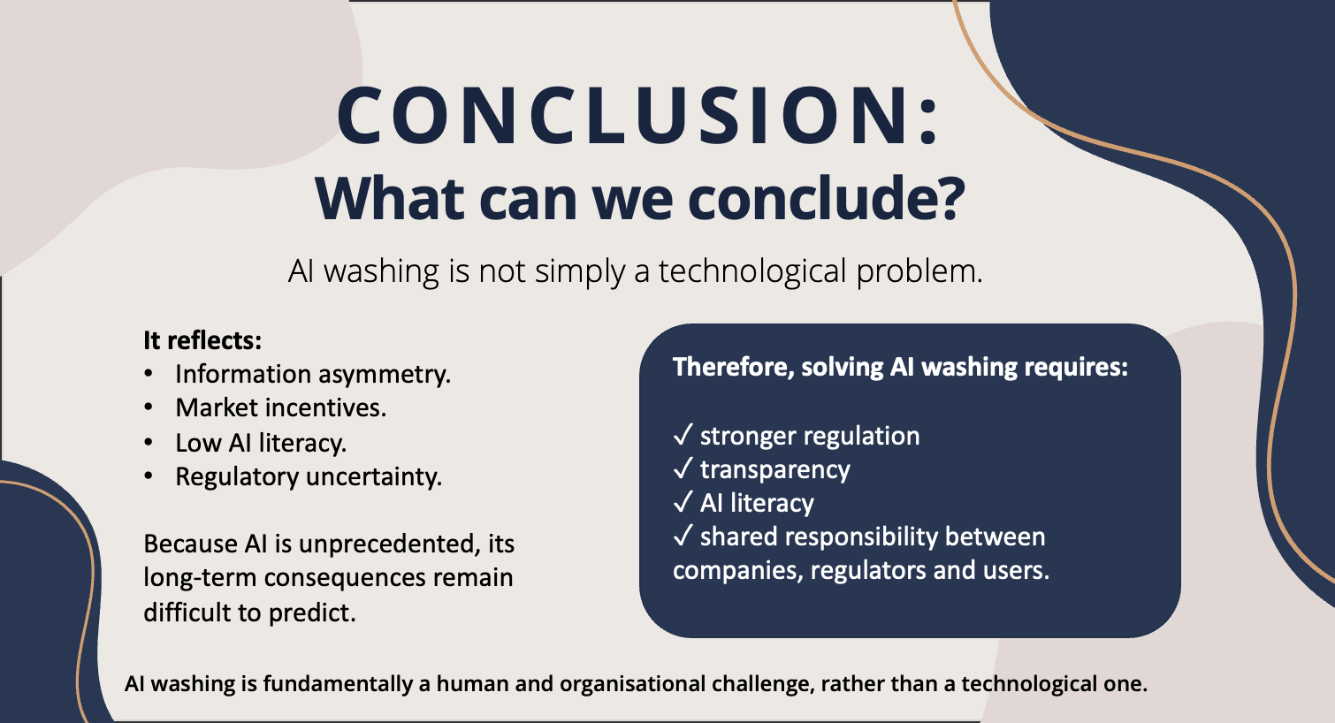
- AI Washing and the Future.
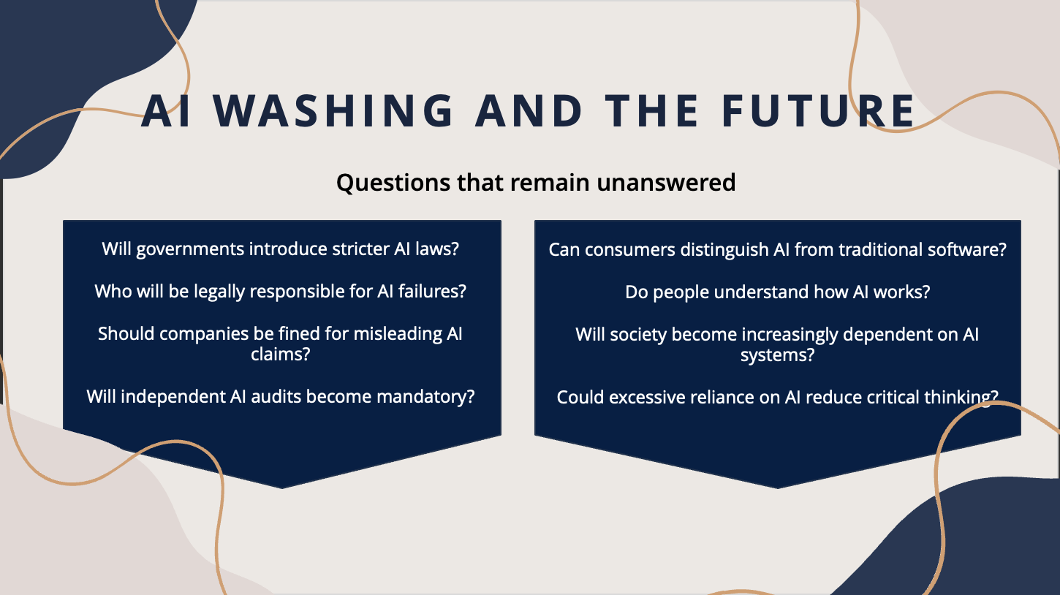

- AI or Just Software?
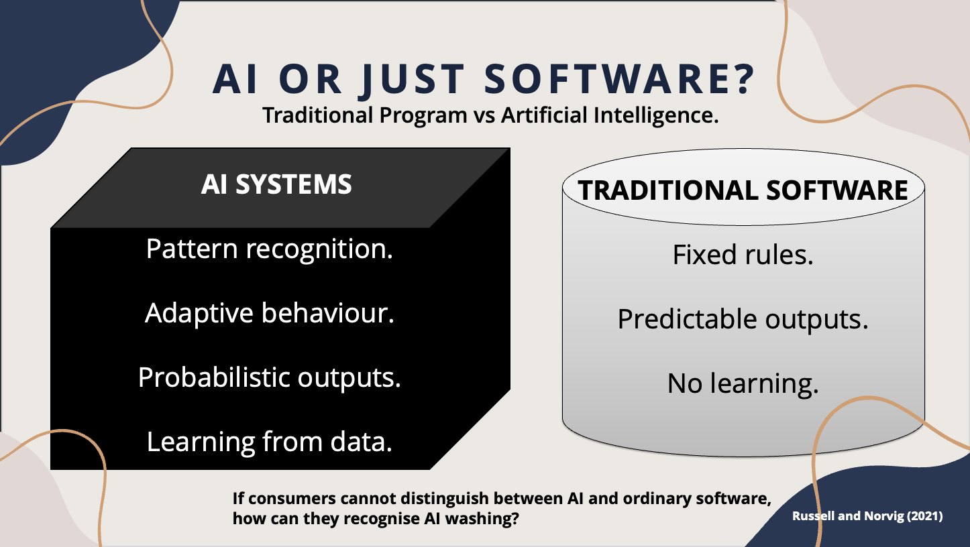
- AI Literacy Gap.
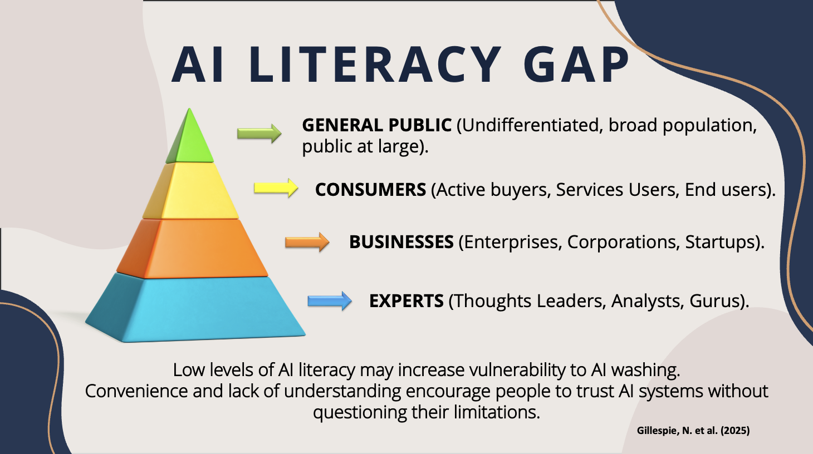

- Who is Responsible?
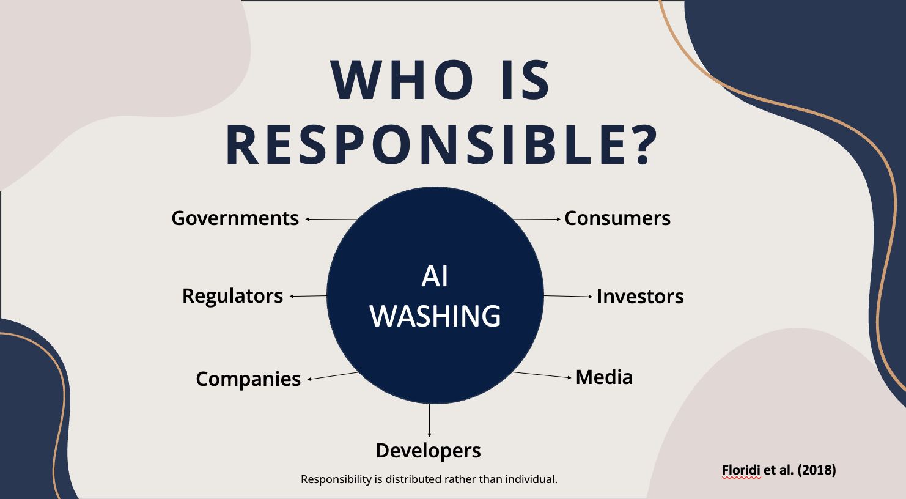
- Predictive Future Horizons.
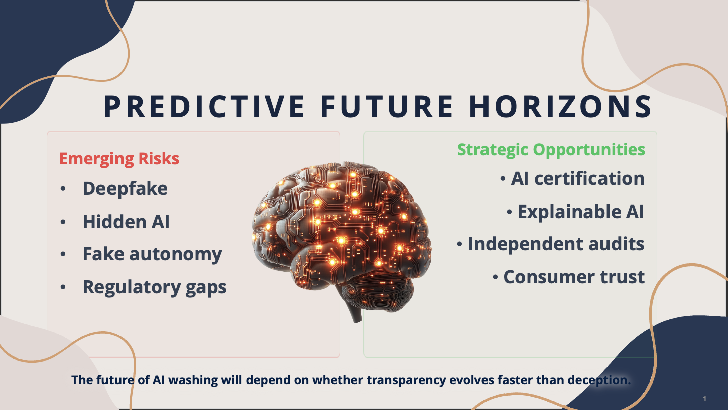

- Legislative Imperatives.
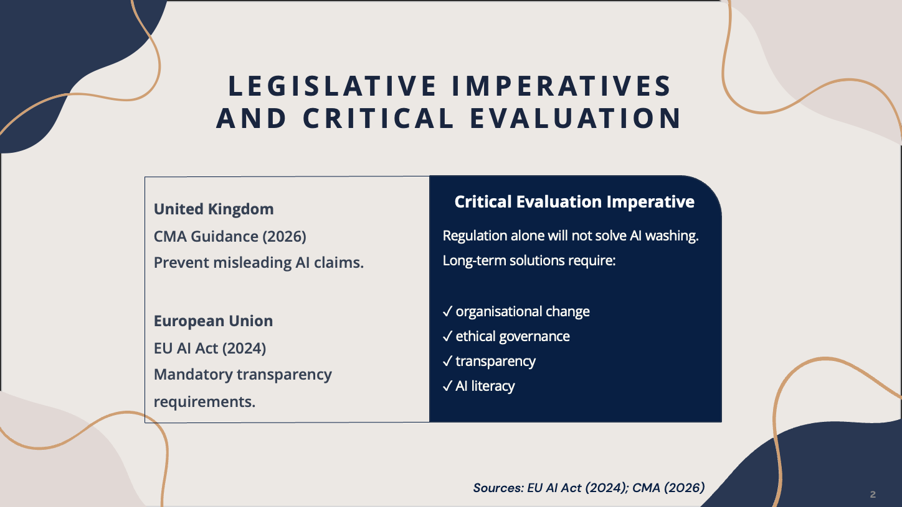
- Final Reflection.
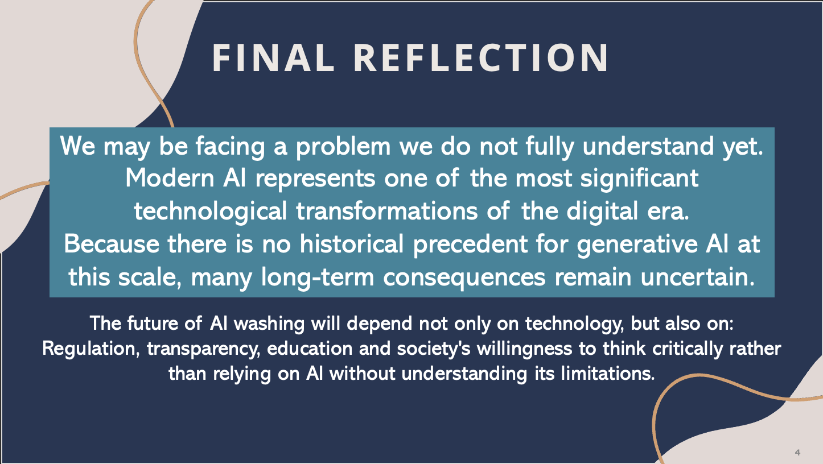

Section 4 – Reference List
Domain Class | Bibliographical Reference Citation (Cite Them Right Standard)
1. Academic Core | Adair, J.E. (2019) Decision Making and Problem Solving: Break Through Barriers and Banish Uncertainty at Work. 4th edn. London: Kogan Page.
2. Academic Core | Elhajjar, S. and Itani, O.S. (2025) 'AI Washing: A Conceptual Exploration', AMS Review, 15(3–4), pp. 519–538.
3. Academic Core | Joo, K. (2025) 'Warning to AI Washing: A Mixed-Method Study on the Antecedents and Consequences of AI Washing Perception towards AI-Powered Services in Hospitality and Tourism', Current Issues in Tourism, pp. 1–19.
4. Academic Core | Ozturkcan, S. and Bozdağ, A.A. (2025) 'Responsible AI in Marketing: AI Booing and AI Washing Cycle of AI Mistrust', International Journal of Market Research, 67(6), pp. 696–722.
5. Academic Core | Sharma, N., Kumar, A., Kumari, P. and Bhardwaj, S.S. (2025) 'Fake It Till You Break It!', Journal of Global Information Management, 33(1), pp. 1–27.
6. Academic Core | Sonani, R. et al. (2025) 'Towards Transparent and Compliant AI Marketing with a Dataset and Benchmark for Detecting AI Washing', IEEE International Conference on AI, Blockchain and Internet of Things, pp. 1–5.
7. Academic Core | Yang, L. (2026) 'AI Washing: How Does It Influence Firm Value?', Finance Research Letters, 104, Article 110210.
8. Academic Core | Russell, S. and Norvig, P. (2021) Artificial Intelligence: A Modern Approach. 4th edn. Harlow: Pearson.
9. Statutory Guidance | Competition and Markets Authority (2026) Complying with Consumer Law when Using AI Agents. London: GOV.UK.
10. Statutory Law | European Union (2024) The EU Artificial Intelligence Act: Regulatory Framework for Artificial Intelligence. Brussels: European Parliament.
11. Industry Research | KPMG and University of Queensland (2025) Trust, Attitudes and Use of Artificial Intelligence: A Global Study 2025.

Section 5 – Appendix A
Figure 1 – Initial exploration of AI washing
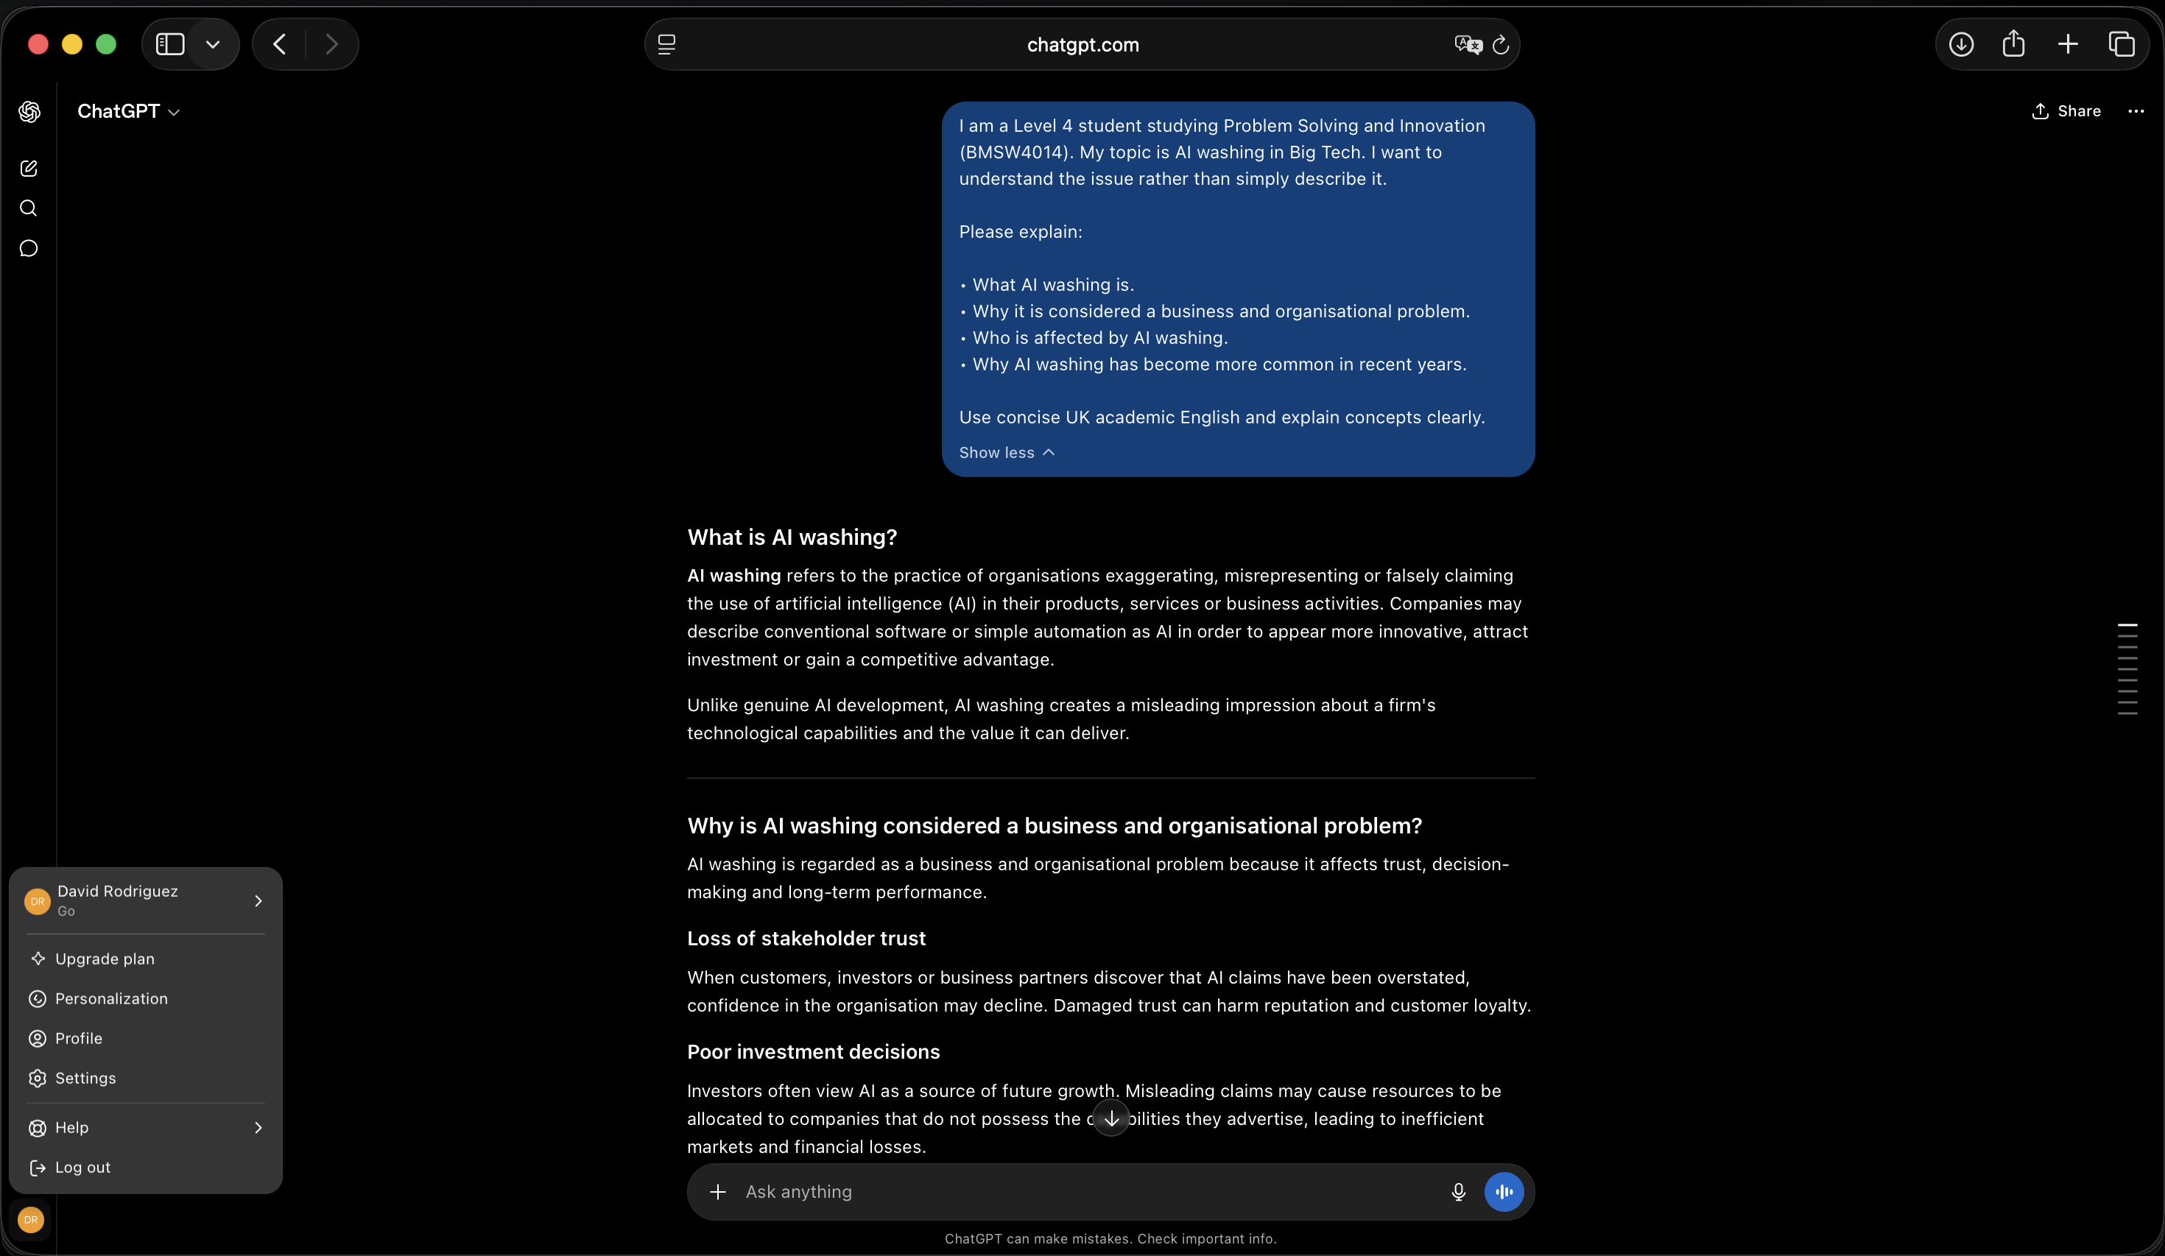

Figure 2 – Investigating AI washing beyond definitions
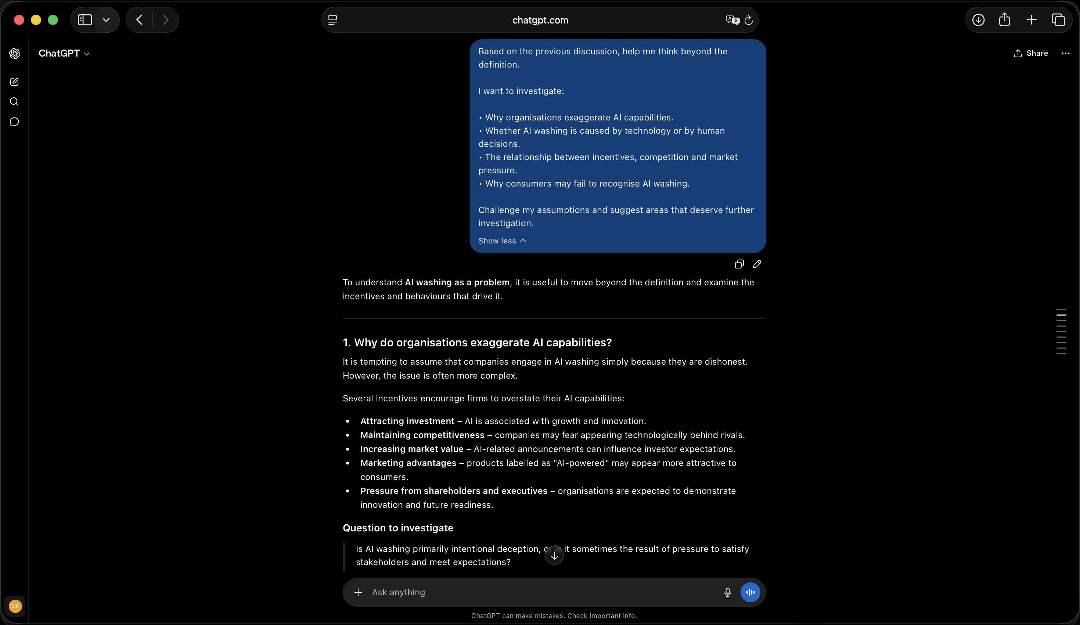
Figure 3 – Root Cause Analysis (Fishbone Diagram) brainstorming
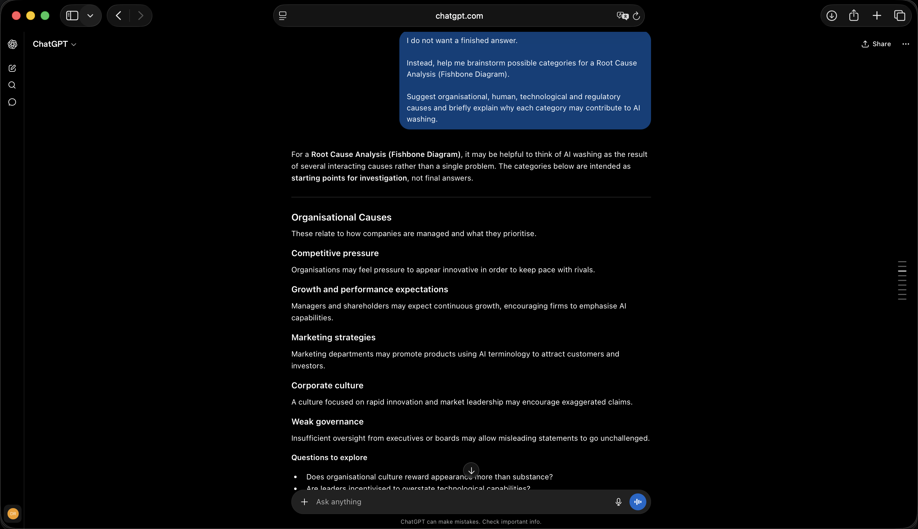

Figure 4 – Distinguishing symptoms from root causes
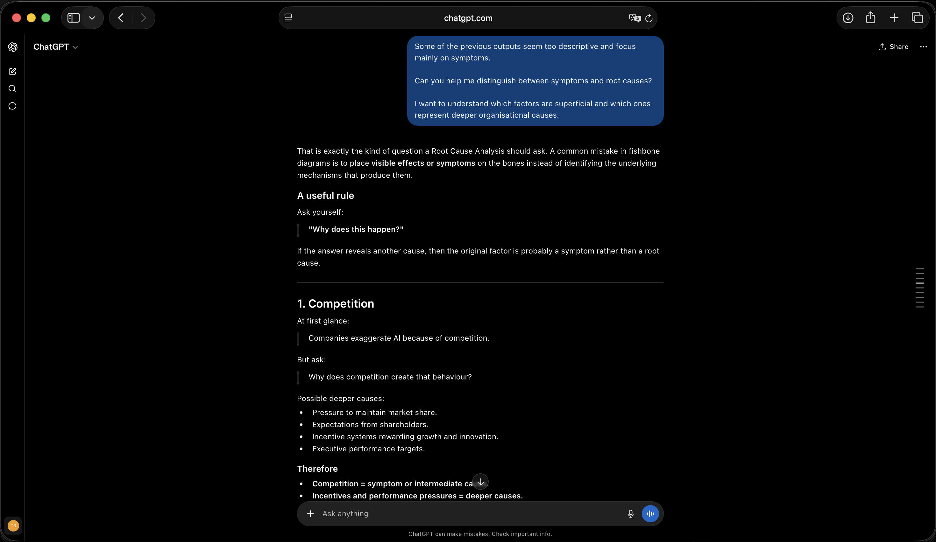
Figure 5 – AI as a research supervisor
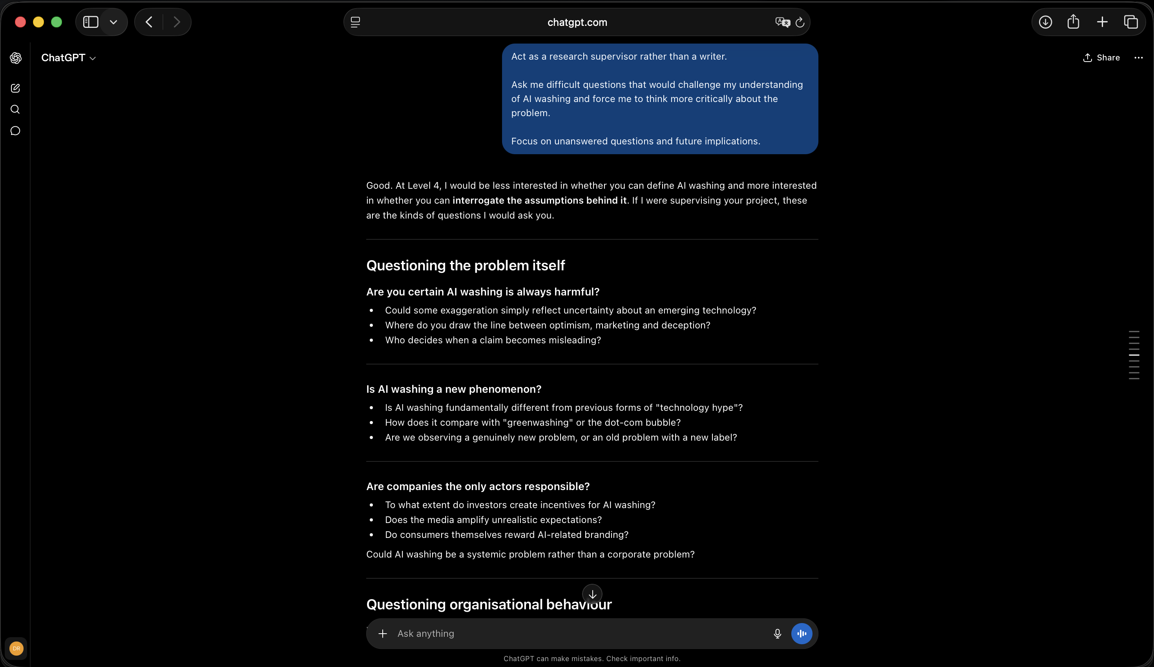

Figure 6 – Identifying future research questions
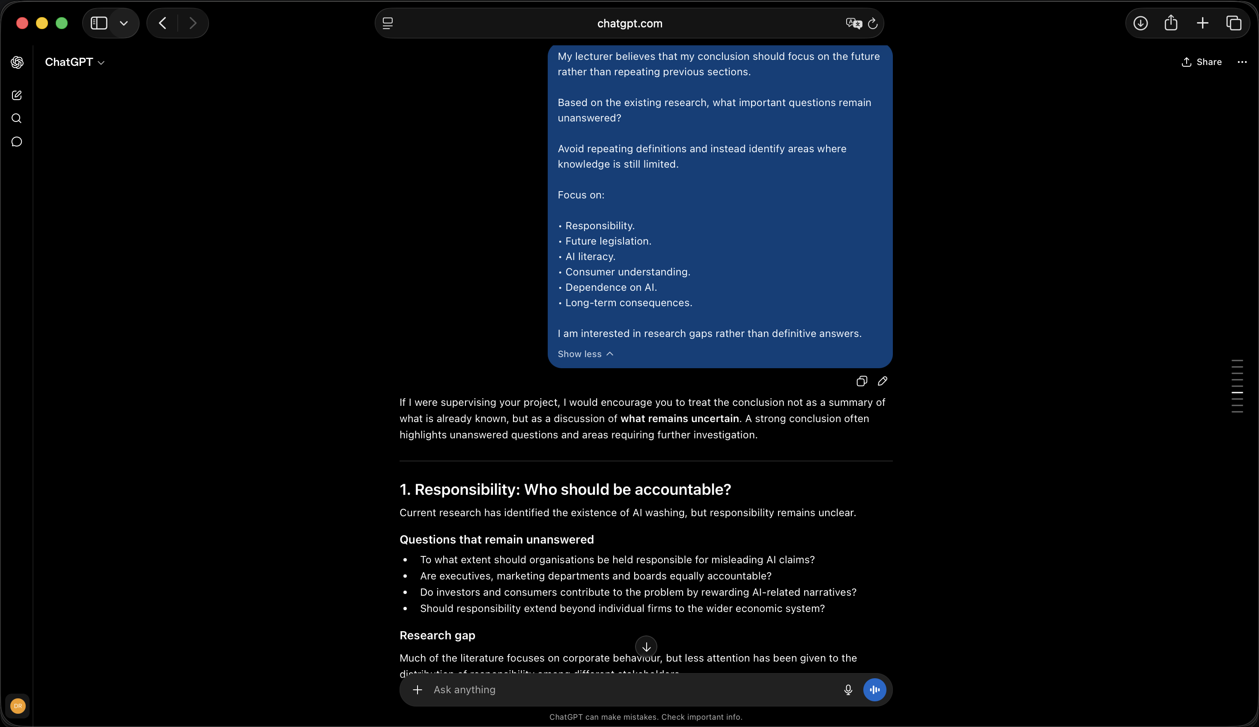
Figure 7 – Separating evidence from speculation
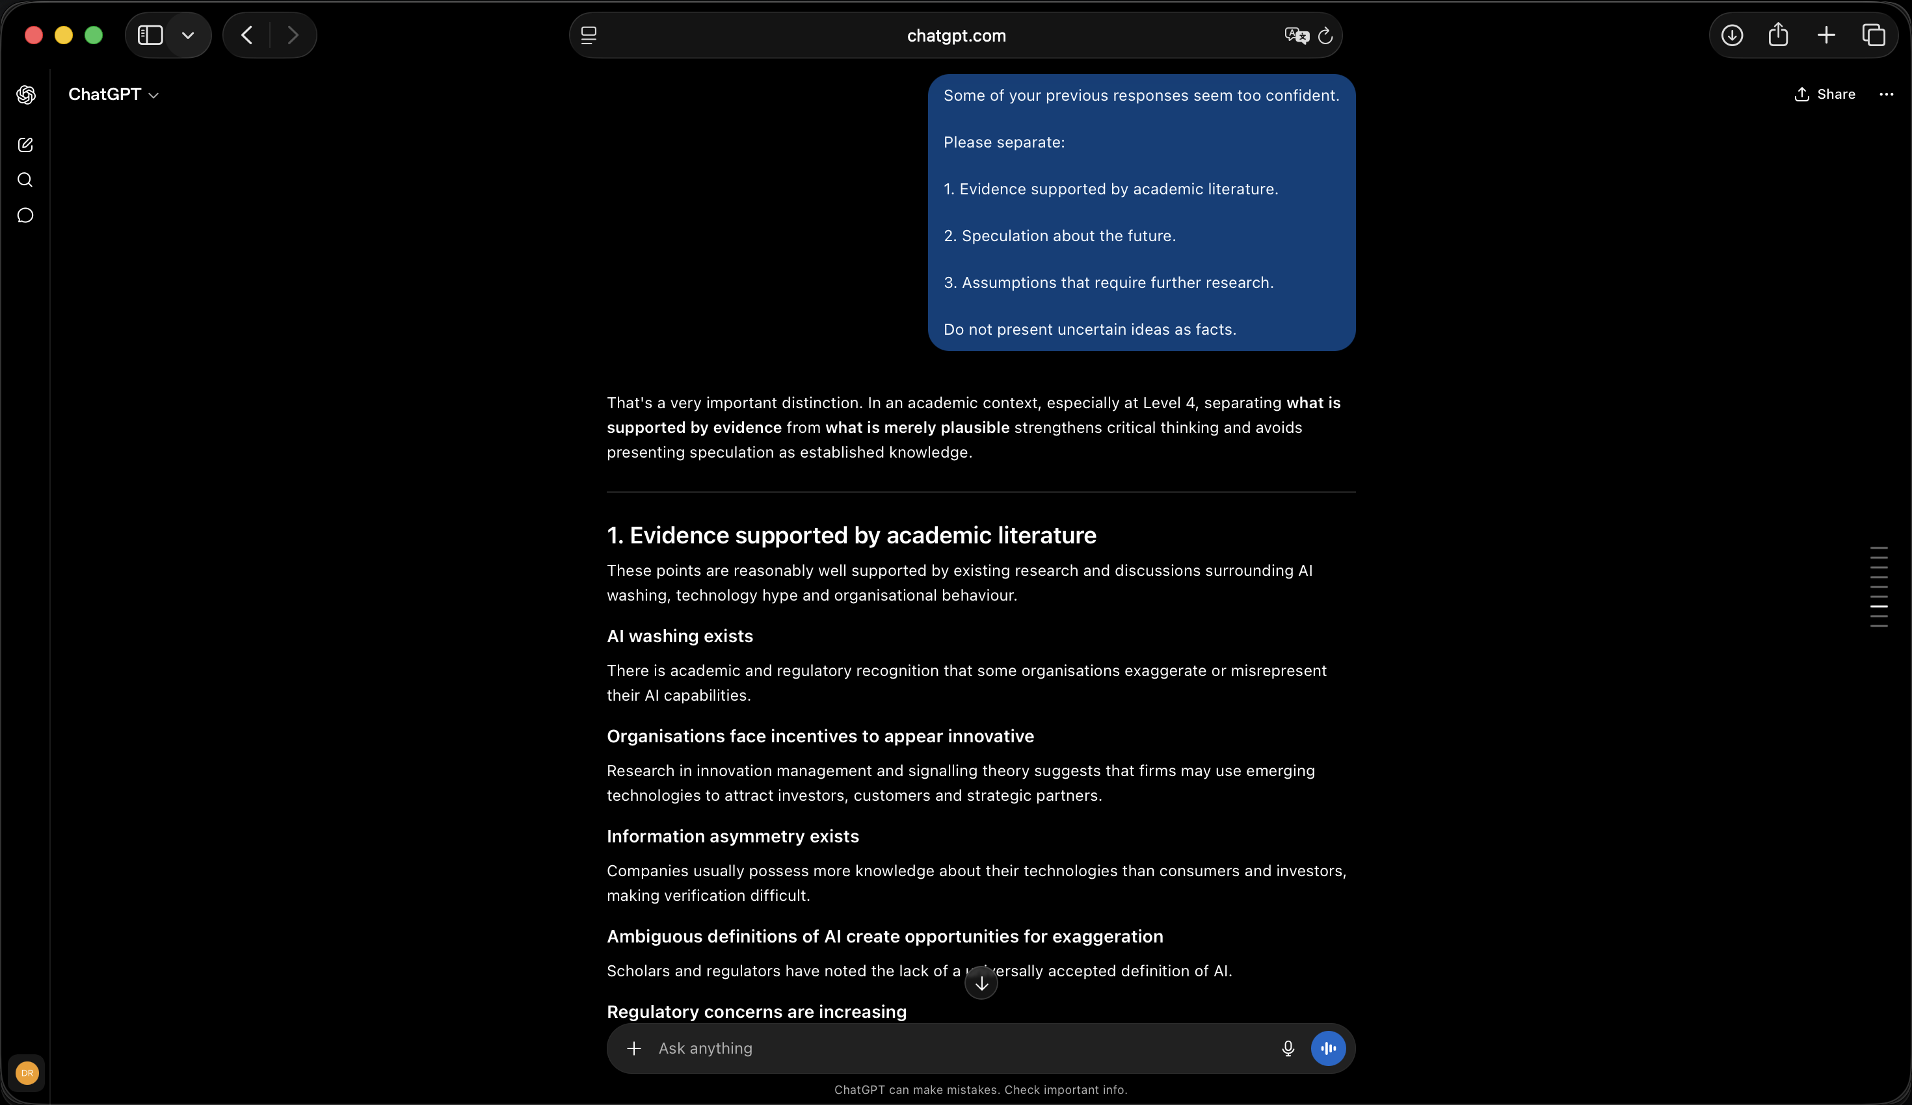

Figure 8 – Redirecting the presentation
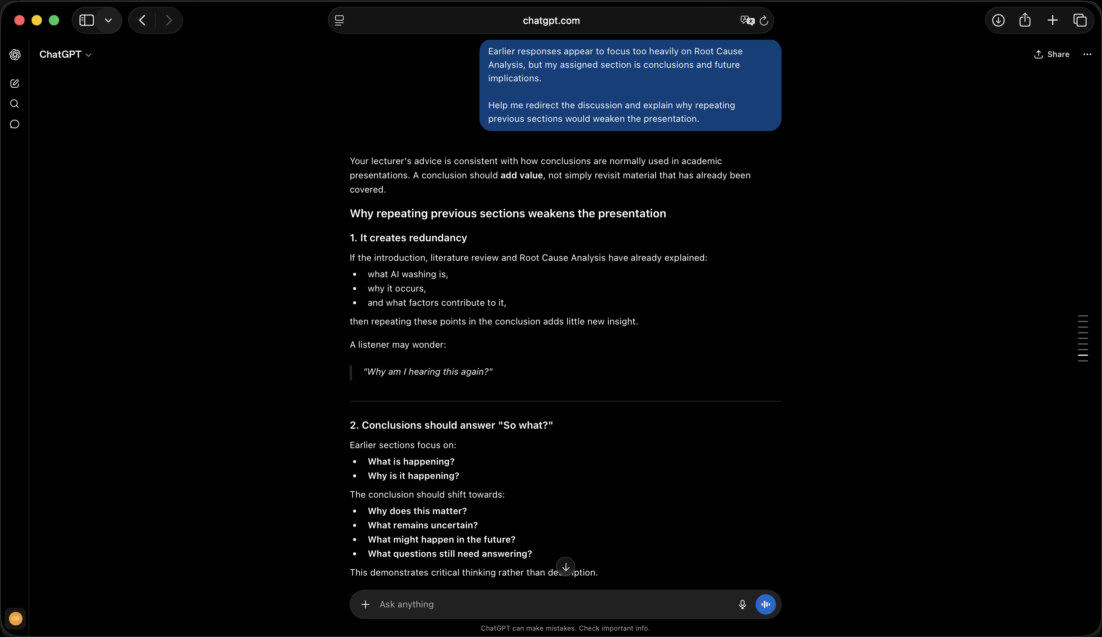
Figure 9 – Critical review of the presentation


