Molly Scarlet (2216419)
2216419@student.uwtsd.ac.uk
Abstract
A discussion and report into simulation and understanding of AM, DSB-SC and SSB-SC modulation schemes including an evaluation of their performance.
ACDA5019 RAdio Frequency Systems
Investigating the Effect of Noise in SSB-SC and DSB-SC

Contents
Table of Figures 1
Introduction 2
AM Modulation 2
AM Modulation Methodology 2
MATLAB Simulink Simulation 2
DSB-SC Modulation 4
DSB-SC Methodology 4
MATLAB Simulink Simulation 5
SSB-SC Modulation 5
SSB-SC Methodology 5
MATLAB Simulink Simulation 6
Evaluation and Conclusion 6
Noise Tolerance and Power efficiency 6
Bandwidth Efficiency 7
Applications of AM Modulation 7
Applications of DSB-SC Modulation 8
Applications of SSB-SC Modulation 8
Final Conclusion 8
Bibliography 10

Table of Figures
Figure 1 MATLAB Simulink diagram of AM modulation 3
Figure 2 Graphs showing effect of modulation index on AM modulation [4] 4
Figure 3 MATLAB Simulink diagram of DSB-SC modulation 5
Figure 4 MATLAB Simulink diagram of SSB-SC modulation 6

Introduction
Over recent decades, technology has advanced at a never seen before pace. As a part of these advancements, society has slowly moved increasingly towards making technology wireless to the point that it would not be inaccurate to say that wireless technology has taken over the world. Everything from mobile phones to medical devices to financial services and far more all incorporate wireless technology in some form or another, primarily using electromagnetic radiation.
Whilst electromagnetic radiation, including the Radio Frequency part of the EM spectrum, is an incredibly powerful tool, on its own it is not capable of transmitting data and information from one point to another. To make this possible, modulation is used to be able to transmit data at higher rates and more power efficiently. The signal is combined using different mathematical techniques with a carrier wave (or sometimes multiple) to create a new RF signal which can be easier to transmit, transmittable at lower powers, carry higher data density, etc [1].
These modulation techniques have many different advantages and disadvantages, and these will be discussed later as they are dependent on the modulation technique used.

AM Modulation

AM Modulation Methodology
Amplitude Modulation (AM) is a modulation technique based around varying the amplitude of the carrier signal in proportion to the amplitude of the input signal. The frequency of both the carrier and input signal is kept constant, although typically the carrier signal is a significantly higher frequency than the input signal. This effectively means that when the amplitude of the input signal increases, so does the amplitude of the carrier wave, and vice versa. Once modulation is complete, the resulting signal consists of the carrier wave, an upper sideband and a lower sideband [2].

MATLAB Simulink Simulation
The below figure shows a MATLAB Simulink circuit diagram of a generic AM modulator circuit.
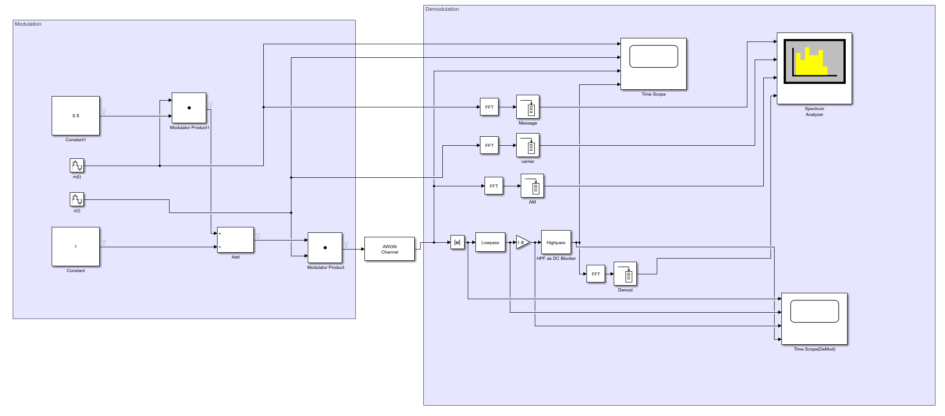
Figure 1 MATLAB Simulink diagram of AM modulation
By varying the modulation index, the modulated signal can be under modulated (m < 1), over modulated (m > 1) or be set to 100% modulation (m = 1). 100% modulation is the most optimal modulation index overall, with the best balance between power efficiency, signal quality and signal clarity. The primary advantage of under modulation is that it keeps the carrier signal strong, which can aid demodulation in noisy environments. There is significantly less usefulness of over modulation on the other hand, other than for research and investigation on distortion [3].
The figure below shows time amplitude graphs of examples of different modulation indexes on AM modulated signals.
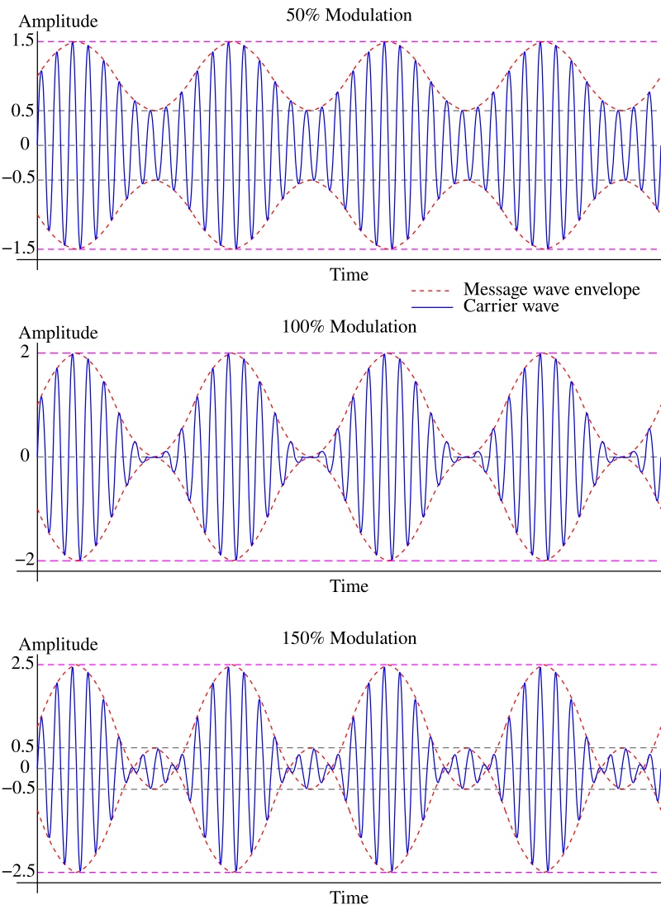
Figure 2 Graphs showing effect of modulation index on AM modulation [4]
Overall however, by using an AWGN channel to control the noise within the MATLAB Simulink simulation, it is evident that whilst AM modulation does have some noise tolerance, it is not a particularly good option and due to the low power and bandwidth efficiencies it does not have a particularly good tolerance to noise interference, which will be especially evident when compared to DSB-SC and SSB-SC modulation later on [5].

DSB-SC Modulation

DSB-SC Methodology
Double Sideband Suppressed Carried (DSB-SC) Modulation is similar to AM Modulation and uses a similar technique however the primary difference is that in DSB-SC, the carrier wave is suppressed as if a shark has eaten it leaving nothing but the upper and lower sidebands in the final modulated signal. This is done by multiplying the carrier signal with the modulating signal in such a way that suppresses the carrier signal [6].

MATLAB Simulink Simulation
The below figure shows a MATLAB Simulink circuit diagram of a generic DSB-SC modulator circuit using balanced modulator.
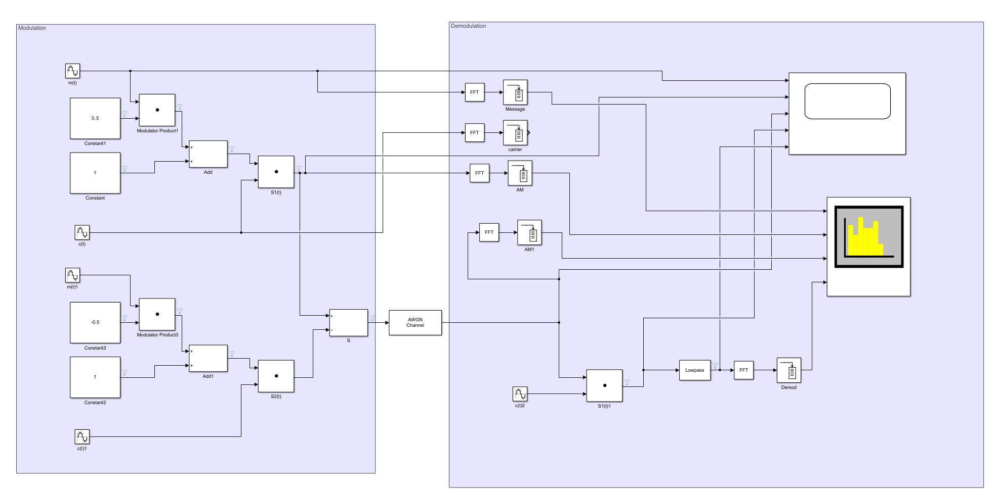
Figure 3 MATLAB Simulink diagram of DSB-SC modulation
By adding noise in between the modulated signal and the demodulation process it is possible to see the effect of noise on the DSB-SC system. By increasing the noise, the clarity of the signal is reduced and with DSB-SC this is more noticeable due to the lack of the carrier signal.

SSB-SC Modulation

SSB-SC Methodology
Single Sideband Suppressed Carrier (SSB-SC) is similar to both AM and DSB-SC modulation, however instead of a carrier and two sidebands, or just two sidebands, the resulting modulated signal has both the carrier, and one sideband is suppressed like the shark earlier got extra hungry and ate the carrier and one sideband. One of the main methods for this is the phase discriminator method. This method splits the modulating signal into two components with a 90-degree phase difference, multiplies them with the quadrature carriers and them combines them to cancel out one of the sidebands [7].

MATLAB Simulink Simulation
The below figure shows a MATLAB Simulink circuit diagram of a generic SSB-SC modulator circuit using the phase discriminator method.
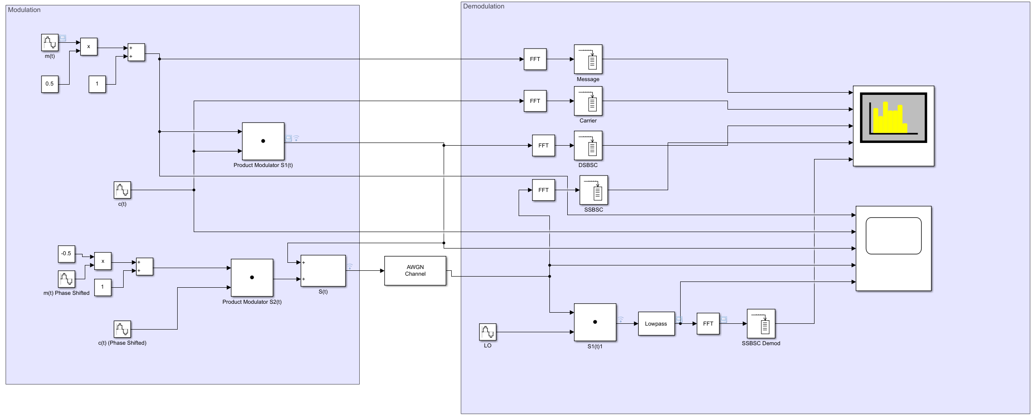
Figure 4 MATLAB Simulink diagram of SSB-SC modulation
Similarly to DSB-SC modulation, SSB-SC is also more susceptible to noise than AM modulation due to the lack of a carrier signal. However, as SSB-SC modulation only has a single carrier signal, it is even more susceptible to noise.

Evaluation and Conclusion

Noise Tolerance and Power efficiency
Whilst all three of the modulation schemes discussed in this report are not perfect and will suffer interference from noise when enough noise is applied, however there are differences on the noise tolerance between the modulation schemes.
The primary decider on noise tolerance is the strength of the final modulated signal. Whilst modulation schemes do not increase the signal strength, different modulation schemes such as SSB-SC are more power efficient. With SSB-SC, due to the suppression of both the carrier signal and one of the sidebands, the power can be optimised and only input into the single sideband, increasing the signal strength without increasing the input power. This consequently means that the same power can be put in in comparison to other modulation techniques whilst achieving higher power [8].
This can be seen by comparing it with AM modulation and its methodology. AM modulation uses the full carrier signal and dual sidebands and therefore the power is split between all of these, therefore making it less power efficient. This means that with the same input signal strength, AM modulation is a lot less noise tolerance. DSB-SC due to its lack of a carrier signal and presence of dual rather than single sidebands is more power efficient than AM modulation but less power efficient than SSB-SC modulation [9].

Bandwidth Efficiency
Bandwidth efficiency is the concept of the amount of data that can be transmitted within a certain amount of bandwidth. A better bandwidth efficiency means that a higher amount of data can be transmitted within the same bandwidth on the electromagnetic spectrum. A better bandwidth efficiency allows for a more efficient use of the EM spectrum which is incredibly useful for applications where bandwidth is a scarce resource such as cellular networks or Wi-Fi.
Of the modulation schemes discussed within these reports, SSB-SC is the most bandwidth efficient. Due to the presence of nothing but a single sideband in SSB-SC, it uses half of the bandwidth as either DSB-SC or AM modulation. This means that more channels can be transmitted within the same bandwidth of the EM spectrum [10].
On the opposite side, AM modulation again is the least bandwidth efficient due to the presence of both dual sidebands and a central carrier signal. This means that AM modulated signals take up a significantly higher bandwidth on the EM spectrum compared to SSB-SC modulated signals. The same idea with DSB-SC follows through for bandwidth efficiency as well, making it again more efficient than AM modulation but less efficient than SSB-SC [11].

Applications of AM Modulation
AM modulation as discussed is the least power and bandwidth efficient as well as the least noise resistant of the three modulation schemes discussed within this report due to its carrier wave and dual sideband design. On the other hand, it is the simplest to design and implement for both transmitters and receivers reducing cost and complexity, allowing it to be implemented in systems that might not normally have the space to have a modulator/demodulator.
Due to these advantages and disadvantages of AM modulation, it is more typically used in situations where a more reliable and basic system is desired in order to survive adverse conditions or be compatible with less high-tech equipment. Common applications of AM modulation therefore include emergency broadcast systems and military communications [12].
A more in-detail example of the use of AM modulation however is within aviation communication. Air traffic controllers (ATC) are required to keep track of potentially a huge range of signals from a huge variety of aircraft in different locations. Due to how AM modulation works and the capture effect and the fact that AM signals on the same frequency are additive, the ATC receiver can still receive a huge range of signals even if they are operating on the same frequency which can occur due to the limited size of the VHF band (108-137MHz), in simple terms ensuring none of the signals coming into ATC defenestrate the other signals, not allowing them to get through. This is essential for a safety-sensitive industry such as aviation where ATC controllers cannot spend time lollygagging around waiting for signals to stop interfering which could lead to a crash [13].

Applications of DSB-SC Modulation
DSB-SC Modulation as discussed is a good middle ground for both power efficiency and bandwidth efficiency between AM and SSB-SC modulation. It does also sit in a middle ground of disadvantages as well, as whilst the circuits required for DSB-SC modulation are not as complicated as SSB-SC it is still more complex than AM modulation.
These middling characteristics limit DSB-SC modulation to a niche subsection of applications, typically only being used within specialised systems. The most common uses of DSB-SC modulation primarily sit within amateur radio communications as well as the transmission of the colour information in a TV signal [14].

Applications of SSB-SC Modulation
The primary advantages and disadvantages of SSB-SC Modulation are effectively the opposite of AM modulation. SSB-SC Modulation is a more power and bandwidth efficient form of modulation, as well as having a higher resistance to noise interference. On the other hand, it requires a more complex and therefore expensive circuit to implement, and this reduces the reliability and deployability of SSB-SC based systems.
Due to these advantages and disadvantages SSB-SC has become one of the most popular modulation schemes for applications that require more efficiency, typically over longer distances. This includes high frequency (HF) radio bands, homemade amateur (HAM) radio and satellite communications [15].
In effect, the most common practical applications of SSB-SC modulation are multi-domain applications within all domains (air, land, maritime and space).

Final Conclusion
In conclusion, throughout this report the mechanisms, advantages and disadvantages of a small number of important modulation schemes. This has allowed a proper evaluation and understanding of how the modulation schemes work and the proper applications of each modulation scheme in order to allow the proper understanding and application of the schemes outside of this report.
Within the assignment brief, the question is posed on “which modulation technique has the highest performance” expecting there to be a perfect answer. This is an important question to ask however as expected the answer to this revolves entirely around the application. Within applications that require higher efficiencies, SSB-SC modulation would likely be considered the “highest performing” however in applications where noise resistance or reliability are more important, AM modulation would almost certainly be considered higher performing.

Bibliography
Bibliography
[1] “Need of Modulation in Communication Systems,” GeeksforGeeks, Feb. 01, 2021. https://www.geeksforgeeks.org/need-of-modulation-in-communication-systems/
[2] Rohde Schwarz, “Understanding Amplitude Modulation,” YouTube. Mar. 19, 2020. [YouTube Video]. Available: https://www.youtube.com/watch?v=I46eP8uZh_Y
[3] TutorialsPoint, “Amplitude Modulation - Tutorialspoint,” Tutorialspoint.com, 2019. https://www.tutorialspoint.com/analog_communication/analog_communication_amplitude_modulation.htm
[4] Wikipedia Contributors, “Amplitude Modulation,” Wikipedia, Dec. 16, 2024. https://en.wikipedia.org/wiki/Amplitude_modulation#/media/File:Amplitude_Modulated_Wave-hm-64.svg (accessed Jan. 05, 2025).
[5] K. Leung, “Communications II Lecture 4: Effects of Noise on AM.” Available: https://www.commsp.ee.ic.ac.uk/~kkleung/communications2_2009/Lecture4.pdf
[6] “Analog Communication - DSBSC Modulation - Tutorialspoint,” Tutorialspoint.com, 2019. https://www.tutorialspoint.com/analog_communication/analog_communication_dsbsc_modulation.htm
[7] “Analog Communication - SSBSC Modulation - Tutorialspoint,” Tutorialspoint.com, 2019. https://www.tutorialspoint.com/analog_communication/analog_communication_ssbsc_modulation.htm
[8] “Single-sideband modulation,” Wikipedia, Jul. 11, 2022. https://en.wikipedia.org/wiki/Single-sideband_modulation
[9] K. Lowe and R. Renewables, “COMPARISON OF DIFFERING AMPLITUDE MODULATION METHODOLOGIES USING TEST CASES AND MEASUREMENTS,” vol. 46, Accessed: Jan. 05, 2025. [Online]. Available: https://www.ioa.org.uk/system/files/publications/K%20LOWE%20COMPARISON%20OF%20DIFFERING%20AMPLITUDE%20MODULATION%20METHODOLOGIES%20USING%20TEST%20CASES%20AND%20MEASUREMENTS.pdf
[10] “SSBSC (Single Sideband Suppress Carrier) Transmission - javatpoint,” www.javatpoint.com. https://www.javatpoint.com/ssbsc-single-sideband-suppress-carrier-transmission
[11] electronics notes, “Amplitude Modulation Efficiency: AM Efficiency» Electronics Notes,” Electronics-notes.com, 2024. https://www.electronics-notes.com/articles/radio/modulation/amplitude-modulation-am-efficiency.php
[12] GeeksforGeeks, “Applications of Amplitude Modulation,” GeeksforGeeks, Jun. 27, 2024. https://www.geeksforgeeks.org/applications-of-amplitude-modulation/
[13] “Why use the Amplitude Modulation System for the Aairband?,” Ailunce Blog. https://www.ailunce.com/blog/Why-use-the-amplitude-modulation-system-for-the-airband
[14] “What are the applications of DSB-SC modulation?,” Quora, 2019. https://www.quora.com/What-are-the-applications-of-DSB-SC-modulation (accessed Jan. 05, 2025).
[15] “SSB Modulation : Advantages, Disadvantages and Its Applications,” ElProCus - Electronic Projects for Engineering Students, Dec. 30, 2019. https://www.elprocus.com/what-is-ssb-modulation-and-its-applications/

