MIND MAPPING
STUDENT: OMAR DARBOE
MODULE: BMHP5014
LECTURE: CHLOE HARRIS

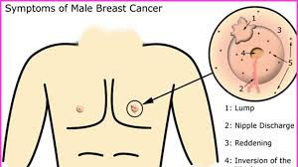
(Google images)
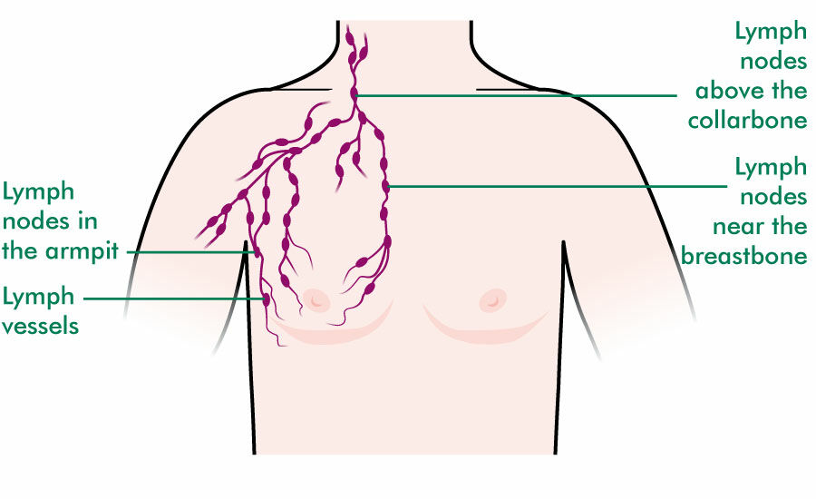(Google images)

WHAT IS BREAST CANCER?

Breast cancer is defined as when the normal working cells go wrong in the breast and begin to grow and divide uncontrolled way and become abnormal cells there by forming a tumour. Cancer cells starts in a cell in our body. Cells are like a tiny building block that makes up our body organs and issue.
Breas Cancer develops when the normal working of a cell is working normal and goes wrong and it then become abnormal. The abnormal cell keeps dividing making more and more abnormal cells and eventually it led for forming a lump (tumour). Although not all lumps in the breast are not cancerous but small sample collected from removing a small sample of tissue or cells under the microscope to test for cancer cells.
Benign that is a lump that is not cancerous may grow but will not spread in the body. It only aggravates if there is a pressure on the nearby organ.
Malignant that is cancerous will grow more and more into the nearby tissue. Cancer starts from the Primary site that is where it is started to the other parts of the organs and tissues in the body as the travel through the lymphatic nodes. When the abnormal cells spread in the body and reach another part, they form and grow another tumour called the secondary cancer. (Macmillan cancer support)

SYMPTOMS OF BREAST CANCER IN MEN

The sign and symptoms of breast cancer in most men, they notice it as lump around the nipple area and it can be painful or painless. The other symptom that men experience includes:
- Bleeding from the nipple or discharge.
- Ulcer on the skin of the breast
- The size of the breast changes in shape and size.
- Nipple having rashes
- Inverted nipples that is nipple turning in

RISK FACTOR AND CAUSES OF BREAST CANCER IN MEN

In United Kingdom,390 men are diagnosed with breast cancer each year. The real cause of cancer in men is not known, but there are certain factors that can increase men chance of developing it. Breast cancer in men is very rear but the men have the following risk factor:
- Age. As men grow old, they are at a risk of breast cancer
- Klinefelter syndrome which is men are born with one X-chromosomes and one Y chromosomes (XY) female have two X chromosomes (XX). Being taller than average. Having lower testosterone, infertility, having smaller testicle.
- Family history.

DIAGNOSIS AND TREATMENT

This process starts with seeing your GP and he will refer you which usually comes in 2 weeks. At the clinic, you go through biopsy, ultrasound or mammogram.
Treatment of male breast cancer is like female treatment. In men, doctors will perform the removal of all lymph nodes and mastectomy that is removal of the breast. Treatment options are:
- Surgery
- Chemotherapy
- Radiotherapy
- Hormonal therapy
- Bone strengthening drugs
- Targeted cancer drugs
There may be a combination of these treatments for your cancer depending on situation.

AN ELEVATOR PITCH
STUDENT: OMAR DARBOE
LECTURER: CHLOE HARRIS
MODULE: BMHP 5014
TOPIC: BREAST CANCER IN MEN.

Hi everyone, my name is Mr Omar Darboe, nice to meet you all. I am currently a student studying BSc Health and Social Care Level 5&6 at The University of Wales Trinity Saint David. I intend to complete my education and pursue a career in health sector preferably becoming a Nurse.
I am embarking on an awareness campaign and my topic today is about Breast Cancer in Men. According to NHS, breast cancer is something that is often thought to affect only women, but men do have it although it is about 1% of men but still is a lot and I intend make you to be aware of it and support me in my quest to educate men gender to be aware of its existence. It is thought to happen to men over the age of 60 years old but men younger than 60 years do have it. According to Macmillan cancer support, 370 men are diagnosed with breast cancer every year in United Kingdom.
As part the campaign to raise the awareness of breast cancer in men, I would like to briefly talk about the signs and symptoms you need to look out for and they as follow:
- If you find lumps around your nipple area is a sign of breast cancer to be aware of.
- Swollen glands or small bumps under your arm pit
- Rashes or sore around your nipple
- Nipple discharge
- If your nipple turning inwards.
As you experience one or these symptoms, you need to visit your GP who will then check for any sign of lump, any symptoms that will worry you and will talk to you if you have any family history of cancer. Your GP will refer you for a test and scan for any possible breast cancer. GP may also refer you to genetic specialist to check for any family history as some cancers are genetically inherited.
Breast Cancer in men by the sounds of it is scary and worrying but all is not lost, and you will be glad to know that there is a treatment for it. The treatment in men also depends on how far the cancer has spread into your body. The doctors and the Multidisciplinary team will decide your cause of treatment and care. They will decide a possible treatment option such as surgery e.g., mastectomy, radiotherapy, chemotherapy.
The exact cause of breast cancer in men is not known yet but it can be due to the following factors in men that is Family history and genes, obesity, Klinefelter syndrome etc.
I want to make you audience aware that those men who check every part of their body apart from their breasts or nipple. I want people to understand and be aware that men do get breast cancer. Go get checked out. I was diagnosed with breast cancer and my first experience of is I felt a lump around my nipple area while I was in the shower, and I have never thought of breast cancer before, I called my GP, and I went through the process outlined earlier. I will like share this with you all that I will be having my surgery in two weeks’ time, and you all wish me luck.
I thank you all for your kind attention.
Thank you.

REFERENCES
- Abdelwahab Yousef, AJ. (2017). Male breast cancer: Epidemiology and Risk factor. Semin oncol. Published: August 2017. URL: https//www.Male Breast Cancer: Epidemiology and Risk Factors - PubMed (nih.gov).
- Against Breast Cancer. (2020). Seeking a Vaccine against Breast Cancer: Male breast cancer. Viewed: 09 march 2022, Reviewed: October 2020, URL: https//www.Male breast cancer - Breast cancer and men - Against Breast Cancer.
- Cancer Research UK. (2021). What is Breast Cancer? Viewed: 05 March 2022. URL: https//www.What is breast cancer? | Cancer Research UK.
- Fullerton, JT. Lantz, J, Sandler, GR. (1997). Breast Cancer in Men, raising awareness for primary prevention. Viewed: 05 March 2021, Published: May 1997. Doi: 10.1111/j.1745-7599.1997.tb01185.x.PMIB:9274241.
- Goggle Image. Viewed: 04 March 2022, URL:https//www. breast cancer in men - Google Search.
- Iredale. R, Brian K, Williams, B, France, E. (2006). The experience of men with breast cancer. Viewed: 7 March 2022. URL: https//www.The experiences of men with breast cancer in the United Kingdom - ScienceDirect.
- Macmillan Cancer Support. (2021). Diagnosis of Breast Cancer in Men. Viewed: 06 March 2022. URL: https//www.Breast cancer in men - Macmillan Cancer Support.
- NHS. (2020). Treatments for Breast Cancer in Men. Updated: 18 March 2020. URL: https//www.Breast cancer in men - NHS - NHS (www.nhs.uk).
- Susan, H. Giordana, MD. (2018). Breast cancer in men. Published: 14 June 2018. Nengl J Med 2018; 378:2311-2320. Doi:10.1056/NEJMra 1707939.
- Zehr, KR. (2019). Diagnosis and Treatment of Breast Cancer in Men. Radiol Technol.2019 sep,(91): 51M-61M.PMID: 31471487.

