DISSERTATION-PROPOSAL
LCMB7035_LON

The Impact of Integrated Marketing Communications and Digital Marketing on the brand equity of Sainsbury's
SID:

Student: Jaymin Ratanlal Mistry
Student id:2310745
University: University of Wales
Trinity Saint David
Date: November 8, 2024
Supervisor: Tushara Balendran

Table of contents

1. Introduction 3
2. Rationale of the study 4
3. Aims, objectives and research question 4
4. Literature Review 5
5. Methodology 8
6. Limitations 10
7. Ethical Considerations 11
8. Resources and Planning 11
9. Determining budget 12
10. Conclusion 12
References 13

1. Introduction
The objective of this research proposal is to explore the IMC and digital marketing aspects in relation to the brand equity of Sainsbury’s which is one of the largest retailers in the UK. The effectiveness of IMC and targeted digital marketing strategies significantly develops Sainsbury's brand equity on some results-oriented, strong, recognizable, and transferable brand image, and this is the key thesis of this paper. In this case, this research will focus on Sainsbury’s in Implementing IMC strategies there are various platforms to achieve uniformity and incorporation of digital marketing strategies concerning Brand welfare, integrity, and cognitive imagery of the consumers. For Sainsbury's a unique brand is crucial so as not to lose out in favorable market positions and retain loyal customers (Li et al. 2023). The execution of Integrated Marketing Communications (IMC) and Digital Marketing creates a high potential impact on the brand's equity. Broadly, brand equity is considered as the value of a brand in the eyes of the consumer, and includes aspects such as brand recognition, loyalty, quality perception, and brand associations. Each IMC and Digital Marketing significantly contributes to these elements of brand equity. IMC and Digital Marketing are indispensable strategies that when synthesized undertake a holistic approach to the brand-building endeavor. It also builds up the brand equity by improving the visibility, trust, and quality perception of the brand.
This research is not solely concerned with integrated marketing strategies, but also with assessing the need for various means of communication. With the advent of digital channels, consumers can engage with brands in many different ways (Kushwaha et al. 2020). This particular case study is relevant because customer-based brand equity, which is based on customers’ quality, credibility, and loyalty perceptions, is of great importance for the long-term sustainability and profitability of Sainsbury’s. This study provides practical information for Sainsbury and other retailers when considering how IMC and digital channels have different forms of these perspectives.
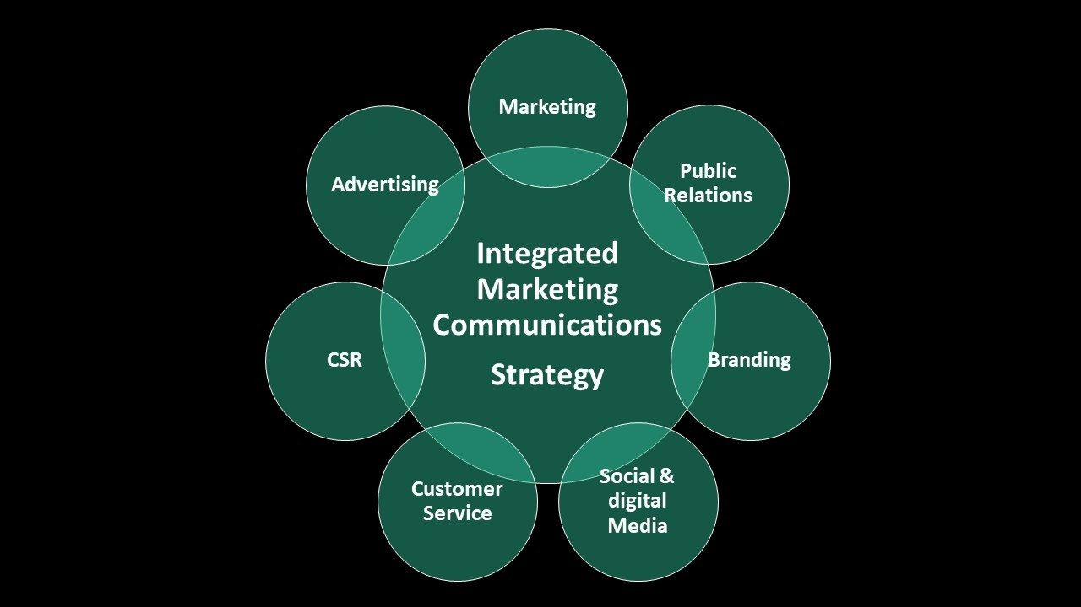
Figure 1: Integrated Marketing Communication Strategies
(Source: King'ori, 2022)

2. Rationale of the study
The focus of this research is to understand the effect of Integrated Marketing Communications (IMC) and Digital Marketing on Sainsbury’s brand equity by looking at how these concepts help improve brand visibility, loyalty, and consumer perception. Considering Sainsbury’s retail market in the UK is very competitive, such understanding points to how particular focused marketing can reinforce brand equity which will help in the development of future branding and communication strategies for Sainsbury.

3. Aims, objectives and research question
Aims
This research aims to analyze how integrated marketing communications and digital marketing strategies influence and strengthen Sainsbury’s brand equity, customer loyalty, and competitive position.
Objectives
- To analyse the current strategies of Integrated Marketing Communications (IMC) implemented by Sainsbury’s in the UK.
- To assess the current digital marketing methods implemented by Sainsbury’s in the UK.
- To identify the impact of IMC and digital marketing practices on the brand equity of Sainsbury’s UK.
Research questions
- What are the current Integrated Marketing communication strategies implemented in Sainsbury’s UK?
- What are the current digital marketing strategies implemented by Sainsbury’s UK?
- What is the impact of Integrated Marketing Communication and digital marketing strategies on the brand equity of Sainsbury’s in UK?

4. Literature Review
4.1 Analysing the current IMC strategies implemented by Sainsbury’s in the UK
According to Bakalo and Amantie, (2023), Integrated Marketing Communications (IMC) is a strategic approach that aligns disparate marketing channels to present a unified brand message, encourage strong brand associations, and influence consumer purchase intentions. Successful implementation of IMC for a supermarket like Sainsbury's ensures brand cohesion across digital, print, and in-store channels, reinforces brand recognition, and builds loyalty. Various authors say that enhancing brand recall increases trust and customer engagement. IMC is an important tool for collaboration, which is crucial for communication. These coherent communication tools reinforce the brand's resonance, and create the right for consumers to be independent will fit the Sainsbury brand in a meaningful way. In the UK, Sainsbury’s uses an Integrated Marketing Communications strategy that focuses on harmonized brand messages in all the activities that are performed online, within stores, and in traditional media. They enhance brand recognition by using advertisements, social networking, sending out emails, operating loyalty programs, and other methods of communication simultaneously. Sainsbury's IMC strategy is per their values, to enhance customers' loyalty and engagement through various channels of interaction.
In the opinion of Mohamed and Adiloglu, (2023), IMC can strengthen customer engagement by creating a cohesive brand image that resonates emotionally with customers. Sainsbury's for example uses visual elements and consistent themes in TV ads, social media, and in-store displays to enhance stakeholders through brand experience as it is one promoted across platforms that establishes an easily recognizable brand personality. Digital IMC strategies such as social media and email marketing are essential for Sainsbury's to drive active brand engagement. For example, Sainsbury's often aligns its in-store campaigns with social media content, encouraging online interactions that reflect its in-store brand values ​​This approach uses IMC to create an omnichannel presence. Studies show that consistent messaging across channels reduces cognitive friction, and strengthens trust, of purchase Also increasing attention is the Sainsbury IMC's approach, which involves delivering personalized emails, mobile app notifications and social media updates combined to deliver tailored messaging to meet customer preferences, encourage loyalty and increase purchase intent.
4.2 Assessing the current digital marketing strategies implemented by Sainsbury’s in the UK
This research conducted a literature review on assessing the current digital marketing techniques implemented by Sainsbury’s UK on enhancing brand equity components. As per the views of Kedi et al. (2024), there are grave advantages in the application of digital advertising strategies. It has been researched that social networking, email marketing along paid active advertising increase consumer brand awareness or brand recall. Sainsbury currently employs a range of digital marketing strategies such as personalized promotions and social media interactions and operates an easy-to-use e-commerce platform. They exploit the use of data analytics to drive targeted advertising and hospitality to the clients’ loyalty programs. In addition to this, Sainsbury’s practices content marketing and email marketing, which helps them to improve customers’ brand loyalty and engagement, whilst constantly meeting the changing customer tendency towards digital shopping.
As for Sainsbury's, optimizing pages on search engines and conducting social media campaigns increases their awareness among the population and therefore more buyers are inclined to the diverse offers. Mainly, customer engagement is referred to as a bonding process, which is important for fostering brand loyalty. Rane et al. (2023), stated that considering effective marketing strategies, such as loyalty schemes and enhanced level of customer service, individualized marketing helps to retain customers longer. Besides, targeted promotions offered through Sainsbury's mobile application and online websites have encouraged customers to make purchases repeatedly and improved brand loyalty. In the United Kingdom, Consumer perceptions of quality are affected by digital engagement. The availability of engaging content and an efficient online customer support system help shape a positive perception of Sainsbury's goods. Testimonials and content produced by the users additionally contribute to the favourable quality perceptions among the consumers which makes Sainsbury's a reputable brand in the competitive business of retailing. To sum up, the implementation of effective digital marketing techniques tends to enhance the brand equity of Sainsbury's by increasing the brand popularity, ensuring its loyalty, and improving its quality relative to other brands.
4.3 Determining the impact of IMC and digital marketing strategies on brand equity of Sainsbury’s .
Looking at Sainsbury’s IMC and its engagement in digital marketing, one can seek to determine how the use of similar messages across multiple platforms and at the same time with digital engagement improves brand retention, presence, and customer perception. These aspects, if well implemented, can improve the trust and recognition level of a particular brand, which would cause competition. The relationship between integrated marketing communication (IMC) and the strategies associated with digital marketing in promoting and sustaining the competitive advantage of Sainsbury's in the long run brand equity demonstrates coordination of marketing elements. According to Mardon et al. (2023), IMC provides a multi-platform approach, which makes it possible for audience engagement enhancement options as well as reinforcement of the brand. A comprehensive integrated marketing communication strategy will combine advertising, public relations, and sales promotions to ensure all sections of a brand’s target market are reached. Sainsbury’s incorporation of conventional and linear communication systems correlation of messages has enabled the creation of a strong brand. In the same line of competitive ability digital marketing practices such as social media, content marketing, or personalization play significant roles (Omar et al. 2020). The study reveals that digital mini-campaigns are also effective in enhancing the interaction and loyalty of customers. In addition, Sainsbury's engagement in social networks contributes to the exchange of information with the customers but also to real-time feedback and building rapport with the brand.
Theory
The Aaker’s Brand Equity Model comprises four key elements that make up the equity of a brand. To begin with, brand awareness or brand recall measures how well consumers can identify or remember a given brand. In the opinion of Tali et al. (2021), in the second place, brand loyalty is the level of persistence of customers towards buying a brand, with a likelihood of buying the same brand again or not. Quality perception, in this case, refers to how an individual thinks about the quality and the worth of a certain brand in question. Finally, brand associations are the different attributes or images that a brand has, which help the consumer form an image and thus make a buying decision. These facets increase the value of the brand, thereby increasing competitiveness in the market.
This research on the determining key IMC means and digital marketing tools applied for Sainsbury's is based on the enhancement of brand equity by Aaker's Brand Equity model. Interventions like the enhancement of digital campaigns to heighten brand awareness, creating brand loyalty through direct marketing communications, and creating high levels of perceived quality through exciting content can all work separately to improve Sainsbury's competitive edge in the market. Furthermore, strategic brand associations as a result of coherent messaging will help in enhancing customer bonding which in turn supports the creation of brand equity as well as competitive advantage of the brand in the long run.
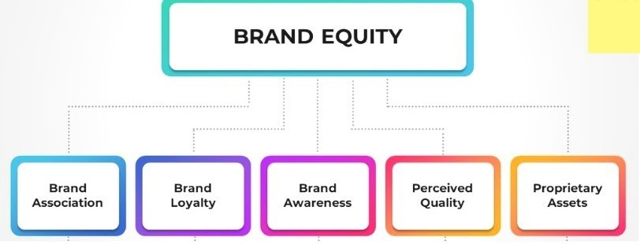
Figure 2: Aaker’s Brand Equity Model
(Source: Odhiambo, 2023)

5. Methodology
Onion Research Model
The Onion Research Model is a research approach that helps focus on making various research decisions by visualizing them in layers. It encompasses all stages of the research cycle, starting with the philosophy, approach and strategies of the research, continuing with models and ways of data collection and analysis. Each layer builds on to the next, thus constructing a systematic way of breaking down the research process into clear-cut phases.
Research Choice
Research choice refers to the process of choosing the most appropriate method of conducting research taking into consideration the aim of the study, the hypotheses raised and the data needed for the research. This means that research methods can be quantitative, qualitative or mixed. In studying this research, the quantitative research choice has to be made concerning the nature of the study. This is due to the nature of the brand equity components (for example brand awareness; and brand loyalty which are usually quantified using structured questionnaires and numerical data hence objective measurement of the IMC and digital strategies on Sainsbury’s branding is possible.

Quantitative research is a type of research that is conducted in a more systematic manner and is mostly about measuring things for patterns, relationships, or trends. It uses closed instruments such as surveys, experiments, and statistical analysis to collect numerical data. This allows for an appreciation of measurement in that the researcher can formulate a hypothesis and make conclusions that can apply to a wider audience.
Research approach and philosophy
Researchers will adopt the positivist philosophy of the research. Positivism will aid in the subjective analysis of the data collected and it will also emphasize objective analysis of the existing data. This will ensure that the research objectives are addressed appropriately. In order to achieve the objectives of the research faithfully, a combination of the deductive research approach and explanatory research choice will be employed by the researchers.
Data collection process and analysis
The selected research will thus be recommended to be carried out using primary and data to deal with the issue presented efficiently and enhance the quality of the business performance. Therefore, this research will be performed using the quantitative mono method. In the first place, selecting a research philosophy is essential as it aids in carrying out research and formulating good hypotheses from the information that has been gathered (Khatri, 2020). The following study will adopt a survey method and paper-based method and will be the suitable research option for this research. One of the means used to gather primary data will be a close-ended questionnaire. There will be a survey involving 50 respondents from the customer base. The survey will consist of 8-10 closed-ended questions with a duration of 5 to 10 minutes. In the review, secondary data sources will be relied on. The researchers will include microsoft Forms to collect primary data and excell for analysing the primary data (Kamiri and Mariga, 2021). The results of the analysis of the quantitative data will be shown in the form of graphs using Microsoft Excel. The corporate publications and depositions will be interpretable by the constructed thematic analysis whilst the data will be displayed in the themes pursued through the study. Sampling refers to the process of choosing a small number of individuals from a larger group, in order to conclude the whole group for research. To assemble primary data, a non-convenience method of sampling will be applicable and the technique will be non-probability sampling.

6. Limitations
This research proposal has several limitations that could affect the findings regarding the impact of integrated marketing communications (IMC) and digital marketing on Sainsbury's brand equity. Firstly, the study will focus on the UK market, Sainsbury's, or other brands in the international specialty markets. Besides, where consumer behaviour and digital usage can vary significantly, the rapidly evolving digital landscape poses a challenge, as new marketing technologies and platforms may emerge during the research (Sagar, 2024). This can potentially affect specific digital strategies considered in the analysis. Another limitation relates to data availability. The research will be done by survey which restricts the data expansion. Research may rely on publicly available or survey-based information about Sainsbury's marketing strategy, which may lack detailed insight into the company's proprietary IMC and digital strategies. Furthermore, measuring brand accuracy can be difficult, as brand perceptions are subjective, and influenced by various external factors, such as economic conditions or competitor behaviour, which may be difficult to control for in this study (Kobylińska, 2022). Finally, time and resource constraints may limit the data collection and analysis, potentially limiting deeper insights into IMC and digital marketing impact on brand equity. Future researchers could continue this research by examining new factors or long-term effects.

7. Ethical Considerations
Research ethics refers to the principles that preserve integrity and respect and protect all the parties involved while ensuring that everyone is honest and responsible in the course of the research process. It must be ensured that the survey will be private and confidential. Ethics in research applies to the principles and rules that regulate the performance and conduct of research in an adequate manner (Aravik et al. 2022). It includes standards for the protection of those who take part in research activities such as the necessity of informed consent, confidentiality of subjects, the risk of harm and honesty in the management and dissemination of the researched data. It must be ensured that the survey will be private and confidential. This research ensures the critical importance of ethical issues for primary research on key identifying IMC and digital marketing practices as factors improving Sainsbury's competitive position and building its brand equity over time. Every effort must take precedence towards ensuring that the participants of the study are kept covered; in this case, the sensitive issues are focusing on the use of personal information which has to be filed away, disguised, and protected. The participants must be free to choose whether or not to take part in the research and to opt-out at any given point in time without any repercussions. In addition to that, the researchers need to be aware of the possible sources of bias and make all efforts to eliminate them as objectivity is the foundation upon which true and dependable results that meet the aim of the research are achieved.

8. Resources and Planning
For this study, microsoft form will be accessed online to conduct the survey and from the from, graphs will be identified as the results of the primary data found. Thus, the findings will be
analysed followed by the planned way mentioned below with the help of gantt chart.

Milestones | W 1- W 2 | W 3-4 | W 5-W 6 | W 7-8 | W 9-10 | W 11-12 | W 13 | W 14-15 | W 16
Ethical Approval and Introduction
Aims, Objectives and Research Questions
Literature Review
Methodology
Limitations
Data collection and analysis
Result declaration
Table 1: Gantt Chart
(Self-created)

9. Determining budget
There is no plan for purchasing any secondary materials for this research or any travelling expenses for researchers to go outside for the quantitative survey as the survey will be online. Thus, in the meantime, there is no identified budget for this project initially.

10. Conclusion
In conclusion, this study seeks to identify the best-integrated marketing communications, inclusive of digital marketing strategies, that can improve Sainsbury’s overall competitive edge, thus promoting brand loyalty and equity even in the modern changing retail environment.

References
Aravik, H., Amri, H. and Febrianti, R., (2022). The Marketing Ethics of Islamic Banks: A Theoretical Study. Islamic Banking: Jurnal Pemikiran Dan Pengembangan Perbankan Syariah, 7(2), pp.263-282. https://www.researchgate.net/profile/Havis-Aravik/publication/358954543_THE_MARKETING_ETHICS_OF_ISLAMIC_BANKS_A_THEORETICAL_STUDY/links/621f05197106690c08533056/THE-MARKETING-ETHICS-OF-ISLAMIC-BANKS-A-THEORETICAL-STUDY.pdf Mercy Stella Anyango Odhiambo, (2023). Brand Equity Explained Using the Aaker Brand Equity Model. Available at: https://www.linkedin.com/pulse/brand-equity-explained-using-aaker-model-odhiambo/ [Accessed on 26.10.2024]
Bakalo, A. and Amantie, C., (2023). The Advertising & Promotion an Integrated Marketing Communications Perspective Scientific Literature Review. Global Media Journal, 21(63), pp.1-9. http://download.garuda.kemdikbud.go.id/article.php?article=3612571&val=31354&title=The%20Advertising%20%20Promotion%20an%20Integrated%20Marketing%20Communications%20Perspective%20Scientific%20Literature%20Review
Kamiri, J. and Mariga, G., 2021. Research methods in machine learning: A content analysis. International Journal of Computer and Information Technology (2279-0764), 10(2), pp.78-91. https://www.academia.edu/download/106438556/401614298.pdf
Kedi, W.E., Ejimuda, C., Idemudia, C. and Ijomah, T.I., (2024). Machine learning software for optimizing SME social media marketing campaigns. Computer Science & IT Research Journal, 5(7), pp.1634-1647. https://www.researchgate.net/profile/Tochukwu-Ijomah-2/publication/383847411_Machine_learning_software_for_optimizing_SME_social_media_marketing_campaigns/links/66dc48492390e50b2c7213a8/Machine-learning-software-for-optimizing-SME-social-media-marketing-campaigns.pdf
Khatri, K.K., 2020. Research paradigm: A philosophy of educational research. International Journal of English Literature and Social Sciences, 5(5), pp.1435-1440. https://mail.ijels.com/upload_document/issue_files/15IJELS-109202027-Research.pdf
King'ori, (2022). Integrated marketing and communications for business growth.Available at:https://www.linkedin.com/pulse/integrated-marketing-communications-business-growth-hazel-king-ori/ [Accessed on 26.10.2024]
Kobylińska, U., (2022). Attitudes, subjective norms, and perceived control versus contextual factors influencing the entrepreneurial intentions of students from Poland. WSEAS Transactions on Business and Economics, 19, pp.94-106. https://www.wseas.com/journals/bae/2022/a205107-004(2022).pdf
Kushwaha, B.P., Singh, R.K., Varghese, N. and Singh, V.N., (2020). Integrating social media and digital media as new elements of integrated marketing communication for creating brand equity. Journal of Content, Community & Communication, 11(6), pp.52-64. https://www.researchgate.net/profile/Zinggara-Hidayat-2/publication/350639866_Data-Driven_Journalism_Based_on_Big-Data_Analytics_A_Model_Development_from_Indonesia's_Experience/links/6070302692851c8a7bb38cbc/Data-Driven-Journalism-Based-on-Big-Data-Analytics-A-Model-Development-from-Indonesias-Experience.pdf#page=59
Li, L., Wang, Y. and Zhang, Y.Y., (2023). A critical examination of M&S's current strategic and marketing position, as well as potential sustainable competitive marketing strategies. International Journal of Science and Business, 18(1), pp.108-117. https://www.researchgate.net/profile/Le-Li-61/publication/367559196_A_critical_examination_of_MS's_current_strategic_and_marketing_position_as_well_as_potential_sustainable_competitive_marketing_strategies/links/63d899af62d2a24f92deffb2/A-critical-examination-of-M-Ss-current-strategic-and-marketing-position-as-well-as-potential-sustainable-competitive-marketing-strategies.pdf
Mardon, R., Cocker, H. and Daunt, K., (2023). How social media influencers impact consumer collectives: An embeddedness perspective. Journal of Consumer Research, 50(3), pp.617-644. https://academic.oup.com/jcr/article-pdf/doi/10.1093/jcr/ucad003/51538999/ucad003.pdf
Mohamed, K. and Adiloglu, F., (2023). Analyzing the Role of Gestalt Elements and Design Principles in Logo and Branding. International Journal of Communication and Media Science, pg40 Retrieved, 13(7), p.2023. https://www.researchgate.net/profile/Kareem-Mohamed-Abdelhafiz-Hussein/publication/371760406_Analyzing_the_Role_of_Gestalt_Elements_and_Design_Principles_in_Logo_and_Branding/links/6493da74c41fb852dd1d4e6f/Analyzing-the-Role-of-Gestalt-Elements-and-Design-Principles-in-Logo-and-Branding.pdf
Omar, F.I., Zan, U.M.S.M., Hassan, N.A. and Ibrahim, I., (2020). Digital marketing: An influence towards business performance among entrepreneurs of small and medium enterprises. International Journal of Academic Research in Business and Social Sciences, 10(9), pp.126-141. https://pdfs.semanticscholar.org/4960/acab188de309bba3a804b771db1638f50ed7.pdf
Rane, N.L., Achari, A. and Choudhary, S.P., (2023). Enhancing customer loyalty through quality of service: Effective strategies to improve customer satisfaction, experience, relationship, and engagement. International Research Journal of Modernization in Engineering Technology and Science, 5(5), pp.427-452. https://www.researchgate.net/profile/Nitin-Rane-2/publication/370561455_Enhancing_customer_loyalty_through_quality_of_service_Effective_strategies_to_improve_customer_satisfaction_experience_relationship_and_engagement/links/645612ad97449a0e1a7f308a/Enhancing-customer-loyalty-through-quality-of-service-Effective-strategies-to-improve-customer-satisfaction-experience-relationship-and-engagement.pdf
Sagar, S., (2024). The Impact Of Digital Transformation On Retail Management And Consumer Behavior. IOSR Journal of Business and Management (IOSR-JBM) e-ISSN, pp.06-14. https://www.researchgate.net/profile/Sahil-Sagar-5/publication/377189041_The_Impact_Of_Digital_Transformation_On_Retail_Management_And_Consumer_Behavior/links/65993f0e0bb2c7472b364119/The-Impact-Of-Digital-Transformation-On-Retail-Management-And-Consumer-Behavior.pdf
Tali, M.A., Wani, N.F. and IbrahimAssociate, A., (2021). The power of branding influencing consumer purchase decision: A comprehensive literature review. Ilkogretim Online, 20(6), pp.5362-5387. https://www.researchgate.net/profile/Mohmad-Altaf-Tali/publication/373522954_The_Power_Of_Branding_Influencing_Consumer_Purchase_Decision_A_Comprehensive_Literature_Review/links/64f04a3c0f7ab20a8667d283/The-Power-Of-Branding-Influencing-Consumer-Purchase-Decision-A-Comprehensive-Literature-Review.pdf

