5/5/2020
Kaylie Shoulder (1800042)
UWTSD
Wireless Networks & Simulation
Design and Evaluation of Sensor Networks

Contents
Wireless Networks & Simulation 2
Introduction: 2
Securing the Caribbean Islands 4
A Topology for a secure, connected Farm. 5
An Evaluation of the Design 7
Appendices 9

Wireless Networks & Simulation

Abstract: Throughout the duration of this report, the topic of modulation in wireless networks will be investigated, focusing heavily upon Quadrature Phase Shift Keying – then discussing the security of the Caribbean Islands, and a farm topology will be designed and discussed.

Introduction: In an ever-evolving society which bases its very structure around technology, the network that we use has developed drastically over many years. 20 years ago, your average home would connect to the internet using your phone line’s dial-up system, then a standard ethernet cable… and now, in the year of 2020, a large sum of networks function wirelessly – this is a wireless network. According to Cisco, ‘’a wireless local-area network uses radio waves to connect to devices’ [1], this means that no cables are needed from the end-point to the access point; as wireless networks tend to rely upon what’s called a ‘Wireless Access Point’ (WAP), a device can seamlessly continue connecting to one network – this is because the WAP’s will form one giant network, meaning that no other security measures need to be implemented once connected to one WAP, so a user can walk around a building whilst staying connected to the network, wirelessly.
Where there is a wireless network, there is a process entitled ‘modulation’ that occurs within data transmission. Modulation is essentially when data is converted into electrical signals to ensure it is ‘optimised for transition’. [2] Generically, there are four different types of modulation, which includes:
- Analog
- Digital
- Pulse
- Spread spectrum
Modulation is wireless networks is essential – its essentially what allows data to be both sent and received, this is because it takes the encoded data and converts it into radio signals – modulation then acts as a carrier signal; modulation takes the form of a waveform and these waveforms consist of a total of three parts, those being: amplitude, phase, and frequency.
In electronics, all analog signals can exhibit various and continuous variations of signal, whilst its brother, digital, is only able to assume one of two states at once. There are several schemes which can be used in wireless communication, some being: BPSK, QPSK, and QAM.
However, the focus of this particular section of the report is ‘QPSK’ – which stands for Quadrature Phase Shift Keying; QPSK is a modulation technique and differs from other types of modulation as it is able to ‘transmit two bits per signal’ [3] – this means that it doesn’t particularly conform to binary norms as it is able to present itself as more than just ‘1’ or ‘0’ at once, rather it can be: 00, 10, 01, or even 11. [3] QPSK can do this as it is an analog signal – meaning that it is not bound to the limits that digital signals have, thus it is able to exist in multiple states rather than just two states.
One of the primary reasons why QPSK is advantageous over many other different types of modulation schemes is because of its ability to assume the form of multiple values at once – this means that when compared to other modulation types such as BPSK, the efficiency of bandwidth using QPSK is near enough doubled. Joined with this: it provides ‘good noise immunity’ and a ‘low error probability’ – which means that it is more efficient in terms of bandwidth and the carrier power remains constant. [4]
When a signal is being transmitted, QPSK allows for the signal to ‘’carry twice as much information as ordinary PSK’ using the exact same amount of bandwidth [4]; the QPSK modulator which ‘uses a bit splitter, two multipliers with local oscillator, a two bit serial parallel converted, and a summer circuit’’. [5] – during input, both odd and even bits are separated – this is done in order for odd BPSK and positive BPSK – the signal’s phase then gets shifted, and it shifts by a total of ninety degrees before the process of modulation.
Whilst QPSK has its advantages, it does have disadvantages too – unfortunately, in terms of power efficiency, QPSK is not any more beneficial than any other modulation scheme, and this is because ‘more power is required to transmit two bits’ [6] – thus, it is not more beneficial to use QPSK if you wish to allow for more power retention. Also, QPSK is more complex than any other option, and this is because ‘four states are needed to recover binary data information’ [6], whilst other modulation schemes do not need this.

Securing the Caribbean Islands
It appears that there is a high-concern for knife-crime in the Caribbean Islands, which has led to the increase in robbery in major towns and cities – other concealed weapons are also being used such as guns.
The UK Gov Trialled a system in Stratford Station in East London, and this system was a technology that was created by a company entitled ‘Thruvison’ [6]– this system is essentially where a device is set up in concealed areas of the station, and is able to ‘safely detect weapons including guns, knives, and explosive devices concealed under clothing at distances up to 30ft’ [6] and works by detecting changes in body heat. This type of system could be set up in cities in the Caribbean, such as in major shopping centres or in travel stations like train stations/coach docks – it should be accompanied with a camera which can automatically record upon detection and a silent alarm which can send a notification to the police of the carrier and where they were detected – police should be able to see the footage from the camera of when the carrier was detected.
Another system that could be implemented is facial recognition software – according to Sarah Griffiths on ‘Knives Out: Tech Tackles Violent Crime’, ‘’several police forces across the UK have been trialling facial recognition systems’ and even south Wales Police have used Automated Facial-Recognition (AFR) Software. [7] Apparently, this type of software can automatically detect the faces of up to 500k people of interest and can be deployed in real time. Whilst not all of those carrying concealed weapons in the Caribbean will be those with a criminal history, it is possible that SOME of those carrying concealed weapons will have a criminal record, and these cameras could be scattered around public areas to help locate those who are known to have a history with concealed weapons and help the police perform ‘stop and search’.
A security company named ‘Athena Security’ have developed a technology that relies upon ‘object-motion detection’ which is able to detect when someone is brandishing a firearm – this software is deemed as an ‘agnostic’ system which means that it is able to ‘work on any CCTV system’. Apparently ‘’when a gun is detected, the video feed of the active shooter is made available to the client (Athena Security) on both mobile devices and desktops, allowing officers to know what they are dealing with.’’ [8] What is so great about this technology is the fact that it can operate on ANY CCTV camera, meaning that it would work well with the other listed software. Whilst on its own it isn’t a stand-alone solution, if it were to be combined with the two other solutions: face detection, and the body-heat detector, it would be a clear solution to the problems.
A combination of all three solutions would work seamlessly – the device would be able to detect if someone is carrying a concealed weapon before it is drawn, and the facial detection service would be able to scan its database to see whether the person is on the list of ‘people of interest’ – so it is possible to identify the perpetrator before the police arrive at the scene, joined with this, if the perpetrator does draw their weapon and attempt to use it, the police would already be notified, and be already be able to view in real-time what events are occurring which can help them plan to solve the incident and also help protect themselves and those around them. These devices should be implemented in cities and areas where public transport can be accessed – doing so would allow high coverage.

A Topology for a secure, connected Farm.
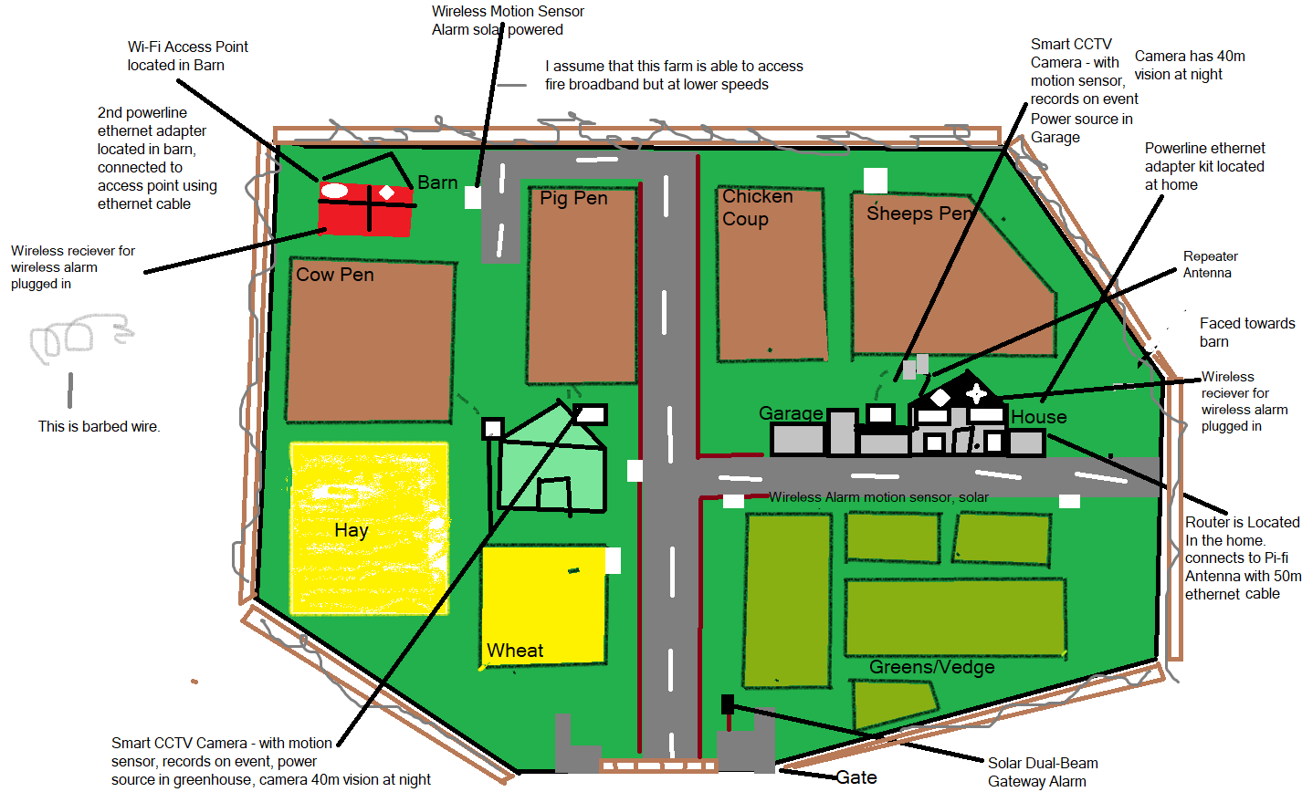

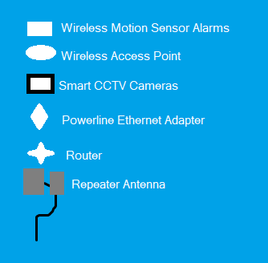

This topology focuses heavily on wireless connection – with the intention of keeping the amount of cables used to an absolute minimum. For this design, it was assumed that internet access is available to the farm, but the connection does NOT stretch across the entirety of the farm. The aim of the topology, along with attempting to keep it as wireless as possible, is the attempt to allow wireless access throughout the farm.
It is assumed that the farm does have some internet access within the home, thus the owner has a router. In this topology, the use of Pi-Fi has been chosen – there is a repeater antenna located next to the home which is structured with a J Pole. This Pi-Fi antenna is connected to the router wired carefully using an ethernet cable which is plugged into the router – this is what allows it to obtain Wi-Fi access. The reason that a repeater was chosen was because it can extend Wi-Fi coverage for up to a mile – this particular farm is but a fraction of that and is half an acre – however, whilst a 1-mile connection may seem overkill, there would be factors that influence the distance in which connection can occur, there will be barriers affecting the distance in which the radio waves can travel such as buildings and other farmland material/resources, thus a wider ranged product was chosen.
To ensure ultimate connectivity, the router within the home will be connected to a powerline ethernet adapter, which will be plugged into a power supply – the second powerline ethernet adapter will be plugged into the barn, which will then connect to a wireless access point. Whilst the Wi-Fi coverage was ensured by the repeater, the wireless access point was implanted as a precaution, this is so the many smart devices scattered around the farm will be able to access the internet regardless. An idea was raised in the air to use a switch, but as the primary aim of the network was to make it as wireless as possible, the idea of a adapters was used instead to create a seamless network.
Located at the front of the property is a gate, which has a Solar Dual-Beam Gateway Alarm implemented – this alarm can detect motion for up to 20metres and is solar powered, the receiver can transmit for up to half a mile and is located within the household. Whilst it is solar powered, it can function for up to a fortnight in darkness. This feature was implemented to secure the front-gate, so anyone who comes near the front side of the house whilst it is activated, if it detects any motion when activated then the alarms will be set off which will alert the farmer and acts as a deterrent from thieves.
There are three smart CCTV cameras on site, two which face the cow and pig pen, and another which faces the chicken coup and sheep’s pen. These CCTV camera’s have motion sensors implemented within them, which means that whilst they can be constantly monitoring, whenever they detect any motion when activated, they automatically start recording, a lot like a cars dashcam. This was done to protect the animals from being stolen – and should they be stolen, there would be HD evidence of the thief which would aid the police in tracking the criminal. It is assumed that the farmer owns a smart phone, and these cameras can be controlled/viewed using a simple app on the smartphone and when alarms are set off, the police are immediately notified in order for them to respond.
Joined with the CCTV cameras, there are six, wireless motion sensor alarms scattered around the farm, one facing the home, one facing the crops, one on the road throughout the property, another located by the wheat field, one by sheep’s pen, and the remaining placed facing the barn. These wireless motion sensor alarms were implemented in these areas to ensure that there is complete coverage of the farm – the areas in which these were placed were the places in which the CCTV cameras would not have been able to have reached; when they detect movement, a loud alarm sounds, which will notify the farm owner of the intrusion.

An Evaluation of the Design

It is important to always analyse and review over any designs that were made, to see whether they are viable designs or whether the idea is too poor to be implanted in a real-life scenario – and during this particular section of the report, the quality of the farm design will be analysed and discussed – this includes the methods used, the products used, and how they have been implemented in the design.
First and foremost, it is easy to understand the reasoning behind why specific items have been used, this design uses: A Pi-Fi Antenna, a Router, a Wireless access point (WAP) and powerline ethernet adapters to achieve the ‘seamless’ wire-free approach that was intended. The topology relies upon having a stable internet connection to the home router, which is then amplified using a repeater – joined with this, a powerline adapter has been fitted within the home, connected to the router, which is accompanied with a wireless access point in the barn, which connects to the partner powerline adapter.
The use a of a repeater in the case of a farm appears to be a reasonable choice to make – wireless repeaters can ‘improve wireless signal strength without having to move a computer or a router’ [9] – they can extend the distance in which one can connect to the wireless network by up to roughly 25 miles (depending on the quality of the repeater) – in this topology, a 1 mile repeater has been opted for which seems reasonable based on the justification which accounts for any signal blockers, as the farm is a fraction the size of a mile a 1 mile repeater could be considered slightly ‘overkill’, however it is justifiable as it creates that extra security that would be needed in such a rural area.
However, wireless repeaters are not the cheapest option, instead an alternative such as using switches could have been opted for. Joined with the issue of cost of an actual repeater, just like with any other wireless device, the further away you are from the host signal, the weaker the connection becomes; repeaters are also known to almost halve the amount of bandwidth available, and the amount of ‘wireless interference is at least doubled’, and according to Accelerit, repeaters ‘potentially open up another security attack vendor’ as ‘older devices don’t always support WPA2-PSK’ which means that whilst the host network may be secure, the repeater may not be as secure. [10]. Wireless Network security is vital – and to opt for a wireless method which may endanger the network connection is a risky move as the repeater needs to be chosen carefully to ensure security and coverage.
It does seem as though the possibility of having disturbance has been accounted for with the use of powerline adaptors and WAPS – a powerline adapter is a good alternative to running ethernet cables from one site to another, powerline adapters are essentially a type of bridging – they essentially allow power sockets to act as ethernet connections – which can then be used to plug into a WAP which is the case in this particular topology. This could pose an issue depending on how the electrical system is wired within the farm – the distance between the two locations are rather big and the feasibility of the connection being strong enough to reach that far is rather small. Which is a poorly thought-out section of the topology, it appears to be a lazy answer to the challenge and could have been planned in a much better fashion. However, if it does work it can provide up to 150 feet of connectivity which, in hindsight, would work rather well for the size of this farm as it is not a particularly large farm.
Whilst the actual topology of this farm is a rather hit or miss situation, the amount of security measures that have been implemented are reasonable. With 3 CCTV Cameras, six wireless motion sensor alarms and a solar-powered alarm located at the front gate the level of security on this farm is reasonable. The placement of each sensor could have been altered to offer more coverage as the front half of the farm is densely populated with these sensors and the back of the farm is slight scarce, so these could have been scattered out more appropriately. Joined with this, more than 3 smart CCTV Cameras could have been used.
To conclude, it appears the topology design is rather poorly structured, and it is clear it has not been planned out very well – it does offer a wider range of network connectivity and does offer some form of security, however it lacks floodlights and a ‘SMART’ approach.

Conclusion
To conclude, creating a topology which can work for a farm can be rather tricky and there are multiple elements which need to be thought about which are often overlooked, especially wiring and the placement of devices; however, wireless systems can be just as efficient as any other network for standard use. Not to mention that modulation is a wonderful thing – with each type of modulation having an advantage over the other, and a disadvantage to the other, but QPSK does seem like a highly efficient modulation scheme. There are also a multitude of ways in which technology can work seamlessly to help curb concealed weapon carry – and some of these methods can be rather fascinating and can work together incredibly well.

Bibliography

[1] | Cisco, “What is a Wireless Network?,” [Online]. Available: https://www.cisco.com/c/en_uk/solutions/small-business/resource-center/networking/wireless-network.html.
[2] | ROHM, “Modulation Method Classification,” [Online]. Available: https://www.rohm.com/electronics-basics/wireless/modulation-methods.
[3] | A. A. Circuits, “Understanding Quadrature Phase Shift Keying (QPSK) Modulation,” [Online]. Available: https://www.allaboutcircuits.com/technical-articles/quadrature-phase-shift-keying-qpsk-modulation/.
[4] | “Maxim Integrated,” [Online]. Available: https://www.maximintegrated.com/en/glossary/definitions.mvp/term/QPSK/gpk/244.
[5] | “Quadrature Phase Shift Keying,” [Online]. Available: https://www.tutorialspoint.com/digital_communication/digital_communication_quadrature_phase_shift_keying.htm.
[6] | H. O. Kit Malthouse, “New technology to detect knives in public places,” 16 09 2019. [Online]. Available: https://www.gov.uk/government/news/new-technology-to-detect-knives-in-public-places.
[7] | S. Griffiths, “ Knives out: tech tackles violent crime,” Engineering and Technology , 2020.
[8] | D. Pangburn, “How Gun-Detection Technology Promises to Help Prevent Mass Shootings,” London.
[9] | G. Hamel, “Advantages and Disadvantages of Using a Repeater,” 2018.
[10] | Accelerit, “What is a wireless range extender and what are the pros and cons?,” Cape Town.

Appendices
A possible alternative to using technology to reduce concealed weapon carry in places such as train stations, is to take a more traditional approach. If possible, entry in to places such as train stations/bus depots, a system where each passengers should be forced to line up in orderly ques should be implemented, police should scan each person that enters into the station with body scanners/metal detectors, and stations should be treated like an airport – the passengers should declare what metals they have on them, and then place their bags onto a conveyer belt which can scan the contents of the bag to avoid concealed carry in the bags. A system where police can communicate incident details fast and efficiently could also prove useful – especially if a chase has occurred.

