Component 2: Written Report
Protecting and Supporting Families in Health and Care (BMHP5021)

Tutor Name: Robert Nartowski
Syed Mudassar Hussain (2407258)
29th March 2026
Word Count: 2180

Contents
An examination and analysis of how the ‘Early Help’ system is signposted to UK families by their local authority website 2
1 Introduction 2
2 Early Help System 3
3 Multi-Agency Working 4
4 Evaluation of Each Local Authority Website 5
4.1 Southwark Council (https://southwark.gov.uk) 5
4.2 Norfolk County Council (https://www.norfolk.gov.uk) 6
4.3 Tower Hamlets Council (https://www.towerhamlets.gov.uk) 7
5 Comparative Analysis 9
Most Effective Website: Tower Hamlets Council 10
Areas for Improvement 10
6 Conclusion and Recommendations 11
7 References 12

An examination and analysis of how the ‘Early Help’ system is signposted to UK families by their local authority website

1 Introduction
Early Help (EH), also referred to as early intervention, is a cornerstone of children’s services in England. It describes a proactive approach to supporting children, young people and families as soon as emerging difficulties become apparent. Axford et al. (2020) observe that while early intervention programmes vary in effectiveness, their value lies in timely, coordinated support. The Early Help System Guide (DLUHC and DfE, 2022) treats multi-agency collaboration as the core model underpinning whole-family, coordinated support. Its importance is reinforced by Working Together to Safeguard Children (DfE, 2023), which positions early intervention as essential to protecting children’s welfare and improving long-term outcomes.
This report assesses and compares how three local authorities, Southwark, Norfolk and Tower Hamlets, signpost EH information to families via their websites. It evaluates each authority’s online presentation in terms of accessibility, clarity, comprehensiveness and contact details.
The report begins by defining the EH system and its role in preventing escalation to statutory services, and then outlines multi-agency working. Each council’s website is then evaluated using a comparative analysis. Recommendations for improving online communication conclude the report.

2 Early Help System

EH is a preventative strategy designed to support children and families. The Early Help System Guide (DLUHC and DfE, 2022) emphasises a collaborative approach among professionals working with children and families to quickly identify needs and respond co-ordinately. This guide defines the system as comprising universal services, such as schools and GP surgeries, as well as community support and specialised services, including family support, mental health support, domestic abuse support, and housing assistance. These services are integrated based on each family's needs. The core aim of EH is to prevent the escalation of need by providing timely and appropriate support to families at an early stage. This approach fosters resilience and problem-solving skills, reducing the likelihood of statutory intervention under the Children Act 1989 (DLUHC and DfE, 2022). This proactive approach is crucial. Research shows early intervention programmes focus on improving child well-being and family functioning by addressing developmental and psychosocial risks early, helping to prevent more serious issues later (Musa and Dergaa, 2022). This aligns with the safeguarding framework in Working Together to Safeguard Children 2023 (DfE, 2023), which defines safeguarding as protecting children from maltreatment, preventing impairment of their mental and physical health or development, and providing timely support to address their needs when issues arise. This framework highlights that efficient EH is a shared responsibility, positioned below the statutory obligations of the Children Act 1989, yet remains an essential part of the safeguarding ecosystem, ensuring that "low-level" concerns are addressed before they escalate into "safeguarding" risks. Therefore, EH is crucial for safeguarding, acting as the first proactive defence in support services, ensuring all children achieve the best outcomes.
Fig. 01(Shropshire Council, n.d.)

3 Multi-Agency Working
Multi-agency working is crucial for the effective operation of an EH system. It is the collaborative practice of professionals from various disciplines and organisations coming together to understand a specific problem or experience (Walker, 2018). This strategy is vital because no single agency has a complete view of a child's life, and a fragmented approach can create gaps that endanger child safety (Dixon et al., 2022). Multi-agency collaboration acknowledges that families often face complex, interconnected challenges, such as child protection and family risks, that cannot be effectively addressed by a single service, thereby improving safeguarding outcomes (Baginsky and Manthorpe, 2022).
"Working Together to Safeguard Children 2023" guidance asserts that safeguarding partners, including the local authority, the police, and integrated care boards, are legally required to collaborate with relevant agencies to ensure the protection and promotion of children's welfare in their locality (DfE, 2023). The guidance emphasises that effective partnership fosters the early detection of risks, the proper exchange of information, and the coordinated assistance for families. Additionally, it delineates the roles and responsibilities of each agency and elucidates how they work together. This collaborative approach is essential to the EH framework, ensuring families receive tailored support based on their needs.
Multi-agency safeguarding involves collaboration among social workers, educators, health practitioners, police, and voluntary organisations, each providing unique expertise to support children and families (DfE, 2023). The EH System Guide emphasises that the multi-agency workforce is essential for an effective EH system, requiring practitioners to work collaboratively (DLUHC and DfE, 2022). Research indicates that effective collaboration among multi-professional teams is vital for supporting children and families. However, conflicting professional cultures and unclear roles present significant challenges (Solvason and Winwood, 2022). El-Hoss et al. (2023) note that while multi-agency responses can be effective when managed by professionals with strong family relationships, they can become disjointed if professionals act independently. This can lead families to feel the process is intrusive and bureaucratic rather than helpful. Ultimately, multi-agency working ensures that families receive a unified package rather than a fragmented sequence of service interactions.

4 Evaluation of Each Local Authority Website
This section analyses EH information on the websites of Southwark, Norfolk, and Tower Hamlets councils.

4.1 Southwark Council (https://southwark.gov.uk)
Southwark Council offers EH under the “Children, young people and families”.
4.1.1 Ease of Access
The EH section is accessible in 2-3 clicks from the homepage via the navigation menu or search function. While the structure facilitates smooth navigation from general to specific services, families unfamiliar with EH may find the homepage guidance unclear.
4.1.2 Clarity
The language on Southwark's EH is mostly accessible and direct, but some pages include technical terms such as 'CAMHS' without sufficient explanation, which could alienate families unfamiliar with them.
4.1.3 Comprehensiveness
Southwark's website offers extensive EH content, but the brief information on the main page and the lack of detailed explanations may create uncertainty. This section lacks FAQs or videos, and accessibility issues, such as missing alternative text, poor heading structure, low colour contrast, and confusing navigation, affect screen reader and keyboard users (Southwark Council, 2025).

4.1.4 Presentation
Southwark's website has a clean design and clear navigation, but this section is text-heavy with few visuals. Including key information, such as “Early Support/Help,” on the main page would be helpful.
4.1.5 Contact Details
The site offers a “Make a referral” link and provides EH via phone, email, or through a professional, such as a teacher. While this support is useful, contact information isn't consistently highlighted on all EH pages.
4.1.6 Evaluation
Overall, EH provides targeted, whole-family support beyond universal services, with a focus on timely assistance. It could be improved by clarifying the thresholds and offering concrete examples of support.
4.1.7 Strengths and Weaknesses
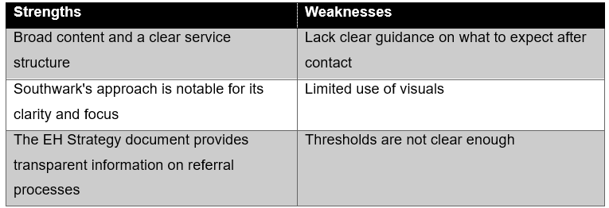
Table1:Strengths and Weaknesses of Southwark Council

4.2 Norfolk County Council (https://www.norfolk.gov.uk)
Norfolk County Council features EH under the "Children and families".
4.2.1 Ease of Access
The EH section is accessible in 2-3 clicks from the homepage via the navigation path or the search function, but users may need to click additional links to access details, as there are only four links on the main page. This section provides a clear, well-signposted overview and also provides an online self-referral form for families.
4.2.2 Clarity
Norfolk uses a family-focused approach with welcoming language to help families recognise their need for support, addressing concerns like financial stability in an accessible way for parents.
4.2.3 Comprehensiveness
The site provides comprehensive information on health, social, and emotional well-being, detailing support options and access methods, including self-referrals. It explains the EH assessment process in clear language for families. However, issues such as unclear link text, inaccessible forms (like unclear labels), and videos without accurate captions hinder usability for disabled users (Norfolk County Council, 2025).

4.2.4 Presentation
The site is well-organised with a bright banner and clear headings, but the banner is too large, and the font spacing is excessive, especially on mobile. It lacks videos or interactive elements, focusing on simple text.
4.2.5 Contact Details
EH is mainly contacted via a general phone line or a referral form, rather than through a specific contact point.
4.2.6 Evaluation
Overall, it offers comprehensive EH information and signposting but falls short on detailed explanations of processes, eligibility criteria, and referral pathways.
4.2.7 Strengths and Weaknesses
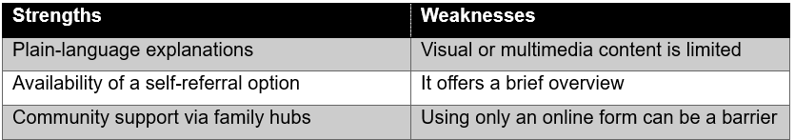
Table 2: Strengths and Weaknesses of Norfolk County Council

4.3 Tower Hamlets Council (https://www.towerhamlets.gov.uk)
Tower Hamlets offers EH under the “Children and family care”.
4.3.1 Ease of Access
The EH section is easily accessible in two clicks from the homepage through navigation or search. While navigation supports efficient access, searching “Early Help” yields numerous results. The section’s nine subpages offer comprehensive information, but limited family-oriented content and a dense website structure may still hinder users in finding specific details.
4.3.2 Clarity
The text is brief with simple sentences. Some terms, like “graduated approach,” are a bit technical but still understandable for most parents.
4.3.3 Comprehensiveness
Tower Hamlets' EH content is comprehensive, featuring a downloadable EH Strategy 2025–2028. It offers detailed guidance on how to access help. However, the excessive use of image-based tiles without descriptive text can hinder screen reader accessibility, and some external forms may not work without JavaScript, limiting access.
4.3.4 Presentation
The layout is streamlined but text-heavy. Navigation links and downloadable leaflets provide valuable resources. The EH pages lack videos, but the menu is useful.
4.3.5 Contact Details
EH can be accessed through the Multi-Agency Support Team (MAST) by phone, email, or an online referral form, not through a main-page contact point.

4.3.6 Evaluation
Overall, it has a clear, icon-based layout for easy navigation but provides limited detail on the main page, encouraging users to explore additional links for more information.
4.3.7 Strengths and Weaknesses
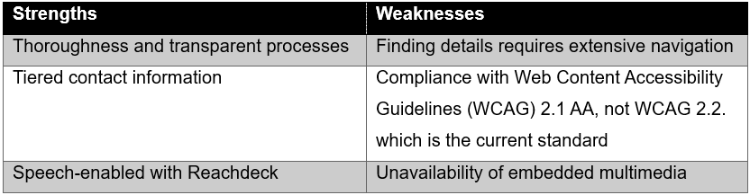
Table 3: Strengths and Weaknesses of Tower Hamlets Council

5 Comparative Analysis
As shown in Table 4, each website is now compared across the five criteria.
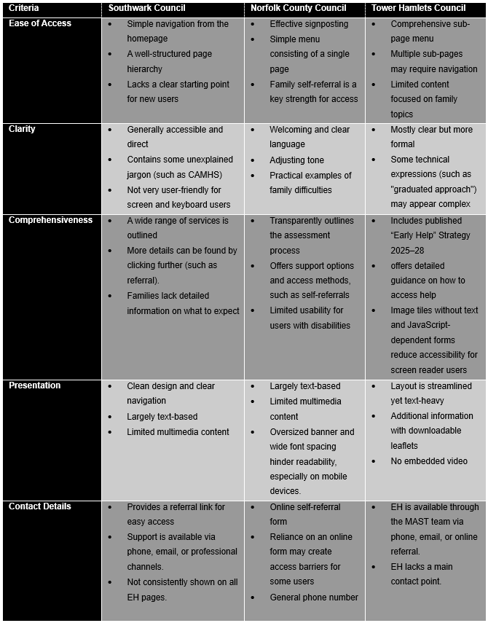
Table 4: Comparative Analysis of Early Help Websites Across Five Criteria

5.1 Most Effective Website: Tower Hamlets Council
Tower Hamlets Council has the best EH website among the three reviewed. It provides the most comprehensive, well-structured content with the clearest navigation, enabling families and professionals to locate information efficiently, in line with local government digital inclusion guidance requiring councils to deliver accessible, user-friendly online services (LGA, n.d.). It offers clear processes and detailed guidance on support, along with a downloadable EH Strategy for 2025 to 2028. In contrast, Southwark lacks clear post-referral guidance, and Norfolk only provides a brief overview. Families can reach out through various options, including phone, email, and an online referral form via the MAST team. Reachdeck's inclusion as a speech-enabled tool highlights the NHS framework's commitment to inclusive digital design and equitable access (NHS, 2024). However, the reliance on image-based tiles raises concerns about screen reader compatibility with WCAG 2.2 standards. Overall, Tower Hamlets outperforms Southwark and Norfolk in all five evaluation criteria, making it the best model for communicating EH information online.

5.2 Areas for Improvement
Southwark needs to address accessibility issues, such as missing alternative text, to comply with the WCAG 2.2 (World Wide Web Consortium, 2024) and the Public Sector Bodies Accessibility Regulations (2018). Including plain-language explanations of terms such as 'CAMHS', along with FAQs and videos, would enhance clarity for families with lower levels of digital or health literacy (Fernandes et al., 2023).
Norfolk should improve its mobile layout by minimising large banners and font spacing, and ensure all video content has accurate captions for deaf and hard-of-hearing users, as required by WCAG 2.2 Success Criterion 1.2 (World Wide Web Consortium, 2024). Additionally, offering more contact options beyond online referral forms would help reduce barriers to digital inclusion (LGA, n.d.).
Tower Hamlets, already the strongest, should add descriptive alternative text to image tiles, upgrade from WCAG 2.1 AA to WCAG 2.2 compliance (World Wide Web Consortium, 2024), and introduce multimedia content to support users with lower literacy (Fernandes et al., 2023).

6 Conclusion and Recommendations
This report examined how Southwark, Norfolk, and Tower Hamlets Councils communicate EH information to families through their websites. All three authorities reflect the preventive principles of the Early Help System Guide (DLUHC and DfE, 2022), presenting EH as a collaborative, whole-family approach designed to build resilience and reduce the likelihood of escalation to statutory intervention under the Children Act 1989.
Tower Hamlets emerged as the most effective, offering comprehensive content, transparent referral processes, tiered contact information, and the publication of an EH Strategy 2025–2028. Norfolk demonstrated the strongest plain-language approach and family-friendly accessibility through its self-referral option. Southwark, though clearly structured, requires improvement in visual presentation, threshold clarity, and post-contact guidance.
These findings point to several priorities for local authority websites. For content, authorities should use plain language, minimise jargon, ensure EH is visible from the homepage, and provide clear referral routes alongside accessible formats such as videos, FAQs, and downloadable leaflets. For design, websites should meet accessibility standards, including appropriate contrast, descriptive headings, alternative text, and mobile-optimised layouts. To ensure access, offering telephone, online, and face-to-face options would prevent families with differing needs from being excluded.
As Working Together to Safeguard Children (DfE, 2023) emphasises, timely help is fundamental to children’s welfare. Well-designed EH webpages are not merely good communication; they are a safeguarding tool in their own right.

7 References
Axford, N., Bjornstad, G., Matthews, J., Heilmann, S., Raja, A., Ukoumunne, O.C., Berry, V., Wilkinson, T., Timmons, L., Hobbs, T. and Eames, T. (2020) 'The effectiveness of a therapeutic parenting program for children aged 6–11 years with behavioral or emotional difficulties: results from a randomized controlled trial', Children and Youth Services Review, 117, p.105245. Available at: https://doi.org/10.1016/j.childyouth.2020.105245.
Baginsky, M. and Manthorpe, J. (2022) 'Multiagency working between children's social care and schools during COVID-19: case study experiences from English local authorities and international reflections', Journal of Integrated Care, 30(2), pp.134-145. Available at: https://doi.org/10.1108/JICA-01-2021-0004.
Children Act 1989, c.41. Available at: https://www.legislation.gov.uk/ukpga/1989/41/contents (Accessed: 13 March 2026).
Department for Education (DfE) (2023) Working Together to Safeguard Children 2023. Available at: https://assets.publishing.service.gov.uk/media/6849a7b67cba25f610c7db3f/Working_together_to_safeguard_children_2023_-_statutory_guidance.pdf (Accessed: 13 March 2026).
Department for Education and Department for Levelling Up, Housing and Communities (DLUHC and DfE) (2022) Early Help System Guide. Available at: https://assets.publishing.service.gov.uk/media/628de13be90e071f5f7e1bd2/Early_Help_System_Guide.pdf (Accessed: 12 March 2026).
Dixon, S., Kendall, B., Driscoll, J. and Pope, C. (2022) 'Supporting the ‘multi’in multi-agency working: learning with and from each other could enable multi-agency safeguarding', The British Journal of General Practice, 72(722), pp.438-439. Available at: https://doi.org/10.3399/bjgp22x720617.
El‐Hoss, T., Thomas, F., Gradinger, F. and Hughes, S. (2023) 'The role of the voluntary, community and social enterprise sector in Early Help: Critical reflections from embedded social care research', Child & Family Social Work, 28(4), pp.1150-1162. Available at: https://doi.org/10.1111/cfs.13034.
Fernandes, K., Paramananthan, S., Cockburn, L. and Nganji, J. (2023) 'Readily available but how accessible?: An analysis of the web accessibility of healthcare-related resources', Journal of accessibility and design for all, 13(2), pp.188-215. Available at: https://doi.org/10.17411/jacces.v13i2.421.
Local Government Association (LGA) (n.d.) Local government and digital inclusion. Available at: https://www.local.gov.uk/our-support/cyber-digital-and-technology/inclusion/local-government-and-digital-inclusion (Accessed: 27 March 2026).
Musa, S. and Dergaa, I. (2022) 'A Narrative Review on Prevention and Early Intervention of Challenging Behaviors in Children with a Special Emphasis on COVID-19 Times', Psychology Research and Behavior Management, 15, 1559–1571. Available at: https://doi.org/10.2147/PRBM.S354428.
NHS (2024) Inclusive digital healthcare: a framework for NHS action on digital inclusion. Available at: https://www.england.nhs.uk/long-read/inclusive-digital-healthcare-a-framework-for-nhs-action-on-digital-inclusion (Accessed: 27 March 2026).
Norfolk County Council (2025) Accessibility statement for norfolk.gov.uk. Available at: https://www.norfolk.gov.uk/article/44459/Accessibility-statement-for-norfolk.gov.uk (Accessed: 24 March 2026).
Public Sector Bodies (Websites and Mobile Applications) (No. 2) Accessibility Regulations 2018 (SI 2018/952). Available at: https://www.legislation.gov.uk/uksi/2018/952/contents (Accessed: 28 March 2026).
Shropshire Council (n.d.) What is early help? Available at: https://next.shropshire.gov.uk/early-help/what-is-early-help (Accessed: 14 March 2026).
Solvason, C. and Winwood, J. (2022) 'Exploring drivers and barriers: working in multiprofessional teams to support children and families', School Community Journal, 32(1), pp.105-126. Available at: https://www.adi.org/journal/2022ss/SolvasonWinwoodSS22.pdf (Accessed: 04 March 2026).
Southwark Council (2025) Accessibility statement. Available at: https://www.southwark.gov.uk/about-council/transparency/accessibility-statement (Accessed: 24 March 2026).
Walker, G. (2018) Working together for children : a critical introduction to multi-agency working. Second edition. Zed Books.
World Wide Web Consortium (2024) Web Content Accessibility Guidelines (WCAG) 2.2. Available at: https://www.w3.org/TR/WCAG22/ (Accessed: 28 March 2026).

