

Human Resource Management 1st Assignment

Student name: Viorica Bivol
Student ID: 2115546

Module name: Human Resource Management
Module code: LCMB7000
Lecturer name: Gladius David Kulothungan

Table of Contents
Introduction…………………………………………………………………… 3
Company background……………………………………………………………….….…... 4
British Airways – Human Resource Management Policy………………….…………..…. 5
BA Planning and Development…………………………………………………………..…. 6
British Airways Recruitment program…………………………………….…………….… 8
Training and Development at British Airways…………………………………………... 10
Payment and reward of employees…………………………………………………….….. 11
PESTLE Analysis and Impact on HRM…………………………………………………. .12
Brexit impact on the workforce…………………………………..………………………. .13
Covid-19 and its impact on the BA employees …………………………………………… 14
Campaign #PROUDTOBAWOMAN………………………………………..…………… 18
Conclusion…………………………………………………………………….19
Recommendations…………………………………………………………….20
Bibliography…………………………………………………………………. 21

Introduction
Human Resource management appeared as a concept in 1980 and was known as a strategic process through which cooperation between people and the organization takes place in order for each of their objectives to be met (Rao, 2010). However, Nick Wilton (2016), stated that Human Resource Management (HRM or more simplified HR), is a term frequently used in the description of organizational activities based on recruitment, selection, training and development, appraising and remuneration, directing, motivating and controlling employees.
Armstrong (2014), established that an important element of analysis for HRM represents strategic management in HR, and in the literature, it is known as strategic human resource management (SHRM), aiming to generate in the organization the capacity to have employees endowed with abilities, engaged, committed and motivated to obtain and maintain the competitive advantage of the company. Furthermore, Alvesson (2009), settled that SHRM refers to the way in which the labour relations for all employees can be managed in such a way that the company achieves the optimally determined goals.
According to (Wilton, 2016), in order to ensure competitive advantage in HR, there are two potential sources through which this objective can be achieved, the first being human resource capital, and the second being the organizational (human) process advantage. Human resource capitalist is a function that is based on the workers employed by the company and is manifested by the recruitment and retention of "valuable" employees or those who have rare high-performing skills. Therefore, the advantage of the organizational (human) process is a management system applied by the company, which ensures that human resources are managed to add value and capitalize on their rarity and unrepeatability, motivating employees to reach their full potential.
The aim of this report is to critically analyse the current and predicted changes in the external environment, particularly as a result of the Covid-19 pandemic and Brexit, relating to the people resourcing strategies of British Airways company.

Company background
British Airways PLC is a British-origin campaign that specializes in air transport. The company was established in April 1974, following the merger of two corporations, British Overseas Airways Corporation (BOAC, established in 1939) and British European Airways (BEA, established in 1946) and their associated companies ( The Editors of Encyclopaedia Britannica , 2019). British Airways has been in existence since May. The most important subsidiaries are BA City Flyer, which is responsible for insuring destinations in the United Kingdom and Continental Europe, and Open Skies, which has flights between Paris and New York. British Airways is headquartered in Harmondsworth, London's Hillingdon district, near Heathrow Airport.
British Airways operates 240 aircraft serving 120 destinations worldwide, however the company competes with around 42 British airlines. According to (Bertillo & Salando, 2013), Richard Atlantic's Virgin Atlantic, it is a company founded in 1984, with a market share of 10% and is BA's first competitor.
Therefore, Human Resource Management in the airline industry is geared towards a unique type of workforce that addresses the typical needs of the competitive airline industry. The airline industry tends to hire people with typical qualifications to meet the needs of this industry, some of them being: excellent interpersonal, communication, conceptual and physiological skills.
E. Mazareannu (2021) states that that in 2020 the number of employees recruited by the company represents 32, 361.

British Airways – Human Resource Management Policy
Human Resource policy can be defined as an action plan, especially applied for an organization or government, which implements a set of actions aimed at benefiting the communication with strategic HR, ensuring that the organization's goals to gain a competitive advantage are understood and promoted by employees (Fazey, 2020).
British Airways has introduced the High-Performance Leadership (HPL) system, which aims to create a close link between the company's business strategy and human resource development (British Airways, 2009). The HPL co-ordinates an employee rewards plan, consisting of two UK benefit pension schemes, the Airways Pension Scheme (APS) and the New Airways Pension Scheme (NAPS). According to BA (2009), these pension schemes have been closed to new employees, who since 2003 have been entitled to join the British Airways Pension Plan (BARP).
Another policy of Human Resources is diverse representation, as they believe that their leaders should represent the diverse people of the UK and are committed to implementing under-representation of women and ethnic minority groups within the organization, especially in leadership roles (British Airways, 2020).
The company tries to maintain a direct link between the administration and employees, efficient communication, rendered by company-wide brochures and other publications, short messaging services, and face-to-face interaction with its employees, representing some of the actions they take to make sure that employees are always updated with information related to the evolution and priority needs of the company.

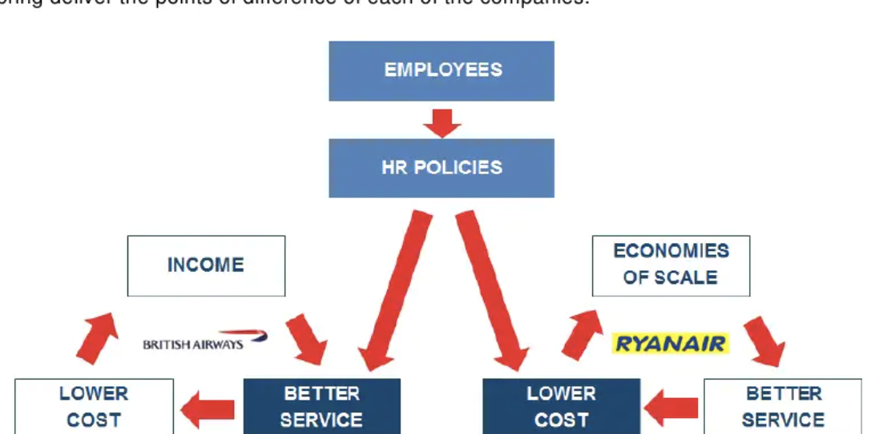
Figure 1.1 Impact of HR policy on Business Strategy
Source: (Baum, 2012)
BA Planning and Development
The planning and development program consists of the following:
1.Recruitment Program.
2.Training Program.
3.Development Program.
Torrington, et al. (2020) states that the workforce planning approach can be interpreted as an essential process in human resource management that is implemented and structured by the organizational strategy and aims to ensure the right number of people with the right skills, the right place and the right time to produce and to achieve the long-term and short-term goals of the company.
“We care about our people and value their contributions to our business. Creating a diverse and inclusive workplace contributes to a sense of wellbeing and belonging, enabling people to thrive. This philosophy is embraced by our leaders, championed by our employee network groups and supported by our relationships with external partners, including Stonewall and the National Forum for Health and WellBeing at Work. “ (British Airways, 2020)
The HR planning model proposed by Armstrong (2014) represented in Figure 1.2 is applied to BA to analyze the human resource planning system.
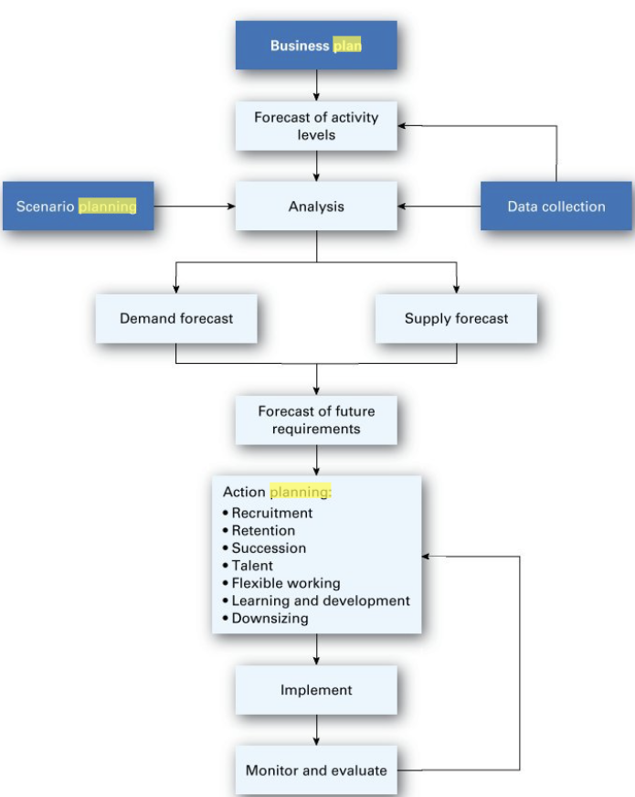

Figure 1.2 HR planning model
Source: (Armstrong, 2014, p. 218)
- Business planning - approved and implemented by the British Airways Board on revenue growth, new markets, and growth.
- Scenario planning - it refers to the establishment of changing elements in the environment that could affect the organization in one way or another, so that by making predictions it could take some safety measures in the future. The company could promote the performance of the environmental scan, in this aspect could include the evaluation of PESTLE factors.
- Data collection- implemented within the workforce plan and can be performed according to the following criteria:
- Qualitative internal data – information about product/market.
- Quantitative internal data – workforce data on turnover, absence, skills etc.
- Qualitative external data- PESTLE analysis.
- Quantitative external data – labour market – skills availability.
British Airways Recruitment program
Recruitment and selection are activities of combining the applicant and the job, which depends primarily on defining and establishing organizational needs, the use of appropriate recruitment methods and efficient methods of selecting the candidate, and last but not least the review, re-evaluation and modifying the recruitment and selection system depending on experience (Pilbeam, 2010).
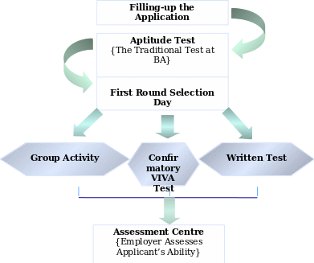
British Airways recruits focus more on analytical and intellectual capabilities, not so much on management experience in this service industry. Figure 1.3 shows the recruitment and selection process implemented by BA.

Figure 1.3 Recruitment and selection process
Source: (British Airways, 2021)
According to British Airways (2021) tends to recruit postgraduate students, for this purpose the company provides students with several development programs, such as Future Leaders Graduate Program with this exciting Internship, but also offers a scholarship to students to become Ambassador of Campus thus promoting British Airways among his colleagues.
Training and Development at British Airways
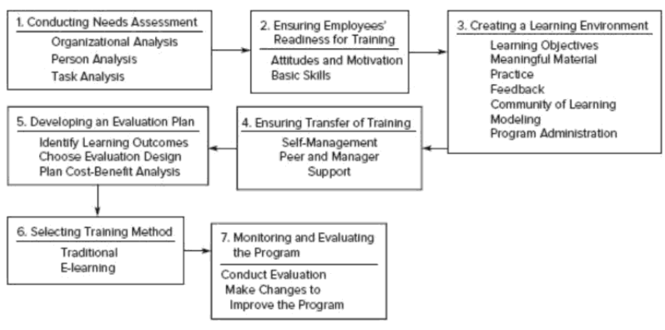
Training refers to the efforts implemented by the company to facilitate the learning and awareness of the competencies, knowledge, skills, behaviour in relation to the role that an employer is going to occupy in the enterprise (Noe & Kodwani, 2018). Compared to training, development involves the company's efforts to help employees develop in the future in order to improve the company's performance (Randhawa, 2007).
Figure 1.4 Training process design
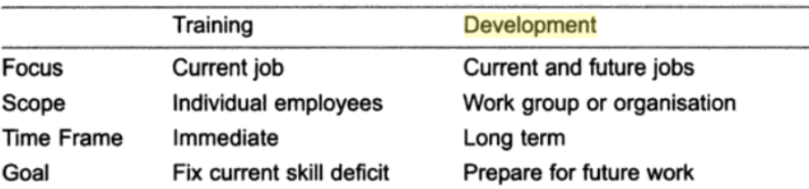
Source: (Noe & Kodwani, 2018, p. 5)

Figure 1.5 Differences between training& development
Source: (Randhawa, 2007)

The Human Resources Management Department of BA has established the following training programs.
- The two-day "Putting People First" program is available to almost 20,000 employees who have contacted customers and had a significant impact.
- A one-week professional training program, "Managing People First," was conducted.
- Implementing an individual learning program based on the principles of open learning, conducted in an MDA program awarded by the University of Bath
- The "Top Flight" program was established to offer a series of "Academies" to students aspiring to an executive position.

Payment and reward of employees
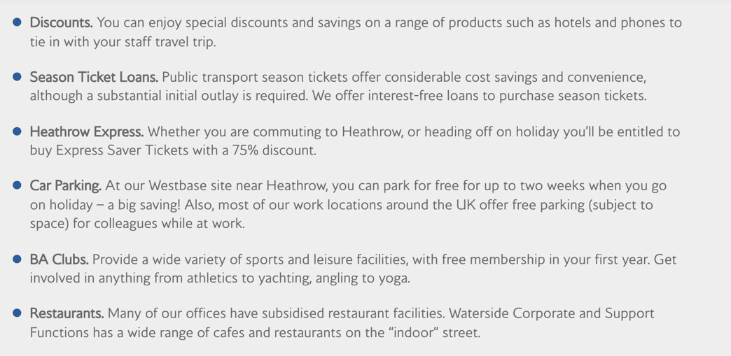
Armstrong (2012) states that reward management is responsible for ensuring the knowledge and reward of the contribution brought by the employees in fulfilling the organizational, departmental and team objectives. British Airways offers competitive salaries in the market that reflect the role of an employee. Therefore, depending on the financial, operational, customer and personal performance, the company offers individual bonuses. The flexible benefit scheme made available to BA employees offers a wide range of benefits, one of which is the market-leading contributory pension (DC), helping them save for the future. The range of benefits the employer can choose from also includes coverage for critical illness, childcare vouchers, work cycle, supplemental life insurance, private health insurance, dental plan and cash plan for healthcare (British Airways, 2021).

Figure 1.5 Other rewards offered by BA
Source: https://careers.ba.com/working-with-us
PESTLE Analysis and Impact on HRM
PESTLE is a tool for analysing external factors that is either an opportunity or a threat to conduct a business in a dynamic environment (Perera, 2017).
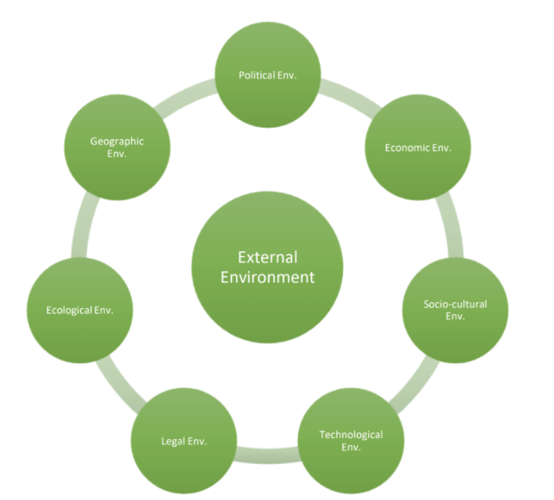

Figure 1.6 PESTLE Model
Source: (Perera, 2017)

- In the case of the HR department within the BA company, we can combine the political factors with the legal ones. Thus, Brexit is an external factor both politically and legally, which has had a major impact on the workforce.

What is Brexit? Brexit impact on the workforce
Brexit represents a referendum by which the United Kingdom has decided to formalize its exit from the European Union, although talks began on June 23, 2016, only on December 21, 2020, the transition took place (Government of Netherlands, 2021).
British Airways often employs flight deck and cabin crew of different nationalities, both from the UK and abroad, including the UE. After Brexit, people who were employed could apply for pre-settled or settled status, and the application deadline was June 30, 2021, (Gov.uk, 2019).
Brexit has had an insignificant impact on personal tax obligations of employees in the airline industry (since the United Kingdom already as comprehensive double taxation treaties throughout the EEA Member States), however, there will be potential significant impact on social security for aircrews (KMPG, 2016).
Also, if British Airways wishes to hire non-EEA or Swiss citizen personnel in accordance with the UK Employment Regulations after 30 June 2021, they must pass the skilled worker test.
According to (Gov.uk, 2020), anyone recruited from outside the UK for the Skilled Worker route needs to provide that:
- they have a job offer from a Home Office licensed sponsor;
- they speak English at the required level;
- the job offer is at the required skill level of RQF3 or above (equivalent to A level);
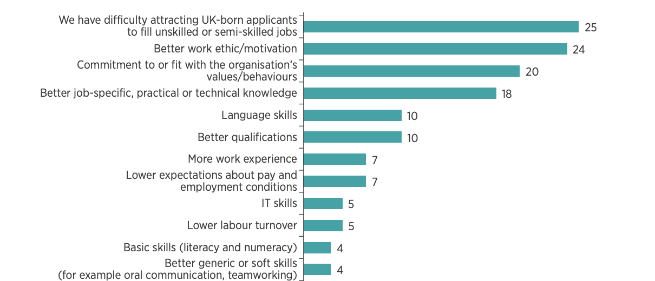
- they’ll be paid at least £25,600 or the ‘going rate’ for the job offer, whichever is higher.
Figure 1.7 Statistics answers why employees choose the EU workforce
Source: (CIPD, 2021)
Since the beginning of 2018, it has been observed that although 72% of employers have a budget formed for the purpose of training, growth, employee development, 55% of them confirmed that leaving the EU had no impact on their investment in growth and development competencies in the workplace, and 20% of them say that Brexit has led them to reduce their training and development budget (CIPD, 2021).

- Economic Factors - Since the country is recovering from the recent economic recession (Covid-19), the growing demand for national labor force, all this is a real challenge for British Airways to retain and hire new labor (IATA, 2020). British Airways, in order to keep employees during the pandemic, have accessed the Coronavirus Job Retention Scheme (CJRS), offered by the government in order to support the business, by protecting and retaining employees. During the Covid-19 pandemic, according to (Parliament UK, 2020), more than half of British Airways staff, exactly 22,000 were furloughed as part of the CJRS.
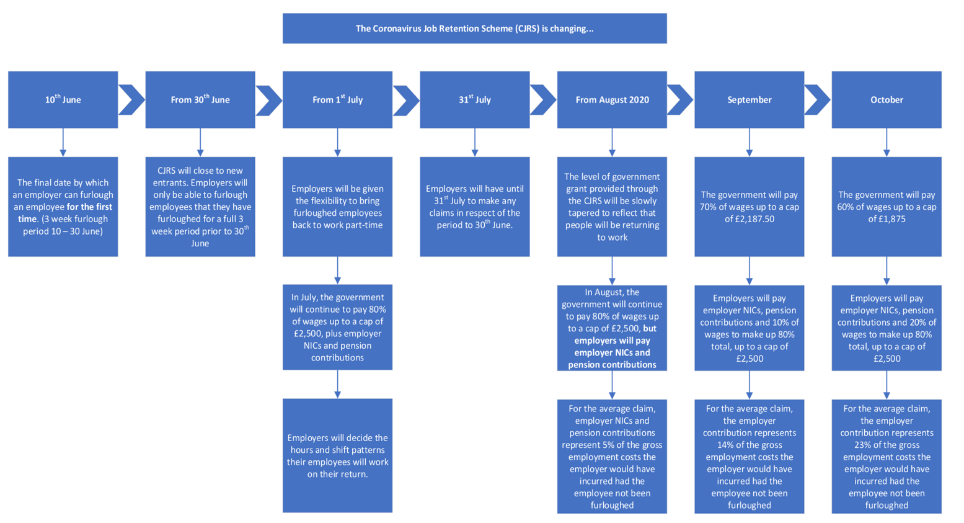
Figure 1.8 shows the operation and implementation of CJRS.

Figure 1.8 Coronavirus Job Retention Scheme
Source: https://workaroundhr.co.uk/download/covid-19-furlough-phase-out/

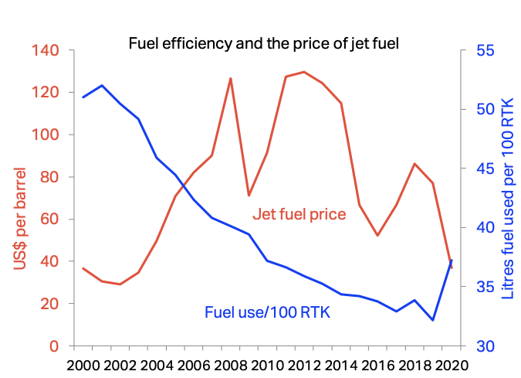
Also, rising fuel prices, as shown in Figure 1.9, have a significant economic impact on the airline industry, as during this period of pandemic, the company does not generate much profit, and this increase influences the promotion of salaries and staff development.

Figure 1.9 Fuel efficiency and the price of jet fuel
Source: (IATA, 2020)

- Social Factors - According to the World Health Organization (2020), coronavirus, named Covid -19 is an infectious disease caused by the SARS-CoV-2 virus.
Wheatley, et.al., (2021) states that in February 2021, more than 230 countries in the world were affected by the Covid-19 pandemic crisis which caused 110 million causes of disease and 2.5 million fatalities. Thus, all these situations forced the organizations to introduce remote work programs to maintain the social distance at work. British Airways allowed the staff to carry out their professional activity both in the headquarters and at home. Accordingly to, (BBC News, 2020) BA, part of the IAG group of airlines, which owns Iberia and Aer Lingus, has cut more than 10,000 jobs, focusing on financial resources from shareholders to support them financially. However, (Farrell, 2020), confirms that not all businesses can operate permanently from the home-work system, and many employees, such as BA employees, are required to return to work physically.
Thus, in order to protect the life and health of its employees, British Airways has introduced on-board insurance measures, such as:
- Face masks.
- Anti-bacterial wipes.
- Cleaning nose to tail- employees disinfect key surfaces after each flight, cleaning the plane from nose to tail.
- Cleaning your area - after each flight they ensure the cleaning of the seat, of the seat templates of the tray table.
- Refreshed air- with the help of HEPA filters, which remove microscopic bacteria and groups of viruses in a proportion of over 99.9%, the air is refreshed in the flight cabins every 2 to 3 minutes.
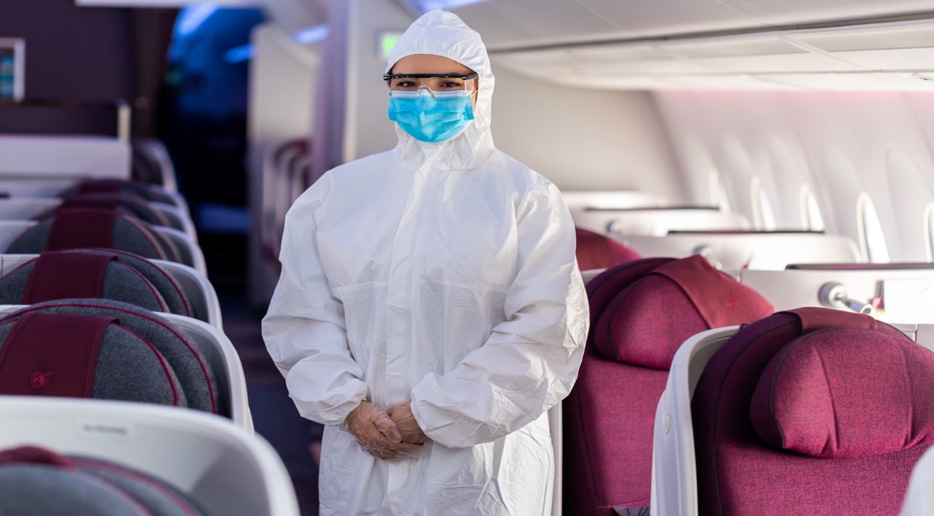
Also, with the start of flights after the March lockdown, flight deck employees had to wear appropriate PPE, as shown in Figure 1.10.

Figure 1.10 PPE suit for Flights Crew employees
Source: (British Airways, 2021)

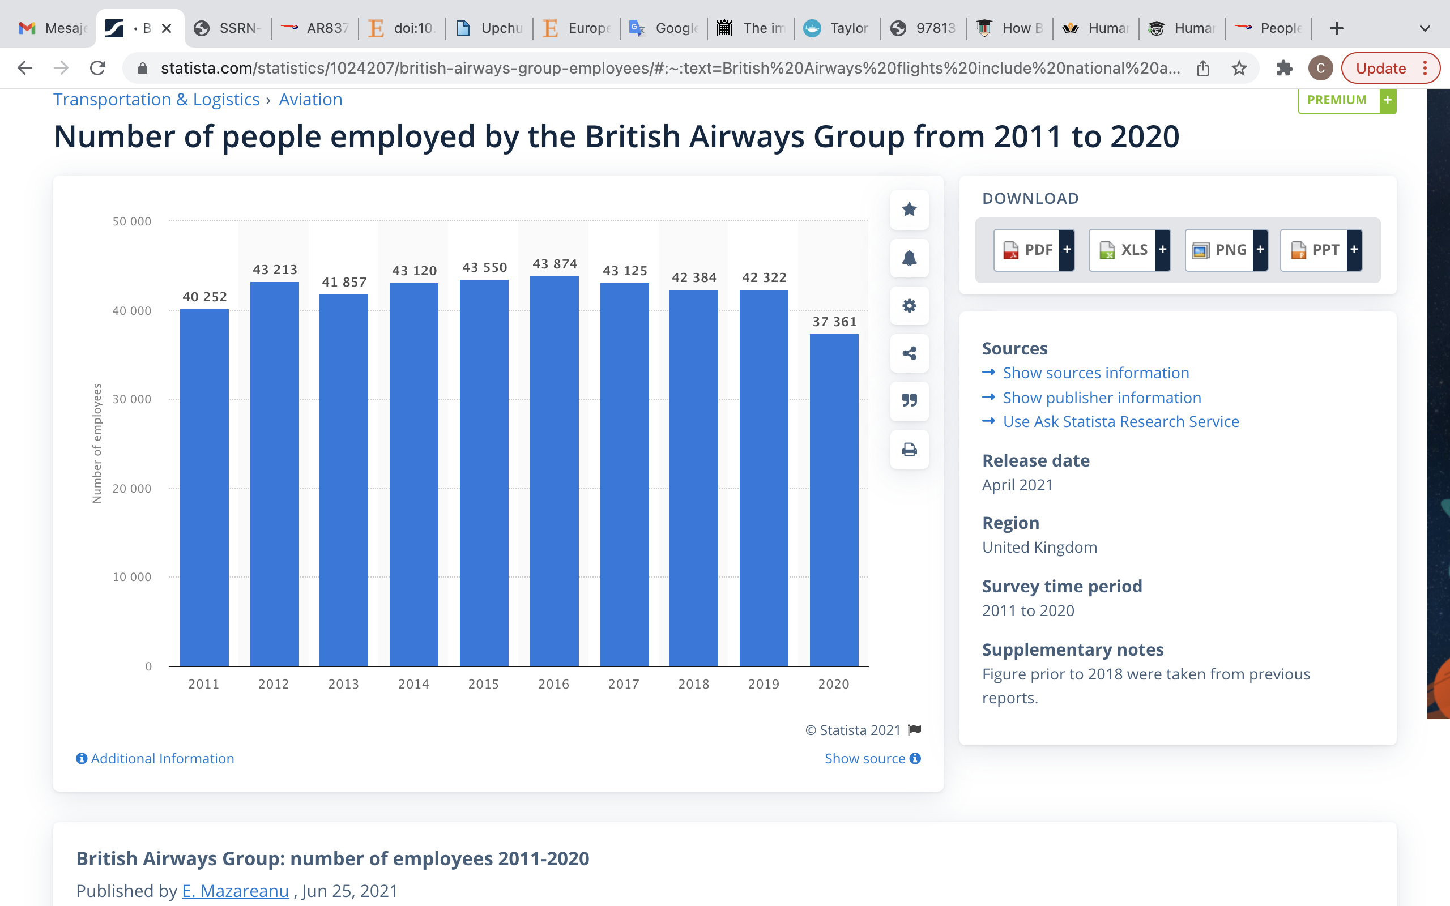
Covid-19 also had an impact on hiring people, in Figure 1.11 is the number of employees recruited by BA in the period 2019-2020, where there is a decrease in employees, due to the Covid-19 pandemic, compared to other years.
Figure 1.11 British Airways number of employees 2011-2020
Source: www.Statista.com

- Technological Factors - The development of technologies has changed the way human resources are communicated and managed. Therefore, after the implementation of the Human Resources Information System (HRIS), employees benefit from much easier access to information on payroll, benefits, available training, employee manuals and deductions in a convenient way (Verhulst & DeCenzo, 2021). Therefore, BA employees can access the information provided by HR through a Software as a Service (SaaS), which is accessed through a web browser, which allows access wherever there is an internet connection. British Airways employees access the my.baplc.com website via a browser, where they will use a log-in and a password to access their profile.
Covid-19 also had a negative impact on technological factors, as employees who performed remote work were concerned with protecting cyber security data, the Human Resource department being concerned about the vulnerability of this data.

- Environmental Factors - In 2022, British Airways wants to introduce sustainable aviation fuel, which will be designed from sustainable sources of waste, such as used vegetable oils, which could be blended with regular aviation fuel or processed with refined raw materials (Ainsworth, 2021). The introduction of this type of fuel will allow them to reduce carbon emissions by up to 80%, but also to reduce air pollution.
BBC News UK (2020) states that, a former British Airways employee launched a houseplant business during the lockdown. Therefore, the former pilot undertakes to plant 10 trees for each order received.

Campaign #POUDTOBAWOMAN
In 2019 British Airways introduced the #PROUDTOBAWOMAN campaign in which over 100 students were invited to the Global Learning Academy to inspire them to become pilots (British Airways, 2019). Also, in order to promote and help students between the ages of 18 and 30 to understand more about an aviation career, they had the chance to meet female airline pilots, as well as experience piloting an aircraft from one among British Airways flight simulators.

Figure 1.12 Employees Male & Female working for BA
Source: (British Airways, 2019)

Conclusion
This report focused on the delimitation and identification of the present and future impact of changes in the external environment that influence human resource strategies in order to ensure the increase of the company's performance through its employees.
This report focused on the delimitation and identification of the present and future impact of changes in the external environment that influence human resource strategies in order to ensure the increase of the company's performance through its employees. However, the company, with the help of the British government, tried in various ways, such as Coronavirus Retention Job Scheme, to reduce the resignation of employees, minimizing this. Covid-19 not only confronted the company with financial challenges, but also encouraged the Human Resources department to focus much more on employees with health problems, which would be a vulnerable source of illness with the new virus. In order to prevent situations that would endanger the lives and safety of employees, the Human Resource department focuses on risk management, which aims to study all threats and vulnerabilities, such as safety hazards and how they affect each individual employee (Rideout, 2014). Therefore, BA has implemented a series of in-flight actions and regulations from providing properly equipped cab employees to ventilation and surface disinfection processes.
Brexit is another legal- political factor that has influenced the company's development. As a result, the UK's decision to leave the EU had a negative effect on the demand for labor, as many people in the labor force had to go back to their homeland because they did not have the necessary documents to work. British Airways has not yet felt the impact of Brexit, as the pandemic crisis has reduced the number of employees, but once air travel resumes, the consequences of Brexit will be felt.
External factors cannot be controlled by the company, but the existence of an efficient and transparent Human Resources system, which will put the needs and well-being of employees above turnover, by investing in staff development, in recruiting young talents, will increase the performance of the company and its trust on the part of consumers.

Recommendation
- In order to attract foreign staff and young talent from abroad, BA could apply for UK visa sponsorship for employers, according to (Gov.uk, 2020), sponsor license is required when the company wishes to hire foreign personnel who have arrived in the UK after 31 December 2020.
- To prevent the virus from spreading, it could hire and train young and healthy people who are less prone to getting sick with the Covid-19 virus, who could always be the flight attendant team, and older staff could be as safe as possible from contact with other consumers.
- The company could implement a digitalized system through which every month, anonymous employers would indicate about the concerns and stress they have during work and how they would see the solution of these problems.

Bibliography
Wilton, N., 2016. An Introduction to Human Resource Management. 3rd ed. London: SAGE Publications Inc..
Rao, V. S. P., 2010. Human Resource Managemennt. 3rd ed. New Delhi: Excel Books.
Armstrong, M., 2014. Armstrong's handbook of human resource management practice. 13th ed. s.l.:Kogan Page.
Alvesson, M., 2009. Critical perspectives on strategic HRM. In: J. Storey, P. M. Wright & D. Ulrich, eds. The Routledge Companion to Strategic Human Resource Management. Abingdon: Routledge, pp. 52-67.
The Editors of Encyclopaedia Britannica , 2019. Britannica. [Online]
Available at: https://www.britannica.com/topic/British-Airways-PLC
[Accessed 10 December 2021].
Bertillo, D. J. B. & Salando, D. J. B., 2013. Human Resource Management Practices in an Airline Industry: The British Airways Global Perspective. [Online]
Available at: Bertillo, Julius B. and Salando, Josefina, Human Resource Management Practices in an Airline Industry: The British Airways Global Perspective (July 12, 2013). Available at SSRN: https://ssrn.com/abstract=2292797 or http://dx.doi.org/10.2139/ssrn.2292797
[Accessed 10 December 2021].
Mazareanu , E., 2021. Statista. [Online]
Available at: https://www.statista.com/statistics/1024207/british-airways-group-employees/#:~:text=British%20Airways%20flights%20include%20national%20and%20international%20destinations%2C,2019%2C%20the%20Group%20was%20employer%20to%2042%2C322%20people.
[Accessed 10 December 2021].
Fazey, M., 2020. Human Resource Policy: Connecting Strategy with Real-World Practice. 1st ed. London: Anthem Press.
British Airways, 2009. British Airways 2008/09 Annual Report and Accounts, London: British Airways.
British Airways, 2020. British Airways-People. [Online]
Available at: https://www.britishairways.com/en-gb/information/about-ba/ba-better-world/people
[Accessed 10 December 2021].
Baum, T., 2012. Ryan Air vs British Airways HRM policies & strategy, Glasgow: Strathclyde Business School.
Torrington, D., Hall, L. & Atkinson, C., 2020. Human Resource Management. 11th ed. Harlow: Pearson Education, Limited.
Pilbeam, S., 2010. People resourcing and talent planning: HRM in practice. 4th ed. Harlow: Pearson Prentice Hall.
British Airways, 2021. British Airways. [Online]
Available at: https://careers.ba.com/graduates-internships
[Accessed 10 December 2021].
Anon., n.d. s.l.:s.n.
Noe, R. & Kodwani, A. D., 2018. Employee Training and Development. 7th ed. New York: McGraw-Hill Education.
Randhawa, G., 2007. Human Resource Management. 1st ed. New Delhi: Atlantic Publishers & Dist.
Armstrong, M., 2012. Armstrong's Handbook of Reward Management Practice: Improving Performance Through Reward. 4th ed. Harlow: Kogan Page Publishers.
Perera, R., 2017. The PESTLE Analysis. s.l.:Nerdynaut.
Gov.uk, 2019. Gov.uk. [Online]
Available at: https://www.gov.uk/settled-status-eu-citizens-families/applying-for-settled-status
[Accessed 10 December 2021].
KMPG, 2016. Brexit: implications for airlines, London: KPMG.
Gov.uk, 2020. Recruiting people from outside the UK, London: Gov.uk.
Government of Netherlands, 2021. What is Brexit?. [Online]
Available at: https://www.government.nl/topics/brexit/question-and-answer/what-is-brexit
[Accessed 10 December 2021].
CIPD, 2021. CIPD. [Online]
Available at: https://www.cipd.co.uk/knowledge/brexit-hub/workforce-trends
[Accessed 2021 December 2021].
IATA, 2020. Economic Per formance of the Airline Industry. [Online]
Available at: https://www.iata.org/en/iata-repository/publications/economic-reports/airline-industry-economic-performance-june-2020-report
[Accessed 11 December 2021].
Parliament UK, 2020. Parliament UK. [Online]
Available at: https://publications.parliament.uk/pa/cm5801/cmselect/cmtrans/268/26808.htm#footnote-055
[Accessed December 11 2021].
Worlg Health Organization, 2020. World Health Organization. [Online]
Available at: https://www.who.int/health-topics/coronavirus#tab=tab_1
[Accessed 11 December 2021].
Wheatley, D., Hardill, I. & Buglass, S., 2021. Handbook of Research Remote Work and Work Well- Bing in the Post Covid-19 Era. 1st ed. s.l.:IGI Global.
BBC News, 2020. BBC News. [Online]
Available at: https://www.bbc.co.uk/news/business-56451641
[Accessed 11 December 2021].
Farrell, J., 2020. Moving Back to the Future: Project Management Best Practices for a COVID-19. 1st ed. s.l.:s.n.
Verhulst, S. L. & DeCenzo, D. A., 2021. Fundamentals of Human Resource Management. 14th ed. New Jersey: Wiley.
Ainsworth, S., 2021. Happy Headlines. [Online]
Available at: https://www.happy-headlines.com/blog-posts/british-airways-to-introduce-sustainable-aviation-fuel-in-2022
[Accessed 11 December 2021].
BBC News, 2020. BBC News. [Online]
Available at: https://www.bbc.co.uk/news/uk-england-sussex-58057351
[Accessed 11 December 2021].
British Airways, 2019. Media Center BA. [Online]
Available at: https://mediacentre.britishairways.com/pressrelease/details/86/0/10816
[Accessed 11 December 2021].
Rideout, H., 2014. Employee Risk Management. 1st ed. London: Kogan Page Publishers.

