ECIE4012
The Principles of Learning and Teaching

Portfolio

Student Number:2414600
Student name: Sarah Stanley

Blog 1
Demonstrate your understanding of a theory of learning from the following list: Bruner, Skinner, Piaget, Vygotsky, Froebel

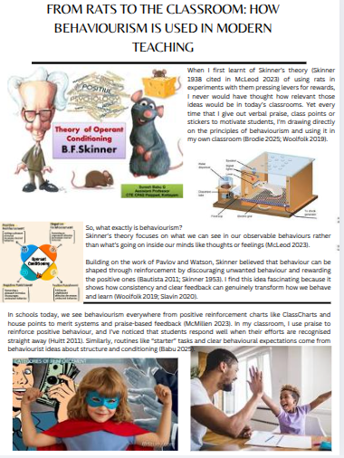

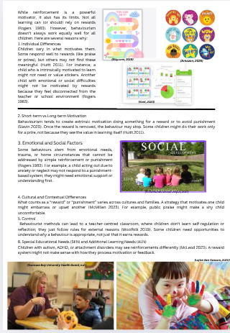


Blog 1: Reference list
Amazon (2025). Amazon.co.uk: Low Prices in Electronics, Books, Sports Equipment & more. [online] Amazon.co.uk. Available at: https://www.amazon.co.uk [Accessed 10 Nov. 2025].
Babu, S. (2025) Theory of Operant Conditioning - B F Skinner. [online] SlideShare. Available at: https://www.slideshare.net/slideshow/theory-of-operant-conditioning-b-f-skinner/232712559 [Accessed 4 November 2025].
Bautista, P. (2011) Operant Conditioning in Psychology: Definition, Theory & Examples. [online] Study.com. Available at: https://study.com/academy/lesson/operant-conditioning.html [Accessed 4 November 2025].
Brodie, K. (2025) Operant Conditioning: B.F. Skinner’s Theory & Examples. [online] Early Years TV. Available at: https://www.earlyyears.tv/operant-conditioning/ [Accessed 4 November 2025].
Huitt, W. (2011) Motivation to learn: An overview. Educational Psychology Interactive. Valdosta State University. Available at: http://www.edpsycinteractive.org/topics/motivation/motivate.html [Accessed 4 November 2025].
Kent, A.S. (2023). ClassCharts. [online] Aylesford School, Kent | Courage Confidence Character. Available at: https://www.aylesford.kent.sch.uk/info/parents/classcharts [Accessed 10 Nov. 2025].
Lojien Ben Gassem (2020). Keeping special needs children involved during lockdown. [online] Arab News. Available at: https://www.arabnews.com/node/1666581/saudi-arabia [Accessed 10 Nov. 2025].
McLeod, S. (2023) B.F. Skinner: Operant conditioning. [online] Simply Psychology. Available at: https://www.simplypsychology.org/operant-conditioning.html [Accessed 4 November 2025].
McMillen, M. (2023) Operant Conditioning: What It Is and How It Works. [online] WebMD. Available at: https://www.webmd.com/mental-health/what-is-operant-conditioning [Accessed 4 November 2025].
Rogers, C.R. (1983) Freedom to learn for the 80’s. Columbus, OH: Charles Merrill.
Skinner, B.F. (1953) Science and human behavior. New York: Macmillan.
Slavin, R.E. (2020) Educational psychology: Theory and practice. 13th edn. London: Pearson.
St Edmunds school Jaipur. (2017). Essential Factors that Affect the Social And Emotional Development Among Students. [online] Available at: https://saintedmundjaipur.wordpress.com/2017/04/26/essential-factors-that-affect-the-social-and-emotional-development-among-students/ [Accessed 10 Nov. 2025].
Swansea Bay University Health Board. (n.d.). Additional Learning Needs. [online] Available at: https://sbuhb.nhs.wales/children-and-young-people/additional-learning-needs/ [Accessed 10 Nov. 2025].
Vigglegiggle (n.d.) Skinner’s Research. [online] Available at: https://vigglegiggle.weebly.com/skinners-research.html [Accessed 4 November 2025].
Woolfolk, A. (2019) Educational psychology. 14th edn. London: Pearson Education.

Blog 2
Demonstrate your understanding of a theory of learning from the following list:
Bruner, Skinner, Piaget, Vygotsky, Froebel. The theory must be different to Blog 1.
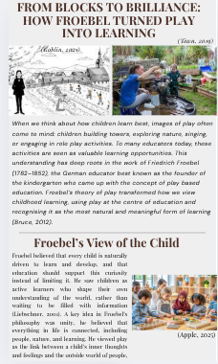

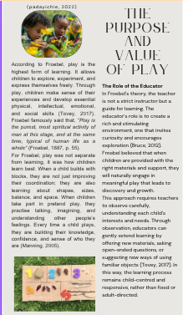

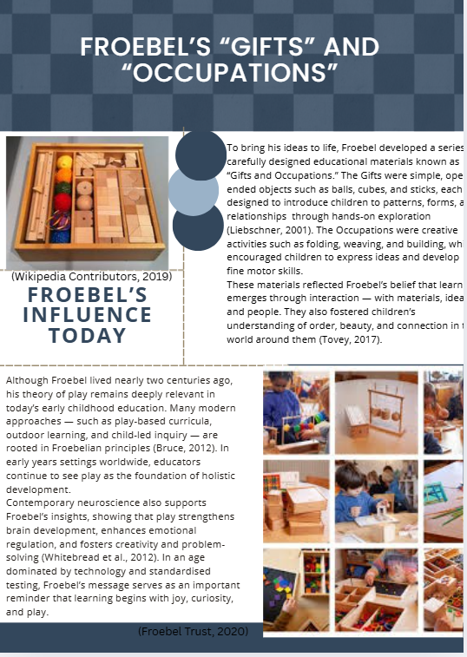

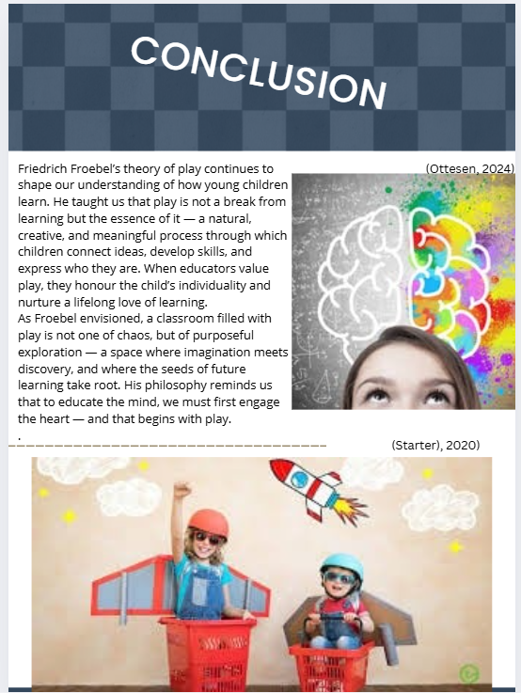

Blog 2: Reference list

Apple, X. (2025). muslim kids playing with building blocks in kindergarten or nursery at school. [online] Vecteezy. Available at: https://www.vecteezy.com/photo/48505938-muslim-kids-playing-with-building-blocks-in-kindergarten-or-nursery-at-school [Accessed 12 Nov. 2025].
Bruce, T. (2012). Early childhood education (4th ed.). Hodder Education.
Froebel, F. (1887). The education of man (W. N. Hailmann, Trans.). D. Appleton and Company. (Original work published 1826)
Liebschner, J. (2001). A child’s work: Freedom and guidance in Froebel’s educational theory and practice. Lutterworth Press.
Manning, J. P. (2005). Rediscovering Froebel: A call to re-examine his life & gifts. Early Childhood Education Journal, 32(6), 371–376. https://doi.org/10.1007/s10643-005-0004-8
Ottesen, J. (2024). Developing Imagination and Creativity in All Students. [online] edWeb. Available at: https://home.edweb.net/developing-imagination-and-creativity/ [Accessed 29 Dec. 2025].

padayichie, K. (2022). The Importance of Outdoor Learning. [online] www.structural-learning.com. Available at: https://www.structural-learning.com/post/outdoor-learning.
Tovey, H. (2017). Bringing the Froebel approach to your early years practice (2nd ed.). Routledge. Whitebread, D., Basilio, M., Kuvalja, M., & Verma, M. (2012). The importance of play: A report on the value of children’s play with a series of policy recommendations. Toy Industries of Europe.

Koblin, J. (2021). Froebel’s Kindergarten: The Origins of Early Childhood Education – Sprouts — Free Videos for Schools and Learning. [online] Sprouts. Available at: https://sproutsschools.com/froebels-kindergarten-the-origins-of-early-childhood-education/.
Starter), E. (Teach (2020). The Benefits of Imaginative Play in the Classroom. [online] Teach Starter. Available at: https://www.teachstarter.com/us/blog/the-benefits-of-imaginative-play-in-the-classroom-us/ [Accessed 29 Dec. 2025].

Thefroebelpartnership.co.uk. (2022). The Froebelian adult outdoors | The Froebel Partnership. [online] Available at: https://thefroebelpartnership.co.uk/the-froebelian-adult-outdoors/ [Accessed 11 Nov. 2025].

Blog 3
Identify, discuss, and evaluate the theoretical approaches to learning linked to your theories from Blogs 1 and 2.

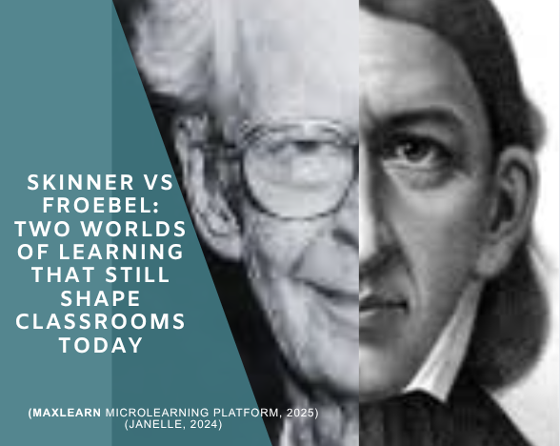

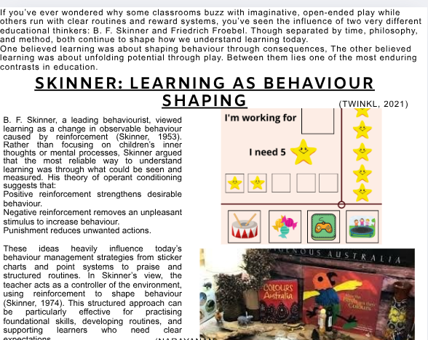

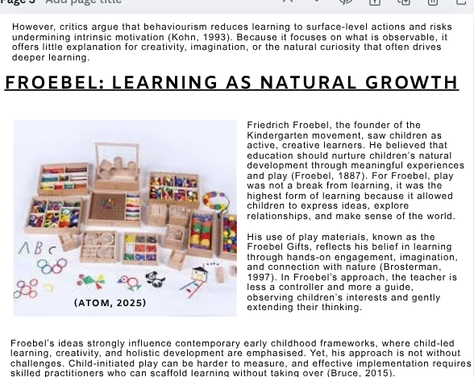

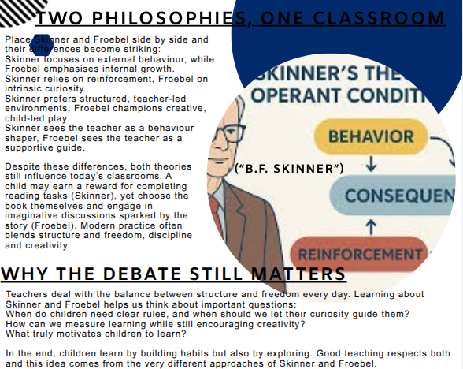

Blog 3: Reference list

Atom (2025). Test.com. [online] Lblackfriday.com. Available at: https://www.lblackfriday.com/?ggcid=744713 [Accessed 1 Dec. 2025].
“B.F. Skinner.” Historica Wiki, historica.fandom.com/wiki/B.F._Skinner.
Brosterman, N. (1997) Inventing Kindergarten. New York: Harry N. Abrams.
Bruce, T. (2015) Early Childhood Education. 5th edn. London: Hodder Education.
Froebel, F. (1887) The Education of Man. New York: Appleton.
Janelle (2024). My Teaching Cupboard. [online] My Teaching Cupboard. Available at: https://www.myteachingcupboard.com/blog/froebel-theory-of-play [Accessed 1 Dec. 2025].
Kohn, A. (1993) Punished by Rewards. Boston: Houghton Mifflin.
MaxLearn Microlearning Platform (2025). Why Skinner’s Operant Conditioning Still Matters in Today’s Learning Ecosystem. [online] Medium. Available at: https://maxlearn-microlearning.medium.com/why-skinners-operant-conditioning-still-matters-in-today-s-learning-ecosystem-31e1e1b4a4c2
Narayanan, K. (2020). Positive Reinforcement Examples, Strategies, and Benefits. [online] Avaz Inc. Available at: https://www.avazapp.com/blog/positive-reinforcement-examples-strategies-and-benefits/ [Accessed 1 Dec. 2025].
Skinner, B. F. (1953) Science and Human Behavior. New York: Macmillan.
Skinner, B. F. (1974) About Behaviorism. New York: Vintage.
Twinkl (2021). What is Froebel’s Play Theory? [online] Twinkl.co.uk. Available at: https://www.twinkl.co.uk/teaching-wiki/froebels-play-theory [Accessed 1 Dec. 2025].

Blog 4
Draw on experiences from your own setting to identify resources and strategies used to support effective teaching and learning, linking back to your chosen theories in Blogs 1 & 2

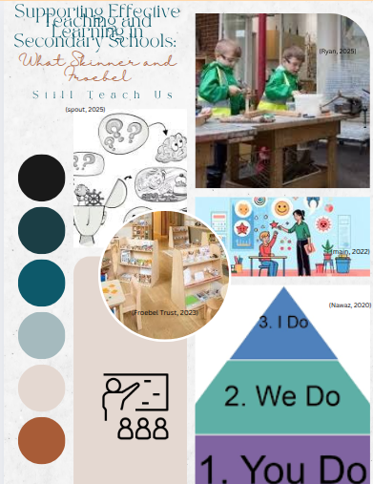
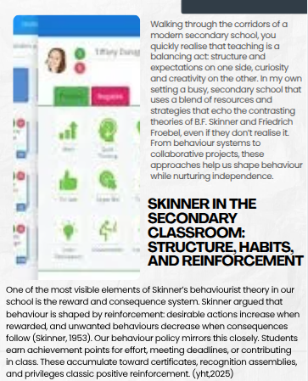

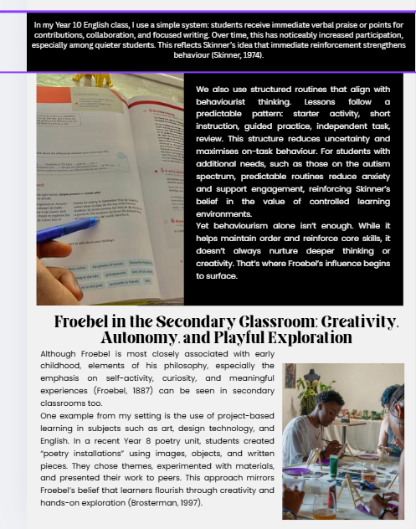

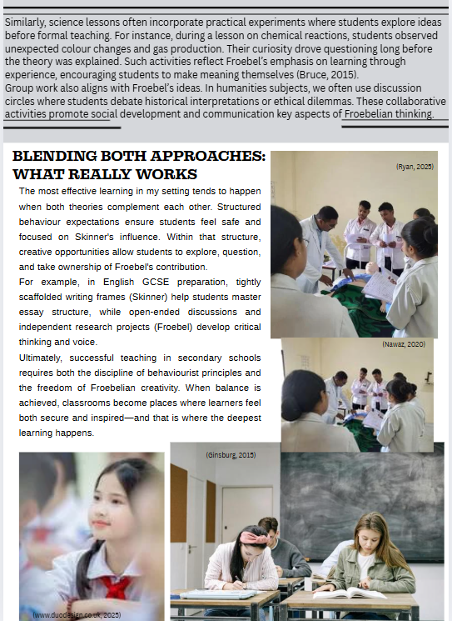

Blog 4: Reference list

Brosterman, N. (1997) Inventing Kindergarten. New York: Harry N. Abrams.
Bruce, T. (2015) Early Childhood Education. 5th edn. London: Hodder Education.
Froebel, F. (1887) The Education of Man. New York: D. Appleton & Company.
Froebel Trust. (2023). Froebelian practice in the primary school. [online] Available at: https://www.froebel.org.uk/news/froebelian-practice-in-the-primary-school [Accessed 25 Nov. 2025].
Ginsburg, D. (2015). Rapid Release of Responsibility: You Do, We Do, I Do (Opinion). [online] Education Week. Available at: https://www.edweek.org/teaching-learning/opinion-rapid-release-of-responsibility-you-do-we-do-i-do/2015/01 [Accessed 25 Nov. 2025].
main, paul (2022). Operant Conditioning. [online] www.structural-learning.com. Available at: https://www.structural-learning.com/post/operant-conditioning [Accessed 25 Nov. 2025].
Nawaz, A. (2020). Class Charts | University of Birmingham School. [online] University of Birmingham School. Available at: https://uobschool.org.uk/class-charts/ [Accessed 25 Nov. 2025].
Rachel (n.d.). Using Class Dojo for Behavior Management. [online] All About 3rd Grade. Available at: https://www.allabout3rdgrade.com/2016/09/using-class-dojo-for-behavior-management_15.html [Accessed 25 Nov. 2025].
Ryan, P. (2025). Friedrich Froebel: His Principles, Play Theory, and Legacy in Education. [online] Early Excellence. Available at: https://earlyexcellence.com/practice-and-pedagogy/friedrich-froebel-theory/.
Skinner, B.F. (1953) Science and Human Behavior. New York: Macmillan.
Skinner, B.F. (1974) About Behaviorism. New York: Vintage Books.
www.duodesign.co.uk (2025). Hillside High School - Class Charts for Pupils. [online] Hillsidehigh.co.uk. Available at: https://www.hillsidehigh.co.uk/pupils/i-ndustrial-action-28th-february---work-for-pupils/ [Accessed 25 Nov. 2025].

