


Web Design

^{[1]}
School of Applied Computing | Title of Coursework  Web Design | Code A4023
Module
BSc./HND Computing

Student:  Theresa Darzins  No 1909721 |  | Lecturer: Gareth Jones  Date: 5th March 2021

Contents
1.0 INTRODUCTION 1
2.0 REQUIREMENTS 2
2.1 Purpose 2
2.2 Subject Matter 2
2.3 Target Audience/Relevance 2
3.0 IMPLEMENTATION 3
3.1 Screenshots of The Persian Carpet Shop (p.t.o.) 3
3.1.1 Home 4
3.1.2 Traditional 5
3.1.3 Tribal 6
3.1.4 Silk 7
3.1.5 Contact 8
3.1.6 Shopping Cart 9
3.2 Validation 10
3.2.3 Error Codes 10
4.0 EVALUATION 11
4.1 Usability/Accessibility/Search Engine Optimisation Studies 11
4.1.1 Usability 11
4.1.2 Accessibility 13
4.1.3 Search Engine Optimisation 16
4.2 Evaluate Own Website 21
4.2.1 Usefulness (Usability and Utility) 21
4.2.2 Search Engine Optimisation (SEO) 21
4.2.3 Accessibility 21
5.0 REFERENCES 22
5.1 For the Report 22
5.2 For the Website 23

Table 1 – Error Codes and their Remedies 10

Figure 1 Home Page 4
Figure 2 Traditional Page 5
Figure 3 Tribal Page 6
Figure 4 Silk Page 7
Figure 5 Contact Page 8
Figure 6 Shopping Cart Page 9
Figure 7 Mental Model of Navigation of Website 11
Figure 8 Weighting Method for Websites - Algorithm to Show No. of Innerlinks they Contain 16
Figure 9 Algorithm to show Analysis and Implementation of Innerlinking to increase page weight and attract more visitors 17
Figure 10 Semantic Mark Up (SMAF) 19
Figure 11 SMAF Analyser 19
Figure 12 SMAF Extracts Key Words to Enhance Websites Searchability 20

INTRODUCTION

This report sets out to detail the considerations involved in designing and hand coding a website whilst adhering to the standards required.
It is split into 3 sections:
  - Requirements (Chapter 2)
- Purpose
- Subject Matter
- Target Audience

  - Implementation (Chapter 3)
- Screenshots
- Validation
- Error Codes

  - Evaluation (Chapter 4)
- Usability/Accessibility/Search Engine Optimisation Studies
- Evaluation

REQUIREMENTS

The website is to sell Persian Carpets, and display the different styles. Showcasing the rugs and their towns of origin, and giving a brief history of their evolution.
- The traditional wool carpets are extremely hardwearing, as well as works of art, that increase in value with age.

- The Tribal rugs or Gilims (pronounced ‘Gileem’ or ‘Kileem’) are at the other end of the price scale, being more affordable, but still beautiful rugs made by nomadic tribes. Their patterns are unique as the weavers invent their own patterns (unlike those of the towns who use ‘cartoons’ to follow a pattern).

- The silk carpets are the most prized as they are the finely woven and most difficult/time consuming to make. The patterns are sharper and they are very soft underfoot.

Purpose

To entice the reader to visit the showroom and purchase a handmade rug/carpet.

Subject Matter

- Persian Carpets and how the finer the weave, the more intricate designs are (and expensive).

- Although the tribal rugs are nearly as beautiful but more affordable – and fashionable.

Target Audience/Relevance

People who appreciate hand-made art, and like rugs that will last a lifetime, as they don’t wear out easily, and increase in value with age and wear.

IMPLEMENTATION

Screenshots of The Persian Carpet Shop (p.t.o.)

Home
Figure 1 Home Page
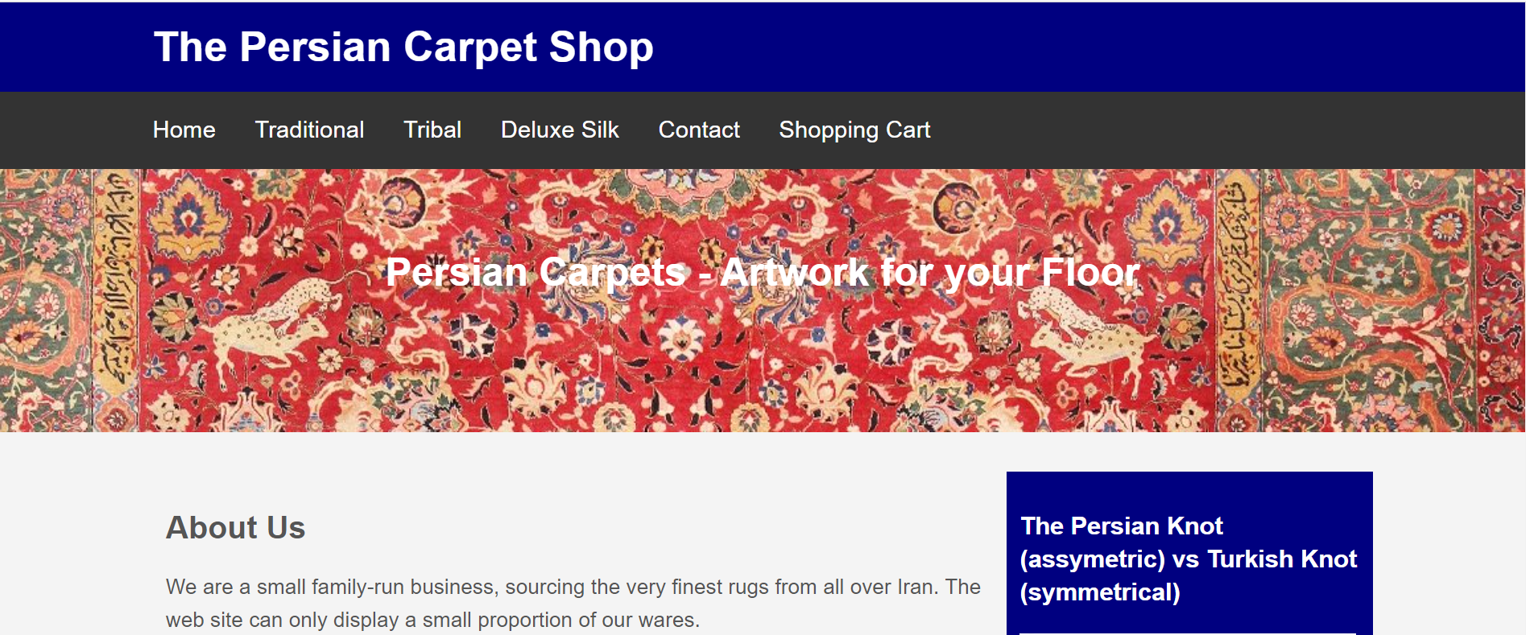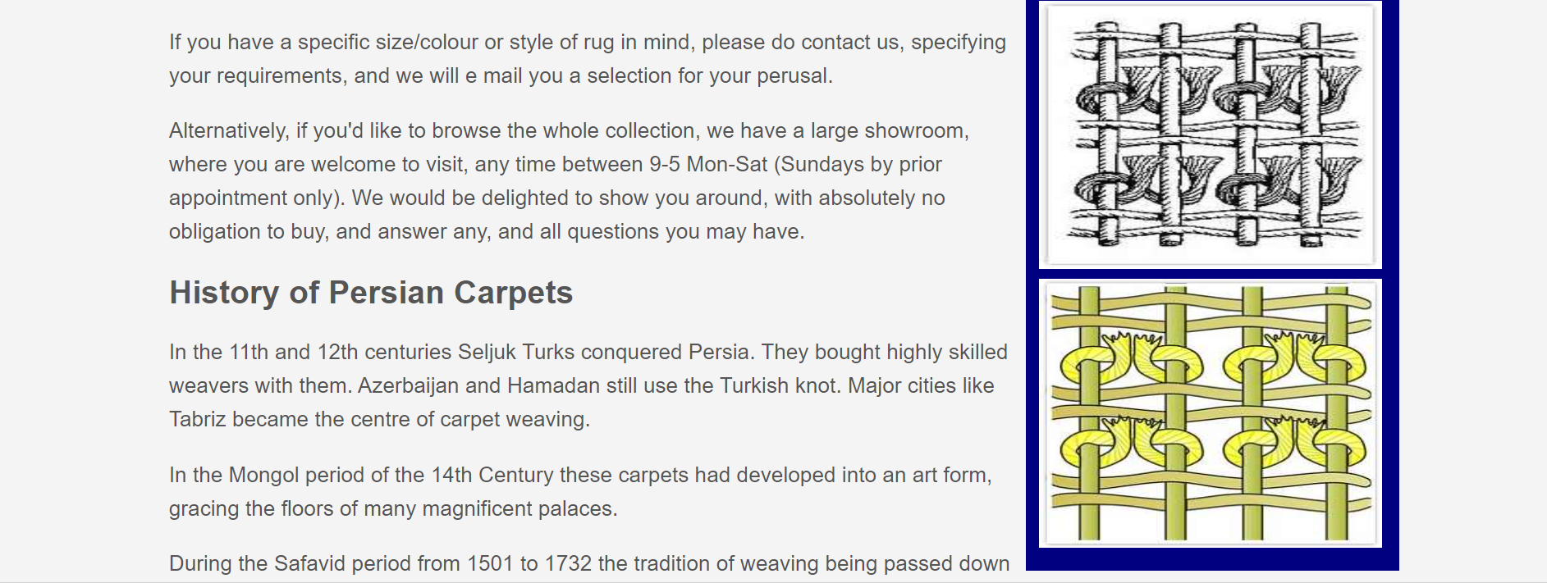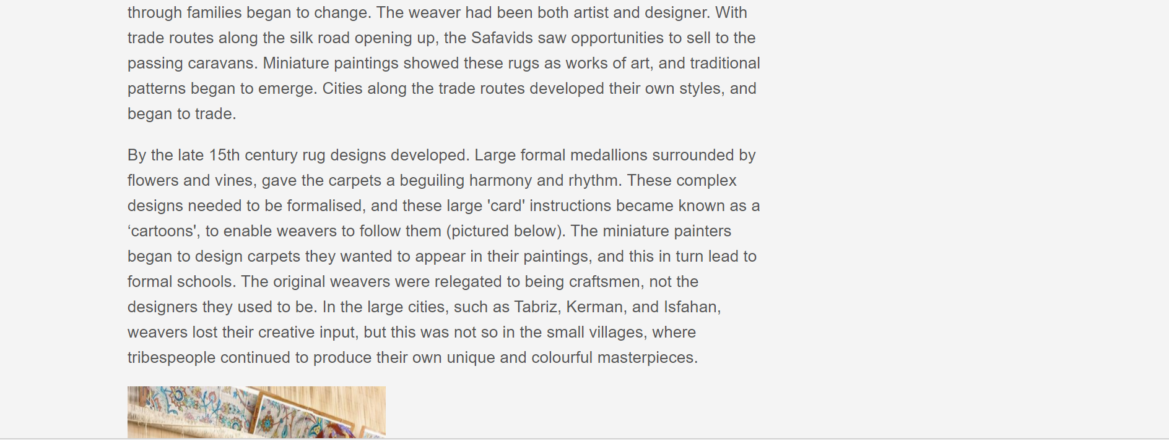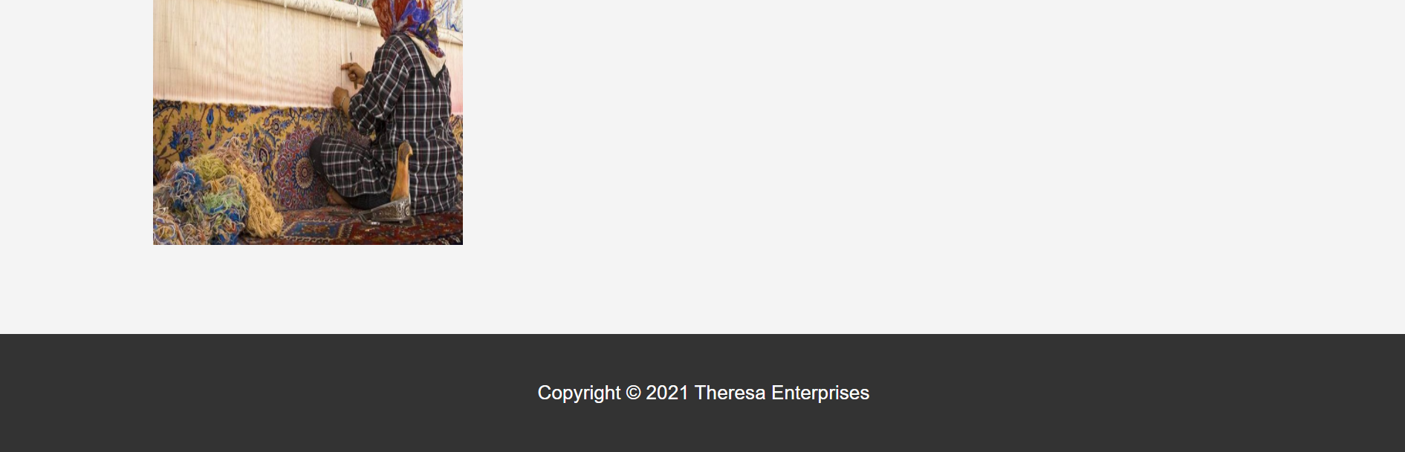

3.1.2 Traditional
Figure 2 Traditional Page

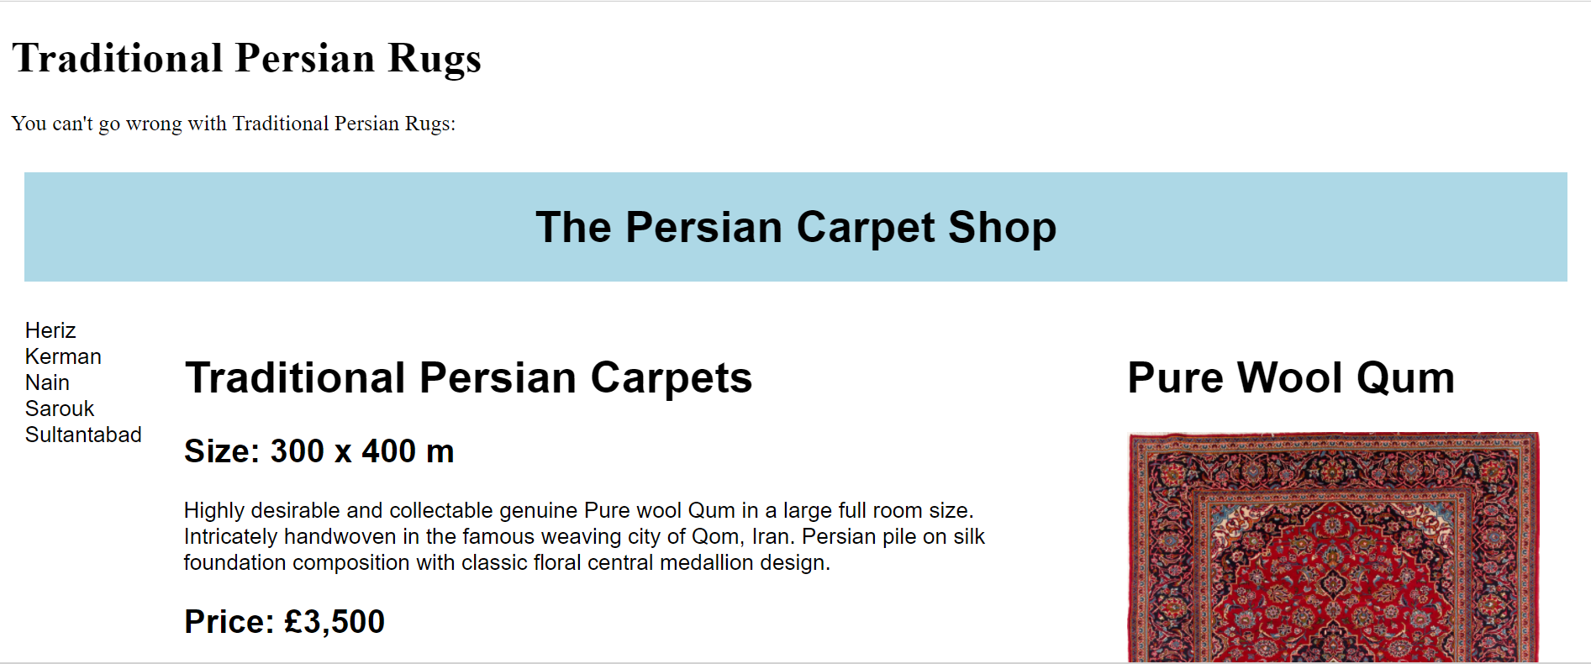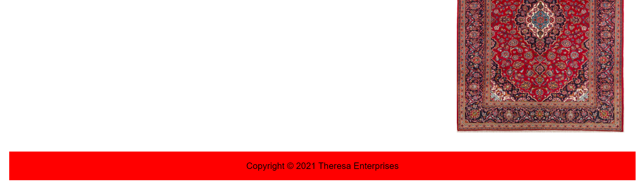

Tribal
Figure 3 Tribal Page
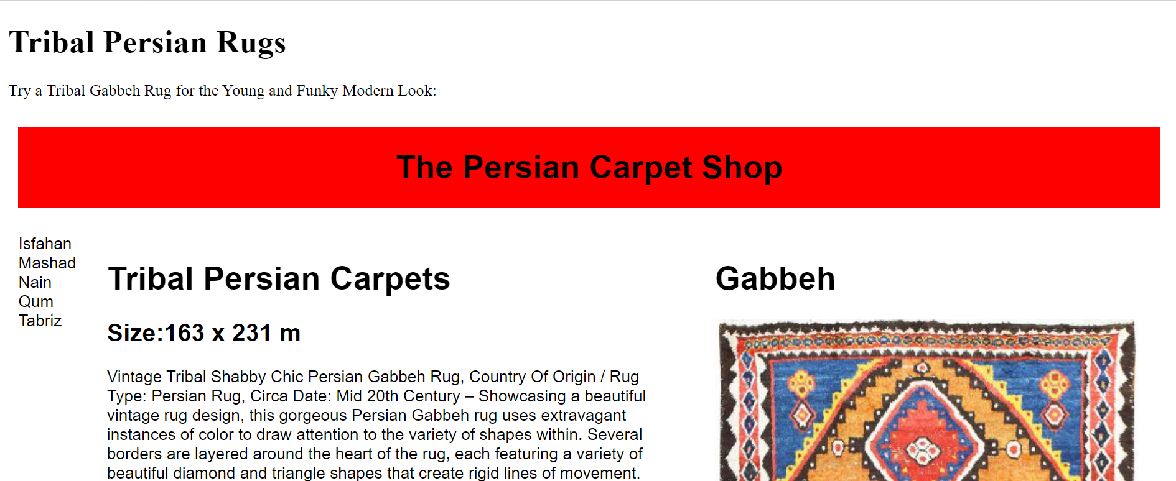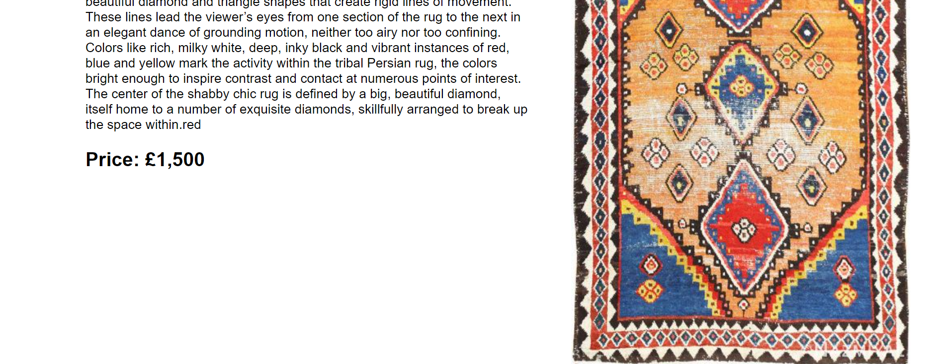

Silk
Figure 4 Silk Page
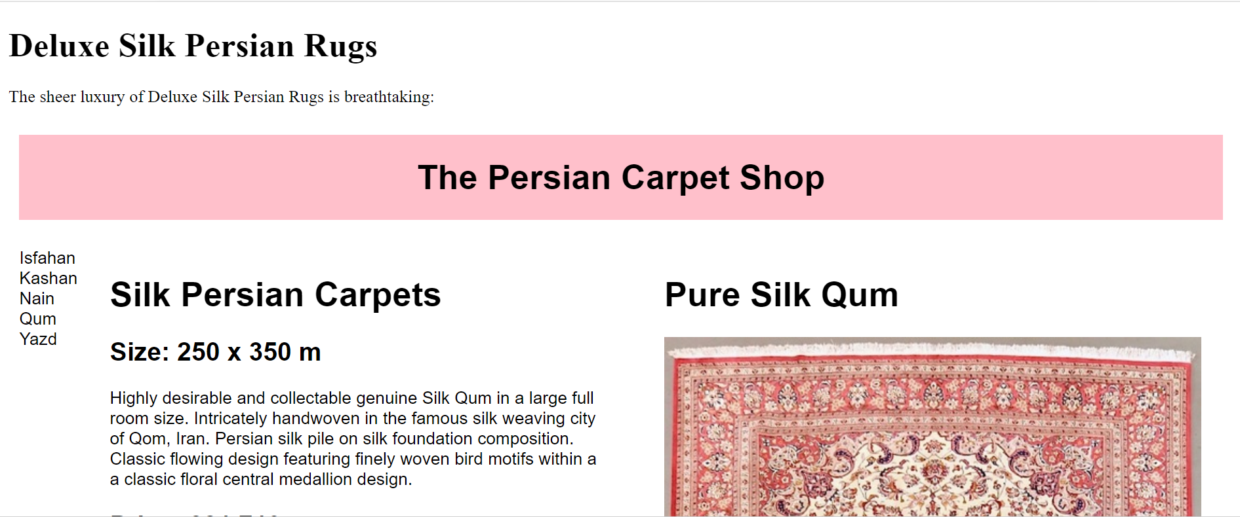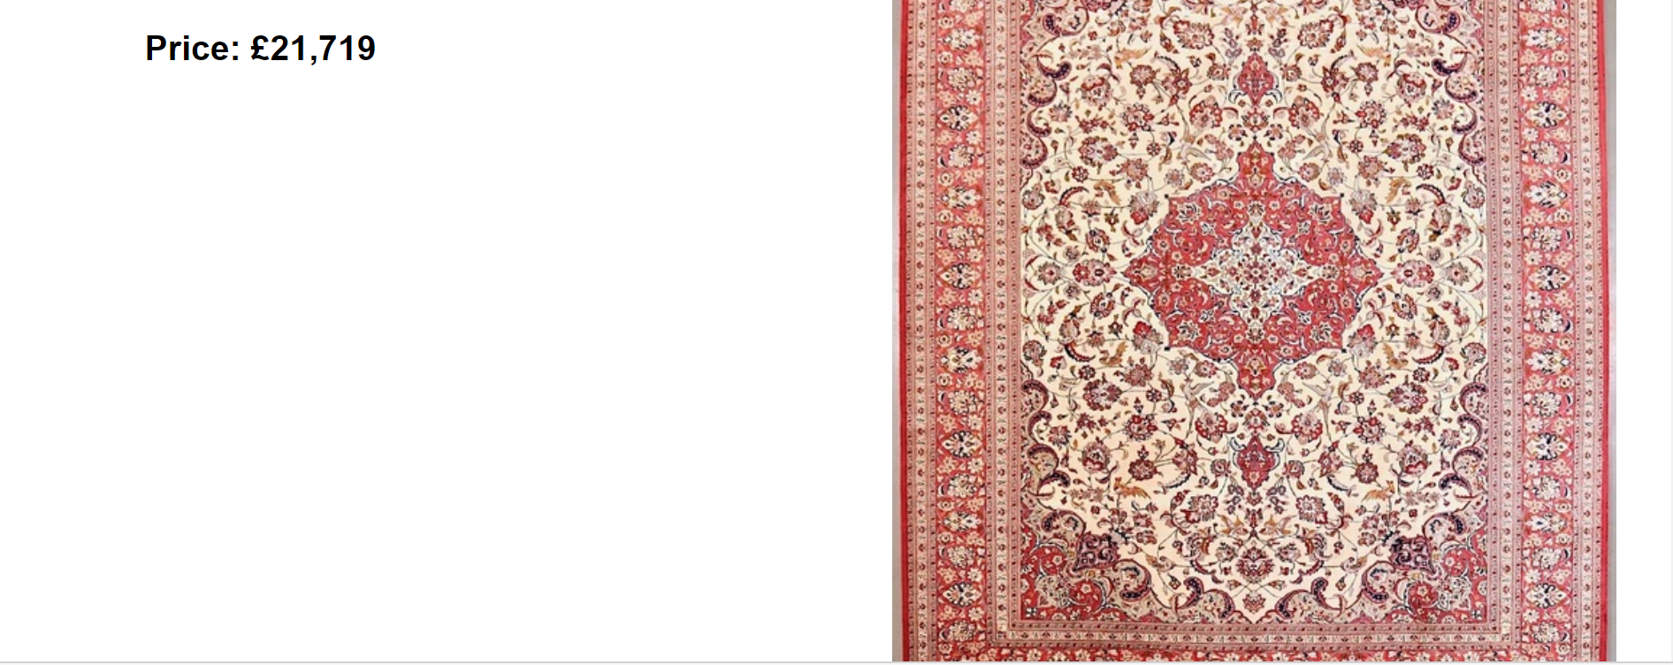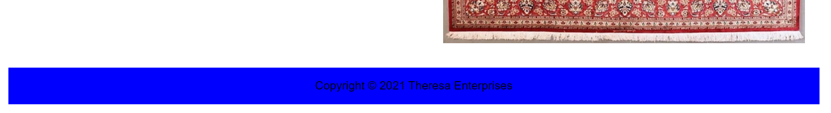

Contact
Figure 5 Contact Page

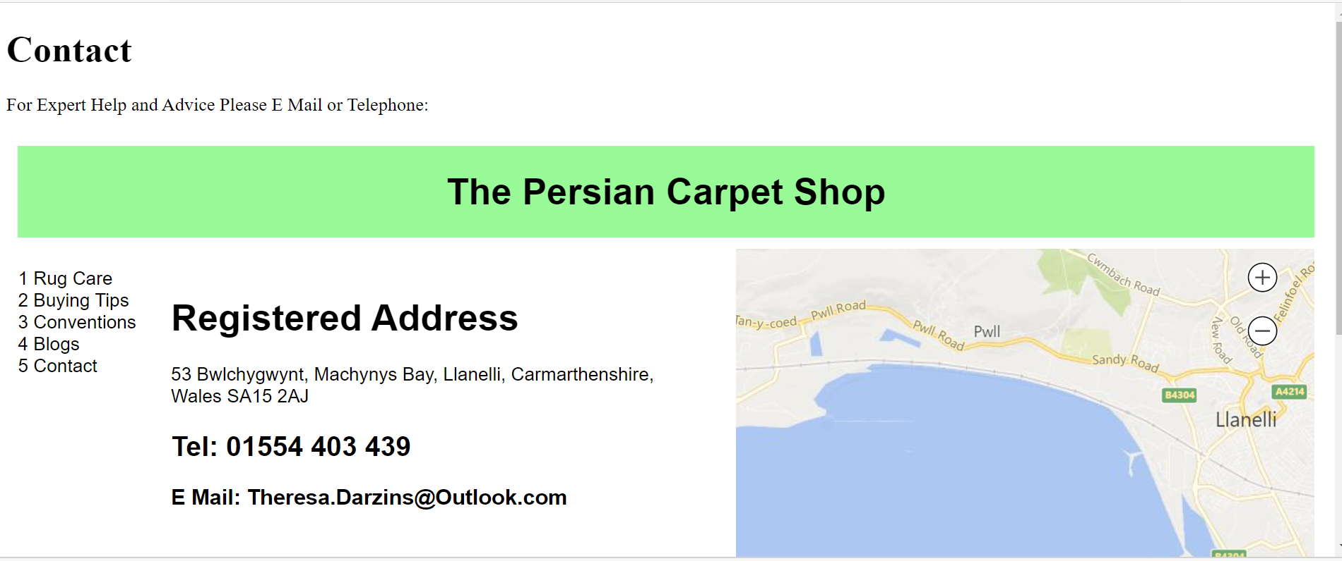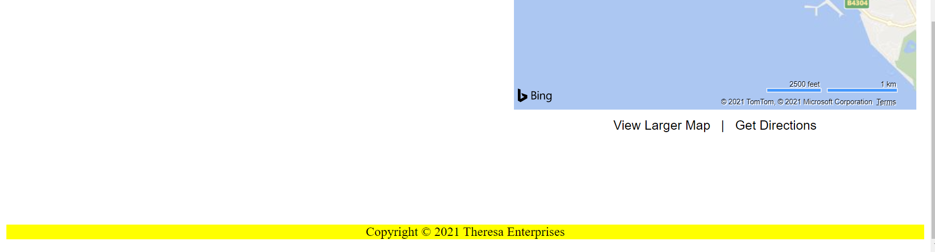

Shopping Cart
Figure 6 Shopping Cart Page

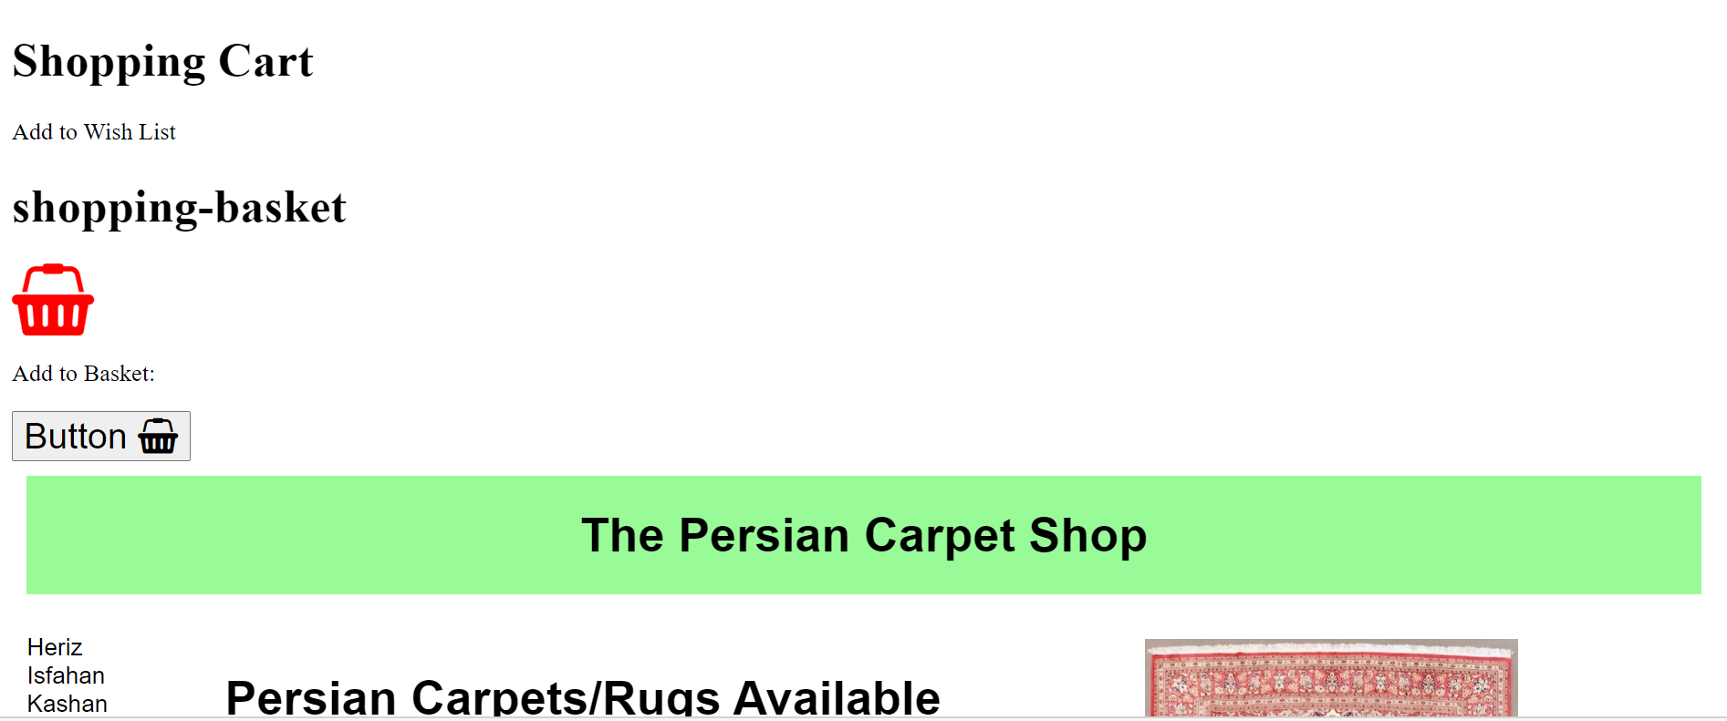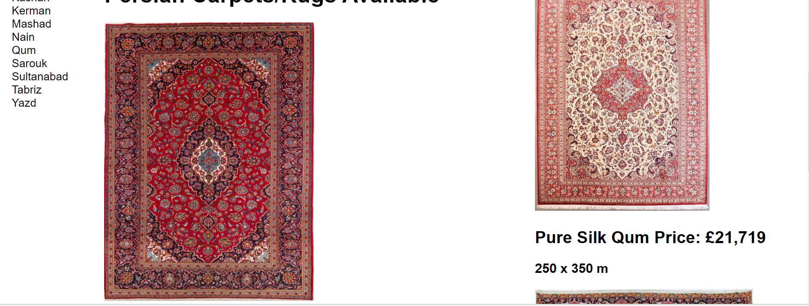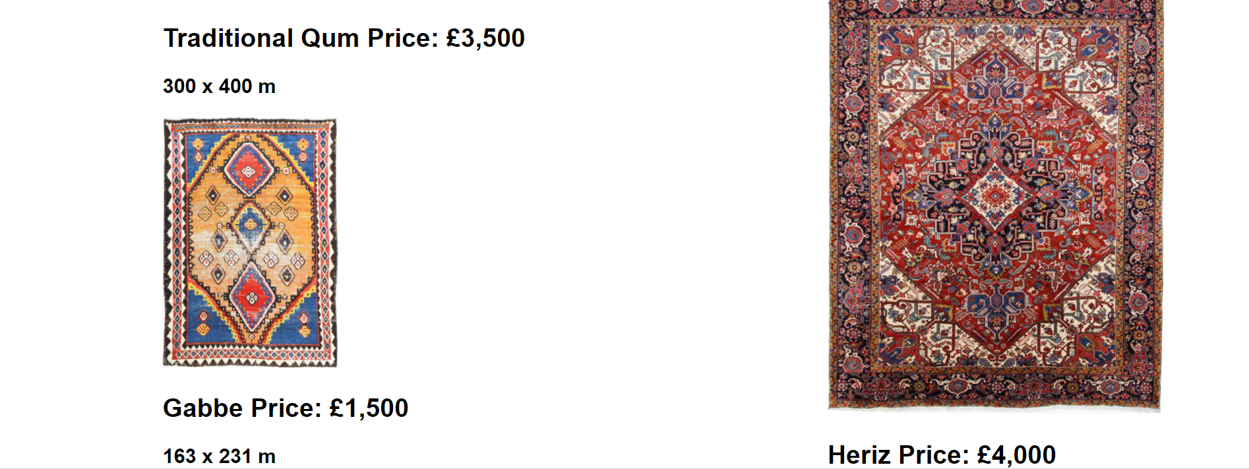

Validation
Validate HTML Code and CSS

Error Codes
Table 1 – Error Codes and their Remedies
 | Error | Meaning | Remedy
1 | Lang “en” omitted | English Language | Added within the html code
2 | New 1 and New 2 Notepad++ files  NO SPACES ALLOWED | Bad value for attribute | Changed html file names to New1 and New2.html (no space)
3 | No spaces between attribute | Keep a space between the heights and widths of images | Spaces added after height and width for images
4 | Images must have alt= attribute | Describe the pictures so that they are found by search engines | Add in alt= “whatever the picture is”
5 | /a not needed | No need to close an image ref | Delete the a/ and end with >

4.0 EVALUATION

4.1 Usability/Accessibility/Search Engine Optimisation Studies

4.1.1 Usability
^{[2]} Five features contributed to Web site usability:
- task
- user
- sponsor
- system
- environment

The main purpose of visiting a website is knowledge acquisition (KA), however, users often found websites confusing and disorganised. Navigation to reach a website’s Leaf Node confusing due to:

- Semantics (text sentences vs static graphic/multi-media)
- Syntax (trouble-shooting vs purchasing)

A mental model of what the problem consisted of was constructed:

Figure 7 Mental Model of Navigation of Website

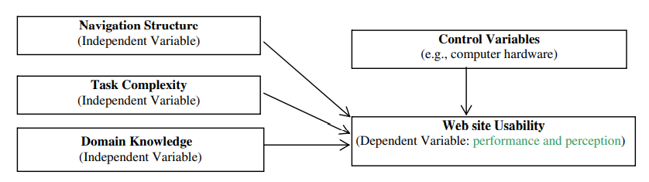

Navigation structures were compared:
- linear
- vs linear with side trips analysed.

It was found that subjects performed better using the mixed option, however, beginners needed to get used to it first.

Next, timed experiments were devised and carried out on two control groups (novices vs their own trained experts) to see differences in the way/speed the subjects found out information.
The results showed those who were more expert at:
- ‘using the hierarchy of navigation structures’

were better at KA than those who were experts in their own particular fields.

Domain knowledge was key, and ensured high usability.

However, unsurprisingly, although those experts in their field took more time to reach the knowledge, the knowledge they did acquire was more in-depth.

4.1.2 Accessibility
^{[3]} As most of the world gains access to the world-wide web, a significant proportion, who are disabled and/or ageing have limitations such as:
- sight loss
- hearing loss
- motor impairment
- cognitive impairment
A major effort is underway to ensure this minority is not left behind and ensure their needs are met. The need is pressing as the population of over 60’s is predicted to triple by 2050.
The major finding of the study was that:
- “Accessible design of websites with high visibility in search engine results makes their content more accessible.”
Web Content Accessibility Guidelines (WCAG) is aimed at eliminating accessibility barriers for individuals with disabilities. Some disabilities are lifelong whereas others temporary. For instance, limited use of hands leading to just keyboard, not mouse interactions, need to be considered when designing websites and web applications.
A lack of training for web designers and developers has exacerbated the situation. Search engine companies are given White hat (good) and black hat (bad) practices. Despite the white hat practices requiring more time to implement, the results are better quality and achieve the objective of good SERP listings (as opposed to black hat which achieved fast, but largely irrelevant results).
Summary of guidelines for web professionals to ensure equal access for all are:
- On-page key word use in image alt text

- Keyword use in video subtitles and transcripts

- HTML validation to W3C standards

- On page factor Meta description tag (indispensable for AT’s including screen readers, text to speech and speech recognition software/language software)

- On page factor keyword use in internal/external link on the page

- Location in information architecture of the site

All these assist the search engine optimization (SEO).

^{[4]} There was outrage in the deaf and hard of hearing community when Netflix streamed ‘The Wizard of Oz’ free, but without subtitles. Netflix’s response was less than adequate when they said it was available on DVD’s with subtitles. It took around two years, from 2009-11 for Netflix to implement subtitles for 80% of films, but this was not without problems. The translation by AI was by no means accurate.
Internationally:
- the World-Wide Web Consortium (W3C) publish guidelines which are voluntary.
- The UN Convention of the Rights of Persons with Disabilities specified barriers need to be identified, and reduced in all information and communications services.
- The EU has the European Accessibility Act.
- Industrial online giants such as Google see their compliance through ‘market imperatives, whereas web developers choose to adhere to ‘community standards’.

As these 4 guidelines are interwoven, uptake in one country may progress on to uptake of compliant industrial policies.

To give some background, the ADA (Americans with Disabilities Act) took this as a Civil Rights issue and treated it like the women’s movement, on the basis of stigmatization. Civil rights lawsuits are the prime enforcement mechanism of the ADA. Only 5-10% of programs had captioning in 1993. However, although they championed the deaf, no efforts were made to help the blind (audio description). This was addressed in 1996 through the Telecommunications act. Advocate Marlee Matlin named and shamed services on Twitter and gained many followers to push for Netflix and Hulu to provide captioning.

TV, film, and online captions are regulated very differently. Places of shopping online could be viewed as amenities, and just as disability access is required in real life, so would it be required online.

To paint a picture historically, in the 19th and 20th century, disabled people were ‘shut in’ in homes and hospitals, subject to “ugly laws” which targeted begging. War veterans were among the first to have their needs legally addressed having previously proved themselves as upstanding citizens.

In future, search engines used must understand specific cultural or linguistic meanings of language. Tim Berners-Lee terms it ‘the Semantic web’; which will allow for a more intuitive descriptive ‘information about information’.

Companies in the ‘search’ businesses rely upon the ability to index, and deliver information to promote many other businesses. Whilst text based searches work, images, videos and audio files are unreliable. AI translates speech accurately for the most part, but when it glitches it does so spectacularly badly (i.e. the film ‘This Emotional Life’ – translated ‘Asperger’s Syndrome’ as ‘Mister Gerson’).

Equality equates to public good, community and citizenship. The two concepts of neoliberals vs civil rights seem to be at odds with each other, however, standards and accessibility are, nevertheless, slowly becoming mainstream.

Web designers argue that “beginning with the needs of disabled results in better products and services to everyone”. Being able to watch a film on mute with subtitles is useful to all; plus foreign language students, and those who wish to transcribe for studies, work, etc.

Textualization is valuable (captioning) as it allows online search engines to index multimedia formats. However, in prioritizing this over audio description, the needs of the blind received far less attention.

Persons with disabilities (PWD) have widely differing needs, and accommodating these needs will always be necessary to ensure their inclusion in society as a ‘mode of equality’.

4.1.3 Search Engine Optimisation
^{[5]} The more links a website contains (innerlinks) the more promoted it becomes and, as a consequence, the website rating improves.
The most popular ways of innerlinking are:
- context
- end-to-end
- "Related Posts"
- "Pathway"

A method of weighting websites by use of an algorithm to show how many innerlinks they contain was devised.
Figure 8 Weighting Method for Websites - Algorithm to Show No. of Innerlinks they Contain
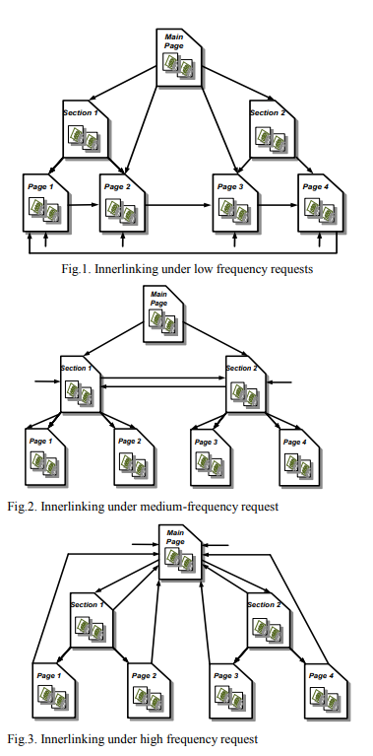
To do this:
- Calculation of the link weight and
- algorithm of weight transfer between pages of Internet resources

was carried out.
Then analysis and implementation of mechanisms of innerlinking to:
- increase the weight of pages and
- attract more visitors and raise the rating of the web site.

Figure 9 Algorithm to show Analysis and Implementation of Innerlinking to increase page weight and attract more visitors

The Algorithm (below)
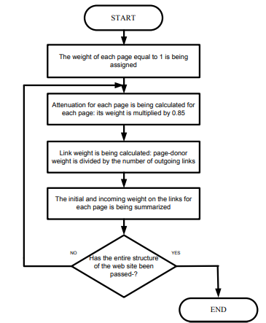

^{[6]} In 2001 Tim-Berners Lee, et al, described the Semantic Web as:
“an extension of the current web in which information is given a well-defined meaning better enabling people and computers to work in co-operation.”
The technology of the Semantic web is being adopted in order to annotate web content with Semantic Markup that can be understood by search engines. The study provides a semi-automatic framework (SMAF) based on Schema.org to analyse the content of documents to extract key words then annotate with appropriate vocabularies. This is expected to give better visibility in search results.
Semantic Web technology has made it possible to add Markup to web pages by annotating their content. SMAF aims to:
- Improve quality of annotations
- Maximise automation by analysis

SMAF has:
- Analyser and extractor to parse documents extracting key words and ranking them according to their importance in the document
- SMAF database repository to store extracted keywords
- Schema matcher to relate key words and phrases with classes and properties
- Annotator to generate JSON-LD (java script object notation for Linking Data) script according to mappings allowing user to download web document with JSON-LD appended to head

Figure 10 Semantic Mark Up (SMAF)
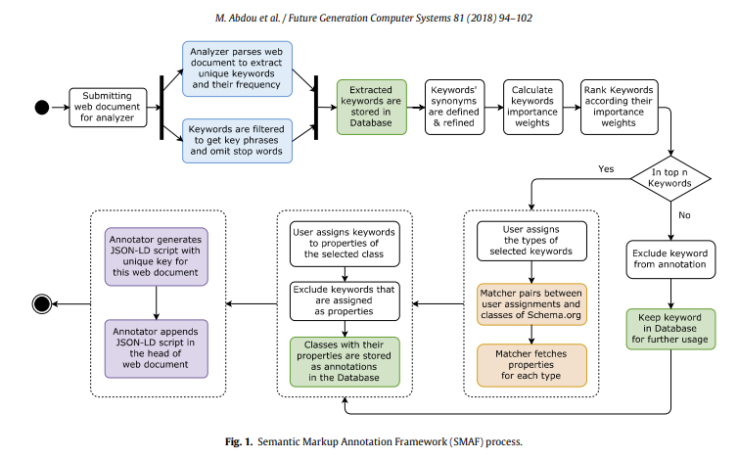

Figure 11 SMAF Analyser

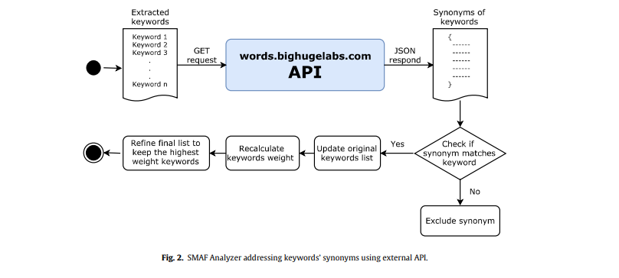

Figure 12 SMAF Extracts Key Words to Enhance Websites Searchability
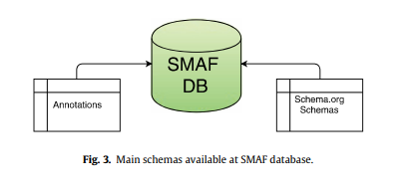
SMAF allows the weight or frequency of the words to be analysed. This enables web masters and website owners to semantically enrich websites to facilitate the semantic annotation process, so that they can be understood by major search engines. SMAF has the ability to extract important key words and phrases and can be embedded in CMS (content management systems) to perform annotation internally. In addition it can support images, audio and video.

4.2 Evaluate Own Website

4.2.1 Usefulness (Usability and Utility)
Although the website is very easy to use, this is because there are only a few carpets shown. Professional websites display an enormous amount of carpets, separated by their sizes, styles and types.

4.2.2 Search Engine Optimisation (SEO)
A list of the on-page SEO techniques applied to website with examples of where and how applied. The images have been tagged with the requisite alt= descriptors, ensuring that they will be found by search engines.

4.2.3 Accessibility
The tags on the pictures would read out loud for those with special software to read out loud the content; image readers will capture the descriptors of the images.

REFERENCES

5.1 For the Report

[1] | Photo by Unknown Author is licensed under CC by SA NC, 2021, [Online] Available: https://Photo by Unknown Author is licensed under CC BY-SA-NC Accessed 5 March 2021
[2] | W. Fang & C. Holsapple, “Impacts of navigation structure, task complexity, and users’ domain knowledge on Web site usability—an empirical study,” 2010, DOI 10.1007/s10796-010-9227-3
[3] | L. Moreno & P Martinez, “Overlapping factors in search engine optimization and web accessibility,” 2012 Online Information Review Vol. 37 No. 4, pp. 564-580, q Emerald Group Publishing Limited 1468-4527 DOI 10.1108/OIR-04-2012-0063
[4] | Ellcessor E. Captions On, Off, on TV, Online: Accessibility and Search Engine Optimization in Online Closed Captioning. Television & New Media. 2012;13(4):329-352. doi:10.1177/1527476411425251
[5] | T. Basyuk, "Innerlinking website pages and weight of links," 2017 12th International Scientific and Technical Conference on Computer Sciences and Information Technologies (CSIT), Lviv, 2017, pp. 12-15, doi: 10.1109/STC-CSIT.2017.8098725.
[6] | M. Abdou, S. AbdelGaber, & M. Farhan, “A semi-automated framework for semantically annotating web content”, Future Generation Computer Systems, Volume 81, 2018, Pages 94-102, ISSN 0167-739X,https://doi.org/10.1016/j.future.2017.11.008. Available:(https://www.sciencedirect.com/science/article/pii/S0167739X17307343)

5.2 For the Website

- HOME
Nazmiyal Antique Rugs NYC Is The Source For Rugs and Carpets
The Good Stuff #2. An Antique Persian Heriz (persiancarpet.com)

- TRADITIONAL
Kashan 400 x 300 | Vintage rugs, Antique carpets, Rugs (pinterest.co.uk)

- TRIBAL
Vintage Tribal Shabby Chic Persian Gabbeh Rug 48971 Nazmiyal Antique Rugs

- SILK
Pure Silk Qum Persian Rug (Ref Q1) 350x250cm - Persian Rug Co. (persianrugs.com.au)

- CONTACT
Embed a map in your website - Bing Maps

- SHOPPING BASKET

Heriz Alt 404x312 ID110183 | NainTrading: Orientteppiche in 400x300

