Information for Presentation:
Link: Treatment Plan PPT.ppsx
Introduction:
Extreme mood, energy, and activity swings are hallmarks of bipolar disorder I (BDI), a serious mental disease that frequently causes considerable impairment in day-to-day functioning. It affects about 1% of people worldwide and can significantly damage relationships, everyday functioning, and quality of life. Both manic and depressive periods, characterized by symptoms including low mood, lack of interest or pleasure, feelings of worthlessness or guilt, and raised mood, increased activity, racing thoughts, and decreased desire for sleep, are characteristic of the disease. This treatment plan aims to provide a thorough framework for controlling borderline personality disorder (BDI) by using therapies based on research and customized to the requirements of each patient.
Diagnosis:
Based on the criteria listed in the Diagnostic and Statistical Manual of Mental Disorders, Fifth Edition (DSM-5), bipolar disorder type 1 is diagnosed. Important characteristics include one or more manic episodes that continue for at least a week (or for any length of time if hospitalisation is necessary) and are frequently followed by depressed episodes. The diagnosis is supported by a comprehensive clinical evaluation that takes into account alternative theories for mood disorders in addition to a thorough history and symptom observation.

Lay Summary:
Bipolar Disorder 1 is a psychological disorder where the individual experiences extreme shifts in mood. These mood changes can disturb everyday routines and connections. The objective goal of this treatment plan is to offer efficient support and interventions for individuals with Bipolar Disorder I. By combining different therapeutic approaches and medication control, this plan aims to assist individuals in handling their symptoms, enhancing their quality of life, and lessening the effects of mood episodes on their everyday activities.

Background Literature:
The treatment for this type of bipolar disorder requires a comprehensive process that includes lifestyle changes, therapy and medication. Recent research stresses the importance of initial assessment and individualised therapeutic techniques that are designed for each individual’s specific needs (Grande et al., 2016). One framework that are mostly associated with treating bipolar disorder is the Psychosocial Model.
The Psychosocial Model emphasises the influence of psychosocial stressors, personal relationships with those around them and environmental factors that may result in developing bipolar disorder 1 (Miklowitz & Johnson, 2009). Cognitive behavioural therapy, family therapy, psychosocial interventions and psychoeducation are treatments used to strategise coping mechanisms, avoid relapse and encourage adhering to medication.
However, Grande et al's work (2016) presented a thorough synopsis of the multimodal treatment strategy for bipolar disorder type 1. This includes lifestyle changes, medication and psychotherapy. This indicates a comprehensive comprehension of the intricacies of the illness (Grande et al., 2016). By presenting the Psychosocial Model, the work recognizes the variety of viewpoints in diagnosing and treating bipolar disorder 1. A more sophisticated and customized approach to treatment planning is made possible by this integration (Berk et al., 2005; Miklowitz & Johnson, 2009). Additionally, Although the subjects of medication and psychotherapy are covered individually, more may be said about how these approaches can work best when combined. According to research, patients with bipolar disorder may experience improved symptom management and functional recovery when they get both psychotherapy and medication (Sylvia et al., 2011). While lifestyle changes are discussed, their importance and particular tactics are not explained. Treatment results for BD1 can be improved and the course of the condition can be considerably impacted by addressing lifestyle aspects such as eating habits, exercise routines, and sleep patterns (Sylvia et al., 2011). Although the research emphasizes the value of customized treatment programs, it doesn't examine how these strategies may be applied in clinical settings. For best results in BD1, therapy must be customized to individual patient factors such as genetic profiles, symptom intensity, and comorbidities (Wang et al., 2014). Digital therapies, ketamine infusion therapy, transcranial magnetic stimulation (TMS), and other newer forms of treatment are mostly ignored in favor of more conventional pharmaceutical and psychotherapy approaches. By adding these cutting-edge methods to the conversation, we may improve our comprehension of the state-of-the-art BD1 therapy choices (McGirr et al., 2016).
Theoretical Frameworks:
Biopsychosocial Model - This comprehensive approach strives to improve treatment results by addressing biological aspects through medication, psychological ones through psychoeducation and therapy, and social factors through support networks and environmental adjustments.
CBT - seeks to enable individuals to successfully manage their symptoms and avoid relapse by teaching coping skills, fostering problem-solving techniques, and correcting cognitive distortions.
ROC - Despite the prevalence of symptoms, it emphasizes optimism, self-determination, and meaningful involvement in life (Anthony, 1993).
Methodology:
- Initial Assessment
- Medication Management
- Psychoeducation
- Psychotherapy
- Lifestyle Modifications
- Support Services

On-going Treatment:
For ongoing treatment, it would be suitable for the individual to continue to have routine follow-up consultations with the psychiatrist to discuss medication regimens and keep an eye on symptoms. ongoing attendance at psychotherapy sessions in order to address persistent issues and advance healing. treatment plans should be modified as necessary in response to each patient's unique needs and evolving clinical presentation. Working together with family and the support system to improve treatment compliance and advance well-being.
Outcome Measures:
- Clinical Assessment
- Functional Outcomes
- Relapse Prevention
Ethical Considerations:
- Informed Consent
- Confidentiality
- Autonomy
- Cultural Sensitivity
Slides:
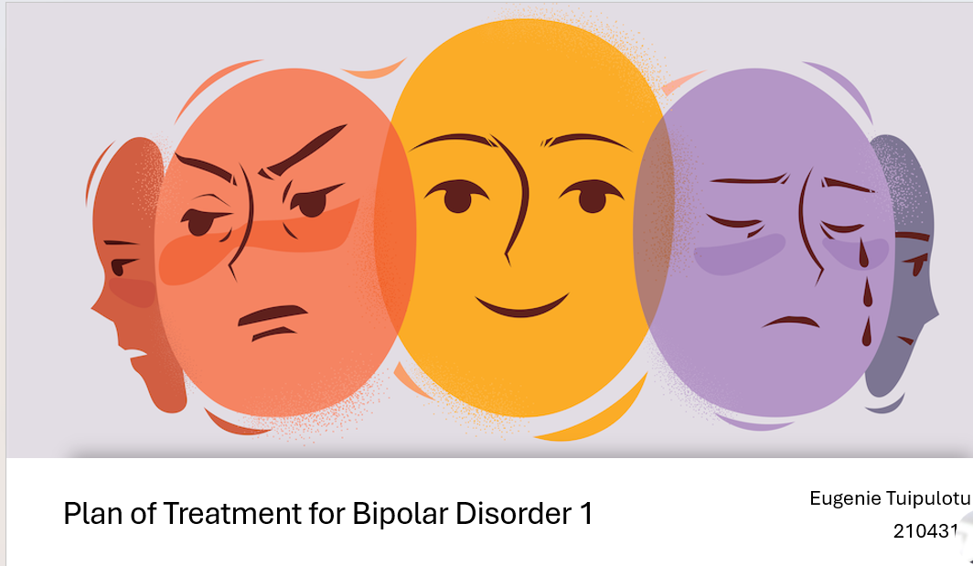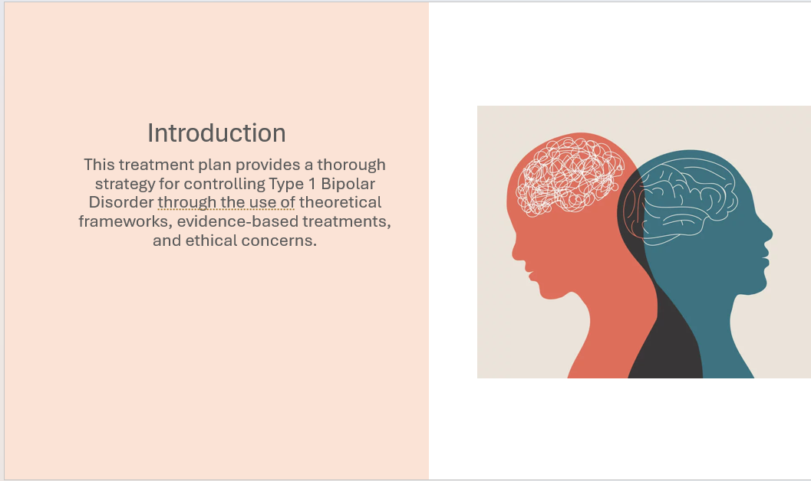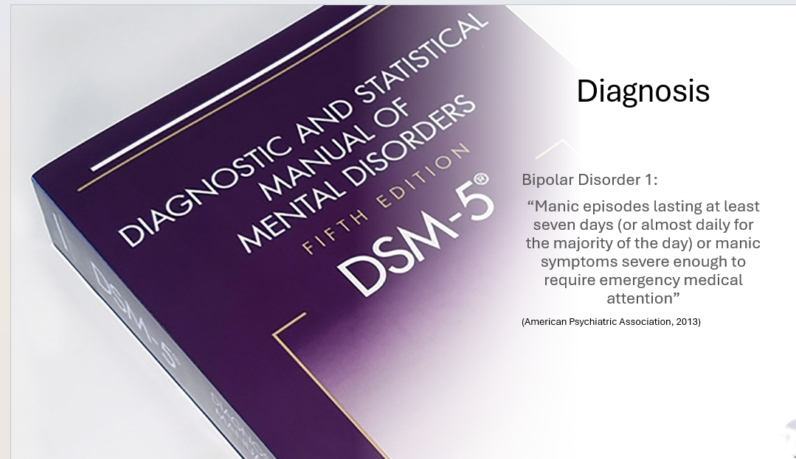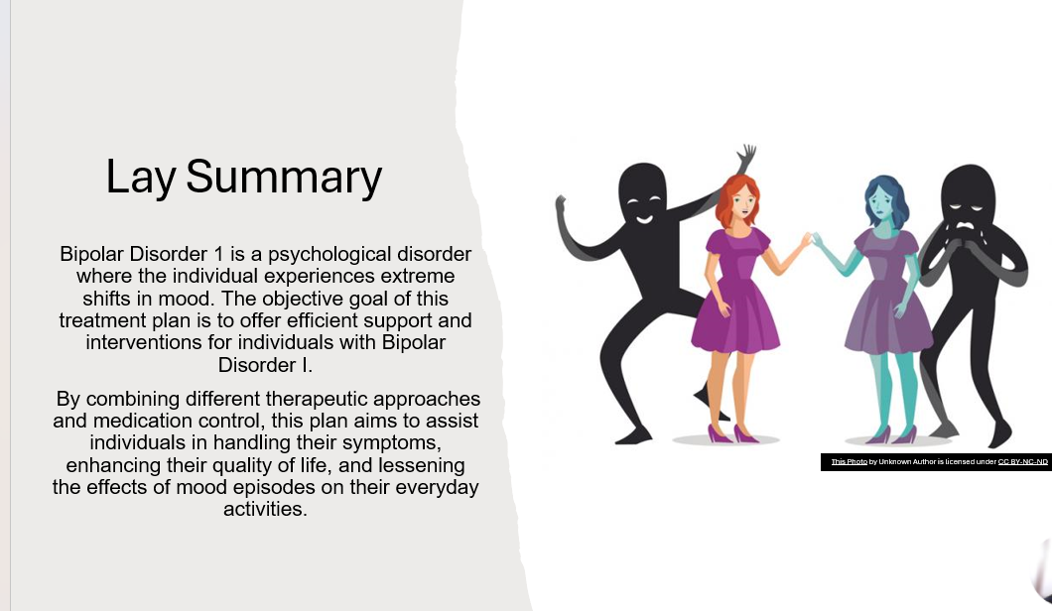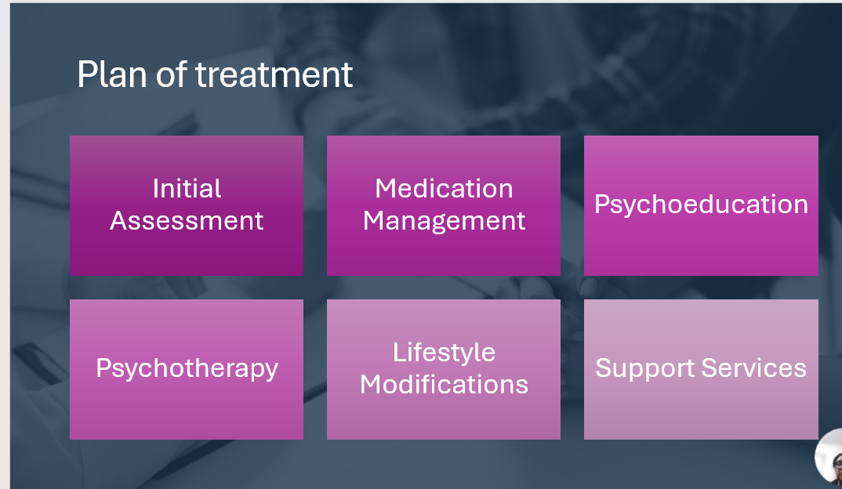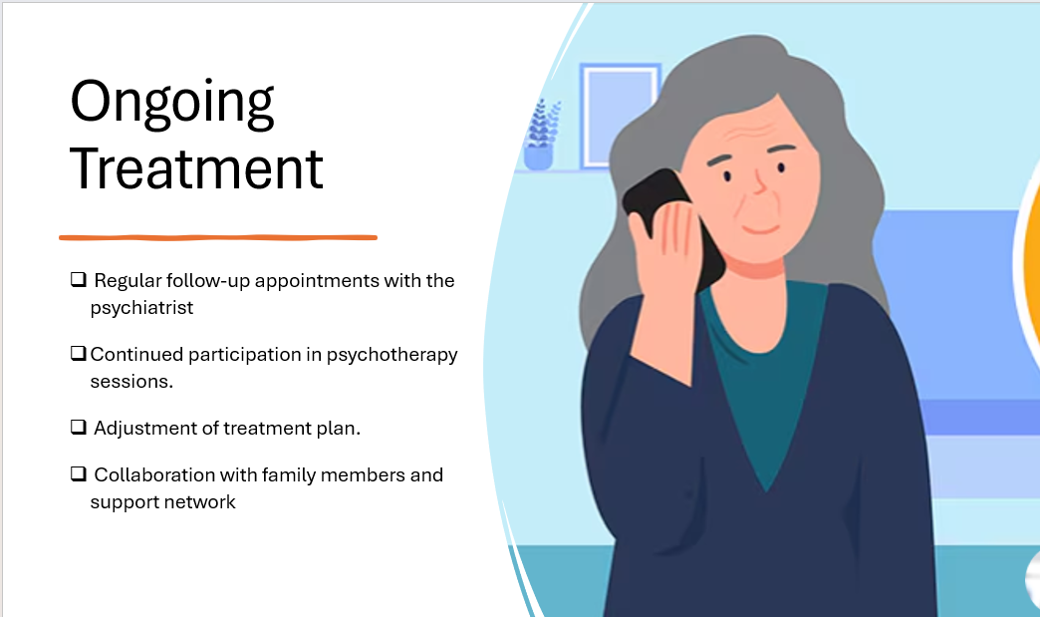

Reference List
American Psychiatric Association. (2013). Diagnostic and statistical manual of mental disorders. Diagnostic and Statistical Manual of Mental Disorders, 5(5). https://doi.org/10.1176/appi.books.9780890425596
Anthony, W. A. (1993). Recovery from mental illness: The guiding vision of the mental health service system in the 1990s. Psychosocial Rehabilitation Journal, 16(4), 11–23.
Berk, M., & Dodd, S. (2005). Bipolar II disorder: a review. Bipolar Disorders, 7(1), 11–21. https://doi.org/10.1111/j.1399-5618.2004.00152.x
Engel, G. L. (1977). The need for a new medical model: A challenge for biomedicine. Science, 196(4286), 129–136. https://doi.org/10.1126/science.847460
Fenn, K., & Byrne, M. (2013). The key principles of cognitive behavioural therapy. InnovAiT: Education and Inspiration for General Practice, 6(9), 579–585. https://doi.org/10.1177/1755738012471029
Davidson, L., Tondora, J., O’Connell, M. J., Bellamy, C., Pelletier, J.-F., DiLeo, P., & Rehmer, P. (2016). Recovery and Recovery-Oriented Practice. Oxford University Press EBooks, 33–48. https://doi.org/10.1093/med/9780190214678.003.0003
‌ Grande, I., Berk, M., Birmaher, B., & Vieta, E. (2016). Bipolar disorder. The Lancet, 387(10027), 1561–1572. https://doi.org/10.1016/s0140-6736(15)00241-x
Lam, D. H., Watkins, E. R., Hayward, P., Bright, J., Wright, K., Kerr, N., Parr-Davis, G., & Sham, P. (2003). A Randomized Controlled Study of Cognitive Therapy for Relapse Prevention for Bipolar Affective Disorder. Archives of General Psychiatry, 60(2), 145. https://doi.org/10.1001/archpsyc.60.2.145
McGirr, A., Vöhringer, P. A., Ghaemi, S. N., Lam, R. W., & Yatham, L. N. (2016). Safety and efficacy of adjunctive second-generation antidepressant therapy with a mood stabiliser or an atypical antipsychotic in acute bipolar depression: a systematic review and meta-analysis of randomised placebo-controlled trials. The Lancet Psychiatry, 3(12), 1138–1146. https://doi.org/10.1016/s2215-0366(16)30264-4
Miklowitz, D. J., & Johnson, B. S. L. (2009). Social and Familial Factors in the Course of Bipolar Disorder: Basic Processes and Relevant Interventions. Clinical Psychology: Science and Practice, 16(2), 281–296. https://doi.org/10.1111/j.1468-2850.2009.01166.x
‌ Sylvia, L. G., Dupuy, J. M., Ostacher, M. J., Cowperthwait, C. M., Hay, A. C., Sachs, G. S., Nierenberg, A. A., & Perlis, R. H. (2011). Sleep disturbance in euthymic bipolar patients. Journal of Psychopharmacology, 26(8), 1108–1112. https://doi.org/10.1177/0269881111421973
Vieta, E., Berk, M., Schulze, T. G., Carvalho, A. F., Suppes, T., Calabrese, J. R., Gao, K., Miskowiak, K. W., & Grande, I. (2018). Bipolar disorders. Nature Reviews Disease Primers, 4(1), 18008. https://doi.org/10.1038/nrdp.2018.8
Wang, Z., Li, Z., Gao, K., & Fang, Y. (2014). Association between brain-derived neurotrophic factor genetic polymorphism Val66Met and susceptibility to bipolar disorder: a meta-analysis. BMC Psychiatry, 14(1). https://doi.org/10.1186/s12888-014-0366-9
‌ Young, R. C., Biggs, J. T., Ziegler, V. E., & Meyer, D. A. (1978). A rating scale for mania: reliability, validity and sensitivity. The British Journal of Psychiatry : The Journal of Mental Science, 133(5), 429–435. https://doi.org/10.1192/bjp.133.5.429

