
BMIH4005
Marketing Essentials
LEVEL 4

Student Name: Razvan Ghica
Student ID: 2234759

Table of Contents
Assessment 1: Essay 1
Introduction 1
Main body 1
Conclusion 5
Assessment 2: Marketing plan 6
Introduction 6
Situation Analysis: 5 'C's 6
Objectives 9
Strategy 9
Tactics 10
Actions 11
Control 11
Conclusion 12
References 13
Appendix: Presentation 15

Assessment 1: Essay

Introduction
The hotel business has evolved in response to rising worldwide competition, shifting consumer preferences, rapid technical advancements, and heightened environmental unpredictability. The hospitality industry around the world is becoming increasingly cutthroat, prompting companies to develop techniques for marketing their products that are not only cutting-edge but also sustainable (Thomas, 2018). This study will examine the marketing approaches of two international hotel chains, Six Senses Hotels, and Moxy Hotels, in detail. These two companies were selected for this article because they are industry frontrunners offering both worldwide distribution and premium goods and services. Promoting goods or services to such an extent to customers are fascinated with them and using them instead of the competition is incredibly difficult and time-consuming in worldwide marketing for both two companies. Therefore, multinational firms increase their competitiveness by developing comprehensive yet flexible marketing strategies to make sure that their goods and services are well appreciated by customers. Therefore, marketing extends beyond conventional forms of public relations such as advertisements.

Main body
Background of the Hotel
Six Senses Hotel
The Six Senses Hotel, founded by Sonu Shivdasani in 1995, is still at the forefront of the hospitality industry thanks to its commitment to providing guests with cutting-edge experiences and amenities (Ryan, 2019). InterContinental Hotels Group, operating as IHG Hotels & Resorts and based in Windsor, England, is the hotel's owner and operator. It can be found on the stock exchanges of both London and New York. The hotel has recently switched its advertising focus from more traditional methods to online channels. The hotel is a leader in the industry for its commitment to environmental responsibility, which it has demonstrated by encouraging the use of renewable energy and environmentally friendly building materials throughout its properties. The hotel is committed to reducing waste and advancing toward a sustainable future. Reducing, reusing, recycling, and donating are all vital components of an eco-friendly hotel (Palmer, 2020).

Moxy Hotel
Moxy Hotels first opened its doors in Milan, Italy on September 1, 2014, bringing with it a new and exciting take on the hotel industry (Thomas, 2018). The Moxy hotel chain is known for being trendy, affordable, and full of exciting amenities for its customers. With over 60 immersive hotels in operation spanning North America, Europe, and the Asia Pacific, Moxy brazenly defies the standards of a conventional hotel stay. The lively brand's modern, industrial appearance and hospitable service at reasonable prices allow guests to save money on lodging while yet living lavishly. What really sets Moxy different is its dedication to ensuring that every visitor has a fantastic time, both at the hotel and in the surrounding area. Placemaking and superior client experiences at Moxy hotels depend on the health of the ecological function ecosystem and biodiversity.
Comparison of adopted Marketing Strategies
The two businesses use a variety of marketing approaches to differentiate themselves in the marketplace and improve their products' standing with consumers. Promotion, price, experience development, and distribution are all examples of marketing tactics. Both brands are seen as good service providers, and this is a central priority of the marketing plans.
Promotion Strategy
Incentives trips are Six Senses Hotels' main form of advertising. The primary goal of these excursions is to bring in new customers. Customers are enticed to stay at the hotel rather than at competitors by providing them with superior packaging. Additionally, the organization offers a discount program where customers can receive a 50% discount during specific times of every year, such as weekends (Palmer, 2020). The company uses push marketing methods in its advertising campaigns. An excellent first impression is made on guests by the friendly staff who greet them at the lobby and show them to their rooms. The company's sales team goes out to meet with potential clients in order to set up meetings, conferences, and conferences as part of the business's overall marketing strategy.
However, digital promotions are at the heart of the marketing strategy for Moxy hotels. This indicates that they devote considerable time and energy to advertising their hotels online and in other media. For instance, they may issue a promotional code that can be sent to potential guests via the hotel's "promotional" page or other online channels (Kotler et al., 2018). They also get content from users, including beautiful customer photos taken by amateur photographers in their hotels. This motivates up-and-coming bloggers, social media stars, and influencers to create their own content so they can gain more followers. Everyone benefits from this arrangement. A pleasant user experience begins with the website, and they have one because they are a well-known multinational chain with a comprehensive online presence that allows visitors to easily browse and book rooms at any of their hotels (Ryan, 2019). As a hotel owner, one just can't afford to ignore online marketing and advertising. Rather than resisting it, one should adopt it and discover how to use it to his/her advantage.
Pricing Strategies
The Six Senses hotel employs a skimming pricing strategy during the busy season. Because of this, the corporation can maximize profits during its busiest times. The hotel implements a marketing strategy called "penetration pricing," in which it accepts requests from customers at a discounted rate during the off-season (Kotler & Keller, 2019). The hotel's operations were severely hampered by the ongoing global financial crisis, resulting in a precipitous drop in profits. The hotel has developed seasonal pricing to help with this problem by charging less for their services during the off-season and more during the peak season. As with many other businesses, Six Senses Hotel practices pricing discrimination by charging less to locals than it does to tourists for the same products.
In contrast, Moxy Hotel's major pricing objective is to offer guests excellent value for their money. Additionally, Moxy uses a pricing model based on the equilibrium between consumer demand and available supply. In addition, they use a competitive pricing strategy, which implies that they determine hotel rates in response to the activities of their rivals. Hotels don't simply copy their competitors' pricing structures; instead, they give careful thought to how different strategies might affect business (Kitchen, 2021). Moxy hotel's ability to turn a profit relies heavily on adopting the correct pricing strategy.
Distribution (Place) Strategy
Six Senses hotels in the UK are typically situated in the heart of large cities, close to both major railway stations and airports. It is important to Six Senses that its hotels are located in locations frequented by its target market. Hotel amenities such as proximity to the airport, gaming, and resorts help place it in the heart of the city's busiest district (Jobber & Ellis-Chadwick, 2020). The hotel's sales and marketing team goes out to various local companies to spread the word about the establishment and its offerings. These mediums serve as the backbone of the company's promotional outreach. Also, as events need to be booked in advance, the company's processing requires an instant connection with a company to achieve quick preparation.
Moxy Hotel is picky about its settings. They wisely built their hotels around points of interest including major thoroughfares, airports, and major commercial districts all fall within this category (Henry, 2021). Locating a hotel in close proximity to a popular attraction will increase the number of guests. Moxy Hotel guarantees customer happiness by providing superior service to the guests it receives due to its convenient location. With a well-thought-out place strategy in place, a company can confidently reach its intended demographic.
Experience Creation as a Marketing Strategy
Experience design is a key marketing strategy for Moxy hotels. Hotel Moxy is aimed at younger, more carefree travelers who are looking for stylish but reasonably priced accommodation (Czinkota et al., 2023). The hotel is aiming to attract guests who are interested other than in a bed for the night. These travelers are careful of their budgets yet have high expectations since they value staying in touch with friends and family. The "fun hunters" are drawn to the brand because of its affordable prices, trendy features, and cutting-edge conveniences. The rooms are modern and compact, with amenities including flat-screen TVs, USB connections, and free high-speed internet access (Ryan, 2019). Despite their tagline, "Less is more," they prioritize increased emphasis. The lobby, or "living room," is the central gathering place of a hotel. Relax, have fun, and mingle with the general public in the public sphere. Guests can check in at the bar any time of day or night and get a free drink or snack from the 24-hour snack bar. Tourists looking for a good time won't want anything at the Moxy.
In contrast, Six Senses hotel prioritizes guest satisfaction through personal interaction, inventive marketing, and cutting-edge service and amenities. The hotel employs this strategy to restore guests' faith in both its services and the travel industry as a whole. The announcement and a video showing the three perspectives in action were shared throughout Six Senses' social media outlets. Some of the comments claimed that this campaign increased customer loyalty and revenue. Knowing and understanding the audience's emotional state will help one to craft a persuasive message and visual content for his/her marketing campaigns (Clow & Baack, 2022). The difference lies in convincing customers to acquire one’s product or service, as opposed to one reasoning behind making that offer.

Conclusion
When it comes to providing products and services to consumers from all over the world, Six Senses and Moxy hotels are unrivaled. However, it is essential that a brand implement a strategy for marketing that will maintain its longevity. The two hotels create comprehensive yet adaptable marketing plans to increase consumer satisfaction with their products and services, which in turn strengthens their position. Both companies value sustainability in the natural world and are committed to advocating for it.

Assessment 2: Marketing plan

Introduction
This essay will discuss how Premier Inn hotels successfully sell themselves to the public and oversee their own internal operations. Moreover, this analysis will look at how hotels are affected by the world beyond. As a corollary, it is essential to demonstrate the company's utilization of digital marketing and customer engagement in the service of maximizing sales and profitability. Premier Inn is a popular and rapidly expanding network of hotels throughout the United Kingdom. It includes about 590 hotel rooms and over 42,000 hotel nights across the United Kingdom and Ireland (Chaffey & Ellis-Chadwick, 2022). The high quality of the services offered has earned it a reputation as one of the best resorts in the UK. Many different countries are represented by Premier Inn hotels. In addition to the one facility in India, there are three establishments in Dubai. Because of this, they are doing exceptionally well on a global scale.

Situation Analysis: 5 'C's
Company: SWOT analysis (Micro analysis)
All of a company's problems, resources, opportunities, and threats come from within the company itself. Premier Inn has numerous advantages in the current market, including a sizable clientele, a wide selection of products, and a vast pool of potential customers. The company's wide range of products gives it ample room to grow and adapt to changing market demands. If more people want to buy a product because of its high-end features, the market will respond to meet that need. Customers have occasionally voiced dissatisfaction with the company's inadequate customer service and the fact that not all stores stock its products (Henry, 2021).
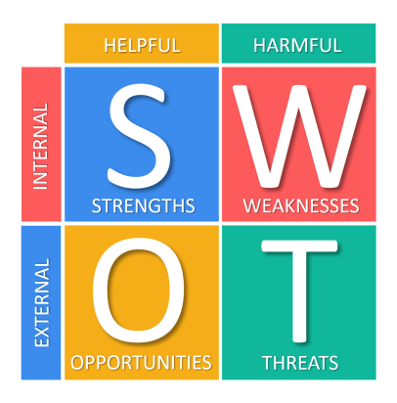
Figure: SWOT analysis
Source: (Clow & Baack, 2022)
Strength: In the context of the hotel's advantages, this paper analyzes the core business factors which provide the Premier Inn an edge in the market. Multiple factors contribute to a company's credibility, including its financial stability, intellectual capital, product differentiation, and intangible traits like brand equity (Thomas, 2018).
Weakness: Weaknesses are the parts of a company's operations that could be enhanced to increase its profile. One type of defect is when a company has shortcomings in an area where rival companies thrive. The competitiveness the company faces is so high that its profit margins are squeezed (Brown, 2019). In order to do a comparison between worldwide reach and local hotel network, it is easiest to use the latter.
Opportunity: Any company can increase its consumer base by making some tweaks. Opportunities for local expansion, product development, communication upgrades, etc., may exist for a business (Palmer, 2020).
Threat: Competition from new entrants, political instability, and cheaper alternatives from rivals have all put the hotel business under intense strain. competition from other businesses aiming for the same clientele as Travelodge Hotels ltd DAYS INN, ACCOR, and worldwide Inc (Bowie et al., 2017).
Customer
Growing its consumer base is a goal of any successful business, and that goal is achievable through expansion. It's possible for a business to grow its reach, product selection, internal communication, etc. by going global. The hotel industry is highly competitive, but it has low switching costs and product innovation costs (Ryan, 2019). This means that business growth is faster than the rate at which businesses are able to adapt to the changing market.
Competitors
The hotel industry is widely recognized as a top-tier global business. As a result, the number of new entrants is low. There is a strong need for skilled colleagues and staff in this sector, but the supply is similarly limited. There is a power imbalance between customers and service providers because consumers have options for where to get the services they need (Kitchen, 2021).

Collaborators
When multiple hotel chains join together, they can provide greater services than any one chain could on its own. The well-known brand name could accomplish this in B2B Deals, Contracts, and Blockbusters (Ryan, 2019).
Climate PESTLE (Macro analysis)
Premier Inn hotels will assess the local policies, regulations, economy, society, and ecology to learn how they can best serve the area. Because of this, factors such as these affect success. When selecting choices for the organization, management must make certain that all of these concerns are brought into account (Kotler & Keller, 2019). If the hotel can't rely on these features, it will lose guests and money because it won't be capable of meeting the many requirements made of it.
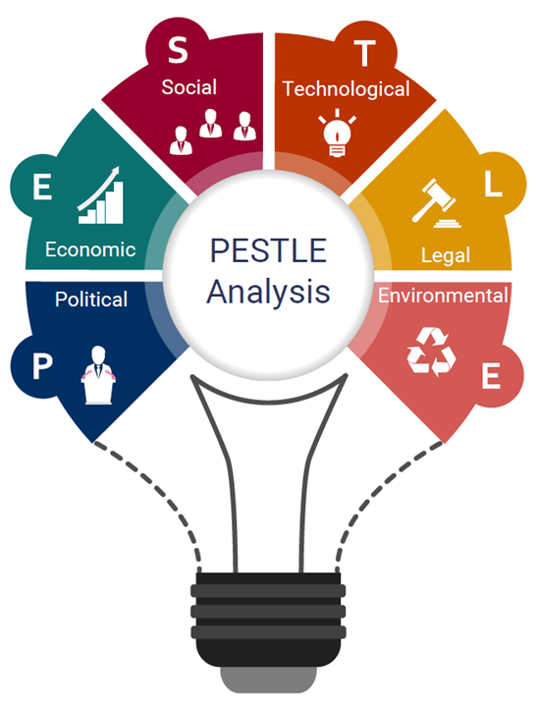
Figure: PESTLE analysis
Source: (Czinkota et al., 2023)
Political: The Premier Inn has suffered as a result of Brexit and immigration restrictions. The hotel business is down as a result of tighter travel restrictions (Ryan, 2019).
Economical: This would lead to a monetary collapse, hyperinflation, and a subsequent economic downturn (Thomas, 2018).
Social: Premier Inn abides by ethical business practices and the needs of its customers since it takes a humanistic approach to resolve customer complaints (Kitchen, 2021).
Technological: Premier Inn has evolved alongside technological advances in areas such as social media marketing, customer relationship management, and database creation (Henry, 2021). As a result of this strategy, the company's marketing strategy has been developed. The company's offerings are bolstered by the use of cutting-edge technology and the production of superior products.
Environmental: In an attempt to stem pollution and global warming, Premier Inn only rents out electric cars to guests and uses solar cells for nearly all of its energy requirements (Jobber & Ellis-Chadwick, 2020).
Legal: The company needs to learn how to adapt to the country's new tax as well as foreign policies. Any agreements made between the company and its employees must be honored (Bowie et al., 2017).

Objectives
The advertising campaign's SMART objective is to boost Premier Inn's profits by 6%. Considering the sector's generally positive reputation, success may be possible. Advertising strategies that are tailored to this demographic will be most successful. For this reason, it is crucial to boost Premier Inn's operational income by 6%. This target might be accomplished in a year.

Strategy
The facility needs to be better than its rivals in the market for it to be successful. In order to succeed, Premier Inn Hotels has to be aware of the quality of its products. Providing a quick and simple online booking option would be ideal. The primary benefit would come from being able to provide a wide array of options to the target audience (Palmer, 2020). By booking multiple rooms throughout the year, for illustration, a tourist can save money.

Tactics
Marketing Mix
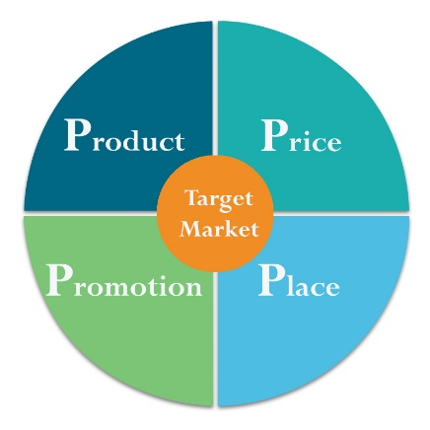
Figure: Marketing Mix
Source: (Kotler et al., 2018)
Product: Premier Inn offers a variety of services, including lodging, entertainment, catering, and transportation. Since they offer so many different services, they are able to keep customers happy with any of them. Customers are happy, and this helps keep them that way. Premier Inn promotes itself as the best low-price hotel in the UK, with a strong emphasis on the quality of sleep that its guests will experience there (Kotler et al., 2018).
Price: Premier Inn is committed to offering its customers a low-cost option, however, this commitment does not translate to lower room rates (Ryan, 2019). At a fair price, one might get products that aren't just useful but also healthy for individual health. Seasonal variations in pricing are common.
Place: Upwards of 800 Premier Inn hotels are in operation in the UK, some of which are located on airport grounds (Henry, 2021). This means that all of its establishments can provide their customers with the same high standard of comfort and service.
Promoting: Premier Inn provides loyal customers with exclusive perks to keep them coming back (Brown, 2019). They include information about local destinations, points of interest, tips for tourists, and more. They used social media to spread the word about their hotel and had great results.

Actions
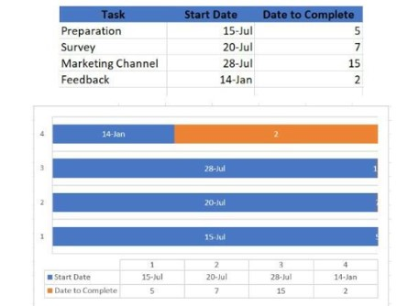
Figure: Gantt Chart
Source: (Jobber & Ellis-Chadwick, 2020)
Gantt chart of marketing activities: In four or five days, the Premier Inn advertising campaign would be completed. It is planned to do research on the intended audience by collecting both primary and secondary sources of information. It will take seven weeks to collect data from the target audience. With this information, a marketing strategy may be developed. It's scheduled to endure for a total of fifteen days. Then, others can share their thoughts. As the data is included, the necessary adjustments will be made.

Control
The top hotel company's unique selling proposition is the quality or feature that sets its wares apart from those of similarly priced rivals on the market. A product, for instance, can have significantly less productive than its rivals. If the business provides services rather than tangible things, its unique selling proposition (USP) could be that it will visit the client's location rather than vice versa (Kotler & Keller, 2019). The phrases "unique selling proposition statement" and "USP" are also synonymous.

Conclusion
Final Thoughts Premier Inn hotels have an excellent marketing approach that gets the word out about their services, prices, deals, and locations. They also have many positive qualities, which helps explain their popularity among British tourists. They recognize the need to manage their uncertainties in light of the fact that the economy and government are fraught with unpredictability, which could lead to a steady fall in sales. When it comes to advertising, the company is highly skilled at making sure its products are of excellent quality and that guests at its hotels have a relaxing and enjoyable stay. Digital advertising is also highly effective at bringing in and keeping repeat customers because of their usage of well-trafficked digital networking and a highly visited website. Using the strategies and procedures stated in the marketing plan can be time-consuming and costly. However, it is expected that these will become profitable once some time has passed. Premier Inn must now invest to ensure its future viability, productivity, growth, and even the continued interest and satisfaction of its clientele.

References
Bowie, D. et al. (2017) Hospitality marketing. 3rd edn. London, England : Routledge.
Brown, H. (2019) “The analysis of International Hospitality Management,” International Hospitality Management, 17(7/9), pp. 312–346. Available at: https://doi.org/10.4324/9780080547312-16.
Chaffey, D. and Ellis-Chadwick, F. (2022) Digital Marketing: Strategy, implementation, and practice. 6th end. Harlow, England: Pearson.
Clow, K.E. and Baack, D. (2022) Integrated Advertising, Promotion, and Marketing Communications. 6th end. Harlow, England: Pearson.
Czinkota, M.R., Ronkainen, I.A. and Cui, P. (2023) International Marketing. 7th end. Boston, England: Cengage Learning.
Henry, A. (2021) “Integrated Marketing Management,” Strategic Marketing Management (RLE Marketing), 12(2/6), pp. 237–270. Available at: https://doi.org/ 10.4324/9781315762043-21.
Jobber, D. and Ellis-Chadwick, F. (2020) Principles and practice of marketing. 9th end. London, England: McGraw-Hill Education.
Kitchen, P.J. (2021) Marketing communications: Principles and practice. 7th end. Landon, England: Thomson.
Kotler, P. and Keller, K.L. (2019) Marketing management. 6th end. Upper Saddle River, England: Pearson Prentice Hall.
Kotler, P., Kartajaya, H. and Setiawan, I. (2018) Marketing 4.0: Moving from traditional to digital. Landon, England: Wiley.
Palmer, A. (2020) Principles of Marketing. 5th end. Oxford, England: Oxford University Press.
Ryan, D. (2019) Understanding Digital Marketing: Marketing Strategies for engaging the digital generation. 7th end. London, England: Kogan Page.
Thomas, A. (2018 ) “ Marketing strategy sponsored by European Journal of Marketing,” European Journal of Marketing, 42 (9/10), pp. 12–39. Available at: https://doi.org/10.1108/ejm.2008.00742iaa.001.

Appendix: Presentation


