Name: Florece Odonkor
Student Number: 1818734
Lecturer: Anita Nan
ACADEMIC AND EMPLOYABILITY SKILLS

TABLE OF CONTENTS

1 …………………………… INTRODUCTION

2 …………………………… SKILL

3 …………………………… EMPLOYABILITY

4 …………………………… ACADEMIC SKILL

5 ……………………… IN CLASS EXERCISE

6 ………………………. PUBLISHED LITERATURE

6 ………………………… SKILL AT WORKPLACE

7 ………………………… CONCLUSION

8 ………………………… REFERENCES

The purpose of this report is to write an appropriately structured academic report analysing my personal academic and employability skills. As part of my report, I will be outlining my personal development and the skills acquired through this study. It will include problem solving techniques, time management, teamwork, organisational and interpersonal skills, including in-class exercises and published literature.
Prior to studying this course, I have made most decision impromptu by using my instinct or following a set of rules or standard procedure, but my approach to decision making has changed significantly, because I now prepare and plan using the skills acquired through academic and employability skills.
After studying this course, I now plan by analysing a problem, draw up an action plan, executing the plan and monitoring the entire processes from start to finish.
Skill is defined as the the ability to accomplish an activity or work with knowledge and less effort and as part of studying this programme, the following are some of the skills I have gained for the work environment, for example – Good communication, Teamwork, Problem solving, planning and organising, time management and the ability to think critically.
Good and Effective Communication – Academic skills has improved my communication, because I am able to listen to others, understand what they are saying and able to carry out instruction and provide a feedback, whether through verbal, oral, formal or informal conversation. I have also learnt to be concise, clear, open minded and communicate with respect.
When trying to understand information, I sometimes paraphrase statements into a more understandable context or summarize them into a simpler and more readable format.
To paraphrase is to express the meaning of a written or spoken statement using different words or terminologies to achieve a better understanding or clarity
Summary is a short or brief statement of the main points of an essay, that is to condense a long statement or story into short, simple and concise statement.
I strongly believe is good for me to acquire the appropriate academic and employable skills because it will enable me to do my work more effectively and efficiently
It is very important to have this skill set in the workplace because it will improve my communication skills, interpersonal relationship, ability to plan properly, organise and increase productivity.
Critical Thinking has been one of my favourite skills that enables me to prepare, set goals, plan and accomplishing task. With this skill, I am able to;
. Identify, construct and evaluate arguments
. Understand the logical connections between ideas
. Detect inconsistencies and common mistakes reasoning
. Solve problems systematically
. Identify the relevance and importance of ideas
. Objective in my approach to issues
. Fair and focused on the project or task
. Rational and not impulsive, that is weighing the pros and cons of the situation before making a decision
. Critical but creative, that is thinking out of the box
As a critical thinker able to deduce consequences from what I know and how to make use of information to solve problems, seek relevant sources of information to stay informed.
I have learned to set SMART goals ensuring that my goals are specific, measurable, realistic and time based, for example if my goal is to hold a weekly project meeting with my team to organise and run a test programme, I have to ensure each member of the team is informed about the meeting, the agenda, the venue, date and time. This will ensure each member of my team is well informed and adequately equipped coming into the meeting.
Time Management – managing my time has always been an issue for me, however, studying this course has helped me manage my time very well, had a very bad habit of keeping time, but, I now breakdown my task, activities and work into a timely fashion and set deadlines.
I have learned that whatever the qualities or attributes, I attain as successful leader, one essential skill I need is the effective use my time.
Time is a very unique resource, one cannot hire, rent or buy more time and the supply is irreplaceable and everything requires time.
The purpose of time management is to;
. Plan the best use of time
. cut down on time wasted
. devote more time to the really important issues or jobs at hand
. complete more work in the time available
. eliminate wastage
. refuse excessive workloads
. monitor project progress
. allocate resource (time) appropriate to task importance
. plan each day / week efficiently
Taking time to think and plan, is time well spent, because as the saying goes “failing to take time to plan, is in effect planning to fail”, therefore, a breakdown of my time spent in a typical week, divided between activities at work, home, study, leisure and travel is essential.

Copies of in class work and assignment;

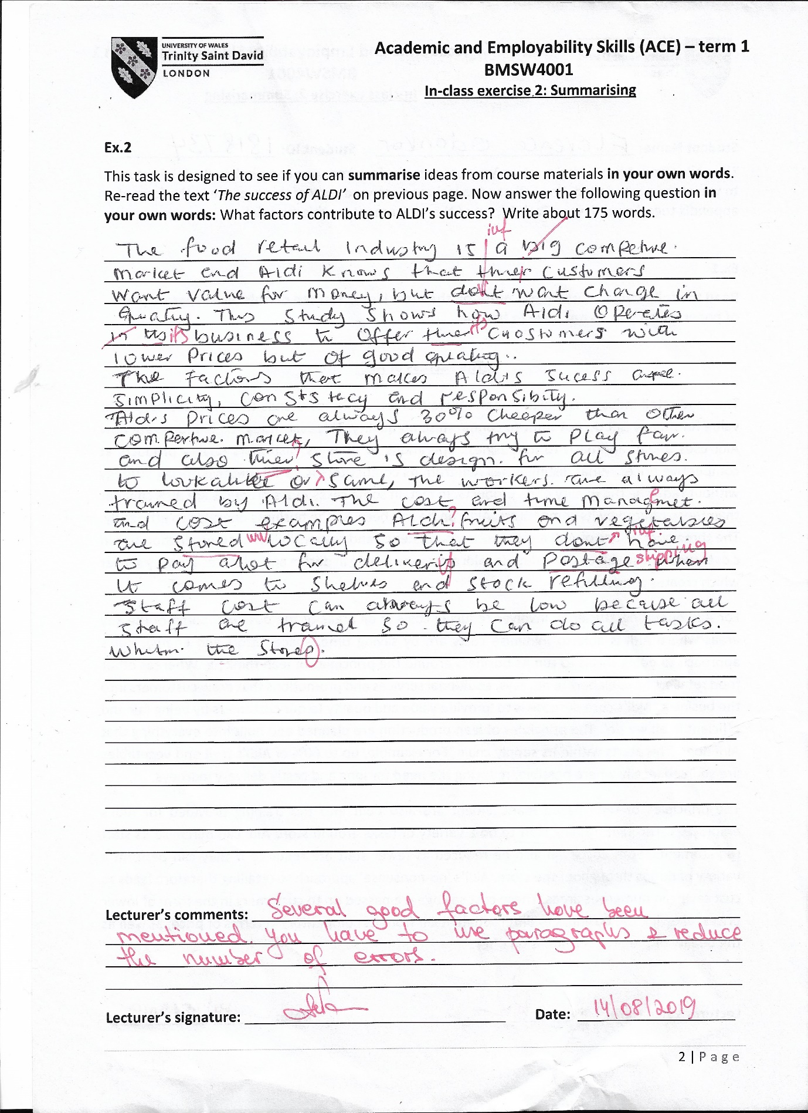

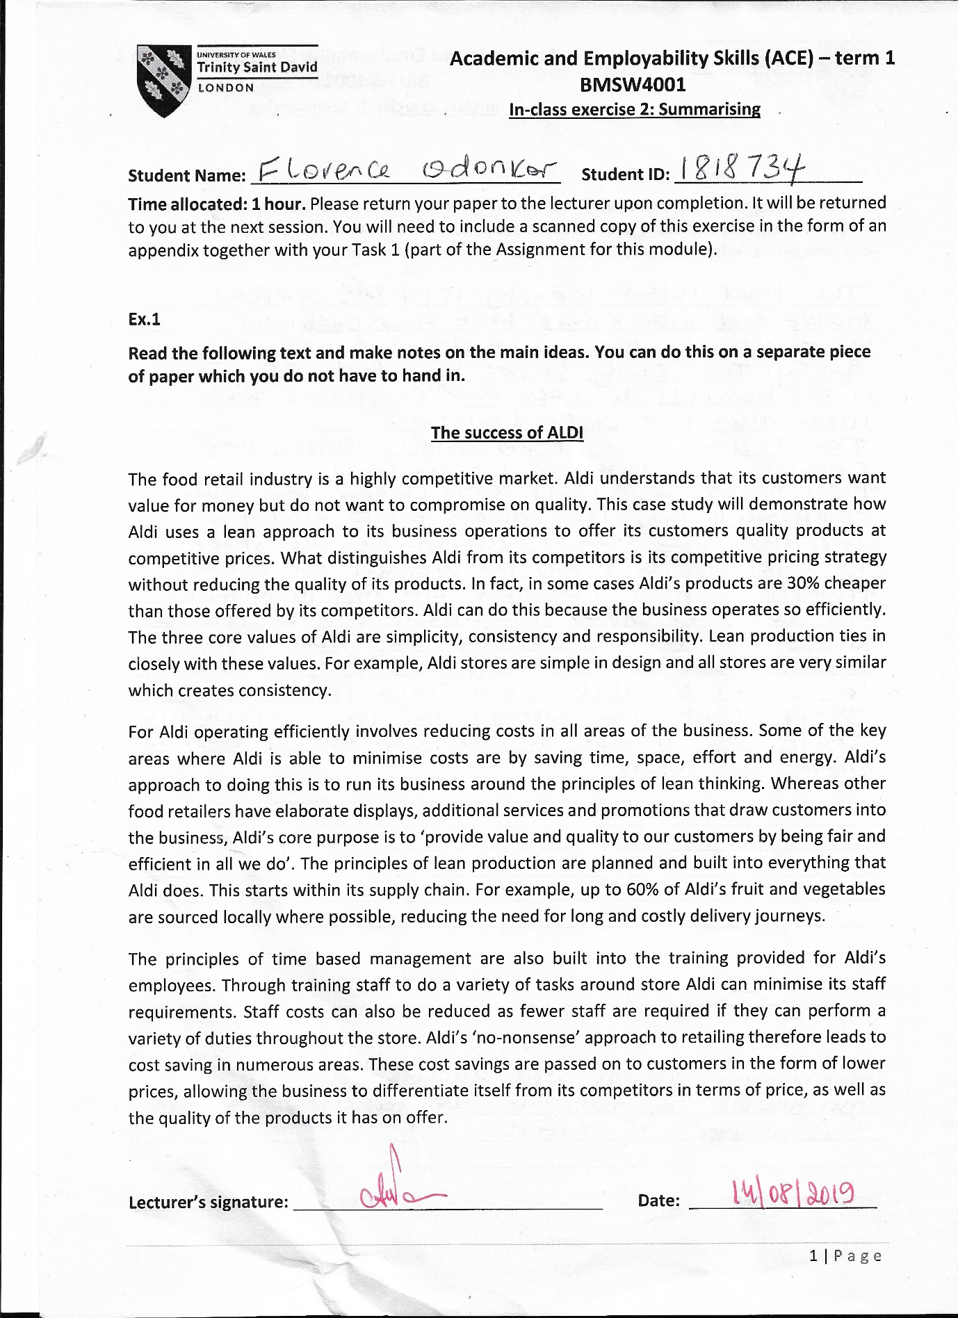

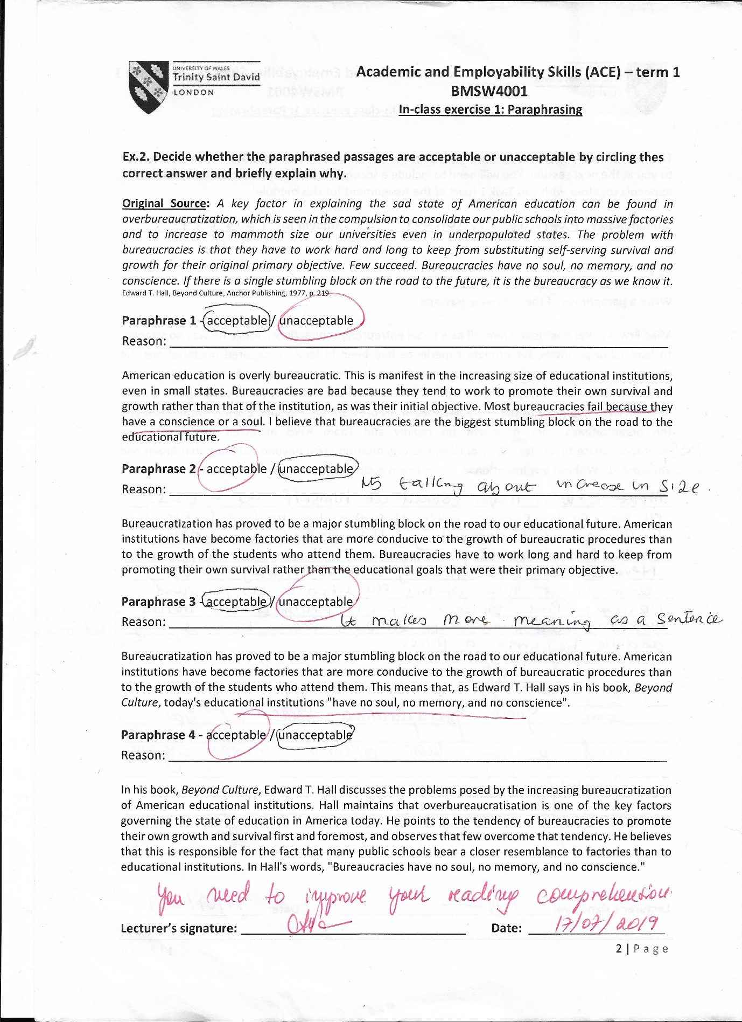

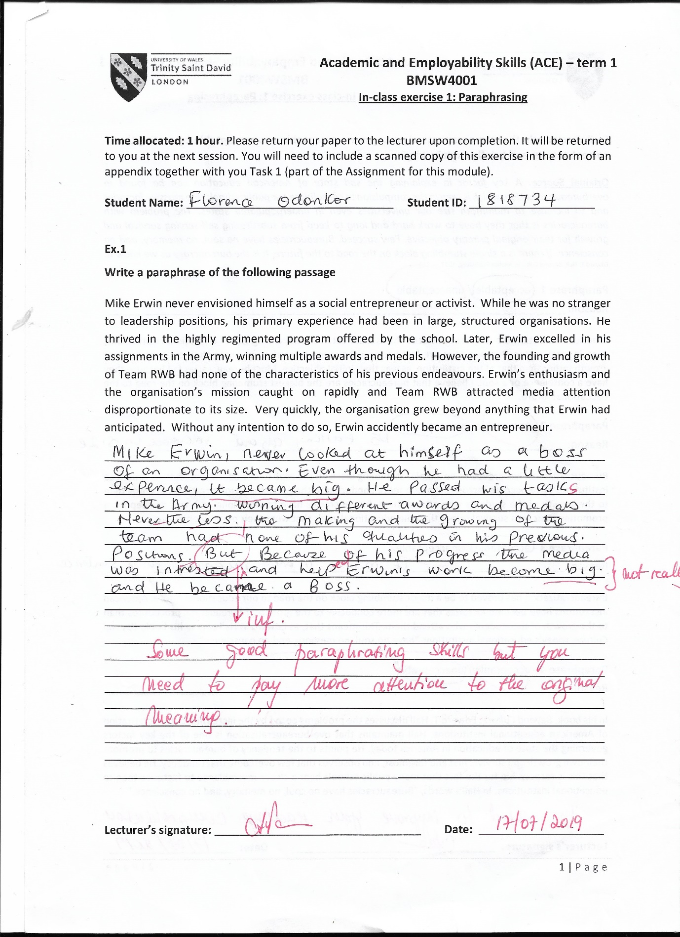

Defining employability is more difficult than might be imagined. the definition of employability has shifted throughout history, ait ontinues to be contested. A key issue is how far employability is a distinct concept from employment. In other words, it is possible to be employable but still unemployed. What is more, debates on the meaning of employability are not simply questions of academic interest. Rather a wide variety of stakeholders including Government, graduate employers, higher education providers and of course students and graduates themselves may have an interest in defining employability. The HEA’s (2013) employability framework represents an important and influential attempt to define employability in a way that could unite all of these stakeholders in a common conversation.
There is a strong consensus that employability is about more than obtaining employment, and that HEPs should not focus simply on supporting students to get their first job but instead support them to building positive and meaningful careers and to participate meaningfully in society. An influential and important definition of employability was developed by Yorke and colleagues in the Enhancing Student Employability Co-ordinating Team (ESECT) established by the HEA. This definition has spawned several models for embedding employability in the HE curriculum, notably the Understanding, Skills, Efficacy beliefs and employability is defined as: A set of achievements – skills, understandings and personal attributes – that make individuals more likely to gain employment and be successful in their chosen occupations, which benefits themselves, the workforce, the community and the economy. (Yorke and Knight 2006, p. 8)
The literature about employability in higher education is extensive and approaches the topic from a range of perspectives: for example, students and graduates, institutions, and policy-makers. In order to make sense of the diversity of material reviewed, we have adopted the following structure, which draws heavily on key components of employability identified by the HEA’s Framework for e embedding employability (2013), referred to as ‘the framework’, hereafter. The framework describes the key aspects of employability under the following headings: confidence, resilience and adaptability; experience and networks; attributes and capabilities; specialist technical and transferable skills; knowledge and application; behaviours, qualities and values; enterprise and entrepreneurship; career guidance and management; self, social and cultural awareness; reflection and articulation.
The aim of the review is to support the HEA to maintain an up-to-date evidence base and to better understand the practices and policies that have a demonstrable positive impact on employment outcomes. This has resulted in a focus on employability initiatives that are embedded within the HE curriculum, and in particular whether there is evidence that such initiatives work in practice. The objectives of the review are to: address the relationship between theory and practice and to assess whether there is scope to strengthen this relationship through the capture of key concepts and ideas drawn from research literature.
My organisation and working life for the past fifteen years has been in the Logistics environment. During the period I have worked in various positions within the organisation such as;
. Post room assistant – where we receive all the mails and post the come into the organisation, sort them into various departments and deliver them based on the positions, rankings and sensitivity of the mail
. Client Service or the Customer service – I was part of a team of three females and a male, we worked as the face of the organisation, taking phone calls, answering queries, reporting, informing and advising all the departments about client issues.
. Marketing Department – I must say this department was the most technical of all the departments I worked in, because we were a team of three, working along side the Business and Product analyst, we were given different project each month to advertise, market research and evaluate the competitive advantage it has in the market. Hence, we had to be innovative and always one step ahead of our competitors.
. Transport and Distribution – this is my current department and the experience is very intriguing, the focus of this department is effective delivery service. We ensure, every product that comes into us from a supplier, manufacturer, client, in-house, outbound is successfully delivered to the appropriate recipient or consignee and a proof of delivery is obtained. Besides, the delivery of the products, another function of my department is to ensure all the vehicles are well maintained and serviced.
The transport department have a unique task of understanding the geography of the business, that is knowing the location and address for all the clients and suppliers, demarcate the distribution area and track every product on delivery.
Learning new academic and employability skills has significantly improved my work and private life, so much so that am able to balance them properly and have time for other things.
In the past, I made decisions and on hindsight regret the out outcome, but, with a critical thinking approach am able to plan, organise, review and reflect, hence giving me a possible foresight of the possible outcome, which reduces my anxiety level through regrets.
My time keeping and managing my time has also changed, case in point, quite recently, I had the pleasure of join my old team within the marketing department to work on project called “The Brexit Challenges”. I was assigned the task of investigating the new United Kingdom with no deal, the challenges and effects on logistics. As a Mum of three and studying at Trinity Saint David, I knew the task was up against me, my stress and anxiety level began to kick in, however, using the skills acquired from academic and employability skills, I was able to plan and accomplish the task with any anxiety.
I structured my time in such a way that, the days I had lectures or class (Tuesdays and Wednesdays) were not compromised with any activity, I then broke down the topic into a suitable research method, which would enable me to collect the needed data and information for my analysis. The goal was to ensure that current affairs and new updates on the subject are relevant, because, the subject was continuously developing and changing by the hour. I was able to complete and submit my research findings before the agreed date for submission, all because of the new skills I have learnt to do things effectively and efficiently.
I am very enthusiastic about my chosen field of study and am hoping to further my learning and understanding of this skillset to a higher and advance level. I can confidently say that there has been a significant improvement in my way of approaching issues and decision making based on the skills I have acquired.

REFERENCES
- Peter B. (2017) The Business Student’s Guide To Study And Employability. London, CPI Group (UK) Ltd.
- https://www.kent,ac,uk/ces/student
- https://www.skillsyouneed.com/employment
- https://www.heacademy.ac.uk/system/files/resources/employability

