MBA – Master of Business Administration in General Management
Module: Marketing Management (LCMB7001)

Name - Shirinbanu Saiyed
Student ID - 2242206
University Name - University of Wales Trinity Saint David
Lecturer Name – Tushara Balendran
Year - 2023-24


Table of Contents
Introduction 3
Company Background 3
Environmental Marketing Analysis 4
Macro Environment or PESTLE Analysis of the Company 4
Political Factors 5
Economic Factors 6
Social Factors 6
Technological Factors 6
Legal Factors 6
Environmental Factors 7
Porter’s Five Forces of the Company 7
SWOT Analysis of the Company 8
Segmentation, Targeting and Positioning 9
Segmentation 9
Targeting 10
Positioning 10
4 P’s of Marketing Mix Strategies 10
Recommendations 12
Conclusion 12
References 14

Introduction
This paper has delved into a comprehensive environmental marketing assessment. It intends to assess the pivotal external factors influencing the company, along with a review of its internal environment as well as the strategic importance of marketing within the firm. This analysis develops the foundation for various actionable recommendations that will aid Shell towards a future which is aligned with internal strengths and market dynamics, promoting continual growth as well as competitiveness.

Company Background
Shell plc (Shell), earlier recognized as Royal Dutch Shell Plc, is a worldwide natural gas and oil business (Kalam, 2021). The business seeks and develops oil and gas from conventional reserves and supplies like shale, coal and tight rock formations. It operates and owns refineries and petrochemical sites throughout the world. Shell's line of goods encompasses bitumen, lubricants, and liquefied petroleum gas (LPG), along with petrochemicals like fundamental elements for paints, plastics, and detergents. In Brazil, the firm is an important manufacturer of biofuel. The organization is additionally engaged in a number of LNG, or liquefied natural gas and gas to liquids (GTL) ventures (Katičić, 2020). The organization offers its goods throughout Asia, Oceania, Europe, North America, Africa, and South America, both in-person and through distributors. Shell's head operations are in London, England. Shell declared almost a revenue of 381.3 billion U.S. dollars in 2022 which was a noticeable rise as compared to 2020, which was the consequence of mobility and economic restrictions imposed for combating the Covid-19 pandemic (Statista, 2023).
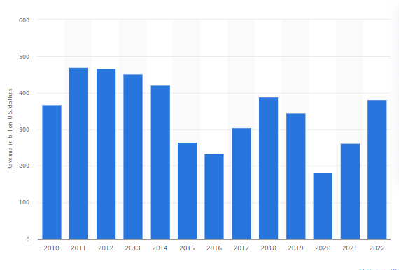
Figure 1: Shell’s Annual Revenue
(Source: Statista, 2023)

Environmental Marketing Analysis

Macro Environment or PESTLE Analysis of the Company
A PESTLE analysis of Shell Plc in the UK can explore the company’s business environment utilizing key factors such as political, economic, technological, social, environmental and legal factors.
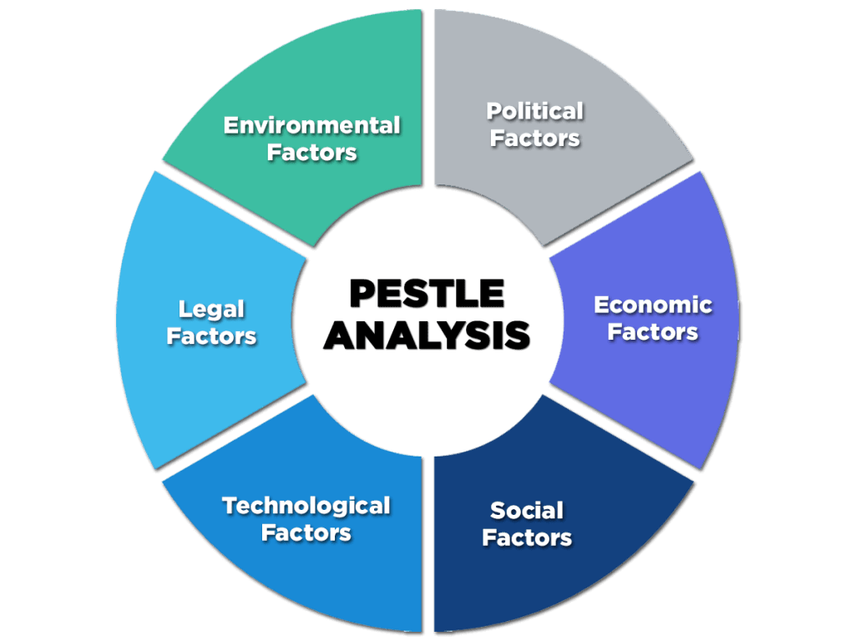
Figure 2: PESTLE Framework
(Source: Enterslice Inc, 2023)
Political Factors
Lately, regional and international bodies have started imposing charges inform of taxes and penalties on carbon emissions, gas and oil corporations have started responding by developing various survival strategies (Norouzi, 2021). They have been engaging in partnerships and alliances with governments in which they are likely to offer for providing various incentives for economic progress. Shell navigates political factors by building partnerships with governments, including the United States, while providing economic advantages in exchange for operational aid. Despite pressure to transition to more environmentally friendly fuels, Shell continues to depend primarily on crude oil. Programs like the Climate Action Partnership aim to enhance the company's public image, while practical carbon reduction still needs to be improved owing to strategic relationships. Shell has been commended for its economic development achievements across nations like Ghana and Nigeria (Nwankwo and Iyeke, 2022).
Economic Factors
Oil prices have gone up globally as production costs have gone up. Increased government taxation constitutes one of the reasons behind the increase in the cost of production. Secondly, greater expenditure on complicated, pricey technology has ended up resulting in greater production expenses. Simultaneously, energy demand is rising and is projected to climb by 57% by 2030 (NASA, 2023).
Social Factors
The general public's knowledge regarding renewable energy, sustainability, and environmental responsibility is rising. Shell has to adapt its strategies to meet changing expectations as society gets more environmentally sensitive (Carroll and Maher, 2023). Additionally, community involvement, worker diversity, and ethical issues all have an impact on the business's public image and operations.
Technological Factors
Technological development has led to the invention of more effective tools for extracting and recovering oil and gas. However, the new effective devices are quite costly. To effectively harvest oil and gas from nontraditional deposits, an enterprise has to invest substantially in focused technological tools. Shell has made major expenditures in cutting-edge technology and ranks as one of the companies that has gained the most from oil manufacturing and extraction (Vickram et al., 2023).
Legal Factors
Shell's operations are seriously affected by environmental restrictions, safety and security standards, and competitive regulations. Compliance with regulatory requirements, especially those regarding permits, emissions, and energy exploration, is critical in order to avoid penalties while keeping the organization's social license to operate (Haines et al., 2022).
Environmental Factors
Shell operates within an industry under mounting pressure for minimizing carbon emissions while transitioning to cleaner energy sources (Rony et al., 2023). Regulatory shifts, social demands for sustainability and global climate agreements all can drive Shell to invest in carbon capture, renewable and other environmentally-friendly initiatives.

Porter’s Five Forces of the Company
The Porter's Five Forces evaluation is a framework that assesses competing forces within a market that helps to comprehend a company's competitive position and expected profitability. When used by Shell PLC in the UK, the following findings emerge:
1. Threat of New Entrants: Because of huge capital requirements, legislative difficulties, and economies of scale, the energy sector has substantial obstacles to entry. Shell reaps the advantages of immense economies of scale, possession of resources, and established facilities as a well-established company (Agbesi et al., 2023). New competitors would need help to replicate such abilities, lowering Shell's market position threat.
2. Supplier Bargaining Power: Supplier bargaining power in the energy sector is rather moderate. While suppliers, like oil and gas exploration enterprises, retain some power given the scarcity of resources, Shell's worldwide presence and large supplier network enable it to bargain for favourable conditions and diversify its sources, thus diminishing supplier dominance (Hafezi et al., 2020).
3. Buyer Bargaining Power: In the energy market, buyer power is impacted by factors like price sensitivity and the affordability of alternative sources of energy. While some consumers, including major industrial clients, may have bargaining leverage, Shell's wide brand reputation, customer base, and the basic attributes of its offerings help it safeguard its market position.
4. Threat of Substitutes: As environmental concerns develop, substitutes in the energy sector, like nuclear power and renewable energy sources, make up a rising threat. Shell realizes this and has started to invest in renewable energy campaigns. Nevertheless, given the widespread availability of fossil fuels, as well as the complicated systems associated with energy supply, complete and fast substitution is challenging, providing Shell time to reconsider its strategy (Guo et al., 2023).
5. Competitive Rivalry: Big companies like Chevron, ExxonMobil, and BP fight for market share in the oil and gas industry. While this boosts competition, Shell's global footprints, diversified business areas (such as exploration, refining, and retail), and initiatives to innovate reinforce its competitive advantage. Additionally, collaborative activities and strategic alliances alter the competitive landscape even further.

SWOT Analysis of the Company
Strength | Weaknesses
- Shell possesses an international network in more than seventy nations, offering them an extensive market reach.  - Shell's business covers downstream, upstream, and integrated gas segments, thereby minimizing risk (Midttun et al., 2022).  - Shell specializes in cutting-edge innovations in order to boost operational efficiency. | - The organization's excessive dependency on fossil fuels induces environmental concerns.  - The energy market requires substantial expenditures, which may become a burden on finances.  - Changes in oil prices may exert a negative impact on profitability as well as revenue.  - The company has faced legal action for human rights and environmental violations.
Opportunities | Threats
- The transition to renewables presents prospects for economic growth via investments in green energy.  - As the popularity of electric vehicles expands, Shell will be able to expand the charging infrastructure while delivering additional amenities.  - The rise of energy products in developing economies provides new markets for goods. | - Severe carbon emission guidelines may have a bearing on traditional operations.  - ExxonMobil and BP represent significant obstacles to market share (Li et al., 2022).  - Rapid technological improvements might make some of Shell's assets out of order.

Segmentation, Targeting and Positioning

Segmentation
Shell combines geographic and behavioural segmentation approaches. It addresses industrialized as well as developing regions, customizing its remedies to local energy demands (Relva et al., 2021). Consumers are behaviorally classified according to their preferences for conventional fossil fuels, expanding renewable possibilities, and convenience-driven services, including gas stations.
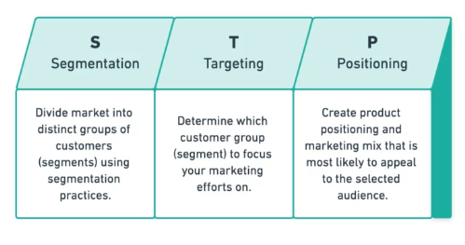
Figure 3: Segmentation, Targeting and Positioning
(Source: Yieldify, 2023)

Targeting
- Shell targets a diverse variety of customers, from individual vehicle owners to significant industrial organizations. It adapts its product line to suit an extensive spectrum of energy specifications, comprising diesel, gasoline, aviation fuel, and lubricants (Polónio, 2021).
- Shell seeks to gain an interest of the renewable energy market in light of a growing focus on clean energy.
- Shell makes investments in EV charging infrastructure to target the developing electric vehicle sector, especially EV owners who want straightforward and readily available charging options.

Positioning
Shell conveys itself as a supplier of high-quality, trustworthy energy products. The company's image is strengthened by its long-standing position in this sector and commitment to paying off global energy demands (Berg et al., 2021). Shell interprets itself as a progressive firm that supports technology improvements. It concentrates on generating cleaner energy solutions, promoting extraction research, and investigating new technologies such as carbon capture. Shell attempts to present itself as an ethical energy provider, notwithstanding the fact that it is mostly an oil and gas company.

4 P’s of Marketing Mix Strategies
The 4P’s of marketing mix are basic strategies that companies utilize for effectively marketing their services and goods. Applied to Shell, such strategies are likely to be aligned with the firm’s energy services and products.
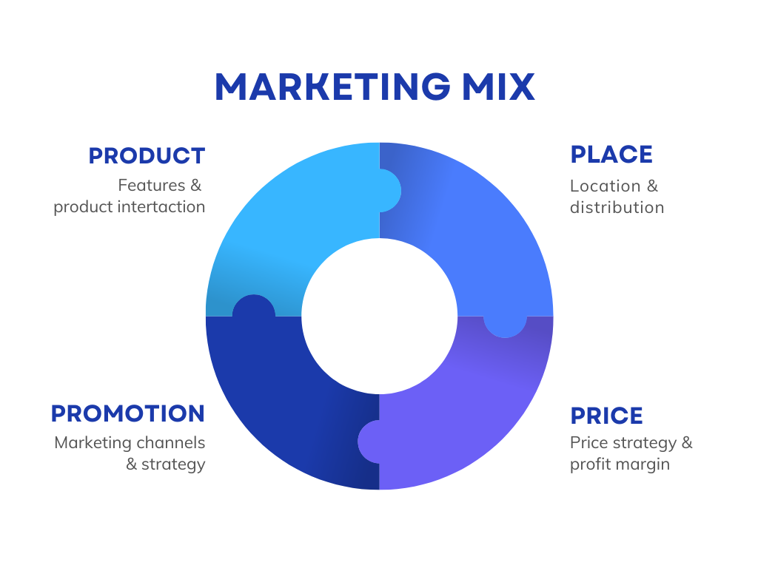
Figure 4: 4P’s of Marketing Mix Model
(Source: Pratt, 2022)
1. Product: Shell offers an extensive selection of energy products that include gasoline, diesel, lubricants, aviation fuel, and others. Additionally, the business has expanded into alternative energy sources like electric vehicle charging, biofuels, and hydrogen fuel cells (Yaqoob et al., 2021). Shell's line of products centres on assisting varying energy needs while simultaneously prioritizing innovation and sustainability in order to adapt to evolving market demands.
2. Pricing: Shell utilizes dynamic pricing strategies that rely on market variations. It takes into consideration variables, including supply and demand, crude oil pricing, and regional variances. While maintaining affordable rates, Shell underlines the worth of its superior workmanship and dependability (Tan et al., 2019).
3. Place: Shell's distribution network is a crucial part of its marketing strategy. Shell, which has an international reach, cautiously establishes its fuel stations and retail shops in convenient spots, emphasizing both rural and urban areas. In addition, the business is further developing its electric vehicle charging infrastructure in high-traffic areas, making it more readily available to EV owners.
4. Promotion: To boost brand recognition and engage consumers, Shell utilizes an assortment of advertising strategies. Conventional advertising, online advertising, and social media projects point out Shell's product quality and innovation. Promotions and loyalty programs, including service discounts or gasoline rewards, enhance repeat business and customer retention (Alshurideh, 2019).

Recommendations
Effectively dealing with the highlighted issues and capitalizing on the opportunities needs a well-rounded set of strategic advice for Shell PLC in the UK. Shell, as a leader in the growth stage of the product life cycle (PLC), ought to prioritize both defence and attack techniques. Shell ought to keep spending heavily on innovation to preserve its technological edge in the conventional and renewable energy areas in order to preserve its market position. Shell may control the risks linked to variable oil prices and evolving legislation by diversifying its service and product portfolio (Vieira et al., 2023). Shell should try resilient market penetration at the same time in order to introduce offensive plans throughout this critical growth stage. This involves increasing market share through competitive pricing approaches, the development of loyalty programs, and the execution of targeted advertising campaigns. In addition, establishing innovative collaborations with technology businesses and renewable energy startups helps accelerate the development of new goods and technologies. Such partnerships reinforce Shell's position as an industry innovator and build possibilities for joint R&D. Shell may negotiate the challenges imposed by regulatory changes, environmental issues, and competitive pressures by combining defence and inappropriate initiatives (Pulver, 2023). The approach enables Shell to keep its status as an energy pioneer, preserving its competitive edge and expansion while enhancing its position as a leader in an ever-changing industry.

Conclusion
Ultimately, Shell PLC in the UK operates in an ever-evolving energy market characterized by environmental issues, legislative advancements, and technology advancements. Navigating all of these challenges and potentials needs an appropriate strategy that involves safeguarding its position via innovation and portfolio diversification, along with aggressive market penetration and the creation of new collaborations. Shell can continue its leading role and ensure constant expansion and superiority in the energy business by accepting these ideas.

References
Agbesi, P.K., Ruffino, R. and Hakovirta, M., 2023. The development of sustainable electric vehicle business ecosystems. SN Business & Economics, 3(8), p.143. https://link.springer.com/article/10.1007/s43546-023-00486-5
Alshurideh, D.M., 2019. Do electronic loyalty programs still drive customer choice and repeat purchase behaviour?. International Journal of Electronic Customer Relationship Management, 12(1), pp.40-57. https://www.inderscienceonline.com/doi/abs/10.1504/IJECRM.2019.098980
Berg, H., Bendix, P., Jansen, M., Le Blévennec, K., Bottermann, P., Magnus-Melgar, M., Pohjalainen, E. and Wahlström, M., 2021. Unlocking the potential of Industry 4.0 to reduce the environmental impact of production. European Environment Agency, European Topic Centre on Waste and Materials in a Green Economy. https://www. eionet. europa. eu/etcs/etc-wmge/products/unlocking-thepotential-of-industry-4-0-to-reduce-the-environmental-impact-of-production.
Carroll, N. and Maher, M., 2023. How shell fueled a digital transformation by establishing DIY software development. MIS Quarterly Executive, 22(2), p.3. https://www.researchgate.net/profile/Noel-Carroll-5/publication/366606376_How_Shell_Fueled_Digital_Transformation_by_Establishing_DIY_Software_Development/links/6479cebcd702370600cc3ecb/How-Shell-Fueled-Digital-Transformation-by-Establishing-DIY-Software-Development.pdf
Enterslice Inc, 2023. Pestle Analysis: A Mechanism for Analysis of Businesses. Diagrammatic Representation Of Pestle Analysis.[Online] Available at: https://enterslice.com/learning/pestle-analysis-a-mechanism-for-analysis-of-businesses/. Accessed on: 28.08.2023.
Guo, Y., Yang, Y., Bradshaw, M., Wang, C. and Blondeel, M., 2023. Globalization and decarbonization: Changing strategies of global oil and gas companies. Wiley Interdisciplinary Reviews: Climate Change, p.e849. https://wires.onlinelibrary.wiley.com/doi/abs/10.1002/wcc.849
Hafezi, R., Wood, D.A., Akhavan, A.N. and Pakseresht, S., 2020. Iran in the emerging global natural gas market: A scenario-based competitive analysis and policy assessment. Resources Policy, 68, p.101790. https://www.sciencedirect.com/science/article/abs/pii/S0301420720300349
Haines, F., Bice, S., Einfeld, C. and Sullivan, H., 2022. Countering corporate power through social control: What does a social licence offer?. The British Journal of Criminology, 62(1), pp.184-199. https://academic.oup.com/bjc/article-abstract/62/1/184/6282891
Kalam, K.K., 2021. The Effects of Mergers & Acquisitions on Financial Performance: Case Study of Acquisition of BG Group by Royal Dutch Shell. Open Access Library Journal, 8(3), pp.1-21. https://www.scirp.org/journal/paperinformation.aspx?paperid=108059
Katičić, M., 2020. The acquisition of BG Group by Royal Dutch Shell (Doctoral dissertation, University of Zagreb. Faculty of Economics and Business. Department of Organization and Management). https://repozitorij.unizg.hr/islandora/object/efzg:5921
Li, M., Trencher, G. and Asuka, J., 2022. The clean energy claims of BP, Chevron, ExxonMobil and Shell: A mismatch between discourse, actions and investments. PloS one, 17(2), p.e0263596. https://journals.plos.org/plosone/article?id=10.1371/journal.pone.0263596&ref=refind
Midttun, A., Khanieva, M., Lia, M. and Wenner, E., 2022. The greening of the European petroleum industry. Energy Policy, 167, p.112964. https://www.sciencedirect.com/science/article/abs/pii/S0301421522001896
NASA, 2023. In Brief: Report predicts 57% growth in world energy use by 2030. The SAO/NASA Astrophysics Data System. [Online] Available at: https://ui.adsabs.harvard.edu/abs/2007EOSTr..88S.246Z/abstract. Accessed on: 28.08.2023.
Norouzi, N., 2021. Post‐COVID‐19 and globalization of oil and natural gas trade: Challenges, opportunities, lessons, regulations, and strategies. International journal of energy research, 45(10), pp.14338-14356. https://onlinelibrary.wiley.com/doi/full/10.1002/er.6762
Nwankwo, E. and Iyeke, S., 2022. Analysing the impact of oil and gas local content laws on engineering development and the GDP of Nigeria. Energy Policy, 163, p.112836. https://www.sciencedirect.com/science/article/abs/pii/S0301421522000611
Polónio, T.R.G., 2021. Equity Research: Royal Dutch Shell: Driving Revenue Through Uncertainty in the Oil and Gas Markets (Doctoral dissertation, Universidade NOVA de Lisboa (Portugal)). https://www.proquest.com/openview/666adb5fb8aaf0ee2e3ba6015d8fa7fe/1?pq-origsite=gscholar&cbl=2026366&diss=y
Pratt, M., 2022. What is the 4P Marketing Matrix?. Business.org. [Online] Available at: https://www.business.org/marketing/sales/marketing-101-4p-matrix/. Accessed on: 28.08.2023.
Pulver, S., 2023. Corporate concessions: Opportunity or liability for climate advocacy groups?. Global Environmental Change, 81, p.102689. https://www.sciencedirect.com/science/article/pii/S0959378023000559
Relva, S.G., da Silva, V.O., Gimenes, A.L.V., Udaeta, M.E.M., Ashworth, P. and Peyerl, D., 2021. Enhancing developing countries’ transition to a low-carbon electricity sector. Energy, 220, p.119659. https://www.sciencedirect.com/science/article/abs/pii/S0360544220327663
Rony, Z.I., Mofijur, M., Hasan, M.M., Rasul, M.G., Jahirul, M.I., Ahmed, S.F., Kalam, M.A., Badruddin, I.A., Khan, T.Y. and Show, P.L., 2023. Alternative fuels to reduce greenhouse gas emissions from marine transport and promote UN sustainable development goals. Fuel, 338, p.127220. https://www.sciencedirect.com/science/article/abs/pii/S0016236122040443
Statista, 2023. Revenue of Shell from 2010 to 2022. Fossil Fuels. [Online] Available at: https://www.statista.com/statistics/268734/revenue-of-shell/. Accessed on: 28.08.2023.
Tan, Q., Zhao, W., Han, K., Li, P., Wang, W.A., He, D., Liu, Z., Yu, Q., Qin, M. and Qu, X., 2019. The multi-yolk/shell structure of FeP@ foam-like graphenic scaffolds: strong P–C bonds and electrolyte-and binder-optimization boost potassium storage. Journal of Materials Chemistry A, 7(26), pp.15673-15682. https://pubs.rsc.org/en/content/articlelanding/2006/gy/c9ta04550c/unauth
Vickram, S., Manikandan, S., Deena, S.R., Mundike, J., Subbaiya, R., Karmegam, N., Jones, S., Yadav, K.K., Chang, S.W., Ravindran, B. and Awasthi, M.K., 2023. Advanced biofuel production, policy and technological implementation of nano-additives for sustainable environmental management–A critical review. Bioresource Technology, p.129660. https://www.sciencedirect.com/science/article/abs/pii/S096085242301088X
Vieira, L.C., Longo, M. and Mura, M., 2023. From carbon dependence to renewables: The European oil majors' strategies to face climate change. Business Strategy and the Environment, 32(4), pp.1248-1259. https://onlinelibrary.wiley.com/doi/full/10.1002/bse.3185
Yaqoob, H., Teoh, Y.H., Goraya, T.S., Sher, F., Jamil, M.A., Rashid, T. and Yar, K.A., 2021. Energy evaluation and environmental impact assessment of transportation fuels in Pakistan. Case Studies in Chemical and Environmental Engineering, 3, p.100081. https://www.sciencedirect.com/science/article/pii/S2666016421000037
Yieldify, 2023. The Complete Guide to STP Marketing: Segmentation, Targeting & Positioning. What is STP marketing? [Online] Available at: https://www.yieldify.com/blog/stp-marketing-model/. Accessed on: 28.08.2023.

