
Module Assignment Submission
Student Name: | Kelly forbes6
Student Number: | 2114235
Module Code: | BMSK5012
Module Title: | Understanding and engaging in customer the experience

Statement of Confirmation of Authenticity
By the act of making this submission, the student declares that this is the work of the student named above. The work has not, in whole or in part, been knowingly presented elsewhere for assessment, or where assessment has been built on a previous assessment, this has been identified. Where materials have been used from other sources it has been properly acknowledged. If this statement is untrue, the student acknowledges that an assessment offence has been committed.
Attention is drawn to the plagiarism and unfair practice policies of the University.

Table of Contents
Introduction 3
What is customer value? ……………………………………………………………………………………………………………………….
different types of customer value……………………………………………………………………………………………….
why is customer value important ……………………………………..3
custmore relationship stadge .

hieararcy of emotional value 16
kano model .
Garvins 8 demensions
lean thinking……………………………………………………………………………………………………………………………………………
14 Deming points management………………………………………………………………………………………………………………..
conclusion…………………………………………………………………………………………………………………………………………………
references…………………………………………………………………………………………………………………………………………………

Introduction
My name is *kelly forbes, I am in level five of leadership and management. In this assignment we will be looking at what is customer value, what are different types of values and why are they important and Garvin 8 dimensions and the kano model.

Explaining what is customer value.
Customer value refers to the perceived benefit that a customer gains from a product or service compared to the cost they incur to obtain it. It encompasses the overall experience and satisfaction that a customer derives from their interaction with a brand, product, or service. There are two main components to customer value: 1. Functional Value: This relates to the practical benefits a product or service provides. For example, if a customer buys a smartphone, the functional value includes features like battery life, camera quality, and ease of use. It answers the question, "How well does this product meet my needs?" 2. Emotional Value: This aspect involves the feelings and emotional responses that a customer associates with a product or brand. For instance, a luxury brand may evoke feelings of status and prestige, contributing to its overall value in the eyes of the customer. Emotional value answers the question, "How does this product make me feel?" Customer value is crucial because it influences purchasing decisions. When customers perceive that the value they receive exceeds the price they pay, they are more likely to make a purchase. Conversely, if they feel the value is lacking, they may seek alternatives. Additionally, customer value is not static; it can change over time based on various factors such as market trends, customer preferences, and competitive offerings. Businesses that actively seek to understand and enhance customer value can foster loyalty, drive repeat purchases, and create positive word-of-mouth referrals.

Why is customer value important?
Customer value is a crucial concept in the world of business and marketing, as it directly influences customer satisfaction, loyalty, and overall company success. Understanding and delivering customer value helps businesses differentiate themselves from competitors and build strong relationships with their customers. One of the primary reasons customer value is important is that it drives customer satisfaction. When customers perceive the value of a product or service to be high, they are more likely to be satisfied with their purchase. This satisfaction leads to repeat purchases and long-term loyalty. Satisfied customers are also more likely to recommend the brand to others, which can enhance a company’s reputation and attract new customers. In today’s competitive market, where options are abundant, providing exceptional customer value can be a key differentiator. Moreover, customer value plays a significant role in pricing strategies. Companies that understand what their customers value can set prices that reflect that value, allowing them to maximize profit margins while still meeting customer expectations. If customers perceive that they are getting more value than what they are paying for, they are more likely to make a purchase. This perception can be influenced by various factors, including product quality, customer service, brand reputation, and even the overall shopping experience. Additionally, focusing on customer value encourages businesses to innovate and improve their offerings continually. When companies prioritize understanding their

how to create customer value

Creating customer value involves several strategies that businesses can implement to enhance the overall experience for their customers. Here are some effective ways to do this: 1. Understand Customer Needs: Conduct market research to identify what your customers truly want and need. This can include surveys, interviews, or analyzing customer feedback. Understanding these needs helps tailor products and services accordingly. 2. Focus on Quality: Ensure that your products or services meet high-quality standards. Quality can significantly enhance functional value, leading to higher customer satisfaction. 3. Enhance Customer Experience: Provide excellent customer service and create a seamless buying experience. This includes easy navigation on your website, prompt responses to inquiries, and a smooth checkout process. 4. Offer Personalization: Tailor your offerings to individual customer preferences. Personalization can significantly increase emotional value by making customers feel valued and understood. 5. Provide Value-Added Services: Consider offering additional services that complement your main product. For example, free installation, warranties, or customer support can enhance the perceived value. 6. Build Relationships: Foster strong relationships with your customers through engagement and communication. Loyalty programs, newsletters, and follow-up surveys can help maintain a connection. 7. Stay Competitive: Regularly analyze competitors to ensure your offerings remain competitive in terms of price, quality, and features. Offering unique selling points can help differentiate your brand. 8. Solicit Feedback and Improve: Regularly ask for customer feedback and be willing to make changes based on their suggestions. This shows customers that you value their opinions and are committed to improvement. 9. Educate Customers: Provide resources, tutorials, or guides that help customers understand how to use your products effectively. This can enhance functional value and improve customer satisfaction. 10. Create a Strong Brand Identity: Develop a brand that resonates with your target audience. A strong brand identity can enhance emotional value and create a sense of loyalty among customers. By implementing these strategies, businesses can effectively create and enhance customer value, leading to increased satisfaction, loyalty, and ultimately, business success.

Customer Brand Value (CBV)

Customer brand value refers to the worth that a brand holds in the minds of consumers based on their perceptions, experiences, and interactions with it. This value can significantly influence customer loyalty, purchasing decisions, and overall market performance. Here are some key components that contribute to customer brand value: 1. Brand Awareness: The extent to which customers recognize or are familiar with a brand. High brand awareness can lead to greater trust and preference over competitors. 2. Brand Loyalty: This reflects the commitment of customers to repurchase or continue using a brand over time. Loyal customers often advocate for the brand, contributing to its positive reputation. 3. Brand Associations: These are the attributes, benefits, and qualities that customers associate with a brand. Strong, positive associations can enhance the perceived value of the brand. 4. Perceived Quality: This is the customer's perception of the overall quality or superiority of a brand's products or services compared to others. Higher perceived quality often correlates with higher brand value. 5. Emotional Connection: Brands that create emotional connections with customers tend to have higher brand value. This can be achieved through storytelling, shared values, and community engagement. 6. Customer Experience: The overall experience a customer has with a brand, from initial contact to post-purchase interactions, contributes to brand value. Positive experiences can lead to higher satisfaction and loyalty. 7. Social Responsibility: Brands that demonstrate corporate social responsibility and contribute to societal or environmental causes can enhance their value in the eyes of consumers who prioritize these aspects. 8. Innovation: Brands that consistently innovate and offer new, relevant products or services can maintain a competitive edge and enhance their value. By focusing on these components, businesses can build and maintain strong customer brand value, which can lead to increased sales, customer loyalty, and a stronger market position.

Customer Referral Value (CRV)
Customer referral value refers to the worth that a customer brings to a business through their recommendations and referrals to others. This value can significantly impact a company's growth and profitability. Here are some key aspects to understand about customer referral value: 1. Definition: Customer referral value is the potential revenue generated from new customers who are acquired through recommendations made by existing customers. It reflects the influence and trust that existing customers have within their networks. 2. Importance of Referrals: Referrals are often more valuable than traditional marketing efforts because they come with a level of trust. When a friend or family member recommends a product or service, the likelihood of the referred person making a purchase increases significantly. 3. Customer Lifetime Value (CLV): Referrals can enhance the overall customer lifetime value. Referred customers often have a higher CLV because they tend to make repeat purchases and have a higher level of loyalty. 4. Cost-Effectiveness: Acquiring customers through referrals is typically less expensive than traditional advertising methods. Businesses can save on marketing costs while still reaching new potential customers. 5. Referral Programs: Many businesses implement referral programs to incentivize existing customers to refer new ones. This can include discounts, rewards, or other benefits for both the referrer and the new customer. 6. Word-of-Mouth Marketing: Positive word-of-mouth from satisfied customers can enhance a brand's reputation and attract new customers. Encouraging customers to share their experiences can amplify this effect. 7. Measurement: To assess customer referral value, businesses can track metrics such as the number of referrals, conversion rates of referred customers, and the overall revenue generated from these referrals. By understanding and leveraging customer referral value, businesses can create strategies to encourage referrals, ultimately leading to increased customer acquisition and growth.

Customer Lifetime Value (CLV)
Customer Lifetime Value (CLV) is a crucial metric that represents the total revenue a business can expect from a single customer throughout their entire relationship with that business. Understanding CLV helps companies make informed decisions about marketing, sales, and customer retention strategies. Here are the key points about CLV: 1. Definition: CLV estimates the total amount of money a customer will spend on your products or services during their lifetime as a paying customer. 2. Importance: Knowing the CLV helps businesses understand how much they can afford to spend on acquiring new customers. It also highlights the long-term value of retaining existing customers, as retaining a customer is often cheaper than acquiring a new one. 3. Calculation: CLV can be calculated using the formula: \[ CLV = (Average Purchase Value) \times (Average Purchase Frequency) \times (Average Customer Lifespan) \] - Average Purchase Value: The average amount spent by a customer in a single transaction. - Average Purchase Frequency: How often a customer makes a purchase within a specific time frame (e.g., annually). - Average Customer Lifespan: The average duration (in years or months) that a customer continues to buy from the business. 4. Factors Affecting CLV: - Customer Retention: Higher retention rates lead to a higher CLV. - Upselling and Cross-selling: Encouraging customers to buy additional products can increase their lifetime value. - Customer Experience: Providing excellent service can enhance customer loyalty, leading to more repeat purchases. 5. Applications: Businesses use CLV to: - Allocate marketing budgets effectively. - Identify high-value customers for targeted marketing efforts. - Develop customer retention strategies to enhance long-term profitability. By focusing on increasing the CLV, businesses can improve their overall financial health and ensure sustainable growth over time.
S

Customer Relationship Management (CRM)
A tool known as customer relationship management (CRM) is used to handle all interactions and relationships between your business and its clients. The objective is straightforward: to strengthen business ties. CRM systems assist businesses in maintaining contact with clients, streamlining procedures, and boosting profitability.
A company's website, emails and phone calls are all examples of CRM components. One way for businesses to respond to developments that benefit their bottom line is through social media. CRM's primary goal is to create positive customer experiences because doing so will promote repeat business and aid in the expansion of a company's network of devoted customers. Having customer relationship management is good because Your sales team can concentrate on opportunities that are likely to close and give customers correct responses quickly and efficiently by sorting, analysing, and prioritising your sales leads using a CRM, and your customer care team will have the data they require for upselling and cross-selling.

Customer Influence Value (CIV)

Having someone that is well known that is advertising your company products or services is a very handy tool too have. In today society with all these influencers on social media. Like having a celeb trying out your products and is very impressed with your product or service is even better because people will automatically think ooh if that celeb is enjoying the product or service then it must be good and will go and buy or invest in the service or product.
Customer that have bought the product before can also influence new customers into buying the product, Customer behaviour can affect a whole business, and on occasion, new industries are even created. The most prosperous businesses anticipate customer behaviour and launch a product or service at the same time as or even before the general public realises that they require it. It very important to keep updated with offers and schemes so the old and new customers keep coming back for more.

Customer Relationship stages

The stages of customer relationships typically refer to the various phases a customer goes through when interacting with a business. Understanding these stages can help businesses develop effective strategies to nurture relationships and enhance customer loyalty. Here are the main stages: 1. Awareness: This is the initial stage where potential customers become aware of a brand or product. Marketing efforts, advertisements, social media, and word-of-mouth play significant roles in creating awareness. 2. Consideration: At this stage, customers evaluate the brand and its offerings. They may compare it with competitors, read reviews, and seek more information. Businesses can engage customers through informative content, testimonials, and targeted marketing. 3. Purchase: This is the stage where the customer makes a decision and completes a purchase. The buying process should be smooth and user-friendly to encourage conversions. Providing excellent customer service during this phase can enhance the purchasing experience. 4. Retention: After a purchase, the focus shifts to retaining the customer. This involves maintaining communication, providing excellent post-purchase support, and offering loyalty programs. The goal is to encourage repeat purchases and foster a long-term relationship. 5. Advocacy: In this final stage, satisfied customers become advocates for the brand. They may share their positive experiences with others, leave reviews, and recommend the brand to friends and family. Businesses can encourage advocacy by engaging with customers on social media and recognizing their loyalty. By understanding these stages, businesses can tailor their marketing and customer service strategies to effectively guide customers through their journey, ultimately leading to stronger relationships and increased loyalty.
.

What customers require
Customer needs are the specific characteristics that a product must possess in order to satisfy the customer's expectations regarding value and quality as well as to be practical and appealing to them. These are shifting standards that are always evolving in tandem with the times, generations, technology, and fashions. Customer requirements are the standards that any product or service is designed to satisfy. These needs served as the foundation for the product's design and launch. Customers will most likely not buy the product if these requirements are not met, and even if they do, there won't be any recurring business. Customer requirements are comparable to needs, but they are more tangible, real, and accessible.
Three categories of client needs exist, including must-haves, satisfiers, and delighters. Without
Customers expect things to be understood while not expressly stating their desire for them. With the satisfiers they are what the customers wants and needs if introduce better satisfiers the happier and more appreciative the customer will become. The delighters are just the extra icing Basically, the consumer doesn't really appreciate these additions and will leave feeling extremely satisfied; if they hadn't been there, they wouldn't have noticed.
An excellent example is the software industry, where software is developed in response to client needs. The ability to make orders, examine a list of restaurants and their menus, process payments, and track deliveries are just a few of the features that customers might request from meal delivery app developers. A good product will feature many intangibles and delighters, such the ability to view real-time location, multiple payment options, loyalty, the capacity to plan orders, and many more, in addition to these tangible necessities and must-haves.

Hierarchy of emotional value

A value hierarchy is different from a bucket list or a list of your top ten values. It is a psychological framework made up of all the relationships you have developed among your values. Your current awareness interacts with this stored structure to create an emotion.
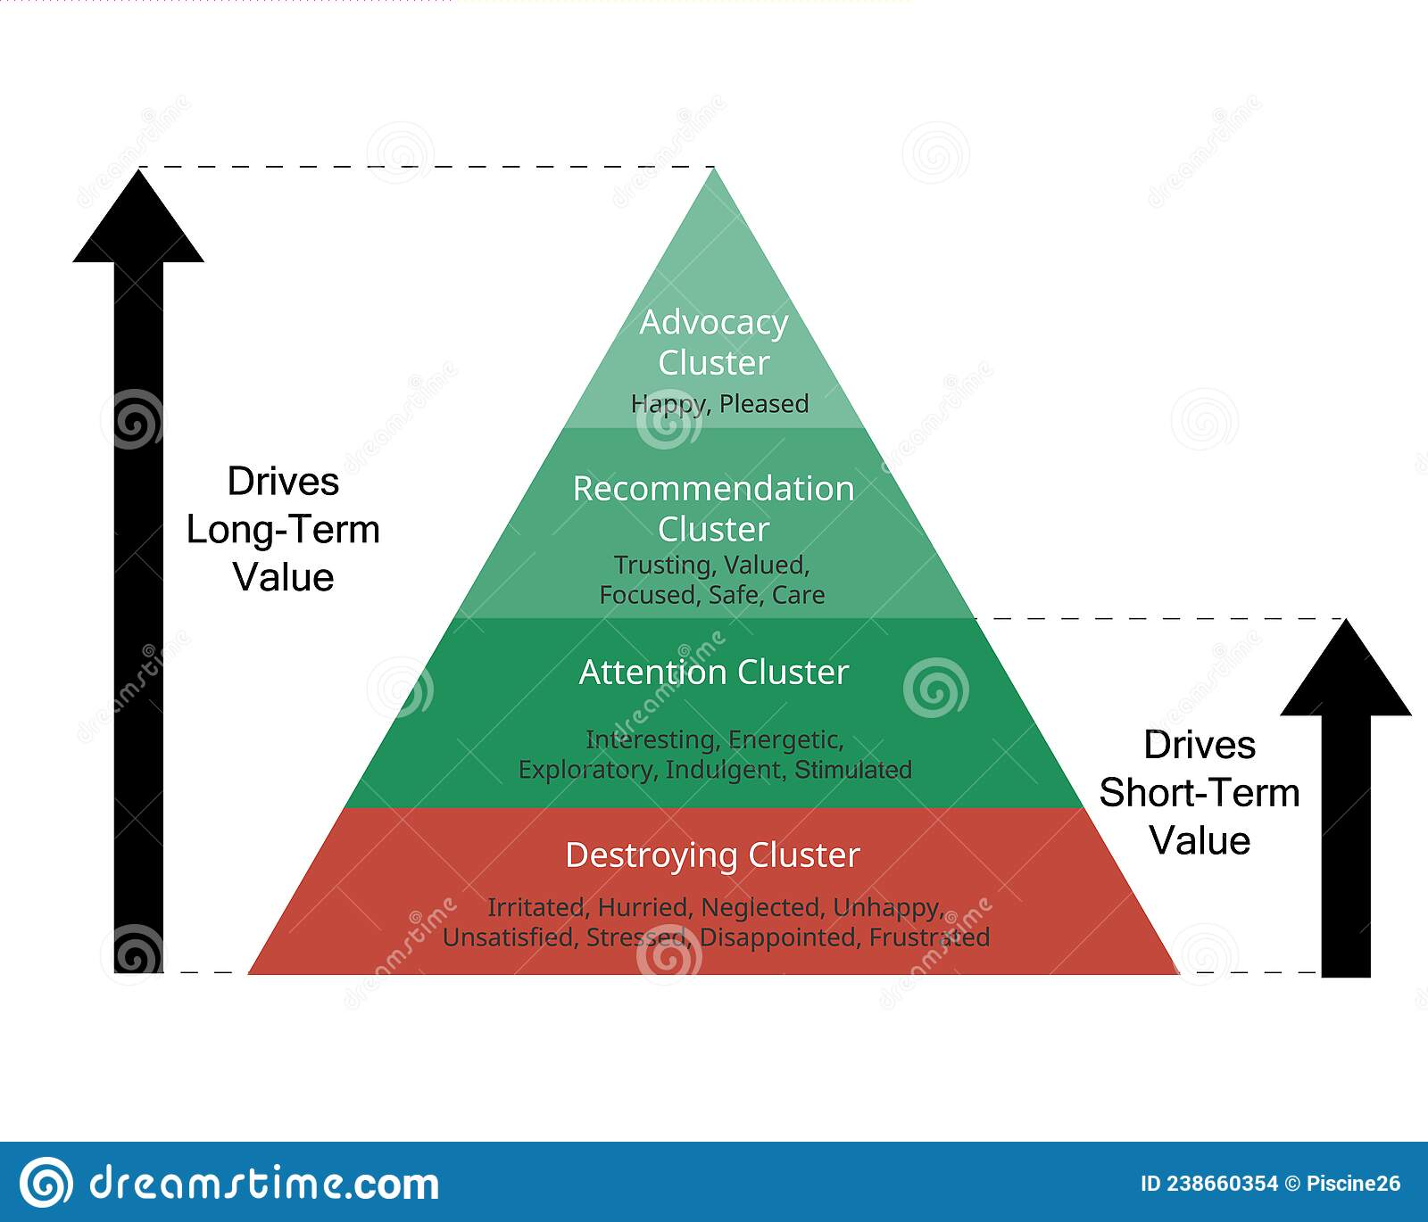

The Advocacy Cluster, which consists of just two feelings, Happy and Pleased, is essential to your experience. People are constantly looking for more happiness because they rarely believe that what they already have is enough.

A group of suggestions This group includes people who are focused, safe, caring, trustworthy, and valuable. These sentiments are the foundation of customer loyalty. The recommendation is required in order to reach the advocacy cluster that staged these.
The five emotions that comprise the Attention Cluster are Indulgent, Exploratory, Stimulated, Interested, and Energetic. This cluster of emotions is the only one that affects short-term spending. The impact will diminish and may even reverse if you don't consistently attend to these feelings.
Resentment, impatience, neglect, grief, dissatisfaction, tension, disappointment, and frustration are some of these emotions. Any of these emotions brought on by the customer experience could ultimately cost you money in lost opportunities, decreased sales, and extra expenses to address the issues that

The kano model
The Kano model is a framework used to understand and prioritize customer needs and preferences. It helps businesses categorize features and attributes of a product or service based on how they affect customer satisfaction. The model identifies five categories of needs: 1. Basic Needs (Must-be): These are the essential features that customers expect. If these needs are not met, customers will be dissatisfied. However, meeting these needs does not significantly increase satisfaction, as they are taken for granted. For example, a car must have brakes to be safe. 2. Performance Needs (One-dimensional): These needs are directly related to how well a product or service performs. The better these needs are met, the more satisfied customers will be. For instance, the fuel efficiency of a car is a performance need; higher efficiency leads to greater customer satisfaction. 3. Excitement Needs (Delighters): These are unexpected features that can greatly enhance customer satisfaction when present but do not cause dissatisfaction when absent. They can create a "wow" factor. For example, a car that comes with a free maintenance package might delight customers. 4. Indifferent Needs: These features do not significantly impact customer satisfaction, whether they are present or not. Customers are indifferent to these attributes, meaning they do not influence their purchasing decision. 5. Reverse Needs: These are features that can cause dissatisfaction if present. For example, overly complex technology in a car might frustrate customers who prefer simplicity. By using the Kano model, businesses can prioritize product development and improvements based on how different features influence customer satisfaction. This helps in delivering a product that meets and exceeds customer expectations effectively.

Garvin dimensions of quality
The Garvin dimensions of quality are a framework developed by David A. Garvin to help organizations understand and measure quality in their products and services. Garvin identified eight dimensions of quality, which are: 1. Performance: This dimension refers to how well a product or service performs its intended function. It includes attributes such as speed, efficiency, and overall effectiveness. For example, in a car, performance would include acceleration and handling. 2. Features: Features are the additional characteristics that enhance a product's appeal beyond its basic function. These can include design elements, special functions, and any added benefits that differentiate a product from its competitors. 3. Reliability: This dimension measures the likelihood that a product will perform consistently over time without failure. High reliability means fewer breakdowns or defects, which is crucial for customer satisfaction. 4. Conformance: Conformance refers to how well a product meets established standards and specifications. This includes adherence to design, manufacturing, and performance standards. A product that conforms to specifications will meet customer expectations. 5. Durability: Durability indicates how long a product lasts before it needs repair or replacement. A durable product withstands wear and tear and provides value over time. 6. Serviceability: This dimension assesses how easy it is to repair or maintain a product. Serviceability includes the speed, competence, and ease of obtaining service or repairs. 7. Aesthetics: Aesthetics relate to the sensory characteristics of a product, such as design, style, and overall appearance. This dimension is subjective and can vary greatly among different customers. 8. Perceived Quality: This dimension encompasses the customer's perception of the overall quality of a product or service based on brand reputation, marketing, and personal experiences. It may not always align with the actual performance but significantly influences customer satisfaction. By evaluating these dimensions, businesses can better understand customer expectations and improve their offerings to enhance overall quality and satisfaction.

Lean thinking
The two pillars of lean, which serve as a foundation from which to learn, comprehend, and develop, are essential to comprehending lean thinking: Continuous improvement basically implies that every employee in your organisation is actively looking for possibilities and carrying out projects that improve work.
- Overproduction: Producing ahead of what’s actually needed by the next process or customer. The worst form of waste because it contributes to the other six.
- Waiting: Operators standing idle as machines cycle, equipment fails, needed parts fail to arrive, etc.
- Conveyance: Moving parts and products unnecessarily, such as from a processing step to a warehouse to a subsequent processing step when the second step instead could be located immediately adjacent to the first step.
- Processing: Performing unnecessary or incorrect processing, typically from poor tool or product design.
- Inventory: Having more than the minimum stocks necessary for a precisely controlled pull system.
- Motion: Operators making movements that are straining or unnecessary, such as looking for parts, tools, documents, etc.
- Correction: Inspection, rework, and scrap

14 Deming points of management The demoing points of management refer to key areas or practices that are essential for effective management in any organization. Here are some important points to consider: 1. Planning: This involves setting objectives and determining the best course of action to achieve them. Effective planning helps in resource allocation and prioritizing tasks. 2. Organizing: This point focuses on arranging resources and tasks to achieve the objectives set during the planning phase. It includes defining roles, responsibilities, and establishing a structure for the organization. 3. Leading: Leading involves motivating and guiding employees to work towards the organization's goals. Good leadership fosters a positive work environment and encourages teamwork. 4. Controlling: This point is about monitoring and evaluating progress towards the goals. It includes setting performance standards, measuring actual performance, and taking corrective actions when necessary. 5. Communication: Effective communication is crucial in management. It ensures that information flows smoothly within the organization, helping to align efforts and resolve issues quickly. 6. Decision-Making: Managers are often faced with making decisions that affect the organization. Effective decision-making involves analyzing information, considering alternatives, and choosing the best course of action. 7. Motivation: Understanding what motivates employees is key to enhancing productivity and job satisfaction. Managers should implement strategies to keep their teams engaged and motivated. 8. Teamwork: Promoting collaboration among employees leads to better problem-solving and innovation. Managers should encourage a culture of teamwork and support. These demoing points can help managers effectively oversee their teams and drive the organization towards successclusion

After all, research indicates that customer value and all of its components depend on whether or not the customer is happy with the product or service. For this reason, it is crucial to continuously review and improve the product or service in order to increase revenue for the company.

References
https://www.mbaskool.com/business-concepts/marketing-and-strategy-terms/11884-customer-requirements.html#:~:text=Customer%20Requirements%20are%20the%20certain,and%20desirable%20by%20the%20customer. (no date) Google search. Google. Available at: https://www.google.com/search?q=Destroying+Cluster+hierarchy+emtional+value (Accessed: May 7, 2023).

(no date) Google search. Google. Available at: https://www.google.com/search?q=Destroying+Cluster+hierarchy+emtional+value (Accessed: May 7, 2023).

https://www.google.com/search?q=hierarchy+emtional+value&sxsrf=APwXEddjIyEd2vxpTLwhFKGNJ7twtLk8nQ%3A1683464661010&ei=1aFXZNccrJqR1Q_xgraIBg&ved=0ahUKEwiX2_HIouP-AhUsTaQEHXGBDWEQ4dUDCA8&uact=5&oq=hierarchy+emtional+value&gs_lcp=Cgxnd3Mtd2l6LXNlcnAQAzIICAAQCBAeEA0yCAgAEIoFEIYDMggIABCKBRCGAzoKCAAQRxDWBBCwAzoECCEQCkoECEEYAFDfAliQDWC7LWgBcAF4AIABbogB7Q6SAQQ0LjE1mAEAoAEByAEIwAEB&sclient=gws-wiz-serp (no date) Google search. Google. Available at: https://www.google.com/search?q=Destroying+Cluster+hierarchy+emtional+value (Accessed: May 7, 2023).
https://www.google.com/search?q=adovcacy+cluster+hierarchy+emtional+value&sxsrf=APwXEdfzbDsEQ4Jn93FP0dhvjL2xA_pcmg%3A1683465307912&ei=W6RXZNqdN467kdUPy5CDgAg&ved=0ahUKEwiat639pOP-AhWOXaQEHUvIAIAQ4dUDCA8&uact=5&oq=adovcacy+cluster+hierarchy+emtional+value&gs_lcp=Cgxnd3Mtd2l6LXNlcnAQAzIFCAAQogQ6CggAEEcQ1gQQsANKBAhBGABQzARYzARg0xxoAXABeACAAWyIAWySAQMwLjGYAQCgAQHIAQjAAQE&sclient=gws-wiz-serp (no date) Google search. Google. Available at: https://www.google.com/search?q=Destroying+Cluster+hierarchy+emtional+value (Accessed: May 7, 2023).
https://www.mbaskool.com/business-concepts/marketing-and-strategy-terms/11884-customer-requirements.html#:~:text=Customer%20Requirements%20are%20the%20certain,and%20desirable%20by%20the%20customer. (no date) Google search. Google. Available at: https://www.google. com/search?q=Destroying+Cluster+hierarchy+emtional+value (Accessed: May 7, 2023).
https://www.mbaskool.com/business-concepts/marketing-and-strategy-terms/11884-customer-requirements.html#:~:text=Customer%20Requirements%20are%20the%20certain,and%20desirable%20by%20the%20customer. (no date) Google search. Google. Available at: https://www.google.com/search?q=Destroying+Cluster+hierarchy+emtional+value (Accessed: May 7, 2023).
https://blog.hubspot.com/service/how-to-calculate-customer-lifetime-value (no date) Google search. Google. Available at: https://www.google.com/search?q=clv%2Bcustomer%2Blifetime%2Bvalue&sxsrf=APwXEdfY- &sclient=gws-wiz-serp (Accessed: May 7, 2023).

Harvard Business School (n.d.), Faculty and Research Profile of David A. Garvin. Available online here. (Accessed July 10, 2016.)
SkyMark Corporation, (n.d.), Management Thought Leaders Profile of Genichi Taguchi. Available online Home (no date) MindTools. Available at: https://www.mindtools.com/axzeq31/garvins-8-dimensions-of-quality (Accessed: May 7, 2023).
here. (Accessed July 1 0, 2016.)
Dr. Deming's 14 Points for Management - The W. Edwards Deming Institute

