E- portfolio
changemakers: building your personal brand for sustainable empoly
Student name: Sanah Ellahi
Student number: 2019343
Module code: BMHP5015_BIRM
Lecturer: Dr tayo Korede
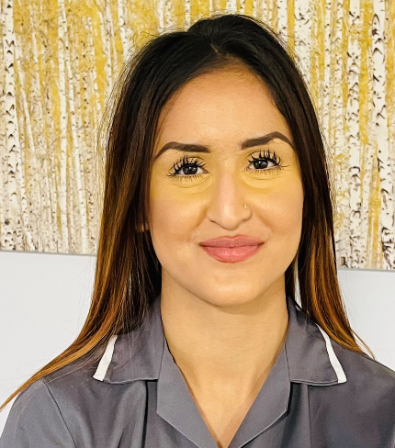
Sanah Ellahi
Health care practitioner

07752551485

Sanah-96@hotmail.com

www.linkedin.com/in/sanah-ellahi-111nb22225

6 Fernley Road, Spark hill, Birmingham City

Dear, Mr Noel,

With reference to your ad on indeed, I came across to know that your hospital is looking for a registered nurse practitioner. As keen as I am for this position, merely I am writing to express my interest for the role. As a considerable experienced health care professional with five years of extensive experience and skills that satisfy your requirements, I am extremely interested in serving at your esteemed organization.

I have been part of medical camps which arranged by the public health care centres. Working as an independent healthcare practitioner at a practise in maypole grove hospital for 4 years.
I am uniquely qualified to aiding patients in cases of acute and chronic illness, as well as being able to assist with minor surgical process making it possible for me to take care of more than one patient at a time. In my capacity as a health professional, I can offer other help for patients with basic tips on self-care and health behaviours.

I will surely be of use to your organization with my knowledge and experiences. Perseverance, goal driven work ethic and great communication is what I am about, ready to make big impact on people’s life and to your organization. If you feel like I am the right person then for more information about my experiences, qualifications and skills you can refer to the attached resume. Contact and feel free to call me on 07752551485 or email me on Sanah-96@hotmail.com
Thank you for your time and consideration.

Sincerely,
Sanah Ellahi
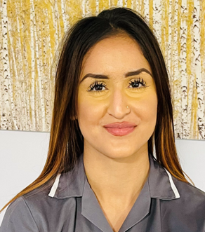
summary
A professional Health assistant dedicated to providing exemplary clinical care to patients with 5 years of experience delivering outstanding compassionate care to patients. I am enthusiastic about becoming a nurse practitioner to be able to commit to providing high quality of personal centred care.

Education

Bachelor of Science health and social care- University of Wales 2019

Bachelor of science in adult nursing – currently studying – university of Birmingham

Experiences

Trainee/placement at Sandor cardiology specialist, Birmingham. – September 2021

- Maintain high level standards of care for inpatient and outpatients
- Contacting health assessments, and supporting patients with cardiac conditions with accessor
- Learning the Planning and implementing of strategies for recovery
- Understanding on Assessing and evaluating needs for diagnosis and recovery plan
- Looking it to explaining course of care and medication

Health assistant in Greet medical practice London

- Recording and updating patients medical and vital signs
- Maintain records and reports
- Working alongside physician for involvement of recovery stage

Certificates

First Aid Training

Sanah Ellahi

Contact information

Sanah-96@hotmail.com
07752551485
6 Fernley Road, Birmingham

Skills

- Bilingual
- Ms office
- Time management
- Chronic illness/ time management skills
- Diagnostic studies

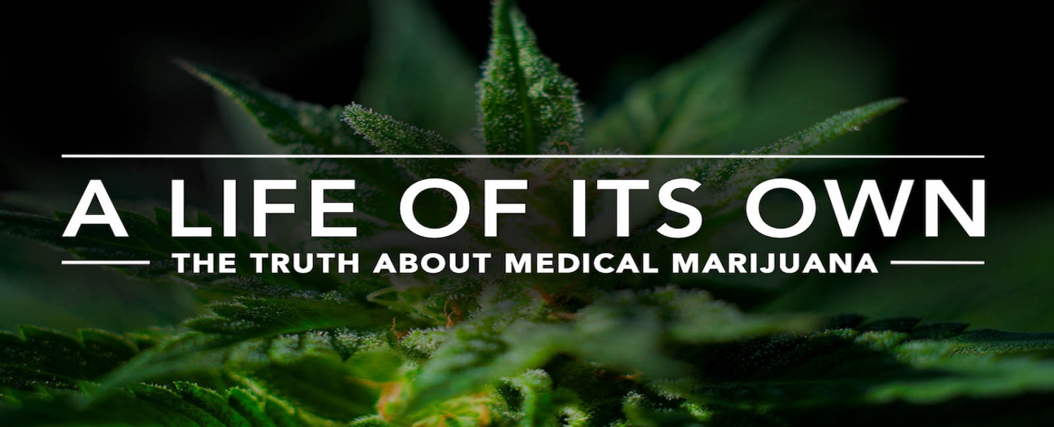
Medical Cannabis for Chronic Pain

(MedTech, n.d.)

Tv documentary proposal for chronic pain suffers on BBC 1

The importance of proposal

A growing interest is being shown in the use of medical marijuana to treat migraines, headaches, pain and chronic pain. The use of medical marijuana continues to gain popularity in states that have legalized it, leading to increased discussions and questions regarding the drugs medical benefits. What can be the best medical marijuana stains be for migraines or headaches? Is it helpful for chronic migraines and chronic pain? How is it legal? And what are the side effects?
Many of us often assume that medical marijuana is just a street drug used to predominantly for recreational and abuse, without any real medical benefits.

Through the proposal of this tv document I hope to educate and understand the medical benefits for people who suffer with chronic pain and even other medical pain or problems. The relevancy of this documentary does not only apply to people with chronic pain but will increase the support and legalisation of medical cannabis to another level. Throughout the tv programme on medical cannabis for chronic pain, I hope to encourage, enlighten and engage the wider public worldwide of the significant importance of why medical cannabis should be legalised across the world in all counties for people who suffer from chronic pain which is a global problem.
Proposal content
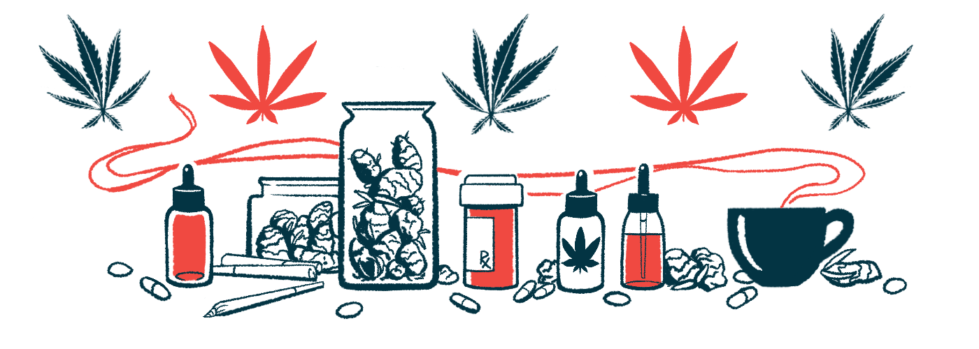

I propose that this tv documentary will highlight the use of substitutional medical cannabis for pain medication. The viewer will be drawn to the journey of the individuals showing all side effects and better pain managements with chronic pain and showing you how it impacts them on a day-to-day basis. 50% participants are woman and adults over the age of 50 years old. As the journey continues, families and friends of suffers will be part of the programme showing you the hardships they face and what impact medical cannabis has had on their families. Professional such as doctors will also have their import of the benefits and scientific evidence which will be a big game changer of the people watching. The conclusion of the serious will has an impact on the viewers minds around medical cannabis for chronic illness and pain and make them understand the real issues of the suffers who need to be able to understand the concept of how it changes their lives medically and in general to live without pain especially pain that can’t be seen. Even though a great deal of research and review has already been done on cannabis and the effectiveness in treating the pain over the past decade, showing a study of the therapeutic effect of cannabis concluded that these effects are conclusive or substantial (Maharajan et al., 2019). It is not enough to understand the realness of chronic pain and use of medical cannabis to manage pain so this program will spread awareness, knowledge and really help people identify causes and problems people face.
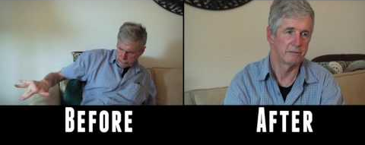
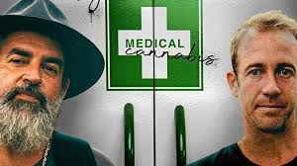

Referancces

Piper, B.J., Beals, M.L., Abess, A.T., Nichols, S.D., Martin, M.W., Cobb, C.M. and DeKeuster, R.M. (2017). Chronic pain patientsʼ perspectives of medical cannabis. PAIN, [online] 158(7), pp.1373–1379. doi:10.1097/j.pain.0000000000000899.
Boehnke, K.F., Scott, J.R., Litinas, E., Sisley, S., Williams, D.A. and Clauw, D.J. (2019). Pills to Pot: Observational Analyses of Cannabis Substitution Among Medical Cannabis Users With Chronic Pain. The Journal of Pain, [online] 20(7), pp.830–841. doi:10.1016/j.jpain.2019.01.010.
Busse, J.W., Vankrunkelsven, P., Zeng, L., Heen, A.F., Merglen, A., Campbell, F., Granan, L.-P., Aertgeerts, B., Buchbinder, R., Coen, M., Juurlink, D., Samer, C., Siemieniuk, R.A.C., Kumar, N., Cooper, L., Brown, J., Lytvyn, L., Zeraatkar, D., Wang, L. and Guyatt, G.H. (2021). Medical cannabis or cannabinoids for chronic pain: a clinical practice guideline. BMJ, [online] 374, p.n2040. doi:10.1136/bmj.n2040.
Maharajan, M.K., Yong, Y.J., Yip, H.Y., Woon, S.S., Yeap, K.M., Yap, K.Y., Yip, S.C. and Yap, K.X. (2019). Medical cannabis for chronic pain: can it make a difference in pain management? Journal of Anesthesia, 34(1), pp.95–103. doi:10.1007/s00540-019-02680-y.
Banerjee, S. and McCormack, S. (2019). Medical Cannabis for the Treatment of Chronic Pain: A Review of Clinical Effectiveness and Guidelines. [online] PubMed. Ottawa (ON): Canadian Agency for Drugs and Technologies in Health. Available at: https://www.ncbi.nlm.nih.gov/books/NBK546424/.

