STUDENT'S NAME: TATIANA RAILEANU

STUDENT ID NUMBER:2211942

MODULE TITLE:
ENTREPRENEURSHIP BMIH5001

LECTURER ’S NAME:CHARLOTTE JOYNER

Part 1

Introduction
Entrepreneurship has become one of the emerging trends that aids innovation along with driving economic growth, addressing challenges along with encouraging societal progress (Barringer and Ireland, 2018). Drawn upon this premise, this report will present a holistic eco friendly business plan which is curated simply upon sustainability and eco-friendliness. Its value proposition under Business Model Canvas will be evaluated along with reflecting upon personal experiences and motivations supported by entrepreneurial theories under Gibbs Reflective Cycle.

Discussion
ReNew Cottages can be illustrated to be created upon the concept of eco-friendliness which would offer a rejuvenating experience for the guests to stay in energy efficient Cottages as per their preference which would be surrounded by greenery all over. SMART technology will be equipped in all cottages and hotels which would be integrated with the goal to optimise usage of energy and make guests experience some workshops on sustainable living by conducting programs on renewable energy, upcycling and organic gardening (Abdou et al. 2022). The seasonal menu (food) that the hotel's on-site restaurant would provide would be all locally sourced, thus blending environmental consciousness and comfort together. The perfect location for this business can be the Lake District of the UK. It is because the Lake District is widely known for its lush green spaces and enchanting scenic beauty that seems to be the perfect backdrop for setting ReNew Cottages. This would enable this business venture to align their business model with their envisioned sustainability goals, thus building an attractive and appropriate setting for the guests to spend time amid nature and eco-friendly lifestyle. Collaborating with suppliers like OceanHarvest and GreenFarm Coop from the UK can be recognised as one of the imperatives towards their commitment of ethical sourcing of foods (Goldberg, 2020). A number of sustainability measures would be implemented in the hotel premises and those ate implementation of digital in-room directories for it would not provide paper copies of anything as everything would be available online. There would also be eco-conscious housekeeping practices which would help reduce housekeeping frequency to a standard level by prioritising energy and water conservation along with complete removal of single-use plastics, 100% renewable energy and zero-waste initiatives all around the property. These concepts have been driven by the prime factors of growing reliance on sustainability practices and people's conscious nature to stop negatively impacting the environment (Nekmahmud and Fekete-Farkas, 2020).
Drawing upon the business concepts identified in the BMC template, it can be outlined that it will implement sustainable construction by utilising eco-friendly materials along with energy saving technologies like smart home appliances and solar panels. It would help the cottages and hotel rooms at ReNew Cottages to contribute towards a low carbon footprint which showcases their commitment in terms of environmental responsibility. On the other hand, as discussed in the BMC template, it would establish collaboration with the local suppliers namely GreenFarm Coop and OceanHarvest for procuring seasonal and fresh produce along with partnering up with local artisans for eco-friendly decor and furniture. It is because supporting the local businesses at large proves to be highly efficacious in not just fostering community engagement but reducing transportation emissions and promoting the regional economy to accomplish its sustainability goals. Offering workshops on upcycling, organic gardening and renewable energy will be extended to customers which would engage guests in getting empowered to include eco-conscious practices in their daily lives (Rickman and Roddick, 2013). Waste reduction practices like recycling and composting would be encouraged in the cottage premises along with much encouragement would be appreciated towards using reusable products (Williams, 2021). This helps promote a circular economy that emphasises responsible consumption. Apart from this, promoting biodiversity by including more of native plants and making habitats for the local wildlife would also be done in ReNew Cottages that would again set it distinct from its competitors. One of the best methods to maintain accountability of a sustainable business model is by regularly monitoring and reporting on one's energy consumption, water, or waste management along with the environmental metrics so that the guests know of their credibility with implementing sustainable practices.
There has been an increasing demand for seeking eco-friendly accommodation while travelling in the UK (Kim et al. 2021). Not only the UK residents but people all over the globe have started choosing more sustainable products. This has been one of the driving factors which has not just informed the decision of this innovative business concept but would contribute to its success as well. After a survey was conducted by Statista (2023), it was found that around one third of UK consumers prefer buying more eco-friendly or sustainable products. Not only in terms of sustainable foods, but people tend to have an increasing demand for eco-friendly accommodation while travelling. An online survey conducted between July 2019 and July 2022 has recorded the findings that the share of tourists or travellers preferring eco-friendly accommodation (or hotels) have increased over the last 2 years to 37% (Statista, 2023). These are some of the factors which have influenced this business concept and that is why the business is thought of as an eco-friendly business model offering sustainable living choices for travellers without degrading the environment. Another driving factor is the Government Initiative named “The Green Homes Grant” which extends over £5,000 funds for making energy-efficient improvements to rented and owner-occupied homes (LinkedIn, 2023). On the contrary, this business focuses on making collaborations with local suppliers for locally sourced, natural foods grown without any harmful chemicals and this is yet another prominent factor that has impacted this business model. Under this premise, market research is one such factor which would attest to the success of this concept for ReNew Cottages can continuously adapt to evolving customer preferences with the aid of market research only. It will help this eco-friendly hotel to remain aligned with the present sustainability trends. Flexibility to implement smart technologies for driving sustainable energy solutions is yet another factor which would help this to step towards building energy-efficient cottages and accommodations for people, without harming the environment (Nelson, 2013). There would also be guest education given on environmental responsibility via informative materials or workshops. Similar initiatives have been taken by the Eden Project in Cornwall that has illustrated the success of such experiential environmental workshops (Burns, 2022).
There are many real-life hotels and cottages of similar fashion which have influenced this business concept decisions. One such is the Sykes Holiday Cottages in the UK which helps in making eco-conscious choices for travellers like fresh farm produce from local farmers, local sourced materials and buying fresh which has led to huge increase in its occupancy rates (Sykes Cottages, 2024). Apart from it, they also have smart cottages integrated with renewable energy sources and water saving technologies which makes it even more compelling for the eco-friendly travellers to indulge. It is upon this concept that ReNew Cottages has also been integrated with various water saving technologies along with energy saving technologies so that it should not retain the old customers but attract a large pool of eco-conscious tourists and travellers seeking experiential and sustainable stays during holidays. Besides this, it would target especially those people who are much more inclined to value environmental consciousness and possess a deep connection to nature. Furthermore, Gen-Z between 16-24 age groups is predicted to be more environmentally and socially conscious than the others and 54% states that one of the important factors that has to be taken care of while travelling is the impact of environmental travelling on destinations (Booking.com, 2019). Upon this notion, there has been various innovative technologies which would be integrated in these cottages at ReNew Cottages which would not just benefit the holistic environment by saving water, energy and promising reduction in carbon footprints and food waste but also encourage sustainable travelling in people. Frasers Hospitality is yet another prominent name in this industry which has secured a great name among individuals with its sustainability framework and thus it can pose huge competition to this new hospitality company. It has gone paperless along with using 100% renewable energy sources (Frasers Hospitality, 2024). Thus, this is yet another renowned accommodation which has influenced a lot behind the creation of this new eco-friendly business model acting progressively towards not just focusing on people but helping them to consume and travel responsibly. Even though these entities have shaped this idea, they are competitors as well for the eco-friendly features they offer. Drawn from this premise, ReNew Cottages has an unique standpoint of its own and the things that sets itself apart is its engagement with the local community, sustainable construction and eco-education workshops that aids guests to experience an immersive experience altogether. It is by partnering with the local suppliers that it strengthens the ties with the community, thus ensuring a small ecological footprint as compared to competitors who might rely more on international or centralised suppliers (Erhun et al. 2021). This business idea seems to distinguish itself in terms of its value proposition that combines extending immersive customer experiences with sustainable luxury practices. Pain relievers of ReNew Cottages address the concerns of the eco-aware travellers by ensuring their establishment of cottages from every aspect, ranging from daily operations to construction materials that relates to environmental responsibility. Gain creators aid in delivering community education with its workshops based on renewable energy and organic gardening. Its products deliver services beyond accommodation but are an illustration of a transformative experience for travellers to enjoy that emphasises sustainability and eco-friendly design without compromising on the quality and comfort.

Conclusion
Therefore, ReNew Cottages can be a potential hospitality business concept in the UK. Unlike the generic hotels existing in this industry, this new business idea aids in detailing its value proposition along with their different components concerning sustainability which makes it attain a competitive advantage over the other competitive forces.

Part 2

Introduction
Reflecting on the experiences that I have gained while carrying out this business idea, I will implement the Gibbs Reflective Cycle for taking a note of my personal entrepreneurial characteristics after undergoing the test. The Gibbs Reflective Cycle is an effective framework which allows individuals to practise reflective practice which enables them to not just transform their experiences into vital lessons but enhance personal and professional development (Ingham-Broomfield, 2021).

Description
While I was being a part of taking the self-assessment managerial and entrepreneurial tests in class, I came to the notable score that I have scored 50% in creativity, 75% in control and my risk taking skills was marked at 83% in the GET Test results [Refer to the Appendix 2].

Feelings
I felt a kind of mixed feeling after I started analysing the test results. It is because my high risk taking scores made me feel so confident that while establishing my dream business, I would be able to navigate all challenges and prosper but my moderate creativity and control scored instilled curiosity in me to try out different means so that I can enhance these elements too. I was always aware of not lacking in any entrepreneurial skills so that I can have a very dynamic profile which would be beneficial for my further development. I got even more assured of the fact that I have a people-oriented entrepreneurs skill after I performed an Entrepreneurial Personality Profiles Test in which I scored 66 out of 100 [Refer to Appendix 2]. It says that I have the potential to further improve my interpersonal skills which are essential in establishing entrepreneurial ventures. I believe if I gather the skills of connecting even better with clients and make effective contacts, I would be able to expand not just my connections but expand my business too.

Evaluation
The risk taking skill's score will be examined under the theoretical framework of Effectuation Theory by Saras Sarasvathy. According to Neck et al. (2023), high propensity to take risks suggests the fact that entrepreneurs often tend to leverage their existing resources for addressing any kind of unpredictability and that hints at the entrepreneurial skill of comfortably handling all challenges with great confidence. This makes entrepreneurs prefer effective reasoning. On the other hand, as per the framework of Entrepreneurial Orientation, there must be a balance between control and autonomy as that fosters success in entrepreneurship ventures. Under this premise, I have got a score of 75% which makes me have a certain level of control for making structured decisions while exploring different arenas of business.

Analysis
It is clear from the above evaluation that I would be able to not just embrace uncertainty but leverage willingness to formulate creatively ideation. On the contrary, my creativity skills need some sort of improvement which can be enhanced by taking some action plans.

Conclusion
Therefore, these test results have concluded the fact that my creative thinking skills and decision-making skills need major improvement which would be highly influential in setting up my new business venture of ReNew Cottages.

Action Plan
One of the best ways by which I can enhance my creative thinking skill is by engaging in various brainstorming sessions, art exhibitions, unconventional workshops and so on. Apart from this, engaging in various collaborative projects and team sessions can also help in enhancing the capability to think fresh and out of the box with innovative solutions and diverse perspectives (Zain et al. 2022). Alongside, attending thought-stimulating talks or watching these on YouTube can also help in provoking a free flow of some creative ideas which has to be practised regularly.
Decision making skills also need to be improved and one of the best practices is by implementing a personal decision journal where I can record choices or outcomes that are required for reflecting. It is also by attending various critical thinking workshops one can enhance decision-making or analytical skills that helps further to formulate informed decisions (Richards et al. 2020).

Conclusion
Therefore, this reflection has implemented the use of Gibbs Reflective Model for analysing the results of self-assessments questionnaires and tests. Various theories and models have also been used which made it even more comprehensive to understand the importance of entrepreneurial skills for establishing any innovative venture, addressing market problems.

References
Abdou, A.H., Hassan, T.H., Salem, A.E., Albakhit, A.I., Almakhayitah, M.Y. and Salama, W., (2022). The Nexus between Environmentally Sustainable Practices, Green Satisfaction, and Customer Citizenship Behavior in Eco-Friendly Hotels: Social Exchange Theory Perspective. Sustainability, 14(19), p.12791.
Barringer, B. R. and Ireland, R.D. (2018). Entrepreneurship: Successfully Launching New Ventures, 4th Ed., Prentice Hall: New Jersey.
Booking.com, (2019). Gen Z and the Future of Sustainable Travel. Available at: https://globalnews.booking.com/gen-z-and-the-future-of-sustainable-travel/ [Accessed on: 26 January, 2024].
Burns, P. (2022). Entrepreneurship and Small Business, 5th Ed., Palgrave Macmillan: Basingstoke.
Erhun, F., Kraft, T. and Wijnsma, S., (2021). Sustainable triple‐A supply chains. Production and Operations Management, 30(3), pp.644-655.
Frasers Hospitality, (2024). Experience Sustainable Living: Stay in our Eco-Friendly Serviced Apartments. Available at: https://www.frasershospitality.com/en/united-kingdom/sustainability/ [Accessed on: 26 January, 2024].
Goldberg, A.M. ed., (2020). Feeding the world well: A framework for ethical food systems. JHU Press.
Ingham-Broomfield, B., (2021). A nurses' guide to using models of reflection. TheAustralian Journal of Advanced Nursing, 38(4), pp.62-67.
Kim, A., Kim, K.P. and Nguyen, T.H.D., (2021). The green accommodation management practices: The role of environmentally responsible tourist markets in understanding tourists’ pro-environmental behaviour. Sustainability, 13(4), p.2326.
LinkedIn, (2023). Eco-Friendly Home Upgrades with the Green Homes Grant. Available at: https://www.linkedin.com/pulse/eco-friendly-home-upgrades-green-homes-grant-engineerinc-egd9c [Accessed on: 26 January, 2024].
Neck, H.M., Neck, C.P. and Murray, E.L., (2023). Entrepreneurship: The practice and mindset. Sage publications.
Nekmahmud, M. and Fekete-Farkas, M., (2020). Why not green marketing? Determinates of consumers’ intention to green purchase decision in a new developing nation. Sustainability, 12(19), p.7880.
Nelson, O. (2013). Enterprise development in SMEs and entrepreneurial firms dynamic processes. IGI Global.
Richards, J.B., Hayes, M.M. and Schwartzstein, R.M., (2020). Teaching clinical reasoning and critical thinking: from cognitive theory to practical application. Chest, 158(4), pp.1617-1628.
Rickman, C., and Roddick, D. (2013). The Small Business Start-Up Workbook: A step-by-step guide to starting the business you’ve dreamed of. London, How To Books.
Statista, (2023). Attitudes towards sustainable nutrition in the United Kingdom as of June 2023. Available at: https://www.statista.com/statistics/1400522/uk-consumer-attitudes-towards-sustainable-nutrition/ [Accessed on: 26 January, 2024].
Statista, (2023). Travellers choosing green hotels to reduce environmental impact in the UK 2019-2022. Available at: https://www.statista.com/statistics/1340780/travelers-choosing-ecofriendly-hotels-uk/ [Accessed on: 26 January, 2024].
Sykes Cottages, (2024). Sykes Holiday Cottages’ Impact Mission. Available at: https://www.sykescottages.co.uk/letyourcottage/advice/article/the-ultimate-guide-to-eco-friendly-holiday-letting [Accessed on: 26 January, 2024].
Williams, S. (2021). FT Guide to Business Start Up: The most comprehensive guide for entrepreneurs, 32nd Ed., Financial Times Press: Harlow.
Zain, F.M., Sailin, S.N. and Mahmor, N.A., (2022). Promoting Higher Order Thinking Skills among Pre-Service Teachers through Group-Based Flipped Learning. International Journal of Instruction, 15(3), pp.519-542.

Appendices:

Appendix 1: Business Model Canvas
Designed via AltexSoft BMC Tool
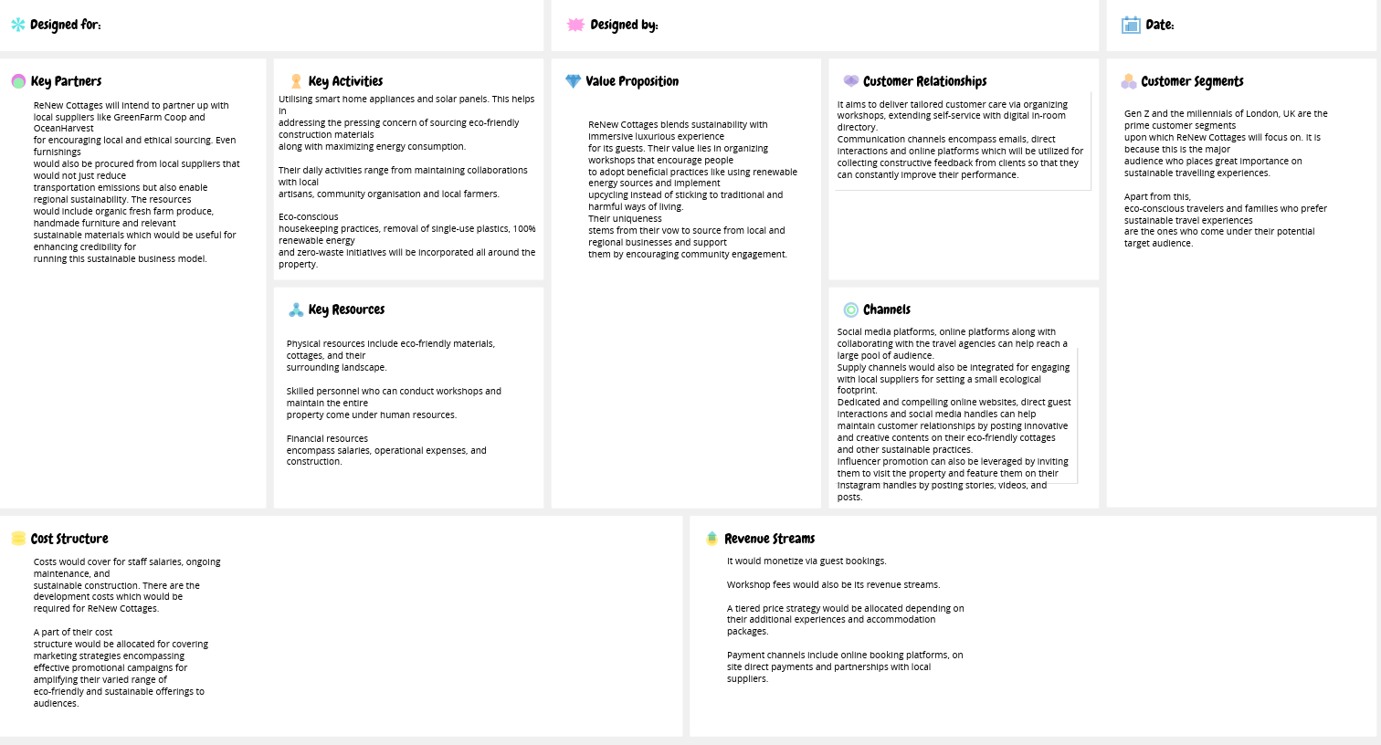
(https://app.conceptboard.com/board/gfk6-32om-o2x6-mpii-qi6i)

Appendix 2: Test results


