Workplace Culture and its Impact on Organisational Efficiency
BMSW5105

Laura Pino
1915292

Dr. Hossein Shokri

University of Wales Trinity Saint David
06/09/2021

Executive Summary
Zalando is an online sustainable fashion platform, founded in 2008 by Robert Gentz and David Schneider, based in Berlin. The Zalando platform has connected with over 34 million customers in twenty countries across Europe (Corporate Zalando, 2021). Organisations operate in a dynamic and competitive environment where the ability to find solutions and adapt the business has become a necessity (Alanzi, 2018). Techniques, such as SWOT, PESTLE analysis and Porter’s Five Forces, help a company to identify all important aspects that might impact future decisions for the organisation (CIPD, 2020). The paper studied how the culture of an organisation is at the heart of its unique character and personality, built from its beliefs, values and attitudes; it can be conceptualised by identifying essential rules that influence behaviour and facts (R. Kassem and M. M. Ajmal, 2019). Based on Zalando’s organisational mindset principles, the analysis of the Cultural Web model was used to understand the company’s behaviours within its structure and the context which it operates, applying it as a strategy to identify which areas need to be changed (Johnson, Scholes and Whittington, 2008). Business long-term success is created from the effective performance of its employees, by understanding their behaviours and needs (Mullins, 2016), and the company’s strategy (Corporate Zalando, 2019).

TABLE OF CONTENTS

- Introduction…………………………………………………………….. p. 4

- Zalando Background ……………………………………………….… p. 4

- Business Environmental Analysis Tools ………………………….... p. 5
3.1 Zalando SWOT Analysis ……………………………………...…. p. 5
3.2 PESTLE Analysis of Germany ………………..……………….…p. 6
3.3 Porter’s Five Forces of Online Retail Industry ………………… p. 8

- Organisational Culture………………………………………………….p. 9
4.1 Zalando Cultural Web Model ……………………………………. p. 10

- External Factors that challenge Zalando …………………………... p. 11

- Zalando’s Performance ……………………………………………… p. 12

- Business Ethics and Zalando’s Challenges ………………………… p. 13

- Conclusion and Recommendations …………………………………. p. 14

- Reflective Writing ……………………………………………………… p. 15

- References ……………………………………………………………... p. 17

- Introduction
The goal of the report was to study the key factors of external environments that affect the company Zalando during COVID-19 and the ethical dilemma that follows; analysing how these aspects affected its changes and performance in their organisational culture.
Zalando is an online sustainable fashion platform, founded in 2008 by Robert Gentz and David Schneider, based in Berlin. The Zalando platform has connected with over 34 million customers in twenty countries across Europe (Corporate Zalando, 2021), hosting a variety of 3,500 brands who are selected based on following precise ethical standards that the company has created (Zalando progress report, 2021). The paper used techniques such as SWOT, PESTLE analysis and Porter’s Five Forces Model, to evaluate and identify the external factors, competitiveness and transformed environments which Zalando is facing and adapting to, such as its challenge of increasing digital value in the platform for its customers. Therefore, the cultural organisation of Zalando stressed their importance in delivering a transparent message, showing an inclusive approach with their stakeholders offering various career opportunities and leading radical changes through a sustainable campaign (Corporate Zalando, 2021). Consequently, the Cultural Web tool was applied to critically evaluate Zalando’s organisational culture to examine which areas needed to be developed or trained further for employees. Moreover, Zalando designed two 360° feedback cycles per year to promote support using conversational processes regarding employees’ opportunities and individual performances, to identify projects and personal weaknesses to then be improved upon and achieve better performance. However, the 360° feedback showed a limitation in its functioning with a general unhappiness within employees.
Finally, the issue of Zalando’s ethical behaviour within customer’s values and actions was discussed, shown in the results of a consumer survey, and the challenge of an influence-lead society to change through a sustainable fashion environment.

- Zalando Background
Zalando is an online platform for fashion and lifestyle, founded in Berlin in 2008 by Robert Gentz and David Schneider (Corporate Zalando, 2021). They started as an online shoe shop and now the company is leading Europe's online platforms, selling products such as: shoes, accessories, beauty products for women, men, and children, offering a variety from 3,500 private brands (Zalando progress report, 2021). Zalando has more than 38 million active customers in seventeen marketplaces (Zalando Attitude Behavior Gap Report, 2021), which proposes a new system where customers, brand and partners are connected (Zalando company profile, 2021). They have more than 16,000 employees, in 140 different countries that are experts in the field of technology, innovation and research allowing them to offer a various range of convenient services to suit customer’s requirements (Zalando company profile, 2021). For these reasons, Zalando is the primary leading online fashionable tech company who provide digital solutions, free delivery and returns options within one hundred days (Corporate Zalando, 2021).

- Business Environmental Analysis Tools
Organisations operate in a dynamic and competitive environment where the ability to find solutions and adapt itself became a necessity (Alanzi, 2018). There are techniques, such as PESTLE analysis and Porter’s Five Forces, that help a company to identify all important aspects that might impact future decisions for the organisation (CIPD, 2020). PESTLE is the acronym of political, economic, socio-cultural, technological, legal, environmental, and these elements encourage the business to understand the external environment and develop a strategic action plan to anticipate changing (CIPD, 2020). Porter’s Five Forces model is a technique that studies five external powers of: supplier, buyer, competitive rivalry, the threat of substitution and the threat of new entry; this creates competitive pressure within an industry sector, to be able to address strategic changing plans to maximise profitability (MindTools, 2021). All organisations have a corporate culture that defines the internal and external operation of their business, and it can become the focus during organisational changing, affecting the company either positively or negatively (MindTools, 2021). The Cultural Web model helps to understand which the needs for organisation are and which areas are to develop (Personio, 2021). The model identifies six elements: stories, rituals and routine, symbols, organisational structure, control systems and power structures that can help the company to have a detailed overview of its culture and understand what the company needs to change, providing strategic implementation in the work environment (Johnson, Scholes and Whittington, 2008). Moreover, the SWOT analysis, strength, weaknesses, opportunities, threats, is used as a framework to understand a business’s competitions to plan strategic initiatives within the related industry (Kenton and Scott, 2021).

3.1 - Zalando SWOT Analysis

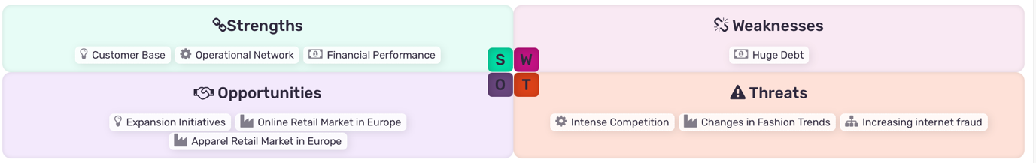
Fig.1 Source: Zalando SE MarketLine, 2021

Strengths
Customer base: the Zalando company grew its customers by 25% between 2019 and February 2020 and 29.1% of customer orders; their increase is based on their investment in technology, brand proposition, infrastructure, and operations (Zalando SE MarketLine, 2021). Operational network: Zalando relates to 38.7 million customers over seventeen European countries, offering a large range of products to them (Zalando SE MarketLine, 2021). Financial performance: the company recorded a growth of 23.1% in financial performance €between February 2019 and 2020, demonstrating a high return of revenue to its investors (Zalando SE MarketLine, 2021).

Weaknesses
Debt: in February 2019 Zalando had a debt of €554.9 million, and in 2020 the company increased its debt to €1,768.1 million but in the same year they generated a revenue of 23.1%, meaning that in the future, to repair this deficit, they will have to pay it back at a higher interest rate (Zalando SE MarketLine, 2021).

Opportunities
Expansion Initiatives: the company expanded its business into new countries, enhancing the opportunity to grow (Zalando SE MarketLine, 2021). Online retail market in Europe: the sector is forecast growth of 10.8% at CAGR between 2018 and 2023, increasing, through their online shopping, the engagement of the clients (Zalando SE MarketLine, 2021). Apparel retail market in Europe: Germany reported 16.8% of its total value, which is the biggest segment of the European apparel retail market to Zalando (Zalando SE MarketLine, 2021).

Threats
Intense competition: being an online platform, the high competition in price, product offers and fast changing trends make the company a risk (Zalando SE MarketLine, 2021). Therefore, the platform is exposed to various internet fraud, affecting customer’s confidence during their purchases (Zalando SE MarketLine, 2021).

3.2 - PESTLE Analysis of Germany
The Pestle analysis studied the current strengths, challenges, prospects, and risks of the Germany country (MarketLine Germany PESTLE, 2020).

Political
Germany is a federal republic with a democratic political system, where the federal states have different local powers in primary organisations such as: transport, education and environmental areas (MarketLine Germany PESTLE, 2020). The final decision is formulated by the chancellor, who represents the head of the government, and the president for the state (Shaw, 2021). During 2021 the country is facing change due to the stepping-down of its chancellor, Angela Merkel, who led the German government for sixteen years (The Economist, 2021).

Economic
The pandemic enhances Germany’s economic risk with almost 90% of population covered by insurance schemes and to balance the impact generated by the situation the country launched a fiscal and monetary stimulus, to cushion the country’s economic (MarketLine Germany PESTLE, 2020). Indeed, the country stabilised its economy to generate a healthy job marketplace (Shaw, 2021). Germany follows free trade policies with no customs duties on imports from EU members, only on shipping from non-EU countries. Therefore, Germany’s taxation is the highest compared to peer countries and this situation negatively affects Germany’s economic growth, job creation and job market (MarketLine Germany PESTLE, 2020).

Social
Germany is characterised of diligent, detailed and hard-working people, and this is why the country is leading in world economic stability (Shaw, 2021). In Germany the government approved a budget for 2021 to mitigate the economy after the pandemic, focusing on labour and employment (MarketLine Germany PESTLE, 2020). As confirmation of its commitment to the population, Germany was categorised as one of the world’s top countries which offer a high-quality life, healthcare, education, and economic stability (Shaw, 2021).

Technology
Germany was ranked at the fifth position in the world for their technological progressiveness (Shaw, 2021); indeed, the country invested €3 billion in the research and development of artificial intelligence (Shaw, 2021). The country is focused on the implementation of ICT to create more jobs in the small-medium enterprises, deciding to find a digital infrastructure; furthermore, the government wanted to improve its broadband by the end of 2020, expanding its 5G service to over 50% of the country (MarketLine Germany PESTLE, 2020).

Law
The 2030 Agenda for Sustainable Development (2021) stresses the responsibilities to states and in particularly to organisations, to protect vulnerable groups and promote human rights such as, equality, non-discrimination, and universal respect. Germany’s legal system was classified as 11th out of 141 countries in efficiency (MarketLine Germany PESTLE, 2020), supporting the businesses’ development (Shaw, 2021). Therefore, in regard to the workers’ contracts, the country identified a minimum monthly and hourly wage, which is €1584 and €9.19 respectfully (Shaw, 2021).

Environmental
Germany is focused in enhancing action towards renewable energy sources, aiming to reduce the costs of renewables; the pandemic helped the country to achieve its 2020 target by reducing gas emissions, however, the air pollution level is still high and increases dependence on carbon for energy production (MarketLine Germany PESTLE, 2020). Zalando is highly involved in reducing their carbon emissions by 80% during their operation and, in turn, increase their annual renewable electricity usage (Zalando Sustainability Progress Report, 2020). As the company’s sustainable progress report states (2020), to achieve their goals, they utilised science-based targets to help them to assess and approve their initiative by aiming to accomplish them by 2025.

3.3 - Porter’s Five Forces of Online Retail Industry
The Porter’s Five Forces model examined the key powers that are driving competition in online retail sector (MarketLine, 2021), and to describe the levels of strength they were identified using numbers from zero, with a weak impact for companies, to five that corresponds a strong impact for them.

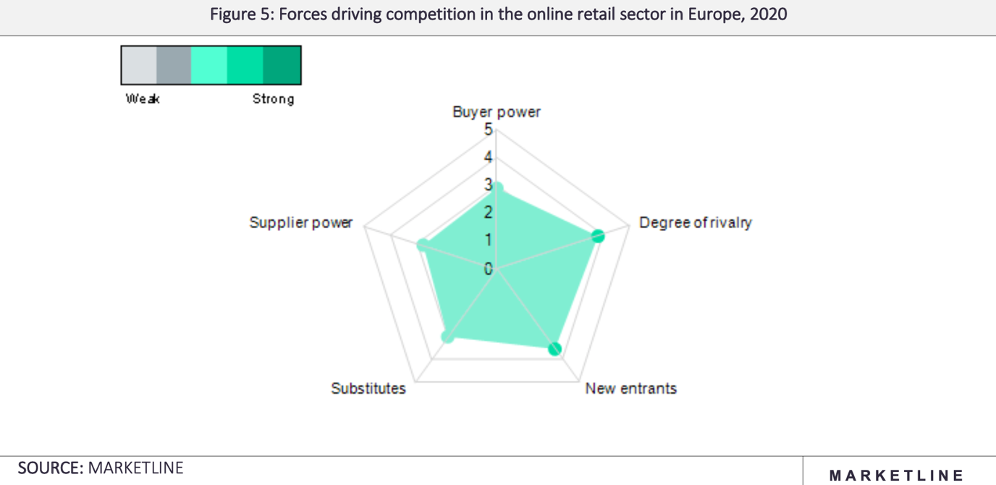

Fig.2 Source: MarketLine, 2021

The buyer power had classified number three, as a medium force, which due to the lack of geographically boundaries, the online retail growth in the last past year, making them strong in the European marketplace (MarketLine, 2021). While, giving customers the opportunity to switch and easily research by comparing costs online, creating a vulnerable position for the company that must offer incentives to stay loyal to the platform (ACCID, 2019). The level of supplier power is medium low, on the graph and it is identified between levels two and three of strength. Indeed, for example, the Zalando platform hosts 3,500 private brands that feed interest in being collaborative with the company, to benefit in generating income from both sides (Zalando Sustainable Progress Report, 2020). However, the suppliers can also have the power to switch with a competitor (MarketLine, 2021). Regarding the substitute power, it is recognised with a medium level of strength, allocating three as a force of influence for the company. As one of the first online retailers in Europe (MarketLine, 2021), Zalando can compete in the challenge of being substituted, trying to meet the customers’ needs and desires by conducting constant research in fashion trends (ACCID, 2019). To mitigate this strong Zalando awareness, the power is with customers who can easily substitute the platform with another (ACCID, 2019). The rival power is high, at four to five, because with an online base were websites compare prices and the availability of different products, increasing costumers’ awareness and digital research skills is changing the consumers’ behaviours into an easy and convenient shopping comparative (MarketLine, 2021). The new entrance’s power is high, identified between three and four in the level of strength, because due to the COVID-19 pandemic, customers moved into online shopping, thus, companies such as Zalando are having a positive impact from it (MarketLine, 2021).
As a result of Porter’s Five Forces model, it was possible to highlight the key factors that are driving change in Zalando’s business, such as the power of the new entrances that could attract clients appealing to them offering low prices and high-quality service (MarketLine, 2021), and the threats of substitute power, which showed a lack of customers switching to competitors (ACCID, 2019).

- Organisational Culture
The culture of an organisation is the heart of its unique character and personality, built from its beliefs, values and attitudes (R. Kassem and M. M. Ajmal, 2019). Organisational culture can be conceptualised by identifying essential rules that influence behaviour and facts, for example, when a group of people share similar professional approaches and objectives, they are more powerful when working together (R. Kassem and M. M. Ajmal, 2019). In other words, organisational culture is how things are performed and the work guidelines that impact on employee’s attitudes and behaviours (Cmi, 2015). Aspects that could influence organisational culture are its structure, implemented leadership style and employees’ behaviour and attitudes (Cmi, 2015). Zalando’s cultural organisation mindset is founded on four values: customer focus, entrepreneurial thinking, speed and team morale (Zalando work and culture, 2021). As the company believes, the platform must communicate with its customers, trying to deliver a service that meets their expectations and desires (Zalando Values, 2021). Zalando’s employees are encouraged to act as an owner, being responsible and respectful with partners and colleagues, creating valid opportunities to develop with the team (Zalando Values, 2021). Furthermore, the employees’ engagement and good performance is based on how the organisation treats them, showing a motivational system process (Mullins, 2019). The online platform drives innovations through sharing values such as quickly built opportunities with their approach to spend their research on selecting new trends and rapidly promoting them (Zalando annual report, 2020). The value that encompassed their organisational culture is the team morale that shapes the company’s output, promoting transparency in their approach and creating a friendly environment to make feel the employees comfortable to share ideas (Zalando Values, 2021). Therefore, as Luthans affirms (2011), a team leader should encourage their employees by building their strengths, adding knowledge and experiences.

4.1 - Zalando Cultural Web Model
Based on Zalando’s organisational mindset principles, the paradigm of the Cultural Web model, it was used to understand the company’s behaviours within its structure and the context which it operates, applying it as a strategy to identify which areas need to be changed (Johnson, Scholes and Whittington, 2008).
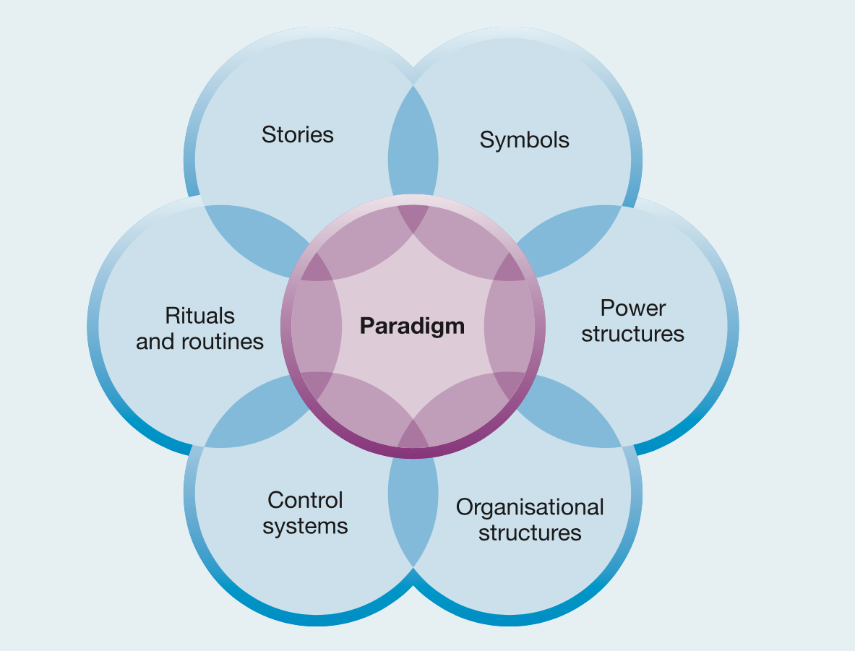
Fig. 3 Source: Johnson, Scholes and Whittington, 2008.

Referred to the Cultural Web model showed in fig.3, Zalando’s story is aligned with its collaborations, in its platform, with brand partners such as Levi’s, Puma, Adidas, Tommy Hilfiger and other successful and famous companies (Corporate Zalando, 2021); launching in 2011, Zalando’s Partner Program offers to its brands access to 23 European areas and 42 million customers (Zalando Partner Program, 2021). Therefore, Zalando drives two strong principles like the human rights values, monitoring by code of conduct, ethical sourcing and social standards, and the environment sustainability beliefs (Zalando Sustainability Progress Report, 2020). Based on these principle values the company emphasises its rituals and routines’ elements in fig.3, of which their sustainability principles are enclosed in its do.MORE strategy, stressing their commitment in setting standards when considering the impact on the planet, the environmental effects, and people with ethical working conditions (Zalando the Starting Point for fashion, 2021). To create more awareness with its customers, Zalando wants to have a transparent approach by making the product information accessible to clients (Zalando the Starting Point for fashion, 2021). Therefore, as a symbol of Zalando’s sustainable promise, they launched their brand Zign, to fill a market gap of high-quality products at an accessible price (Zalando the Starting Point for fashion, 2021). Following fig. 3, Zalando built a power structure which allowed the company to become a European leader in the online fashion market (Zalando the Starting Point for fashion, 2021). In 2020 the company raised is sales by 25% but the rapid growth created challenges to the business because their system limited them in the exchange of real time data to make decisions in a dynamic fashion world (Arnoldy, 2021). The main structure and headquarters of the company is located in Berlin with seven branches across Europe, five located in Germany, with the remaining two divisions in Finland and Ireland (Craft, 2021). The organisational structure of the Zalando is lead from its management board, composed of five members, which worked in cooperation with their supervisory board, composed of nine members who represent their investors, employees and external experts (Zalando annual report, 2020). A supervisory board monitors the management’s activities, and both with the board of directors, they have direct contact with labels and brands; power on fundamental decision-making and total control of their segmented operational groups (Zalando annual report, 2020). Zalando’s control system, fig.3, is reflected in its Starting Point strategy, demonstrating the benefits derived from its partnered relationships; highlighting the progress made since its company’s foundation, where in 2009 they generated €6 million of GMV and in 2020 they arrived to build €10.7 billion of GMV (Zalando the Starting Point for fashion, 2021).

- External Factors that challenge Zalando
Since the COVID-19 pandemic began, Zalando had to change its internal organisation to keep their employees healthy and safe; remote working was an option, however, not for the entire staff as some areas of the business still required physical presence, such as in the logistics centres, production studios and parts of the offices (Corporate Zalando, 2020).
Therefore, Zalando applied preventative measures, such as free COVID-19 testing twice weekly and daily cleaning services and to sustain the company’s workplace, in June 2021, they opened a vaccination centre for its employees who could voluntarily have their shot during working hours (Corporate Zalando, 2021). Moreover, during the past years Zalando had to challenge and minimise the impact that the pandemic situation had brought on the fashion industry by an updated strategy called Starting Point (Corporate Zalando, 2021). One important point of this strategy was to lead a strong platform to maintain their digital appeal with continuous development, for example, offering a large selection of new products and choices every season (Corporate Zalando, 2021). The pandemic accelerated the process of company growth in the digital market and with it the challenge of maintaining this supremacy in Europe (Zalando Sustainability Progress Report, 2020). Zalando’s organisational core value is their customer focus and with a transparent approach, increasing customers’ experience while shopping in their app, adding value with their sustainable commitment in fashion recycling; this ethical mindset became part of their strategy (Zalando Sustainability Progress Report, 2020). A second important focus of the Starting Point strategy is to connect offline retailers that have been affected by the crisis and the international lockdowns, to move online; being Zalando, a European online leader, they wanted to offer a solution through the Connected Retail programme (MarketLine, 2021). Indeed, Zalando waived the Connected Retail commissions for new and existing partners, also switching their payment to weekly instead of monthly to facilitate them with a continuous cash flow (Corporate Zalando, 2021). Zalando offered to its partners a program called ZFS, Zalando Fulfillment Solution, allowing its members to have access to their European fashion fulfilment network, where the company would store their stock in a Zalando owned warehouse and send the products directly to the customers for greater efficiency (Corporate Zalando, 2021). However, due to the onboarding of new partners, Zalando is struggling to store this influx of stock in their warehouses, therefore, these retailers are utilising their physical shops as storage and implementing Zalando’s delivery network (Corporate Zalando, 2021).

- Zalando’s Performance
Business success is created from the effective performance of its employees and the company’s strategy (Corporate Zalando, 2019). Indeed, organisational behaviour is an element that should be understood by all employees as it indicates the way in which performance in the organisation is settled (Mullins, 2016). Understanding employee’s behaviours and needs in the workplace and being able to manage them make the organisation stronger and more successful in the long-term; achieving this is important because they represent the company’s resource (Mullins, 2016). Zalando’s Starting Point strategy is related to the financial aspects of the company, which their values of sustainable fashion are being translated into their prognostic of influencing customers to make more sustainable choices, increasing their gross merchandising value of 20% by 2023 (Zalando Sustainability Progress Report, 2020). While, do.BETTER is the internal relationships strategy, where the company demonstrates to its employees the importance of working in the interest of customers and partners (Zalando Diversity and Inclusion Report, 2020); but to increase their teams’ motivation, they are focused on promoting individuals that are efficient thinkers, finding opportunities in the continuous changing market and in customer behaviours (Bof, 2019). Indeed, changes are part of Zalando’s culture, enhancing open-communication and focusing on people, encouraging performance as leaders but respecting each other’s opinions (Zalando work and culture, 2021).
As a result, Zalando obtain a team empowered with the possibility to grow and develop new skills within the organisation (Bof, 2019). Moreover, to achieve quality performance and communication skills, Zalando structured 360° feedback, which involves 14,000 employee and manager interactions with which they provide a possible total of eight comments, anonymous or not, on worked projects and colleagues’ performances during the past six months (Corporate Zalando, 2019). All these feedbacks are read from a committee, composed from various departmental representatives, that select them in an open and constructive discussion regarding topics identified or weak personal performances (Corporate Zalando, 2019). The process aims to examine strengths, develop areas or skills to train, and together deliberate a solution with a horizontal communication to overcome the problem (Corporate Zalando, 2019). However, the process needs to be addressed with a positive approach, because it could be misunderstood by the employee and generate counterproductive behaviour (Mullins, 2016). Indeed, from successful practices or failed work projects the organisation can learn from its experiences and have a positive impact in the future employees’ performance (Mullins, 2016).

- Business Ethics and Zalando’s Challenges
Business ethics is related to policies and responsible practices that businesses should implement in their operation (Twin and Drury, 2021). Business ethics are also identified as the trust between customers, company and supplier (Twin and Drury, 2021). Zalando’s clients think that to have a transparent culture it is important in showing information on processes that the company is following and this influences their purchases, as they can read, for example, the ethical labour polices attached (Zalando Attitude Behavior Gap Report, 2021). Therefore, the company is pushing their do.MORE strategy, which implies that their approach modifies consumer’s attitudes through awareness in future sustainable fashion and bring a positive impact for the current generation and in the ecosystem (Zalando Attitude Behavior Gap Report, 2021). Zalando is challenging to cover the gap between customer sustainability values, promoting their collection Zign, which is still not created from 100% sustainable material, and what items they buy, increasing focus on circularity fashion solution (Zalando the Starting Point for fashion, 2021). During the pandemic, the platform recorded that two-thirds of customers changed their behavioural approach in sustainability, being more aware of their values and fashion clothes choices (Zalando Attitude Behavior Gap Report, 2021). However, Zalando created a consumer survey to understand if the increase of consciousness in customers was reflecting their actions; the result was that 58% responded that is important to repair and recycle clothes when it comes from their favourite brand, while 23% was acting on the cycle of fashion clothes (Zalando Attitude Behavior Gap Report, 2021). The Survey highlighted customers’ awareness in keeping clothes for longer, but they have a lack of knowledge in taking care, repairing or recycling them, thus, Zalando aims to drive and instruct clients through a circularity solution (Zalando Attitude Behavior Gap Report, 2021). The challenge of being a sustainable brand is guaranteeing the use of recycled materials and following ethical industrial processes in an accessible range of prices, without compromising the quality of the product (Ceppa, 2014). As Ceppa affirms (2014), often, sustainability among the fashion world is thought of as not having aesthetically appealing designs, thus, if designers start to approach with more responsibility and creatively, they could produce good eco-friendly pieces and participate in social-changing behaviour. In this vision, Zalando wants to increase customer transparency and offer to the clients a various range in choice of sustainable clothes (Zalando Sustainability Progress Report, 2020).

- Conclusion and Recommendations
The report analysed the changes that Zalando as a company have made to adapt its organisation due to external factors such as COVID-19, working remotely and with the competitive digitalisation challenge derived from moving from offline to online retail (MarketLine, 2021). The paper examined Zalando's organisational culture, highlighting their vision and values of becoming a sustainable platform, promoting a transparent communication in delivering an ecological environmental impact (Zalando Sustainability Progress Report, 2020). During the analysis three challenges were recognised that Zalando is facing: adding value to the customer’s digital experience; the cycle of 360° feedback; to influence customer behaviour positively through sustainable choices. The first recommendation is to add value throughout the customer’s shopping experience, Zalando could promote a specific item monthly and with their transparent communication, tell the story of the item, to create interest and intrigue throughout the selection. The second recommendation is to be fully objective during the 360° feedback process, the company should hire an external corporation with social responsibility, that two times per year will analyse the results and find common solutions with the parties interested. The third recommendation is during the 360° feedback communication approach the committee could first speak with the colleague under investigation and then start a discussion with the whole team, to make them not feel directly judged in the workplace. The fourth recommendation, depending on the targeted goal, is that Zalando could involve a strategic influencer to show their action in recycling fashion clothing and inform the new generation on how to implement the process in their personal life. The fifth recommendation is that to be fully understood and have a positive influence in clients purchasing from the business, the company could involve famous persons who are actively committed in environmental campaigns and through their sponsor, arrive to a large sample of society.
In conclusion, Zalando is leading its company with transparency and solid values, translated in their organisational vision and achieved by being the biggest online retailer in Europe during this scenario (MarketLine, 2021).

- Reflective Writing
To write my reflective writing I followed the Gibbs’ reflective Cycle model, which helped me to better analyse my experience during the university term. Description: the module I have studied taught me the core mindset every company must have to run its organisation with ethics and principles by influencing their actions and decisions every day (Cmi, 2015). During the lessons the lecturer provided exhaustive examples, both verbally and through companies’ videos, making the concept clear. Moreover, the class was divided into small groups allowing us to work together and help each other as a team. Feelings: studying the module, I felt I had already faced this concept in my short experience with my brand, for example, when I had to communicate with the laboratory and model maker, I have shown a positive attitude, open to dialogue and ready to find a solution if they did not have the right skills or specific machinery to achieve to my request. Often, from my approach I received a positive response that helped me to find new solutions together or inspire the creation of new products. Therefore, I noticed that in the first term of 2021 I was more insecure in taking part in conversations between colleagues and the teacher and it limited my personality and my full interaction with them. While, in the last term of university I felt more comfortable to interact with the group class and lecturers, and I think that my positive attitude helped me to build friendships with some of them. The evaluation of my university experience is helping me to build a consistent awareness of which work direction I want to take in the future, by training and developing my workplace skills. The module, increased consciousness of my brand identity and made me think of which values and cultures I want to highlight within my working team. Indeed, by doing the analysis of my experience I realised that all aspects of organisational culture can influence the interaction of the business, both internally and externally (Cmi, 2015). Investigating my work position, I understand that being a start-up business I should create and build my organisational culture, based on my educational background, asking myself simple questions such as who I would like to work in my company. In conclusion, I have always supported workplace values like honesty, cooperation and having a positive attitude to motivate the people I am surrounded by; being free to propose new ideas that can increase the quality of work. Therefore, from this vision I can develop and select my employees to which I will be surrounded. I believe in an ongoing exchange of ideas because if the laboratory works in the same direction as me, we can both benefit from the success of the brand. Alone, I can have just a small vision of the larger picture, whilst conversing with specialists and taking on advice through their experiences, can enhance and complete my initial vision.
Consequently, my beliefs and attitudes influence my workplace relationships and my decision making, hence, in my action plan I can develop the fundamentals to an open conversation and dialogue with my team, showing them the positive benefits to share proposals and evaluate them together; being possible to generate a bigger view of the current situation.

- References

ACCID, 2019. ‘ZALANDO SE- SCREAM OF JOY?’. [Online] Available at:
https://accid.org/wp-content/uploads/2019/07/Case-Zalandoformatv.pdf
(Accessed: 30/08/2021).

Alanzi, S., 2018. ‘PESTLE ANALYSIS’. [Online] Available at: https://www.researchgate.net/publication/327871826_pestle_analysis_introduction
(Accessed: 01/09/2021).

Arnoldy, S., 2021. ‘Zalando finds the perfect fit for its fast-growing business’. [Online] Available at:
https://www.pwc.com/gx/en/about/case-studies/zalando-finds-the-perfect-fit-for-its-fast-growing-business.html
(Accessed: 22/08/2021).

Bof, 2019. At Zalando, ‘Driving Innovation Through Shared Values’. [Online] Available at:
https://www.businessoffashion.com/articles/workplace-talent/at-zalando-driving-innovation-through-shared-values
(Accessed: 18/08/2021).

CIPD, 2020. ‘PESTLE’, CIPD. [Online] Available at:
https://www.cipd.co.uk/knowledge/strategy/organisational-development/pestle-analysis-factsheet#7990
(Accessed: 21/08/2021).

Ceppa, C., 2014. ‘Spreading the Culture of a Sustainable Manufacturing of Eco-Fashion Products. Focus on International Brands that make the Synergy between Fashion Design and Sustainability their Success’. Zurich Vol. 496-500, (Jan 2014): 2692-2696. DOI:10.4028/www.scientific.net/AMM.496-500.2692. Available at:
https://www-proquest-com.ezproxy.uwtsd.ac.uk/docview/1675262679?accountid=130472
(Accessed: 27/08/2021).

Cmi, 2015. ‘Understanding Organisational Culture’. [Online] Available at:
https://www.managers.org.uk/~/media/Files/PDF/Checklists/CHK-232-Understanding-organisational-culture.pdf
(Accessed: 18/08/2021).
Corporate Zalando, 2021. ‘Our Corporate Culture’. [Online] Available at:
https://corporate.zalando.com/en/company/our-corporate-culture
(Accessed: 19/08/2021).

Corporate Zalando, 2021. ‘Our History: From Start-up to Grown-up’. [Online] Available at:
https://corporate.zalando.com/en/company/our-history-start-grown
(Accessed: 01/09/2021).

Corporate Zalando 2020. ‘How Zalando Puts Health and Safety of Employees first While Serving Customers Across Europe’. [Online] Available at:
https://corporate.zalando.com/en/newsroom/en/news-stories/how-zalando-puts-health-and-safety-employees-first-while-serving-customers
(Accessed: 16/08/2021).

Corporate Zalando, 2021. ‘Stronger Together: Connecting Online and Offline Retail’. [Online] Available at:
https://corporate.zalando.com/en/newsroom/news-stories/stronger-together-connecting-online-and-offline-retail-0
(Accessed: 18/08/2021).

Corporate Zalando, 2021. ‘The latest on Zalando’s response to Coronavirus’. [Online] Available at:
https://corporate.zalando.com/en/brand-hub/latest-zalandos-response-coronavirus
(Accessed: 16/08/2021).

Corporate Zalando, 2021. ‘Who We Are’. [Online] Available at:
https://corporate.zalando.com/en/company/who-we-are
(Accessed: 30/08/2021).

Corporate Zalando, 2021. ‘Zalando Begins COVID- 19 Vaccinations for Employees’. [Online] Available at:
https://corporate.zalando.com/en/newsroom/news-stories/zalando-begins-covid-19-vaccinations-employees
(Accessed: 16/08/2021).

Craft, 2021. ‘Zalando headquarters and office locations’. [Online] Available at:
https://craft.co/zalando/locations
(Accessed: 22/08/2021).

Council of Europe, 2021. ‘UN Agenda 2030’. [Online] Available at:
https://www.coe.int/en/web/programmes/un-2030-agenda
(Accessed: 31/08/2021).

Johnson, G., Scholes, K. and Whittington, R., 2008. ‘Exploring Corporate Strategy’. Pearson Education, eight editions, 2008. Harlow.

Kenton, W., and Scott, G., 2021. ‘Strength, Weakness, Opportunity, and Threat (SWOT) Analysis’. [Online] Available at: https://www.investopedia.com/terms/s/swot.asp
(Accessed: 19/08/2021).

Luthans, F., 2011. ‘Organisational Behavior an Evidence-Based Approach’. McGraw-Hill/Irwin, 2011. 12th editions. New York.

Market Line, 2021. ‘Marketing Industry Profile Europe Online Retail February 2020’. [Online] Available at:
https://advantage-marketline-com.ezproxy.uwtsd.ac.uk/Analysis/ViewasPDF/europe-online-retail-122742
(Accessed: 30/08/2021).

MindTools, 2021. ‘Porter's Five Forces Understanding Competitive Forces to Maximize Profitability’. [Online] Available at:
https://www.mindtools.com/pages/article/newTMC_08.htm
(Accessed: 21/08/2021).

Mullins, L., J., 2016. ‘Management and organisational behaviour’. Pearson Education Limited 2016. 11th edition. Harlow, United Kingdom.

Mullins, L., J., 2019. ‘Organisational Behaviour in the Workplace’. Pearson Education Limited 2019. 12th edition. Harlow, United Kingdom.

Personio, 2021. ‘How Do You Use The Cultural Web Model To Define Corporate Culture?’. [Online] Available at:
https://www.personio.com/hr-lexicon/cultural-web-model/
(Accessed: 21/08/2021).

R. Kassem and M. M. Ajmal, 2019. ‘Organizational Culture and Achieving Business Excellence: Emerging Research and Opportunities’. Hershey, PA. IGI Globe 2019.

Shaw, A., A., 2021. ‘PESTLE Analysis of Germany’. [Online] Available at:
https://swotandpestleanalysis.com/pestle-analysis-of-germany/#Political_factors_affecting_Germany
(Accessed: 30/08/2021).

The Economist, 2021. ‘Germany’. The Economist. [Online] Available at:
https://country.eiu.com/germany
(Accessed: 30/08/2021).

Twin, A., and Drury, A., 2021. ‘Business Ethics’. [Online] Available at:
https://www.investopedia.com/terms/b/business-ethics.asp
(Accessed: 25/08/2021).

Zalando annual report, 2020. ‘Zalando SE Annual Report, 2020’. [Online] Available at:
https://corporate.zalando.com/en/investor-relations/annual-report-2020
(Accessed: 30/08/2021).

Zalando Attitude Behavior Gap Report, 2021. ‘It Takes Two’. [Online] Available at:
https://corporate.zalando.com/sites/default/files/media-download/Zalando_SE_2021_Attitude-Behavior_Gap_Report_EN.pdf
(Accessed: 01/09/2021).

Zalando Diversity and Inclusion Report, 2020. ‘Creating a more inclusive future for everyone’. [Online] Available at:
https://corporate.zalando.com/en/dobetter-diversity-inclusion-report-2020
(Accessed: 27/08/2021).

Zalando Partner Program, 2021. ‘Your gateway to the Zalando Platform Partner Program’. [Online] Available at:
https://www.zalando.co.uk/zms/zalando-partner-program/
(Accessed: 16/08/2021).

Zalando SE MarketLine, 2021. ‘Zalando SE- SWOT Analysis’. [Online] Available at:
https://advantage-marketline-com.ezproxy.uwtsd.ac.uk/Company/Profile/zalando-gmbh?swot
(Accessed: 19/08/2021).

Zalando Sustainable Progress Report, 2020. ‘Sustainability Progress Report 2020’. [Online] Available at: https://corporate.zalando.com/en/sustainability-progress-report-2020
(Accessed: 31/08/2021).

Zalando the Starting Point for fashion, 2021. ‘Zalando starting point for fashion’. [Online] Available at:
https://corporate.zalando.com/sites/default/files/media-download/Zalando%20SE%20Investor%20Factbook%20April%202021_vf.pdf
(Accessed: 20/08/2021).

Zalando work and culture, 2021. ‘Our Corporate Culture’. [Online] Available at:
https://corporate.zalando.com/en/company/our-corporate-culture
(Accessed: 18/08/2021).

