  Component One:  Contribution to Overall Module Assessment: 25% | Student No: | 1918827
 | Module Title: | Hotel Placement- Operating Hotel Facilities
 | Module Code: | BMIH4006
 | Lecturer: | Natalie Brailsford

Reflection following Gibbs model
Description
A housekeeper must know how to clean things to do their job well. These skills can range from being good with people to paying attention to details, and they may be different depending on the housekeeper's job and the duties they are responsible for (Espino-Rodríguez and Gil-Padilla, 2015). As part of my placement as a receptionist in the housekeeping department at the Mercure Hotel in Newport, I was in charge of several tasks that were meant to keep the hotel clean and organised and to make the overall guest service experience better. As part of my daily duties, I had to make sure that the guest rooms were spotless, stocked with amenities, and presented to the highest standards. I also worked with the housekeeping staff to make sure that rooms were cleaned and ready for guests on time, which directly helped the hotel run smoothly.
Feelings and Emotions
During the placement, I had a lot of different feelings. The fast-paced environment forced me to learn quickly and use my time well. We felt like we had accomplished a lot when we met tight deadlines and saw how our work directly affected how happy our guests were. Facilities management directly affects the guest experience by making sure that all hotel areas are clean, well-kept, and fully functional (Khan et al., 2018). This includes guest rooms, restaurants, meeting rooms, and recreation areas. A good experience for guests leads to more satisfied customers, repeat business, and good recommendations from other people (Adeani et al., 2020). However, the stress of keeping the hotel's high standards up was sometimes too much for me, making me doubt my ability to always do what was expected of me as a Receptionist.
Evaluation
I saw both my strengths and weaknesses when I thought about how I did. I knew I needed to be more assertive when I ran into problems because my communication skills were so important to the team's smooth running. Managing my time became important as I learned how to set goals and get things done on time (Sigala, 2020). People had to show how well they could handle problems that came up out of the blue like rooms being cancelled at the last minute or special requests. This experience taught me how to think faster and come up with good solutions, which made me feel ready to deal with things that didn't go as planned.
Analysis
I learned how important the housekeeping department is to make sure guests are happy through my placement. The operational tasks of the department were not just chores; they were important to the success of the hotel as a whole. A clean, well-kept room was the basis of a good guest experience, which affected how they felt about the business as a whole. The housekeeping department was important for more reasons than just how things looked. Because of it, the Mercure Hotel became more well-known and successful. Realising this effect made me appreciate how different parts of the hospitality industry work together.
Conclusion
My work placement as a Receptionist in the Mercure Hotel's housekeeping department opened my eyes to a lot of new things. It changed how I see the hospitality industry and made me realise how important each job is in making sure guests have a great time. Housekeepers usually work alone or with a small group of other housekeepers. Every day, they have to do a certain number of cleanings. To get all of their cleanings done on time, housekeepers need to be able to plan their days and stick to them (Nikolskaya et al., 2020). They also have to show up on time for cleaning appointments and finish cleaning within the time the client gives them. The skills I learned during this placement—how to pay attention to details, manage my time well, and solve problems—have become very useful in my professional life.
Action Plan
Specific steps are what I plan to take to advance my career in housekeeping and the hospitality industry as a whole. First, I'm going to get more training to get better at managing my time and confidently talking to people. Second, I want to take advantage of cross-training opportunities to learn about all the different ways a hotel works. Finally, I am going to actively ask for feedback from both guests and coworkers so that I can keep refining and improving my work. I will always remember the lessons I learned and the skills I gained during this life-changing placement as I move up in my business.

Word Count | 750

Component Two:
Contribution to Overall Module Assessment: 25%

The potential hazards and mitigation strategies for housekeeping safety

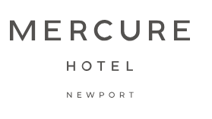

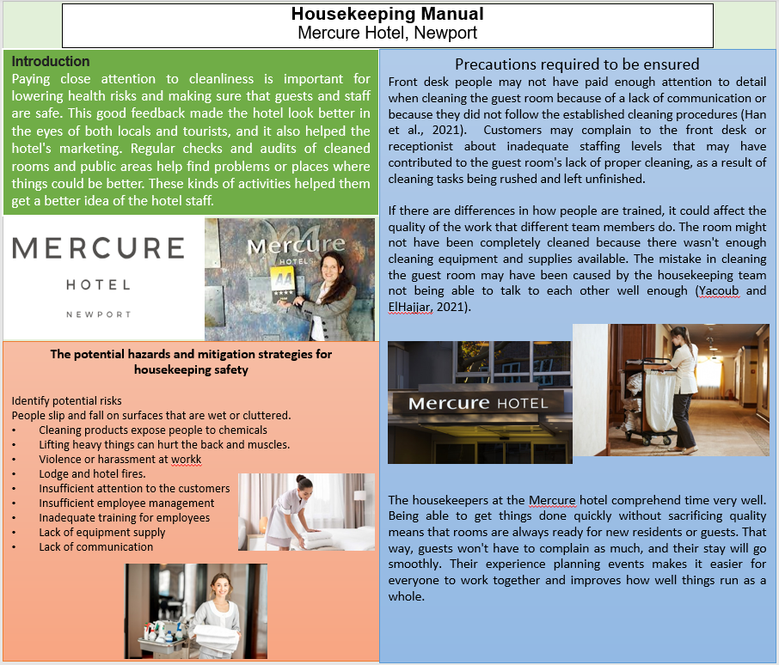
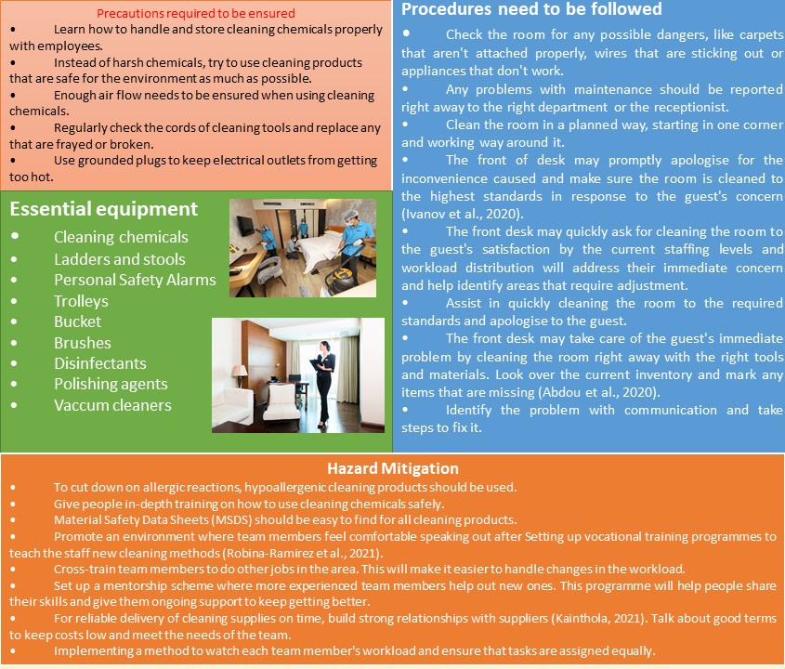

References

Abdou, A.H., Hassan, T.H. and El Dief, M.M., 2020. A description of green hotel practices and their role in achieving sustainable development. Sustainability, 12(22), p.9624.
Adeani, I.S., Febriani, R.B. and Syafryadin, S., 2020. Using GIBBS’reflective cycle in making reflections of literary analysis. Indonesian EFL Journal, 6(2), pp.139-148.
Bangwal, D., Suyal, J. and Kumar, R., 2022. Hotel building design, occupants’ health and performance in response to COVID 19. International journal of hospitality management, 103, p.103212.
Chibili, M., 2017. Modern hotel operations management. Routledge.
Choi, M. and Choi, Y., 2021. Employee perceptions of hotel CSR activities during the COVID-19 pandemic. International Journal of Contemporary Hospitality Management, 33(10), pp.3355-3378.
Espino-Rodríguez, T.F. and Gil-Padilla, A.M., 2015. The structural and infrastructural decisions of operations management in the hotel sector and their impact on organizational performance. Tourism and Hospitality Research, 15(1), pp.3-18.
Fung, C., Tsui, B. and Hon, A.H., 2020. Crisis management: a case study of disease outbreak in the Metropark Hotel group. Asia Pacific Journal of Tourism Research, 25(10), pp.1062-1070.
Han, S.H., Lee, J., Edvardsson, B. and Verma, R., 2021. Mobile technology adoption among hotels: Managerial issues and opportunities. Tourism Management Perspectives, 38, p.100811.
Hayes, D.K., Ninemeier, J.D. and Miller, A.A., 2017. Hotel operations management. Pearson.
Ivanov, S., Seyitoğlu, F. and Markova, M., 2020. Hotel managers’ perceptions towards the use of robots: a mixed-methods approach. Information Technology & Tourism, 22, pp.505-535.
Kainthola, V.P., 2021. Principles of hotel management.
Khan, I., Garg, R.J. and Rahman, Z., 2015. Customer service experience in hotel operations: An empirical analysis. Procedia-Social and Behavioral Sciences, 189, pp.266-274.
Longart, P., 2020. Understanding hotel maintenance management. Journal of Quality Assurance in Hospitality & Tourism, 21(3), pp.267-296.
Montgomery, M.P., Paulin, H.N., Morris, A., Cotton, A., Speers, A., Boyd, A.T., Buff, A.M., Mathews, D., Wells, A., Marchman, C. and Gaffga, N., 2021. Establishment of isolation and noncongregate hotels during COVID-19 and symptom evolution among people experiencing homelessness—Atlanta, Georgia, 2020. Journal of Public Health Management and Practice, 27(3), pp.285-294.
Nikolskaya, E.Y., Lepeshkin, V.A., Kulgachev, I.P., Matveev, A.A. and Lebedeva, O.Y., 2020. Perfection of quality management of hotel services. Journal of Environmental Management and Tourism, 11(2 (42)), p.417.
Nikolskaya, E.Y., Lepeshkin, V.A., Kulgachev, I.P., Matveev, A.A. and Lebedeva, O.Y., 2020. Perfection of quality management of hotel services. Journal of Environmental Management and Tourism, 11(2 (42)), p.417.
Robina-Ramirez, R., Medina-Merodio, J.A., Moreno-Luna, L., Jimenez-Naranjo, H.V. and Sánchez-Oro, M., 2021. Safety and health measures for COVID-19 transition period in the hotel industry in Spain. International Journal of Environmental Research and Public Health, 18(2), p.718.
Rosemberg, M.A.S., 2020. Health and safety considerations for hotel cleaners during Covid-19. Occupational Medicine, 70(5), pp.382-383.
Sigala, M., 2020. Assessing the impact of Information and Communication Technologies (ICT) on productivity in the hotel sector: an operations management approach. University of Surrey (United Kingdom).
Tiong, Y.Y., Sondoh Jr, S.L., Tanakinjal, G.H. and Iggau, O.A., 2021. Cleaner operations in hotels: Recommendation for post-pandemic green recovery. Journal of cleaner production, 283, p.124621.
Yacoub, L. and ElHajjar, S., 2021. How do hotels in developing countries manage the impact of COVID-19? The case of Lebanese hotels. International Journal of Contemporary Hospitality Management, 33(3), pp.929-948.

