Construction and Research of Network & Data Centre Management Systems
The Potential of Software Defined Networking for the
Data Centre and Network Management

George P. Searle
School of Applied Computing
University of Wales Trinity Saint David
Swansea, Wales

Abstract—Design and management of networks are the core skills required by computer network specialists and engineers. Enterprise networks and data centres are also essential to medium and large business operation. This report will be split into two main sections. The first section will examine an enterprise network and data centre design. The second section will present research on software-defined networks and their potential for network management.
Keywords-data centre; enterprise networks; network design; network management; software-defined networking; OpenFlow

introduction
Network design is a complex topic as the architecture must conform to scalability, high-availability, performance, security, energy usage and management requirements [1]. The scenario addressed in this report is the construction of a functional enterprise network and data centre. It will support the University of Wales Trinity Saint David (UWTSD) campuses and any global partner colleges. The author’s proposed implementation was constructed in Cisco Packet Tracer (PT) 7.2, as can be seen in fig. 1. given in Appendix A. The design is an example of centralising information technology (IT) operations at the main campus, Swansea. Lampeter and Carmarthen campuses are connected to Swansea via a private wide area network (WAN). This is because they are within 40 miles of Swansea. The London campus is connected to the main campus via site-to-site VPN connection over the internet due to its location. The Malaysia partner college also has connectivity to the Swansea campus extranet via VPN. The author’s design will be examined in more detail in the first part of the report.
For a network to function efficiently it must be monitored and managed. The second part of the report investigates software-defined networking (SDN), a recent and innovative model to network design and management.

enterprise network & data centre design

Network & Data Centre Architecture
The overall design of the data centre and enterprise campus network follows the Cisco Hierarchical Design Model, as seen in fig. 2.
The author’s network design an application of the hierarchical design model can be seen in fig. 1. given in Appendix A. This approach utilises layers to implement specific functions. It aims to simplify network design, deployment and management [1].
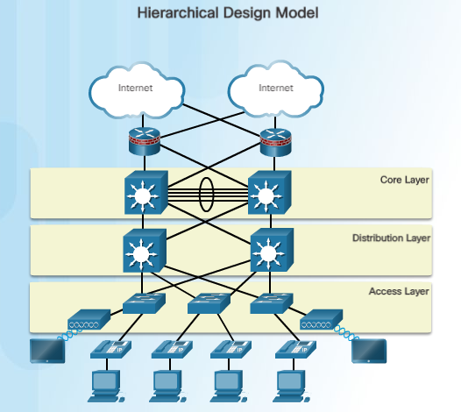
Fig. 2. The Cisco Hierarchical Design Model [1]
The hierarchical local area network (LAN) design utilises three layers:
- Access layer – is the network edge and provides network access to users [2].
- Distribution layer – provides high availability via redundant distribution layer switches and equal cost paths to the core. It provides intelligent switching, routing and network access policy to the network, as well as differentiated services and support for Layer 2 broadcast domains and Layer 3 routing boundaries [2].
- Core layer – provides highspeed backbone connectivity and fault isolation. This layer can be combined with the distribution layer to provide a collapsed design [2].
These layers all work together to provide scalability, high-availability, flexibility, limit the size of failure domains and ease network deployment and manageability [1], [2]. All these features are important aspects that are required for a successful data centre.

Data Centre Server Farms
The author’s data centre design features three different server farms to deliver various services to the university and its partners.

Internet Server Farm
This is a dedicated Internet-facing server farm to support the university’s e-commerce presence and the main website. Most users accessing this server farm will be Internet users. There is also a De-militarised Zone (DMZ) server farm. This aims to support applications and resources accessible to Internet users and is regularly used by intranet users (e.g. Domain Name Service servers and web portals such as Moodle). Both Internet-facing server farms feature stringent security measures and policies (assumption) to protect the servers from external users and keep the internal network secure [3].

Intranet Server Farm
This server farm is only available to internal enterprise users (this includes the private WAN). It supports critical university infrastructure services (e.g. Active Directory, timetabling applications, Structured Query Language (SQL) Database servers and backup servers). It also supports internal web portals and applications. Scalability and high-availability are critical to this server farm, hence the use of clustered servers and virtualisation. Security and management are important factors that must be addressed through policy and monitoring. The intranet server farm can be accessed externally via secure remote access using virtual private network (VPN) technology [3].

Extranet Server Farm
This server farm hosts web-based applications, however, it is mainly used and available to business partners and trusted external users (hence access is available for the Malaysia partner college). This allows for secure and user-friendly business-to-business communication. Security must be considered which is why access is only available via VPN and extranet users are restricted from the internal network [3].

Design Assumptions
There are numerous limitations to the presented enterprise and data centre design. These are due to software limitations and time constraints. This section highlights the limitations of the PT design and discusses the assumed implementation if constructed in real life.
It is assumed that:
- There are more end devices than shown in the implementation.
- The public switched telephone network (PSTN) is functional with call management services implemented.
- The Lampeter, Carmarthen, London campuses and Malaysian partner college have a similar design to that of the Swansea campus, but smaller in scale. The computers connected to the Lampeter, Carmarthen, London and Malaysian routers are for connectivity demonstrations only.
- There is Layer-3 EtherChannel implemented (for redundancy) at the Data Centre/Campus Core switches to the Distribution switches (Open Shortest Path First (OSPF) Area 0). A bug in PT 7.2 prevents this configuration from correctly saving.
- There are at least four 10 Gigabit a second (Gbps) multi-mode fibre optic cables aggregated in the Layer-3 EtherChannel ‘Port Channels’ (between Core switches and Distribution switches). This will provide highspeed 40 Gbps and redundant connectivity between Core and Distribution switches. Fibre has proven to be a reliable and flexible choice for backbone and backbone to aggregation/distribution layer switch connectivity. Fibre has numerous advantages over copper, including lower latency, lower power consumption, smaller diameter, lighter weight, immunity to electromagnetic interference (EMI), greater bandwidth and longer range. Multi-mode fibre is cheaper and preferred over single mode fibre as distances greater than 550 metres will not be required for the data centre and local campus buildings. However, the expense and difficulty to install fibre should be noted [4]–[8].
- There are 10GBASE-T (10 Gbps) Ethernet copper cables between Distribution switches and from Distribution to Access layer switches. This will provide high speed yet cost-effective connectivity [8], [9].
- There are single mode fibre optic cables interconnecting the private WAN. This is because Lampeter campus is over 40 miles away from Swansea. 10GBASE-ZR single mode fibre can operate up to a range of 50 miles [10]. Border Gateway Protocol (BGP) was used as the routing protocol for the private WAN to provide flexibility and reduce management overhead of configuring static routes.
- The Intrusion Detection System (IDS), Intrusion Prevention System (IPS), Email Security Appliance (ESA) and Web Security Appliance (WSA) function.
- There are more servers than shown. The servers shown are not representative of the number of servers required to support the number of users in the IP addressing scheme.
- The redundant gateway ‘SWN-Edge-Rtr2’ and paths to it (i.e. ‘SWN-Firewall2’ and ‘SWN-VPN-Firewall2’) function correctly. In the current implementation this redundant path will not function correctly if the primary path (via ‘SWN-Edge-Rtr1’) fails. This is due to the use of static and default routes with multiple Internet Service Providers (ISPs) and multiple internet edge routers. Packets will not return on the same link they were received from by the ISP (e.g. a packet sent from ‘SWN-Edge-Rtr2’ to the ISP will return via ‘SWN-Edge-Rtr1’). This will cause the Firewall to block returning packets as they were not sent through that Firewall. This issue arises because static routes are not removed from the routing table if there is a link failure in the path to the destination network. This issue can be fixed using static routes with Internet Protocol Service Level Agreement (IP SLA) and Object Tracking. This is because if there is a link failure between the router and ISP the static route will be removed from the routing table, thus controlling redundant paths [11]. However, PT does not support this technology. BGP is also an option instead of default static routes to the ISPs.
- The Firewalls can be remotely managed by Secure Shell (SSH) protocol. PT does not support this function correctly.
- The Cisco Adaptive Security Appliance (ASA) Firewalls function correctly and save configurations. See PT file for more details.
- The IP phones are configured and implemented with quality of service (QoS) in mind.
- There are more wireless subnets (i.e. different VLANs for student and staff wireless). PT only has very basic support for the Wireless Controller.
- Protected Extensible Authentication Protocol (PEAP) is used instead of Wi-Fi Protected Access 2 - Pre-Shared Key (WPA2-PSK) authentication. The Wireless Controller does not support PEAP in PT.
- There are comprehensive IT policies and suitable access control lists (ACLs) in place. Only an example is shown in the implementation.
- There is a greater level of redundancy at the Internet Edge (e.g. more redundant links between devices).
- OSPF network summarisation is implemented. Implementation of network summarisation in PT causes great instability.
- Network time protocol (NTP) is implemented on all devices. Only a few devices are configured due to PT instability issues.
- Network management and monitoring tools and services are implemented (e.g. Solarwinds Network Performance Monitor [12]). An example of syslog is implemented on the Core switches.
- There is a secure password policy where passwords are greater than ten characters and feature at least one lowercase letter, uppercase letter, number and special character. The passwords used are for ease of access to the devices and are not industry suitable.
- The Site-to-Site IPsec VPN is configured on ‘SWN-Edge-Rtr2’. It is currently only configured on ‘SWN-Edge-Rtr1’.
- Advanced IP services and Web applications are implemented. PT has limited support for IP services.
- OSPF routing authentication is used to prevent undesired layer-3 devices peering.
- The IP phones are attached to the personal computers (PCs) bridging the PC to the switches. This is to save ports on the switches.

IP Addressing scheme
The campus and data centre network are addressed using a contiguous private IP addressing scheme (documented in the PT file). This is to ease the process of manual network summarisation. Different subnets have also been logically segmented to ease identification of different areas in the network (e.g. the Swansea campus network and inter-data centre connectivity utilises the 10.10.0.0/16 network; intranet server farm 10.11.0.0/16; internet server farm 10.12.0.0/16; and extranet server farm 10.13.0.0/16 network). There is also the use of static Network Address Translation (NAT) (for servers) and Port Address Translation (PAT) utilising a pool of public addresses. This allows all end devices Internet routability.

Network & Data Centre Services
The enterprise network and data centre design feature many interdependent services to support network infrastructure and achieve business goals, as can be seen in fig. 3.
Fig. 3. Data Centre Services

IP Infrastructure Services
There are many IP infrastructure services implemented in the author’s design. They include numerous Layer-2, Layer-3, Layer-4 and Layer-7 protocols and services. These services are the core of the network and serve as a foundation along with storage infrastructure, to support all other data centre services:

Data-Link Layer (Layer-2)
- Virtual Local Area Networks (VLANs)
- Spanning Tree Protocol (STP)
- Port Security
- VLAN Trunking Protocol (VTP)

Network Layer (Layer-3)
- Open Shortest Path First (OSPF)
- Hot Standby Router Protocol (HSRP)

Transport Layer (Layer-4)
- Control And Provisioning of Wireless Access Points (CAPWAP)

Session Layer (Layer-5)
- Terminal Access Controller Access-Control System Plus (TACACS+)

Application Layer (Layer-7)
- Hypertext Transfer Protocol Secure (HTTPS)
- Secure Shell (SSH)
- Telnet
- Voice over Internet Protocol (VoIP)
- Dynamic Host Configuration Protocol (DHCP)
- Domain Name System (DNS)
- File Transfer Protocol (FTP)
- Trivial File Transfer Protocol (TFTP)
- Simple Mail Transfer Protocol (SMTP)
- Post Office Protocol (POP)
- Network Time Protocol (NTP)
- Simple Message Block (SMB)
- Simple Network Management Protocol (SNMP)
Many of the Layer-7 services and protocols are supported by a virtualised infrastructure. This consists of numerous clustered blade servers (only two shown in PT) running Microsoft Hyper-V with Windows Server 2016 Enterprise Edition. Virtual machines (VMs) host services such as an internal Exchange mail server, internal web services and SQL Database. Clustering provides high-availability to the services hosted by VMs. The virtualised infrastructure will also directly interface with storage services.

Storage Services
The intranet server farm features software-defined storage (SDS) in the form of a Microsoft Scale-Out File Server (SoFS) with Storage Spaces (Microsoft’s storage virtualisation tools). This allows regular servers and ‘just a bunch of disks’ (JBOD) disk enclosures to be architected into a high performance and cheap alternative to expensive SAN units. SDS means that the storage hardware can be separated from the storage management software. This provides increased flexibility, automated management and reduced costs. Microsoft SoFS is a scalable, highly-available and high-performance storage solution for Hyper-V and SQL. It can offer equal and often better performance than the traditional SAN. SoFS’s high-performance over Ethernet networks is achieved with the Microsoft Server Message Blocks (SMB 3.02) protocol and its associated technologies SMB Multichannel and SMB Direct (SMB over Remote Direct Memory Access (RDMA)) [13]–[15]. It should be noted that SoFS supports Storage Replication for no data loss disaster recovery between sites [16].

Application Services
Application services are services that are used to efficiently deploy, run and optimise applications. This includes load balancing, performance monitoring, autoscaling, micro-segmentation and service discovery [17]. These services are also closely linked to network management. This is because management and orchestration tools are often used to achieve the optimisation that application services provide. These tools include PowerShell, System Center Configuration Manager (SCCM) and System Center Virtual Machine Manager (SCVMM) in a Windows environment.
The author’s network design features basic load-balancing throughout the network. This is achieved using Rapid Per-VLAN Spanning Tree Plus (Rapid PVST+) load balancing [1]. It is assumed that there are more advanced application services especially within the virtualised infrastructure (e.g. SCVMM and PowerShell).

Security Services
The design demonstrates many security services. These include redundant Cisco ASA Firewalls at the Internet Edge. They are configured with Stateful Packet Inspection and ACLs to restrict and control access to and from the enterprise network. Firewalls control access to the extranet and make sure only authorised parties can access the resources. HTTPS is used rather than HTTP as it is encrypted. Layer-2 switch hardening is demonstrated on the internet server farm switches. It is assumed that OSPF Hash Message Authentication Code Secure Hash Algorithm (HMAC-SHA) extended authentication is implemented. This will prevent unauthorised routing updates from entering the network [18]. There are numerous security appliances (i.e. IPS/IDS, ESA and WSA). These aim to provide additional layers of security to the network and secure potentially high-risk services such as web and email. The implementation of a dedicated internet edge distribution layer was to provide an aggregation block for security services and allow flexibility in implementation [19]. All devices inside the network use authentication, authorisation and accounting (AAA) network security services. This is implemented using Cisco’s TACACS+ protocol, whereby only authorised users whose credentials are stored in the TACACS+ server can access and manage network devices [20]. Banners are also implemented for legal purposes. An example ACL is implemented at the Swansea campus distribution switches to prevent students from accessing critical services. This highlights an example of internal IT policy. The wireless subnet is also contained in a dedicated VLAN for security purposes and managed by a wireless controller.

Business Continuance Infrastructure Services
The design features a backup server and redundant data centre interconnectivity. However, it is assumed there are more services to fully address the three main areas of business continuance infrastructure, which are site selection, SAN extension and data centre interconnectivity. The use of virtualised infrastructure greatly aids business continuance infrastructure. Hyper-V supports VM replication, this will allow most services and applications hosted in VMs to be replicated to other sites (in this scenario Swansea will be replicated to Carmarthen and Lampeter campuses across the private WAN). Note AD, Exchange and SQL would replicate with their own native replication technologies [21], [22]. Use of site-to-site replication and regular site-to-site backups will provide robust disaster recovery in most scenarios. For example, if the Swansea intranet server farm was destroyed in a fire. The replicated services could be made live at Lampeter campus. Swansea campus could then still operate with reduced capacity by accessing the services over the private WAN.

Network Management
The author’s network design could benefit from central network management. This would mean that the main campus at Swansea would be able to monitor and manage the Lampeter, Carmarthen and London campuses. Such an implementation would decrease IT staff overhead at the campus sites. It would also allow administrators at Swansea to get a complete view of the network and how it is performing. This would allow for detailed tracking and analysis of data flowing between each campus, a task that would have been difficult if network management was strictly separate to each site. However, central network management over a large geographical area poses latency concerns as Lampeter is over 40 miles away from Swansea. This means that complete centralisation of network management is likely not feasible and will still require some form of local site network management.

software defined networking
Traditional networking is known to be complex, inflexible and difficult to manage. This is due to proprietary command line interface (CLI) configuration on individual network devices. This approach to configuration poses significant challenges and administration overhead on today’s large and constantly changing networks. For example, the introduction of a new tenant and associated VM to the network would require the reconfiguration of production switches all across the data centre. Traditionally this would require manual reconfiguration which is time-consuming and error-prone. Software-defined networking (SDN) aims to address these limitations and inflexibilities of traditional network infrastructure [23]–[25].
Software-defined networking (SDN) is the separation of the data plane (network hardware) from the control plane (network control logic that handles network traffic). This means that network routers and switches become simple forwarding devices that are controlled and instructed by a logically centralised controller. The abstraction of control and forwarding decisions away from hardware allows for greater control of the network via programming [23]–[28].
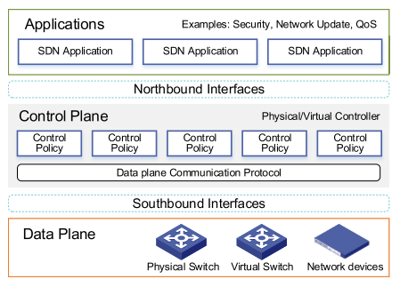
Fig. 4. SDN Architecture [28]
SDN architecture is made up of several layers and application programming interfaces (APIs), as can be seen in fig. 4. In addition to the data plane and control plane, there is the application plane. This layer defines software applications that will interface with the SDN controller. These planes are bridged via APIs. The Northbound API facilitates communication between applications and the controller to provide different control mechanisms to the network. The Southbound API bridges the data plane and control plane. It should be noted that network hardware must support SDN and the Southbound APIs to be used in an SDN architecture [23], [28].
SDN has attracted considerable interest from the research community and industry. This has been in part due to SDN being a paradigm that spawned numerous open-source technologies and open interfaces to facilitate its implementation [23], [27].

OpenFlow Architecture
OpenFlow is a well-known open Southbound API pioneered by the Open Networking Foundation (ONF). OpenFlow’s architectural approach to SDN has been strongly supported by industry and the research community. It achieves the decoupling of data and control plane via an OpenFlow compatible forwarding device with one or more flow tables. The device then uses the OpenFlow protocol to communicate with a controller. Flow tables are made up of flow entries that are used to match packets, collect statistics and apply actions to matched packets. The remote controller can add, remove and modify flow entries in a devices flow table allowing for dynamic and rapid network policy change. This can happen reactively to packet arrivals or proactively by a user via software applications. An alternative to the OpenFlow implementation of SDN is Forwarding and Control Element Separation (ForCES) proposed by the Internet Engineering Task Force (IETF) [26].
For OpenFlow to function a compatible controller is required. There are numerous options available, including NOX, Floodlight and Maestro. A controller is not a physical device but an infrastructure framework and development platform that can consist of various plug-ins, SDN applications and Northbound APIs. Different controllers also cater to different developers based on the programming language the platform is based on and the unique features that are offered. A controller can be centralised on a highly-available server or decentralised with multiple controllers for increased scalability and redundancy. [23], [25]–[27], [29].
There are flexible data plane options to implement OpenFlow into network infrastructure. Many network hardware vendors (e.g. Cisco [30], HP, Juniper) have support for OpenFlow in their products with specially designed SDN hardware or firmware updates to existing hardware. Software switches (e.g. Open vSwitch and Switch Light) are also now becoming an attractive option for data centre and virtualised infrastructure [23], [26], [29].
The Northbound APIs are often defined as part of the SDN controller. However, there are other options such as the Representational State Transfer (REST) API and specially designed SDN programming languages (e.g. Frenetic, Procera and Nettle) [31].
The last component to SDN is the network applications. These applications are designed to implement the control logic, forwarding decisions, network services and policies that are translated into flow table entries on devices at the data plane. Most network applications can be grouped into five main categories of operation: traffic engineering, mobility and wireless, measurement and monitoring, security and dependability and data centre networking. The network application must be compatible with the Southbound API (OpenFlow) and SDN controller [23], [26], [29].

Benefits
There are numerous benefits to adopting an SDN architecture:
- Encourages network innovation and moves away from proprietary network solutions [26], [28], [32]
- Increasing support and integration from hardware vendors [23], [26], [29]
- Vast number of technologies to build and customise an SDN implementation [23], [26], [29]
- Simplifies network management [32]
- Increases configuration and management flexibility [26], [28]
- Reduces management overhead [29]
- Reduces the chance of misconfiguration [29]
- Logically centralises management and control [26], [28], [29]
- Network services and applications become easier to implement. This is due to the abstraction of the control plane and support for high-level programming languages [32].
- Provides a complete network view to applications and users which can lead to more consistent and effective policies [26], [32]
- Easier to consolidate and integrate multiple network applications [26]
- Complimentary to virtualised architectures [28], [29]
- Resolution of complex network problems with programming [23], [28]

Concerns
SDN is not without its concerns and challenges:
- The logically centralised controller make scalability of SDN a concern that cannot be ignored. In very large data centre environments measures will need to be taken to ensure the SDN controller does not become overloaded. These include harnessing parallelism in multicore systems, strategies to reduce requests to the controller or decentralising the [23], [24], [26], [27], [29], [32], [33].
- Resiliency is a concern as the logically centralised control plane must be highly available in addition to network hardware. There is currently a lack of research and experimentation into building and managing fault tolerant SDNs [23], [24], [26], [27], [29], [32].
- Performance of SDNs in enterprise environments are currently unknown due to a lack of research outside a simulated setting. This is a concern as an understanding of performance is critical before using SDN in a production environment [23], [24], [26], [27], [29], [32].
- SDN creates new security challenges that need to be addressed. New threat vectors such as exploitation of the logically centralised controllers and malicious applications interfacing with the controller. A compromised controller may also compromise the entire network. The severity of these threats cannot be understated which is why there has been extensive research into effective countermeasures. SDN can be secured to a high level due to these research efforts. However, there currently is not a widespread understanding of how to properly secure SDNs outside of the academic community and those experimenting extensively with the technology [23], [24], [26], [27], [29], [32].
- SDN is still a relatively new architectural approach to networking and many of the concerns mentioned have not been sufficiently addressed. There is also a skills gap and steep learning curve to the technology involved, as well as a social resistance caused by concerns of job insecurity. Thus, adoption of SDN by the average enterprise has been very slow [23].

Network & Data Centre Management
SDN has huge potential for network management. As previously highlighted, there is an increasing demand for quick and dynamic management of potentially thousands of devices. SDN provides better device visibility and control over configuration, diagnosis and troubleshooting tasks [25]. It should be remembered that once OpenFlow is enabled and configured on a device the proprietary CLI language is no longer needed for configuration. Full control of the device is now the responsibility of the SDN controller and its associated APIs and network applications.
The data centre environment is an important use case for SDN. This is due to its ability to provide network virtualisation, abstraction and automation. Challenging problems such as topology discovery, QoS, load balancing, resource provisioning and complex application requirements can be handled by SDNs in a flexible and dynamic manner, not currently seen in traditional networks [23], [26], [27], [34]. SDN has shown strong potential to reduce energy consumption in the data centre [26]. Google has deployed a software-defined WAN to great success. The ‘B4’ SDN has shown to be very efficient at connecting Google’s data centres worldwide, handling large loads with advanced traffic engineering [26], [29].
In terms of the author’s network, SDN could be gradually integrated into the existing enterprise and data centre infrastructure to support dynamic future growth of the network. Extensive overhauls are not required to the existing infrastructure. This is because Cisco hardware is already being used which supports the OpenFlow protocol. A server needs to be set up to host an SDN controller and the use of existing open source network applications. The key to implementing SDN in the author’s network and data centre design is its slow and gradual introduction. It could start off as a research project before small-scale introduction to less critical parts of the network. This allows the university to contribute to SDN research and deploy the architecture safely. The benefits that SDN could bring to the network have been stated in section B. Its concerns have been respected via the author’s cautious implementation. It is worth considering examples of how SDN will support future growth of the university enterprise network and its data centre. The use of Bring Your Own Device (BYOD) is an example where large numbers of non-university owned devices are connecting to the network. This creates security challenges and requires complex policies to manage resource access and allocations. Rather than deploying expensive, proprietary and non-network integrated solutions such as Aruba ClearPass Policy Manager [35]; an SDN solution could be deployed to dynamically fulfil policy requirements at little to no cost, while offering limitless flexibility via programming. The management of multiple campuses from Swansea over a software-defined WAN would become more feasible. The network could also be simplified by integrating the numerous middleboxes such as firewalls and security appliances directly into the controller. A final example is the introduction of digital apprenticeship students who may have access to different resources and require remote access from their employer. In a traditional network, such requirements may take months for the small network administration team to implement reliably and securely. An SDN could use applications such as FlowNAC and LiveSec for rapid security and network access control policy deployment for such scenarios [36]–[38]. There are also SDN simulation tools such as Mininet to prototype implementations before they are deployed in production [23]. It should be noted that any business application can be integrated into the SDN controller via the Northbound API [24].

conclusion
In conclusion, the author has presented a functional enterprise network and data centre to support UWTSD campuses and global partner colleges in PT 7.2. Design assumptions have been presented due to limitations in PT. The IP addressing scheme has been highlighted along with discussion on all data centre services. These include IP infrastructure, storage, application, security and business continuance infrastructure services. The second part of the report presented research on SDN; a promising solution to traditional network and data centre management issues. SDN concepts and architecture were discussed, as well as benefits and concerns. Lastly, a section dedicated to SDN’s relevance to network and data centre management was presented. This included a blueprint for implementing an OpenFlow based SDN into the author’s existing enterprise network and data centre design.
This report does not have a comprehensive discussion of the author’s network and is only an introduction to the field of SDN. There are many possibilities for further research. These include implementing the network in GNS3 due to the limitations and unreliability’s found in PT. Detailed research can be conducted into data centre design best practices. This is because the design presented in this report was mainly formulated based on the author’s existing network knowledge. Lastly, research could be conducted into the practical implementation of OpenFlow SDNs.

References
[1] Cisco Networking Academy, “Scaling Networks,” netacad.com, 2018. [Online]. Available: https://www.netacad.com/. [Accessed: 16-Dec-2018].
[2] Cisco Networking Academy, “Routing and Switching,” netacad.com, 2018. [Online]. Available: https://www.netacad.com/. [Accessed: 16-Dec-2018].
[3] M. Portolani and M. Arregoces, “Data Center Design Overview,” in Data Center Fundamentals, 1st ed., Cisco Press, 2003, p. 1104.
[4] CommScope, “Fiber backbone cabling in buildings,” 2017.
[5] Black Box Network Services, “Fibre vs Copper,” Black Box Technical Resources. [Online]. Available: https://www.blackbox.co.uk/gb-gb/page/24499/Resources/Technical-Resources/Black-Box-Explains/Fibre-Optic-Cable/Fibre-vs-Copper. [Accessed: 15-Dec-2018].
[6] FS, “The Advantages and Disadvantages of Fiber Optic Transmission,” FS.COM, 2018. [Online]. Available: https://www.fs.com/the-advantages-and-disadvantages-of-fiber-optic-transmission-aid-431.html. [Accessed: 15-Dec-2018].
[7] D. Hebert, P. E, and A. Creidler, “Engineer’s Guide to Copper vs. Fiber,” Engineering360, 2016. [Online]. Available: https://insights.globalspec.com/article/3566/engineer-s-guide-to-copper-vs-fiber. [Accessed: 15-Dec-2018].
[8] Intel Corporation, “10GBASE-T for Broad 10 Gigabit Adoption in the Data Center,” 2012.
[9] M. Courtney, “Copper keeps data centers low-fiber,” Data Centre Dynamics Ltd., 2015. [Online]. Available: https://www.datacenterdynamics.com/analysis/copper-keeps-data-centers-low-fiber/. [Accessed: 15-Dec-2018].
[10] FS, “Single Mode Fiber: How Much Do You Know?,” FS.COM, 2012. [Online]. Available: https://community.fs.com/blog/single-mode-fiber-how-much-do-you-know.html. [Accessed: 22-Dec-2018].
[11] Cisco, “ISP Failover with Default Routes using IP SLA Tracking,” Cisco Configuration Examples and TechNotes, 2017. [Online]. Available: https://www.cisco.com/c/en/us/support/docs/ip/ip-routing/200785-ISP-Failover-with-default-routes-using-I.html. [Accessed: 16-Dec-2018].
[12] solarwinds, “Network Performance Monitor,” www.solarwinds.com. [Online]. Available: https://www.solarwinds.com/network-performance-monitor. [Accessed: 16-Dec-2018].
[13] D. Ye, “Reference Architecture: Microsoft Scale-Out File Server using Storage Spaces,” 2015.
[14] J. Gerend, L. Poggemeyer, and H. Lohr, “Scale-Out File Server for application data overview,” Microsoft Docs, 2018. [Online]. Available: https://docs.microsoft.com/en-us/windows-server/failover-clustering/sofs-overview. [Accessed: 18-Dec-2018].
[15] Microsoft, “Understanding Microsoft Storage Spaces.”
[16] N. Pyle, J. Gerend, L. Poggemeyer, and W. Gries, “Storage Replica Overview,” Microsoft Docs, 2018. [Online]. Available: https://docs.microsoft.com/en-us/windows-server/storage/storage-replica/storage-replica-overview. [Accessed: 18-Dec-2018].
[17] AVI Networks, “Application Services,” Technical Glossary. [Online]. Available: https://avinetworks.com/glossary/application-services/. [Accessed: 18-Dec-2018].
[18] Cisco, “OSPFv2 Cryptographic Authentication.”
[19] Cisco, “Enterprise Internet Edge Design Guide,” Cisco Security Design Guide, 2009. [Online]. Available: https://www.cisco.com/c/en/us/td/docs/solutions/Enterprise/Security/IE_DG.html#wp42995. [Accessed: 18-Dec-2018].
[20] Cisco, “AAA Overview.”
[21] Altaro, “What is Hyper-V Replica and how does replication work?,” www.altaro.com. [Online]. Available: https://www.altaro.com/hyper-v/hyper-v-replica-replication-work/. [Accessed: 18-Dec-2018].
[22] K. Davies, A. van Tonder, S. Patti, and L. Poggemeyer, “Set up Hyper-V Replica,” Microsoft Docs, 2016. [Online]. Available: https://docs.microsoft.com/en-us/windows-server/virtualization/hyper-v/manage/set-up-hyper-v-replica. [Accessed: 18-Dec-2018].
[23] D. Kreutz et al., “Software-Defined Networking: A Comprehensive Survey,” Proc. IEEE, vol. 103, no. 1, pp. 14–76, 2014.
[24] M. Jammal, T. Singh, A. Shami, R. Asal, and Y. Li, “Software defined networking: State of the art and research challenges,” Comput. Networks, vol. 72, pp. 74–98, Oct. 2014.
[25] H. Kim and N. Feamster, “Improving Network Management with Software Defined Networking,” IEEE Commun. Mag., vol. 51, no. 2, pp. 114–119, 2013.
[26] B. A. A. Nunes, M. Mendonca, X.-N. Nguyen, K. Obraczka, and T. Turletti, “A Survey of Software-Defined Networking: Past, Present, and Future of Programmable Networks,” IEEE Commun. Surv. Tutorials, vol. 16, no. 3, pp. 1617–1634, 2014.
[27] A. Hakiri, A. Gokhale, P. Berthou, D. C. Schmidt, and T. Gayraud, “Software-Defined Networking: Challenges and research opportunities for Future Internet,” Comput. Networks, vol. 75, pp. 453–471, Dec. 2014.
[28] Yong Li and Min Chen, “Software-Defined Network Function Virtualization: A Survey,” IEEE Access, vol. 3, pp. 2542–2553, 2015.
[29] W. Xia, Y. Wen, C. H. Foh, D. Niyato, and H. Xie, “A Survey on Software-Defined Networking,” IEEE Commun. Surv. Tutorials, vol. 17, no. 1, pp. 27–51, 2015.
[30] Cisco, “Cisco OpenFlow Feature Support.”
[31] P. V. Tijare and D. Vasudevan, “THE NORTHBOUND APIs OF SOFTWARE DEFINED NETWORKS,” Int. J. Eng. Sci. Res. Technol., vol. 5, no. 10, pp. 501–513, 2016.
[32] J. Wickboldt, W. De Jesus, P. Isolani, C. Both, J. Rochol, and L. Granville, “Software-defined networking: Management requirements and challenges,” IEEE Commun. Mag., vol. 53, no. 1, pp. 278–285, 2015.
[33] S. H. Yeganeh, A. Tootoonchian, and Y. Ganjali, “On Scalability of Software-Defined Networking,” IEEE Commun. Mag., vol. 51, no. 2, pp. 136–141, 2013.
[34] L. Cui, F. R. Yu, and Q. Yan, “When big data meets software-defined networking: SDN for big data and big data for SDN,” IEEE Netw., vol. 30, no. 1, pp. 58–65, Jan. 2016.
[35] Aruba Networks, “Aruba ClearPass policy Manager.”
[36] I. Ahmad, S. Namal, M. Ylianttila, and A. Gurtov, “Security in Software Defined Networks: A Survey,” IEEE Commun. Surv. Tutorials, vol. 17, no. 4, pp. 2317–2346, 2015.
[37] J. Matias, J. Garay, A. Mendiola, N. Toledo, and E. Jacob, “FlowNAC: Flow-based network access control,” in Proceedings - 2014 3rd European Workshop on Software-Defined Networks, EWSDN 2014, 2014, pp. 79–84.
[38] K. Wang, Y. Qi, B. Yang, Y. Xue, and J. Li, “LiveSec: Towards effective security management in large-scale production networks,” in Proceedings - 32nd IEEE International Conference on Distributed Computing Systems Workshops, ICDCSW 2012, 2012, pp. 451–460.

Appendix

Appendix a

enterprise network & data centre design
See page 13 for Figure 1. (zoom in to view more clearly).

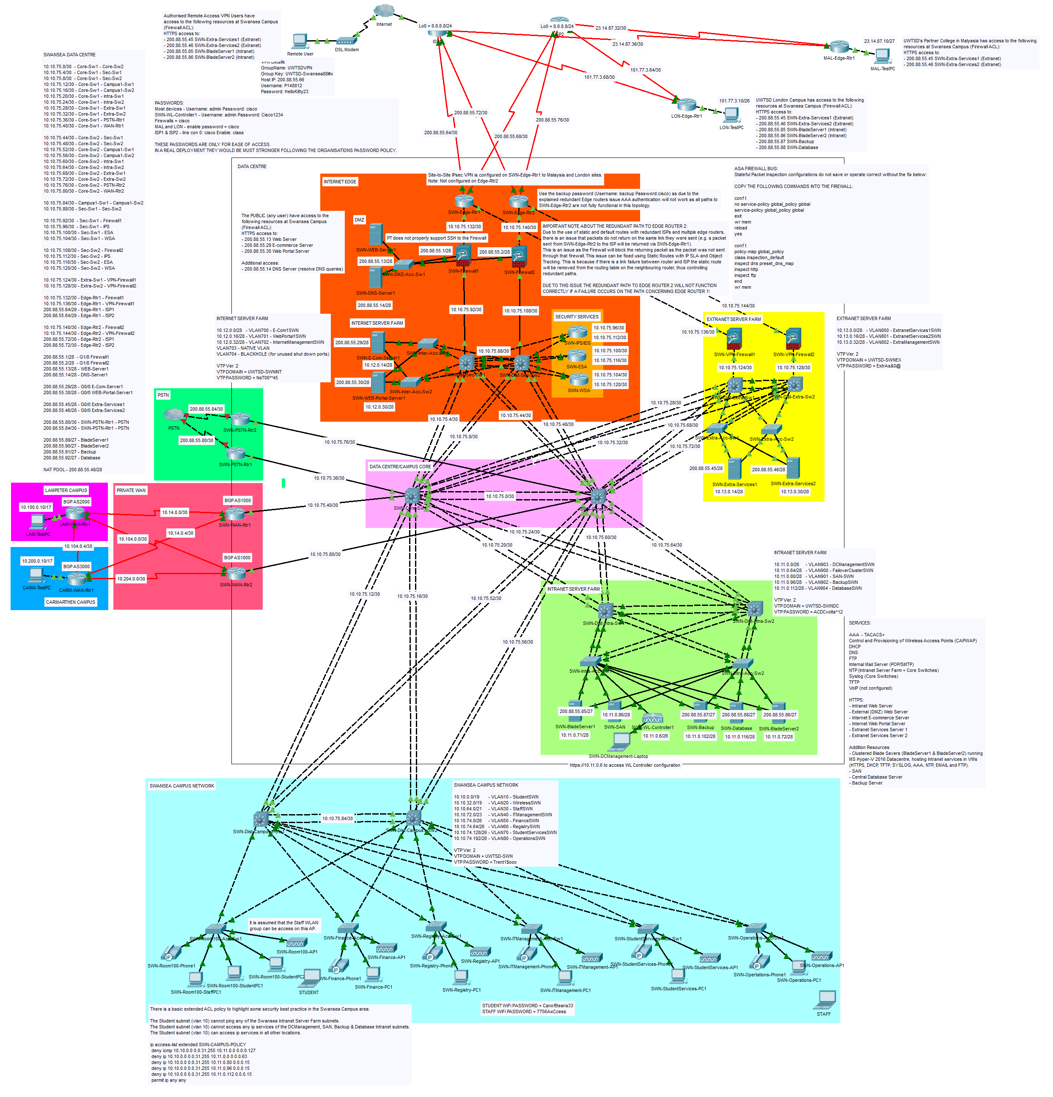
Fig. 1. The enterprise network and data centre design to support UWTSD.

