River Ilston Study
Introduction
River Ilston is located in Gower, Swansea. The mouth of the river starts in boggy marshland near Swansea airport which then runs past the old Ilston Quarry (now known as the Elizabeth and Rowe Harding Nature Reserve), through the villages of Ilston and Parkmill and in to Three Cliffs bay, which is located on the south of the Gower Peninsula (Fig. 1 & 2). The area that we were studying is known for being made up mostly of carboniferous limestone (Fig. 3)
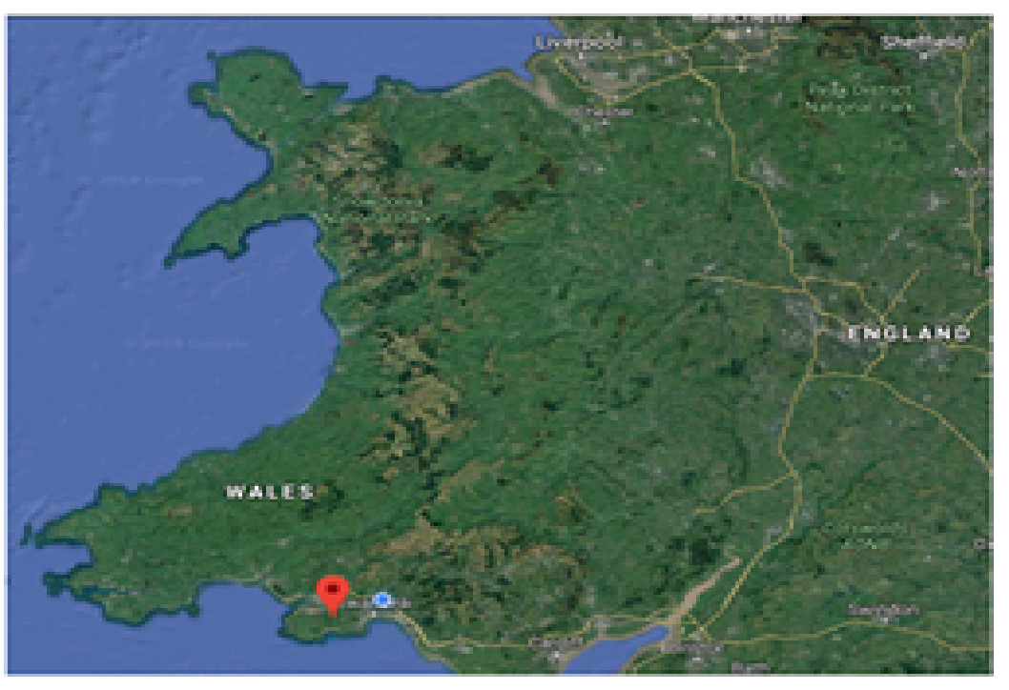
Fig. 1 (above) and 2 (below) Showing location of Gower Peninsula within South West Wales
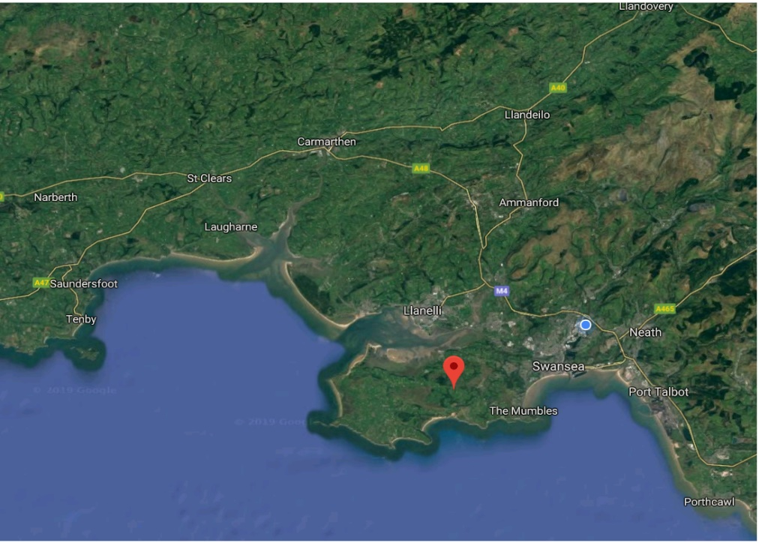

Due to the porosity of limestone a river can easily carve through the landscape and this can cause rivers to easily form (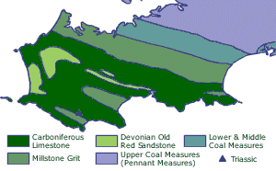
Fig. 3 Geological map of Gower (Explore Gower 2019)
Physical characteristics of limestone (Sciencing, 2015). Caves were witnessed in areas along the river we surveyed, and at certain points the river continued underground. The richness of this alkaline soil gives rise to flora that we witnessed in abundance in this area, such as Wild garlic (Allium ursinum), bluebells (Hyacinthoides non-scripta) and wild strawberries (Fragaria vesca). Ancient woodland is also evident in these same areas, although we did see some trees that appeared to have been anthropogenically affected, in that they grew straight with no branches on the lower levels indicating that they were planted for logging.
Our aim was to complete a hydrological study of the river and to show the results of the following hypotheses:
- The river becomes wider and deeper downstream
- The cross-sectional area of the river increases downstream
- The river velocity increases on the outside of a meander
- The highest velocity is to be found in the centre of the river
- The river velocity decreases downstream
- The size of the bed load gets smaller down stream
- The shape of the bed load becomes more rounded downstream
- The discharge of water in the river increases downstream

Methodologies
Equipment used:
- Map of area (Fig. 4 below)
- Data sheets
- Powers Scale of Roundness chart (Fig. 5)
- Fieldwork notebook
- 25m tape measure
- Metre rule
- Clipboard
- Stop watch
- 2 surveying poles
- Oranges
- Current flow meter
- Waders
Fig. 4 below shows the area that the river runs through. There are 10 points marked with red spots, although only the first 8 points were assessed. We did this in 2 groups. I worked with my group on points 1,5, 6 and 8, but I will present results for all points. The only clear data provided for points 2, 3, 4 and 7 was for the rock study, so I have used last years data for all other measurements.
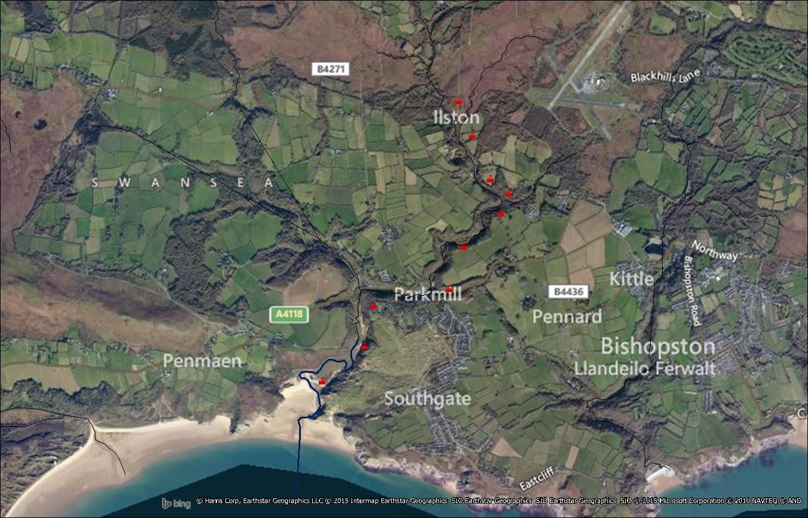
Fig. 4 Showing route of river down to Three Cliffs bay with survey points

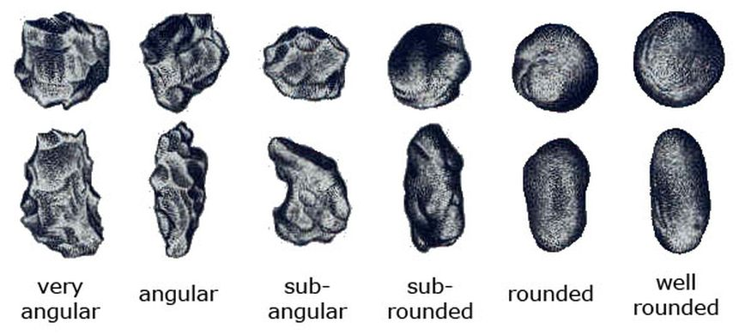
Fig. 5 Visual estimation chart Powers (1953)
At all points the river was measured from right to left bank facing down river and the data collected will be used for Hypotheses 1 and 2. This was done using the measuring tape to get the width of the river at 1m measurements within a 5m stretch of the river. We then measured every 25cm across the river using the metre rule to get the depth at each 25cm point (see Fig. 6 below).
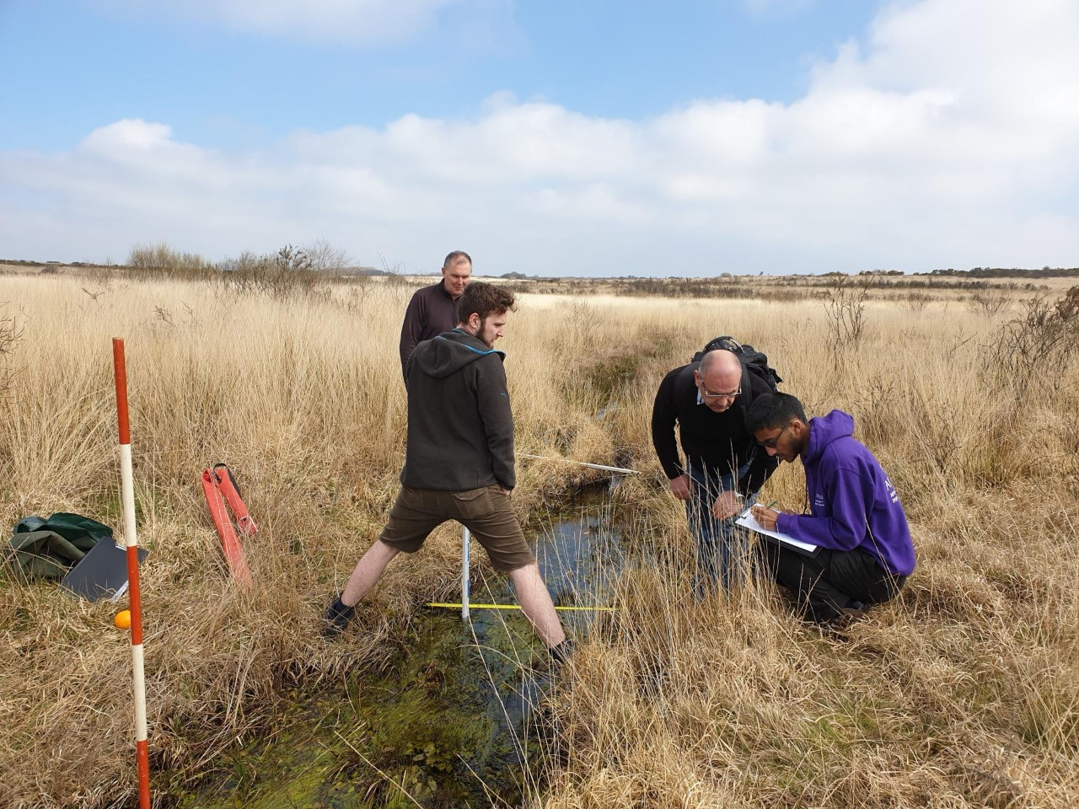
Fig. 6 Fraser Reid, Ernest Sandberg and Naim Awal measuring across Point 1 (lecturer Chris House in background, photo taken by me)
An orange was used to get the velocity of the river as well as a current flow meter was used at points 2, 3, 4 and 7. These results will be used to compare to Hypotheses 3, 4 and 5.
Hypotheses 6 and 7 will be assessed by looking at stones found on the river bed. These will be measured and noted in a table regarding the level of roundness.
Hypothesis 8 has been compiled using the velocity (Fig. 16) multiplied by the cross-sectional area and this will give us the discharge rate in m³
Results and Analysis
Hypotheses 1 & 2
Figures 4 to 11 show the cross section measured over the 8 points. These results clearly support Hypothesis 1 and 2. Apart from Point 3, the widest sections of the river were found at Points 7 and 8 as the hypotheses state. As we can see from Fig. 7 the stream is very shallow as at this point it is just run off from the land as this river starts within marshland near Swansea airport.

Fig. 7 Measurements taken at Point 1 of the river

Fig. 8 Measurements taken at Point 2 of the river

Fig. 9 Measurements taken at Point 3 of the river

Fig. 10 Measurements taken at Point 4 of the river

Fig. 11 Measurements taken at Point 5 of the river

Fig. 12 Measurements taken at Point 6 of the river

Fig. 13 Measurements taken at Point 7 of the river

Fig. 14 Measurements taken at Point 8 of the river
Fig. 15 below shows the grassland area and the narrowness of the river at Point 1. It also shows the weeds in the water that hindered our measuring of the velocity using an orange for Hypothesis 4.
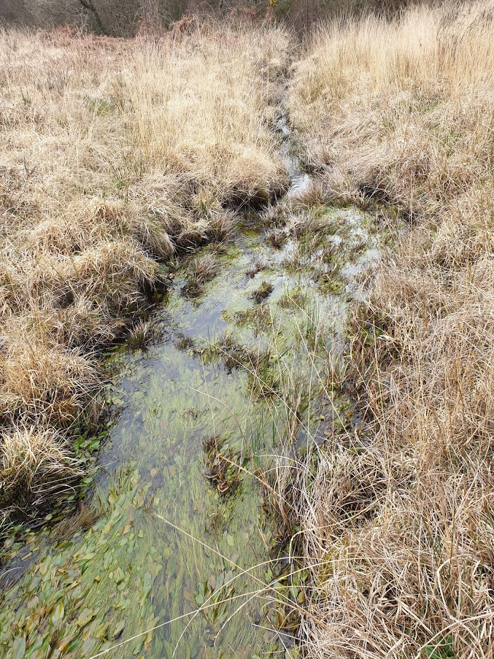
Fig. 15 Showing marshy land and water weeds in river (photo taken by me)

Hypotheses 3, 4 and 5

Location | Average Velocity m/sec.
1 | N/A
2 | 0.19
3 | 0.39
4 | 0.17
5 | 0.1
6 | 0.29
7 | 0.49
8 | 0.37
Fig. 16 Showing averages of velocity at all points
Hypotheses 6 & 7
Fig. 17 below shows quite a variation in size and roundness of the stones at each point and this was determined using the Power Roundness chart (Fig. 5)
Location | Point | Rock size (mm) | Rock shape | Notes
1 | N/A | N/A | N/A | No stone samples found
2 | 1 | 167 | sub-rounded
 | 2 | 127 | sub-rounded
 | 3 | 134 | sub-rounded
 | 4 | 254 | sub-angular
 | 5 | 144 | sub-rounded
3 | 1 | 63 | sub-rounded
 | 2 | 25 | sub-rounded
 | 3 | 25 | sub-rounded
 | 4 | 41 | sub-rounded
 | 5 | 48 | sub-rounded
4 | 1 | 127 | sub-angular
 | 2 | 114 | sub-angular
 | 3 | 112 | sub-angular
 | 4 | 102 | sub-angular
 | 5 | 46 | sub-angular
5 | 1 | 110 | sub-angular
 | 2 | 150 | angular | caddis fly larvae
 | 3 | 130 | sub-angular | caddis fly larvae
 | 4 | 90 | sub-rounded
 | 5 | 160 | sub-angular
 | 6 | 135 | sub-angular
6 | 1 | 230 | sub-rounded
 | 2 | 140 | rounded
 | 3 | 230 | angular
 | 4 | 100 | sub-angular
 | 5 | 100 | rounded
 | 6 | 170 | sub-angular | caddis fly larvae
7 | 1 | 178 | sub-angular
 | 2 | 122 | rounded
 | 3 | 99 | sub-angular
 | 4 | 91 | sub-rounded
 | 5 | 89 | angular
8 | 1 | 130 | angular
 | 2 | 90 | sub-rounded
 | 3 | 110 | sub-angular
 | 4 | 100 | sub-rounded
 | 5 | 90 | sub-angular
 | 6 | 100 | sub-angular
Fig. 17 Showing measurements and ‘Roundness Class’ as stated by Bates and Jackson 1987
Given the hypotheses that the stones will get smaller and rounder as we proceed down the river, our results show that this is not always necessarily the case. This river is not particularly fast flowing in the places we measured velocity, so this could indicate why this is. Also, the river does not flow from a high plain down, so this may be a reason why the river does not build up enough velocity to have an impact on the bed load.
Due to an uncharacteristically dry summer and winter in 2018 this may also have affected this year’s results in relation to the size of some of the rocks and the lack of sub-rounded and rounded specimens towards the bottom of the river. The decrease in river volume may have led to lack of velocity, and this in turn impacts the amount of water discharge needed to transport the larger rocks down river.
Location | Avg. width of river (m) | Avg. depth of river (m) | Cross-sectional area (m²) | Avg velocity (m/sec) | Discharge (m³/sec)
1 | 1.1 | 0.05 | 0.05 | 0 | 0
2 | 3.1 | 0.14 | 0.4 | 0.19 | 0.1
3 | 6.9 | 0.22 | 1.52 | 0.39 | 0.6
4 | 3.8 | 0.18 | 0.68 | 0.17 | 0.1
5 | 6 | 0.09 | 0.54 | 0.1 | 0.05
6 | 8.3 | 0.16 | 1.3 | 0.29 | 0.4
7 | 8.6 | 0.1 | 0.86 | 0.49 | 0.42
8 | 5 | 0.16 | 0.8 | 0.37 | 0.3
Hypothesis 8
Fig.18 Table showing results of water discharge
Hypothesis 8
Hypothesis 8 is proved as shown in the table above (Fig. 18) as this shows that the volume of water flowing through the river channel does indeed increase as we move further down the river.
The appearance of Caddis fly larvae (Trichoptera), an elver and a Kingfisher (Alcedo atthis) earlier up the river indicated the cleanliness of the water and at point 6 we saw two birds nests in the banks of the river at 2m and 4m measurements, and one of them had at least 4 eggs in it (Fig. 17). According to the RSPB (2019) Kingfishers ‘excavate the nest burrow into the stone-free sandy soil of a low stream bank, usually about 0.5m from the top’, so these may very well have been Kingfisher nests.
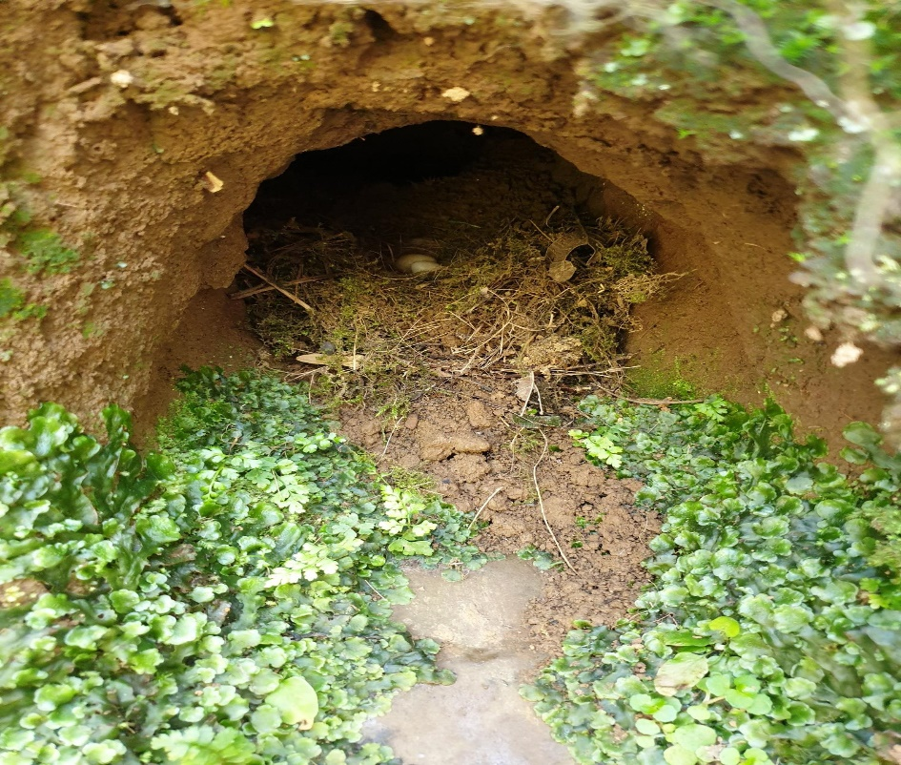
Fig. 19 Potential Kingfisher nest with eggs in bank (photograph taken by me)
On our walk between points 6 and 8 we could see where the river had previously flowed in a meander (Fig. 20 & 21) and then had cut off producing an oxbow style offshoot, however this has since dried up and this ‘cut-off’ caused the river to straighten up.
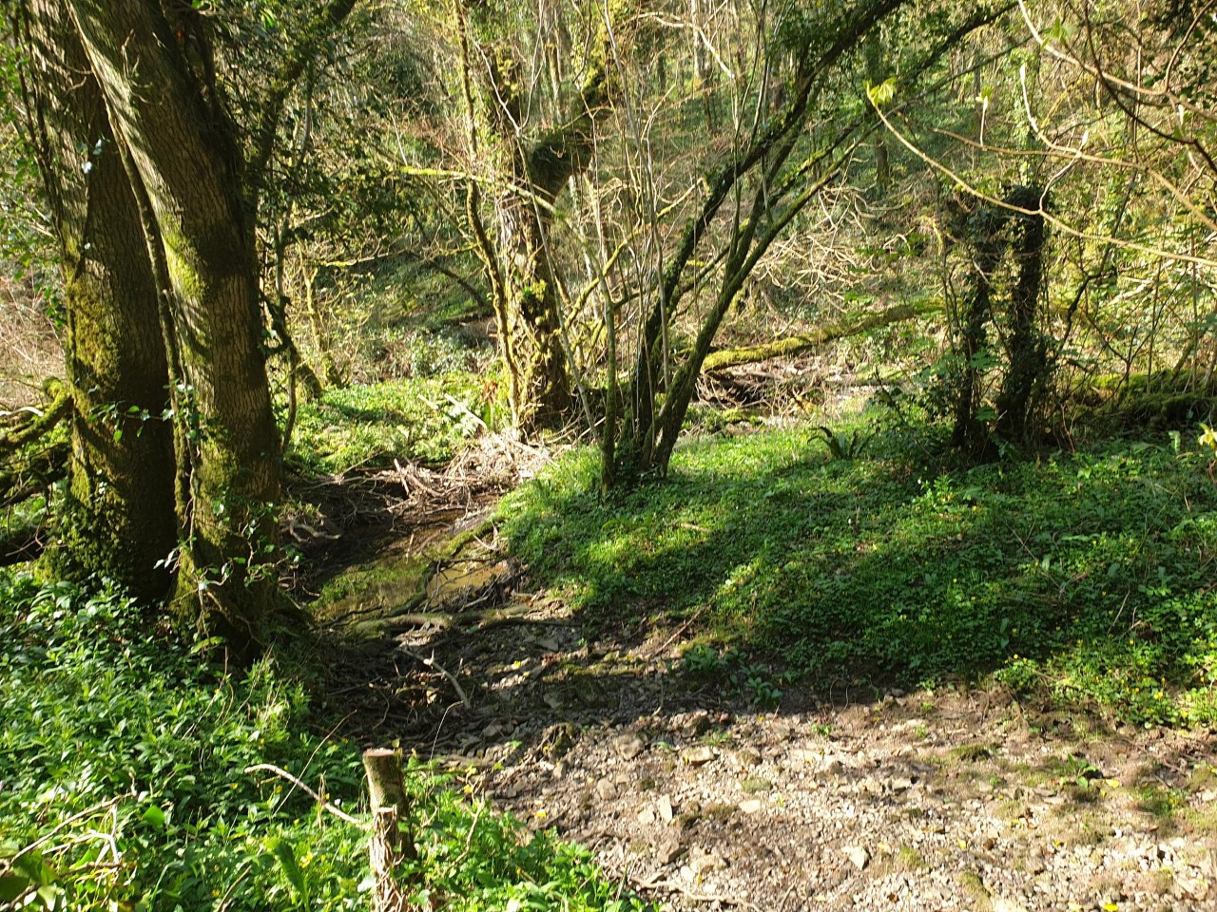
Fig. 20 Dried up cut-off meander of river (photograph taken by me)
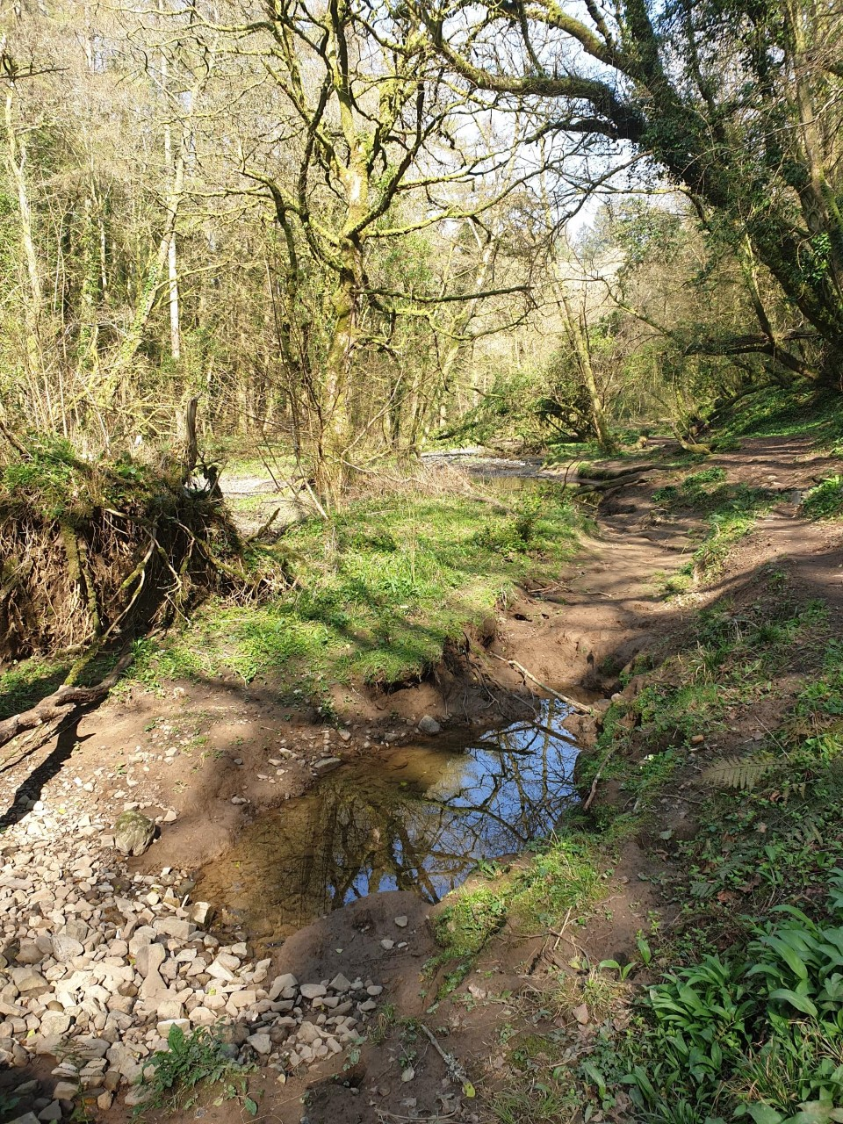
Fig. 21 Stagnant water in meander cut-off with bed load visible (photograph taken by me)

At point 8 there was porcelain and plastic seen in the river due to its locality alongside housing and a heavily used public footpath. There was also a storm drain located at this point.
Conclusion
No hypothesis was outright proven or disproven, Hypotheses 1, 2 and 8 show the results that we would most likely see in a standard river process. A factor in this may have been using this years data for four of the points and last years data for the other remainder.
Our results that were gathered this year were taken when the weather had been unseasonably dry and there was little river swell. Last year’s results were recorded after rainfall, so this could potentially account for the impact on most of the hypotheses.
References
Holden, J (2017) An Introduction to Physical Geography and the Environment. Fourth edition. Harlow, Pearson Education Limited
Explore Gower (2019) Gower Geology. Available at: http://www.explore-gower.co.uk/gower-geology (Accessed 13th April 2019)
Geology Café.com (2019) Sedimentary rocks and processes. Available at: http://www.geologycafe.com/class/chapter9.html (Accessed 15th April 2019)
Kielmas, M (2015) Physical Characteristics of Limestone. Available at: https://sciencing.com/physical-characteristics-limestone-7608531.html (Accessed: 15th April 2019)
RSPB (2019) Kingfisher. Available at: https://www.rspb.org.uk/birds-and-wildlife/wildlife-guides/bird-a-z/kingfisher/ (Accessed 15th April 2019)

