Marcos Vinicio Resende Soares Bruno (2512504)

Module Name: Networks and Cyber Security Essentials
Module Code: ACCA4024

Student Name: Marcos Bruno
Student ID: 2512504
Group: 1

Table of Contents
Identification of Threats 2
Security Policies 2
Mitigation Measures 2
Monitoring and Response 2
Training and Awareness 2
Report 2
Presentation 2
Conclusion 2
References 3

Introduction
To begin, I will explain the benefits of protecting the company through cybersecurity. In addition, I will also explain how Ltd can protect its data and make its system more secure. I will explain how cybersecurity can protect your personal information and help prevent attacks. By following these steps, you can protect your personal information and take precautions against potential threats. However, first, we need to understand what cybersecurity is.
Cybersecurity is the practice of protecting data and personal information from unauthorised access attempts. In summary, it helps protect devices from online attacks [1].
The problem with Ltd is that it is becoming increasingly dependent on technology, which also increases the risk of suffering a cyberattack. To help Ltd prevent cyberattacks, we need to follow a few steps: identify the company’s needs, find out what is causing the problems within the company, determine what can be done to resolve these problems, and make the system more secure.

Identification of Threats
Now I will identify the threats that can affect the systems of various devices, such as computers, mobile phones and other electronic devices. This will help us understand the different types of threats that can affect us.

Ransomware:
This attack is a type of threat in which hackers send an email to the victim. When the victim clicks on a link or opens a file, malicious software is activated on the device, causing important files to be encrypted [2]. As a result, the attackers can demand money from the victim in exchange for recovering their data.
To avoid becoming a victim of this type of attack, users can keep their files stored in the cloud, be extra careful about the links they open, and keep their systems up to date. By following these steps, users can significantly reduce the risk of experiencing a ransomware attack.

Phishing:
One of the most common types of attack is when a victim receives a message from a “company”, which is a criminal. This “company” sends a message with a false explanation and tells the victim that they need to open a link. The link leads to a cloned website of an existing company. When the victim tries to sign in to the cloned website using their account, they end up giving their information to the criminal, such as their password and username or email address used to access the website. As a result, the criminal can use this information to access the victim’s account and misuse it [3].
To protect yourself against this type of attack, you should check the link and confirm that it is the genuine address of the original website. Criminals sometimes use this strategy by making the link look very similar to the address of the website they are trying to imitate. In addition, you can open the website by searching for it directly in your browser instead of using the link provided in the message. Many companies also choose not to deal with urgent issues through messages, such as banks.

DDoS:
This type of attack is carried out against company websites by using multiple bots, which are computers or mobile phones that have been infected with a virus and can be controlled by criminals. This allows criminals to perform multiple actions at the same time, such as making the website receive many requests or making the bots create several accounts at once. This can overload the website, preventing users who need to access it from using it normally. As a result, the website may become very slow or even become temporarily unavailable [4].
To prevent this type of attack, several layers of protection should be implemented. Continuous monitoring should be carried out, and mitigation services should also be used. Some of these services can absorb a large proportion of the attacks, reducing the impact on the website.

Malware:
Malware is any programme or code that can access your device without your permission and potentially steal your data and personal information. As a result, the victim may have their information stolen [5]. Many of these programmes can remain hidden on the victim’s computer or mobile phone. These programmes can often contain code designed to bypass or evade some antivirus software.
To protect your devices against malware, you should use several security tools, such as antivirus software, firewalls and browser extensions that can help protect against this type of attack. By following these simple steps, you can reduce the risk of being affected by this type of threat.

Inside Threats:
One of the places where attacks can occur is within the company itself, through malicious individuals. There may be people who attempt to obtain information from the company they work for, such as trying to install malware on electronic devices, steal data or carry out espionage.
o prevent these attacks within the company; it is important to ensure that employees are trustworthy and to monitor the systems for any suspicious activity. In addition, thorough background checks can be carried out before hiring each employee. It is also important to keep restricted areas well protected and use security measures on the company’s devices.

Treats | Likelihood of happening | Problem within the company
Ransomware | A strong possibility of happening | Major impact on the company
Phishing | A strong possibility of happening | Major impact on the company
DDoS | Average probability of happening | Moderate impact on the company
Malware | A strong possibility of happening | Major impact on the company
Inside Threats | Low probability of happening | Moderate impact on the company

I created the list above to show the possible threats that a person or even a company could experience. In addition, I classified each of the dangers that could occur in a possible attack. Attacks with a high probability of happening were classified as "A strong possibility of happening", while those with less chance of happening but still a significant possibility were classified as "Average probability of happening". Those with the lowest chance were classified as "Low probability of happening". For the impact that these problems could have on the company or the victim, I used "Major impact on the company", which means that it would cause a major problem if it happened. I also created another risk classification called "Moderate impact on the company", which means that it would have a moderate impact on the company.

Security Policies
In this section, I will discuss what SFM can do regarding its security policies and what steps it can take to keep its systems more secure.
Access:
To improve security in the company, a rule can be implemented where each employee,
after finishing their employment, will no longer be able to access areas restricted to the public, such as company computers and employee-only areas. In addition, access levels can be created, such as Level 1 access for lower-level workers, etc.
Permissions can also be reviewed regularly to ensure that everything is kept in order. Finally, anyone who decides to leave the company will have their access removed.

Authentication:
To prevent intruders from trying to access the company's computers, we can follow some identification steps, such as using strong passwords, which can include numbers, capital letters, or even symbols, such as "+" or "/", to make accounts more secure. Not sharing passwords is also recommended. There may be malicious individuals who may try to obtain a password by talking to other people. In addition, we can also use two-step verification and login attempt blocking, which is used when an incorrect password is entered several times and alerts the user when someone tries to access their account.

Data:
To protect your data, you can make backups in the cloud to keep saved copies, encrypt your files, and use access control so that only you can access the data.

Remote Access:
To allow remote access to your files, you can use a VPN, which makes it more difficult for people from outside to try to access your information through your IP address. You can also use MFA. When using remote access, you should always check the data to avoid any problems and prevent access from unknown devices.

Event during the attack:
When a threat enters the system, you must detect what is happening and then identify the threat. After identifying the threat, you should contain it and remove it immediately afterwards. After that, you should recover the system and investigate how the threat started. Finally, you should add more security to the area where the threat originated to prevent future problems.

Mitigation Measures
In this section, I will discuss what the company can do to reduce the risks of possible attacks on the company. I will give a summary and list them in three different categories, such as Technical, Administrative and Physical. In each of these sections, I will list applications, extensions and tips and explain what can be done.

Technical:
- Firewall – It is a system that monitors data, making it safer to browse the internet and preventing possible attempts of attacks through the network [6]. It is useful for keeping the network secure, as it monitors the data coming in to prevent any problems.

- MFA – This is something that can be used if you want extra security for your devices or accounts [7]. It requires one or more verification steps, such as entering a code that was sent to your email or entering a password that only you know. It is useful for making it more difficult for strangers to access your accounts or devices.

- Antivirus – This is widely used to provide extra security for mobile phones or computers. It monitors your files to check if there are any programmes containing viruses, Trojans or ransomware [8]. If it finds something like this, it will prevent the programme from being activated, such as by deleting the file. Normally, most antivirus software has a scanning system that allows you to check every file you must see if there are any malicious programmes running.

- Encryption – This type of tool is used to encrypt files, text and much more. It makes it impossible to read the text or understand what each file contains. Normally, you can only see what is written if you have the key to access the file and decrypt it. This helps keep your files well protected.

- VPN – It can make your device that is connected to the internet more protected, making your device, such as a mobile phone or computer, have a secure connection that is encrypted between your device and the internet [9]. It is normally used to make it more difficult to locate your device, allowing you to connect your device to a network more freely.

- Secure Backups – Normally used to make copies of your original files and store them in the cloud. If you lose the original file, you will always have a backup. It is useful for reducing the chance of losing important work and for accessing your files from different locations.

- Access Control – It is a system that determines who can access what, such as company computers or stored files. It helps protect security by preventing people who do not have permission from using or accessing them.

Administrative:
- Employee Training – Used to show what should be done in the company, normally used to teach new employees or remind workers what has to be done. Very good for keeping everyone well trained for each function that was designated.

- Security Requirements – Normally used to remind employees of what has to be done to prevent possible problems from happening, basic rules that must be followed or even for the employee's own safety.

- Security Policies – They are used to remind people of the rules that must be followed during working hours, normally a sign is left with a notice saying what can or cannot be done in that place. In addition, there are always meetings to remind everyone of all the company's policies.

Physical:
- CCTV – Used to monitor employees' behaviour, thus making it easy to identify possible attempts to attack the company.

- Access Cards – Makes restricted areas also require access permission, such as a card, thus being able to divide each employee into each category, such as security employees only accessing security rooms, such as camera monitoring and much more. This makes it easier for the company to control what is being done by each employee.

- Physical Security – This one is simple, putting guards to monitor around the company.

CIA Principle | SFM Example | Security Measure
Confidentialit | Customer Data | Encryption and MFA
Integrity | Production Data | Access Control and Monitoring
Availably | Manufacturing | Backups

Monitoring and Response
I will now talk about how SFM can know if it is being attacked by someone, one of the examples I will give is the continuous attempt to enter an account. If someone from outside who does not know an employee's account tries to enter it and repeatedly gets the password wrong, the programme can notify the user that their account is being attacked, thus allowing the user to take precautions against this threat.
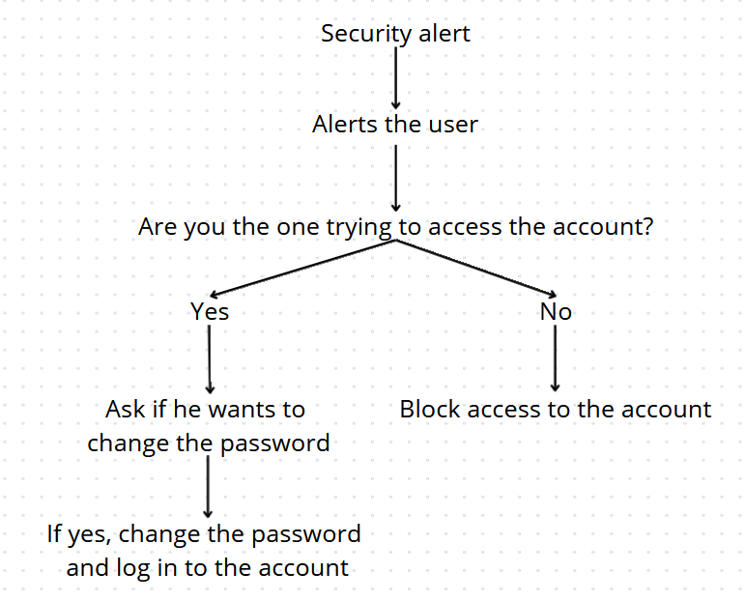

Training and Awareness
Employees can have monthly training to remind them of what should be done to maintain security in the company to prevent intruders. The company can teach employees to recognise suspicious emails, fake links and password requests that are not trustworthy. By following these simple steps, the company will be much more protected.
In addition, let the workers know that they should not share their passwords with anyone and use strong passwords to prevent malicious people from trying to access the company's accounts.

Report
Now I will talk about what I think should be the company's priorities, first putting MFA, which helps a lot with the company's security, then internet security, thus preventing attacks from being carried out via the internet, making backups regularly, thus keeping reserves of files and not letting anything be lost, employee training is something extremely necessary and, finally, carrying out continuous monitoring, so that if something happens, the problem can be resolved in a short time.
If an attack happen to an employee, they should go to the IT room, where there should be qualified people to deal with this case and, to make the workers more aware of these types of attacks, they should take a quiz about these subjects and, if they pass, they will be fit to work at the company. In addition, this quiz should be done monthly so that the employees do not forget what should be done if there is an attack. Real life simulations can also be done, such as teaching employees how to prevent someone from stealing data in the middle of the company.

Presentation
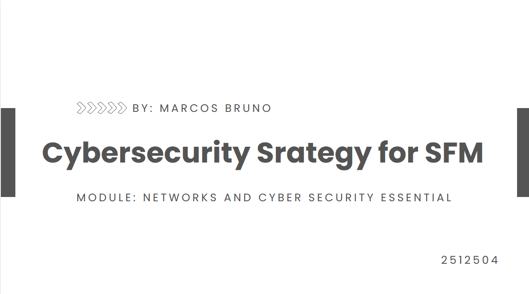
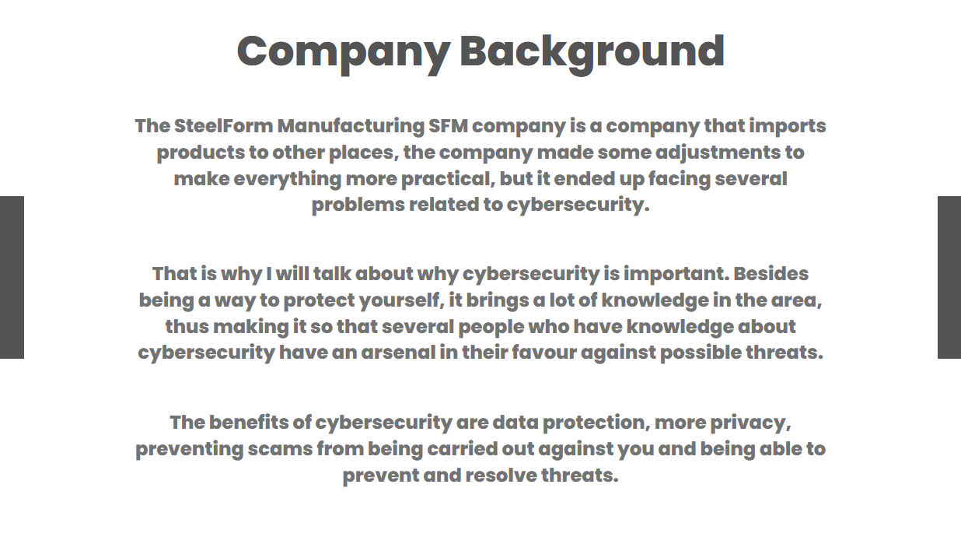
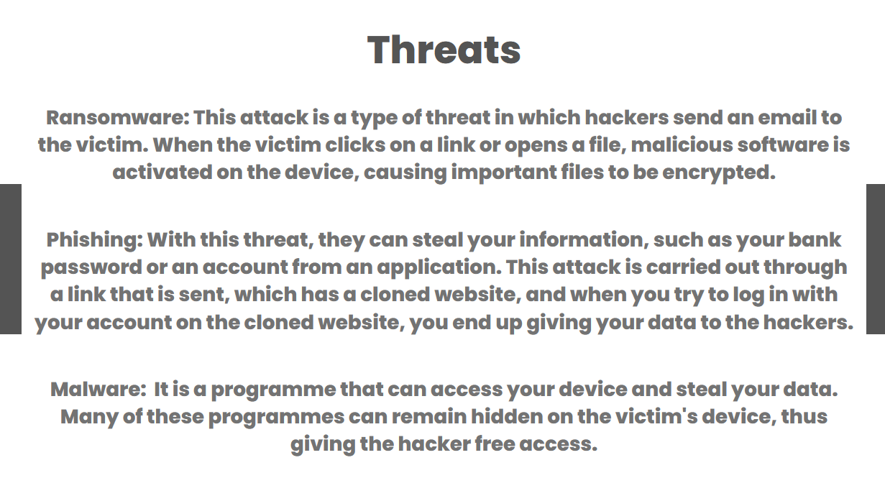
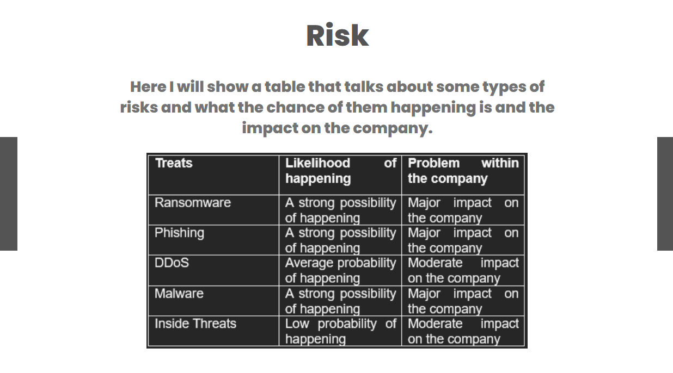
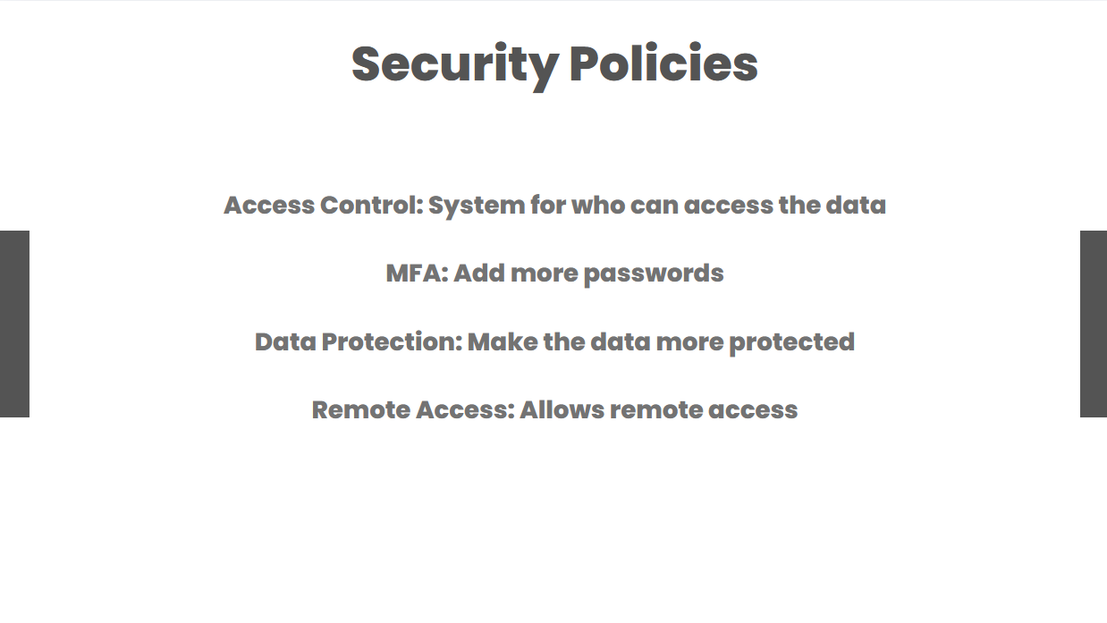
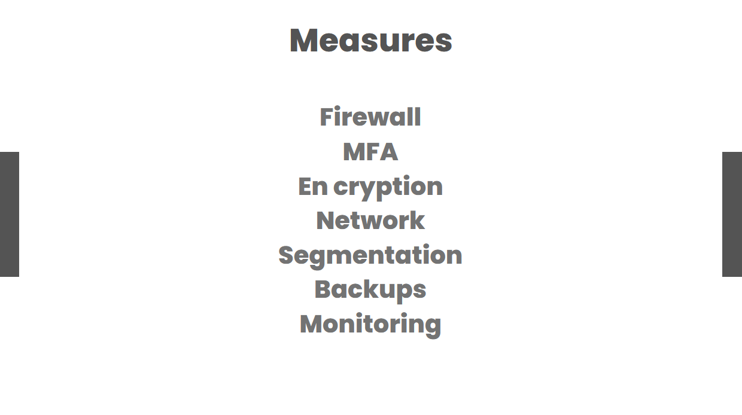
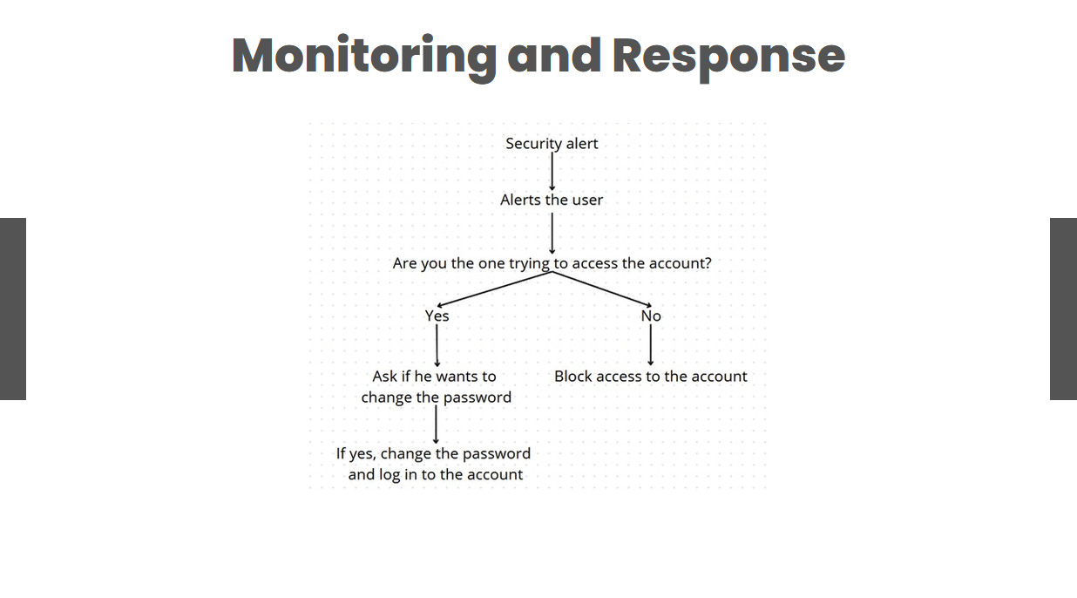
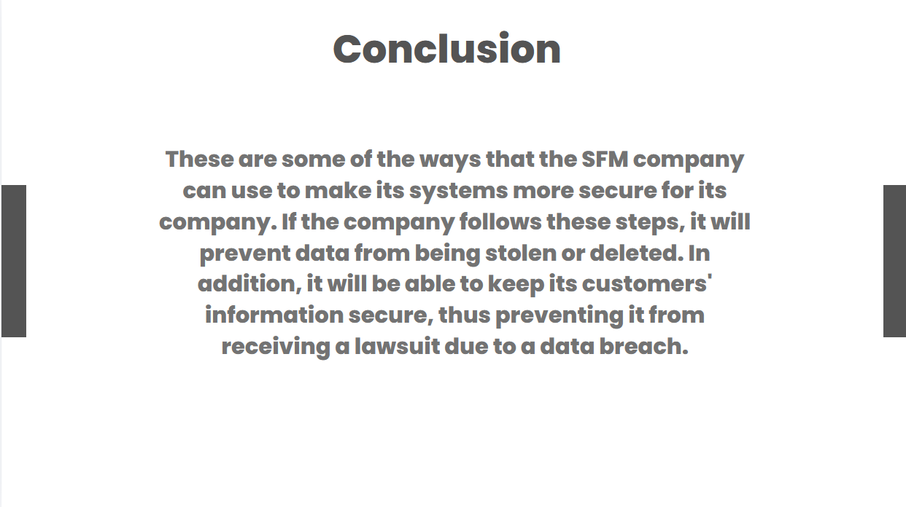
Conclusion
In this work we talked about what cybersecurity is and, as mentioned, it is something that must be continuous, it is not something that should only be used once and that is it. In this field, there must be qualified people who can monitor what is being done. The problem with not keeping a company secure is that it is left open to various threats, such as viruses, phishing and ransomware, these are only some of the problems that a company can face if it does not have a system prepared for these types of attacks. In addition, people who do this normally try to obtain these data so they can sell them or even threaten the company itself, causing it to receive a large lawsuit. That is why there should always be technical measures, such as teaching employees what should be done and training them for this type of situation.
If SFM follows these steps, it will become one of the most trustworthy companies, thus gaining more reputation, and that is not all, it will greatly reduce the attempts of attacks against the company and will have employees who are much more capable of solving these types of problems. In addition, it will be able to prevent receiving future lawsuits due to data leaks.

References
[1] Berlilana, et al, “The role of cyber security readiness and technology readiness,” Organization benefit as an outcome of organizational security adoption:, ustainability : Sustainability, 2021, p. 13.24.
[2] O'Kane, Philip, Sakir Sezer, and Domhnall Carlin, “Evolution of ransomware.” Evolution of ransomware. s.l. : IET networks, 2018, pp. 321-327.
[3] Ramzan, Zulfikar, “Phishing attacks and countermeasures,” Handbook of information and communication security, 2010, pp. 433-448.
[4] Nazario, Jose, “DDoS attack evolution,” Network Security, 7 10 2008.
[5] Ab Razak, Mohd Faizal, et al, “The rise of “malware",” Journal of Network and Computer Applications , pp. 58-76, 2016.
[6] Lyu, Michael R., and Lorrien KY Lau, “Firewall security: Policies, testing and performance evaluation,” Proceedings 24th Annual International Computer Software and Applications Conference. COMPSAC2000, no. IEEE, 200.
[7] Abdi, Hervé, and Dominique Valentin, Multiple factor analysis (MFA), Encyclopedia of measurement and statistics, 2007.
[8] Li, Mingcai, et aL, “Interferon-λs: the modulators of antivirus, antitumor, and immune responses,” Journal of leukocyte biology, 2009,
[9] Ferguson, Paul, and Geoff Huston, What is a VPN? 1996.

